AI Assisted Coding (III Year) Assignment
NAME : K.AKSHAY
HT NO :2303A52209
BATCH :35

Lab 2: Prompt Engineering – Improving Prompts and Context Management
Lab Objectives
- To understand and apply different prompt engineering techniques for generating Python programs using AI-assisted tools.
- To analyze how context and examples affect correctness and efficiency of AI-generated code.
- To refine real-world Python programs through iterative prompt improvement.

Task 1 Zero-Shot Prompting – Palindrome Number Program

Prompt: Write a Python function to check whether a given number is a palindrome
Code :
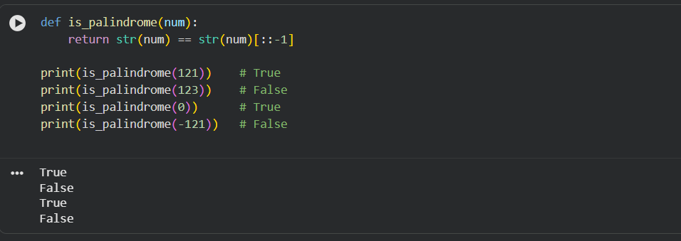

Observations
- Works correctly for positive integers and zero
- Negative numbers are not handled explicitly (logical ambiguity)
- Relies on string conversion instead of numeric logic
Conclusion
Zero-shot prompting produces concise code but often ignores edge cases unless explicitly instructed.

Task 2: One-Shot Prompting – Factorial Calculation
Prompt: Write a Python function to calculate the factorial of a number.
Example: Input: 5 → Output: 120
Code 1:
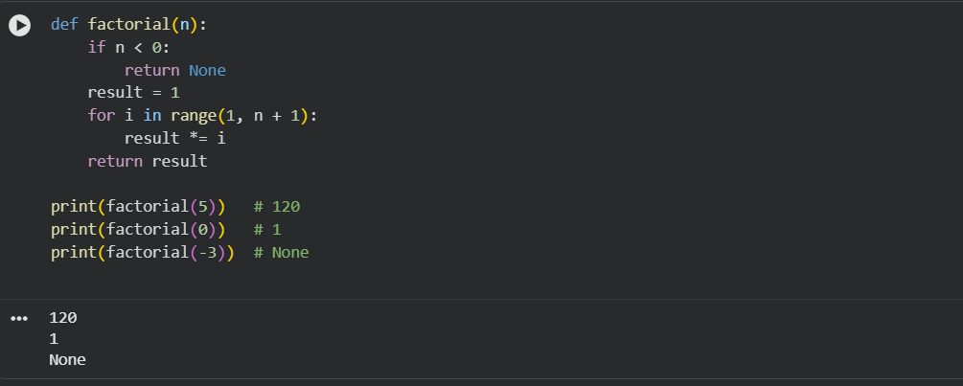

Conclusion
Providing even a single example improves correctness and defensive logic.

TASK-3 Few-Shot Prompting – Armstrong Number Check
Prompt: “Write a Python function to check Armstrong numbers.
Examples:
Input: 153 → Armstrong Number
Input: 370 → Armstrong Number
Input: 123 → Not an Armstrong Number”
Code:
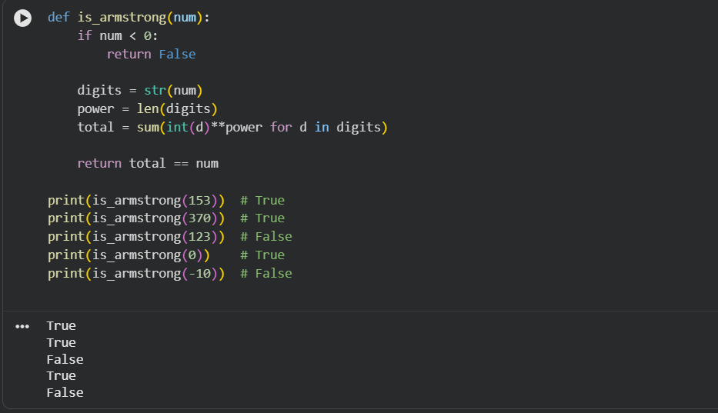
Analysis
- Multiple examples guided correct logic structure
- Handles zero and negative values properly
- Code is cleaner and more reliable than zero-shot
Conclusion
Few-shot prompting significantly improves accuracy and robustness.

TASK -4 Context-Managed Prompting – Optimized Number Classification
Prompt: “Generate an optimized Python program to classify a number as prime, composite, or neither.
Constraints:
- Handle invalid inputs
- Use efficient logic
- Do not use unnecessary loops”

Code:

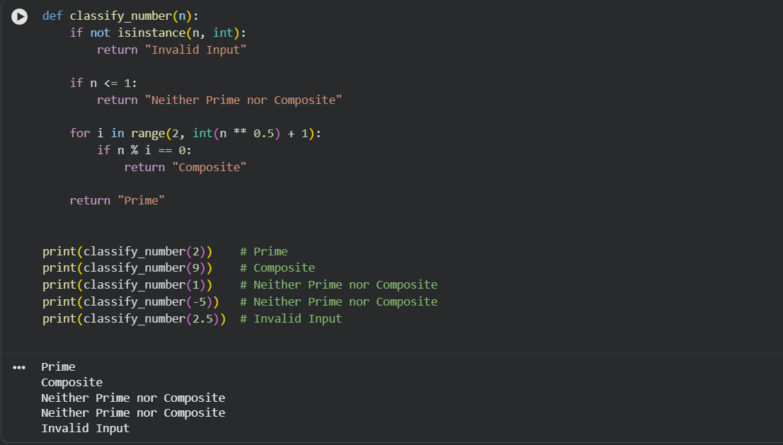

Conclusion
Context-managed prompts produce the most production-ready code with clear constraints and validation.

TASK -5 Zero-Shot Prompting – Perfect Number Check
Prompt: “Write a Python function to check whether a number is a perfect number.”

Code:
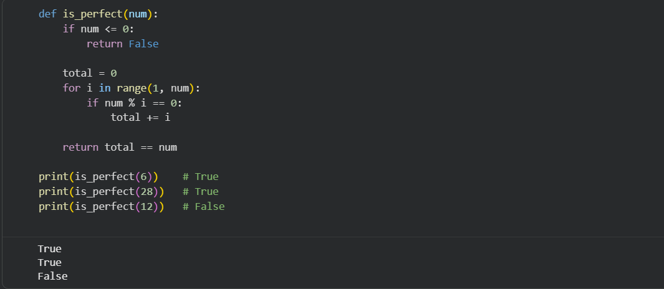

Issues Identified
- Inefficient loop runs up to num-1
- No optimization using square root
- Still logically correct, just slow

TASK -6 Few-Shot Prompting – Even or Odd Classification with Validation.
Prompt: “Write a Python program to check even or odd with validation.
Examples:
Input: 8 → Even
Input: 15 → Odd
Input: 0 → Even”

Code:

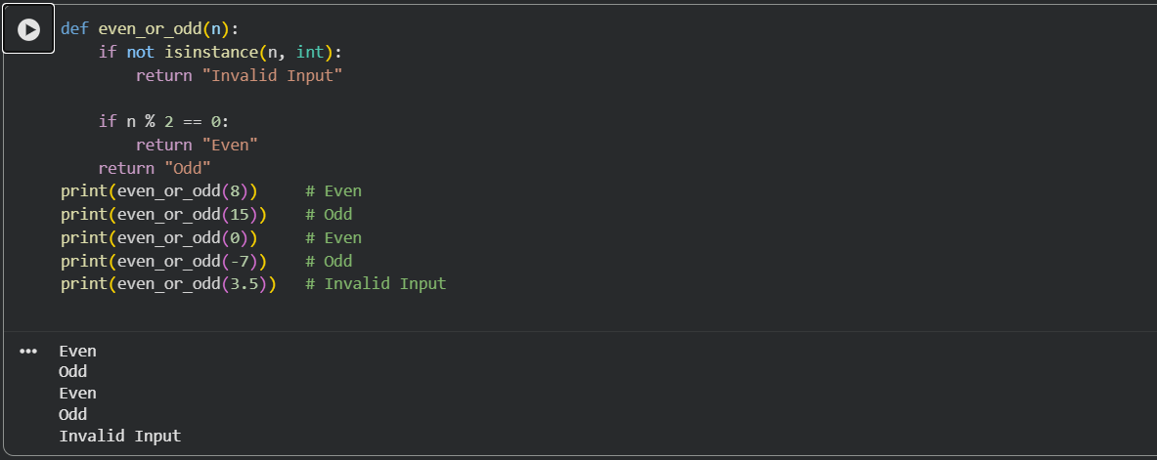

Analysis
- Examples improved validation handling
- Output clarity improved
- Works for negative integers and rejects non-integers

Final Conclusion
Prompt engineering directly affects code correctness, efficiency, and robustness. Zero-shot prompting is suitable only for trivial tasks. Few-shot and context-managed prompting consistently produce better-structured, validated, and optimized Python programs. Clear instructions and examples significantly improve AI-assisted code generation.

