AI Assisted Coding (III Year) Assignment
NAME : K.AKSHAY
HT NO :2303A52209
BATCH :35

Experiment 6: AI-Based Code Completion Working with Suggestions for Classes, Loops, and Conditionals Week 3 – Friday
Learning Outcomes LO1: Use AI-based tools to generate Python code using classes, loops, and conditionals.
LO2: Explain AI-generated code line-by-line.
LO3: Identify errors or inefficiencies in AI-generated code.
LO4: Optimize AI-generated code for readability and performance.
LO5: Demonstrate responsible use of AI tools in coding tasks.

Task Description 1: AI-Based Code Completion for Conditional Eligibility Check
Prompt Used “Generate Python code to check voting eligibility based on age and citizenship.”
AI-Generated Code age = int(input("Enter age: ")) citizen = input("Are you a citizen? (yes/no): ")
if age >= 18 and citizen.lower() == "yes": print("Eligible to vote") else: print("Not eligible to vote")
Explanation
Takes age and citizenship as input
Uses conditional statements
Person must be 18 or above and a citizen
Output Verification Enter age: 20 Are you a citizen? yes Eligible to vote Task Description 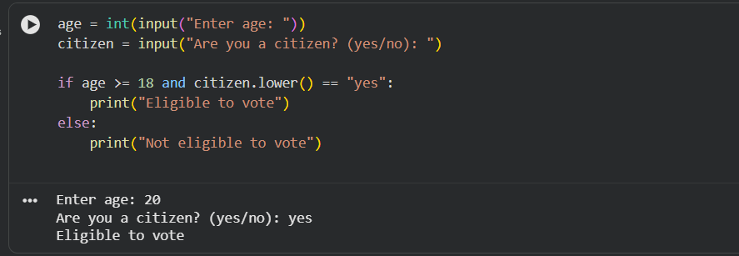
2: AI-Based Code Completion for Loop-Based String Processing
Prompt Used “Generate Python code to count vowels and consonants in a string using a loop.”
AI-Generated Code text = input("Enter a string: ") vowels = "aeiouAEIOU" vowel_count = 0 consonant_count = 0
for ch in text: if ch.isalpha(): if ch in vowels: vowel_count += 1 else: consonant_count += 1
print("Vowels:", vowel_count) print("Consonants:", consonant_count) Explanation Loop iterates through each character
Checks for alphabets only
Counts vowels and consonants separately
Output Verification Enter a string: Hello World Vowels: 3 Consonants: 7
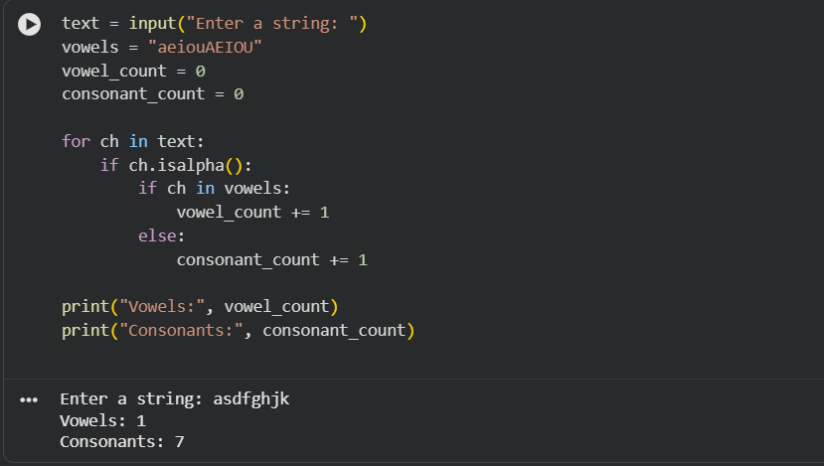
Task Description 3: AI-Assisted Code Completion Reflection Task
Prompt Used “Generate a Python program for a library management system using classes, loops, and conditional statements.”
AI-Generated Code class Library: def init(self): self.books = []
def add_book(self, book):
self.books.append(book)

def display_books(self):
if not self.books:
print("No books available")
else:
for book in self.books:
print(book)
lib = Library() lib.add_book("Python Basics") lib.add_book("DataStructures") lib.display_books()

Review of AI Suggestions Code is simple and readable
Uses class, loop, and conditional
Suitable for beginners
Reflection AI helped generate a complete working program quickly. Human review is still needed to add features like issue and return of books.
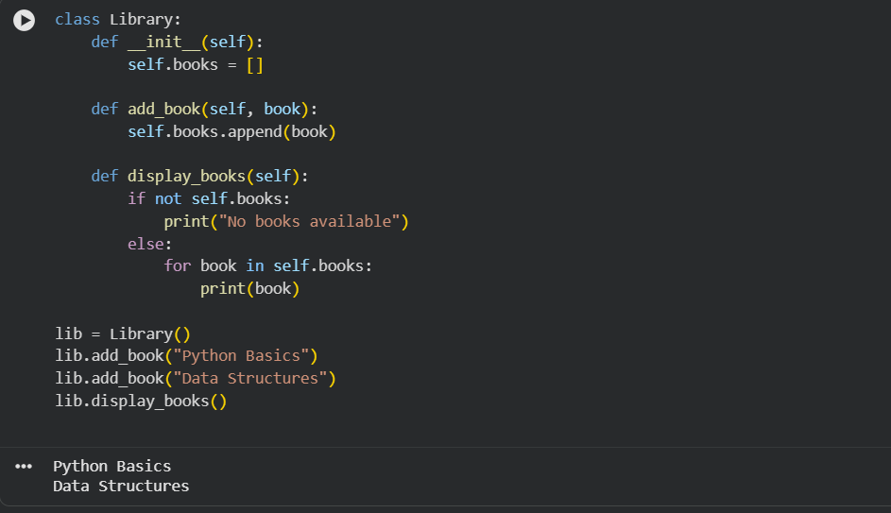
Task Description 4: AI-Based Code Completion for Class-Based Attendance System
Prompt Used “Generate a Python class to mark and display student attendance using loops.”
AI-Generated Code class Attendance: def init(self): self.records = {}
def mark_attendance(self, name, status):
self.records[name] = status

def display_attendance(self):
for name, status in self.records.items():
print(name, ":", status)
att = Attendance() att.mark_attendance("Alice", "Present") att.mark_attendance("Bob", "Absent") att.display_attendance()

Output Alice : Present Bob : Absent Observation
The AI-generated class correctly stores and displays attendance using loops.
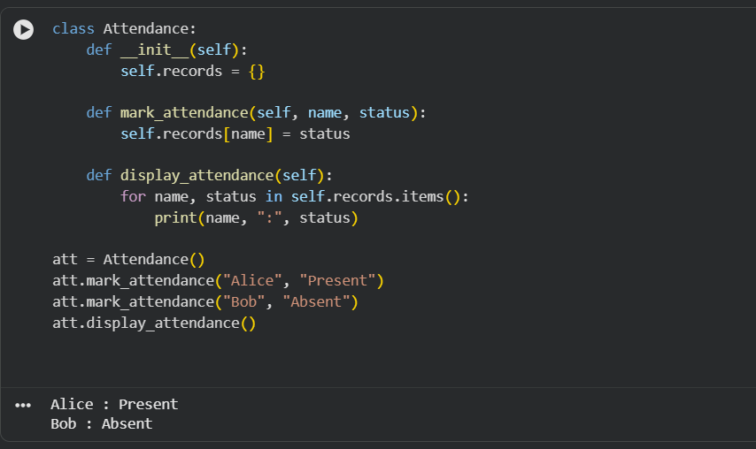

Task Description 5: AI-Based Code Completion for Conditional Menu Navigation
Prompt Used “Generate a Python program using loops and conditionals to simulate an ATM menu.”
AI-Generated Code balance = 5000
while True: print("1. Check Balance") print("2. Withdraw") print("3. Exit")
choice = int(input("Enter choice: "))

if choice == 1:
print("Balance:", balance)
elif choice == 2:
amount = int(input("Enter amount: "))
if amount <= balance:
balance -= amount
print("Withdrawal successful")
else:
print("Insufficient balance")
elif choice == 3:
print("Thank you")
break
else:
print("Invalid option")
Output Verification Enter choice: 1 Balance: 5000

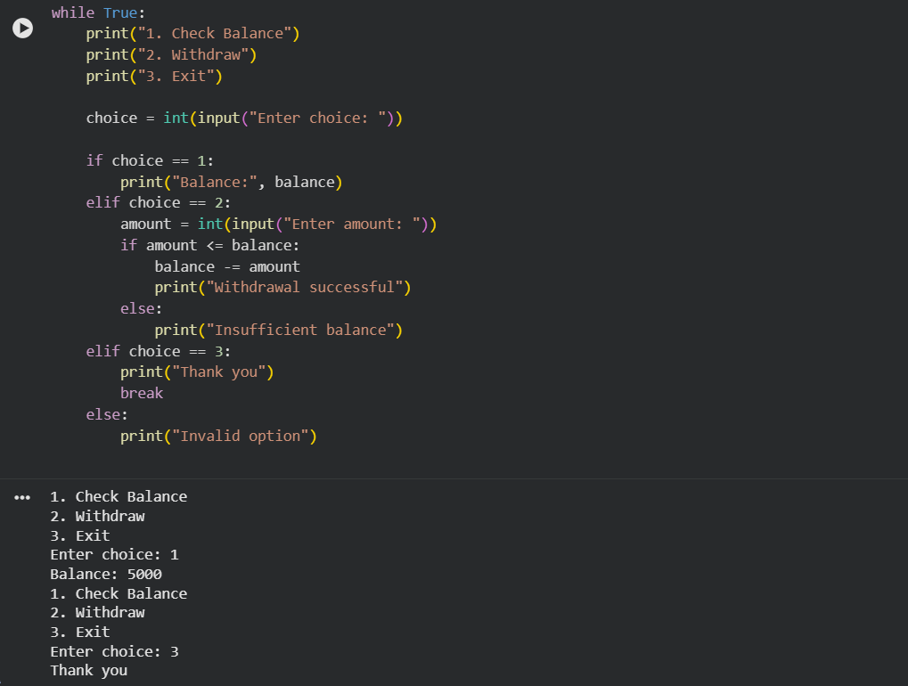

Ethical and Responsible Use of AI AI-generated code was reviewed before use
Logic was tested using sample inputs
AI was used as an assistant, not a replacement for learning
Conclusion
This experiment demonstrates how AI-based code completion tools can help generate Python programs involving classes, loops, and conditionals. While AI improves productivity, human understanding and verification are essential to ensure correctness, efficiency, and ethical usage.

