ASSIGNMENT_ 8/24(week 4) Thursday

NAME:K AKSHAY
BATCH : 35
2303A52209

Parent–Child Components in React (Online Shopping Website)

Scenario
An online shopping website displays products dynamically. Each product is shown as a separate component, and product data is passed from a parent component.
This report explains how React handles parent–child component structures, the difference between props and state, and how state updates the UI dynamically.
1. Parent–Child Component Structure in React
In React, applications are built using reusable components. For an online shopping website, the best design is a parent–child structure:
- The Parent Component stores and manages the list of products.
- The Child Component displays the details of each product separately.
Example Design
- ProductList.jsx (Parent) manages product data.
- ProductCard.jsx (Child) displays each product.
Parent Component Code
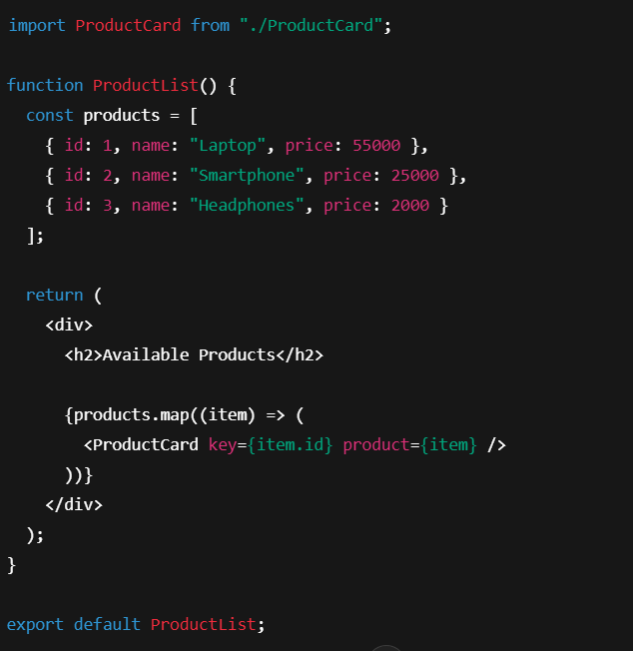
Child Component Code

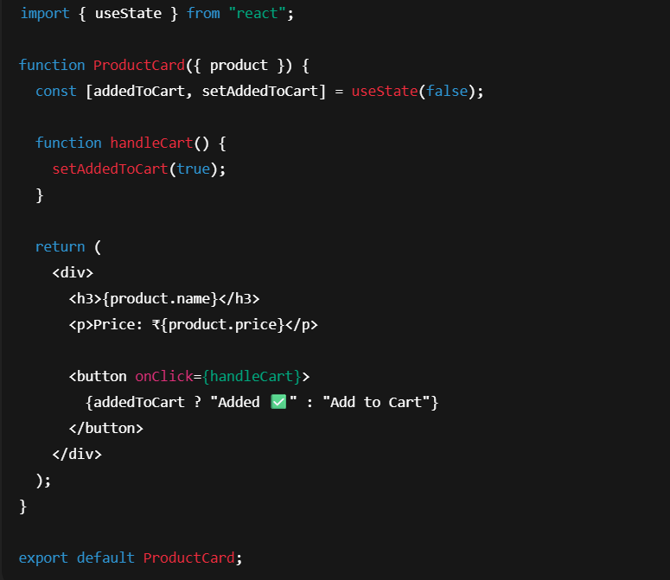

This structure ensures the website remains modular, reusable, and easy to maintain.

2. Difference Between Props and State
React uses both props and state to manage data inside components.
Feature | Props | State
Definition | Data passed from parent to child | Data managed inside a component
Mutability | Cannot be changed by child component | Can be updated using setState
Control | Controlled by parent component | Controlled by the component itself
Purpose | Used for communication | Used for dynamic UI updates
Summary
- Props are read-only values passed from parent to child.
- State stores data that can change over time inside a component.

3. Passing Data from Parent to Child Using Props
Data is passed from the parent component to the child component using props.
In Parent Component

In Child Component
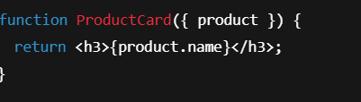
This allows each child component to receive and display product information without directly modifying the original data.

4. Role of State in Dynamically Updating UI
State helps React applications update the user interface automatically whenever data changes.
For example, when a user clicks an “Add to Cart” button, the button text changes instantly using state.
State Example
When the state changes, React updates the UI without requiring a page reload.

5. What Happens When a Component’s State Changes?
When a component’s state changes:
- React detects the change
- The component is re-rendered
- The updated UI is displayed automatically
- Only the affected component updates, making React efficient


Conclusion
In an online shopping website:
- The parent component holds and manages product data.
- Child components display each product separately.
- Props allow passing data from parent to child.
- State enables dynamic updates such as cart interactions.
- When state changes, React automatically re-renders the UI.
This approach makes React applications modular, reusable, and interactive.

