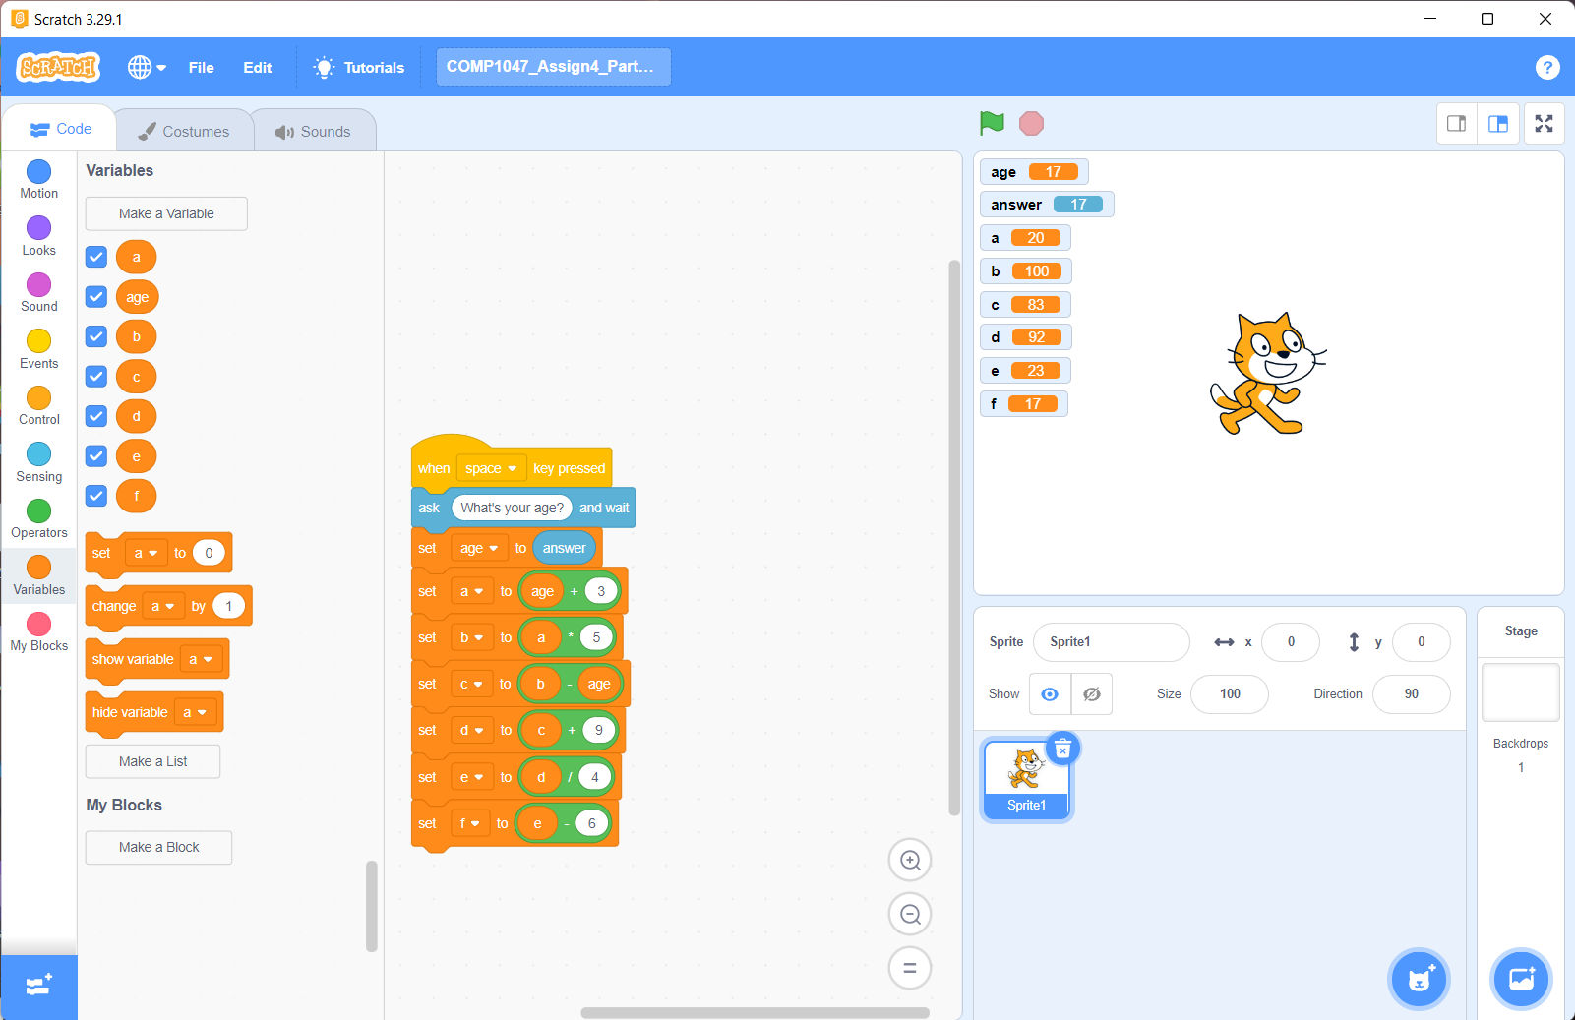

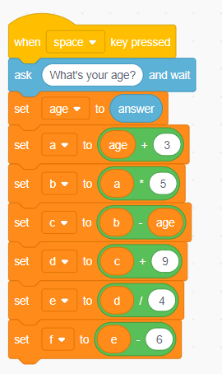

g. I observed that if I input a different value it will print the same value. For example if I input 50 as the age, I get 50 in the end.

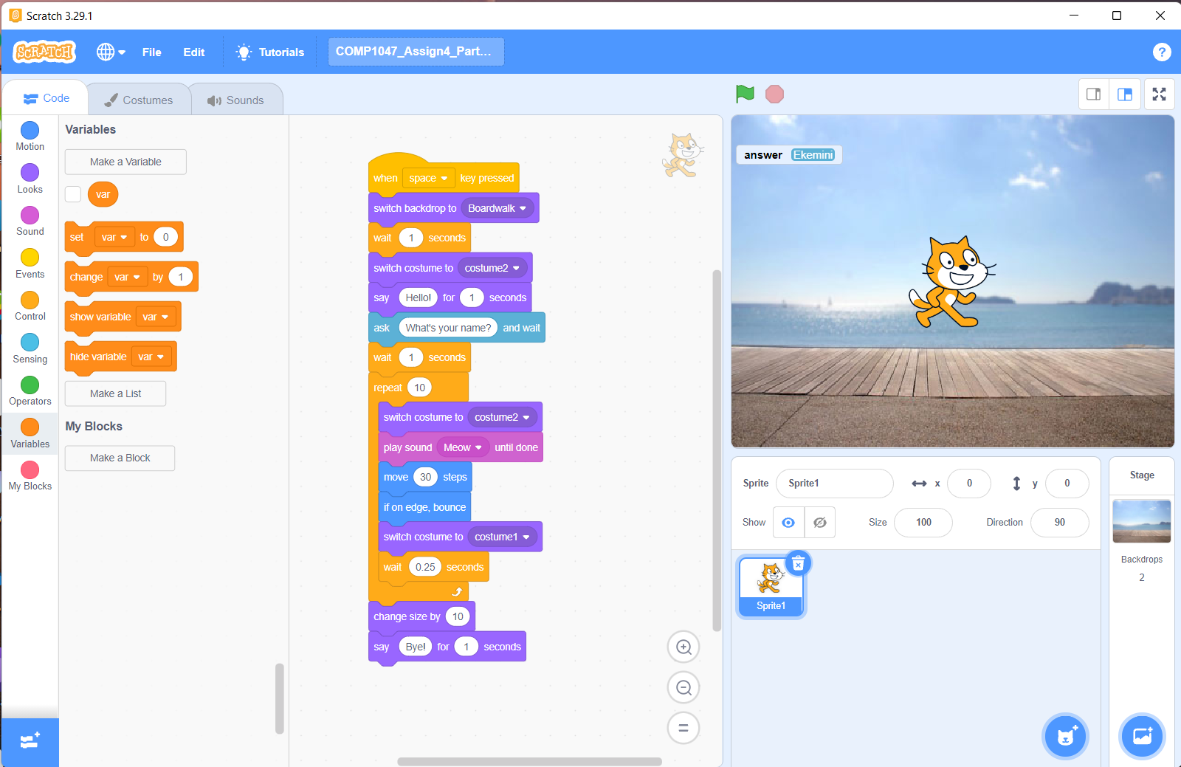

No

Yes

PRINT

Not divisible by 6

PRINT

Hurrah!

num += 10

Is num % 6 == 0?

Stop

READ

num

Start