Coding with Knots

Julian Rohrhuber (The Institute For Music And Media, Robert Schumann Hochschule, Düsseldorf)  
David Griffiths (FoAM Kernow)

## Abstract

In this paper we explore new ways to approach understanding of the mysterious Precolumbian quipus, using both visual and sonic interpretations. We base our investigation on the Harvard Quipu Archive, starting with graphical visualisation techniques that give us an overall view so we can compare textile structures and perform basic cryptanalysis. We use listening and sonification in order to filter and compare the different modes of data representation (knot type, colour, twist and material). This provides new ways to explore both currently understood and unknown patterns of meaning in quipus.

## Introduction

The Inca empire flourished at its height to 37 million people, without the need of money or a written language. We know that numeric information was stored by the Incas using *quipus*, a digital knot based recording system which was used in combination with black and white stones to read and calculate. Not many of them are extant, most were burned in the colonial wars. Until today, two thirds of the quipus discovered are untranslated, and do not fit into any known numeric coding system.

As a civilisation coming to terms with transitions to digital forms of social organisation, the Incas provide us with a useful counterpoint with which to understand our relationships with technology.

Much of the data contained within the Inca's knots are still completely unknown to archaeological research, and there may be value in bringing a cross-disciplinary approach, applying different visualisation and sonification methods to this problem. These methods, becoming attuned to what we try to convey with them, in turn may change the way we approach contemporary data.

The information available to us via the database of the Harvard Quipu Archive[1] is derived from a set of quipus encoded with information on thread type, knot type, knot position, colour and the currently understood base 10 numeric encodings.

## Methods

How to approach something of which we only know for sure that it represents something, but something we don't know? Even more, where we don't know in what way it is represented? From reports we learn that quipus were reformulated in use --- they were a dynamic medium, more like a chalkboard than a book; they were used to archive, to convey, and operate on information(Urton 2003). Quipus are a "communication-based textile" (Andrew 2008) in a very literal sense. Resembling scripture, we still cannot take it as a given that they were read from left to right only.

The problem resembles that of the archaeological reconstruction of *chaînes opératoires*: the ramified paths of actions that were performed in the production of Palaeolithic stone tools, paths which sometimes can be read out of the artefacts and the left-overs and traces of this process (Bleed 2001). Only that here, the resulting artefact, rather than merely a result, is meant to actively convey and compute information. Where the translation and computation practice is unknown, however, progress is difficult.

For the time being, perhaps the best we can do is to superpose the left-overs of past methods with our own translational and computational practices, and hope for a heuristic widening of the horizon. In the following we briefly address one particular form of such a heuristic: in *modality* (image and sound) on the one hand, and in *temporality* (reading methods), on the other.

## Visualisation

To get a first understanding of the types of structures present in a quipu, a simple parser for the data was constructed which then converted the data into a form readable by the common command line application Graphviz(Gansner and North 2000). This convenient way to automatically layout tree structures provided us with a schematic representation of the structure of the record, with knots and colours.

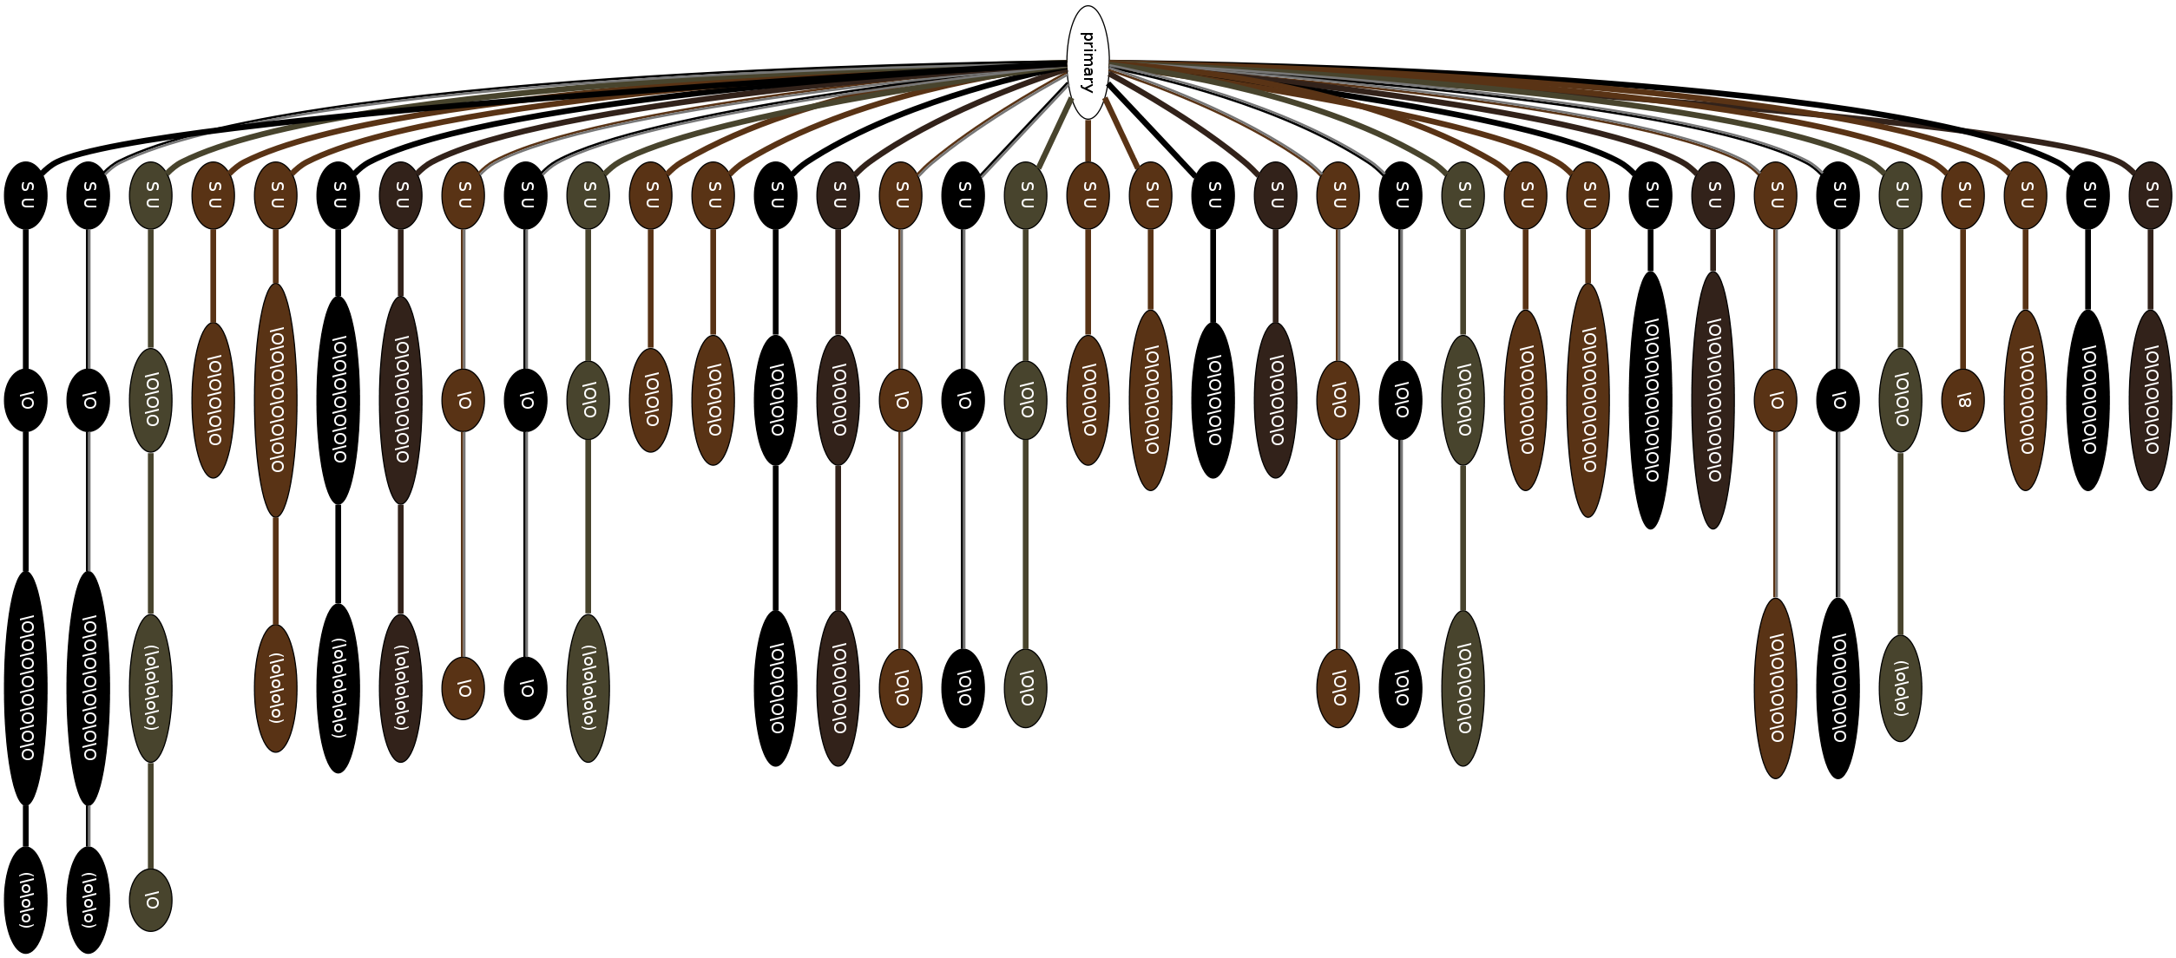

Quipu catalogued as #UR1138 rendered using Graphviz

The quipu cord colours are encoded in the database using Ascher colour codes (M. Ascher and Ascher 1978) which is an adapted form of ISCC-NBS colour coding, a standard provided by Judd and Kelly (2001). This was converted to hex RGB values required for the visualisation using an online tool.[2]

# PixelQuipu

The visualisations produced with Graphviz are quite limited, as they tend to result in very large images, and don't provide enough control over how they are drawn. Also, topologically oriented displays are naturally limited where metrics are at stake. We needed to get more of an overview of the data, displaying the knots in the right positions with the pendants being the right length. A new system, which we have named *pixelquipu*(Griffiths 2017), was devised to display a quipu directly from the Harvard dataset:

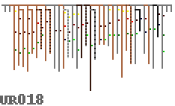  
 Each knot is shown as a single pixel attached to the pendant, with a colour code of *red* as single knot, *green* for a long knot and *blue* as a figure of eight knot (*yellow* represents something unknown or missing). We are interested in the overall data rather than the specific values, so the value of the knot sets the brightness of the pixel. The colour variations for the pendants are represented, but there is no difference between twisted and alternating colours, also no twist direction is visualised.

Such a representation makes it easier to compare whole quipus, to compare their parts, to find reoccurring details and to shift focus from global to local structure.

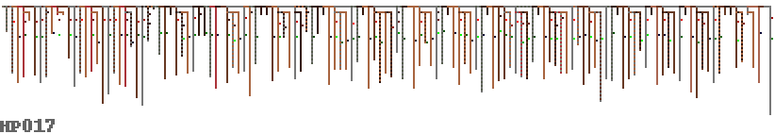  
 We can now look at some quipus in more detail – what was the purpose of the red and grey striped pendants in the quipu below? They contain no knots, are they markers of some kind? This also seems to be a quipu where the knots do not follow the decimal coding pattern that we understand, they are mostly long knots of various values.

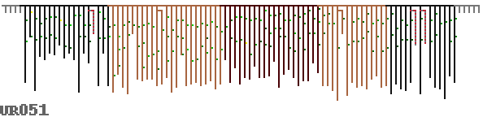  
 There also seems to be data stored in different kinds of structure in the same quipu – the collection of sub-pendants below in the left side presumably group data in a more hierarchical manner than the right side, which seems much more linear – and also a colour change emphasises this.

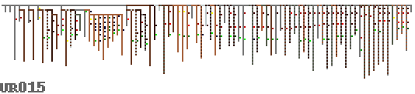  
 Read left to right, this long quipu below seems very much like you’d expect binary data to look – some kind of header information or preamble, followed by a repeating structure with local variation. The twelve groups of eight grey pendants seem redundant – were these meant to be filled in later? Did they represent something important without containing any knots?

  
 The original idea of the pixelquipu was the attempt to fit all the quipus on a single page for viewing, as it represents them with the absolute minimum pixels required. So finally, figures 4 and 9 display pendant colour and entropy for all 247 quipu we have the data for.

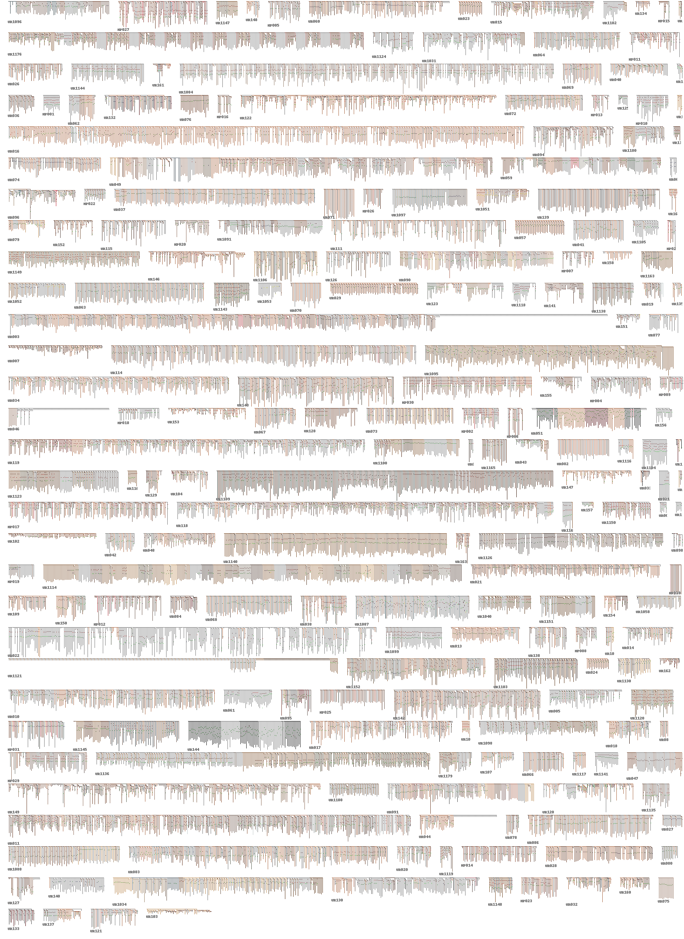

All 247 quipu in the collection

# Entropy

As we have so little idea what the Inca are telling us (or rather each other!) in their quipus, it seems appropriate to add a basic cryptanalysis approach to our toolkit of inquiry. One of the first things that a cryptanalyst will do when inspecting an unknown system is to visualise its entropy in order to get a handle on structures or patterns in the underlying information. The concepts of entropy differ very much in the different theories, and we should always keep in mind that the information concept itself depends on the theoretical context (see for instance Garfinkel and Rawls 2009 for a useful critique).

Here, for simplicity, we use entropy as Shannon (1949) defined it: a measure of the *minimum* possible knowledge some set of data may convey. Entropy thereby describes how representation is bounded by specific laws of physics, ignoring the unknown specific coupling between operations in quipu use. "We require that a system of signals and a system of information be capable of being not only coupled but *variably* coupled in the sense that while this information would depend upon signal characteristics that it not be given in one-to-one fashion with signal characteristics. We require that it be possible to perform physical operations that will affect it while at the same time logical operations like matching, counting, comparing, classifying, measuring, be possible with it." (ibid. p. 110).

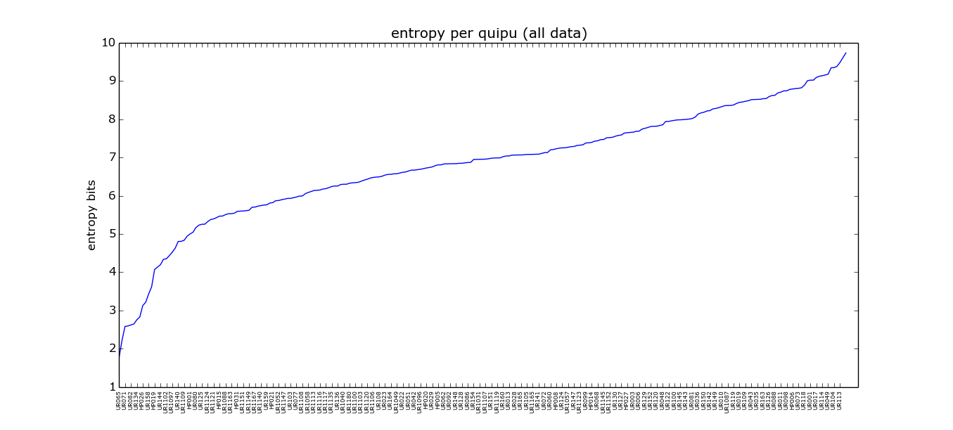

All the quipus in the Harvard database in order of average entropy bits they represent (only listing every other quipu ID)

The graph shown in Figure 5 is calculated by making lists of all the discrete data of the same type, e.g. knot value, type, tying direction, pendant colours and ply direction (ignoring lengths and knot positions as these are continuous) – then calculating Shannon entropy on histograms for each one and adding them together.

We can also compare different types of information against one another, for example the main data we currently understand has some specific meaning are the knot values, partly derived from the knot type (long, single or figure of eight), which represent a decimal notation. If we compare the entropy of these we can expect them to have roughly similar average amounts of information, as seen in Figure 6.

The meanings of colours, ply and structure are largely unknown, but we can compare them with the knot values which we do understand. This could give an indication of whether they contain information. Figure 7 shows the knot values compared with the colours, and Fig. 8 with pendant ply direction.

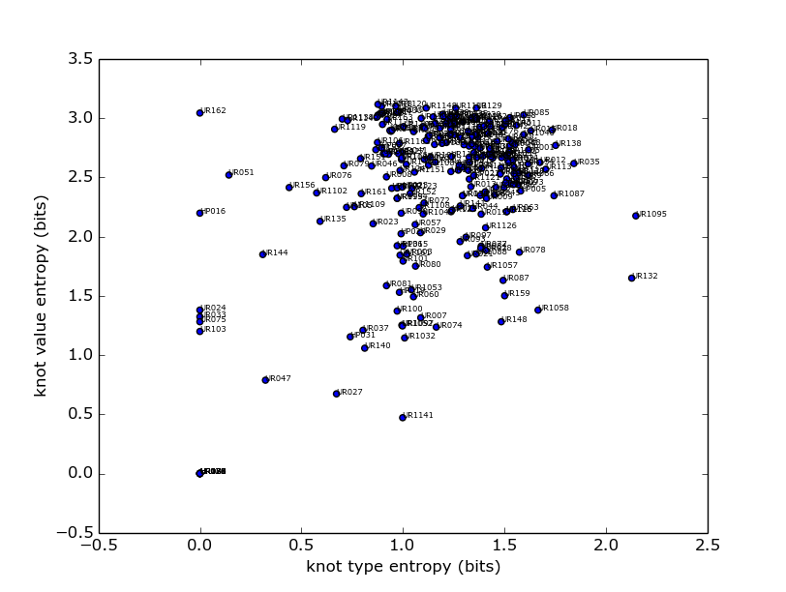

Quipu knot type plotted against knot value entropy.

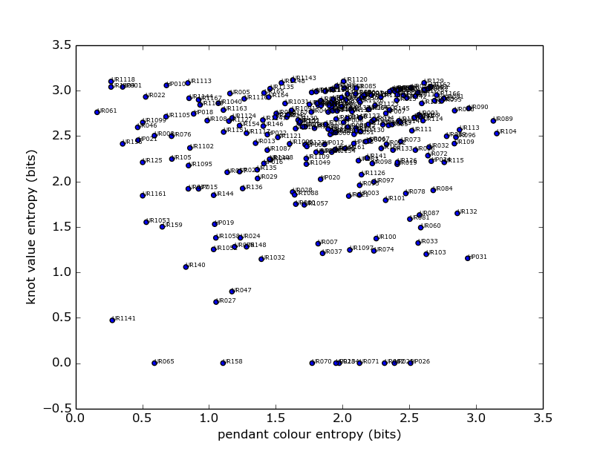

Quipu knot values plotted against pendant colour entropy.

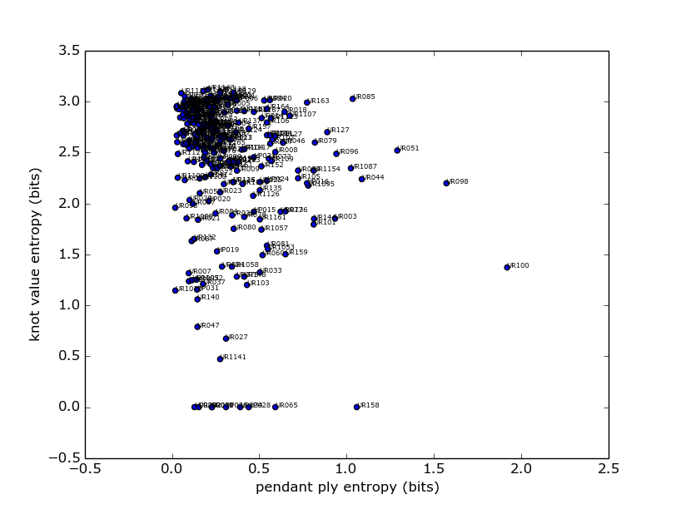

Quipu knot values plotted against pendant ply direction entropy.

From this work we could see that the relationship to various data types is fairly uniform, and is not clustered in any way which would indicate different modes or categories of quipu. We can also use this technique to locate outliers to inspect further.

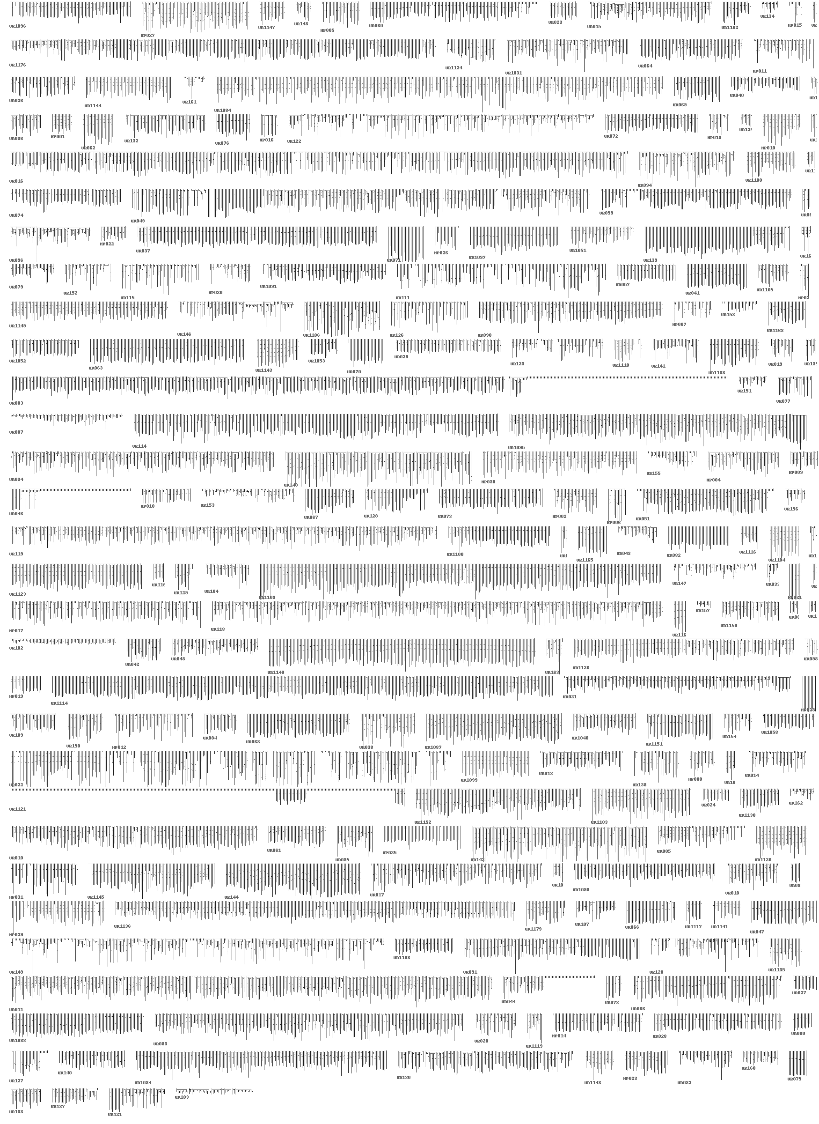

The local entropy for all the Quipu in the Harvard database.

As well as looking at a quipu as a discrete unit, we can also look inside them and view their structure in terms of relative entropy. This is done below hierarchically, so a pendant’s entropy (shown as brightness) is that of its data plus all the sub-pendants, which seemed most appropriate given the non-linear form that the data take.

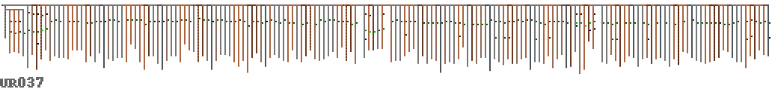

Quipu UR037 showing pendant colours.

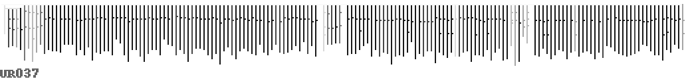

Quipu UR037 showing hierarchical entropy.

# Sonification

Where the significance of the structure of a specific medium is unknown, sonification can be a way to gain new insight. There are various reasons for this, which have partly to do with the way understanding is coupled with perception. Partly it is also due to the fact that listening takes a specific time and this is time we spend with absorbing a texture and its potential internal connections.

Visualisation offers the advantage of a very differentiated spatial distribution. By contrast, sonification is an excessively temporal method, which means that it can not only animate relationships, as one would do with a moving image, but everything is conveyed through oscillation. However, there are very many different sonification approaches in a sonification laboratory (Bovermann, Rohrhuber, and de Campo 2011) --- which one to choose if we want to better understand quipus?

Our case presents specific challenges, because quipus are a branching structure, which, instead of just being laid out in space, has to be distributed in a time series. This obstacle has the positive effect that it broaches the tacit assumptions that remain hidden in pictorial representation: in fact we do not know how the quipus were read, so that the correct reading order is uncertain, and out of the many possible paths, many are non-trivial. Moreover, even reading orders that were not used by the Khipukamayuq (quipu-makers) may reveal important facts about what they encode.

The material qualities of quipus present us with the challenge of taking many levels of structured properties into account, including colours, knot positions, knot types, and ply. In our first experiments, we used sonification to juxtapose them in time.

Our experiments used the computer language SuperCollider, which in its abstraction level is optimal for the task at hand. Most of the program text can be changed at runtime, so that no graphical user interface precludes ideas of the researchers. The language is relatively well documented, and can be easily extended toward specific needs. A typical program in our system looks as follows:

// inka telefax  
(  
Tdef(\x, {  
 ~traverse.(~data, { |x|  
 var note = x[\colours] / 255 * 32;  
 if(note.notEmpty, {  
 (instrument: \sin, note: note, sustain: 0.1).play;  
 });  
 0.1.wait;  
 })  
}).play  
)

In the following, we explain the motivations and outcomes of such scripts starting from a single dimension (here the sonification of thread colour) and the concurrent display of multiple dimensions.

## Sonification experiments

### Thread colour: a single dimension display

Quipus have a very distinct shape: a rather long series of small graphs, each of which has a couple of potentially relevant, but very different dimensions (such as color, number, length). Because sonification can give good insight into parallel serial data, our first sketch was to treat the series of pendants from one end of the primary cord to the next, as a series in time (as you would do with a text).

The current state of research makes it plausible that the colours used in quipus are of significance, but it is so far unclear of what. The shades of colours are subtle, as is their possible meaning. To start with, we sonified the colour pattern of the quipu #UR004 in a very simple way: a series of very short sine tone chords represent the red, green and blue components. The different colours of each pendant were thereby read like a musical chord, as can be seen in Figures 12 and 13.

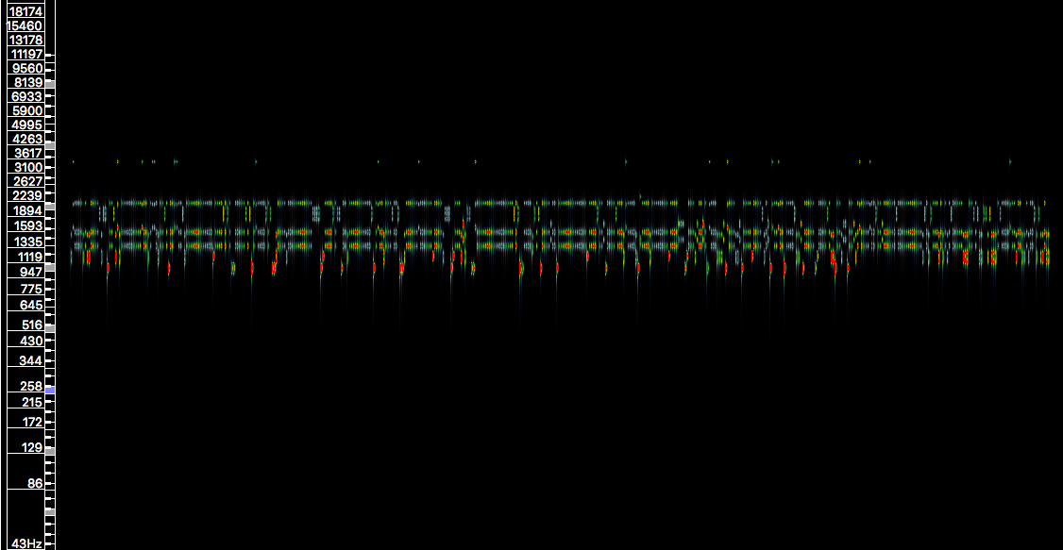

A spectrogram of a sonification of pendant colour taken from quipu #UR004.

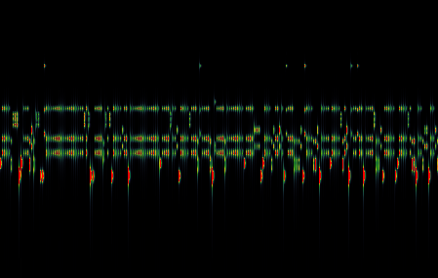

A close up for the pendant colour sonification from quipu #UR004.

This causes tones of grey to sound like a single tone, and the difference between components stands out as distance between separate partials. A rather simplistic sketch as it is, it nevertheless revealed a surprisingly rich rhythmic structure, which would be easy to overlook visually. This gave us some confidence that we should pursue this direction a little further.

### Superposition: a multidimensional display

After an inquiry in the interpretations of archaeological findings, we found two promising quipus which made us curious. An essay by Juliana Martins on the astronomical analysis of an Inca Quipu pointed to two interesting candidates from Leymebamba (#UR006 and #UR009).

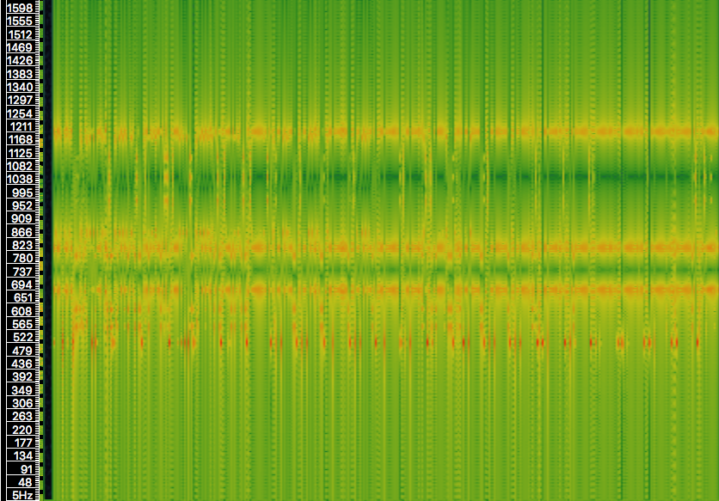

A spectrogram of a sonification of multiple data dimensions of quipu #UR006. See Table 1 for details of the mapping.

Figure 14 shows a spectrogram created using the timbral mappings described in Table 1. It is not well visible in the spectrogram, but audible that each short sound event (about 1/10 of a second shorter as we go down the subsidiaries) has a number of independent timbral properties, some of which have significant pattern across longer sections.

|  |  |
| --- | --- |
| quipu | sound |
| colour | sine tone spectrum of three partials |
| branching level | duration between sound grains (inter onset duration) |
| pendant length | duration of each sound grain (relative to inter onset time) |
| pendant attach (verso or recto) | pan position left or right channel |
| pendant ply (S or Z) | envelope shape (audible as “inversion effect”) |
| unknown values | are usually interpreted as neutral (pan) or low (colour) |

An overview of which 'quipu dimension' is mapped onto which sound dimension.

The moments of audible acceleration result from areas with many pendants that have subsidiaries (side branches). In various dimensions rhythmic patterns appear, which partly coincide and partly remain independent. Also, in some moments, we can hear sudden changes of the overall pattern, indicating a transition into a different logic. You can see how the multidimensional display is a relatively straightforward extension of the one-dimensional one.

(  
Tdef(\x, {  
 var pani = ('R':-1, 'V':1, 'U':0);  
 var plyi = ('S': 0, 'Z': 1, 'U': 0.5);  
 ~traverse.(~data, { |x, level|  
 var colours = x[\colours], note, pan, len, ply;  
 var dur = 1/2 ** (level - 1) / 10;  
 if(colours.notEmpty, {  
 pan = pani[x[\pendant_attach]];  
 ply = plyi[x[\pendant_ply]];  
 len = x[\pendant_length] ? 25 / 25;  
 note = x[\colours] / 255 * 36 + 12;  
 (  
 note: note,  
 dur: dur,  
 instrument: \sin,  
 amp: 0.1/3,  
 pan: pan,  
 legato:len * 1.5,  
 ply: ply  
 ).play;  
 });  
 dur.wait;  
 })  
}).play  
)

### Knot-Spectra

So far we have considered only the properties of the pendants themselves, which certainly stand out less than the more obvious knots which were tied in them. Some of the knot patterns have been interpreted as numerical records in a decimal base encoding. The counter check of reading them as additions (like on an abacus) is consistent, and where such calculations have been found, the Harvard data set contains the numerical interpretation as a value. There are many quipus, however, which do not fall into this category. Here knots most probably are of significance, but we lack a matching interpretation. The attributes are: position, value, type (single, long, eight, or undefined), and spin.

We know from the numerical quipus that the place on the pendant is of significance, so that it makes sense to acoustically display this information. The following example is one from our experiments, where the known numerical value is interpreted as node (zero if not available), and is superposed with the spectral distribution derived from the position pattern. The spin is used as a pan position in the stereo field (left/right/center):

(  
Tdef(\x, {  
 ~traverse.(~data, { |x, level|  
 var knots = x[\knots];  
 knots.do { |k|  
 var note, pan;  
 note = k[\value];  
 pan = k[\spin];  
 (  
 note:note,  
 harmonic: k[\position],  
 sustain: 0.01,  
 instrument: \sin,  
 sustain: 0.4,  
 pan: pan  
 ).play;  
 };  
 0.1.wait;  
 })  
}).play  
)

For another variant in sonifying the knot data, we used the multichannel sound system available in the experimental laboratory in Robert Schumann Hochschule Düsseldorf. The program code demonstrates that very little modification is necessary to use the spectral information as an offset into the eight channels:

(  
 Tdef(\x, {  
 ~traverse.(~data, { |x, level|  
 var knots = x[\knots];  
 knots.do { |k|  
 var note, pan;  
 note = k[\value];  
 pan = k[\spin];  
 (  
 note:note,  
 out: k[\position] * (8 / 20),  
 sustain: 0.01,  
 instrument: \sin,  
 sustain: 0.4,  
 pan: pan  
 ).play;  
 };  
 0.1.wait;  
 })  
 }).play  
 )

### The Project "Inca Telefax. Listening to Precolumbian Administration without understanding a word"

Because quipus are material artefacts that are fabricated with an effort, we can reasonably expect every detail to convey some relevant information. Even in the case that some of it might have been ornamentation, it was still an integral part of the art of quipu-making. And certainly most of the details were addressed to someone (someone else than us, we should say). As most of the crucial knowledge about how to read these details and make sense of their patterns has been purposefully destroyed by the Spanish authorities, today we can perhaps do nothing more than to indirectly infer the administrative cognitive labour. Indeed where modes of access are lacking, there is nothing more than the pure acknowledgement that this labour has indeed taken place.

The Project Inka Telefax. Listening to Precolumbian Administration without understanding a word, is a result from the above sonification and visualisation efforts. As part of the exhibition Thinking Out Loud, it is a three-channel sound installation with accompanying images (the above pixelquipu) on permanent display. The piece takes elements from the sonification of quipu data from the Khipu Database Project, initiated by by Gary Urton.

One can understand this installation as a displacement of administrative information from an unknown context into the contemporary world of an administrative office of the London based Open Data Institute. Between July 15th 2016 and March 31th 2017, it is played at 9:59am on every Monday, Wednesday, and Friday for about 30 seconds in the work space.

# Conclusions

Weaving in the broadest sense of the term covers an intermediate space between what has been called "form and function". Form usually being that of non-functional representation or decoration, function usually that of non-formal use for specific practical purposes. These terms are misplaced, as it is commonly acknowledged, because decorative and iconic detail at least has a social function (see also Andrew 2008). Quipus are a specific case, however, because here, the decorative detail serves a representative function, mostly, but perhaps not exclusively, an administrative one. Because of the small number of extant artefacts, their retrospective decoding becomes a difficult task; at the same time, all measurable information about them has been translated to the predominant administrative tool of our culture, Excel spreadsheets.

Our basic cryptanalysis gives us a comparison between different quipus, and shows that the differences between them are fairly continuous - our entropy analysis has not revealed easily determined categories of quipu in the corpus in the dimensions that we compared. This may be surprising given that different Khipukamayuq may have employed different techniques, and that these may have evolved over time or distance. On the other hand, when we measure discontinuities of potential data storage within the quipus --- we find areas of complexity along with areas of low information, further analysis may help to understand structural patterns. By proposing some experimental "laboratory methods" for the sonification of those data sets, we hope to have broadened the perspective of their reading.

Listening to the inner structure of these artefacts is a method of systematic spreading of awareness over time. Unlike an image which can be read in any order, a sonification aligns the reading direction, while keeping undecided what is being listened to. Sound thereby has very different affordances than the common descriptive, diagrammatic and numerical methods. Used by artists and composers, such sonifications can cultivate a movement between archaeological interest and aesthetic sensibility. Used by archaeologists as a methodological alternative, it might lead to new ideas of how to read quipus in their cultural context.

# Biographies

David Griffiths is a game designer, programmer and livecoding algoraver based in Cornwall UK. In 2014 he co-founded FoAM Kernow, an independent research institution for exploring uncharted regions of art, technology and science with Amber Griffiths. In 2014 FoAM Kernow was awarded the Soil Association innovation award for the "Farm Crap App" and in 2016 David appeared on the Cerys Matthews Radio 6 Music show talking about Sonic Kayaks - turning paddlers into citizen scientists to help climate change research using music. Since 2013 he has lectured as assistant professor of critical programming at the Robert Schumann School of Music and Media in Düsseldorf, and alongside Aymeric Mansoux and Marloes de Valk he created the satirical Facebook game Naked on Pluto which won the Telefonica Vida competition in 2011. David also teaches primary school children, teenagers and school teachers programming, Minecraft and electronics, and previously he worked in the games (Computer Artworks & Sony Europe) and film computer graphics industry (Moving Picture Company), and has credits on feature films including Troy and Kingdom of Heaven.

Julian Rohrhuber is professor for music informatics and media theory. His research includes the philosophy of science, media theory, and algorithmic acoustics. In collaboration with his students, he is concerned with art as a form of theory as well as teaching as a mode of research. The possibility of reasoning through sound motivates his work on algorithmic composition and live coding. In 2014, for example, he realised the piece Politiken der Frequenz together with Marcus Schmickler, a treatment of the sonification of mathematical conceptions of number and their political implications. Publications are concerned with topics like algorithms and politics, history and philosophy of programming and mathematics, art theory, sonification, and documentary film.

# Bibliography

Andrew, Sonja. 2008. “Textile Semantics: Considering a Communication-Based Reading of Textiles.” *Textile* 6 (1): 32–65.

Ascher, Marcia, and Robert Ascher. 1978. *Code of the Quipu Databooks*. University of Michigan Press.

Bleed, Peter. 2001. “Trees or Chains, Links or Branches: Conceptual Alternatives for Consideration of Stone Tool Production and Other Sequential Activities.” *Journal of Archaeological Method and Theory* 8 (1): 101–127. doi:[10.1023/A:1009526016167](http://dx.doi.org/10.1023/A:1009526016167). <http://dx.doi.org/10.1023/A:1009526016167>.

Bovermann, Till, Julian Rohrhuber, and Alberto de Campo. 2011. “Laboratory Methods for Experimental Sonification.” In *The Sonification Handbook*, edited by Andy Hunt Thomas Hermann.

Gansner, Emden R., and Stephen C. North. 2000. “An Open Graph Visualization System and Its Applications to Software Engineering.” *SOFTWARE - PRACTICE AND EXPERIENCE* 30 (11): 1203–1233.

Garfinkel, Harold, and Anne Rawls. 2009. *Toward a Sociological Theory of Information*. Paperback; Routledge. <http://www.amazon.com/exec/obidos/redirect?tag=citeulike07-20\&path=ASIN/1594512825>.

Griffiths, Dave. 2017. “Nebogeo/Coding-with-Knots: Publication Version.” doi:[10.5281/zenodo.291962](http://dx.doi.org/10.5281/zenodo.291962). <https://doi.org/10.5281/zenodo.291962>.

Judd, D. B., and K. L. Kelly. 2001. “Method of Designating Colors.” *Journal of Research of the National Bureau of Standards* 23: 355.

Shannon, & Weaver, C. E. 1949. *A Mathematical Theory of Communication*. University of Illinois Press.

Urton, Gary. 2003. *Signs of the Inka Khipu*. University of Texas Press.

1. The Harvard Quipu Archive is available at http://khipukamayuq.fas.harvard.edu/ (accessed 4th January 2017)
2. NBS/ISCC Color System http://tx4.us/nbs-iscc.htm, accessed 4th January 2017