**1.** **Introduction**

The grocery stores in OMG school campus have increased by year since its established. They want to make a database system to store the information in order to retrieve the information quickly and make some statistics. I create table for the school’s grocery stores. Each store contains many products and equipment, and it can serve plenty of customers. Thus, I also make tables for products, employees, equipment, orders, and customers, and define the relationships between those tables.

**2.** **Mission Statement and Mission Objectives**

The Purpose of the OMG database is to store the data for the grocery stores in OMG campus maintain data for the store’s product allocation and transaction records that help the owners, the managers and workers to easily look up the required information, make daily updates, calculate and analysis through this database.

**3. Relational Design Basics**

|  |  |  |  |  |  |  |  |
| --- | --- | --- | --- | --- | --- | --- | --- |
|  | Products | Grocery Stores | Employees | Equipment | Customer | Transactions | Allocation |
| PK | ProductID | StoreID | EmployeeID | EquipmentID | CustomerID | TransactionID | AllocationID |
| FK |  |  | StoreID | StoreID |  | ProductID  CustomerID  StoreID | StoreID  ProductID |

**4. Conceptual Design**

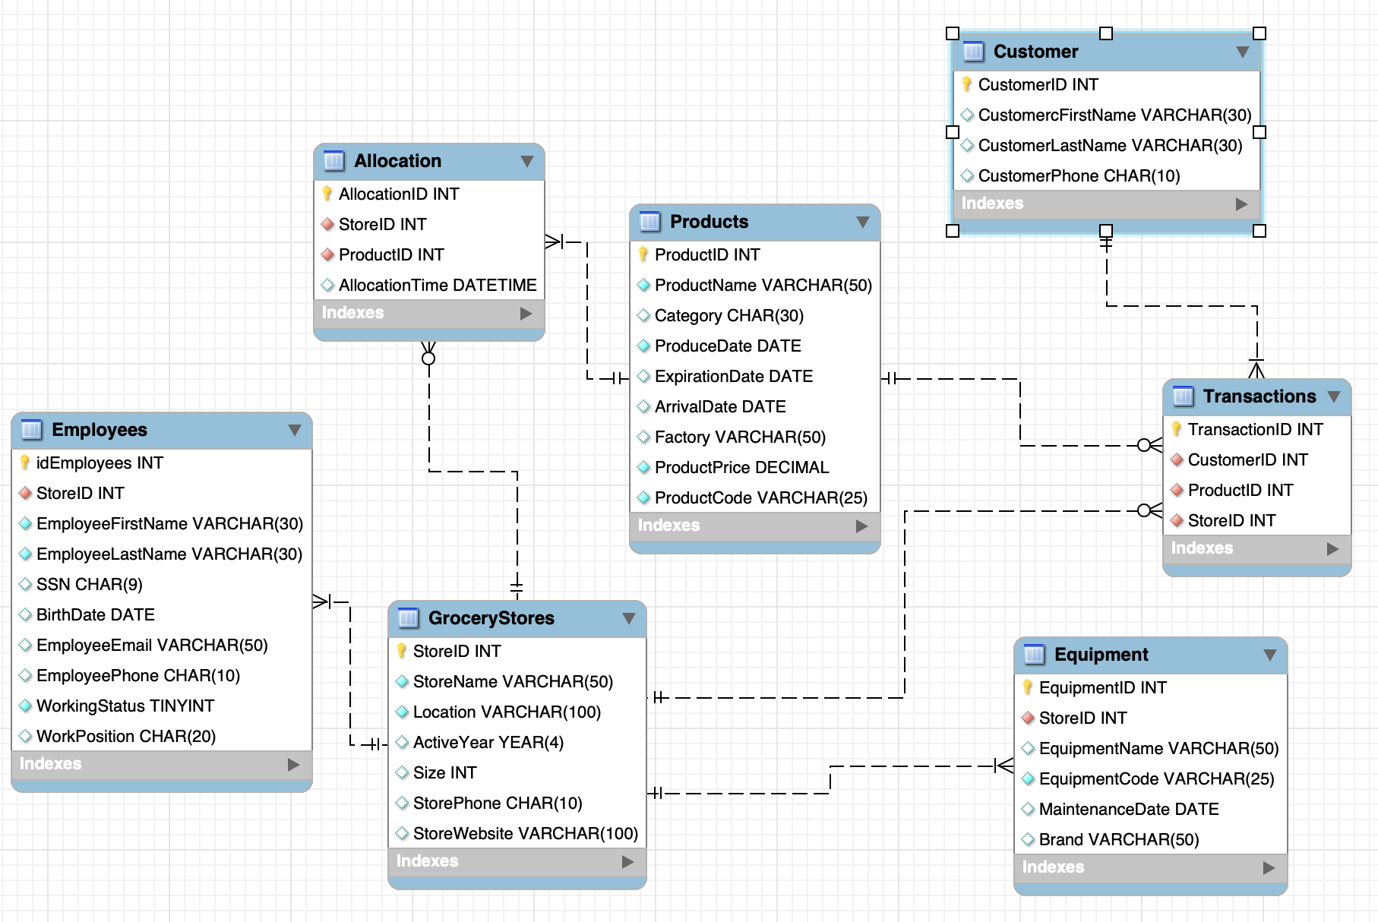

Customers is optional for Products, Products is optional for Grocery store, and Customers is optional for Grocery store.

Grocery store is mandatory for Equipment.

Grocery store is mandatory for Employees.

Products is mandatory for Customers.

Grocery store is mandatory for Products.

**5.** **Logical design**

See the Appendix file.

business rules:

1. Each grocery store must have at least one employee.

2. There are not any product’s price in the grocery stores larger than $999.

3. Products do not need to be bought by any customer, but each customer buys at least one product.

Views:

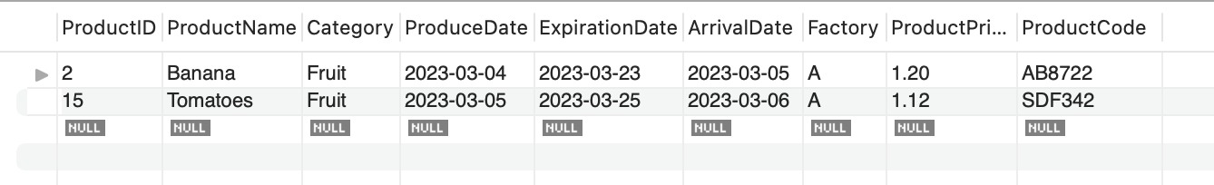

This is the view of the Products table that shows the expiration dates of the products that are earlier than today. This will help the users to find out the food that has expired and handle them timely.

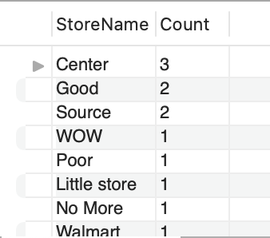

This is the view of the GroceryStore table that shows the amount of the stores with the same name. This will help the users to find out how many branches does the store has.