

**University of Asia Pacific**

**COURSE CODE**: CSE-212

**COURSE TITLE:** Database

**Name of Project**: Student attendance management system

**Date of Submission**: 29-12-2018

**SUBMITTED TO**

Nadeem Ahmed

Lecturer

Department of CSE

University of Asia Pacific.

**SUBMITTED BY**

Abu Kaisar Jamil, Farzana Akhtar Lubna

**Section**: 'B'

**Roll:** 69, 64

**Reg. NO:** 17101069, 17101064

Department of CSE

INDEX

|  |  |  |
| --- | --- | --- |
| No | Topic | Page |
| 1 | Project Scenario | 03 |
| 2 | ER Diagram of student attendance | 04 |
| 3 | Schema Diagram of student attendance | 05 |
| 4 | Queries and Output | 06-09 |
| 5 | Appendix | 10 |

Project Scenario

A university offers few courses to all students under each department. Each student has to register to take any course. Each course has a course code, title, credit, semester and department. For each course there is assigned a faculty to teach that course. It’s not compulsory to assign all faculties to take the course but all the courses must be assigned to at least one faculty. Each course faculty has a faculty id, faculty name, department name. For each student there will be a student id, name, course name, semester and year. The purpose is to generate the desired reports automatically at the end of the session or in the between of the session as require.

**Entities and their attributes:**

* **Student:** s_id, s_name, semester, year.
* **Course_regi:** s_id, c_Code.
* **Course:** c_code, tittle, credit, department.
* **Faculty:** f_id, f_name, department.
* **Faculty assigned:** f_code,c_code.
* **Attendance:** s_id, c_code, date, status.

ER-Diagram

**student**

**course_reg**

**faculty assigned**

**course**

**is assigned**

**studAtten**

**faculty**

**attendance**

Schema Diagram

student

s_id

s_name

semester

year

s_id

c_code

course_regi

s_id

c_code

date

status

attendance

course

c_code

title

credit

department

f_id

f_name

department

faculty

f_assigned

f_id

c_code

Queries and Output

1. select c_code from f_assigned_where f_id=892

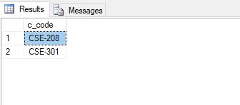

1. select c_code from course_regi where s_id=101

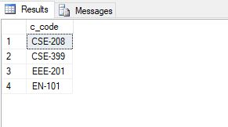

3. select f_name from faculty where department LIKE 'CS%'

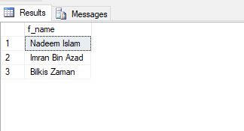

4.select status from attendance where date='2019-01-01' and s_id=101

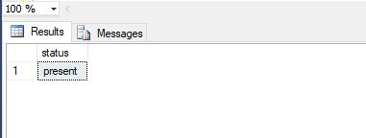

5.select status,date from attendance where s_id=108

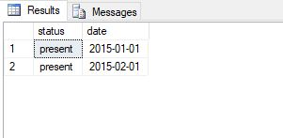

6. select s_id,date from attendance where status='absent'

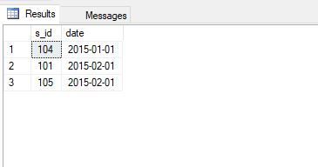

7. select s_id, date, status from attendance where c_code= 'EN-101'

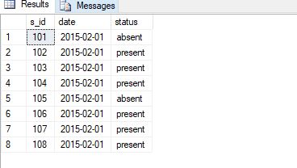

8. select s_id, date from attendance

where c_code='CSE-208' and status='absent'

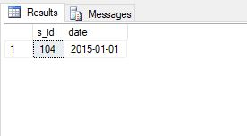

9. select s_id, date from attendance

where status='present' and c_code='EN-101'

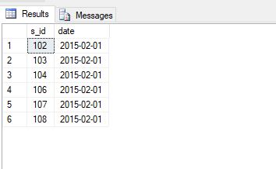

10. select count (s_id)_from attendance

where status = 'present' and c_code='CSE-208'

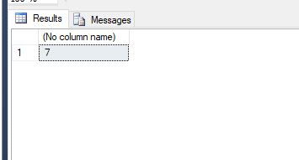

11. select count (s_id)_from attendance

where status = 'absent' and c_code='EN-101'

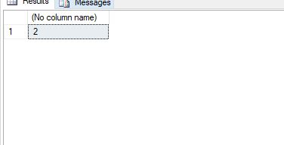

Appendix

create database StudentAttend;

create table student(

s_id int,

s_name varchar(20),

semester varchar(20),

year varchar(20),

primary key(s_id)

)

insert into student

values(101 ,'Jam', 'Spring','2018'),

(102,'Sakin' ,'Spring','2018'),

(103,'Shakhawat' ,'Spring','2018'),

(104,'Zahid' ,'Fall','2019'),

(105,'Mujahid' ,'Fall','2018'),

(106,'Dipto' ,'Spring','2018'),

(107,'Pranto' ,'Spring','2018'),

(108,'Dipu' ,'Fall','2018')

create table faculty(

f_id int,

f_name varchar(20),

department varchar(20),

primary key(f_id)

)

insert into faculty

values(891,'Nadeem Islam','CSE'),

(892,'Imran Bin Azad','CSE'),

(8103,'Maishaa Srejuti','Basic Science'),

(893,'Bilkis Zaman','CSE'),

(894,'Babul','English'),

(895,'Kairul Alam','EEE')

create table course(

c_code varchar(20),

title varchar(50),

department varchar(20),

credit numeric(2,0),

primary key(c_code)

)

insert into course

values('EEE-101','Intro.to EEE','EEE',4),

('CSE-301','Intro.to Computer Science','CSE',4),

('CSE-399','Database','CSE',4),

('EN-101','Spoken English','English',3),

('CSE-208','Algorithm','CSE',4),

('EEE-201','Robotics','EEE',3)

create table f_assigned(

f_id int,

c_code varchar(20),

primary key(f_id,c_code),

foreign key(f_id) references faculty,

foreign key(c_code) references course,

)

insert into f_assigned

values(891,'CSE-399'),

(894,'EN-101'),

(892,'CSE-301'),

(892,'CSE-208'),

(895,'EEE-101'),

(895,'EEE-201')

create table course_regi(

s_id int,

c_code varchar(20),

primary key(s_id,c_code),

foreign key(s_id) references student,

foreign key(c_code) references course

)

insert into course_regi

values(101,'CSE-399'),

(104,'CSE-399'),

(101,'EN-101'),

(105,'EN-101'),

(106,'EN-101'),

(107,'EN-101'),

(102,'CSE-208'),

(103,'CSE-208'),

(101,'CSE-208'),

(101,'EEE-201'),

(106,'EEE-201'),

(107,'EEE-201'),

(108,'CSE-399')

create table attendance(

s_id int,

c_code varchar(20),

date date,

status varchar(50),

primary key(c_code,s_id,date),

foreign key(s_id) references student,

foreign key(c_code) references course

)

insert into attendance

values(101,'CSE-208','1/1/2019','present'),

(102,'CSE-208','1/1/2015','present'),

(103,'CSE-208','1/1/2015','present'),

(104,'CSE-208','1/1/2015','absent'),

(105,'CSE-208','1/1/2015','present'),

(106,'CSE-208','1/1/2015','present'),

(107,'CSE-208','1/1/2015','present'),

(108,'CSE-208','1/1/2015','present'),

(101,'EN-101','2/1/2015','absent'),

(102,'EN-101','2/1/2015','present'),

(103,'EN-101','2/1/2015','present'),

(104,'EN-101','2/1/2015','present'),

(105,'EN-101','2/1/2015','absent'),

(106,'EN-101','2/1/2015','present'),

(107,'EN-101','2/1/2015','present'),

(108,'EN-101','2/1/2015','present')