
St. Anthony’s College
San Jose, Antique

INFORMATION TECHNOLOGY DEPARTMENT

Capstone Project Concept Proposal

Group #: 7 Submission Date: July 13, 2026

Project Title: GIS-Based Provincial Fire Response and Decision Support System With Inter-Municipality Coordination for BFP in Antique
Proponents:
1.Bangcaya, Rhoda May V.
2.Estrabo, Jhon Kylho
3.Fajardo, John Rey D.
4.Peralta, Renz Asher E.
5.Regala, Khing Jay C.

Technical Adviser: DIKEMBIE KREISLER M. GALILEA

Brief Background of the Study
Fire incidents remain a major public safety concern in the Philippines because of their serious effects on lives, properties, livelihoods, and community safety. Fires may occur in residential areas, business establishments, grasslands, forests, and other vulnerable locations. Their effects may become more severe in communities with limited fire response resources, difficult road access, distant fire stations, and insufficient water sources. These conditions emphasize the need for faster, more organized, and technology-supported fire prevention and emergency response operations.
In the Province of Antique, these concerns are intensified by its wide geographic coverage, numerous barangays, remote communities, and limited fire response resources in some municipalities. According to the Bureau of Fire Protection–Antique, the province recorded 243 fire incidents in 2025. From January to February 2026, Antique recorded 20 fire incidents, compared with 28 incidents during the same period in 2025. Moreover, grass fire incidents decreased from 92 in 2024 to four in 2025, while forest fire incidents decreased from 23 in 2024 to zero in 2025. Despite these improvements, BFP-Antique continued to emphasize the importance of fire prevention, preparedness, and immediate response, particularly during dry and extremely hot conditions when fires may spread more rapidly.
The main problem is the lack of an integrated and real-time software system for fire incident reporting, severity assessment, response mapping, resource recommendation, water-source identification, firetruck routing, and inter-municipality coordination. Existing fire response processes often rely on phone calls, radio communication, handwritten records, and separate files. These practices may cause delays in verifying fire reports, identifying the exact incident location, assessing fire severity, selecting available firetrucks, locating nearby water sources, planning evacuation activities, and requesting assistance from neighboring municipalities. As a result, the ability of BFP personnel and local government units to respond quickly, accurately, and effectively during fire emergencies may be limited.
To address these challenges, the proposed system is the GIS-Based Provincial Fire Response and Decision Support System with Smart Dispatch and Inter-Municipality Coordination for BFP in Antique. The system integrates GIS mapping, real-time fire reporting, rule-based fire severity assessment, fire incident analytics, fire station and firetruck information, verified water-source locations, smart dispatch recommendations, and digital coordination tools. Uploaded images will be used for manual verification and incident documentation by authorized BFP personnel. The system allows the Provincial BFP Office to monitor incidents and resources across all municipalities, while municipal BFP stations and barangay officials manage information within their assigned areas through their respective dashboards.
Furthermore, the system provides recommendations for the nearest available firetruck, recommended accessible route, required response resources, verified water sources, and nearby municipalities that may provide assistance. It includes a searchable BFP knowledge base, Digital Incident Command System, evacuation-area identification, automatic incident timeline generation, incident validation, firetruck assignment, route recommendations, inter-municipality assistance requests, and post-incident documentation. GIS technology displays fire locations, municipal boundaries, fire stations, road routes, water sources, nearby structures, evacuation areas, and barangay fire incident levels, enabling authorized personnel to make faster and more informed decisions.
Residents can submit fire reports through a Citizen Emergency Application by providing their GPS location, landmark, description, and image. Firefighters can access the reported location, confirmed incident severity, assigned tasks, recommended route, nearby landmarks, and possible water sources through a mobile application. Its offline emergency mode stores maps, road information, and verified water-source records within the firefighter’s assigned municipality. The system also records report, verification, dispatch, travel, arrival, containment, and clearance times to generate response-time analytics, fire-prevention statistics, incident trends, and executive reports.
In conclusion, the proposed GIS-Based Provincial Fire Response and Decision Support System with Smart Dispatch and Inter-Municipality Coordination for BFP in Antique aims to strengthen fire preparedness and emergency response operations through GIS mapping, rule-based severity assessment, smart dispatch recommendations, real-time incident reporting, offline water-source identification, route planning, incident management, response analytics, and inter-municipality coordination. By integrating relevant fire-response information into a centralized platform, the system can assist authorized BFP personnel and local government units in making faster, more organized, and better-informed emergency response decisions.
Objectives
The main goal of this study is to develop and evaluate a GIS-Based Provincial Fire Response and Decision Support System with Smart Dispatch and Inter-Municipality Coordination for BFP in Antique. The system will use GIS mapping, a Progressive Web Application, a mobile application for firefighters, rule-based decision support, real-time fire reporting, fire severity assessment, water-source identification, smart dispatch recommendations, route planning, and inter-municipality coordination to improve fire response operations in Antique.
Specifically, the study aims to:

- Develop a fire reporting and GIS mapping system that allows users to submit the fire location, landmark, description, and image, while authorized BFP personnel can view active incidents, nearby fire stations, available firetrucks, verified water sources, and recommended response routes.

- Design and implement a centralized database for managing fire incidents, barangay information, fire stations, verified water sources, firetruck availability, road data, user accounts, uploaded images, response records, incident timelines, and inter-municipality assistance requests.

- Develop rule-based decision-support features for fire severity assessment, smart firetruck dispatch, GIS-based water-source identification, route recommendations, incident monitoring, response documentation, and identification of nearby municipalities that may provide additional resources and assistance.

- Implement a secure role-based and municipality-based access control system for provincial and municipal BFP personnel, Residents, firefighters, and authorized responders. The system shall include role-specific dashboards, real-time incident updates, offline maps and verified water-source information, incident command functions, and inter-municipality assistance coordination.
Methodology
This research will adopt the Agile Development Methodology with a developmental and descriptive-evaluative approach. Agile will be used because it supports continuous planning, designing, development, testing, feedback gathering, and system improvement. The developmental approach will focus on creating the GIS-Based Provincial Fire Response and Decision Support System with Smart Dispatch and Inter-Municipality Coordination for BFP in Antique. Meanwhile, the descriptive-evaluative approach will assess the system in terms of functionality, usability, rule-based decision support, usefulness of GIS mapping, smart dispatch recommendations, water-source identification, route planning, security, efficiency, accuracy, and overall acceptability. The system will be developed for provincial and municipal BFP personnel, barangay officials, firefighters, authorized responders, and residents to improve fire reporting and emergency response coordination in the Province of Antique.

The first phase will involve gathering requirements from selected provincial and municipal BFP personnel, barangay officials, firefighters, authorized responders, and residents in Antique. The researchers will identify common problems in the existing fire response process, including manual fire reporting, delayed incident-location identification, difficulty in locating available water sources, separate fire incident records, limited information regarding available firetrucks, and slow coordination between nearby municipalities during major fire incidents. The researchers will also determine the required system features, user roles, fire-report details, fire station information, firetruck records, verified water-source data, road network information, assistance-request procedures, offline access requirements, notification needs, municipality-based access restrictions, and report-generation requirements.

During the design phase, the researchers will design the system architecture, database structure, dashboards, mobile application, and operational workflow. The system will include modules for real-time fire reporting, resident and barangay access, a Provincial BFP dashboard, Municipal BFP dashboards, GIS-based fire mapping, rule-based preliminary fire severity classification, verified water-source mapping, a searchable BFP knowledge base, smart firetruck dispatch recommendations, route recommendations, inter-municipality assistance, incident command management, incident status tracking, response-time analytics, post-incident documentation, and role-based and municipality-based access control.

The Provincial BFP Office will be authorized to monitor incidents and resources from all municipalities. Municipal BFP personnel will only be allowed to access and manage records associated with their assigned municipality. During an official inter-municipality assistance request, the requesting and receiving municipalities will be provided with limited access to the incident and resource information necessary for coordination. The database will store fire incident records, barangay profiles, fire station data, verified water sources, road network information, firetruck availability, uploaded fire images, user accounts, assistance requests, response histories, incident timelines, and system activity logs.

During the development phase, the researchers will develop the system using selected software tools, APIs, and technologies. The system will allow residents, barangay personnel, and authorized users to submit fire reports by providing a GPS location, landmark, description, image attachment, and other relevant incident details. Uploaded images will be reviewed manually by authorized BFP personnel for report verification and incident documentation. The system will not automatically analyze fire images.

The rule-based decision-support feature will provide a preliminary fire severity classification based on verified incident information, such as the type of fire, number of affected structures, presence of trapped or injured persons, possible hazardous materials, rate of fire spread, nearby structures at risk, road accessibility, available firetrucks, and nearby water sources. The preliminary classification may be reviewed, confirmed, or changed by authorized BFP personnel.

The smart dispatch feature will recommend available firetrucks based on predefined criteria, including distance from the incident, estimated travel time, crew availability, water capacity, operational status, and road accessibility. The system will only provide recommendations, while the final assignment and dispatch decision will remain under the authority of designated BFP personnel. GIS mapping will record and display fire locations, barangay and municipal boundaries, fire stations, verified water sources, road networks, evacuation areas, nearby structures, and recommended response routes.

The researchers will also develop a mobile application for firefighters and authorized field responders. The application will display the reported fire location, verified incident details, assigned tasks, recommended route, nearby landmarks, and verified water sources. It will include an offline emergency mode that allows firefighters to access previously downloaded maps, roads, landmarks, and water-source records within their assigned municipality without an internet connection. The application will also allow responders to update their status, submit field observations, upload photographs, and record incident activities. Once connectivity becomes available, locally stored information will be synchronized with the central system.

The system will undergo testing to determine whether all functions operate correctly. Functional testing will verify whether authorized users can register or log in, submit and verify fire reports, upload images, record incident locations, view active incidents, classify preliminary fire severity using predefined rules, locate nearby fire stations and verified water sources, receive smart dispatch recommendations, view recommended response routes, request inter-municipality assistance, update incident status, access offline information, and generate post-incident reports.

Security testing will also determine whether users can only access information based on their assigned roles, municipalities, barangays, or incidents. Municipal BFP users will be tested to ensure that they cannot directly view or modify records belonging to other municipalities unless the information is connected to an authorized assistance request. Selected users will evaluate the system in terms of functionality, usability, efficiency, GIS mapping usefulness, rule-based decision support, smart dispatch usefulness, security, accuracy, and overall acceptability.

After testing and refinement, the system will be deployed for pilot implementation among selected users in the Province of Antique. The pilot implementation will use controlled fire-reporting scenarios, simulations, historical incident data, or organized response drills. Residents, barangay personnel, and authorized users will submit sample fire reports through the system. Provincial and municipal BFP personnel and barangay officials will use their respective dashboards to monitor incidents, verify locations, confirm preliminary severity classifications, check available firetrucks, identify verified water sources, view recommended routes, request backup assistance, update response status, and generate reports.

Firefighters will use the mobile application to access incident details, assigned tasks, routes, and offline emergency information within their assigned municipalities. The researchers will observe system performance, monitor usage, and collect user feedback to determine whether the system improves fire reporting, smart dispatch recommendations, water-source identification, response coordination, documentation, and inter-municipality assistance.

After the pilot implementation, the researchers will monitor the system and address technical issues, user concerns, and identified areas for improvement. Updates may include refining the rule-based fire severity classification, enhancing GIS mapping, improving smart dispatch recommendations, updating verified water-source records, refining route recommendations, improving inter-municipality assistance alerts, enhancing dashboard presentation, strengthening municipality-based access restrictions, improving security, and improving report generation based on user feedback. This phase will help ensure that the system remains useful, reliable, secure, and aligned with the operational needs of provincial and municipal BFP personnel, barangay officials, firefighters, authorized responders, and residents in the Province of Antique.
Tools and Technologies
Programming Languages: TypeScript, JavaScript,Dart
Frameworks/Libraries: Next.js (React.js), Tailwind CSS,Flutter
Database: PostgreSQL or MySQL
Development Tools: Visual Studio Code
Design Tools: Figma , Canva, Google Stitch
Version Control: Git and Github
Deployment Platform: Vercel

Initial Timeline (Gantt Summary)
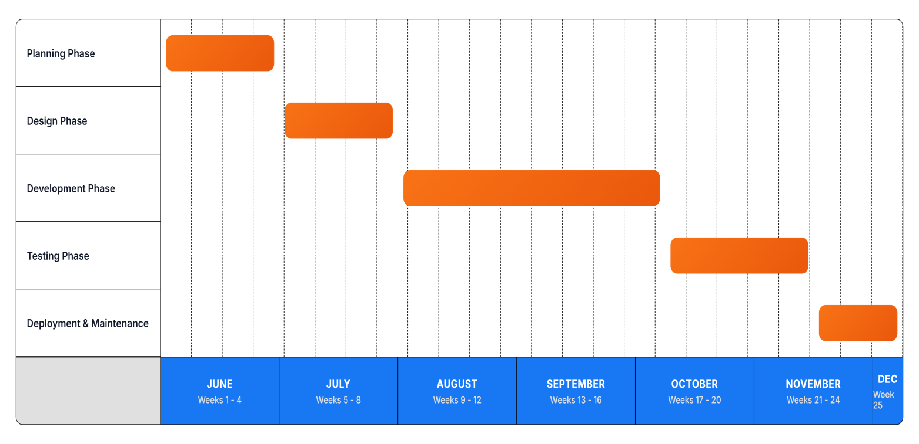

Approved by:

DIKEMBIE KREISLER M. GALILEA
Technical Adviser

