The following mock tabulation illustrates how survey responses from residents and BFP personnel may be presented for the proposed provincial fire response system. All values are simulated and are provided for document formatting only.
Table 1. Resident and BFP Personnel Mock Survey Results
Residents  (n = 30) | Response |  | BFP Personnel  (n = 10) | Response
Residents  (n = 30) | Yes | No | BFP Personnel  (n = 10) | Yes | No
Q1 | 27 | 3 | Q1 | 9 | 1
Q2 | 25 | 5 | Q2 | 8 | 2
Q3 | 26 | 4 | Q3 | 9 | 1
Q4 | 24 | 6 | Q4 | 10 | 0
Q5 | 28 | 2 | Q5 | 9 | 1
Q6 | 27 | 3 | Q6 | 8 | 2
Q7 | 29 | 1 | Q7 | 9 | 1
Q8 | 26 | 4 | Q8 | 10 | 0
Q9 | 28 | 2 | Q9 | 9 | 1
Q10 | 25 | 5 | Q10 | 9 | 1
Total | 265 | 35 | Total | 90 | 10
Percentage | 88.33% | 11.67% | Percentage | 90.00% | 10.00%
Note. Mock data only. Q1-Q10 refer to the ten proposed survey items.
Table 1 presents simulated responses from 30 residents and 10 BFP personnel. The questionnaire consists of ten items, each with a Yes or No response. Across 300 resident answers, 265 are Yes responses (88.33%) and 35 are No responses (11.67%). Across 100 BFP personnel answers, 90 are Yes responses (90.00%) and 10 are No responses (10.00%).
The two groups provide a combined total of 400 item responses, comprising 355 Yes answers and 45 No answers. Percentages are based on the total number of answers across the ten questions, rather than the number of individual participants. These figures illustrate the tabulation format and do not represent actual survey findings.

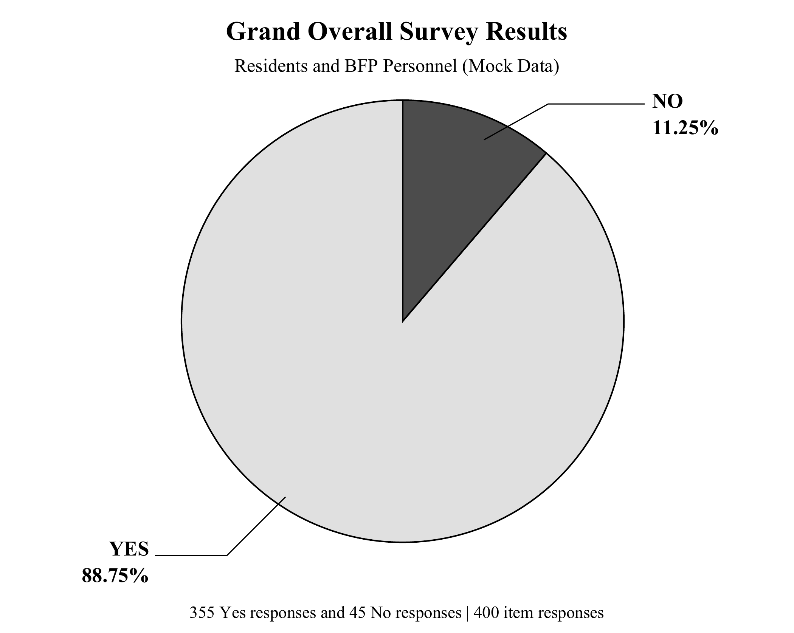
Figure 1. Mock Survey Results in a Pie Chart
The pie chart in Figure 1 shows the overall distribution of the simulated responses from residents and BFP personnel. Of the 400 item responses, 88.75% are Yes answers and 11.25% are No answers. These percentages are calculated from the combined response counts in Table 1.
The chart summarizes answers across the ten proposed survey items. It does not indicate the percentage of individual participants who support the system. Actual responses must replace these mock values before the table and figure are presented as research findings.

