Resident and BFP Survey Results
  - GIS-Based Provincial Fire Response and Decision Support System with Smart Dispatch and Inter-Municipality Coordination for BFP in Antique
ILLUSTRATIVE TABULATION | 30 RESIDENTS + 10 BFP PERSONNEL
This mock dataset demonstrates the presentation of a ten-item Yes/No survey for residents and BFP personnel. The questions and figures below are proposed examples; they do not represent collected survey findings.
Table 1. Mock Survey Responses of Residents and BFP Personnel
Proposed survey item | Residents (n = 30) |  | BFP personnel (n = 10)
Proposed survey item | Yes | No | Yes | No
Q1. Is a digital fire-reporting system needed? | 27 | 3 | 9 | 1
Q2. Would submitting a fire location through a map be helpful? | 25 | 5 | 8 | 2
Q3. Would uploading photographs help clarify fire reports? | 26 | 4 | 9 | 1
Q4. Is timely communication between residents and BFP needed? | 24 | 6 | 10 | 0
Q5. Would incident-status notifications be helpful? | 28 | 2 | 9 | 1
Q6. Would a map showing nearby fire stations be useful? | 27 | 3 | 8 | 2
Q7. Is a centralized record of reported fire incidents needed? | 29 | 1 | 9 | 1
Q8. Would coordination between municipal BFP offices be helpful? | 26 | 4 | 10 | 0
Q9. Is secure access to personal and incident information necessary? | 28 | 2 | 9 | 1
Q10. Would you be willing to use the proposed system? | 25 | 5 | 9 | 1
Total responses | 265 | 35 | 90 | 10
Percentage of responses | 88.33% | 11.67% | 90.00% | 10.00%
Note. All values are simulated. Each item has 30 resident responses and 10 BFP responses. Group percentages use 300 resident answers and 100 BFP answers across ten questions.
In this illustrative dataset, residents recorded 265 Yes responses (88.33%) and 35 No responses (11.67%). BFP personnel recorded 90 Yes responses (90.00%) and 10 No responses (10.00%). These figures demonstrate the calculation and presentation of response frequencies only.

Overall Response Distribution
  - Combined resident and BFP responses
The pie chart combines the response counts in Table 1. The 400 item responses comprise 355 Yes answers and 45 No answers. Each participant contributes one answer to each of the ten proposed questions.
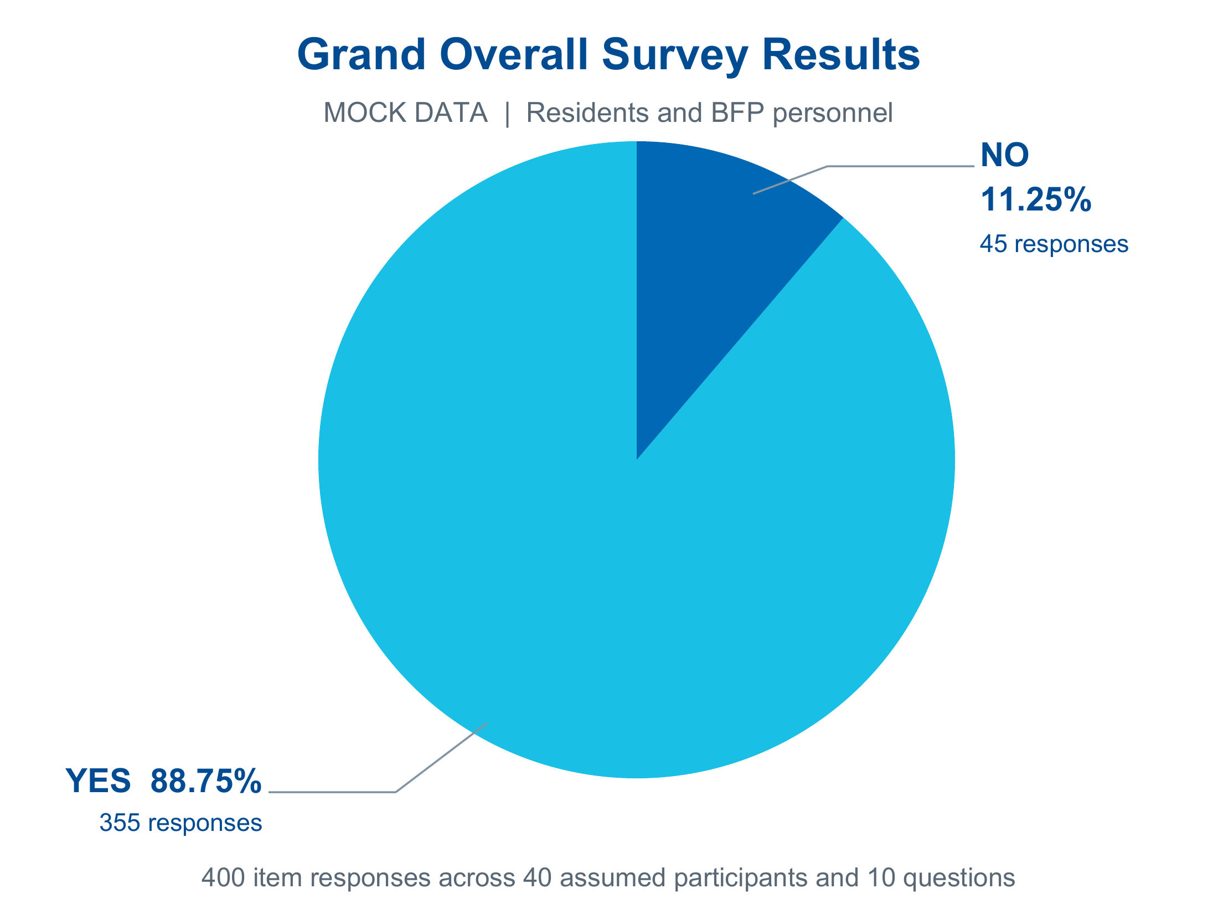
Figure 1. Overall Distribution of Mock Survey Responses
Figure 1 shows that Yes answers account for 88.75% of the simulated responses, while No answers account for 11.25%. These percentages describe the distribution of answers across the ten survey items, rather than the percentage of individual participants who support the system.
Calculation: Yes = 355 / 400 × 100 = 88.75%; No = 45 / 400 × 100 = 11.25%. The combined percentages are calculated from the response totals, not by averaging the two group percentages.
MOCK DATA - FOR DOCUMENT LAYOUT AND DEMONSTRATION ONLY
Replace the proposed questions and simulated counts with the validated questionnaire and actual survey results before using this material as research evidence.

