《量子信息基础》2021.6.3随堂作业：

1. Consider the Bell state $\left.\left|Φ^{-}\right.\right\rangle =\frac{1}{\sqrt{2}}\left(\left.\left|0_{1},0_{2}\right.\right\rangle -\left.\left|1_{1},1_{2}\right.\right\rangle \right)$ of two photons, and suppose now that we wish to express it not on a basis of horizontal ( $\left.\left|0\right.\right\rangle$) and vertical ( $\left.\left|1\right.\right\rangle$) polarized states, but instead on a basis rotated by 45°, i.e., a new basis
$$\left.\left|+45\right.\right\rangle =\frac{1}{\sqrt{2}}\left(\left.\left|0\right.\right\rangle +\left.\left|1\right.\right\rangle \right)$$

$$\left.\left|-45\right.\right\rangle =\frac{1}{\sqrt{2}}\left(\left.\left|0\right.\right\rangle -\left.\left|1\right.\right\rangle \right)$$

2. Show that, expressed on this particular basis, the resulting state is still a Bell state.
3. Repeat part (a), but with the Bell state $\left.\left|Φ^{+}\right.\right\rangle =\frac{1}{\sqrt{2}}\left(\left.\left|0_{1},0_{2}\right.\right\rangle +\left.\left|1_{1},1_{2}\right.\right\rangle \right)$. What difference do you note between the two results?
4. Since

$$\left.\left|0\right.\right\rangle =\frac{1}{\sqrt{2}}\left(\left.\left|+45\right.\right\rangle +\left.\left|-45\right.\right\rangle \right)$$

$$\left.\left|1\right.\right\rangle =\frac{1}{\sqrt{2}}\left(\left.\left|+45\right.\right\rangle -\left.\left|-45\right.\right\rangle \right)$$

$$\left.\left|Φ^{-}\right.\right\rangle =\frac{1}{\sqrt{2}}\left(\left.\left|0_{1},0_{2}\right.\right\rangle -\left.\left|1_{1},1_{2}\right.\right\rangle \right)=\frac{1}{2\sqrt{2}}\left(\left({\left.\left|+45\right.\right\rangle }_{1}+{\left.\left|-45\right.\right\rangle }_{1}\right)\left({\left.\left|+45\right.\right\rangle }_{2}+{\left.\left|-45\right.\right\rangle }_{2}\right)-\left({\left.\left|+45\right.\right\rangle }_{1}-{\left.\left|-45\right.\right\rangle }_{1}\right)\left({\left.\left|+45\right.\right\rangle }_{2}-{\left.\left|-45\right.\right\rangle }_{2}\right)\right)=\frac{1}{2\sqrt{2}}\left({\left.\left|+45\right.\right\rangle }_{1}{\left.\left|+45\right.\right\rangle }_{2}+{\left.\left|+45\right.\right\rangle }_{1}{\left.\left|-45\right.\right\rangle }_{2}+{\left.\left|-45\right.\right\rangle }_{1}{\left.\left|+45\right.\right\rangle }_{2}+{\left.\left|-45\right.\right\rangle }_{1}{\left.\left|-45\right.\right\rangle }_{2}-{\left.\left|+45\right.\right\rangle }_{1}{\left.\left|+45\right.\right\rangle }_{2}+{\left.\left|+45\right.\right\rangle }_{1}{\left.\left|-45\right.\right\rangle }_{2}+{\left.\left|-45\right.\right\rangle }_{1}{\left.\left|+45\right.\right\rangle }_{2}-{\left.\left|-45\right.\right\rangle }_{1}{\left.\left|-45\right.\right\rangle }_{2}\right)=\frac{1}{\sqrt{2}}\left({\left.\left|+45\right.\right\rangle }_{1}{\left.\left|-45\right.\right\rangle }_{2}+{\left.\left|-45\right.\right\rangle }_{1}{\left.\left|+45\right.\right\rangle }_{2}\right)$$

It is still a Bell state.

推导和答案正确给20分

$$\left.\left|Φ^{+}\right.\right\rangle =\frac{1}{\sqrt{2}}\left(\left.\left|0_{1},0_{2}\right.\right\rangle +\left.\left|1_{1},1_{2}\right.\right\rangle \right)=\frac{1}{2\sqrt{2}}\left(\left({\left.\left|+45\right.\right\rangle }_{1}+{\left.\left|-45\right.\right\rangle }_{1}\right)\left({\left.\left|+45\right.\right\rangle }_{2}+{\left.\left|-45\right.\right\rangle }_{2}\right)+\left({\left.\left|+45\right.\right\rangle }_{1}-{\left.\left|-45\right.\right\rangle }_{1}\right)\left({\left.\left|+45\right.\right\rangle }_{2}-{\left.\left|-45\right.\right\rangle }_{2}\right)\right)=\frac{1}{\sqrt{2}}\left({\left.\left|+45\right.\right\rangle }_{1}{\left.\left|+45\right.\right\rangle }_{2}+{\left.\left|-45\right.\right\rangle }_{1}{\left.\left|-45\right.\right\rangle }_{2}\right)$$

变成了正关联

推导和答案正确给20分

1. The following figure gives a schematic representation of a system designed to implement the B92 protocol using linearly polarized photons. Alice encodes her data according to the polarization angle $θ$ of the photon, with $0^{o}≡0$ and ${45}^{o}≡1$. Bob makes measurements with a Pockels cell PC2 randomly set to rotate by an angle $θ_{Bob}$ of either of ${45}^{o}$ or ${90}^{o}$. A polarizer set to transmit perfectly for photons with $θ=0^{o}$ when $θ_{Bob}=0^{o}$ is placed after PC2, followed by a single-photon detector D.
2. Describe the possible outcomes for both of Bob’s measurement settings. Explain how this arrangement can be used for unambiguous transmission of bits.
3. In the absence of losses, detector errors, and an eavesdropper, compare the fraction of Alice’s bits that Bob receives in the B92 protocol to the fraction in the sifted data set of the BB84 protocol.
4. How would an eavesdropper be detected in this scheme?

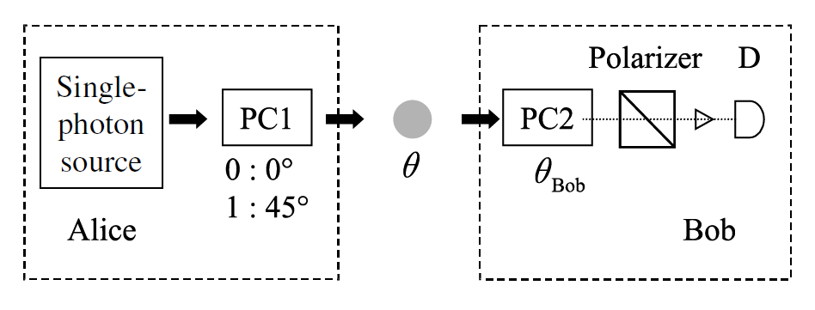

1. When Alice sends a 0 ( $0^{o}$ rotation at Alice side), Bob would detect 50% of the counts when $θ_{Bob}={45}^{o}$. When Alice sends a 1 ( ${45}^{o}$ rotation at Alice side), Bob would detect 50% of the counts when $θ_{Bob}={90}^{o}$.

答案正确给20分

1. Bob would only receive 25% of the bits in B92 compared to 50% in B84.

答案正确给20分

1. If Eve use a Pockels cell randomly set at ${45}^{o}$ or ${90}^{o}$. She would only detect 25% of the bits Alice sends out. The bit rate that Bob would receive will be reduced by a factor of 4. If Eve send out randomly the bits at Alice’s bit rate, the error rate will increase.

答案正确给20分