《量子信息基础》第二章第一部分：

1. <即教材\*问题1.5>

Consider the wave function

$Ψ\left(x,t\right)=Ae^{-λ\left|x\right|}e^{-iωt}$

where $A$, *λ*, and $ω$ are positive real constants.

1. Normalize $Ψ$.
2. Determine the expectation values of $x$ and $x^{2}$.
3. Find the standard deviation of $x$. Sketch the graph of ${\left|Ψ\right|}^{2}$, as a function of $x$, and mark the points $\left(〈x〉-σ\right)$ and $\left(〈x〉+σ\right)$, to illustrate the sense in which $σ$ represents the “spread” in $x$.
4. What is the probability that the particle would be found outside this range (which means outside of $\left(〈x〉-σ\right)$ and $\left(〈x〉+σ\right)$)?

A photon propagates in the $z$ direction and passes a linear optical polarizer which is oriented in the $x$ direction (see figure below). The state in Figure (a) is $ψ_{a}$ while the state in Figure (b) is $ψ_{b}$.

1. Write done the formula of $ψ_{c}$, assuming the light beam is polarized with an angle of *α* to the $x$ axis.
2. How much is the probability that a single photon could pass the polarizer in (c)?
3. How does the system maintain the normalization condition?

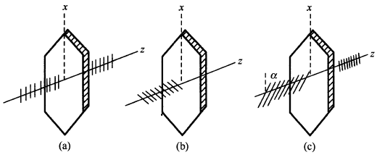

1. <即教材\*问题1.15>

Show that

$\frac{d}{dt}\int_{-∞}^{∞}{Ψ_{1}^{*}Ψ_{2}dx}=0$

for any two (normalizable) solutions to the Schrödinger equation (with the same $V\left(x\right)$), $Ψ_{1}$ and $Ψ_{2}$.

\* David J. Griffiths, and Darrell F. Schroeter, Introduction to Quantum Mechanics (3rd Edition), Cambridge University Press (2018).