《量子信息基础》第三章第一部分

1. (Text book\* Problem 5.20)

Find the average energy per free electron ($E_{tot}/N$), as a fraction of the Fermi energy.

1. Considering we have free electron gas in a rectangular area in two dimension, derive the Fermi energy and the density of energy states in two dimension. *Note: the Fermi-energy formula written on the text book was derived in three dimension. You need follow the same procedure but the result will be slightly different comparing to the three dimension case.*
2. (1) Write down the indices of the following 9 crystal planes in the cubic lattice system.

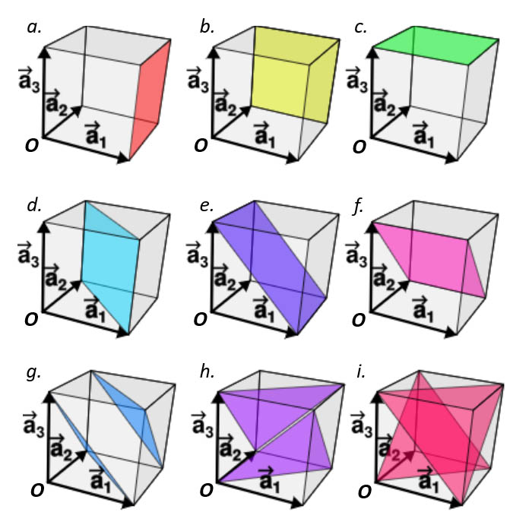

(2) Write down the indices of the shortest lattice vector which starts from the point *O* and ends at the crystal planes with colors in the above figure.

1. (1) Write down the reciprocal vector $\overset{⃑}{G}$ of the 1D and 2D lattice of

$$\overset{⃑}{R}=u\overset{⃑}{a}$$

$$\overset{⃑}{R}=u{\overset{⃑}{a}}_{1}+v{\overset{⃑}{a}}_{2}$$

(2) Prove that in the Bloch’s theorem, where $\overset{⃑}{G}$ is the 1D reciprocal vector.

$$u_{k}\left(x\right)=\sum_{h}{A_{h}e^{iGx}}$$

\* David J. Griffiths, and Darrell F. Schroeter, Introduction to Quantum Mechanics (3rd Edition), Cambridge University Press (2018).