Homework 7: PowerShell
- Initial Setup
For this assignment a single virtual machine was created. The machine would later act as Directory Controller (DC) with the following machine specifications:

Directory Controller (DC)
- Generation 2
- 1 CPU
- RAM – 4096 MB, not dynamic (more memory given for “snappy-ness”)
- Network card – NAT switch with DHCP
- Disk – 100 GB
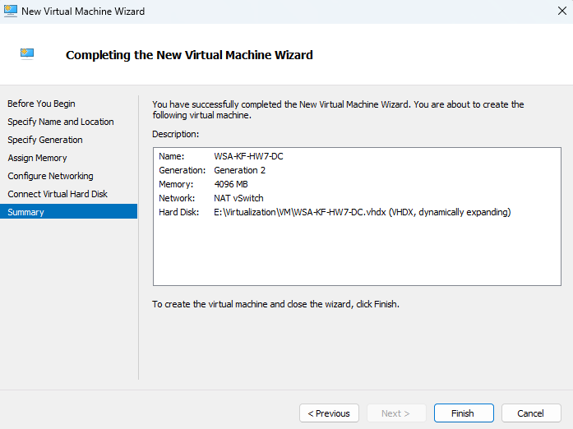

Individual Server/PC Setup
After creating of the VM some of its settings were adjusted, namely the “Computer Name” and “Network Settings” were adjusted to correspond to the following schematic.
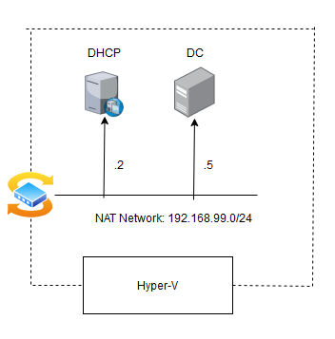

DC Deployment
The resulting script for AD Deployment, to create the Active Directory within the DC Server (Root Domain name used was WSA.HW7) is shown here:
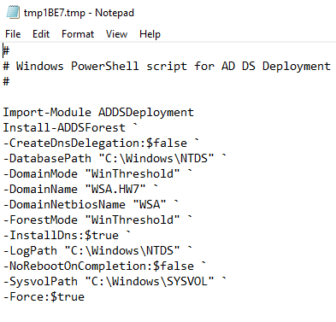

Tasks
In this section I shall provide proof of the 2 tasks and their subtasks, required for the assignment.

Create an interactive PowerShell script
To fulfil this task the script named: “Interactive-ADUser-Creation.ps1” was created. The script implements all requirements of the task, but also has some additional checks to prevent the user from creating an account with the same username as an already existing user inside of AD or with a password that does not meet the minimum-security requirements. Unnecessary folder creation is avoided, provided the folder structure is pre-existing. If something goes wrong during the user account creation, the account is deleted and the user is asked if they wish to try again and create a new user account.
For more information see the attached .ps1 file in the archive.

Create non-interactive PowerShell script
For this task a script named: “Batch-Directories.ps1” was created. The script implements all requirements of the task and additionally checks if some of the folders have already been created and skips their creation. A full documentation was also created; hence the “Get-Help” PowerShell command will provide the user will the information they need to use the script. The script first needs to be sourced and then can be called with “Create-BatchDirectories” command, the command accepts four parameters, but also has some default values if none are provided by the user.
For more information see the attached .ps1 file in the archive.

