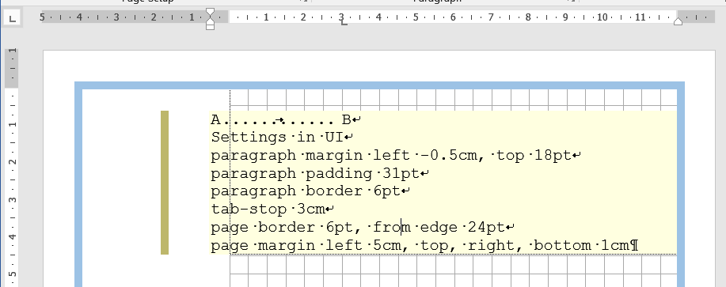
A B
Settings in UI
paragraph margin left -0.5cm, top 18pt
paragraph padding 31pt
paragraph border 6pt
tab-stop 3cm
page border 6pt, from edge 24pt
page margin left 5cm, top, right, bottom 1cm

