Republic of Senegal
One People – One Goal – One Faith
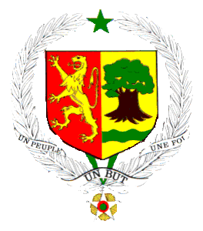

TABLE OF CONTENTS

