CO-ACES CMZ Core Chemistry (Kai)
Dates June 19-24
Task 2 current status and updates

Tabulate Spectral Properties of ACES and Co-Aces Data
Co-Aces
- data is tabulated into 2 formats 1: ‘CO-ACES Cube Properties.txt’ text file containing all desired properties though middle columns are skewed due to their long source names. Be careful if trying to extract data directly from the file, be sure spacing is correct.
- A more easily readable version of the table can be found in ‘CO-ACES Cube Properties.csv’

Aces
- Data is also tabulated in 2 formats The first of which is a textile that is formatted from Latex style, much of the data will be unaccessible through code for the time being. The file name is: ‘Acesdata.txt’
- To access a more legible version the file ‘Acesdata.csv’ has that. In addition there is an HTML version. Go to https://data.rc.ufl.edu/secure/adamginsburg/ACES/tables/ to access it. Ask Betsy or Clarie Cook for access info.
- For the moment I have avoided heavily modiffying the table as which data will be used is uncertain yet, thus I will wait until sources have been confirmed, before I make the tables anything other than basic spreadsheets

Resulting data products:
  - Variables containing the above properties (Code to extract each of these properties from an input FITS file)
  - Code can be found at ‘ExtractingFITS.ipynb’ The code effectivly extracts all the tabulated data (frequency range, Beam Size, number of channels, etc) from a fits file that you input into the variable named ‘path’. To get data simply print labeled variables.
  - Example: I want to extract the frequency min: 1. change path variable to desired fits file 2. type print(Freqmin) The value will be given to you in GHz
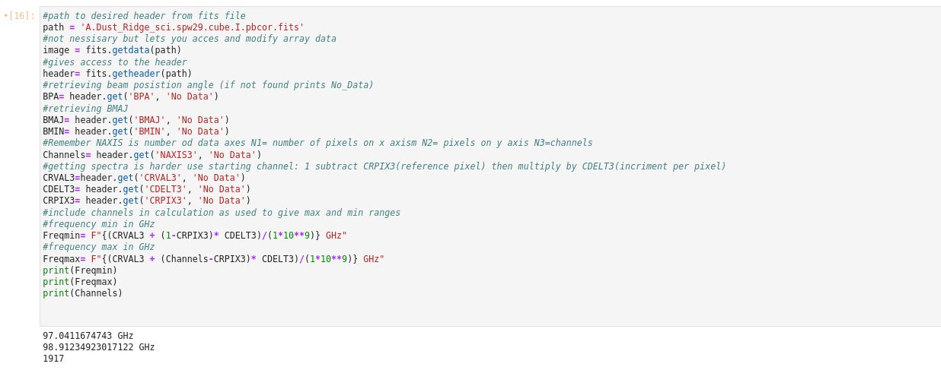
  - Warning: the name physically displays GHz, if you just want the number delete the f”{}GHz” section from the calculation

Contributions to paper:
- Nothing done hear yet as tables need to be formatted to be source specific, and the structure of the ACES data is still messed up from Latex. Going to wait to see if a Txt file gets added, as well as from additional instruction on how these tables should look.

