Research paper · version 1.0 · 30 October 2026

River flow or rainfall? Writing parametric flood triggers from global data, tested gauge by gauge in the Guadalquivir basin, Spain
Charles Kakooza · KAI Water & Energy, Kampala, Uganda
Correspondence: through https://kai-water.charkaks0.workers.dev/contact

Abstract
A parametric flood policy pays when an index crosses an agreed trigger. Where a river has no gauge, the index has to come from global data: a flood model's river flow, or rainfall. We test both against 14 river gauges in the Guadalquivir basin, Spain (583–16,166 km², water years 1985–2022, 286 gauge-years), in the region where a recent industry study compared four ways of setting rainfall triggers for drought cover. Flood-frequency curves were fitted by L-moments (GEV and log-Pearson III) to the annual maxima of the gauges, of the GloFAS reanalysis and of catchment rainfall from NASA POWER, and 1-in-T triggers were scored year by year against the floods the gauges measured. The model's 10-year flood is 0.22 of the gauged one at the median gauge, so a trigger written in m³/s from the model caught only 6 of 60 1-in-5 flood years (Peirce skill 0.06); written as the model's own 1-in-5 level it caught 30 (Peirce 0.38; McNemar p = 1.2 × 10⁻⁷). Set from each gauge's own record, as a quantile, a return period or a share of the mean annual maximum, triggers on the same index performed alike; one absolute level shared by all gauges paid in 0% to 78% of years from one gauge to the next and lost skill (Peirce 0.23). Storm rainfall (the wettest three days) was a weaker index than river flow (23 of 60, Peirce 0.26); the October–April rainfall total matched it (31 of 60, Peirce 0.39), and the two disagreed on few flood years (6 against 7). Requiring both to pass cut false payouts from 47% to 29% of payouts, at the cost of 6 flood years. Basis risk remained high in every design, and the rank correlation of the gauge's annual maxima with the index's predicted where it would be (Spearman ρ = 0.80 across gauges for river flow). Triggers from global data should be set from each site's own record, written in the index's own terms, screened with local evidence and calibrated before they enter a contract. Data, code and a notebook that reproduce every number are published with this paper.
Keywords: parametric insurance; flood trigger; basis risk; GloFAS; rainfall index; NASA POWER; flood frequency; L-moments; verification; Guadalquivir

1. Introduction
Parametric (index) insurance pays a fixed sum when a measured index passes an agreed level, instead of after a loss assessment. Payouts are fast and cheap to administer, which is why the approach has spread from crop and weather cover to flood risk, risk pools and forecast-based humanitarian finance [4]. Its weakness is basis risk: the index can pass the trigger when the insured suffers no loss, or stay below it when they do. Basis risk is the main reason that demand for index cover stays lower than its price alone would suggest [3].
For river floods the natural index is discharge at a gauge. Most places at risk have no gauge, and where one exists its record is often too short, interrupted or not public. Global hydrological reanalyses fill the gap. The Global Flood Awareness System (GloFAS) runs the LISFLOOD model over the whole land surface at about 5 km resolution, driven by atmospheric reanalysis, and publishes daily river discharge from 1979 onwards [1, 8]. A trigger for any river reach can therefore be read from GloFAS in minutes. The question a buyer and an insurer must answer first is whether that trigger pays in the years the river actually floods.
Global models are calibrated against a subset of the world's gauges [9] and are known to struggle where rivers are regulated by reservoirs and abstractions, and in semi-arid climates where runoff is a small and variable share of rainfall. Both conditions describe the Guadalquivir in southern Spain.
The other common index is rainfall, which is estimated everywhere and does not depend on river engineering. Model Library [14] recently set out four ways of fixing a trigger level (an absolute physical value, a quantile of each location's own record, a return period from a fitted extreme-value model, and a share of a reference value) and tested them on a drought cover in Andalucía indexed on October–April rainfall from NASA POWER at three cells. One absolute level of 280 mm, the central cell's 1-in-5, would have paid in 12 % of seasons at the western cell and 64 % at the eastern one. That test concerns drought, the dry tail of seasonal rainfall. Floods are the wet tail, and a river carries rain that fell days earlier and far upstream.
This paper asks four practical questions in the Guadalquivir basin, which drains most of Andalucía: (1) how close a global model's flood magnitudes are to the gauged ones; (2) whether a trigger written as a fixed flow, or as the model's own return period, pays in the right years; (3) how the four ways of setting the level, and a rainfall index instead of river flow, change the answer; and (4) whether the basis risk at a site can be anticipated before a policy is written. We answer them with an open, reproducible test on 14 gauges.

2. Data
Gauges. Daily mean river flow and station metadata come from the Anuario de Aforos 2021-2022 for the Guadalquivir basin, published by CEDEX for Spain's Ministry for the Ecological Transition [2]. We kept every gauge with a catchment of at least 500 km² and at least 25 years of daily flow in water years 1985–2022 (October to September). This gave 14 gauges with catchments of 583 to 16,166 km² (Table 1; Figure 1). The raw CEDEX files are not redistributed; they are fetched from CEDEX and checked against published SHA-256 checksums.
Global model. Daily river discharge (24-hour mean) from the GloFAS reanalysis, LISFLOOD, consolidated product, version 4.0, at 0.05° resolution, retrieved through the Open-Meteo flood API, which serves the Copernicus Emergency Management Service data under CC BY 4.0. For each gauge, all cells within ±0.1° (about 10 km) were retrieved, and the cell whose mean flow over the common period was closest to the gauge's (in log ratio) was used. This choice uses the gauge and is therefore the model's best case; at an ungauged site the cell has to be found from the upstream area alone.
Rainfall. Daily precipitation (PRECTOTCORR: MERRA-2, bias-corrected, on a 0.5° × 0.625° grid) from the NASA POWER daily API [15, 6], the source of the Model Library study. Each gauge's catchment was taken from HydroBASINS level 8 [12]: of the sub-catchments within about 13 km of the gauge, the one whose upstream area best matched the gauge's catchment area (ratio 0.45 to 2.67, median 1.23). Catchment rainfall is the mean of the POWER cells that overlap the catchment, weighted by overlap area.
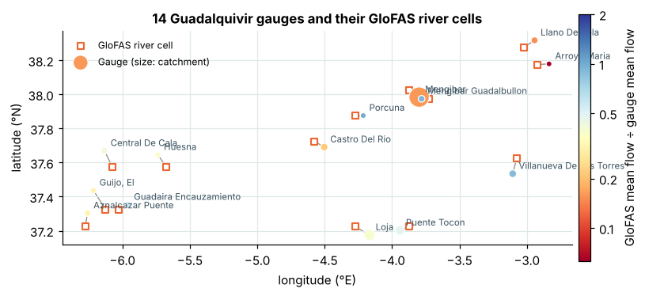
Figure 1. The 14 gauges (dots, sized by catchment area, coloured by the ratio of GloFAS mean flow to gauged mean flow) and their matched GloFAS river cells (squares). An interactive version with basemaps, rivers and sub-catchments is at https://kai-water.charkaks0.workers.dev/case-guadalquivir.

3. Methods

3.1 Annual maxima and flood frequency
For each source, the largest daily flow of each water year was taken, keeping years with at least 80 % of days; the comparison uses the years both sources cover (17 to 24 per gauge, 286 gauge-years in total). The generalised extreme value (GEV) distribution and the log-Pearson type III (LP3) distribution were fitted by L-moments [10, 11], the latter to log₁₀ flows as in flood-frequency practice [5]. The better fit was chosen by the probability-plot correlation with Gringorten plotting positions [7]; the GEV was chosen at 11 of 14 gauges and at 10 of 14 GloFAS cells (LP3 is not fitted where a year's maximum is zero). Return levels for 1-in-2 to 1-in-50 years carry a 90 % percentile bootstrap band (300 resamples of the annual maxima, refitted).

3.2 Triggers
A year is a flood year at a gauge when its annual maximum reached the gauge's own fitted 1-in-T level. Two triggers were set from the model for each T = 2, 5, 10 and 25 years. The fixed-flow trigger pays when the model's annual maximum reaches the gauge's 1-in-T level in m³/s: the trigger a buyer would write by reading a design flow off a gauge-based study and applying it to the model. The return-period trigger pays when the model's annual maximum reaches the model's own 1-in-T level, i.e. the trigger is defined by frequency rather than by magnitude. Payouts are counted per gauge-year: a hit (flood year, paid), a miss (flood year, not paid) or a false payout (paid, no flood year).
Four ways to set the level, on three indices. Following Model Library [14], every 1-in-T trigger was also set in four ways, all aimed at paying once in T years: (i) absolute, one level for every gauge, the median of the gauges' own fitted 1-in-T levels (in mm for rainfall; for river flow per 1,000 km² of catchment, since one flow in m³/s cannot be shared by catchments of 583 to 16,166 km²); (ii) quantile, each gauge's own empirical 1 − 1/T quantile (Weibull plotting position); (iii) return period, each gauge's fitted 1-in-T level; and (iv) share of a reference, one share of each gauge's mean annual maximum, the same for all gauges (the median ratio of the fitted 1-in-T level to the mean). Each was applied to three indices: river flow from GloFAS; storm rainfall, the catchment's largest 3-day total of the year, as in excess-rainfall flood cover; and wet-season rainfall, the October–April catchment total, the index of the Model Library study. Both rainfall windows were fixed in advance; 1-, 5-, 10- and 30-day windows are reported as a sensitivity test. Two-index triggers pay when river flow and wet-season rainfall both pass their own 1-in-5 levels, or when either does.

3.3 Verification
From the pooled 2 × 2 table of all gauge-years we report the hit rate H, the false-alarm rate F (false payouts as a share of non-flood years), the share of payouts that were false, and the Peirce skill score H − F [16], which is 0 for a trigger with no skill and 1 for a perfect one, whatever the base rate. Against chance, we test whether a trigger that paid out the same number of times at random would have caught as many flood years (one-sided hypergeometric test). Two triggers are compared on the same flood years with McNemar's test [13] on the flood years caught by one but not the other. Across gauges, Spearman's rank correlation relates basis risk to the agreement between the two annual-maximum series.

3.4 Reproducibility
The analysis was run by the KAI engine and reproduced independently by an open notebook built on textbook formulas (NumPy, SciPy, pandas). The notebook re-derives every trigger count exactly and the median magnitude ratio to within 0.02 of the engine's results, and stops with an error if they drift. A rebuild script regenerates the derived data files from the CEDEX and GloFAS sources; it reproduced all 286 annual maxima and all 14 cell choices exactly. A second script builds the catchments and catchment rainfall from HydroBASINS and NASA POWER, and a third sets and scores the triggers in the four ways on the three indices.

4. Results

4.1 The model sees these floods at about a fifth of their size
GloFAS mean flow was within a factor of 2 of the gauge at only 4 of 14 gauges (median ratio 0.38), and the model's 10-year flood was 0.22 of the gauged one at the median gauge, within a factor of 2 at 4 gauges (Figure 2; Table 1). The low bias held at every return period (median ratios 0.21, 0.19, 0.22, 0.29 and 0.36 for 1-in-2 to 1-in-50). It did not depend on catchment size (Spearman ρ = 0.22, p = 0.44) but did follow the mean-flow bias (ρ = 0.54, p = 0.049): where the model's water balance is low, so are its floods. A search up to 25 km around the largest gauge (Mengibar, 16,166 km²) found no river cell with a larger flow, so the bias is in the model, not in the choice of cell.
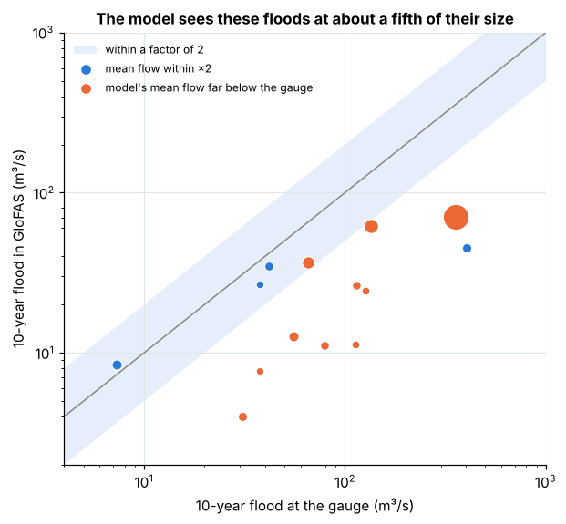
Figure 2. The 10-year flood at each gauge against the 10-year flood in GloFAS (log scales; dot size: catchment area). Blue: GloFAS mean flow within a factor of 2 of the gauge; orange: far below. Shading: within a factor of 2 of the 1 : 1 line.
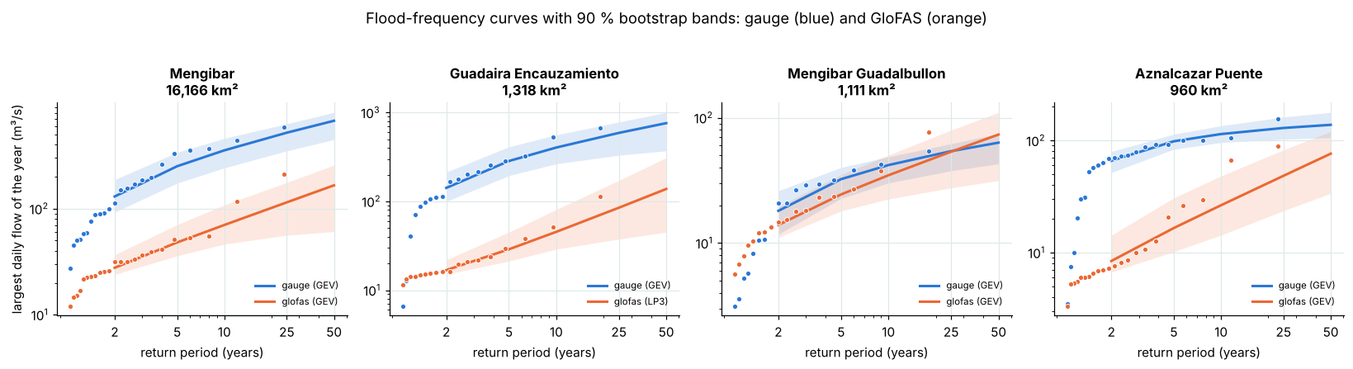
Figure 3. Flood-frequency curves at four gauges: annual maxima at their plotting positions, the preferred fit and its 90 % bootstrap band, for the gauge (blue) and GloFAS (orange). Where the curves run roughly parallel (Mengibar), a trigger written as a return period can still work; where the model is flatter or noisier, it cannot.

4.2 Write the trigger as a return period, not in m³/s
Because the model's floods are too small, a trigger written in m³/s from a gauge-based design flow almost never fired: at 1-in-5 it caught 6 of 60 flood years, with a Peirce skill of 0.06, no better than a trigger paying at random (p = 0.093; Table 2). Written as the model's own 1-in-5 level, the same trigger caught 30 flood years with a false-alarm rate of 0.12 (Peirce skill 0.38; p = 1.4 × 10⁻⁹ against chance). On the same flood years, 24 were caught by the return-period trigger but not the fixed-flow one, and 0 the other way round (McNemar p = 1.2 × 10⁻⁷). The ranking held at every trigger level (Figure 4): skill peaked at 1-in-5 (0.38) and fell to 0.22 at 1-in-25, where only 11 flood years exist in the pooled record. The return-period trigger is not free of basis risk: at 1-in-5 it also paid 27 times without a flood, so 47% of its payouts would have been false.
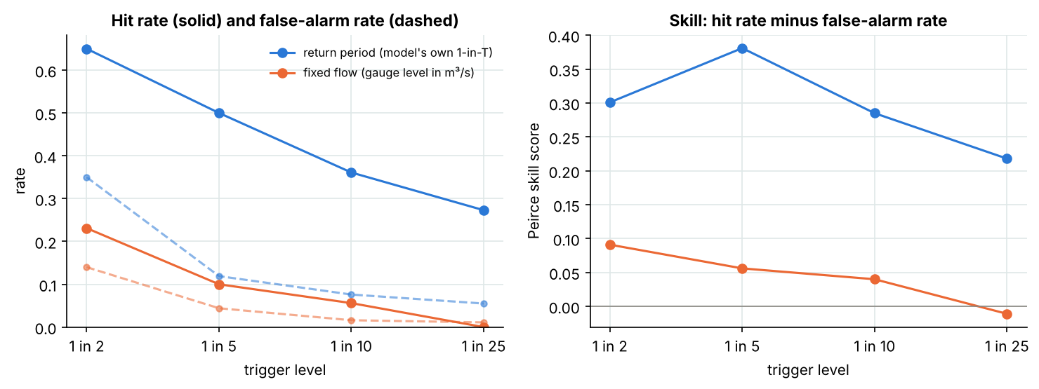
Figure 4. Pooled verification of the two triggers at four trigger levels: hit rate and false-alarm rate (left) and the Peirce skill score (right). The return-period trigger keeps a positive skill at every level; the fixed-flow trigger has almost none.
Table 2. Verification of 1-in-T triggers set from GloFAS, pooled over 14 gauges and 286 gauge-years.
Trigger | Written as | Caught | Missed | False payouts | Hit rate | False-alarm rate | Peirce skill | Caught by chance | p (vs chance)
1 in 2 | Return period | 93 | 50 | 50 | 0.65 | 0.350 | 0.30 | 71.5 | 2.8 × 10⁻⁷
1 in 2 | Fixed m³/s | 33 | 110 | 20 | 0.23 | 0.140 | 0.09 | 26.5 | 0.034
1 in 5 | Return period | 30 | 30 | 27 | 0.50 | 0.119 | 0.38 | 12.0 | 1.4 × 10⁻⁹
1 in 5 | Fixed m³/s | 6 | 54 | 10 | 0.10 | 0.044 | 0.06 | 3.4 | 0.093
1 in 10 | Return period | 13 | 23 | 19 | 0.36 | 0.076 | 0.28 | 4.0 | 1.6 × 10⁻⁵
1 in 10 | Fixed m³/s | 2 | 34 | 4 | 0.06 | 0.016 | 0.04 | 0.8 | 0.17
1 in 25 | Return period | 3 | 8 | 15 | 0.27 | 0.055 | 0.22 | 0.7 | 0.025
1 in 25 | Fixed m³/s | 0 | 11 | 3 | 0.00 | 0.011 | -0.01 | 0.1 | 1
Caught by chance: expected hits of a trigger that paid the same number of times at random; p: one-sided hypergeometric probability of at least as many hits by chance.

4.3 Four ways to set the level, on river flow and on rainfall
On each index, the three methods set from each gauge's own record gave almost the same trigger. At 1-in-5, the quantile, return-period and share triggers on river flow caught 29 to 31 flood years with Peirce skill 0.38 to 0.40, and paid in 12% to 29% of years at any gauge (Table 3; Figure 5). One absolute level for all gauges did not: 10.8 m³/s per 1,000 km² of catchment, the median gauge's 1-in-5 level, paid in 0% of years at one gauge and 78% at another, and its skill fell to 0.23 with 54 false payouts. Rainfall showed the same pattern (0% to 50% of years for storm rainfall, 0% to 33% for wet-season rainfall), as in the Andalucía drought case, where 280 mm paid in 12 to 64 % of seasons across three cells [14].
Storm rainfall was the weaker index. Written as each catchment's own 1-in-5 three-day total, it caught 23 of 60 flood years (Peirce 0.26), and other storm windows did no better (1 to 10 days: Peirce 0.15 to 0.26; 30 days: 0.29). Wet-season rainfall matched river flow: 31 flood years caught against 30 (Peirce 0.39 against 0.38), with 28 and 27 false payouts. The two indices largely agreed (median rank correlation of their annual series 0.62): 6 flood years were caught by river flow alone and 7 by rainfall alone (McNemar p = 1). Requiring both to pass caught 24 flood years with 10 false payouts, so the share of payouts that were false fell from 47% to 29%; paying when either passed caught 37 with 45 false payouts.
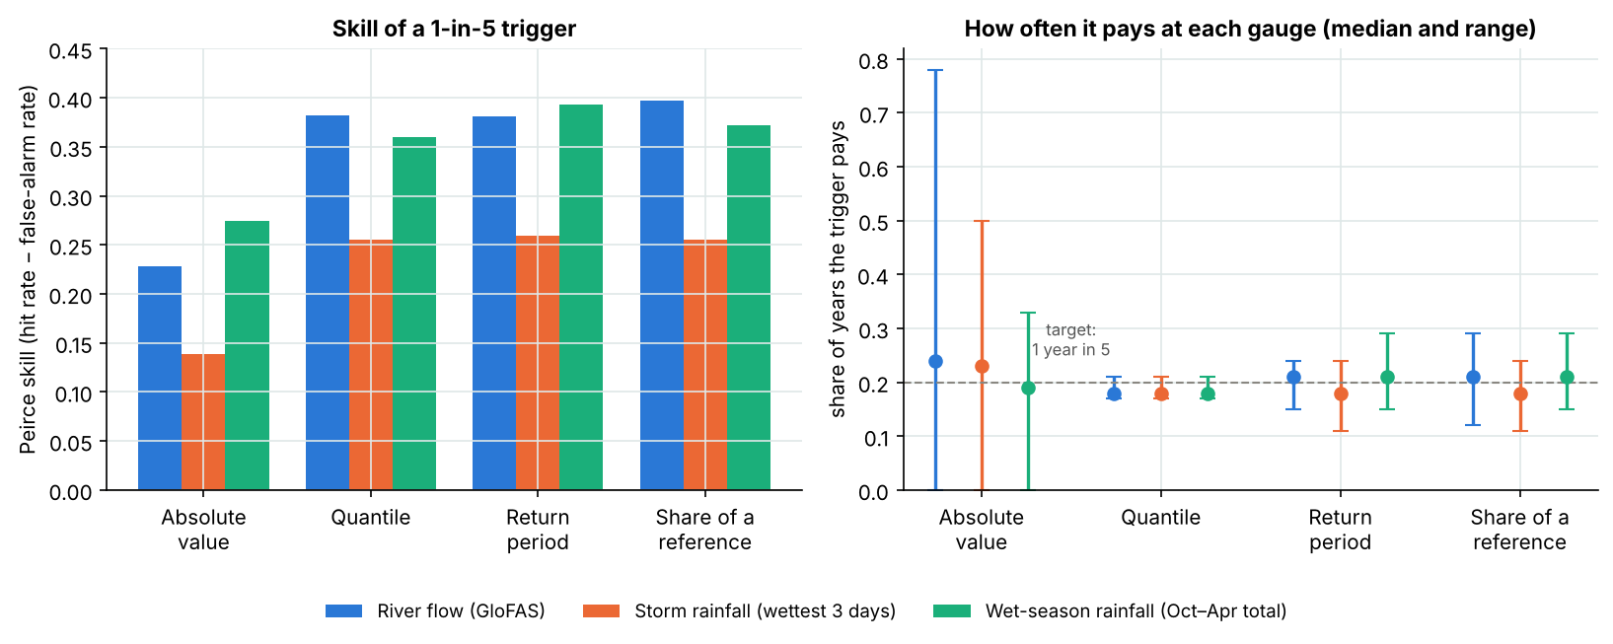
Figure 5. Triggers set to pay once in five years, in four ways, on river flow and on rainfall. Left: Peirce skill against the gauges' flood years, pooled over 14 gauges. Right: how often each trigger pays at each gauge (dot: median gauge; bar: lowest to highest). One absolute level for all gauges pays in very different shares of years from one gauge to the next.
Table 3. 1-in-5 triggers set in four ways on three indices, and two-index triggers, pooled over 14 gauges (286 gauge-years, 60 flood years).
Index | Method | One level for all gauges | Pays, range across gauges | Caught (of 60) | False payouts | Share of payouts false | Peirce skill | p (vs chance)
River flow (GloFAS) | Absolute value | 10.8 m³/s per 1,000 km² | 0%–78% | 28 | 54 | 66% | 0.23 | 6.5 × 10⁻⁴
 | Quantile |  | 17%–21% | 29 | 23 | 44% | 0.38 | 4.6 × 10⁻¹⁰
 | Return period |  | 15%–24% | 30 | 27 | 47% | 0.38 | 1.4 × 10⁻⁹
 | Share of a reference | 1.20 × mean | 12%–29% | 31 | 27 | 47% | 0.40 | 3.4 × 10⁻¹⁰
Storm rainfall (wettest 3 days) | Absolute value | 64 mm | 0%–50% | 20 | 44 | 69% | 0.14 | 0.019
 | Quantile |  | 17%–21% | 23 | 29 | 56% | 0.26 | 2.0 × 10⁻⁵
 | Return period |  | 11%–24% | 23 | 28 | 55% | 0.26 | 1.3 × 10⁻⁵
 | Share of a reference | 1.23 × mean | 11%–24% | 23 | 29 | 56% | 0.26 | 2.0 × 10⁻⁵
Wet-season rainfall (Oct–Apr total) | Absolute value | 438 mm | 0%–33% | 22 | 21 | 49% | 0.27 | 1.4 × 10⁻⁶
 | Quantile |  | 17%–21% | 28 | 24 | 46% | 0.36 | 3.6 × 10⁻⁹
 | Return period |  | 15%–29% | 31 | 28 | 48% | 0.39 | 6.3 × 10⁻¹⁰
 | Share of a reference | 1.26 × mean | 15%–29% | 30 | 29 | 49% | 0.37 | 4.5 × 10⁻⁹
River and wet-season rainfall both pass |  | each at its own 1-in-5 level |  | 24 | 10 | 29% | 0.36 | 2.1 × 10⁻¹¹
Either passes |  | each at its own 1-in-5 level |  | 37 | 45 | 55% | 0.42 | 1.3 × 10⁻⁹
Pays: share of years the trigger pays at a gauge, lowest and highest gauge (target 20 %). One level for all gauges: the absolute level, or the share of each gauge's mean annual maximum. Peirce skill: hit rate − false-alarm rate. p: one-sided hypergeometric test against a trigger paying as often at random.

4.4 Basis risk can be anticipated from a short record
Skill varied strongly between gauges (Table 1). The share of 1-in-5 flood years caught ranged from 0.20 to 1.00, and it followed the rank correlation of the gauge's annual maxima with the model's (Spearman ρ = 0.80, p = 0.0006; Figure 6). The median rank correlation was 0.42. Gauges where the model ranked the big years well (ρ ≥ 0.6: Mengibar, Castro del Río, Central de Cala, Aznalcázar Puente) caught half or more of their flood years, up to all of them; gauges where it did not (ρ near zero or negative: Villanueva de las Torres, Llano de Vela, Arroyo María) caught a fifth to two-fifths.
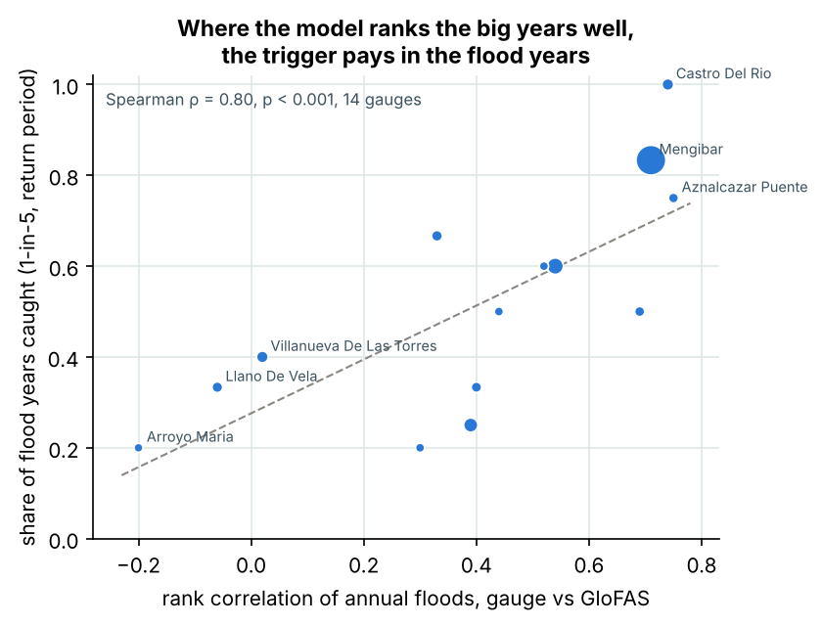
Figure 6. Share of 1-in-5 flood years caught by the return-period trigger at each gauge against the rank correlation of annual maxima, gauge against GloFAS (dot size: catchment area; dashed: least-squares line).
Table 1. Gauges, 10-year floods (Q10) with 90 % bootstrap bands, and the 1-in-5 return-period trigger at each gauge.
Gauge | Catchment km² | Years | Mean-flow ratio | Q10 gauge, m³/s (90 % band) | Q10 GloFAS, m³/s (90 % band) | Q10 ratio | Rank corr. | Flood years | Caught | False payouts
Mengibar | 16,166 | 23 | 0.16 | 355 (242–460) | 70 (46–109) | 0.20 | 0.71 | 6 | 5 | 0
Loja | 4,210 | 23 | 0.39 | 135 (88–181) | 62 (48–78) | 0.46 | 0.54 | 5 | 3 | 2
Puente Tocon | 2,944 | 18 | 0.48 | 66 (42–86) | 37 (29–42) | 0.56 | 0.39 | 4 | 1 | 3
Villanueva De Las Torres | 1,685 | 21 | 0.90 | 7 (5–10) | 9 (6–10) | 1.16 | 0.02 | 5 | 2 | 3
Castro Del Rio | 1,665 | 17 | 0.22 | 56 (31–84) | 13 (6–25) | 0.23 | 0.74 | 2 | 2 | 1
Guadaira Encauzamiento | 1,318 | 18 | 0.56 | 404 (264–560) | 45 (29–81) | 0.11 | 0.33 | 3 | 2 | 2
Llano De Vela | 1,240 | 20 | 0.15 | 31 (24–37) | 4 (3–5) | 0.13 | -0.06 | 3 | 1 | 2
Mengibar Guadalbullon | 1,111 | 17 | 0.93 | 42 (30–49) | 35 (22–50) | 0.83 | 0.40 | 3 | 1 | 2
Central De Cala | 1,010 | 19 | 0.42 | 79 (26–121) | 11 (7–16) | 0.14 | 0.69 | 6 | 3 | 1
Aznalcazar Puente | 960 | 22 | 0.32 | 114 (96–135) | 26 (14–48) | 0.23 | 0.75 | 4 | 3 | 2
Huesna | 678 | 21 | 0.37 | 126 (59–216) | 24 (10–46) | 0.19 | 0.52 | 5 | 3 | 2
Guijo, El | 672 | 23 | 0.31 | 113 (74–146) | 11 (9–13) | 0.10 | 0.44 | 4 | 2 | 2
Porcuna | 670 | 20 | 0.99 | 38 (20–54) | 27 (14–46) | 0.71 | 0.30 | 5 | 1 | 2
Arroyo Maria | 583 | 24 | 0.05 | 37 (30–47) | 8 (5–12) | 0.21 | -0.20 | 5 | 1 | 3
Mean-flow ratio: GloFAS mean flow ÷ gauged mean flow over the common days. Q10 ratio: GloFAS ÷ gauge. Rank corr.: Spearman correlation of annual maxima. Years: water years both sources cover.

5. Discussion
Frequency, not magnitude. A global model can be biased in magnitude and still carry useful information on which years are large. Writing the trigger as the model's own return period uses that information and discards the bias; writing it in m³/s keeps the bias and discards the information. In this basin the difference was between a trigger with clear skill and one with none. The same holds for a trigger written as a percentile of the model's flows, or as a share of a named past flood in the model, which are also defined in the model's own terms: on this record the quantile, return-period and share triggers were interchangeable.
One level for all sites hides the frequency. An absolute level is easy to read and to settle, but it pays at a different frequency at every site, which Model Library [14] showed for drought and which holds more strongly for floods: catchments differ in size, climate and regulation, and dividing by area does not remove the spread. Each site needs its own level, set from its own record; the agreed level can then be written into the contract in m³/s or mm for settlement.
Rainfall or river flow. In this basin, flood years follow wet winters more than single storms: reservoirs absorb the first rains and spill or release once full, and soils and aquifers fill slowly. A season total therefore ranked flood years as well as the river model, and storm rainfall did not. For prompt flood payouts that favours river flow: a season total is known only at the end of April and marks a flood year, not the flood, so it suits seasonal or anticipatory finance rather than event cover. Where both indices are available, requiring them to agree is a simple way to cut false payouts; it lowers the payout frequency, which the price must reflect.
Basis risk remains, and can be screened. Even the better trigger paid without a flood in 47% of payouts at 1-in-5. For a buyer that is a large risk, and in a regulated basin it is expected: reservoirs cut and delay flood peaks in some years and not in others, which a model without the reservoirs' operation cannot reproduce. The strong link between rank correlation and the share of floods caught offers a practical screen: a few years of local evidence (a short gauge record, flood marks, satellite flood extents or insurance claims) give a rank correlation that indicates, before the policy is written, whether the global index can carry the trigger or needs local calibration.
Limits. One basin, strongly regulated and semi-arid, so the size of the bias will differ elsewhere. GloFAS 4.0; version 5.0 of the reanalysis is the next test. Daily means, so instantaneous peaks are higher than the values used. 17 to 24 years per gauge, so levels beyond 1-in-25 are extrapolations and the 1-in-25 scores rest on 11 flood years. The cell was matched with the gauge's mean flow, the model's best case. Rainfall comes from one reanalysis-based product on a grid of about 50 km, coarse for the smaller catchments, and the HydroBASINS catchments differ in area from the gauges' by up to a factor of 2.7. Flood years are defined from the gauges' daily flows, not from losses; a contract would also have to consider where and how losses occur.

6. Conclusions
On 14 gauges in the Guadalquivir basin, the GloFAS reanalysis saw floods at about a fifth of their measured size. A parametric trigger written in m³/s from the model was no better than chance; the same trigger written as the model's own 1-in-5 level caught half the flood years with a false-alarm rate of 0.12, but a large share of its payouts were still false. Set from each gauge's own record, quantile, return-period and share triggers performed alike; one level for all gauges did not. Storm rainfall was a weaker index than river flow, wet-season rainfall an equal one, and the two together cut false payouts. Four recommendations follow for anyone writing flood triggers from global data: set the level from each site's own record and write it in the index's own terms, never as a flow read from another source; prefer river flow for event cover and test a second index alongside it; screen basis risk with the rank correlation against any local record before the policy is written; and calibrate locally before the trigger enters a contract.

Data and code availability
The data package published with this paper on Zenodo contains the derived data (annual maxima at the gauges and at their GloFAS cells; catchment rainfall maxima and the catchments and rainfall cells behind them; gauge list), the result files, the figures, the notebook that reproduces every number, the shared functions, the scripts that rebuild the derived data from the sources, the script that sets and scores the triggers in four ways, and the scripts that compute the statistics quoted here and build this paper from them. The same material is maintained at https://github.com/Kaitale/kai-case-studies/tree/main/spain-guadalquivir-flood-triggers (code MIT; text, figures and derived data CC BY 4.0). An interactive version with maps is at https://kai-water.charkaks0.workers.dev/case-guadalquivir.

Acknowledgements and competing interests
Gauge data: Fuente: CEDEX, Anuario de Aforos 2021-2022 (MITECO). Global model: contains modified Copernicus Emergency Management Service information 2026 (GloFAS 4.0), served by Open-Meteo (CC BY 4.0). Rainfall: data obtained from the NASA Langley Research Center POWER Project, funded through the NASA Earth Science/Applied Science Program. Catchments: HydroBASINS [12]. The comparison of four ways to set a trigger follows Model Library [14], whose published figures are quoted; Model Library had no part in this study. The author founded KAI Water & Energy, which offers parametric trigger studies (KAI-Hydro).

References
- Alfieri, L., Burek, P., Dutra, E., Krzeminski, B., Muraro, D., Thielen, J. and Pappenberger, F. (2013) GloFAS – global ensemble streamflow forecasting and flood early warning. Hydrology and Earth System Sciences 17, 1161–1175.
- CEDEX (2024) Anuario de Aforos 2021-2022. Centro de Estudios y Experimentación de Obras Públicas for the Ministerio para la Transición Ecológica y el Reto Demográfico, Madrid.
- Clarke, D.J. (2016) A theory of rational demand for index insurance. American Economic Journal: Microeconomics 8(1), 283–306.
- Coughlan de Perez, E., van den Hurk, B., van Aalst, M.K., Jongman, B., Klose, T. and Suarez, P. (2015) Forecast-based financing: an approach for catalyzing humanitarian action based on extreme weather and climate forecasts. Natural Hazards and Earth System Sciences 15, 895–904.
- England, J.F., Cohn, T.A., Faber, B.A., Stedinger, J.R., Thomas, W.O., Veilleux, A.G., Kiang, J.E. and Mason, R.R. (2019) Guidelines for Determining Flood Flow Frequency – Bulletin 17C. U.S. Geological Survey Techniques and Methods, book 4, chap. B5.
- Gelaro, R., McCarty, W., Suárez, M.J., Todling, R., Molod, A., Takacs, L. et al. (2017) The Modern-Era Retrospective Analysis for Research and Applications, Version 2 (MERRA-2). Journal of Climate 30(14), 5419–5454.
- Gringorten, I.I. (1963) A plotting rule for extreme probability paper. Journal of Geophysical Research 68(3), 813–814.
- Harrigan, S., Zsoter, E., Alfieri, L., Prudhomme, C., Salamon, P., Wetterhall, F., Barnard, C., Cloke, H. and Pappenberger, F. (2020) GloFAS-ERA5 operational global river discharge reanalysis 1979–present. Earth System Science Data 12, 2043–2060.
- Hirpa, F.A., Salamon, P., Beck, H.E., Lorini, V., Alfieri, L., Zsoter, E. and Dadson, S.J. (2018) Calibration of the Global Flood Awareness System (GloFAS) using daily streamflow data. Journal of Hydrology 566, 595–606.
- Hosking, J.R.M., Wallis, J.R. and Wood, E.F. (1985) Estimation of the generalized extreme-value distribution by the method of probability-weighted moments. Technometrics 27(3), 251–261.
- Hosking, J.R.M. and Wallis, J.R. (1997) Regional Frequency Analysis: An Approach Based on L-Moments. Cambridge University Press.
- Lehner, B. and Grill, G. (2013) Global river hydrography and network routing: baseline data and new approaches to study the world's large river systems. Hydrological Processes 27(15), 2171–2186.
- McNemar, Q. (1947) Note on the sampling error of the difference between correlated proportions or percentages. Psychometrika 12(2), 153–157.
- Model Library (2026) Four ways to set a parametric trigger, tested on Andalucía rainfall and yields. Article, 9 October 2026. https://modelibrary.com
- NASA POWER (2026) Prediction Of Worldwide Energy Resources, daily point API, precipitation PRECTOTCORR. NASA Langley Research Center. https://power.larc.nasa.gov (accessed 30 October 2026).
- Peirce, C.S. (1884) The numerical measure of the success of predictions. Science 4(93), 453–454.
© 2026 Charles Kakooza. This work is licensed under the Creative Commons Attribution 4.0 International licence (CC BY 4.0). Cite as: Kakooza, C. (2026) River flow or rainfall? Writing parametric flood triggers from global data, tested gauge by gauge in the Guadalquivir basin, Spain. Version 1.0. Zenodo.

