KAI-Hydro technical report KH-TR-2026-01 · version 1.0 · 30 October 2026

Flood triggers from global data, tested on 14 river gauges: river flow or rainfall? The Guadalquivir reference case
Charles Kakooza · KAI Water & Energy, Kampala, Uganda
Companion to the research paper of the same data · interactive case: https://kai-water.charkaks0.workers.dev/case-guadalquivir

Summary for insurers, brokers and risk pools
- The question. Where a river has no gauge, can a global flood model carry a parametric flood trigger?
- The test. 14 gauges in Spain's Guadalquivir basin, 286 gauge-years (1985–2022). Triggers were set from the GloFAS global reanalysis as if no gauge existed, and scored against the floods the gauges measured.
- Magnitude. The model's 10-year flood is 22% of the gauged one at the median gauge. A trigger written in m³/s from it caught 6 of 60 1-in-5 flood years: no better than chance.
- Frequency. Written as the model's own 1-in-5 level, the same trigger caught 30 of 60 flood years, with clear skill (Peirce 0.38).
- Four ways to set the level. A quantile, a return period or a share of the mean flood, each from the site's own record, gave the same skill. One level for all sites paid in 0% to 78% of years from one gauge to the next.
- River flow or rainfall. Storm rainfall (wettest 3 days) caught 23 of 60 flood years; wet-season rainfall (October–April) caught 31, as many as river flow. Requiring both to pass cut the share of false payouts from 47% to 29%.
- Basis risk. 47% of that trigger's payouts came in years without a flood. Where the model ranks a site's big years well, the trigger works; where it does not, it fails. The rank correlation against any short local record predicts which (ρ = 0.80 across gauges).
- So. Write triggers in the model's own terms, screen basis risk with local evidence, and calibrate before the trigger enters a contract.

1. Why this test
A parametric policy pays on an index, not on an assessed loss. Its value to the buyer depends on how often the index and the loss move together. For river floods without a gauge, the index usually comes from a global flood model such as GloFAS, which publishes daily discharge for every river reach on Earth from 1979. Before a trigger from such a model is priced, three facts are needed: how big the model thinks the floods are, whether the trigger would have paid in the years the river flooded, and how often it would have paid when it did not. This report gives those facts for one basin and sets out how KAI-Hydro uses them when it writes a trigger for a client.

2. Data and method in brief
Gauges: daily flow at every Guadalquivir gauge with at least 500 km² and 25 years of record (CEDEX, Anuario de Aforos 2021-2022). Model: GloFAS reanalysis 4.0 at 0.05°, the cell within 10 km whose mean flow best matches the gauge (the model's best case). Each water year's largest daily flow from both; GEV and log-Pearson III fitted by L-moments, the better one kept, with 90 % bootstrap bands. Flood years are years in which a gauge reached its own 1-in-T level; triggers pay when the model reaches either the gauge's level in m³/s (fixed flow) or the model's own 1-in-T level (return period). Rainfall: catchment means of NASA POWER daily rainfall over HydroBASINS catchments. Each trigger was also set four ways (one absolute level for all gauges, each gauge's own quantile, return period, or share of its mean annual maximum) on river flow, storm rainfall and wet-season rainfall, following Model Library's Andalucía study. Full method: the paper, section 3.
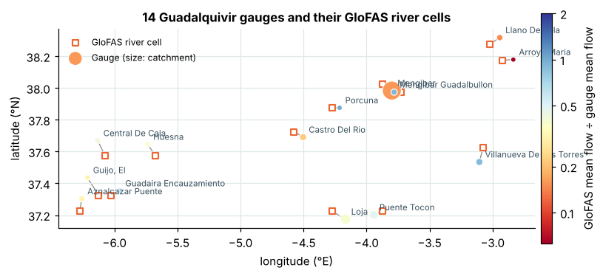
Figure 1. The 14 gauges and their GloFAS river cells. Interactive map with basemaps, rivers, admin boundaries and sub-catchments: https://kai-water.charkaks0.workers.dev/case-guadalquivir.

3. Results
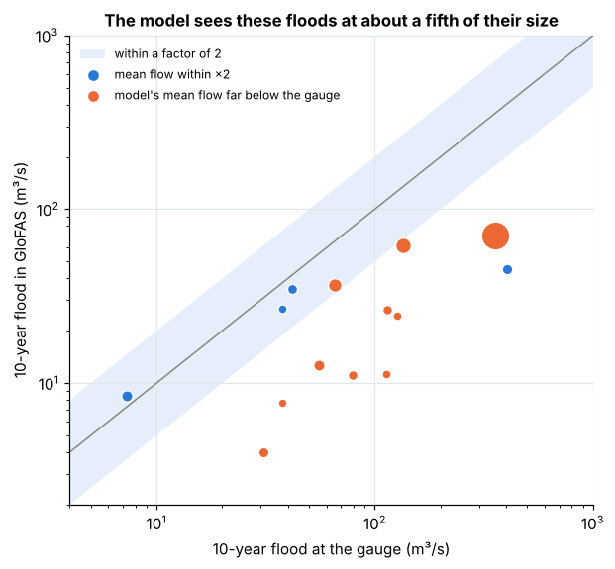
Figure 2. The 10-year flood, gauge against GloFAS, one dot per gauge.
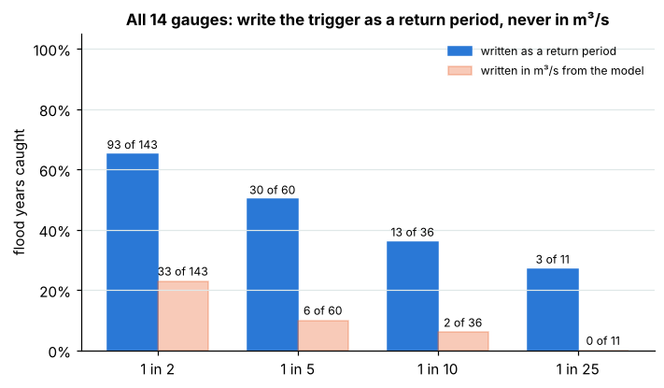
Figure 3. Share of flood years caught, pooled over all gauges, at four trigger levels, for the two ways of writing the trigger.
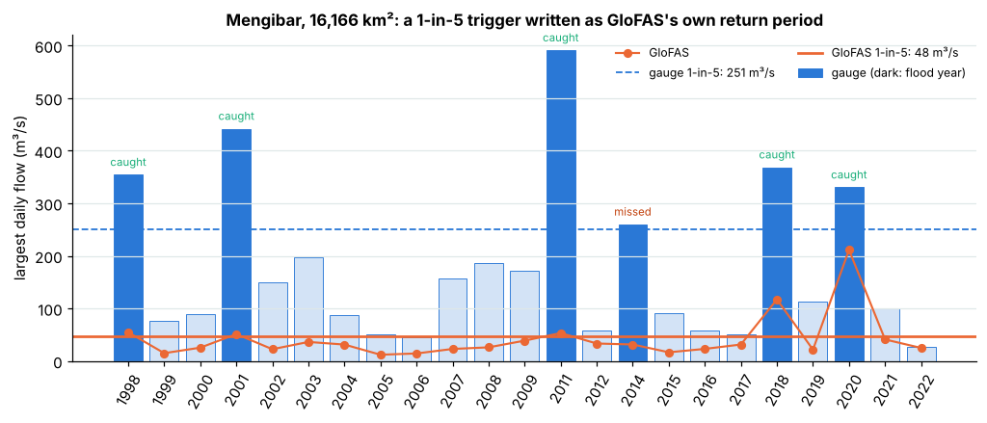
Figure 4. Year by year at Mengibar (16,166 km²): a 1-in-5 trigger written as GloFAS's own return period caught 5 of 6 flood years with no false payout; written in m³/s it would have caught none.
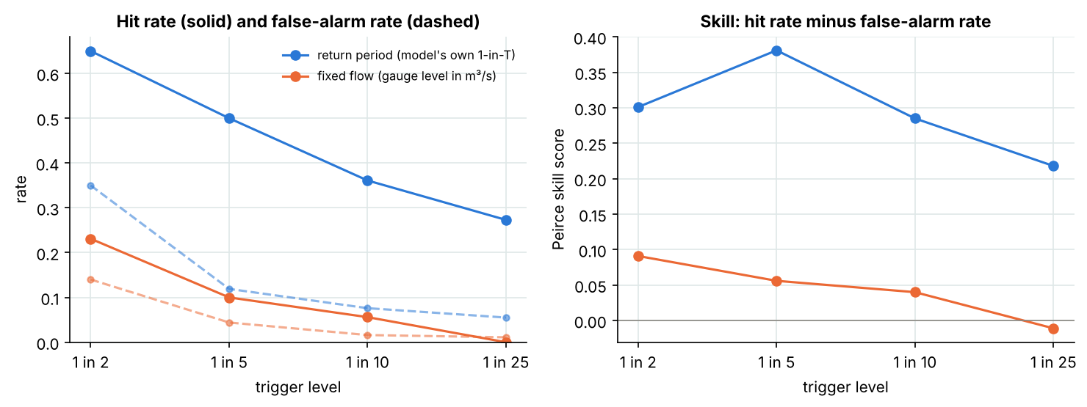
Figure 5. Hit rate, false-alarm rate and Peirce skill for both triggers at 1-in-2 to 1-in-25.
Table 1. Pooled verification, 14 gauges, 286 gauge-years.
Trigger | Written as | Caught | Missed | False payouts | Hit rate | False-alarm rate | Peirce skill | Caught by chance | p (vs chance)
1 in 2 | Return period | 93 | 50 | 50 | 0.65 | 0.350 | 0.30 | 71.5 | 2.8 × 10⁻⁷
1 in 2 | Fixed m³/s | 33 | 110 | 20 | 0.23 | 0.140 | 0.09 | 26.5 | 0.034
1 in 5 | Return period | 30 | 30 | 27 | 0.50 | 0.119 | 0.38 | 12.0 | 1.4 × 10⁻⁹
1 in 5 | Fixed m³/s | 6 | 54 | 10 | 0.10 | 0.044 | 0.06 | 3.4 | 0.093
1 in 10 | Return period | 13 | 23 | 19 | 0.36 | 0.076 | 0.28 | 4.0 | 1.6 × 10⁻⁵
1 in 10 | Fixed m³/s | 2 | 34 | 4 | 0.06 | 0.016 | 0.04 | 0.8 | 0.17
1 in 25 | Return period | 3 | 8 | 15 | 0.27 | 0.055 | 0.22 | 0.7 | 0.025
1 in 25 | Fixed m³/s | 0 | 11 | 3 | 0.00 | 0.011 | -0.01 | 0.1 | 1
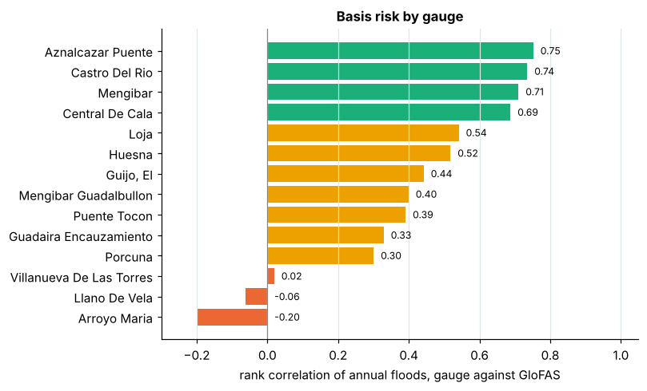
Figure 6. Basis risk by gauge: rank correlation of annual floods, gauge against GloFAS.
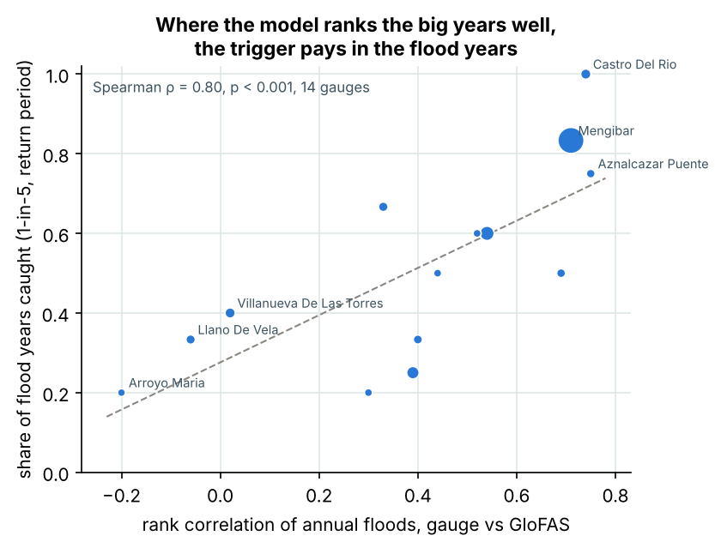
Figure 7. Share of 1-in-5 flood years caught at each gauge against the rank correlation: a screen for basis risk.

River flow or rainfall, four ways
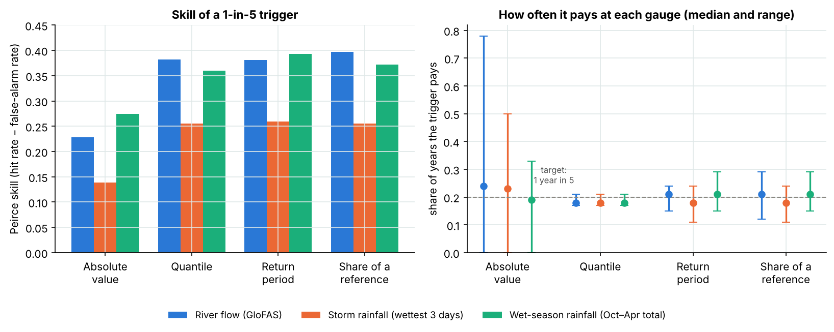
Figure 8. Triggers set to pay once in five years, four ways, on river flow and on rainfall: skill (left) and how often each pays at each gauge (right).
Table 2. 1-in-5 triggers set four ways on three indices, and two-index triggers (286 gauge-years, 60 flood years).
Index | Method | One level for all gauges | Pays, range across gauges | Caught (of 60) | False payouts | Share of payouts false | Peirce skill | p (vs chance)
River flow (GloFAS) | Absolute value | 10.8 m³/s per 1,000 km² | 0%–78% | 28 | 54 | 66% | 0.23 | 6.5 × 10⁻⁴
 | Quantile |  | 17%–21% | 29 | 23 | 44% | 0.38 | 4.6 × 10⁻¹⁰
 | Return period |  | 15%–24% | 30 | 27 | 47% | 0.38 | 1.4 × 10⁻⁹
 | Share of a reference | 1.20 × mean | 12%–29% | 31 | 27 | 47% | 0.40 | 3.4 × 10⁻¹⁰
Storm rainfall (wettest 3 days) | Absolute value | 64 mm | 0%–50% | 20 | 44 | 69% | 0.14 | 0.019
 | Quantile |  | 17%–21% | 23 | 29 | 56% | 0.26 | 2.0 × 10⁻⁵
 | Return period |  | 11%–24% | 23 | 28 | 55% | 0.26 | 1.3 × 10⁻⁵
 | Share of a reference | 1.23 × mean | 11%–24% | 23 | 29 | 56% | 0.26 | 2.0 × 10⁻⁵
Wet-season rainfall (Oct–Apr total) | Absolute value | 438 mm | 0%–33% | 22 | 21 | 49% | 0.27 | 1.4 × 10⁻⁶
 | Quantile |  | 17%–21% | 28 | 24 | 46% | 0.36 | 3.6 × 10⁻⁹
 | Return period |  | 15%–29% | 31 | 28 | 48% | 0.39 | 6.3 × 10⁻¹⁰
 | Share of a reference | 1.26 × mean | 15%–29% | 30 | 29 | 49% | 0.37 | 4.5 × 10⁻⁹
River and wet-season rainfall both pass |  | each at its own 1-in-5 level |  | 24 | 10 | 29% | 0.36 | 2.1 × 10⁻¹¹
Either passes |  | each at its own 1-in-5 level |  | 37 | 45 | 55% | 0.42 | 1.3 × 10⁻⁹

4. How KAI-Hydro writes a trigger from these findings

Setting the level: what the test says
- From each site's own record, in the index's own terms: its 1-in-T return period, its own quantile, or a share of its mean annual flood. All three gave the same skill here; the return period is the only one that reaches beyond the record.
- Never one level for all sites. It pays at a different frequency at each site. Once each site's level is agreed, write it into the contract in m³/s or mm for settlement.
- River flow for event cover; wet-season rainfall as a second index. Paying only when both agree cut the share of false payouts from about half to under a third; price the lower payout frequency.
- Never a flow read from another source (a gauge study or a design report) applied to the model.
Each comes with an attachment level (payout starts) and an exhaustion level (full payout), so the payout can rise with the size of the event.

The study a client receives
- Snap the site onto the river by catchment area; flag catchments too small for a 5 km model.
- Flood history: 40+ years of daily discharge from GloFAS 5.0, plus any gauge or record the client holds.
- Return levels with 90 % bands; levels beyond the record flagged as extrapolations.
- Basis-risk screen: rank correlation of the model's big years against any local evidence (short gauge record, flood marks, satellite flood extents, claims).
- Back-test of the trigger set four ways on river flow and on rainfall: hits, misses and false payouts, year by year.
- Calibration where the screen says so, before the trigger enters a contract.
- Delivery: a trigger sheet, a method note, and the same study as design floods for engineers.

5. Limits
One basin, strongly regulated and semi-arid; GloFAS 4.0 (the 5.0 rerun is in progress); daily means rather than instantaneous peaks; 17 to 24 years per gauge; the cell choice uses the gauge's mean flow (best case); rainfall from one product on a 50 km grid, over HydroBASINS catchments up to 2.7 times the gauge's area; flood years are defined by flow, not by losses.

Appendix A. Return levels at every gauge
Preferred fit per series (GEV or LP3, by probability-plot correlation), with 90 % percentile bootstrap bands (300 resamples).
Gauge | Return period | Gauge, m³/s | 90 % band | GloFAS, m³/s | 90 % band | GloFAS ÷ gauge
Mengibar | 1 in 2 | 130.3 | 92–188 | 27.7 | 24–37 | 0.21
 | 1 in 5 | 251.1 | 174–339 | 48.0 | 36–71 | 0.19
 | 1 in 10 | 354.6 | 242–460 | 70.2 | 46–109 | 0.20
 | 1 in 25 | 520.0 | 350–631 | 114.6 | 56–176 | 0.22
 | 1 in 50 | 673.8 | 448–808 | 165.9 | 61–257 | 0.25
Loja | 1 in 2 | 42.9 | 29–69 | 30.2 | 25–39 | 0.70
 | 1 in 5 | 91.6 | 58–134 | 47.3 | 38–61 | 0.52
 | 1 in 10 | 135.0 | 88–181 | 62.2 | 48–78 | 0.46
 | 1 in 25 | 207.1 | 137–247 | 86.1 | 62–105 | 0.42
 | 1 in 50 | 276.5 | 190–311 | 108.5 | 70–128 | 0.39
Puente Tocon | 1 in 2 | 26.6 | 20–35 | 23.2 | 21–26 | 0.87
 | 1 in 5 | 47.3 | 34–63 | 30.7 | 26–35 | 0.65
 | 1 in 10 | 65.6 | 42–86 | 36.7 | 29–42 | 0.56
 | 1 in 25 | 94.5 | 52–128 | 45.5 | 32–54 | 0.48
 | 1 in 50 | 121.0 | 59–174 | 53.2 | 34–63 | 0.44
Villanueva De Las Torres | 1 in 2 | 3.0 | 2–4 | 4.6 | 4–6 | 1.55
 | 1 in 5 | 5.4 | 4–7 | 6.8 | 5–8 | 1.26
 | 1 in 10 | 7.3 | 5–10 | 8.5 | 6–10 | 1.16
 | 1 in 25 | 10.2 | 6–15 | 11.1 | 8–12 | 1.09
 | 1 in 50 | 12.6 | 7–19 | 13.4 | 10–15 | 1.07
Castro Del Rio | 1 in 2 | 21.6 | 18–30 | 3.5 | 3–5 | 0.16
 | 1 in 5 | 38.9 | 28–58 | 7.2 | 5–12 | 0.18
 | 1 in 10 | 55.5 | 31–84 | 12.7 | 6–25 | 0.23
 | 1 in 25 | 85.2 | 33–130 | 27.2 | 7–62 | 0.32
 | 1 in 50 | 115.9 | 33–179 | 49.0 | 8–132 | 0.42
Guadaira Encauzamiento | 1 in 2 | 141.8 | 100–214 | 16.8 | 15–22 | 0.12
 | 1 in 5 | 284.4 | 195–411 | 28.9 | 21–45 | 0.10
 | 1 in 10 | 403.6 | 264–560 | 45.4 | 29–81 | 0.11
 | 1 in 25 | 589.9 | 331–782 | 84.8 | 38–172 | 0.14
 | 1 in 50 | 759.5 | 370–1003 | 137.9 | 45–310 | 0.18
Llano De Vela | 1 in 2 | 14.6 | 9–21 | 2.0 | 2–2 | 0.14
 | 1 in 5 | 26.7 | 19–31 | 3.1 | 2–4 | 0.11
 | 1 in 10 | 30.8 | 24–37 | 4.0 | 3–5 | 0.13
 | 1 in 25 | 33.2 | 27–45 | 5.6 | 3–7 | 0.17
 | 1 in 50 | 34.0 | 27–53 | 7.2 | 3–10 | 0.21
Mengibar Guadalbullon | 1 in 2 | 18.1 | 12–26 | 13.9 | 11–20 | 0.77
 | 1 in 5 | 32.3 | 23–40 | 24.4 | 18–35 | 0.75
 | 1 in 10 | 41.9 | 30–49 | 34.7 | 22–50 | 0.83
 | 1 in 25 | 54.1 | 38–62 | 53.5 | 28–80 | 0.99
 | 1 in 50 | 63.2 | 43–75 | 73.4 | 31–110 | 1.16
Central De Cala | 1 in 2 | 16.6 | 5–40 | 4.0 | 3–5 | 0.24
 | 1 in 5 | 48.1 | 14–86 | 7.4 | 5–10 | 0.15
 | 1 in 10 | 78.8 | 26–121 | 11.2 | 7–16 | 0.14
 | 1 in 25 | 134.2 | 54–165 | 18.8 | 9–30 | 0.14
 | 1 in 50 | 192.0 | 88–217 | 27.5 | 10–50 | 0.14
Aznalcazar Puente | 1 in 2 | 66.0 | 52–80 | 8.4 | 7–14 | 0.13
 | 1 in 5 | 98.4 | 83–114 | 16.6 | 10–31 | 0.17
 | 1 in 10 | 114.2 | 96–135 | 26.5 | 14–48 | 0.23
 | 1 in 25 | 129.4 | 103–162 | 48.4 | 24–83 | 0.37
 | 1 in 50 | 138.0 | 106–178 | 76.3 | 34–120 | 0.55
Huesna | 1 in 2 | 28.0 | 18–53 | 5.9 | 4–11 | 0.21
 | 1 in 5 | 74.3 | 40–133 | 14.2 | 7–28 | 0.19
 | 1 in 10 | 126.1 | 59–216 | 24.4 | 10–46 | 0.19
 | 1 in 25 | 232.8 | 94–364 | 47.0 | 18–82 | 0.20
 | 1 in 50 | 358.7 | 120–523 | 75.9 | 28–124 | 0.21
Guijo, El | 1 in 2 | 47.3 | 36–60 | 7.3 | 7–8 | 0.15
 | 1 in 5 | 84.4 | 62–108 | 9.5 | 8–11 | 0.11
 | 1 in 10 | 113.3 | 74–146 | 11.2 | 9–13 | 0.10
 | 1 in 25 | 155.8 | 83–202 | 13.7 | 10–17 | 0.09
 | 1 in 50 | 192.3 | 87–255 | 15.9 | 11–21 | 0.08
Porcuna | 1 in 2 | 9.5 | 5–19 | 6.2 | 4–10 | 0.66
 | 1 in 5 | 24.0 | 12–39 | 15.9 | 9–25 | 0.66
 | 1 in 10 | 37.6 | 20–54 | 26.8 | 14–46 | 0.71
 | 1 in 25 | 61.4 | 35–76 | 47.8 | 20–101 | 0.78
 | 1 in 50 | 85.4 | 52–96 | 70.3 | 23–178 | 0.82
Arroyo Maria | 1 in 2 | 19.8 | 17–24 | 3.1 | 3–4 | 0.16
 | 1 in 5 | 29.4 | 24–37 | 5.2 | 4–7 | 0.18
 | 1 in 10 | 37.5 | 30–47 | 7.7 | 5–12 | 0.21
 | 1 in 25 | 50.4 | 38–62 | 13.2 | 6–21 | 0.26
 | 1 in 50 | 62.4 | 45–77 | 20.2 | 7–34 | 0.32

Appendix B. The 1-in-5 trigger at every gauge
Gauge | Catchment km² | Years | Mean-flow ratio | Q10 gauge, m³/s (90 % band) | Q10 GloFAS, m³/s (90 % band) | Q10 ratio | Rank corr. | Flood years | Caught | False payouts
Mengibar | 16,166 | 23 | 0.16 | 355 (242–460) | 70 (46–109) | 0.20 | 0.71 | 6 | 5 | 0
Loja | 4,210 | 23 | 0.39 | 135 (88–181) | 62 (48–78) | 0.46 | 0.54 | 5 | 3 | 2
Puente Tocon | 2,944 | 18 | 0.48 | 66 (42–86) | 37 (29–42) | 0.56 | 0.39 | 4 | 1 | 3
Villanueva De Las Torres | 1,685 | 21 | 0.90 | 7 (5–10) | 9 (6–10) | 1.16 | 0.02 | 5 | 2 | 3
Castro Del Rio | 1,665 | 17 | 0.22 | 56 (31–84) | 13 (6–25) | 0.23 | 0.74 | 2 | 2 | 1
Guadaira Encauzamiento | 1,318 | 18 | 0.56 | 404 (264–560) | 45 (29–81) | 0.11 | 0.33 | 3 | 2 | 2
Llano De Vela | 1,240 | 20 | 0.15 | 31 (24–37) | 4 (3–5) | 0.13 | -0.06 | 3 | 1 | 2
Mengibar Guadalbullon | 1,111 | 17 | 0.93 | 42 (30–49) | 35 (22–50) | 0.83 | 0.40 | 3 | 1 | 2
Central De Cala | 1,010 | 19 | 0.42 | 79 (26–121) | 11 (7–16) | 0.14 | 0.69 | 6 | 3 | 1
Aznalcazar Puente | 960 | 22 | 0.32 | 114 (96–135) | 26 (14–48) | 0.23 | 0.75 | 4 | 3 | 2
Huesna | 678 | 21 | 0.37 | 126 (59–216) | 24 (10–46) | 0.19 | 0.52 | 5 | 3 | 2
Guijo, El | 672 | 23 | 0.31 | 113 (74–146) | 11 (9–13) | 0.10 | 0.44 | 4 | 2 | 2
Porcuna | 670 | 20 | 0.99 | 38 (20–54) | 27 (14–46) | 0.71 | 0.30 | 5 | 1 | 2
Arroyo Maria | 583 | 24 | 0.05 | 37 (30–47) | 8 (5–12) | 0.21 | -0.20 | 5 | 1 | 3

Appendix C. Rainfall windows
Each rainfall index written as the catchment's own 1-in-5 level and scored against the same 60 flood years. The 3-day and October–April indices were chosen in advance; the others are a sensitivity test.
Index | Median rank corr. with gauge | Caught (of 60) | False payouts | Peirce skill
River flow (GloFAS), for comparison | 0.42 | 30 | 27 | 0.38
Rainfall, wettest day | 0.18 | 19 | 37 | 0.15
Rainfall, wettest 3 days | 0.30 | 23 | 28 | 0.26
Rainfall, wettest 5 days | 0.34 | 23 | 33 | 0.24
Rainfall, wettest 10 days | 0.42 | 25 | 41 | 0.23
Rainfall, wettest 30 days | 0.50 | 26 | 32 | 0.29
Rainfall, October–April total | 0.52 | 31 | 28 | 0.39

Appendix D. Data package and how to reproduce
File | What it holds
data/annual_maxima.csv | 286 rows: gauge_id, water_year, gauge_max_m3s, glofas_max_m3s
data/gauges.csv | 14 gauges: catchment, position, record length, matched GloFAS cell, mean-flow ratio
results/return_levels.csv | 1-in-2 to 1-in-50 levels with 90 % bands, both sources, per gauge
results/trigger_scores.csv | caught, missed and false payouts at 1-in-2 to 1-in-25, both triggers, pooled
results/skill_scores.csv | hit rate, false-alarm rate, Peirce skill, test against chance
results/per_gauge_1in5.csv | Table 1 of the paper
results/kai_engine_results.json | the KAI engine's published results, checked by the notebook
01_global_model_flood_triggers.ipynb | the notebook: fits, triggers, figures and the check against the engine
data/rainfall_maxima.csv | each water year's largest 1-, 3-, 5-, 10- and 30-day catchment rainfall, and the October–April total (mm)
data/rain_catchments.csv · rain_cell_weights.csv | HydroBASINS sub-catchments used for each gauge, and the NASA POWER cells with their weights
results/trigger_methods.csv · trigger_methods_sites.csv | triggers set four ways on three indices: pooled scores, and how often each pays at each gauge
results/rain_windows.csv · rain_vs_river.json | rainfall windows compared; river against wet-season rainfall, and the two combined
flood_tools.py · rebuild_data.py | shared functions (L-moments, GEV, LP3, bootstrap, scoring) and the rebuild script
rebuild_rainfall.py · compare_triggers.py | catchments and catchment rainfall; the four-way comparison and its figure
paper/paper_stats.py | the skill scores, per-gauge table, McNemar and Spearman tests, and the skill and basis-risk figures
paper/build_documents.py · print.js | builds the paper and this report from the result files, and prints them to PDF
To reproduce: install Python 3.11 or newer and the packages in requirements.txt, then run the notebook from its folder; it stops if any trigger count drifts from the published results. To rebuild the derived data from the sources, run rebuild_data.py on a connection that CEDEX serves; it fetches the CEDEX files (SHA-256 checked) and the GloFAS cells, and writes *_rebuilt.csv files to compare with the published ones. rebuild_rainfall.py rebuilds the catchments and catchment rainfall from HydroBASINS (level-8 shapefile, downloaded separately) and the NASA POWER API, and compare_triggers.py sets and scores the triggers four ways on the three indices.

Data credits and licence
Fuente: CEDEX, Anuario de Aforos 2021-2022 (MITECO). Contains modified Copernicus Emergency Management Service information 2026 (GloFAS 4.0), via Open-Meteo (CC BY 4.0). GloFAS data are provided for information purposes only and are not a flood warning. Rainfall: NASA Langley Research Center POWER Project, funded through the NASA Earth Science/Applied Science Program. Catchments: HydroBASINS (Lehner and Grill, 2013). Four-way comparison after Model Library, Four ways to set a parametric trigger, tested on Andalucía rainfall and yields (9 October 2026). This report: © 2026 Charles Kakooza, CC BY 4.0.

