|  |
| --- |
| SFWR ENG 3Gc3 |
| SphereQuest |
| Project Documentation |
|  |
| **Jason Costabile, Ben Kybartas, & Kaitlin Smith** |
| **4/5/2010** |

|  |
| --- |
|  |

# Introduction

Welcome to SphereQuest! SphereQuest is a game designed to bring you inner peace by bringing you on a personal journey through your inner self. Find the wise men throughout the mazes and answer their riddles to ascend to a higher plane of consciousness!

# User Manual

Current Plane of Consciousness

Your Zen level

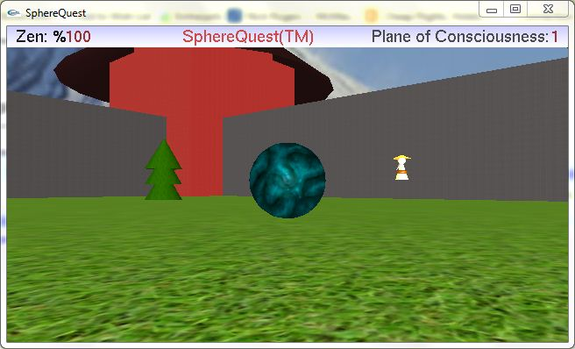

Obstacles

Wise man

Sphere (you!)

## Objective