

Citywide Stormwater Catchment Delineation
and Pipe Capacity Analysis

City of Lenexa, Kansas

Kaitlyn Rawlings
Asset Management GIS Analyst
City of Lenexa

April 17th 2026

ArcGIS Pro Model Builder | Python (arcpy) | Manning’s Equation | NRCS TR-55

.

Contents

Contents 1
List of Figures 2
Project Overview 3
Data Sources 3
Workflow 4
Phase 1 — Terrain Flow Analysis 4
Phase 2 — Catchment Delineation 5
Phase 3 — Pipe Capacity Analysis (catchment_capacity.py) 6
Phase 4 — Runoff and Risk Assessment (catchment_runoff.py) 6
Maps and Results 7
Map 1 — NRCS Curve Number Distribution 8
Map 2 — Open Channel and Flood Control BMP Distribution 9
Map 3 — Flood Risk Assessment 10
Map 4 — Capacity Deficit Severity 11
Conclusion 12
Limitations 13
D8 Flow Routing Algorithm 13
Manning’s Equation 13
Incomplete Pipe Attribute Data 13
NOAA Atlas 14 Point Estimate 14
Inlet-Only Pour Point Delineation 14
Open Channel & BMP Capacity Not Computed 14
SSURGO Hydrologic Soil Data 14
Tools and Technologies 15
Acknowledgments 15
References 15

List of Figures

ArcGIS Pro ModelBuilder Workflow ………………………………………………………...………….4
Terrain Flow Analysis Modelbuilder Workflow ………………………….…………………….………5
Catchment Delineation Modelbuilder Workflow .....………………………………………….……….5
NRCS Curve Number Distribution………………………………………………………………………9
Open Channel and Flood Control BMP Distribution……………………..………………………….10
Stormwater Inlet Flood Risk Assessment…………………………………………………………….11
Stormwater Pipe Capacity Deficit Severity…………………………………………………………...12

Project Overview

This project delineates stormwater catchment areas and examines citywide pipe capacity across the City of Lenexa, Kansas. Using a 1-meter resolution DEM and the D8 flow routing algorithm (O'Callaghan & Mark, 1984), terrain analysis characterizes surface flow direction and accumulation, which are used to delineate 15,615 catchment polygons from storm inlet structure locations.

A custom Python script conducts a pipe capacity analysis for each catchment using City of Lenexa conduit data and Manning's equation (Chaudhry, 2008; ASCE, 1992). A second script estimates runoff volume per catchment using NRCS curve numbers derived from NLCD land cover (U.S. Geological Survey, 2024) and SSURGO hydrologic soil groups (USDA NRCS, n.d.), applying the NRCS TR-55 method (USDA NRCS, 1986) with a 10-year 24-hour design storm depth of 5.50 inches (Perica et al., 2013). Catchments where runoff exceeds pipe capacity are identified as potential flood risk locations. Open channel drainage features and flood control detention facilities present within each catchment are also inventoried to provide broader infrastructure context.

Data Sources

- 1-meter resolution DEM - Web Mercator projection, full Lenexa city extent
- City of Lenexa Lucity Storm Structures - Inlet locations and structure type codes
- City of Lenexa Lucity Storm Conduits - Pipe diameter, slope, material, and upstream/downstream connections (enclosed gravity pipes, pipe capacity analysis); all conduit types including open channels and swales (open channel conveyance inventory)
- City of Lenexa Lucity BMP Assets - Detention facility type, function, and operational status
- USA Annual NLCD (Esri Living Atlas / USGS MRLC), 30-meter resolution, 2024 (U.S. Geological Survey, 2024)
- USDA SSURGO - Groups B, C, D, C/D (USDA NRCS, n.d.)
- NOAA Atlas 14 - 10-year 24-hour depth for Lenexa, KS = 5.50 inches (Perica et al., 2013)

Workflow

The analysis was conducted in four phases, automated in ArcGIS Pro Model Builder. Figure 1 shows the ModelBuilder workflow for Phases 1 and 2. Phases 3 and 4 (catchment_capacity.py and catchment_runoff.py) are implemented as standalone Python scripts run after the ModelBuilder outputs are complete.

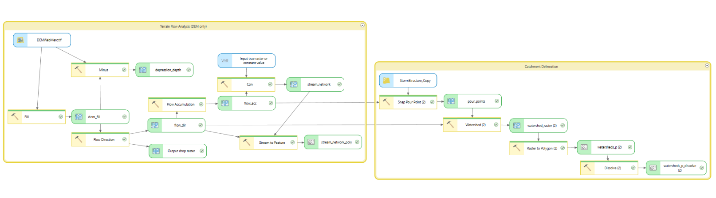
Figure 1. ArcGIS Pro ModelBuilder workflow

Phase 1 — Terrain Flow Analysis
The project began with a terrain flow analysis to establish how water moves across the landscape, providing the foundation for downstream catchment delineation. The 1-meter DEM was first processed through the Fill tool to create a hydrologically conditioned surface by removing artificial sinks that would otherwise interrupt flow paths. The Flow Direction tool then applied the D8 algorithm, routing each cell to its steepest downslope neighbor (O’Callaghan & Mark, 1984), and the Flow Accumulation tool used these results to identify which cells receive the most upstream drainage. The stream network was extracted where flow accumulation exceeded 100,000 cells and converted to a vector polyline for visualization. A depression depth raster was also generated by subtracting the original DEM from the filled surface, illustrating locations where surface ponding is likely to occur.
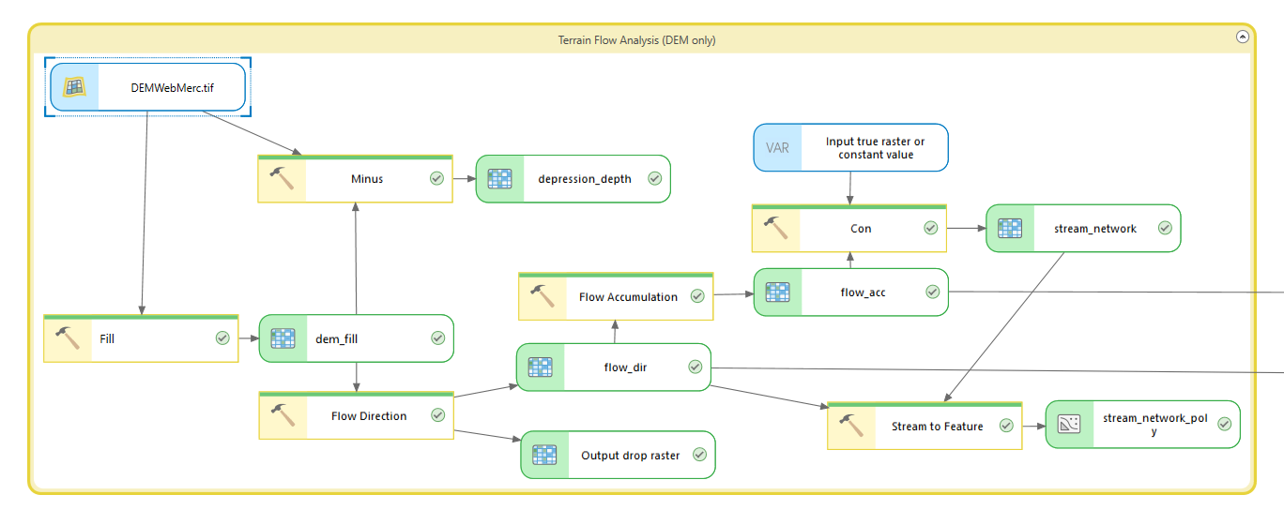
Figure 2. Terrain Flow Analysis ModelBuilder workflow

Phase 2 — Catchment Delineation
For catchment delineation, storm inlet structures served as pour points, which are the locations where surface runoff converges and enters the pipe system. A definition query filtered the storm structure layer to inlet types only (Inlet, Junction Box, Pipe Inlet), which are the structure types with connected enclosed gravity pipes, excluding outfalls, virtual structures, and other non-inlet types that do not receive surface runoff. The Snap Pour Point tool moved each inlet to the nearest high-accumulation cell within 15 meters to account for potential spatial offsets between the structure location and the DEM. Using these snapped pour points alongside the flow direction raster from Phase 1, the Watershed tool delineated the contributing drainage area for each inlet. The Raster to Polygon tool converted the resulting watershed raster to vector polygons, and the Dissolve tool merged fragmented polygons by gridcode, which corresponds to the inlet structure number, producing a final dataset of 15,615 catchment polygons.

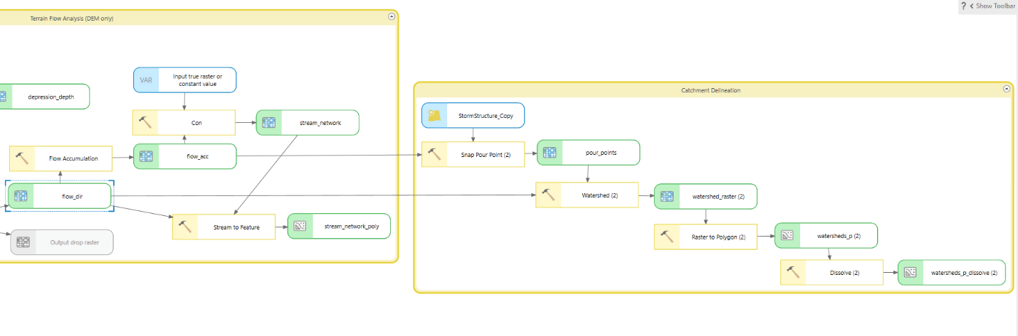
Figure 3. Catchment Delineation ModelBuilder workflow

Phase 3 — Pipe Capacity Analysis (catchment_capacity.py)
To determine pipe capacity for each catchment, a custom Python script (catchment_capacity.py) was developed to apply Manning’s equation (Chaudhry, 2008; ASCE, 1992) to the City of Lenexa storm conduits layer alongside the catchment polygons produced in Phase 2. Manning’s equation calculates the maximum flow rate (volume/time) of water a pipe can carry when completely full:

$$Q=\left(\frac{1}{n}\right)*A*R^{\frac{2}{3}}*S^{\frac{1}{2}}$$

Where:
- Q = flow rate, the volume of water moving through the pipe per unit of time
- n = Manning’s roughness coefficient, which accounts for pipe material friction
- A = cross-sectional area of the pipe when completely full
- R = hydraulic radius, which for a full circular pipe is diameter divided by 4
- S = pipe slope expressed as rise over run

For each catchment polygon the script:
- Located the inlet structure via gridcode
- Retrieved all enclosed gravity pipes connected to that structure as upstream or downstream nodes (CNG_TYPE_CD = 1)
- Calculated Manning’s capacity for each connected pipe
- Summed results and wrote capacity fields to the watershed output

Where pipe slope data was null (approximately 85% of records) a default slope of 1.0% was applied per City of Lenexa stormwater design standards. Pipes with null or zero diameter values were excluded from the capacity calculation entirely. Total capacity (TOTAL_CAP_AF) was summed across all connected pipes per inlet and normalized by catchment area to produce a capacity-per-acre metric (CAP_PER_ACRE).

Phase 4 — Runoff and Risk Assessment (catchment_runoff.py)
To estimate runoff volume and identify at-risk catchments, a second custom Python script (catchment_runoff.py) was developed using the NRCS TR-55 method (USDA NRCS, 1986). The script first constructed a curve number (CN) raster by combining NLCD land cover data (U.S. Geological Survey, 2024) with SSURGO hydrologic soil groups (USDA NRCS, n.d.) and applying the TR-55 curve number lookup table (USDA NRCS, 1986, Table 2-2). Curve numbers represent the runoff potential of a land surface based on its cover type and soil characteristics — higher values indicate less ground absorption and greater runoff potential, while lower values indicate more infiltration. The area-weighted average CN per catchment was then calculated using Zonal Statistics, which summarizes raster cell values within each polygon boundary to produce a single mean CN value representing the mix of land cover and soil conditions within each drainage area.
Using these catchment-level curve numbers, the script applied the NRCS TR-55 rainfall-runoff equation to estimate runoff depth for a 10-year 24-hour design storm with a rainfall depth of 5.50 inches (Perica et al., 2013):

$$Q=\frac{{\left(P-0.2S\right)}^{2}}{(P+0.8S)} where S=\left(\frac{1000}{CN}\right)-10$$

Where:
- Q = runoff depth in inches
- P = rainfall depth in inches
- S = potential maximum soil retention after runoff begins
- CN = curve number

For each catchment polygon the script:
- Calculated the area-weighted average curve number from the CN raster
- Applied the TR-55 equation to estimate runoff depth
- Converted runoff depth to volume in acre-feet using catchment area
- Compared runoff volume to total pipe capacity (TOTAL_CAP_AF)
- Flagged catchments where runoff exceeded capacity as at-risk (RISK_FLAG = 1)
- Performed an adjusted risk flag (RISK_FLAG_ADJ) using a spatial intersect of open channel drainage features and flood control detention facilities against catchment polygons to account for additional stormwater infrastructure present in at-risk catchments

The capacity deficit (CAP_DEFICIT_AF) represents the volume of runoff exceeding pipe capacity during the design storm event. Catchments with no pipe data were assigned a flag of -1 and could not be assessed. The adjusted risk flag (RISK_FLAG_ADJ) extends this assessment by accounting for open channel and BMP presence: flag 1 indicates at-risk catchments with no supplemental infrastructure present, flags 2 through 4 indicate at-risk catchments where open channel conveyance, a flood control BMP, or both are present respectively, and flag -2 identifies uncharacterized catchments where no pipe data exists but drainage infrastructure is present.

Maps and Results

Four maps were produced to visualize the results of this analysis. Together they tell a complete story of the City of Lenexa’s stormwater infrastructure: from land surface runoff potential to flood control infrastructure distribution, to where flood risk exists and how severe they are.

Map 1 — NRCS Curve Number Distribution
This map displays NRCS curve number runoff potential across the City of Lenexa at 30-meter resolution. The curve number is based on a combination of NLCD land cover and SSURGO hydrologic soil groups. The color scale ranges from red to green, where higher curve numbers indicating greater runoff potential are shown in red, and lower curve numbers indicating greater infiltration are shown in green. High runoff areas are typically characterized by impervious surfaces such as parking lots and dense urban development, slow-draining soils, or a combination of both. Low runoff areas are generally vegetated open spaces such as forests and parks with heavy grass cover, sandy or well-drained soils, or a combination of both.

The curve number distribution across Lenexa reflects the city’s development pattern. The eastern portion of the city is heavily developed, while the west consists of newer or actively developing land. The southern portion contains more industrial land use with extensive concrete, pavement, and parking lots, which is reflected in the deeper red values in that area. Lower curve numbers appear along the stream corridors visible on the map, where natural vegetation and permeable soils reduce runoff potential.

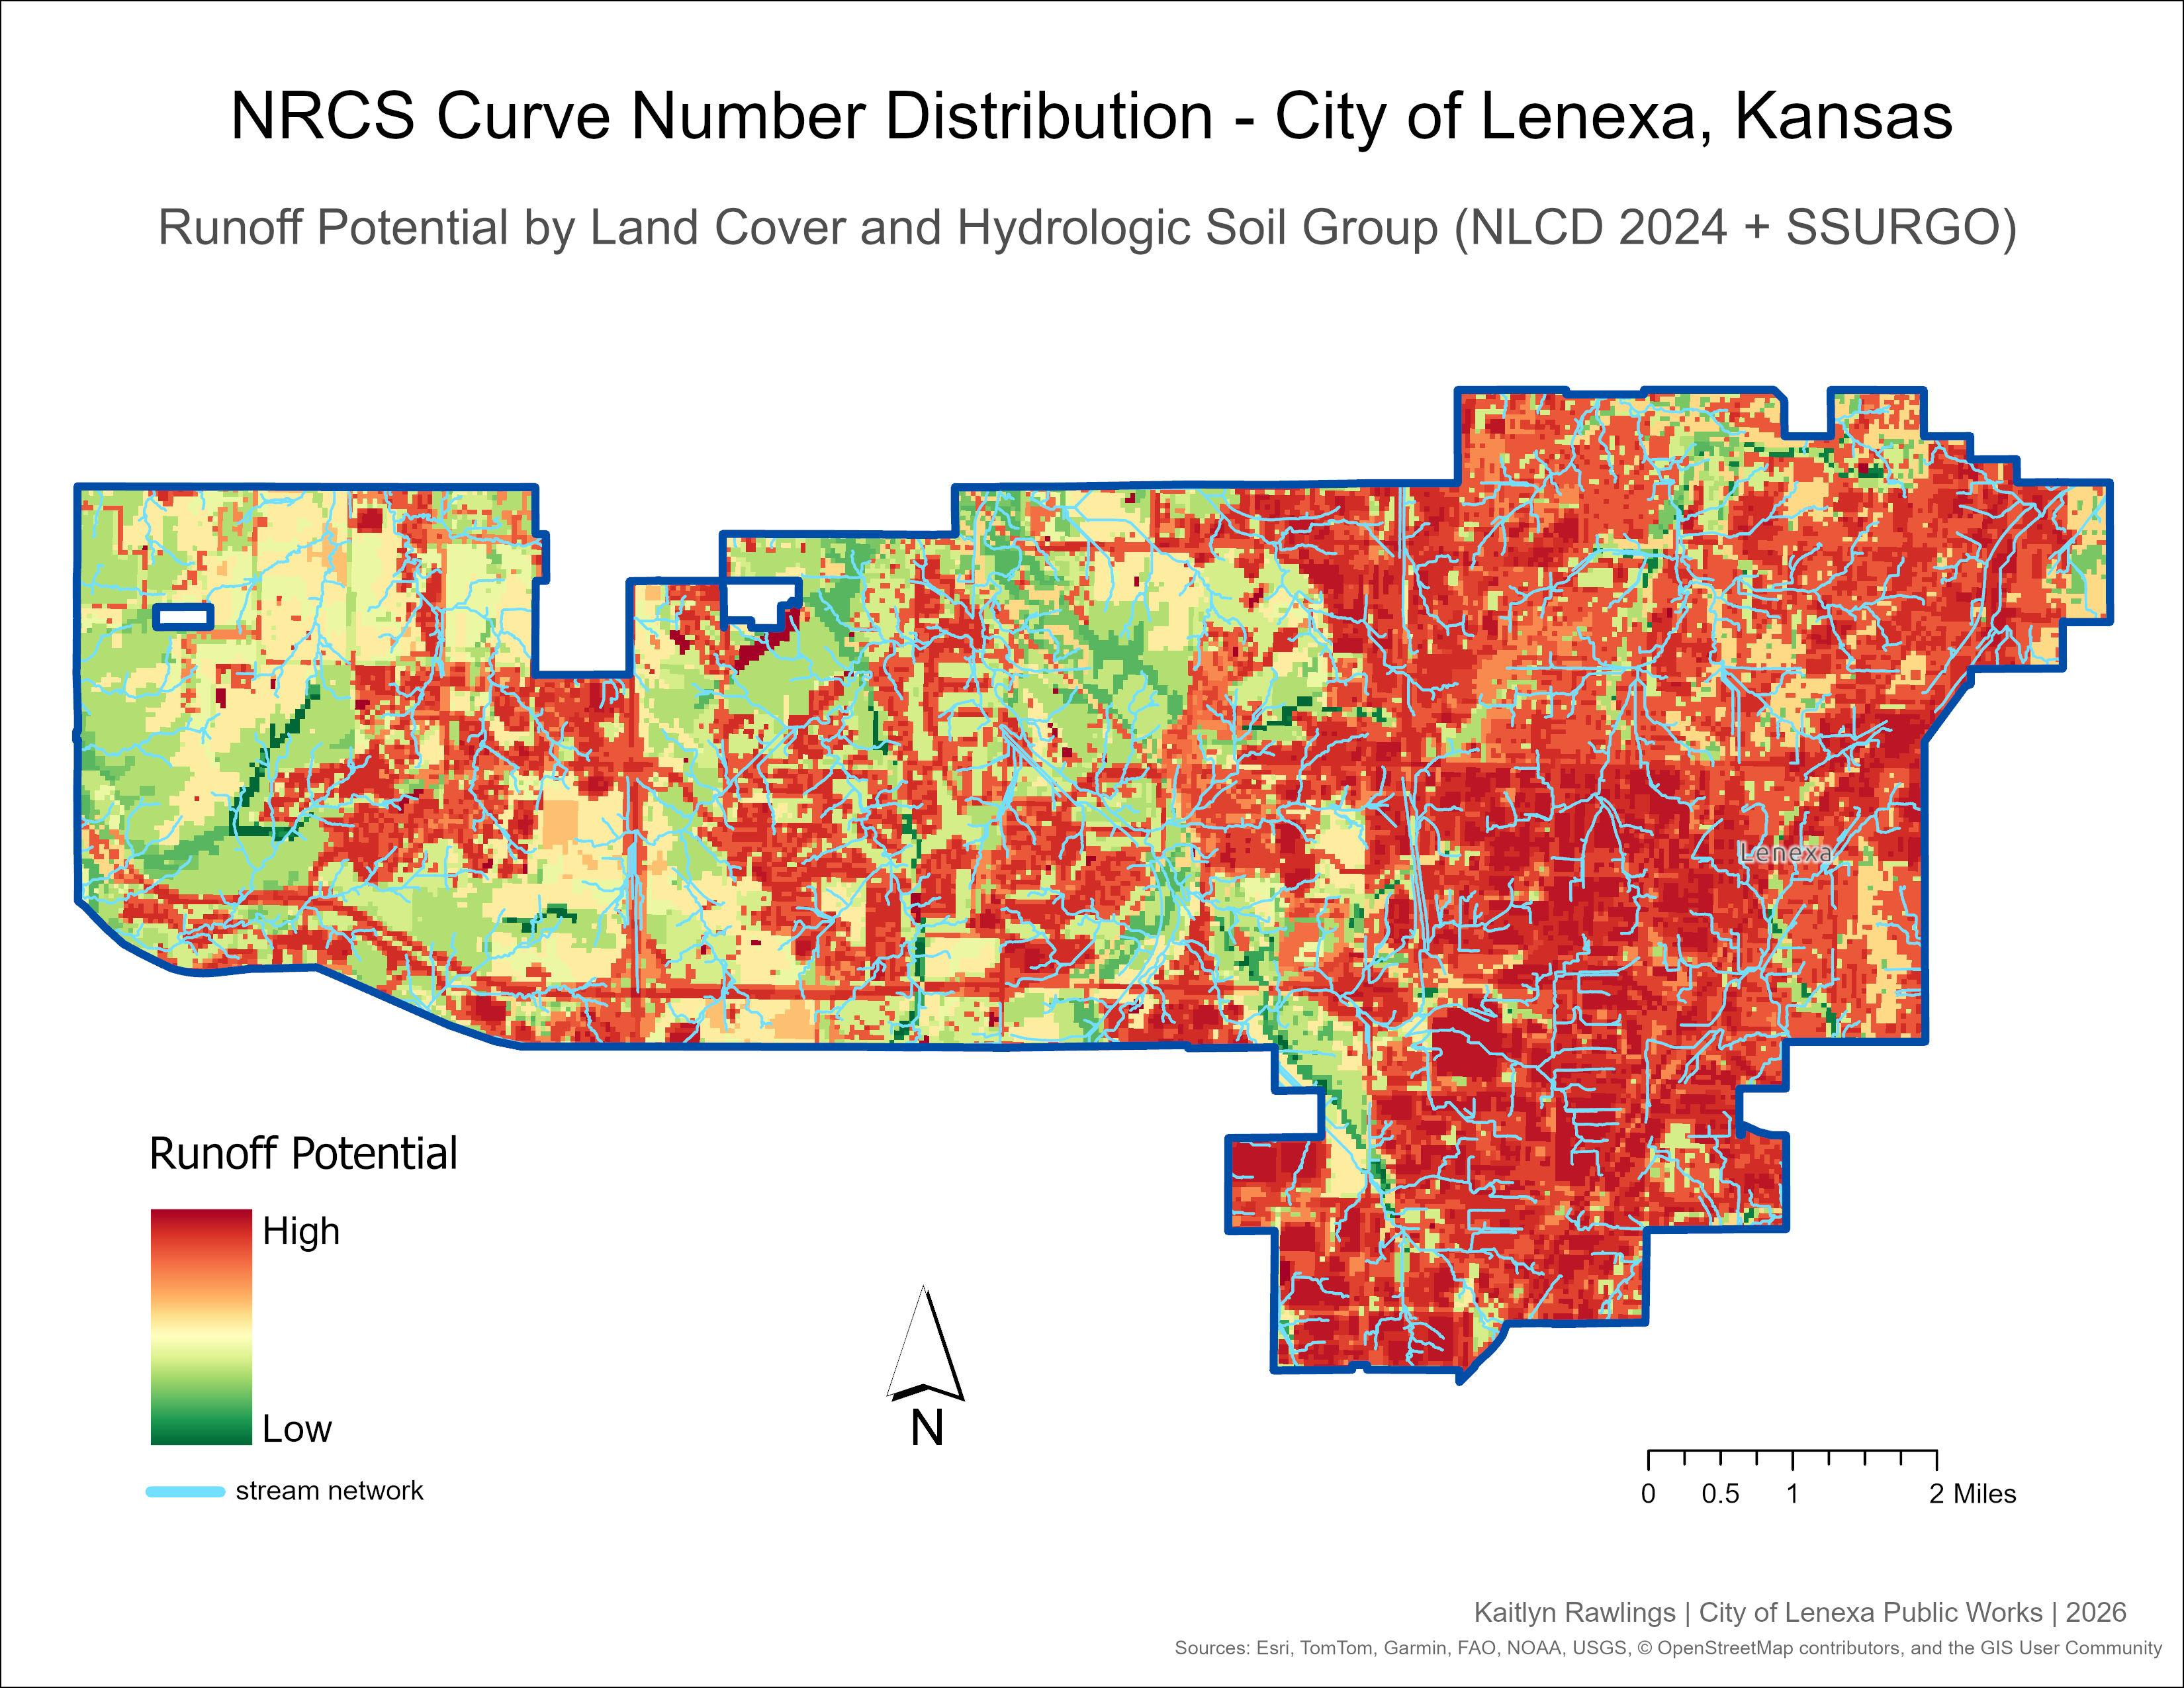
Figure 4. NRCS Curve Number Distribution — City of Lenexa, Kansas.

Map 2 — Open Channel and Flood Control BMP Distribution
This map displays the City of Lenexa’s open channel stormwater conduits and flood control Best Management Practices (BMPs) to provide broader infrastructure context beyond the enclosed gravity pipe network. Because Manning’s equation applies only to closed circular pipes, the pipe capacity analysis alone does not account for the ditches, swales, stream channels, and detention facilities that also move and store stormwater across the city. This map helps explain why catchments flagged as at-risk based on pipe capacity alone may not represent genuine flood concerns when additional drainage infrastructure is present.

Catchments are symbolized by total open channel linear footage using a graduated color ramp from yellow to violet, classified by natural breaks, and filtered to catchments with open channel footage present and a shape area under 500,000 m² to exclude terrain delineation artifacts. Active flood control BMP detention facilities are overlaid in teal, filtered to operational status and flood control types only. A total of 1,981 catchments contain open channel footage and 558 catchments intersect a flood control BMP. The BMP distribution reflects Lenexa’s development timeline, with newer western subdivisions more likely to have engineered detention while older eastern neighborhoods rely more heavily on the pipe network.

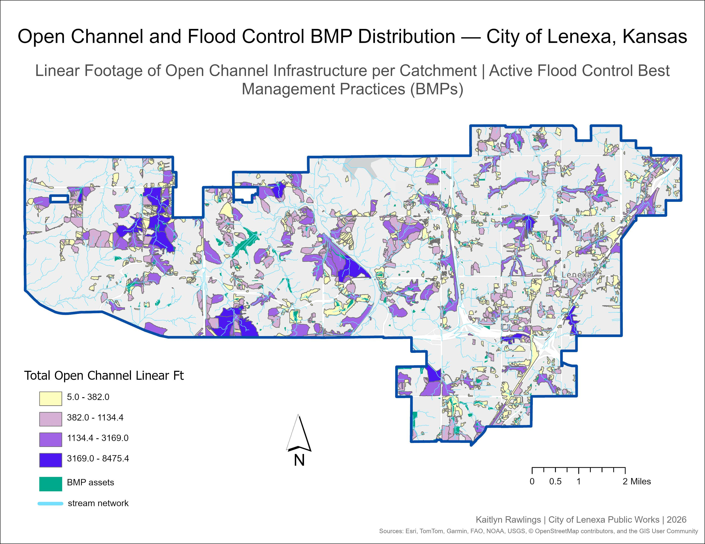
Figure 5. Open Channel and Flood Control BMP Distribution — City of Lenexa, Kansas.

Map 3 — Flood Risk Assessment
This map displays the adjusted flood risk assessment across the City of Lenexa’s stormwater catchment areas for a 10-year 24-hour design storm event. Risk is determined by comparing estimated runoff volume per catchment, calculated using the NRCS TR-55 method, against the full-flow pipe capacity of the enclosed gravity pipes serving each inlet. Catchments where runoff exceeds pipe capacity are flagged as at-risk, and an adjusted risk flag further classifies those catchments based on whether open channel drainage or flood control BMP infrastructure is also present.

The map is filtered to catchments with pipe data and a shape area under 500,000 m² to exclude terrain delineation artifacts. Of the 5,222 catchments with pipe data, 5,156 (98.7%) show adequate pipe capacity for the 10-year 24-hour design storm, reflecting Lenexa’s well-maintained stormwater infrastructure. The remaining 66 catchments (1.3%) were flagged as at-risk by the pipe model, of which only 33 have no supplemental open channel or BMP infrastructure present. Adequate catchments are shown in green, at-risk catchments with no supplemental infrastructure in red, orange where open channel drainage is present, yellow where a flood control BMP is present, and light yellow where both are present. Gray catchments have no pipe data but contain open channel or BMP infrastructure and cannot be fully assessed.

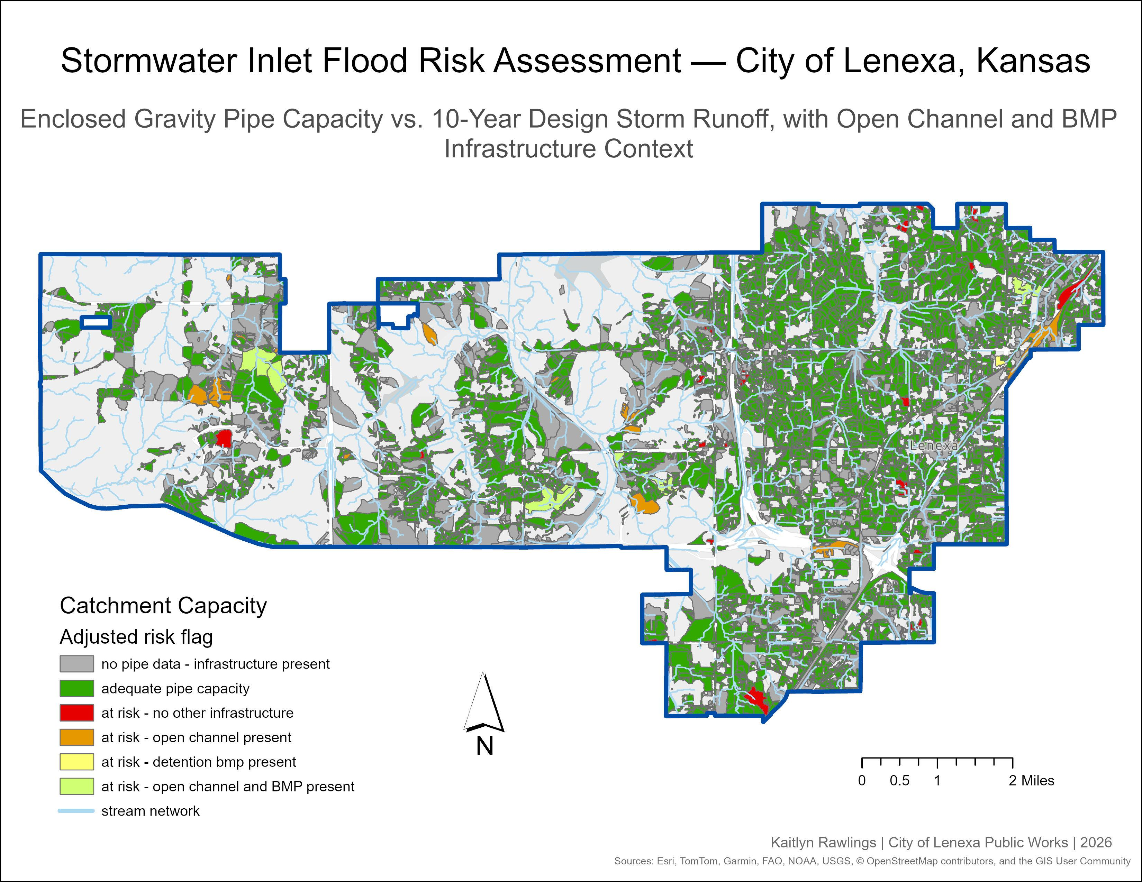
Figure 6. Stormwater Inlet Flood Risk Assessment — City of Lenexa, Kansas.

Map 4 — Capacity Deficit Severity
This map displays the pipe capacity deficit severity for the 33 catchments identified as at-risk with no supplemental open channel or BMP infrastructure present. These are the catchments where the pipe model flags a deficit and there is nothing else in the data to suggest the risk may be offset by additional drainage infrastructure, making them the highest priority locations for further investigation.

Catchments are symbolized on a graduated color ramp from light yellow to dark red based on the volume of runoff exceeding full-flow pipe capacity during the 10-year 24-hour design storm, expressed in acre-feet. The map is filtered to a shape area under 500,000 m² to exclude terrain delineation artifacts. Deficits range from 0.002 to 49.5 acre-feet with a median of 0.54 acre-feet. The most severe deficits appear in the flat western portions of the city, which is likely influenced by D8 flow routing producing unrealistically large catchment areas on low-gradient terrain that inflate runoff volume estimates. These locations should be field verified before any infrastructure conclusions are drawn.

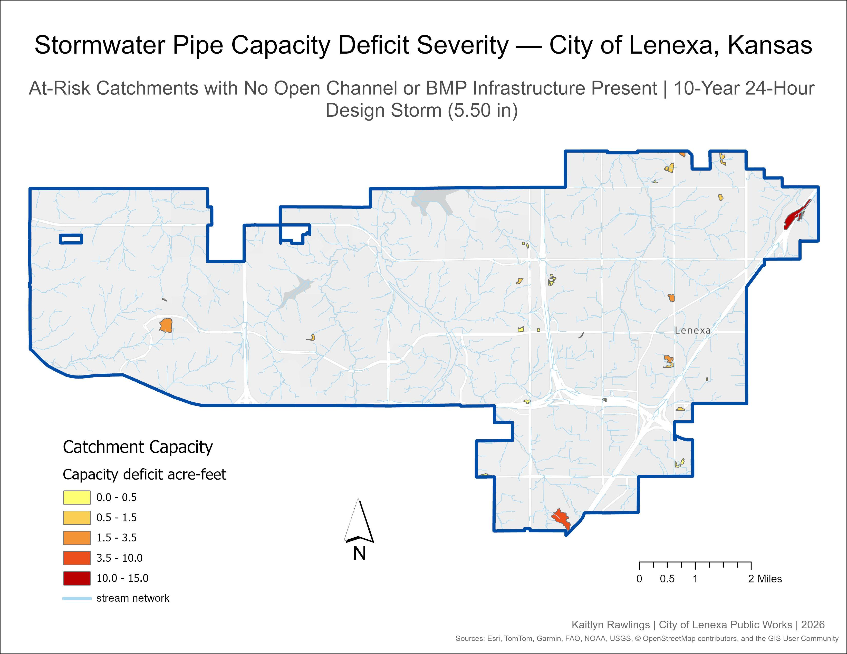
Figure 7. Stormwater Pipe Capacity Deficit Severity — City of Lenexa, Kansas.

Conclusion

This analysis provides a citywide baseline assessment of stormwater infrastructure capacity across the City of Lenexa, Kansas. Of the 15,615 catchments delineated from storm inlet structures, 5,222 had sufficient pipe attribution to be assessed, and 98.7% of those showed adequate enclosed gravity pipe capacity for the 10-year 24-hour design storm. This result reflects Lenexa's well-maintained and consistently upgraded stormwater system.
The 66 catchments flagged as at-risk by the pipe model represent a small but meaningful subset requiring further attention. Importantly, the adjusted risk assessment reduces this to 33 catchments with no supplemental open channel or BMP infrastructure present, locations where the model identifies a pipe capacity deficit and no additional drainage features exist in the data to suggest the risk may be mitigated. These are the highest priority locations for field verification.
The open channel and BMP distribution map reveals that much of Lenexa's flood control capacity lies outside the enclosed pipe network. The concentration of detention facilities in the western and central portions of the city reflects the stormwater management requirements imposed on newer development, while older eastern neighborhoods rely more heavily on the pipe system alone. This distinction is important context for interpreting the risk results, as catchments flagged as at-risk in infrastructure-rich areas are likely better protected than the pipe model alone suggests.
Taken together, these four maps do not paint a picture of a city with a stormwater crisis. They identify a small number of locations that warrant investigation, characterize where supplemental infrastructure exists, and establish a data-driven foundation for prioritizing future capacity assessments and infrastructure planning decisions.

Limitations

D8 Flow Routing Algorithm
One limitation of this model comes from the D8 flow routing algorithm’s behavior on flat terrain. The D8 algorithm works by routing each DEM cell to one of its eight neighbors based on the steepest descent (O’Callaghan & Mark, 1984). In low-gradient areas where elevation differences between neighboring cells are negligible, the algorithm must assign a flow direction arbitrarily, which can cause flow paths to meander across large areas before reaching an outlet. This results in unrealistically large catchment areas being assigned to a single inlet structure. Because Lenexa has relatively flat terrain, particularly in the western half of the city, this artifact is present throughout the model output. To partially mitigate this, catchments were filtered to a shape area of less than 500,000 m² for all map displays, though this does not eliminate the issue entirely and deficit values in flat western areas should be interpreted with caution.

Manning’s Equation
Manning's equation calculates the maximum flow rate a pipe can carry, assuming the pipe is flowing at complete capacity and free of any blockages. In practice, pipes rarely operate at full capacity — partial blockages, sediment buildup, joint deterioration, or pipes approaching the end of their service life can all reduce actual flow capacity below the modeled value. This means the capacity values in this analysis likely represent an optimistic upper bound, and at-risk catchments identified by the model may reflect conditions that are worse in the field than the numbers suggest.

Incomplete Pipe Attribute Data
The City of Lenexa’s pipe attribute data was incomplete in two notable ways. First, approximately 85% of enclosed gravity pipes had null slope values in the asset management database Lucity. These were assigned a 1.0% default slope per City of Lenexa stormwater design standards, but this is a generalized assumption that may not accurately reflect actual pipe grades, resulting in capacity values that could be over or underestimated depending on true field conditions. Second, approximately 2,260 enclosed gravity pipes (14% of the total) had null or zero diameter values and were excluded from the capacity calculation entirely. Catchments whose only connected pipe(s) had missing diameter data were assigned as no pipe capacity and flagged as uncharacterized (RISK_FLAG = -1) rather than appearing as at-risk. This means the model may be undercounting at-risk locations, making catchments with unmeasured pipes invisible in the risk assessment rather than flagged for investigation.

NOAA Atlas 14 Point Estimate
The 10-year 24-hour rainfall depth of 5.50 inches used in this analysis is derived from NOAA Atlas 14 point frequency estimates for Lenexa, Kansas (Perica et al., 2013). This value represents a single point estimate for the city and does not account for spatial variation in rainfall intensity across the study area. In reality, a storm event of this magnitude would not deposit uniform rainfall across the entire city simultaneously, meaning some catchments may be over or underestimated depending on their location relative to storm cell movement and intensity patterns.

Inlet-Only Pour Point Delineation
Catchment delineation in this model is based solely on storm inlet structures as pour points. Other stormwater infrastructure such as open channel drainage features and BMP detention facilities were not used as pour points for two reasons — open channel features like ditches and swales are linear features with no single inlet point to snap to, and while some BMP sites do have associated Lucity structure records, those structure types were not included in the pour point definition query. This means the model has no way to independently delineate the drainage areas contributing to those features, and any runoff draining to a ditch, swale, or detention basin gets absorbed into the nearest inlet catchment based on terrain flow routing, which may not reflect how water actually moves through the drainage network in the field.

Open Channel & BMP Capacity Not Computed
While open channel drainage features and BMP detention facilities are inventoried in this model, their hydraulic capacity was not computed. Open channel capacity was excluded because assumed cross-section geometry for ditches, swales, and stream channels cannot be validated without field survey data, and applying generalized Manning’s values would introduce uncertainty that the available data cannot support. BMP detention volume was similarly excluded because storage volume and stage-storage curves are not available in Lucity, resulting in only the presence and type of each facility being recorded. Both infrastructure types are therefore treated as qualitative context rather than quantitative capacity inputs.

SSURGO Hydrologic Soil Data
The SSURGO hydrologic soil data raster had no defined NoData value in the source file. Cells with a pixel value of 0 and cells falling outside of SSURGO’s spatial coverage were consequently assigned hydrologic soil Group C as a default value. Group C was selected because it is the most common hydrologic soil group in the Kansas City metro area and represents a conservative assumption, producing higher runoff estimates than Group B, which reduces the risk of underestimating runoff in areas where soil data is absent. Approximately 40% of catchments in the western portion of the city were affected by this gap in SSURGO coverage (USDA NRCS, n.d.).

Tools and Technologies

- ArcGIS Pro Model Builder
- Python / arcpy
- ArcGIS Spatial Analyst
- CentralSquare / Lucity
- NOAA Atlas 14, NLCD, SSURGO
- Claude (Anthropic)

Acknowledgments

Python scripts (catchment_capacity.py and catchment_runoff.py) were developed collaboratively with Claude, an AI assistant by Anthropic (claude.ai, 2026). Claude assisted with script development, debugging, Manning’s equation implementation, NRCS TR-55 methodology, and portions of this documentation. All analytical decisions, parameter selection, data interpretation, and results were reviewed and validated by the author.

The author thanks Ted Semadeni, Lenexa Storm Water Superintendent, for guidance on local stormwater design standards.

References

American Society of Civil Engineers (ASCE). (1992). Design and Construction of Urban Stormwater Management Systems. ASCE Manuals of Engineering Practice No. 77.

Anthropic. (2026). Claude [AI language model]. https://claude.ai

Chaudhry, M. H. (2008). Open-Channel Hydraulics (2nd ed.). Springer.

Environmental Systems Research Institute (ESRI). (2024). ArcGIS Pro documentation: Spatial Analyst toolbox. https://pro.arcgis.com

O’Callaghan, J. F., & Mark, D. M. (1984). The extraction of drainage networks from digital elevation data. Computer Vision, Graphics, and Image Processing, 28(3), 323–344.

Perica, S., et al. (2013). NOAA Atlas 14: Precipitation-Frequency Atlas of the United States, Volume 8. NOAA, National Weather Service. https://hdsc.nws.noaa.gov/pfds/

U.S. Department of Agriculture, Natural Resources Conservation Service (USDA NRCS). (1986). Urban Hydrology for Small Watersheds, Technical Release 55 (TR-55). https://www.nrcs.usda.gov

U.S. Department of Agriculture, Natural Resources Conservation Service (USDA NRCS). (n.d.). Web Soil Survey — SSURGO. https://websoilsurvey.nrcs.usda.gov/

U.S. Geological Survey. (2024). National Land Cover Database (NLCD) Annual Land Cover. MRLC. https://doi.org/10.5066/P94UXNTS

