# **Birthday Tracker**

# **Technical Documentation**

# **Kaitlyn Parsons**

# **2018**

|  |  |
| --- | --- |
| **Contents** | |
| 2 | User Manual |
| 3 | Toe Chart |
| 4 | UML Diagram |
| 5 | Debugging |

# **User Manual**

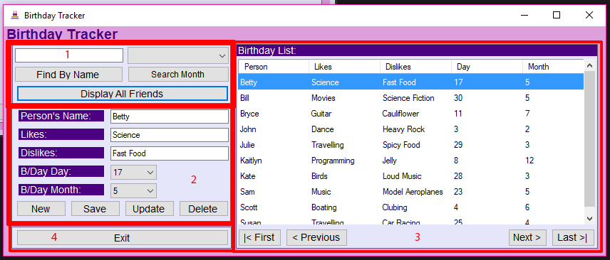

**Section 1: Searches**

* Find By Name – Searches for a name entered into the textbox above it. If you only enter one letter, this will search for all names beginning with the entered letter/s.
* Search Month – Searches for all the friends within the month that is selected from the dropdown list above it and displays them in the Birthday list. There is a textbox field hidden in the purple bar next to ‘Birthday List:’ which will specify the birthdays of which month you are looking at for extra help.
* Display All Friends – Clears the search fields for name and month and displays all the friends again.

**Section 2: Details**

* New – Clears all the fields ready for you to enter a new friends birthday details.
* Save – This will save a new friend to the csv file and display it in the birthday list. Ensure you complete all 5 fields to allow the friend to be added and avoid a warning message.
* Update – This will update the selected friend’s details.
* Delete – This will delete the selected friend from the birthday list and csv.

**Section 3: Birthday List**

* This is the interactive list that when you click on a row, the fields in Section 2 will automatically populate with the information related to that friend.
* First – Navigates to the first friend index in the birthday list.
* Previous - Navigates to the previous friend index in the birthday list.
* Next - Navigates to the next friend index in the birthday list.
* Last - Navigates to the last friend index in the birthday list.

**Section 4: Exit**

* Exit – this will exit the application.

**TOE Chart**

|  |  |  |
| --- | --- | --- |
| Task | Object | Event |
| Ends the application. | buttonExit | Click |
| Clears the fields to input a new friends details. | buttonNew | Click |
| Saves a new friend to the csv file and birthday list. | buttonSave | Click |
| Updates the selected friend. | buttonUpdate | Click |
| Deletes the selected friend. | buttonDelete | Click |
| Moves to the first friend index. | buttonFirst | Click |
| Moves to the last friend index. | buttonLast | Click |
| Moves to the next friend index. | buttonNext | Click |
| Moves to the previous friend index. | buttonPrevious | Click |
| Displays all the friends in the birthday list. | buttonShowAll | Click |
| Searches the birthday list for a specific month that you can select from the dropdown menu and sorts the list alphabetically by name. | buttonSearchMonth | Click |
| Searches for a friend in the birthday list by name.  If only one letter is entered then it searches for names in the list that begin with that letter. | buttonFind | Click |
| Prevents user from entering commas in the textbox to avoid problems with the csv file. | textName,  textLikes,  textDislikes | KeyPress |
| Get friends information. | textName,  textLikes,  textDislikes,  comboFriendDay,  comboFriendMonth | None |
| Display friends. | dataBirthdays | None |
| Search friend by name. | textFindByName | None |
| Search for friends by month. | comboMonths | None |
| Displays the row clicked in the section that you enter a friends details so that you can update that friend if needed. | dataBirthdays | CellClick |
| Loads the csv file and sorts the table alphabetically by the first column. | Form1 | Load |

**UML Diagram**

|  |
| --- |
| **Form 1** |
| String: path  DataTable: dt  Int: Rowindex |
| WriteFile()  LoadFile()  sortedTable()  clearFields()  displayFriendRow(DataGridViewCellEventArgs e)  saveFriendDetails()  deletePerson()  findFriendByName()  searchBirthMonth()  showAll()  displayFriendOnButtonMovement()  updateFriend()  preventCommas(KeyPressEventArgs e)  Form1_Load(object sender, EventArgs e)  dataBirthdays_CellClick(object sender, EventArgs e)  buttonNew_Click(object sender, EventArgs e)  buttonSave_Click(object sender, EventArgs e)  buttonUpdate_Click(object sender, EventArgs e)  buttonDelete_Click(object sender, EventArgs e)  buttonFirst_Click(object sender, EventArgs e)  buttonLast_Click(object sender, EventArgs e)  buttonPrevious_Click(object sender, EventArgs e)  buttonNext_Click(object sender, EventArgs e)  buttonSearchMonth_Click(object sender, EventArgs e)  buttonFind_Click(object sender, EventArgs e)  buttonShowAll_Click(object sender, EventArgs e)  textName_KeyPress(object sender, EventArgs e)  textLikes_KeyPress(object sender, EventArgs e)  textDislikes_KeyPress(object sender, EventArgs e)  buttonExit_Click(object sender, EventArgs e) |

**Debugging**