COME-HERE RIDER
DELIVERY SYSTEM FOR HASSLE FREE TRANSACTION

A Capstone Project
Presented to the Faculty of the
College of Information Technology Education
PHINMA University of Iloilo

In Partial Fulfillment
of the Requirements for the degree
Bachelor of Science in Information Technology

By:
Tangente, Clark Kent
Erecre, L.A.

November 2025
i

Approval Sheet
In partial fulfillment of the requirements for the Bachelor of Science in Information Technology, this Capstone Project entitled “COME-HERE RIDER: DELIVERY SYSTEM FOR HASSLE FREE TRANSACTION” prepared and submitted by Clark Kent Tangente and L.A. Erecre who are hereby recommended for corresponding final evaluation.

Elaiza L. Lorilla
Adviser

Approved by the Panel of Evaluators with a grade of PASSED

Dr. Arnold M. Fuentes, Ph. D, MPA, MMIT
Chairman

Andreas V. Armada
Member

Accepted in partial fulfillment of the requirements of the degree Bachelor of Science in Information Technology

Seth dA. Nono, MSCS
CITE, DEAN

ii
ACKNOWLEDGEMENT
Researchers would like to express our deep sincere gratitude to all who have helped us with this study. First and foremost, to God for providing us with daily strength despite our limitations; the insight to keep working; an optimistic outlook despite our negative thoughts; and the information and chance to start and complete this study.
To our teacher’s mentors for providing us with invaluable supervision, support, patience and knowledge-sharing that they imparted to us. It was a great privilege and honor to work and study under their guidance.
To our families and friends, for their unconditional love, emotional and financial support and also for being our inspiration for our hard work in school and words of encouragement in doing our best to fulfill this research study.
The proponents would want to express their gratitude, love and appreciation to everyone who provided crucial support and assistance that helped this research to be completed. This research would not have been possible without them.

iii

ABSTRACT
In today’s evolving digital economy, efficient delivery management systems have become essential to meet increasing consumer expectations. However, many existing delivery platforms and traditional coordination methods are limited by slow processes, human errors, and the lack of intelligent automation. These inefficiencies often result in delayed deliveries, miscommunication between users and riders, and overall operational losses.
This research introduces Come-Here Rider, an innovative system designed to enhance the interaction between users and riders. The platform enables users to request products or necessities, while assigned riders efficiently purchase and deliver these items using an optimized workflow. By incorporating technologies such as real-time tracking, intelligent route management, and data-driven decision-making, the system minimizes errors, improves efficiency, and promotes a seamless user experience. Ultimately, Come-Here Rider aims to revolutionize on-demand purchasing and delivery services through automation, speed, and reliability.

iv

TABLE OF CONTENTS
Title page-----------------------------------------------------i
Approval Sheet------------------------------------------------ii
Acknowledgement----------------------------------------------iii
Abstract------------------------------------------------------iv
Table of Contents----------------------------------------------v
List of Figures-----------------------------------------------vi
List of Tables-----------------------------------------------vii
CHAPTER I
Introduction-------------------------------------------------
Background of the Study--------------------------------------
Statement of the Problem--------------------------------
Objectives of the Study---------------------------------
Significance of the Study-------------------------------
Scope and Limitation------------------------------------
CHAPTER II
Literature Review---------------------------------------------
Overview-------------------------------------------------
Traditional VS Modern System-----------------------------
Technology Use-------------------------------------------
Case Studies---------------------------------------------
CHAPTER III
Methodology-----------------------------------------------------
Research Design--------------------------------------------
Model Use--------------------------------------------------
Data flow Diagram------------------------------------------
Entity Relationship Diagram--------------------------------
CHAPTER IV
Result and Discussion-----------------------------------------
System’s Features------------------------------------------
Implementation Challenges----------------------------------
User Feedback----------------------------------------------
Comparison to other System---------------------------------
CHAPTER V
Conclusion and Recommendation-----------------------------------
Conclusion-----------------------------------------------
Recommendation-------------------------------------------
Final Thoughts--------------------------------------------

Appendices—------------------------------------------------
Screenshots------------------------------------------
Curriculum Vitae-------------------------------------
Grammarian Certificate----------------------------------

LIST OF FIGURE
Figure 1 —------------------------------—---------Agile Model
Figure 2 —------------------------ System Diagram Architecture
Figure 3 —-----------------------------------Use Case Diagram
Figure 4 —--------------------------—------------ DFD Level 0
Figure 5 —--------------------------—------------ DFD Level 1
Figure 6 —--------------------------—------------ DFD Level 2
Figure 7 —--------------------------—-------------—ERD

LIST OF TABLES
Table 1 —------------------------- Justification of Agile Method
Table 2 —-------------------------------------------Task Manager

Chapter 1
Introduction to the Study
The goal of this capstone project is to design and develop Come-Here Rider, an innovative delivery management system that connects users with riders who purchase and deliver the items customers need. This system aims to modernize the process of coordinating orders and deliveries, addressing the inefficiencies found in traditional manual and communication-based methods.
By providing a real-time, web-based platform for order requests, tracking, and updates, Come-Here Rider seeks to reduce errors, enhance transparency, and improve delivery efficiency. The system ensures that user requests are accurately fulfilled and that riders can easily navigate and complete orders in a timely manner. Ultimately, Come-Here Rider aims to streamline the delivery process, promote user convenience, and support the growing demand for faster, smarter, and more reliable service interactions.
Come-Here Rider will feature a web-based platform that provides authorized users such as customers, riders, and system administrators with a centralized dashboard to monitor and manage delivery transactions in real time. Through this platform, customers can place requests for the items they need, riders can view and accept orders, and administrators can track all ongoing and completed deliveries. The system will also notify users through real-time updates and email notifications, ensuring smooth coordination and transparency throughout the process.
The system will be powered by a secure database management system to maintain data integrity and protect sensitive information from unauthorized access. To support better decision-making, Come-Here Rider will include data analytics features that automatically generate delivery reports, track rider performance, and visualize customer order trends. These insights will help administrators identify peak hours, optimize delivery routes, and improve overall service quality.
Additionally, user roles and permissions will be implemented to provide appropriate access levels for customers, riders, and administrators. This ensures accountability, enhances data security, and promotes efficient management within the system.

By the end of this project, Come-Here Rider is expected to enhance delivery service efficiency, improve order coordination, and minimize errors caused by manual or unstructured communication between users and riders. The system will enable both customers and administrators to make informed decisions, optimize delivery operations, and ensure faster, more accurate transactions. Ultimately, this solution will strengthen Come-Here Rider’s commitment to convenience, reliability, and innovation in providing seamless delivery experiences to the community.
Technical Background of the Study

The rise of on-demand delivery services has transformed how goods and services are accessed, creating a demand for intelligent systems that can efficiently connect customers with service providers. Traditional delivery methods, often relying on phone calls, text messages, or manual coordination, are prone to errors, delays, and lack of transparency. Modern digital solutions aim to address these challenges by integrating web-based platforms, mobile applications, and real-time tracking systems to streamline operations and enhance user experience.

Implementing Come-Here Rider is a crucial step in improving the coordination between users and riders, ensuring that customer orders are fulfilled efficiently, accurately, and on time. The system helps minimize errors, streamline deliveries, and prevent delays, ultimately enhancing the overall service experience. Key technologies involved in the system include:
- Database Management Systems (DBMS) – Implementation of modern database management systems, such as MySQL or PostgreSQL, to store and organize user data, order details, delivery statuses, and transaction logs.
- Data Visualization and Analytics Tools – Tools that generate visual reports and charts to track rider performance, customer demand trends, and overall system efficiency.
- API Server – Deployment of an API server that acts as the bridge between web and mobile clients and the database, ensuring smooth data communication across the platform.
- Real-Time Notifications and Reports – The system generates instant updates for users and riders, including order confirmations, status changes, and completed deliveries, improving transparency and operational responsiveness.
- Security and User Management – Role-based access control ensures that customers, riders, and administrators have appropriate permissions, protecting sensitive information and maintaining accountability.
Statement of the Problem
Come-Here Rider addresses the lack of an automated delivery and order management system, which often results in inefficiencies, miscommunication, and delays between users and riders. Traditional, manual coordination methods create challenges that affect timely order fulfillment and overall service reliability. Common problems faced with conventional delivery management include:
- Inefficient Order Tracking – Manual tracking makes it difficult to monitor the status of orders in real time, often resulting in missed requests or uncertainty about order progress.
- Data and Reporting Inaccuracies – Without automated systems, there is a higher likelihood of miscommunication, incorrect records, and errors that hinder accurate reporting and decision-making, affecting overall service efficiency.
- Lack of Real-Time Monitoring – The absence of real-time data prevents timely assessment of delivery performance, rider availability, and customer satisfaction, limiting the ability to make quick, informed decisions.
- Time-Consuming Processes – Manual coordination and communication between users and riders require significant time and effort, increasing the likelihood of errors and slowing down service delivery.
- Delayed Actions on Requests – Slow processing and follow-up on orders lead to extended delivery times, reduced efficiency, and a lower level of user satisfaction.
This study seeks to address these problems by developing Come-Here Rider, an intelligent delivery and order management system that integrates modern technologies such as cloud computing, real-time tracking, and data analytics. The goal is to create a platform that provides accurate, real-time order monitoring, coordinates users and riders efficiently, tracks delivery progress, and enhances overall operational efficiency. By implementing this system, users can minimize errors, save time, improve communication, and enable better decision-making for both administrators and riders.

Objectives of the Study
The main objective of this study is to design and develop Come-Here Rider, an intelligent delivery and order management system that improves the accuracy, efficiency, and reliability of coordinating orders between users and riders.

Specific Objectives
- To identify the key features required in Come-Here Rider based on the needs of users, riders, and administrators.
- To design a centralized web-based platform that allows authorized users to manage orders, track deliveries, and monitor system performance efficiently.
- To enable users and riders to add, update, and track orders in real time, ensuring accurate and transparent order management.
- To automate notifications and updates for order status, confirmations, and changes, improving communication and reducing delays.
- To provide role-based access control, ensuring data integrity and preventing unauthorized modifications to records.
- To integrate analytical tools for monitoring delivery performance, identifying bottlenecks, and supporting data-driven decision-making.
- To implement secure, cloud-based data storage using MySQL, allowing synchronized, accessible, and protected information management across the platform.

Significance of the Study
The significance of this study focuses on the development of Come-Here Rider, an intelligent delivery and order management system designed to address the inefficiencies in traditional manual coordination between users and riders. Manual order handling is time-consuming, prone to errors, and often lacks transparency, making it difficult to track orders and ensure timely deliveries. By developing this system, the study aims to solve these challenges by providing real-time order tracking, automated notifications, and data-driven insights for efficient delivery management.
The key beneficiaries of Come-Here Rider include:
- Proponents / Developers – The automation and optimization of order and delivery processes will allow the proponents to focus on improving system features and enhancing user experience, rather than handling manual coordination tasks.
- Customers / Users – Users will benefit from faster, more accurate, and transparent delivery services. Real-time tracking and automated updates ensure that orders are fulfilled reliably, improving overall satisfaction.
- Riders / Delivery Personnel – Riders will gain a centralized platform to view, accept, and manage orders efficiently. This reduces confusion, prevents missed requests, and streamlines delivery workflows.
- Administrators – The system enables administrators to monitor overall performance, track order patterns, and generate analytical reports. This allows for better planning, resource allocation, and data-driven decision-making to enhance operational efficiency.
- Community / General Public – By providing a reliable, efficient, and transparent delivery platform, the system ensures that users receive the items they need in a timely manner, improving convenience and trust in the service.

Scope and Limitation of the Study
This study focuses on the design and implementation of Come-Here Rider, developed to enhance the efficiency, accuracy, and reliability of coordinating orders and deliveries between users and riders. The system provides real-time tracking of orders, instant updates on delivery status, and automated notifications to improve communication and decision-making. It also incorporates analytics to monitor rider performance, forecast demand, and enable faster issue resolution. Overall, the study aims to streamline delivery operations through a smart, data-driven, and automated system that promotes accuracy, efficiency, and reliability.
Key Features of Come-Here Rider:
- User Login & Role Management – Users and riders authenticate using email and password. Role-Based Access Control (RBAC) ensures that customers, riders, and administrators have access to appropriate functionalities based on their roles, protecting sensitive information and maintaining accountability.
- Real-Time Order Tracking – Enables users and administrators to monitor the status of orders instantly, ensuring accurate and up-to-date information on deliveries.
- Order and Delivery Management – Allows users to place requests, and riders to accept, update, and complete orders, streamlining the management process and improving workflow efficiency.
- Real-Time Notifications – Keeps users and riders informed through automated updates and alerts about order progress, changes, or completed deliveries.
- Reporting & Analytics – Provides administrators with the ability to generate detailed, customizable reports, offering insights into order trends, rider performance, and overall system efficiency to support better decision-making.
The system is designed for use by users, riders, and administrators, with the scope including development, testing, and evaluation in a real-world environment to ensure efficiency, accuracy, and reliability in delivery operations.

Limitation of the Study
This study focuses on improving order coordination and delivery management through Come-Here Rider, but it has the following limitations:
- Internal Use Only – The system is designed exclusively for registered users and riders, meaning unregistered individuals or external parties cannot access or place orders.
- No Automatic Purchasing – The system does not autonomously fulfill requests or handle payments; human intervention by riders or administrators is required to complete deliveries.
- Basic Analytics – Reporting features provide fundamental insights such as order trends, rider activity, and delivery status, without advanced predictive analysis or integration with other external management systems.
- Custom-Fit Design – The system is tailored to the current workflows of users and riders in the target service area, meaning significant modifications may be needed for application in other delivery contexts or broader markets.
- Environment-Specific Testing – Testing and implementation were conducted within the controlled pilot environment, so performance and reliability in larger-scale or different operational settings have not been fully validated.

Definition of Terms
- Users- individuals or groups who interact with and utilize the delivery system to fulfill their specific roles.
- Riders- refers to the individual responsible for picking up and delivering orders to customers.
- Administrator- responsible for maintaining user accounts, monitoring delivery activities, updating system information, and resolving issues that may occur during transactions.
- API Server- is the component of the delivery system that acts as a bridge between the frontend (user interface and the backend (database and logic.
- Real-time Tracking- The ability to monitor and update inventory data as it changes instantly, ensuring that inventory records are always accurate and up-to-date.
- Database Management System (DBMS)- is the component of the delivery system that acts as a bridge between the frontend (user interface) and the backend (database and logic).
- Backend- refers to the server side of a website or application — the part that users don’t see but that makes everything work behind the scenes.
- Frontend- refers to the part of a website or application that users directly interact with. It’s everything you see and experience in your web browser — like buttons, text, images, animations, menus, and layouts.

Chapter 2

Review of Related Literature
Overview of Come-Here Rider: Delivery for Hassle-Free Transactions
This chapter presents the background of the study and problem statement, discussing what are the issues that the AR Food Garage is currently facing. Furthermore, it contains the objective and beneficiaries. Lastly, the features of the web application are discussed along with the delimitation of the study.

Theoretical Framework
This chapter presents the related literature done through a thorough foraging search by the researchers. This chapter will also synthesize the system design and the conceptual framework process. The definition of terms is also included for further elaboration and understanding of the study. This study of Rawat R. M. et al. (2021) stated that the food or restaurant sector has traditionally been one of the businesses with the most significant earnings and fastest growth rates. Because of the rapid growth of technology, restaurants must develop new cutting-edge services for their customers to remain competitive
in the food industry. The pandemic had a significant influence on the restaurant industry in 2020. This post will demonstrate how technology may help food ordering comply with the COVID-19 pandemic. The consequences of COVID-19 on the food industry are investigated in this article, and technologies for restaurants to utilize to deal with COVID-19-related challenges are offered. The study aims to reduce the point of contact during COVID-19 and computerize the ordering and billing process, simplifying the work. Thus, providing a computerized and scalable food ordering system will assist the business by reducing its workload and providing better management and smooth operation. The restaurant can also use various other means to increase its presence as a business. The study relates to the project's proposed application as it can increase the customers' reach and interaction with the AR Food Garage without physically going to the restaurant. Online customers can select and modify their orders and track their meal status. The project proposed application will also develop a faster management system for the business owner, replacing the Facebook page with the web application. The proposed web application will also allow the business to continue operating even amid a pandemic since order management will be made smoother and easier to handle. Furthermore, Aditya G.M. et al. (2021) discovered that there are
generally long queues and crowds at canteens and motels during lunch breaks at work or on campus. This essay introduces the possibility of placing food orders remotely and proposes
a method to eliminate the queue system. This study also suggests a real-time meal suggestion system to assist consumers in picking meals based on prior purchases. The technique was implemented using a mobile application built with Flutter. A machine learning model has been implemented into the mobile application to give product recommendations to the user. The proposed technique has been tested successfully with two suppliers serving 60 clients. This can be compared to the study by allowing customers to quickly order from any device.
According to the study by Ferdianto F. et al. (2021), the purpose of this research is to analyze problems and business opportunities related to mobile app-based design in food or
beverage pre-ordering systems at places to eat or drink around the office or university, and to design information systems to answer problem analysis and the opportunities that exist. This application system enables users to pre-order food/drinks online via a mobile application by gathering locations to eat/drink near workplaces and colleges (canteens, food courts, and restaurants) and assisting partners in writing orders, financial statements, and consumer behavior. This research refers to the
project regarding the online ordering of meals and drinks. The distinction is that the web application will only be installed on one side of the family company, which is in Alfonso, Cavite.
According to Khedikar S., et al. (2020), this study aims to replace traditional food ordering devices in restaurants with tablet food ordering. When the client enters the restaurant and takes his selected seat, he may be greeted with a tablet that remains at his table. He will select his preferred food, and his order will be delivered immediately to the kitchen. When his dinner is ready, the waiters can deliver it to the appropriate table. Based on his experience, the consumer might share his comments. A critical database stores the client's login information and order history. This solution expedites the meal ordering process while providing an appealing, error-free manner for the digital elements involved. Similar to this, it also seeks to innovate the manual listing of orders for online consumers using the web application that will be established.
The procedure used in this research is significantly different from the system because it focuses on on-site ordering. The system is designed with online clients who want to have their items delivered in mind; nevertheless, on-site customers can also utilize the mobile application, but only on their own devices. Since their online consumers are quickly rising, rather than having clients on-site due to pandemics, the business owners' purpose is to utilize and give an ordering and administration system for online customers and make their menus available for viewing online. Customers can still utilize the system on-site, but only by connecting to it with their data
and devices.

When it comes to the algorithm used, the article about Binary Search Algorithms states that it works well in sorted data. Furthermore, this algorithm works by entering tags and validating them in the database if similar tags are present. This study also states that if the tags are not present in a particular row, the data is immediately disregarded and proceeds to the next. SoftLogic (2022). A binary Search Algorithm will be used in searching for the meal name entered by the customers. The tag will be the identifier in showing the result by comparing if the details are matched in the database. This will also be applied to the business owners' panel page, specifically in finding details of specific customers for tracking purposes.

Research Paradigm

To create the mobile food ordering and web-based management system for the AR food garage, the following guidelines must be followed to accomplish the given requirement for creating the project's final output. The standard requirements are basic knowledge of programming, including HTML, CSS, JavaScript, REACT, Node.js, PHP/MySQL, Firebase, and or MongoDB. They are followed by the analysis skills required to solve problems encountered during or after the project development. To have a good interface, the developer should have skills in CSS or design. The essential requirement for this project is information. The development team should gather valuable information to use in the project. The Rapid Application Development model will be used as the basis for the prototyping process. When these requirements are met, the AR FOOD GARAGE: A Mobile Application for Food Ordering and Web-Based Order Management will be successfully created.

Conceptual Framework

This section contains the details needed for the system to be developed. The process requires the input to be gathered and utilized, the method to be used, the output, and the evaluation of the system.
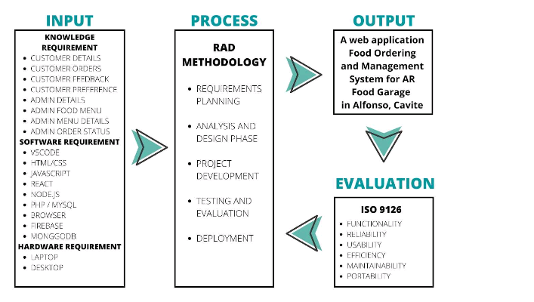

Figure 1.
The above shows the conceptual framework of mobile and web applications. This figure develops a guideline of what the project is and its goal. Knowledge requirements, Hardware requirements,
Software requirements and development process using Rapid Application Development (RAD) must follow the objectives and be able to develop two separate panels for admin and online customers.

Definition of terms

- Binary Search algorithm
An algorithm will search the meal names entered by the user and process them if they match their tags. FAQ Chatbot A chatbot is computer software that simulates and interprets human dialogue, enabling users to converse with digital gadgets as if they were speaking to real people. Early evangelists are the most potential customers of the business. ISO 9126 is a standard in creating a system that will help in providing an output with quality.
- MERN Stack
It is an abbreviation for MongoDB, Express, React, and Node.js. On-site customers refer to the customer who is ordering in the physical store. Self-service: The ability of the customer to perform the selection of orders without the direct help of the business owner.
- The server
Defined as the compilation of codes that connect the client and admin panel to the database to access data. Web-based: An online web application implemented with specific features in managing orders and is responsive to any screen.

References
Aditya, G. M., Goyal, A., Niharika, N., & Dey, A. (2021). Machine Learning Based Platform and Recommendation System for Food Ordering Services within Premises. IEEE Xplore.
https://doi.org/10.1109/ICETCE46604.2021.9587601
Aquino, J. (2021). The Cavite population will hit 4.3 million in 2020. The Cavite Rising.
https://thecaviterising.com/cavite-population-hits-4-3-million-in-2020/
Chandra, Y. U., & Cassandra, C. (2019). Stimulus Factors of Ordering Online Food Delivery. IEEE
Xplore. https://doi.org/10.1109/ICIMTech.2019.8843715
Ferdianto, F., Juwitasary, H., Budiman, A., & Fahmi, I. (2021). Development of Mobile
Application for Pre-Order Food and Beverage. IEEE Xplore.
https://doi.org/10.1109/ICoSE2A51187.2021.9535046
Ghazali, N. A. F. B. (2020). FOOD ORDERING SYSTEM (iORDER) (Master's thesis, Universiti
Sultan Zainal Abidin.
https://myfik.unisza.edu.my/www/fyp/fyp19sem2/report/051543.pdf
Khedikar, S., Kumavat, P., Jain, P., & Kulkarni, P. (2020, April). Digital Food Ordering System
for Restaurants. International Research Journal of Engineering and Technology (IRJET),
7(4), 1657-1662. https://doi.org/10.35940/ijrte.C1702.0974S20
Obanghe, B. A. A. (2020, December). Automated Canteen Ordering System (Bachelor's thesis,
Baze University.
https://portal.bazeuniversity.edu.ng/student/assets/thesis/20210226154356999512575.pdf
PhilAtlas. (2022). Pajo Municipality of Alfonso Province of Cavite.
https://www.philatlas.com/luzon/r04a/cavite/alfonso/pajo.html

Chapter 3
Methodology
This chapter describes the systematic approach undertaken in the design and development of Come-Here Rider, an intelligent delivery and order management system. From planning to deployment, the project followed a structured development strategy, enabling the team to efficiently manage schedules, assign tasks, and focus on creating a system that is both functional and user-friendly.
The research design incorporated both qualitative and quantitative methodologies. To understand current delivery and order coordination processes, identify key challenges, and gather user requirements, interviews and observations were conducted with potential users, riders, and administrators. The insights gathered from these activities guided the design and development of the system’s features.
Agile methodology was employed during system development, allowing iterative testing, prototyping, and continuous enhancements based on user feedback. Interface design, database organization, and coding were carried out using a variety of modern tools and technologies suited to the system’s requirements.
To ensure the platform’s functionality, accuracy, and reliability, the system underwent multiple testing stages, including unit testing, system testing, and user acceptance testing. This methodical approach provided a solid foundation for developing a robust, contemporary delivery management system tailored to meet user needs and improve operational efficiency.
Research and Development Stage
One of the most crucial phases in the development of Come-Here Rider is the Research and Development (R&D) stage. Ideas and feedback gathered from respondents—including potential users, riders, and delivery management experts—serve as a guide for the development process. By providing insights on the system's functionality, design, and user requirements, these respondents help ensure that the final product is practical, effective, and tailored to real-world delivery management needs.
The R&D phase begins with the analysis of data obtained from questionnaires, interviews, and observations. This process helps identify key challenges in the current delivery coordination methods, such as delayed notifications, inefficient tracking, and communication gaps, while highlighting opportunities for improvement through automation, real-time order tracking, and accurate reporting.
System design proceeds based on these findings, with the architecture incorporating modern technologies such as cloud-based data storage for secure and accessible order information, analytics tools for performance monitoring and reporting, and real-time tracking features to monitor order progress. Feedback from respondents guides the development of system features and interfaces, ensuring alignment with user expectations and operational requirements.
The system is developed in iterative phases, with frequent testing and evaluation to meet performance standards. Additional input from users and riders is integrated throughout development to enhance functionality and usability. After the prototype is completed, further user testing is conducted to ensure that the system is intuitive, user-friendly, and effective in handling delivery coordination and management activities.

Agile Method
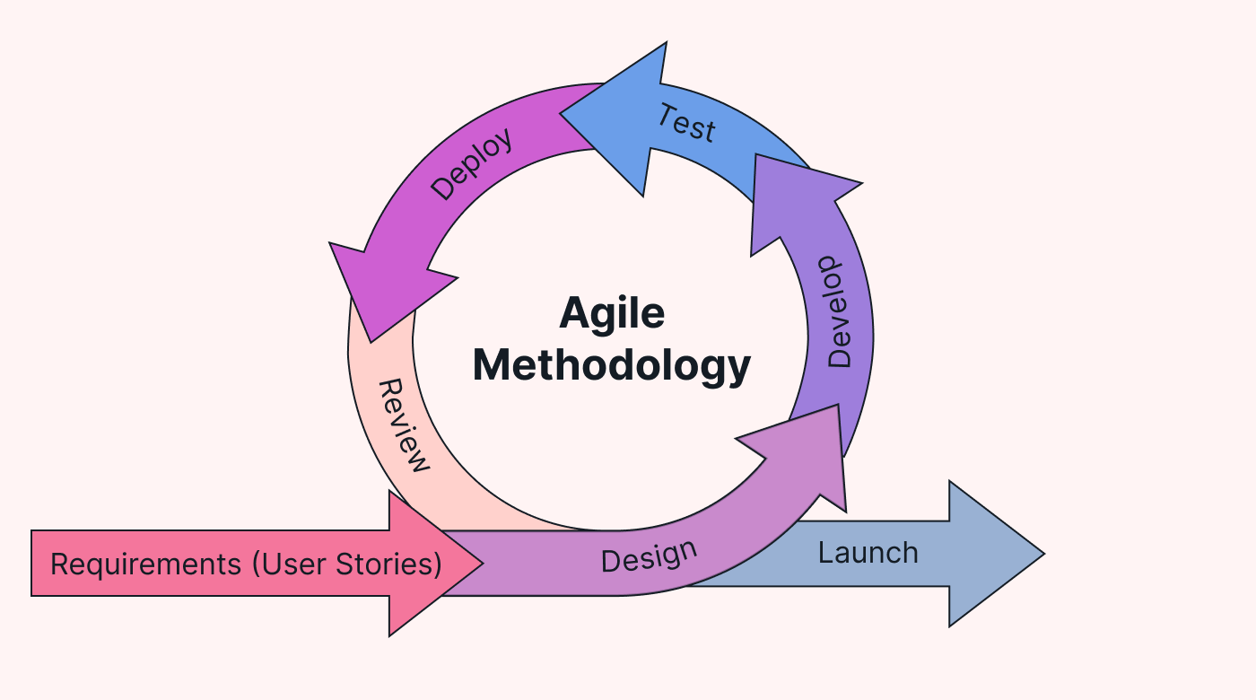
Figure 1. Agile Model
The Agile Method is a development approach where the system is built and improved through short, iterative cycles, allowing for continuous feedback, testing, and adaptation. This method promotes flexibility, ensures the system evolves to meet user needs, and encourages collaboration between developers and stakeholders throughout the project. The Agile process for developing Come-Here Rider includes the following steps:
- Requirement Gathering & Backlog Creation – The development team collaborates with stakeholders, including users, riders, and administrators, to gather detailed requirements for the system. All requirements, such as real-time order tracking, notifications, reporting, and rider management, are documented and prioritized in a product backlog, ensuring the most critical features are addressed first.
- Sprint Planning – The team selects a set of features from the backlog to implement in a sprint, typically lasting 1–2 weeks. Goals, tasks, and responsibilities are clearly defined, and measurable objectives are set to track progress effectively.
- Design & Development – Developers design system modules and write code for the selected features. Each feature is built as a small, functional increment, allowing the system to gradually grow while maintaining stability and quality.
- Testing & Quality Assurance – Each increment undergoes rigorous testing, including unit testing, integration testing, and user acceptance testing. Bugs and issues are identified early, ensuring that features work as intended before moving to the next sprint.
- Review & Feedback – At the end of each sprint, completed features are demonstrated to stakeholders, including users, riders, and administrators. Feedback is collected to determine whether the features meet user needs or require adjustments.
- Iteration & Improvement – Based on feedback, features are refined, improvements are made, and additional functionalities are planned for the next sprint. This cycle is repeated until the system fully satisfies all requirements and operates reliably.
- Deployment & Maintenance – Once development is complete, the system is deployed for actual use. Continuous maintenance and updates are performed based on user feedback, ensuring Come-Here Rider remains efficient, responsive, and aligned with evolving operational needs.

Data Collection Techniques
Different data collection methods were employed to obtain the information required for the development of Come-Here Rider. These strategies aimed to address current delivery and coordination challenges while ensuring the system meets the needs of users, riders, and administrators. The following techniques were used:
- Surveys
Surveys were the primary tool for collecting quantitative data from potential users and riders. The questionnaires covered current delivery processes, difficulties faced, and expectations for an improved system. Both demographic information and detailed input on essential features, system requirements, and performance expectations were collected. This provided valuable insights into which system characteristics should be prioritized for efficient and reliable order management.
- Interviews
Selected respondents were interviewed in-depth to gather qualitative data. Participants were chosen based on their experience with delivery operations, order coordination, or system administration. Open-ended questions encouraged respondents to provide detailed analysis and perspectives, giving a deeper understanding of current workflows, challenges, and how an improved system could enhance accuracy, communication, and operational efficiency.
- Observations
Observations were conducted to understand the daily operations of order and delivery management in real-world settings. This method involved monitoring how orders were coordinated, tracked, and fulfilled by users and riders. Direct observation helped identify inefficiencies, bottlenecks, and areas where automation or real-time tracking could improve service reliability.
- Document Analysis
Existing records, reports, and case studies related to delivery and order management systems were examined to provide additional insight into system design. This included reviewing previous system logs, operational reports, and relevant scholarly works. Document analysis helped identify best practices, trends, and technical developments that could be incorporated into Come-Here Rider to improve its functionality, performance, and usability.

Justification for Selecting the Agile Methodology
Agile was chosen over other SDLC models, such Waterfall, for a number of important reasons:
ASPECTS | AGILE METHOD | TRADITIONAL APPROACH
Development Style | Built with continuous updates and improvements based on user feedback. | Developed once with little to no updates or system improvements.
Flexibility | Highly - can easily adjust to customer and business needs. | Low — changes require major effort and time.
User Involvement | High — users can give feedback through online like ratings | Limited—feedback is collected manually and less frequently
Delivery | Orders processed and tracked in real-time with frequent updates. | Orders processed manually with delays in tracking and communication.
Risk Management | System can detect issues to minimize errors | Issues are identified only after delay occurs
Testing | Continuous testing ensures reliability and accuracy | Testing mostly at the end, issues detected late
Collaboration | High – drivers, customers, communicate through the system | Moderate – structured roles and limited communication
Adaptability to Change | Excellent – quickly incorporates feedback and new needs | Poor – coordination happens through calls or written reports
Efficiency | Reduces errors, rework, and speeds up entire process | Can be slow and costly, especially when mistakes occur
Table 1. Justification for Selecting the Agile Methodology

System Architecture and Design

Overview
Come-Here Rider is designed to efficiently manage, monitor, and coordinate orders between users and riders. The system provides real-time updates on the status of each order, including statuses like Pending, Accepted, In-Progress, Completed, or Cancelled. To ensure seamless interaction, reliable processing, and secure data management, the platform is built using a multi-tiered architecture that separates the user interface, business logic, and data storage layers.
The system supports multiple user types with distinct responsibilities:
- Users / Customers – Place orders, track delivery progress, and receive notifications about order status.
- Riders – Accept and update orders, mark progress, and complete deliveries.
- Administrators – Monitor overall system performance, generate reports, and manage user and rider accounts.
This division of roles ensures accountability, clear workflow management, and smooth coordination between users, riders, and administrators.
Come-Here Rider also features automated notifications and reporting capabilities. Whenever an order is updated or completed, the system generates a detailed report outlining the order details, progress, and final status. These reports are sent via email to users, riders, and administrators to ensure timely communication and transparency.
By integrating real-time tracking, role-based functionalities, status updates, and automated notifications, Come-Here Rider provides a structured, responsible, and efficient approach to managing orders and deliveries, enhancing reliability, operational efficiency, and overall user satisfaction.

System Architecture
The Come-Here Rider system is designed using a three-layered architecture to efficiently manage orders, coordinate riders, and provide timely notifications. This design separates the user interface, application logic, and data storage, ensuring modularity, scalability, and secure information management.

Presentation Layer -This layer provides the interface for users, riders, and administrators through web and mobile applications.
- Users can place orders, track delivery status, and receive notifications.
- Riders can view assigned orders, update order progress, and mark deliveries as completed.
- Administrators can monitor system performance, manage user and rider accounts, and generate reports.
The interface is designed for ease of use, enabling quick access to order details, delivery logs, and notifications, which supports smooth workflow and improved operational efficiency.

Application Layer - The backend handles the core system logic, including order management, rider assignment, status updates, user authentication, and automated notifications. It processes all requests from the presentation layer, generates reports on order and rider performance, and sends email notifications whenever an order status changes. The layer integrates SMTP servers to deliver timely notifications and ensures all business rules for order handling are followed.

Data Layer - This layer stores all system data in a relational database such as MySQL or PostgreSQL. It includes:
- Order and delivery records
- Rider and user information
- Delivery logs and status updates
- Generated reports
The data layer ensures secure storage, backup, and retrieval of all information while maintaining an audit trail of all actions, supporting accountability, data integrity, and informed decision-making across the system.

System Components and Modules

Modules of Come-Here Rider
- Order Management Module – Handles the creation, tracking, and completion of customer orders.
Key Features:
  - Place, edit, or cancel orders by users.
  - Assign orders to riders automatically or manually.
  - Track real-time order status: Pending, Accepted, In-Progress, Completed, Cancelled.
  - Notify users and riders of order updates.
- Rider Management Module – Manages rider accounts, assignments, and performance.
Key Features:
  - Add, edit, or deactivate rider accounts.
  - Monitor rider activity and order completion times.
  - Track rider location (if integrated with GPS) and delivery efficiency.
  - Maintain accountability and performance logs.
- User Management Module – Manages roles, permissions, and access for users and administrators.
Key Features:
  - Users/Customers: Place and track orders, receive notifications.
  - Riders: Accept orders, update order progress, mark deliveries complete.
  - Administrators: Monitor system operations, manage users and riders, view reports.
  - Track activity logs for accountability and auditing.
- Notifications & Reporting Module – Sends updates, alerts, and reports to stakeholders.
Key Features:
  - Automated email and push notifications for order status changes.
  - Generate delivery reports for administrators showing completed, pending, and delayed orders.
  - Track trends in order volume, rider efficiency, and service performance.
- Analytics & Insights Module – Provides actionable insights for operational decision-making.
Key Features:
  - Analyze order patterns, peak demand periods, and customer preferences.
  - Monitor rider performance and delivery times.
  - Forecast resource allocation needs and identify areas for operational improvement.

Use Case Diagram
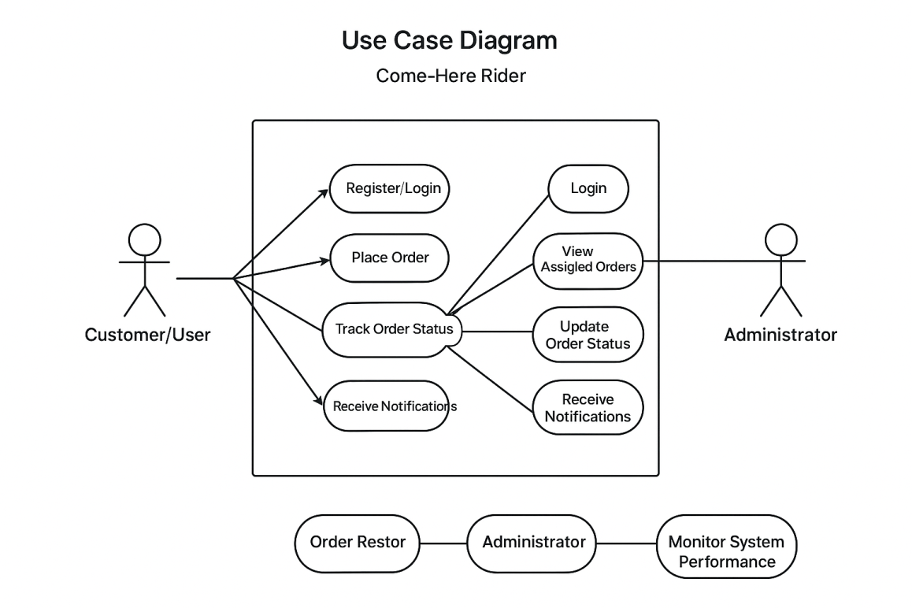
Figure 3. Use Case Diagram
Data Flow Diagram
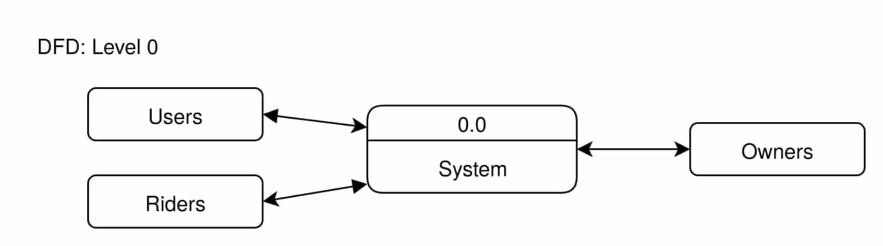
Figure ___: Data Flow Diagram Level 0

The Use Case Diagram illustrates how different users—Customers, Riders, and Administrators—interact with the system. It defines the functional scope of the platform by visually mapping user roles to their actions, such as placing orders, updating order statuses, accepting deliveries, generating reports, and managing accounts. This visual representation helps stakeholders and developers understand the system’s expected features from the perspective of each user type.
The Data Flow Diagram (DFD) complements this by showing how information moves within the system. It depicts the flow of data between users, system modules, and the database, highlighting processes such as order placement, rider assignment, status updates, notifications, and report generation. By visualizing the inputs, processes, and outputs, the DFD helps identify potential inefficiencies and ensures that all interactions are accounted for in the system design.
Together, the Use Case Diagram and DFD provide a clear and structured view of the system’s functionality and data management, supporting effective development and accurate implementation of Come-Here Rider.

Entity Relationship Diagram (ERD)
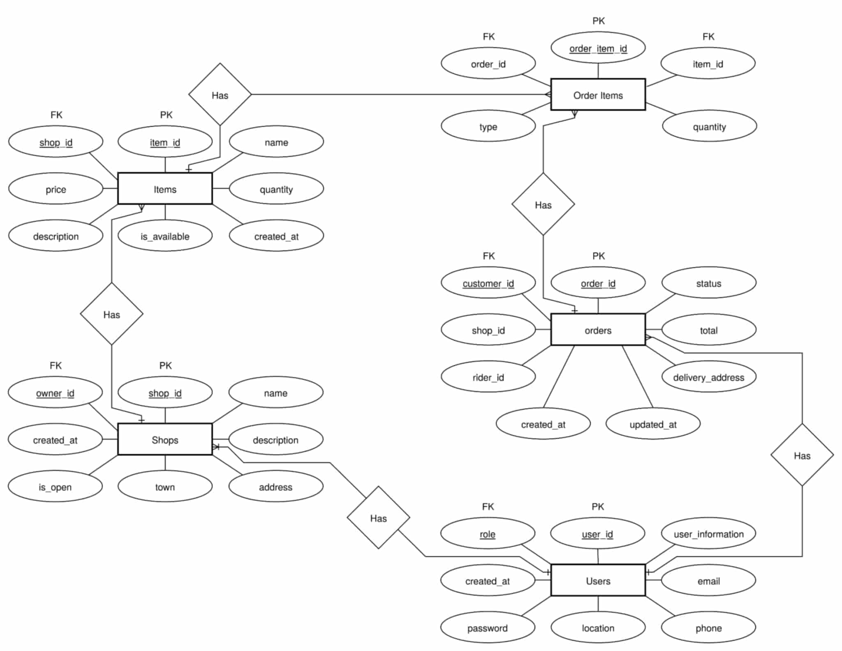

Figure 7 : Come-Here Raider ERD

Database Design

The database design of the Come-Here Rider System serves as the foundational structure that supports the system’s functionality, ensuring the efficient management of information related to users, shops, items, and delivery operations.This design follows a relational database model, which provides a structured and consistent way to store, retrieve, and manipulate data.

The system is designed to integrate three primary user roles—customers, shop owners, and delivery riders—within a unified digital platform. The database ensures data accuracy, integrity, and security through the use of keys, constraints, and relationships among tables.To represent these relationships clearly, an Entity-Relationship Diagram (ERD) is developed, depicting the entities, their attributes, and their interconnections.

Entities Overview
- Users – stores information for all system users.
- Shops – stores registered shops and their details.
- Items – stores products offered by shops.
- Orders – tracks transactions between customers, shops, and riders.
- Order Items – junction table linking orders and items with quantity.

1. Users
- user_id (PK): unique identifier
- user_information: name/details
- email, phone, location, password
- role (FK): customer, owner, rider
- created_at: account creation timestamp
- Relations: can own shops, place orders, or deliver orders

2. Shops
- shop_id (PK): unique identifier
- owner_id (FK): shop owner
- name, description, address, town
- is_open: open/closed status
- created_at: registration timestamp
- Relations: belongs to one user; has many items and orders

3. Items
- item_id (PK): unique identifier
- shop_id (FK): associated shop
- name, description, price, quantity, is_available
- created_at: added timestamp
- Relations: belongs to one shop; linked to multiple orders

4. Orders
- order_id (PK): unique identifier
- customer_id (FK), shop_id (FK), rider_id (FK)
- status, total, delivery_address
- created_at, updated_at
- Relations: customer places many orders; shop receives many; rider delivers many

5. Order Items
- order_item_id (PK): unique identifier
- order_id (FK), item_id (FK)
- type, quantity
- Relations: links items to orders; orders can have many items

User Interface Design
The Come-Here Rider System was designed using a modular, user-centered approach that prioritizes usability, accessibility, and clarity, providing a smooth experience for customers, shop managers, delivery riders, and administrators. Its main goal is to streamline shop browsing, item selection, order placement, and delivery tracking while allowing efficient management of shops, items, and users. React.js was used to build a fast, component-based, and scalable interface that allows easy updates and reuse of elements such as dashboards, order lists, item cards, and delivery tracking modules. Bootstrap ensures a responsive and consistent layout that adapts well to devices of different screen sizes.

After logging in, users are presented with role-specific dashboards. Customers can browse shops, view items, place orders, and track deliveries. Managers can monitor their shops, manage items, process orders, and view shop performance. Delivery riders see assigned orders, delivery addresses, and update delivery progress. Administrators have a comprehensive view of the system, including total users, shops, orders, and riders, as well as access to reports and management tools. Navigation is organized through a sidebar that displays the user’s profile and relevant links for each role, with the main content area dynamically updating to show real-time information.

The interface allows users to navigate between sections without page reloads, keeping the experience seamless. Dashboard elements and interactive components are arranged for clarity, balance, and responsiveness, ensuring consistency across all roles. Overall, the Come-Here Rider System delivers a polished, professional, and user-friendly platform that supports customers, managers, riders, and administrators in efficiently performing their respective tasks.

Security Considerations

The following are the key security considerations implemented in Come Here Rider to protect user data and ensure safe system operations:
1.Session Management
Session management in Come Here Rider protects the Manager, User, and Rider by securely handling their login sessions and activities within the system. It ensures that only authorized individuals can access their respective accounts by assigning unique session IDs after login, preventing unauthorized access or impersonation.
2.Role-Based Access Control (RBAC)
Role-based access control has been implemented in Come Here Rider to prevent unauthorized actions. Users are assigned specific roles such as manager, rider, or customer, with permissions defined according to their responsibilities.
3.Password Hashing
Password hashing is used by Come-Here Rider to secure user credentials. Before user passwords are stored in the database, they are hashed using safe techniques like bcrypt. This means that even in the event that the database is compromised, attackers will not be able to recover the original passwords because plain-text passwords are never saved. Another layer of protection is added upon login when the hashed password is compared to the saved hash for authentication.
4.Secure Authentication & Authorization
Authentication verifies the identity of each user, for example, by requiring a username and password, so that only registered Managers, Riders, or Users can log in. Authorization then determines what each role is allowed to do: Managers can manage orders, add or remove records, and oversee the system; Riders can update delivery statuses and access relevant delivery information; Users can place orders and track them.

Technology Stack
The Come-Here Rider System was developed using modern tools and technologies to ensure efficiency, scalability, and a user-friendly experience for all roles, including customers, managers, riders, and administrators.
- Frontend – The system’s interface was built using HTML, CSS, and JavaScript, providing a clean, responsive, and interactive user experience. HTML structures the content and layout, CSS ensures consistent styling and visual alignment, and JavaScript adds dynamic behavior such as real-time updates, interactive forms, and order tracking features. Together, these technologies enable a modern, role-specific dashboard and seamless navigation across the platform.
- Backend – The backend is implemented using Flask, a lightweight Python web framework that handles core system logic, including user authentication, shop and item management, order processing, and delivery tracking. Flask’s modularity allows clear separation between authentication and core operations, simplifying maintenance, scaling, and integration with the frontend.
- Database – The system uses MySQL for structured and reliable data storage, managing users, shops, items, orders, and delivery records. phpMyAdmin is employed for database administration, providing an easy-to-use interface for managing tables, queries, and data integrity.
- Deployment Tools – The deployment environment uses containerized services to ensure scalability and smooth operation:
  - Portainer: manages Docker containers for efficient deployment.
  - Nginx Proxy Manager: handles reverse proxy configuration and secure access.
  - Cloudflare: enables secure remote access and tunneling to local services.
- Additional Tools and Platforms –
  - GitHub: version control and collaboration.
  - VS Code: primary development environment.
  - Charting Libraries (optional): for visualizing orders, deliveries, and system statistics.
This technology stack provides a solid foundation for a responsive, secure, and scalable Come-Here Rider system, enabling real-time order management, shop monitoring, and delivery tracking across all user roles.

Data Gathering techniques

Survey Questionnaire for System Assessment
The purpose of the following survey is to gather responses from users on their present inventory management procedures and their expectations for the Computer Lab Assets and Inventory Management System. The information gathered from this survey will be used in creating an Inventory Management System that will satisfy user requirements and tackle current inventory management issues. Please be as truthful and precise as you can when responding to the following questions.

Demographic Information
Name: ____________________
Address: _______

1. Do you often use delivery services for your daily needs (e.g., food, parcels, groceries)?

Yes

No

2. Have you experienced delays or issues with your current delivery service provider?

Yes

No

3. Do you think delivery fees today are too expensive?

Yes

No

4. Do you want a delivery system that is easy to use?

Yes

No

5. Would consistent rider behavior influence your loyalty to a service?

Yes

No

6. Do you worry about the safety of your packages?

Yes

No

7. Would you be interested in trying Come Here Rider once it becomes available?

Yes

No

8. Do you prefer riders who follow safety guidelines?

Yes

No

9. Have you ever received a damaged package?

Yes

No

10. Would you pay extra for a secure delivery service?

Yes

No

11. Do you use a delivery app on your phone?

Yes

No

12. Do you order deliveries at least once a week?

Yes

No

13. Have you ever missed receiving an item due to delayed delivery?

Yes

No

14. Do you think speed is the most important factor in delivery?

Yes

No

15. Would reliability influence your choice of delivery service?

Yes

No

16. Have you stopped using a service due to unreliable performance?

Yes

No

17. Would you try a new service if it is proven to be reliable?

Yes

No

18. Do you think convenience is more important than price?

Yes

No

19. Have you ever avoided ordering due to complicated procedures?

Yes

No

20. Do you think polite riders improve the delivery experience?

Yes

No

Sampling Methods for Respondents
A simple random sampling method was employed in this study. A total of ten (10) individuals who regularly use the Come-Here Rider system—either as customers, shop managers, or delivery riders—served as the respondents. This sampling approach was chosen to ensure that the participants are actual users who can provide relevant and accurate insights regarding the system. Although limited to ten respondents, this method allows for a focused yet representative sample, minimizing bias and ensuring that each participant has an equal opportunity to share their experiences and feedback. Through this approach, the study aims to gather reliable data reflecting the perceptions of users toward the Come-Here Rider system, including its usability, functionality, and overall effectiveness.

Data Analysis Techniques

The data gathered from the survey were analyzed using both quantitative and qualitative techniques to assess the relevance and necessity of developing the Come-Here Rider system. The primary goal of the analysis was to determine the system’s potential impact in improving shop management, order processing, delivery tracking, and overall user experience. Respondents included customers, shop managers, delivery riders, and administrators who provided data through structured survey forms.
Quantitative analysis was conducted using spreadsheet applications such as Google Sheets and Microsoft Excel. Survey responses were encoded and processed through data coding procedures. Descriptive statistical tools, including mean, percentage, and frequency distribution, were applied to identify patterns and levels of agreement among respondents. Visual representations such as bar graphs and pie charts were used to facilitate interpretation and provide a clearer understanding of user perceptions regarding the system’s functionality, usability, and relevance.
Qualitative data obtained from open-ended responses were examined to identify recurring themes and insights related to system efficiency, user-friendliness, and necessity. This mixed-method approach allowed for a comprehensive analysis that integrates numerical data with user feedback. The results indicated that the development of the Come-Here Rider system is highly relevant and technically beneficial, supporting efficient order management, shop monitoring, delivery coordination, and enhancing the overall user experience across all roles.

Ethical Considerations
The Come-Here Rider system was developed and implemented with strict adherence to data privacy, regulations, and ethical standards to safeguard user information and maintain system integrity. Compliance with the Data Privacy Act of 2012 (Republic Act No. 10173) ensures that sensitive and personal data, such as user credentials, shop information, order details, and delivery records, are protected from misuse, alteration, or unauthorized access. All information is securely stored in the database, with access restricted to authorized personnel only.
The confidentiality of participants was carefully maintained throughout survey and assessment procedures. No personally identifiable information was shared, and all responses were used solely for system evaluation and academic purposes. Participation was voluntary, and respondents were informed of the study’s objectives. Survey data were processed anonymously using spreadsheets to protect participants’ identities.
These measures ensure that the Come-Here Rider system upholds ethical responsibility, respects user privacy, and maintains transparency in handling personal and operational data across all roles, including customers, managers, riders, and administrators.

Chapter 4
Results and Interpretation
This chapter presents a comprehensive examination of the outcomes following the development and implementation of the Come-Here Rider system. It highlights how the system effectively addressed key challenges in traditional ordering and delivery processes—such as manual order tracking, miscommunication between users, and delays in delivery—by introducing a modernized, digital platform.
The results are based on a combination of system tests, performance evaluations, and user feedback sessions. Findings demonstrate that the Come-Here Rider system significantly improved order accuracy, streamlined shop and delivery operations, and reduced errors in order processing. The platform’s real-time tracking features and intuitive user interface contributed to faster decision-making, smoother coordination between customers, managers, and riders, and enhanced transparency across all transactions.
Through structured testing and deployment, users reported increased efficiency and ease in managing orders, deliveries, and shop operations. This chapter discusses the alignment between the system’s performance and the project’s original objectives. It highlights key functionalities, including real-time order tracking, delivery status updates, and automated notifications, which directly contributed to smoother coordination and faster service.
The chapter also examines the system’s impact in comparison to conventional manual methods, emphasizing the practical benefits and overall value added by the Come-Here Rider system. It provides a critical reflection on lessons learned, potential limitations, and recommendations for future improvements. These findings demonstrate that the Come-Here Rider system represents a significant step toward digital transformation in shop management, order processing, and delivery tracking.

Task Manager

Gantt Chart / Project Timetable – Computer Lab Assets and Inventory Management(ClAIMS)
WEEK | TASK | UI/UX | BACKEND | QA | DOCUMENTER
Week 1–2 | Planning and Gathering Information | _________ | _________ | ________ | Collect system needs and make a project planl
Week 3–4 | Design and Wireframeg | Create page layout using React.js, CSS, and Bootstrap | _________ | ________ | Compile wireframes and design documentation
Week 5–8 | Frontend Implementation | Build Dashboard, Login, and etc. | _________ | ________ | Update progress in the documentation
Week 9–12 | Backend Development | _________ | Build Flask server, MySQL database | ________ | Write details about database and backend setup
Week 13–16 | System Integration Phase | Integrate frontend with backend | Check if data flows correctly | ________ | Write how the system was connected
Week 17–20 | Testing and Fixing Errors | Fix design and layout issues | Fix backend errors and data problems | Test system performance and functions | Write test results
Week 21–22 | System Checking and Improvement | Improve design based on feedback | Improve backend performance | Test again after changes | Write summary of results
Week 23–24 | Final Documentation | _________ | _________ | ________ | Finish and complete all documents
Week 25–26 | Final Demo and Submission | Prepare frontend demo | Show backend features | Help during system demo | Submit all final files

Table 2 : Task Manager

Presentation of Results
The Come-Here Rider system was developed, implemented, and thoroughly evaluated to improve the management of shops, orders, and deliveries, ensuring accurate tracking of order statuses, including Pending, In Progress, Completed, and Cancelled. The system focuses on automating order updates, minimizing errors, and providing an efficient mechanism for monitoring shop operations and delivery progress. During testing, the system underwent performance evaluation to measure its ability to handle multiple orders, process status updates quickly, and maintain database integrity.
User testing was conducted with customers, shop managers, riders, and administrators, who placed orders, updated delivery statuses, and reviewed dashboards, providing feedback on ease of use, clarity of the interface, and effectiveness of notifications. Data from the database were analyzed to verify accurate recording of orders, correct assignment of deliveries, and proper logging of transactions. The evaluation focused on accuracy, efficiency, and user satisfaction, ensuring that order and delivery statuses reflected real-world conditions, transactions were processed promptly, and users found the system reliable and user-friendly. Overall, the Come-Here Rider system demonstrated significant improvements in shop management and delivery coordination by providing real-time updates, automated notifications, and comprehensive dashboards, thereby increasing operational efficiency, accountability, and reducing errors associated with manual tracking.

Project Structure
project/
|
+-- .env.example # Environment variables template
|
+-- Dockerfile # Docker container configuration
|
+-- dev.py # Development server entry point
|
+-- logs/ # Application logs directory
|
+-- migrations/ # Database migration files
| |
| +-- README # Migration instructions
| |
| +-- alembic.ini # Alembic configuration
| |
| +-- env.py # Migration environment setup
| |
| +-- script.py.mako # Migration script template
| |
| +-- versions/ # Individual migration versions
| |
| +-- 0958f770df5c_.py
| |
| +-- 86c16f7b131f_.py
| |
| +-- c02d3f8d2211_.py
|
+-- requirements.txt # Python dependencies
|
+-- schema.sql # Database schema definition
|
+-- wsgi.py # WSGI application entry point
|
+-- app/ # Main application package
| |
| +-- __init__.py # Application factory and initialization
| |
| +-- config.py # Application configuration
| |
| +-- models/ # Database models
| | |
| | +-- __init__.py
| | |
| | +-- account_action.py # Account action model
| | |
| | +-- document.py # Document model
| | |
| | +-- order.py # Order model
| | |
| | +-- report.py # Report model
| | |
| | +-- user.py # User model
| | |
| | +-- vehicle.py # Vehicle model
| |
| +-- routes/ # Application routes/controllers
| | |
| | +-- __init__.py
| | |
| | +-- admin.py # Admin routes
| | |
| | +-- api.py # API routes
| | |
| | +-- auth.py # Authentication routes
| | |
| | +-- favorites.py # Favorites routes
| | |
| | +-- geolocation.py # Geolocation routes
| | |
| | +-- main.py # Main routes
| | |
| | +-- manager.py # Manager routes
| | |
| | +-- orders.py # Order routes
| | |
| | +-- profile.py # Profile routes
| | |
| | +-- reports.py # Report routes
| | |
| | +-- rider.py # Rider routes
| | |
| | +-- user.py # User routes
| |
| +-- static/ # Static assets
| | |
| | +-- css/ # CSS stylesheets
| | |
| | +-- images/ # Image files
| | |
| | +-- js/ # JavaScript files
| | |
| | +-- uploads/ # User uploaded files
| | |
| | +-- forbidden_passwords.txt # Password blacklist
| | |
| | +-- manifest.json # PWA manifest
| | |
| | +-- sw.js # Service worker
| |
| +-- templates/ # HTML templates
| | |
| | +-- base.html # Base template
| | |
| | +-- admin/ # Admin templates
| | | |
| | | +-- (17 template files)
| | |
| | +-- general/ # General templates
| | | |
| | | +-- (8 template files)
| | |
| | +-- manager/ # Manager templates
| | | |
| | | +-- (11 template files)
| | |
| | +-- orders/ # Order templates
| | | |
| | | +-- (3 template files)
| | |
| | +-- profile/ # Profile templates
| | | |
| | | +-- (3 template files)
| | |
| | +-- reports/ # Report templates
| | | |
| | | +-- (3 template files)
| | |
| | +-- rider/ # Rider templates
| | | |
| | | +-- (8 template files)
| | |
| | +-- user/ # User templates
| | |
| | +-- (7 template files)
| |
| +-- utils/ # Utility functions
| |
| +-- __init__.py
| |
| +-- decorators.py # Custom decorators
| |
| +-- file_upload.py # File upload utilities
| |
| +-- geolocation.py # Geolocation utilities
| |
| +-- password_validator.py # Password validation
| |
| +-- validators.py # General validation functions

Chapter 5

Summary, Conclusion, and Recommendation

Summary
The goal of this study was to enhance shop, order, and delivery management by designing and developing the Come-Here Rider system. By automating order processing, delivery tracking, and report generation, the system aims to improve accuracy, efficiency, and transparency across all user roles, including customers, shop managers, riders, and administrators. To ensure real-time updates, minimize errors, and streamline operations, the system leverages contemporary web technologies.
A structured development approach, including requirement analysis, system design, development, testing, and evaluation, was employed for the project. Results showed notable improvements in user experience, order processing speed, and delivery coordination. The system successfully achieved its objectives, demonstrating that it is a reliable and effective solution for managing shops, processing orders, and coordinating deliveries, while meeting the operational needs of all users.

Conclusion
The results showed that the Come-Here Rider system was a reliable and effective tool for automating shop, order, and delivery management. Users were able to monitor orders, track deliveries, and manage shops more efficiently and accurately, reducing errors and minimizing manual effort. According to user feedback, the system’s interface was intuitive and easy to navigate, which enhanced the convenience and organization of order processing, shop management, and delivery coordination.
The system also highlighted the importance of using modern technologies, such as Flask for backend processing and HTML, CSS, and JavaScript for a dynamic frontend, demonstrating how purpose-built software can effectively address practical challenges in real-world operations. Overall, the Come-Here Rider system successfully achieved its objectives, improving operational efficiency, data accuracy, and the overall management of shops, orders, and deliveries.

Recommendations
Based on the development, implementation, and evaluation of the Come-Here Rider system, the following recommendations are proposed to support future improvements and broader adoption:
- System Expansion
Future versions should expand system accessibility to include additional stakeholders, such as shop assistants or regional coordinators, as the current system primarily serves customers, shop managers, delivery riders, and administrators. Increasing user roles, responsibilities, and permissions across the platform would improve operational efficiency, communication, and coordination among all parties.
- Feature Addition
The current system already supports key functionalities, including order management, delivery tracking, notifications, and real-time dashboards. Future development could focus on integrating intelligent features, such as predictive delivery time estimation, automatic route optimization for riders, and advanced analytics for shop performance. These enhancements would improve decision-making, operational efficiency, and proactive management of orders and deliveries.
- Enhance Data Security
The system currently uses MySQL for data storage and management, with secure access for authorized users. To further strengthen data security, measures such as multi-factor authentication (MFA), enhanced encryption for stored and transmitted data, regular database audits, access logging, and AI-assisted threat detection are recommended. These steps would minimize vulnerabilities and ensure the confidentiality, integrity, and reliability of sensitive system data.
- Further Testing and Scalability Evaluation
Pilot testing in larger or more complex operational environments—covering multiple shops, delivery zones, or a higher volume of users—is advised. This would assess the system’s performance, scalability, and reliability under increased load, providing valuable insights for broader adoption and future enhancements.

References (APA Format)
Aditya, G. M., Goyal, A., Niharika, N., & Dey, A. (2021). Machine learning based platform and recommendation system for food ordering services within premises. IEEE. https://doi.org/10.1109/ICETCE46604.2021.9587601
Aquino, J. (2021). The Cavite population will hit 4.3 million in 2020. The Cavite Rising. https://thecaviterising.com/cavite-population-hits-4-3-million-in-2020/
Chandra, Y. U., & Cassandra, C. (2019). Stimulus factors of ordering online food delivery. IEEE. https://doi.org/10.1109/ICIMTech.2019.8843715
Ferdianto, F., Juwitasary, H., Budiman, A., & Fahmi, I. (2021). Development of mobile application for pre-order food and beverage. IEEE. https://doi.org/10.1109/ICoSE2A51187.2021.9535046
Ghazali, N. A. F. B. (2020). Food ordering system (iORDER) (Master's thesis, Universiti Sultan Zainal Abidin). https://myfik.unisza.edu.my/www/fyp/fyp19sem2/report/051543.pdf
Khedikar, S., Kumavat, P., Jain, P., & Kulkarni, P. (2020, April). Digital food ordering system for restaurants. International Research Journal of Engineering and Technology (IRJET), 7(4), 1657–1662. https://doi.org/10.35940/ijrte.C1702.0974S20
Obanghe, B. A. A. (2020, December). Automated canteen ordering system (Bachelor's thesis, Baze University). https://portal.bazeuniversity.edu.ng/student/assets/thesis/20210226154356999512575.pdf
PhilAtlas. (2022). Pajo Municipality of Alfonso, Province of Cavite. https://www.philatlas.com/luzon/r04a/cavite/alfonso/pajo.html

Appendices:

Appendix A: System Interface Screenshots

Login Page
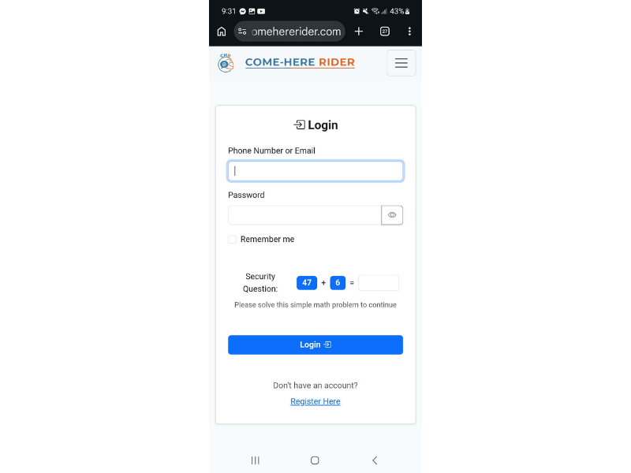
Dashboard (User and Rider)
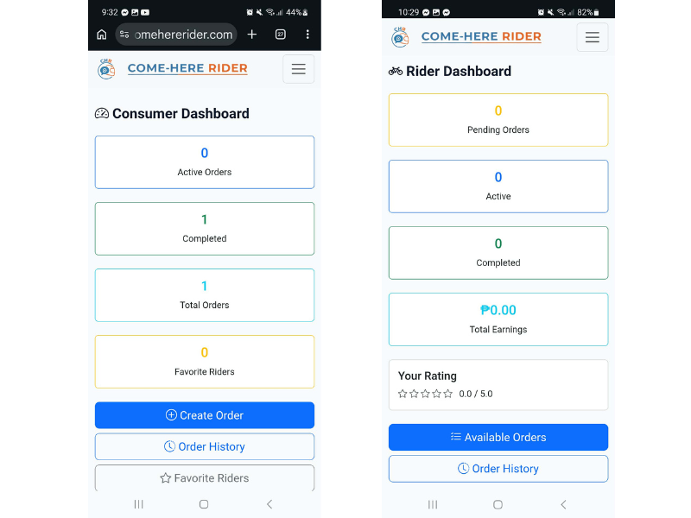
Profile (User and Rider)
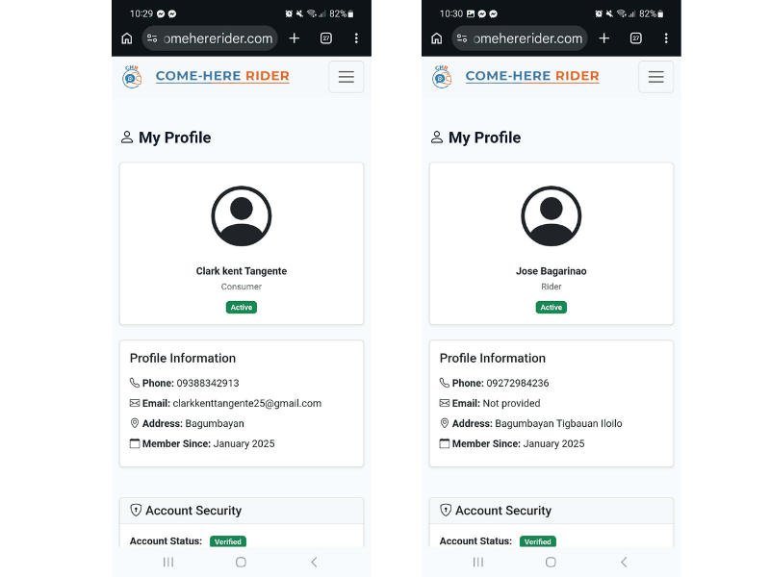
User Order History
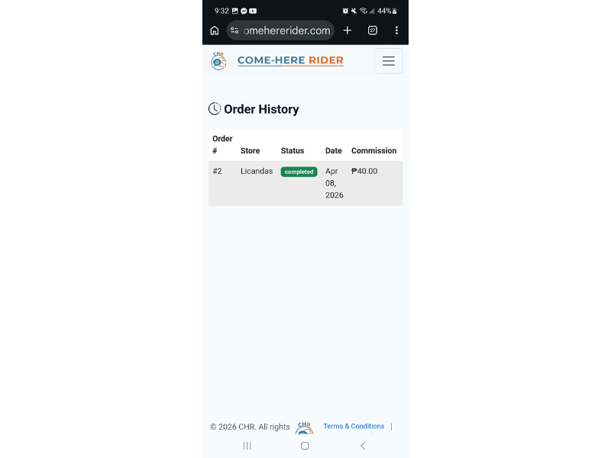

Appendix B: Use Case Diagram


Appendix C: Data Flow Diagram


Appendix D: User Survey Form and Summary
Name: ____________________
Address: _______

1. Do you often use delivery services for your daily needs (e.g., food, parcels, groceries)?

Yes

No

2. Have you experienced delays or issues with your current delivery service provider?

Yes

No

3. Do you think delivery fees today are too expensive?

Yes

No

4. Do you want a delivery system that is easy to use?

Yes

No

5. Would consistent rider behavior influence your loyalty to a service?

Yes

No

6. Do you worry about the safety of your packages?

Yes

No

7. Would you be interested in trying Come Here Rider once it becomes available?

Yes

No

8. Do you prefer riders who follow safety guidelines?

Yes

No

9. Have you ever received a damaged package?

Yes

No

10. Would you pay extra for a secure delivery service?

Yes

No

11. Do you use a delivery app on your phone?

Yes

No

12. Do you order deliveries at least once a week?

Yes

No

13. Have you ever missed receiving an item due to delayed delivery?

Yes

No

14. Do you think speed is the most important factor in delivery?

Yes

No

15. Would reliability influence your choice of delivery service?

Yes

No

16. Have you stopped using a service due to unreliable performance?

Yes

No

17. Would you try a new service if it is proven to be reliable?

Yes

No

18. Do you think convenience is more important than price?

Yes

No

19. Have you ever avoided ordering due to complicated procedures?

Yes

No

20. Do you think polite riders improve the delivery experience?

Yes

No

Summary of Responses (e.g., tables, charts)
