MINISTRY OF EDUCATION AND TRAINING

**CAN THO UNIVERSITY**

**COLLEGE OF INFORMATION TECHNOLOGY AND COMMUNICATION**

**🙞 🕮 🙜**



**.NET APPLICATION DEVELOPMENT – CT310H**

**INFORMATION TECHNOLOGY**

**(HIGH-QUALITY PROGRAM)**

**Topic**

**RESTAURANT MANAGEMENT**

**Group of students:**

Ho Minh Nhut,

Nguyen Duy Khang,

Le Minh Man,

Nguyen Thi Diem My,

La Thanh Trong.

**Course: 46**

**Instructor:** TS. Nguyen Nhi Gia Vinh

Can Tho, 04/202

**Group Member:**

|  |  |  |  |
| --- | --- | --- | --- |
| # | Student Code | Full Name | Role |
| 1 | B2005889 | Ho Minh Nhut | Team Leader |
| 2 | B2005843 | Nguyen Duy Khang | Member |
| 3 | B2014957 | La Thanh Trong | Member |
| 4 | B2003791 | Le Minh Man | Member |
| 5 | B2014996 | Nguyen Thi Diem My | Member |

**Description:**

This application is designed to manage a chain of restaurants. It caters to two primary user groups: administrators and staff.

For administrators, the application grants access to various functions including managing financial reports, branches, restaurant staff, categories, and menu items (both food and beverages).

Staff members, on the other hand, are empowered to handle tasks such as taking table orders for customers, processing payments, printing bills, rearranging tables, and adding or updating menu items on bills.

Furthermore, the application supports two types of ordering methods: takeaway and dining in at the restaurants.

**MỤC LỤC**

INTRODUCTION 1

1. Problem statement 1

2. Project objective 1

3. Target and Scope of research 1

CONTENT 2

CHAPTER 1 2

Problem Description 2

1. More details on the problem. 2

2. Solution related to the problem 3

2.1. Winform 3

2.2. Report Viewer control 3

2.3. Microsoft SQL Server 4

2.4. System SQL Client 4

CHAPTER 2 6

DESIGN AND INSTALL 6

1. System Design 6

1.1. Database 6

1.2. Installation 9

CHAPTER 3 10

FUNCTIONAL COMPONENTS OF RESTAURANT MANAGEMENT 10

1. Login Page 10

2. Administrator Page 11

2.1. Dashboard Page 11

2.2. Branches Page 12

2.3. Staff Management Page 14

2.4. Menu Item Page 15

2.5. Category Management Page 17

3. Order Page 17

3.1. Table 17

3.2. Order Details. 18

3.3. Print and Pay bills. 19

3.4. Flowchart. 20

CONCLUSION 21

1. Result Achievement 21

2. Future development. 21

REFERENCES 22

**ABSTRACT**

In many restaurant management, the need for an integrated, user-friendly software solution is crucial to streamline operations and enhance customer satisfaction. This project introduces a restaurant management app designed for both administrators and staff in restaurant chains. The app solves common problems by helping with financial management report, staff organization, menu updates, categories, and branches. It even lets customers order for takeaway or dine-in easily. By making tasks simpler and more organized, the app aims to change how restaurants are run, making them more efficient and improving customer service.

# INTRODUCTION

## 1. Problem statement

In today's digital world, there exists a significant gap in efficient, comprehensive software solutions that seamlessly integrate the diverse needs of both administrators and staff within a chain of restaurants. In this context, establishing an software for managing and ordering food and beverages, rearranging tables, printing bills,… becomes an important and promising direction to meet consumer needs. An efficient products, branches, staff members management, and financial report, will ensure that businesses can operate professionally and meet customer demands.

## 2. Project objective

Project objective is to develop a robust restaurant management application tailored to the specific needs of administrators and staff within a chain of restaurants.

For administrator include many important features such as managing foods and drinks, managing categories, managing staff members and branches, also financial report.

On the other hand, staff members can take orders from customers, handle payment, print bills, table arrangement, this type of orders support both take away and dinning at the table.

## 3. Target and Scope of research

Target: Building a restaurant management with .NET using Winform.

Scope of research: Restaurants, small shops.

# CONTENT

# CHAPTER 1

# Problem Description

## 1. More details on the problem.

In this context, we build a .NET application using Winform in order to manage restaurants. For this platform we provide important features which administrators can manage their own branches, foods beverages, categories, staff members, financial report. For staff members, they can take orders from customers both takeaway and at the table.

* Branches Management: The system allows administrators to add, update, delete restaurants branches, including branch name, address, hotline, and image of that branch.
* Staff Management: A restaurant branch can have many staff members, including their role and branch they work on. Administrators can add, update, delete staffs’ information such as fullname, CID number, role, branch, date of birth, gender, address, phone number, and password.
* Menu items Management: The system allows administrators to add, update, delete their product, including the product tile, description, category, price, and product image. Moreover, the product will be displayed base on the chosen catogery, and also a search to look for a specific product.
* Category Management: The system allows administrators to add, update, delete detail category based on the available categories which include name and its description.
* Financial report: The system displays total revenue, total orders, revenue chart, and trending item for each branches.
* Table management: The restaurant branches can have several tables, staffs members. The application shows the status of the table and take bills.
* Bill export: After the staff members take bills from the tables, the system will export pdf files for that bill and save to their devices.

## 2. Solution related to the problem

### 2.1. Winform

WinForms, short for Windows Forms, is a graphical user interface (GUI) framework developed by Microsoft for building Windows desktop applications. It's a part of the .NET framework and provides developers with a powerful set of tools and controls to create visually appealing and interactive applications.

* Form Designer: WinForms provides a visual designer tool that allows developers to design application interfaces by dragging and dropping controls onto a form, making UI design intuitive and efficient.
* Controls: It offers a rich set of controls like buttons, labels, text boxes, list boxes, combo boxes, data grids, etc., which can be easily customized and arranged to create complex user interfaces.
* Layout Management: WinForms supports various layout management options such as anchoring, docking, and flow layout, which help in creating responsive and adaptive user interfaces.
* Event Handling: WinForms applications are event-driven, meaning developers can write code to handle user interactions and respond to events like button clicks, mouse movements, etc.
* Data Binding: WinForms supports data binding, allowing developers to bind controls to data sources like databases, XML files, or objects, and automatically synchronize data between the controls and the data source.
* Custom Controls: Developers can create custom controls by inheriting from existing WinForms controls or by creating entirely new controls from scratch, enabling them to extend the functionality of the framework.

### 2.2. Report Viewer control

The ReportViewer control in WinForms is a powerful tool provided by Microsoft for embedding reports generated by SQL Server Reporting Services (SSRS) into desktop applications. It allows developers to display, navigate, and print reports created using SQL Server Reporting Services or local report files (RDLC) within their WinForms applications. ReportViewer includes built-in print control features, allowing users to print reports directly from the WinForms application with options to adjust page settings, margins, and print layout.

### 2.3. Microsoft SQL Server

Microsoft SQL Server is a relational database management system (RDBMS) developed by Microsoft. It's a comprehensive and widely used platform for storing, managing, and retrieving data efficiently and securely. SQL Server is primarily built around a row-based table structure that connects related data elements in different tables to one another, avoiding the need to redundantly store data in multiple places within a database. The relational model also provides referential integrity and other integrity constraints to maintain data accuracy.

### 2.4. System SQL Client

The System.Data.SqlClient namespace, often referred to as SQL Client in .NET, is a crucial component of the .NET Framework and .NET Core for interacting with SQL Server databases.

* SqlConnection: Represents a connection to a SQL Server database and provides methods for opening, closing, and managing database connections.
* SqlCommand: Represents a SQL command or stored procedure to be executed against a SQL Server database. It provides methods for executing SQL queries, stored procedures, and parameterized commands.
* SqlDataReader: Provides a forward-only, read-only stream of data from a SQL Server database. It is typically used for retrieving data from SELECT queries and processing the results row by row.
* SqlDataAdapter: Represents a set of data commands and a database connection that are used to fill a DataSet or DataTable with data from a SQL Server database. It facilitates data retrieval and manipulation operations such as filling datasets, updating databases, and managing concurrency.
* SqlParameter: Represents a parameter for a SqlCommand object and provides type-safe access to parameter values. It helps prevent SQL injection attacks and ensures the integrity and security of SQL commands.
* Transaction Management: SQL Client supports transaction management, allowing applications to perform multiple database operations as part of a single transaction. This ensures data consistency and atomicity of database operations.
* Connection Pooling: SQL Client includes built-in connection pooling, which improves performance and scalability by reusing existing database connections instead of creating new connections for each database operation.

# CHAPTER 2

# DESIGN AND INSTALL

## 1. System Design

### 1.1. Database

The RESTAURANT_BRANCH table serves as the foundation, storing details about each branch location. This includes a unique identifier for easy referencing, branch name, address, contact information, and potentially an image for visual representation.

|  |  |  |  |  |
| --- | --- | --- | --- | --- |
| No. | Field | Data Type | Constraint | Description |
| 1 | Id | INT | PRIMARY KEY |  |
| 2 | Name | NVARCHAR | NOT NULL |  |
| 3 | Address | NVARCHAR | NOT NULL |  |
| 4 | Phone | NVARCHAR | NOT NULL |  |
| 5 | Image | NVARCHAR |  |  |

TABLES table tracks individual tables within each branch, the branch it belongs to, its current availability status.

|  |  |  |  |  |
| --- | --- | --- | --- | --- |
| No. | Field | Data Type | Constraint | Description |
| 1 | Id | INT | PRIMARY KEY |  |
| 2 | Display name | NVARCHAR | NOT NULL |  |
| 3 | Branch id | INT | FOEIGN KEY |  |
| 4 | Status | INT | NOT NULL |  |

USERS table is used to store users’ information, the role_id from ROLE connect to USERS table indicate whose role belongs to (administrator, staffs, …).

|  |  |  |  |  |
| --- | --- | --- | --- | --- |
| No. | Field | Data Type | Constraint | Description |
| 1 | Id | INT | PRIMARY KEY |  |
| 2 | Role id | INT | FOEIGN KEY |  |
| 3 | CCCD | CHAR | NOT NULL |  |
| 4 | Name | NVARCHAR | NOT NULL | Citizen credential ID |
| 5 | DOB | DATE | NOT NULL | Date of birth |
| 6 | Gender | CHAR | NOT NULL |  |
| 7 | Address | NVARCHAR | NOT NULL |  |
| 8 | Phone | NVARCHAR | NOT NULL |  |
| 9 | Password | NVARCHAR | NOT NULL |  |
| No. | Field | Data Type | Constraint | Description |
| 1 | Id | INT | PRIMARY KEY |  |
| 2 | Role name | NVARCHAR | NOT NULL |  |
| 3 | Salary | MONEY | NOT NULL |  |

MENU ITEM table store individual menu items, each with its unique ID for referencing, price to reflect its cost, name to clearly identify the dish, a detailed description to provide customers with a better understanding of the offering, an image to visually showcase the dish and potentially entice customers, and a category ID that links it back to the relevant category in the DETAIL_CATEGORY, CATEGORY table.

|  |  |  |  |  |
| --- | --- | --- | --- | --- |
| No. | Field | Data Type | Constraint | Description |
| 1 | Id | INT | PRIMARY KEY |  |
| 2 | Price | MONEY | NOT NULL |  |
| 3 | Name | NVARCHAR | NOT NULL |  |
| 4 | Describe | NVARCHAR | NOT NULL |  |
| 5 | Img | NVARCHAR |  |  |
| 6 | Category Detail Id | INT | FOEIGN KEY |  |

|  |  |  |  |  |
| --- | --- | --- | --- | --- |
| No. | Field | Data Type | Constraint | Description |
| 1 | Id | INT | PRIMARY KEY | Category ID |
| 2 | Name | NVARCHAR | NOT NULL |  |
| 3 | Describe | NVARCHAR | NOT NULL |  |

|  |  |  |  |  |
| --- | --- | --- | --- | --- |
| No. | Field | Data Type | Constraint | Description |
| 1 | Id | INT | PRIMARY KEY | Category Detail ID |
| 2 | Name | NVARCHAR | NOT NULL |  |
| 3 | Describe | NVARCHAR | NOT NULL |  |
| 4 | Category ID | INT | FOEIGN KEY |  |

BILL table stores information about each generated bill, including a unique bill ID for easy referencing, the table it pertains to (referencing the TABLES table through a foreign key to establish the connection), and the total amount to be paid by the customer. Bill Details table is used to capture the specifics of each bill.

|  |  |  |  |  |
| --- | --- | --- | --- | --- |
| No. | Field | Data Type | Constraint | Description |
| 1 | Id | INT | PRIMARY KEY |  |
| 2 | Checkin Date | Date | NOT NULL |  |
| 3 | Discount | INT | NOT NULL | Default 0 |
| 4 | Total | MONEY | NOT NULL |  |
| 5 | Table ID | INT | FOEIGN KEY |  |
| 6 | Status | INT | NOT NULL | Paid or not paid |

BILL_DETAIL table comes into play. It links back to the BILL table using a foreign key for the bill ID and stores details about each menu item included in that specific bill. This includes the menu item ID (referencing the MENU_ITEM table to identify the specific dish), the quantity ordered by the customer, and the price per item.

|  |  |  |  |  |
| --- | --- | --- | --- | --- |
| No. | Field | Data Type | Constraint | Description |
| 1 | Id | INT | PRIMARY KEY |  |
| 2 | Bill ID | INT | FOEIGN KEY |  |
| 3 | Item ID | INT | FOEIGN KEY |  |
| 4 | Quantity | MONEY | NOT NULL |  |

### 1.2. Installation

In SQL Server, the application is required to use login credential with uid and pwd, server, and database. We have created a .env file which stores these informations privately.

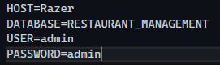

Next, we installed libraries such as SQL Client, ReportViewer, DotNetEnv by navigating to Nuget Packages 🡪 Browse.

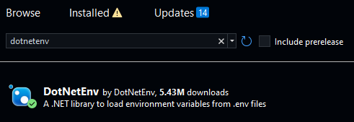

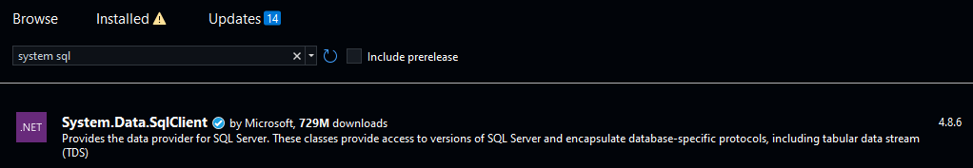

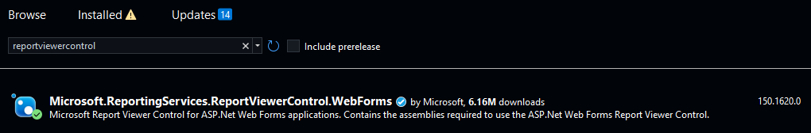

# CHAPTER 3

# FUNCTIONAL COMPONENTS OF RESTAURANT MANAGEMENT

## Login Page

The system required users to login to the application. If the user’s role is administrator, the system will redirect to Administrator Page, or else the system redirect user to default Staff Page.

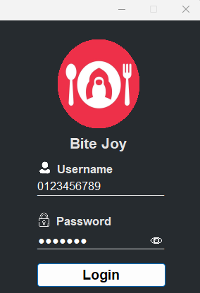

Flow chart:

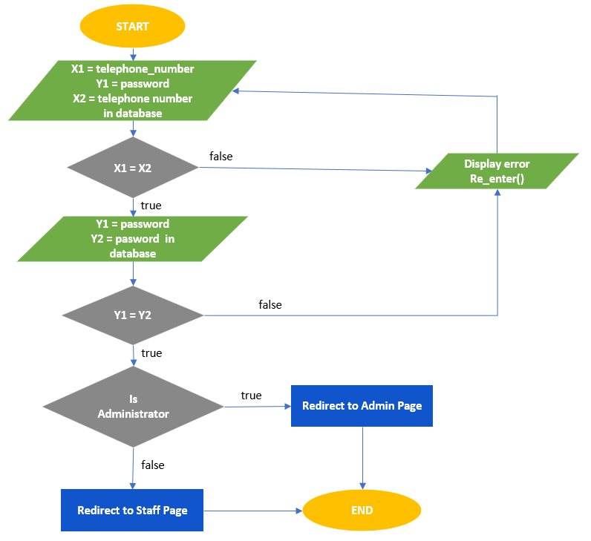

The system handles error when either phone number or password is not available in the database, and when phone or password field are empty.

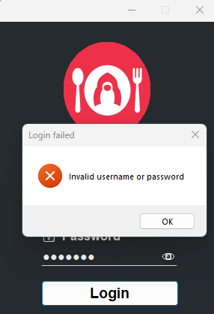 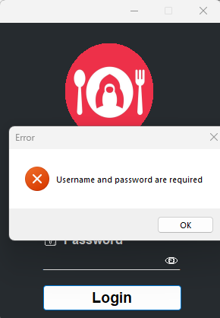

## Administrator Page

### Dashboard Page

After successfully login to the Administrator Page, the Dashboard Page will be showed by default and display the financial report for a particular branch or all branches.

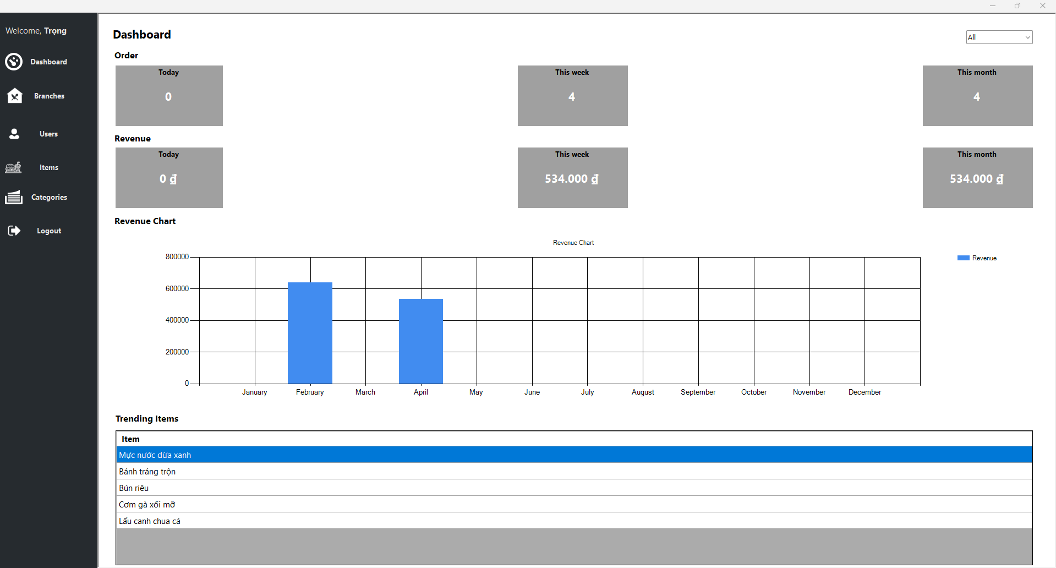

Administrator can select which branch report should be displayed; the system will display all branches first by default.

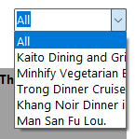

The system displays Orders and Revenue by today, this week, and current month respectively.

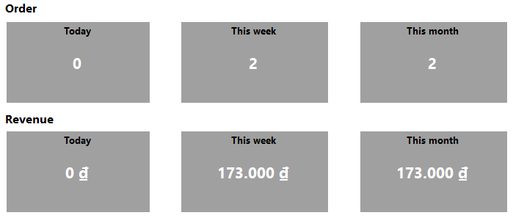

The system display Revenue chart for each month in current year.

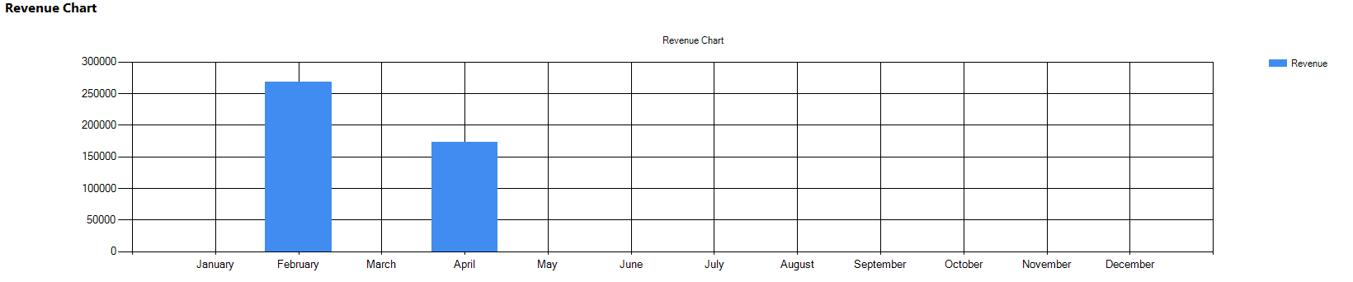

The system will use bill details as a method to calculate the products which mostly taken order from customers for each branch.

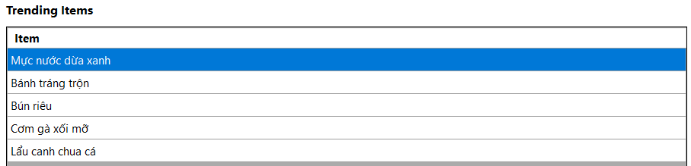

### Branches Page

Branches page allows administrators to manage their branches such as add, update, delete, display branches.

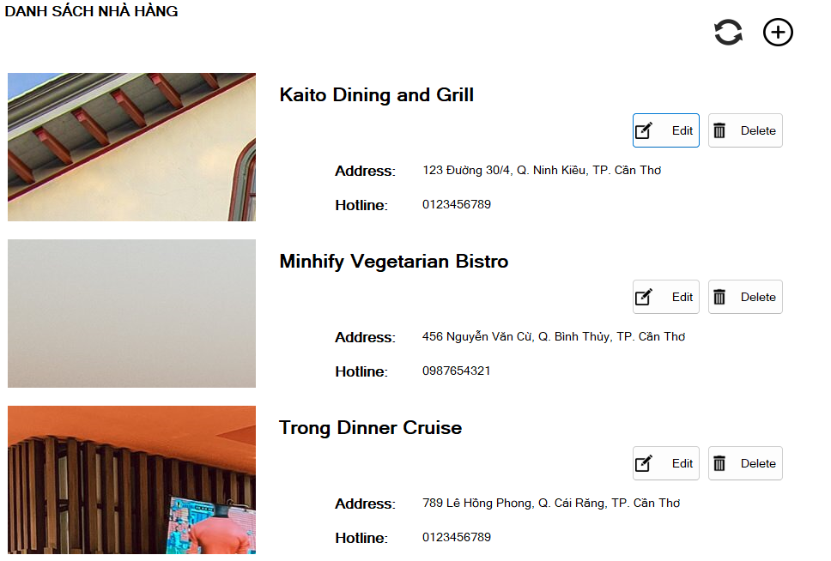

Add a new branch interface, the system will take a new id and assign it in the id textbox.

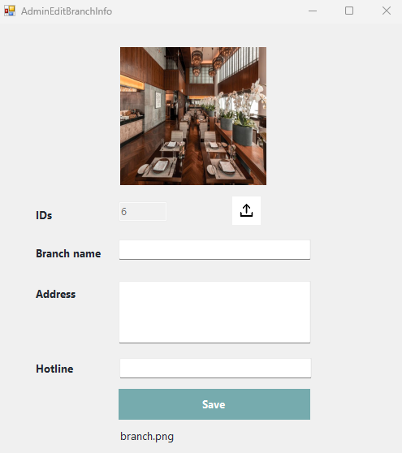

Update current branch interface, the system will take that branch information and assign to the textbox.

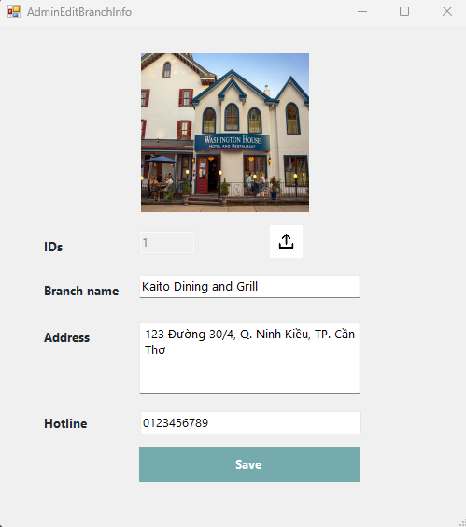

When clicking on delete button, there will be a confirmation asking if administrator want to confirm this operation.

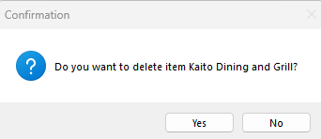

### Staff Management Page

In this page, administrators can list all staff members by their role and their current branch they work on.

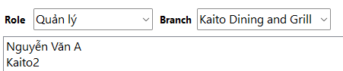

Administrator can add a new staff member by clicking on a new button.



Administrator update staff member by clicking on their name on the list.

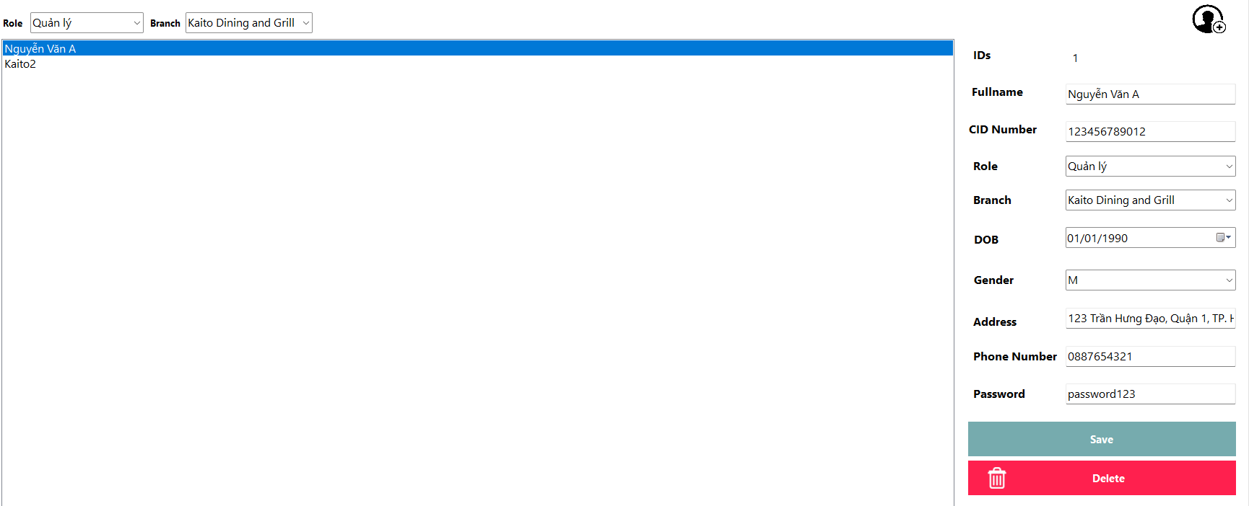

Administrator can also delete staff member by clicking on Delete button, which also display confirmation if they want to confirm this operation.

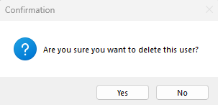

### Menu Item Page

Menu Item Page will display all foods and beverages information in a custom view.

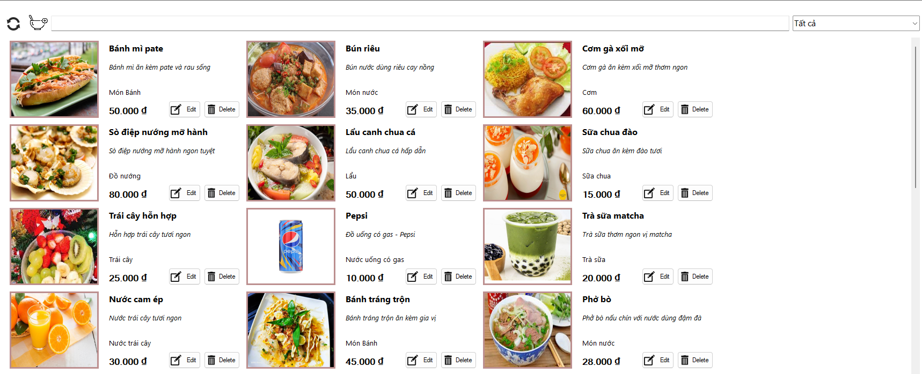

Administrators can filter out products based on their category, or search by their title.

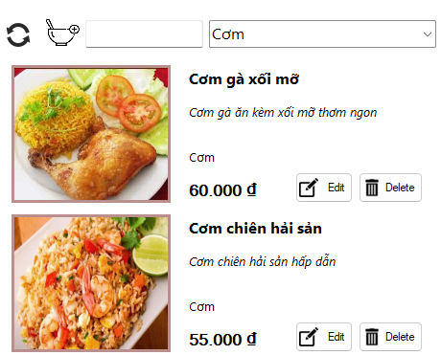 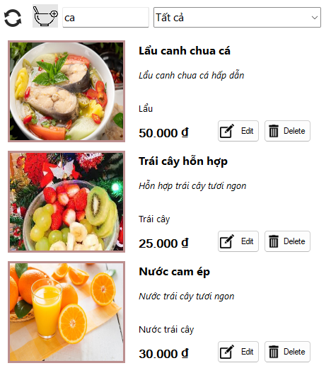

When clicking on the add a new product button. A new dialog will create and assign new id for its id. Also, a picture with bread will be used as default. When clicking on the Edit button. The system will take that product’s information and assign its values to the textbox.

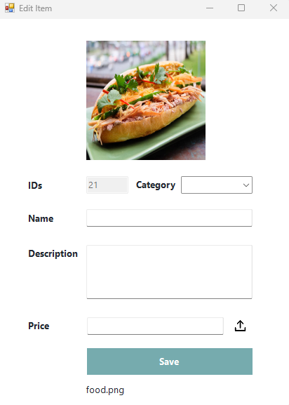 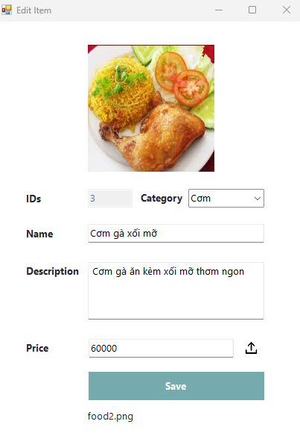

When clicking on the delete button, there will display confirmation if they want to confirm this operation.

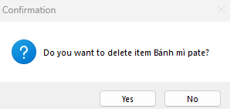

### Category Management Page

In this page, administrators can add, update, delete detail category based on the available category in the database. Category named “Món khai vị” will be displayed as default.

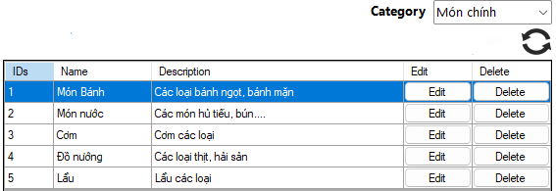

There is also a form for administrator to add a new detail category.

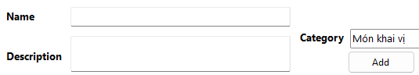

For each item on the DataGridView table, there will be 2 button to Edit and Delete. Administrator can edit its name and description inside the row.

## Order Page

### Table

In this option, staff members can choose 2 types of orders (Takeaway and Inside). If it is takeaway then the system will not display tables. On the other hand, inside mode will display all tables.

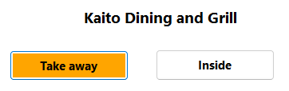 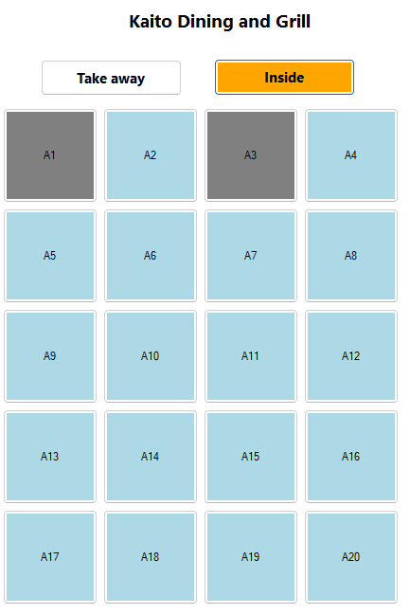

In some situation, customers request for a table arrangement, staff members can click on that table, and pick a new table from the combobox.

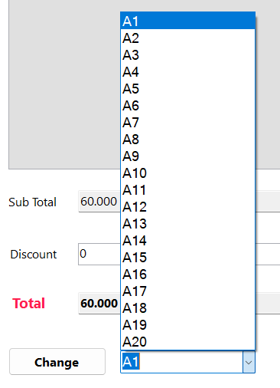

### Order Details.

When customers take an order, staff members can click on the empty tables (blue table means empty), and select order button, which allows staff members to add menu items on the list to that table. Here is the example for table A4.

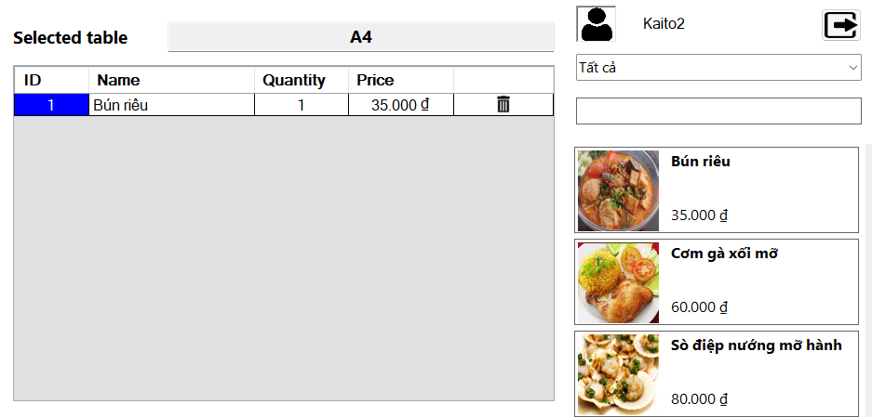

After the menu item is added to the list, sub total field will be calculated automatically by mulplying between quantity and price for each item. The discount field is typed manually, then the total field is updated.

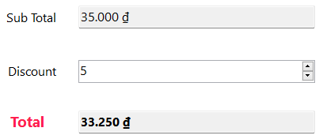

### Print and Pay bills.

The bill details will be shown if the staff click on Bill button. When customers pay for the bills, staff members can click on the Pay button, after that the table status is changed to empty, and the bill status is updated to paid.

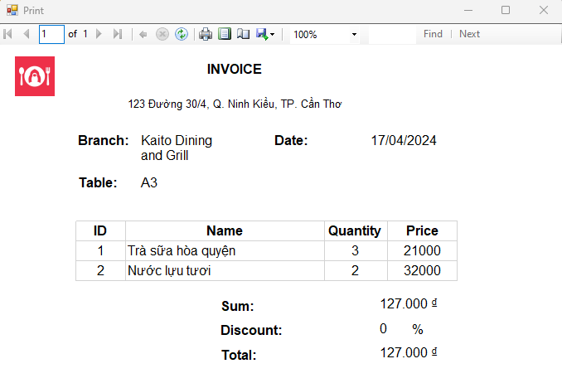

### Flowchart.

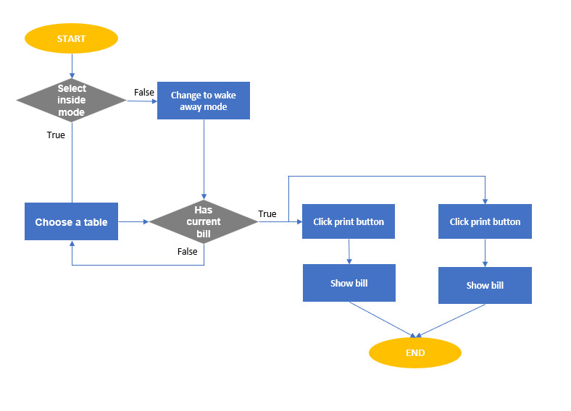

# CONCLUSION

## 1. Result Achievement

* We have successfully build an restaurant management application with .NET using Winform. There are several noticeable features such as:
  + Add, Update, Delete Branches, Staff members, Menu Items, Categories, search and filter function. The system displays financial report for each branche.
  + Staff members take orders from both takeaway and dining at the table, they can choose the menu items on the list and add them into the bill for that table (except takeaway). Then, customers pay for the bills, the staffs now can choose that table and comfirm that transaction. If the users request for a invoice, staffs can print out a PDF file showing that transaction.

## 2. Future development.

* Improving user-friendly interface, enchancing system performance and security.
* Adding new features such as Inventory management, Table management.

# REFERENCES

|  |  |
| --- | --- |
| [1] | Sells, Chris, and Justin Gehtland. Windows forms programming in Visual Basic. NET. Addison-Wesley Professional, 2004. |
| [2] | McDonald, Brian, Shawn McGehee, Rodney Landrum, Brian McDonald, Shawn McGehee, and Rodney Landrum. "Rendering Reports from. NET Applications." Pro SQL Server 2012 Reporting Services (2012): 243-278. |
| [3] | Mistry, Ross, and Stacia Misner. Introducing Microsoft SQL Server 2014. Microsoft Press, 2014. |
|  |  |