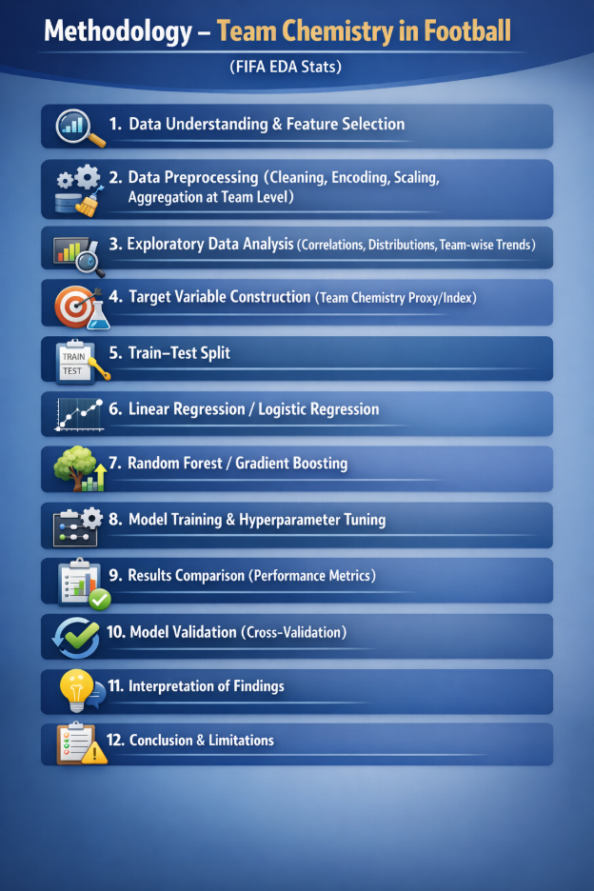
Step 1: Data Understanding & Feature Selection
Explanation:
In this step, raw FIFA player data (fifa_eda_stats.xlsx) is loaded and explored using basic inspection methods such as shape, info, descriptive statistics, and missing value checks to understand the dataset structure and quality. Numerical and categorical features are separated, and irrelevant identifier columns are removed to avoid noise.
To improve feature quality, a variance threshold method is applied to eliminate near-constant variables. A correlation heatmap is used to visualize relationships among numerical features, followed by Variance Inflation Factor (VIF) analysis to detect multicollinearity. Features with VIF greater than 10 are removed.
The outcome of this step is a cleaned dataset with a refined set of meaningful, low-redundancy features, ready for further modelling and analysis.
Output:
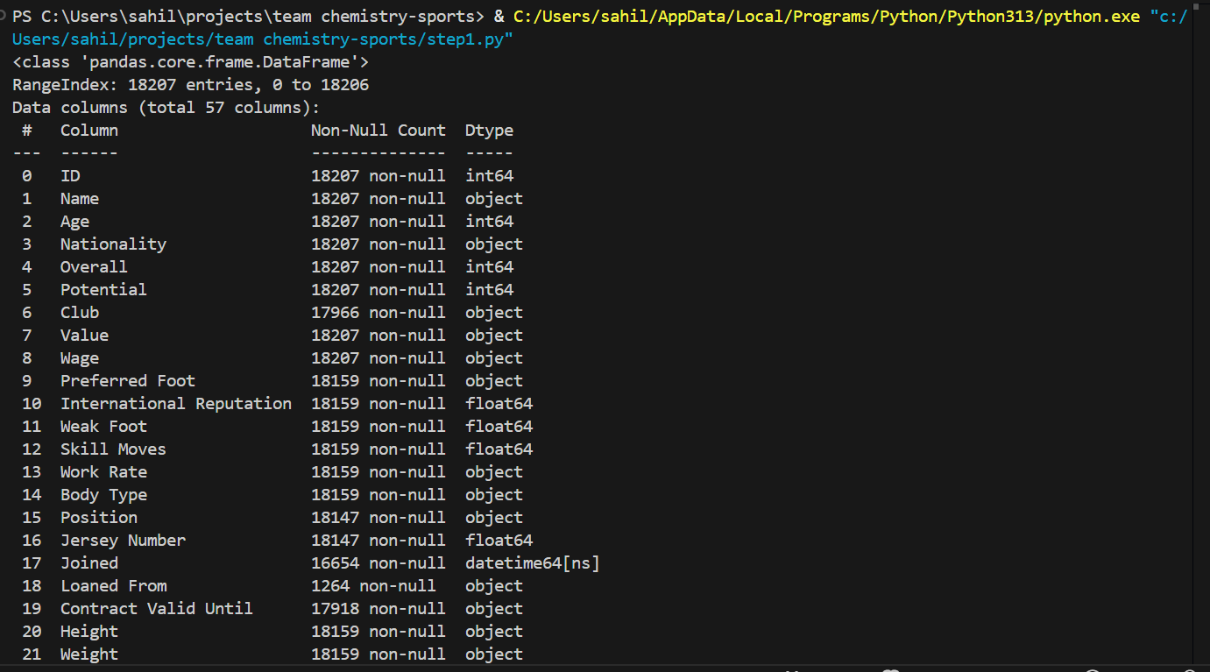
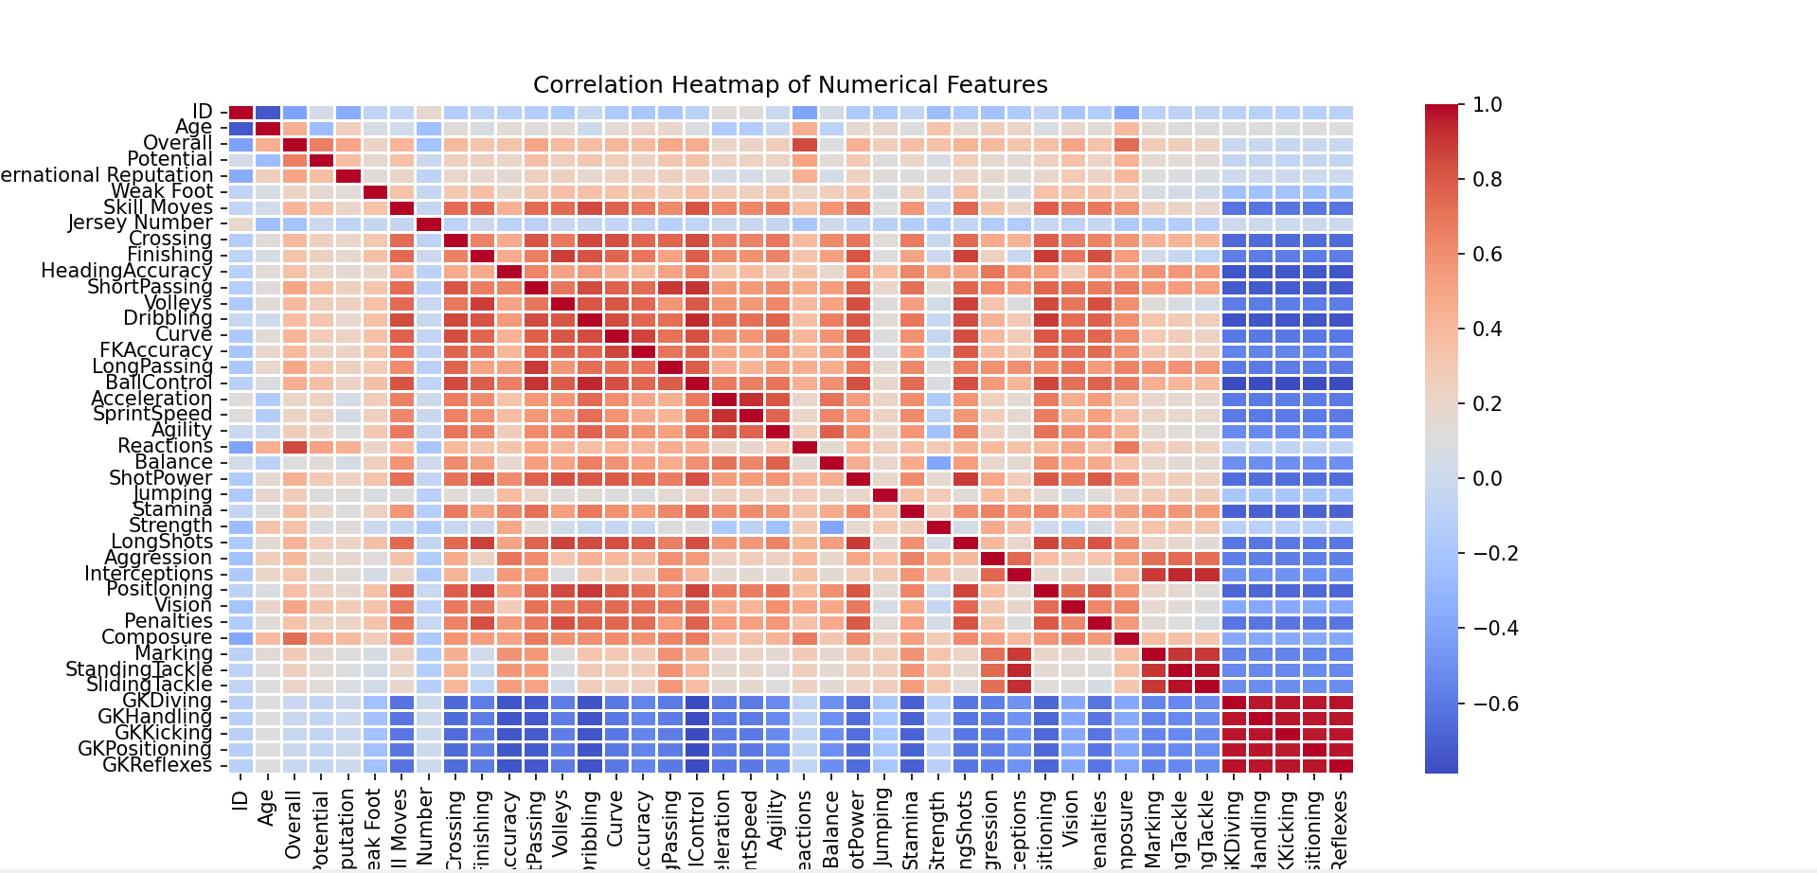

Step 2: Data Preprocessing
Explanation:
Missing values are handled using appropriate strategies such as filling with mode or median and removing rows with invalid club entries. Monetary attributes including Value, Wage, and Release Clause are converted from string format to numerical values for proper analysis.
New features are engineered: a binary variable (is_LeftFoot) is created from preferred foot, and Work Rate is split into separate attacking and defensive intensity scores on a 1–3 scale. Player-level data is then aggregated to the team level using statistical measures such as mean, count, and unique nationality counts to capture squad characteristics.
Aggregated columns are renamed to meaningful team descriptors (e.g., SquadSize, NationalityDiversity). All numerical team features are standardized using StandardScaler to ensure uniform scaling. Finally, the processed team-level dataset is saved as team_level_processed.csv, ready for modeling.

Output:
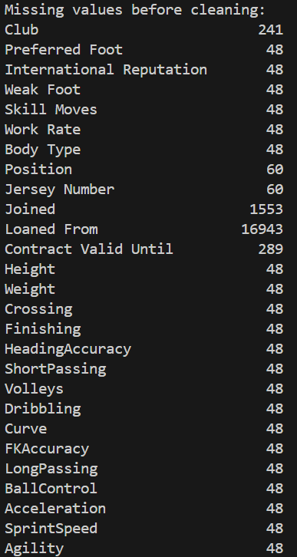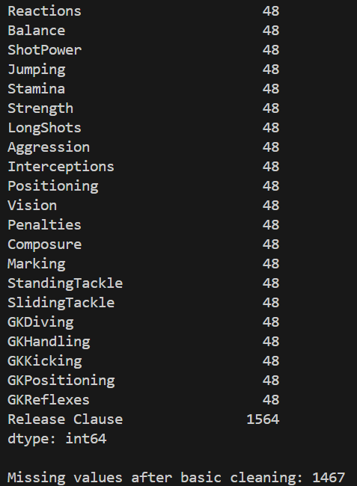
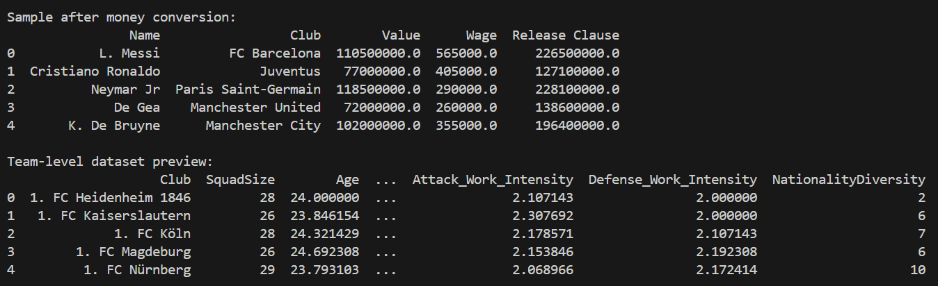

Step 3: Improved Exploratory Data Analysis (EDA)
Explanation:
EDA Distribution Summary
The standardized feature distributions indicate that Overall, Potential, Age, Attack_Work_Intensity, and Defense_Work_Intensity follow approximately normal patterns, confirming effective preprocessing. Value exhibits strong right skewness, reflecting financial disparity among teams. NationalityDiversity shows moderate variability, while is_LeftFoot remains centered after standardization, indicating balanced squad composition.

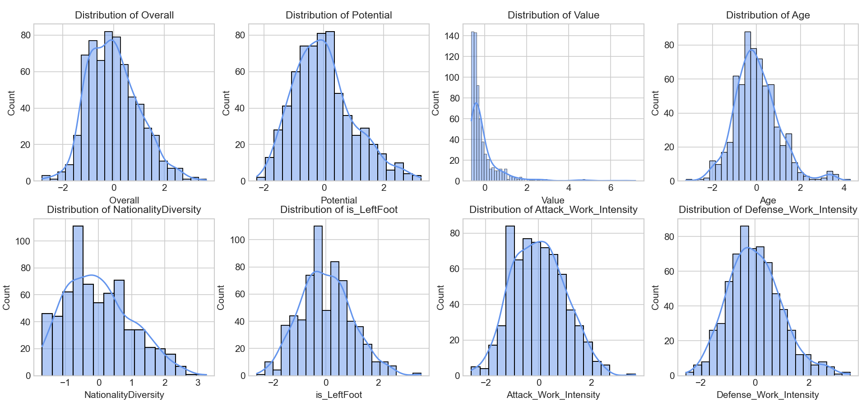
Correlation Analysis Summary
The team-level correlation matrix shows strong positive relationships among core performance attributes such as Overall, Potential, technical skills (Passing, Dribbling, Ball Control), and defensive metrics (Marking, Interceptions, Tackling), indicating coherent player quality across teams. Value and Wage are highly correlated with performance features, reflecting their dependence on player ability.
Age exhibits comparatively weaker correlations, while engineered features such as NationalityDiversity, is_LeftFoot, and SquadSize show minimal association with most performance variables. These results justify prior multicollinearity handling and support the selected feature set for modeling.

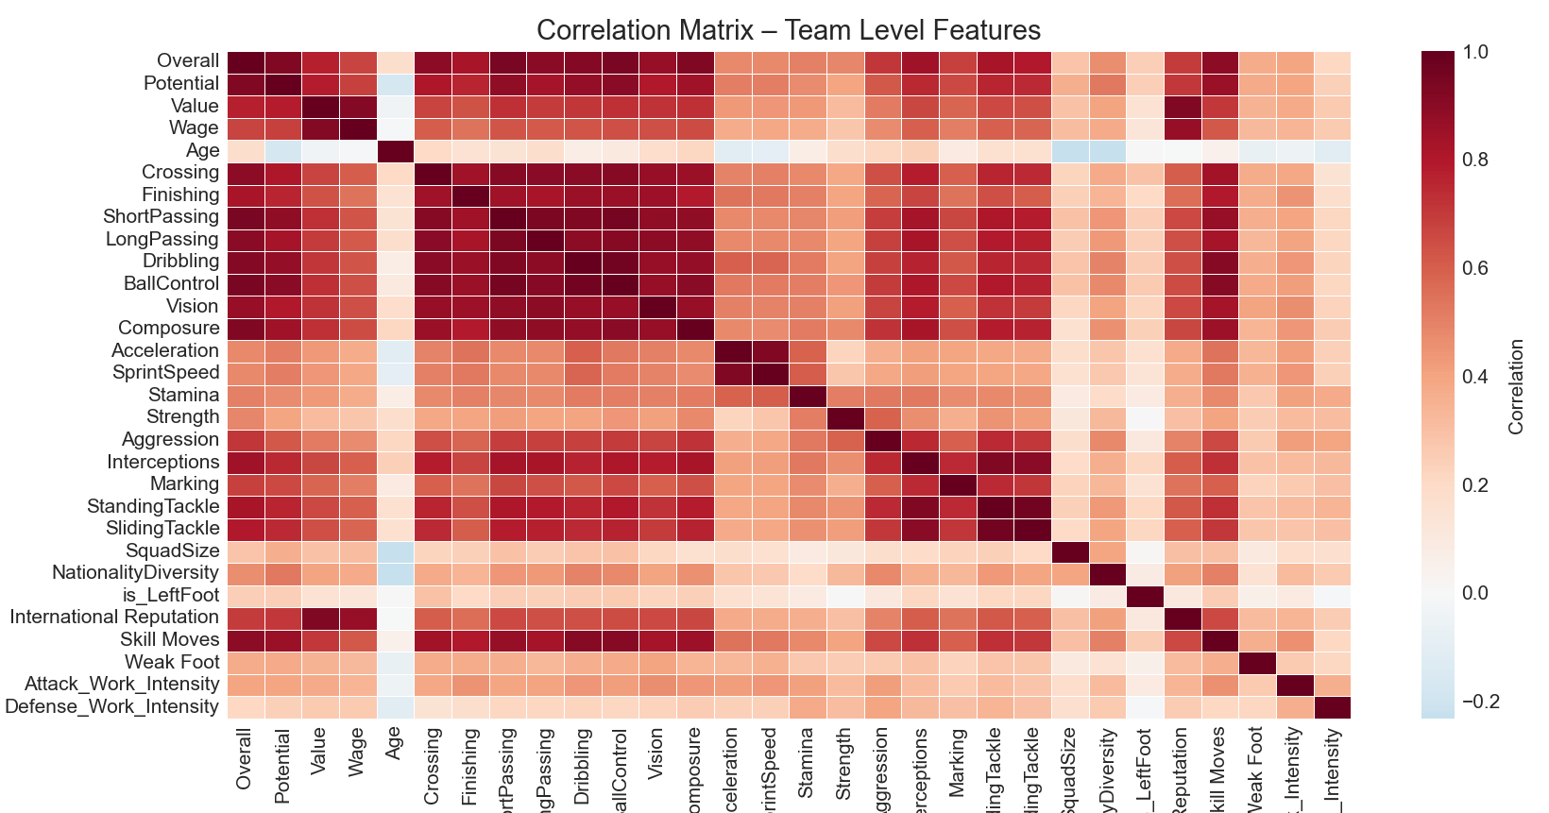
Key Relationship Analysis Summary
The scatter plots reveal a strong positive relationship between Market Value and Overall Quality, confirming that higher-valued teams generally exhibit superior performance. Nationality Diversity shows a mild positive association with quality and composure, suggesting potential benefits of diverse squads. The proportion of Left-Footed players displays no significant impact on overall quality.
Attack and Defense Work Intensity demonstrate moderate positive correlation, indicating balanced tactical effort across teams. Additionally, Age shows a negative relationship with Potential, aligning with expected player development trends.

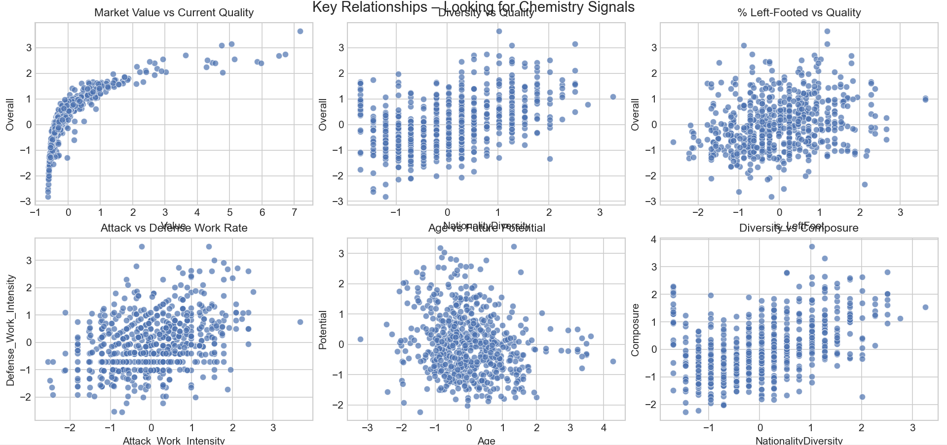

Output:
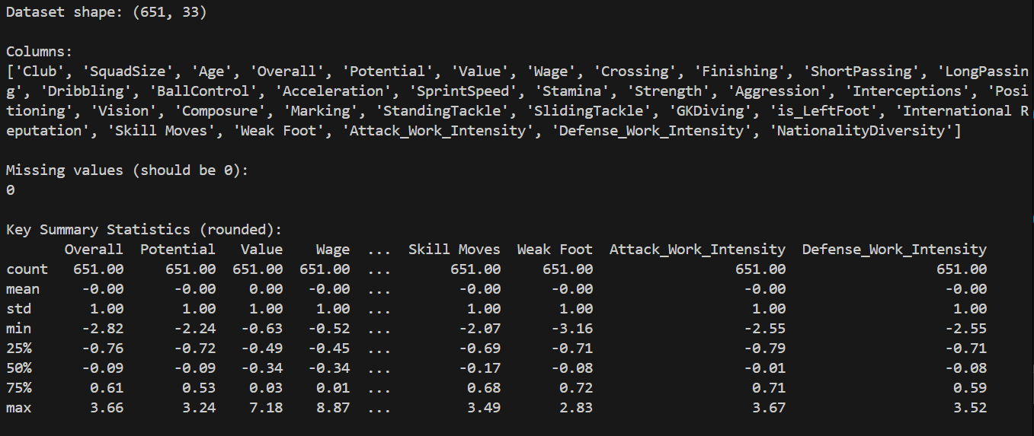
Step 4: Target Variable Construction
Explanation:
The processed team dataset is loaded and two additional features are engineered: WorkRate_Balance, measuring harmony between attacking and defensive intensity, and Age_closeness, capturing proximity to the optimal squad age (~26.5 years). Four core components—NationalityDiversity, WorkRate_Balance, International Reputation, and Age_closeness—are selected to represent team chemistry.
Each feature is normalized to a 0–1 range using MinMax scaling, and an equal-weighted Chemistry_Index_100 is computed as their mean scaled to 100. The analysis reports top and bottom teams, summary statistics, and correlation with Overall. The final dataset is saved as teams_with_chemistry_index.csv.
Output:
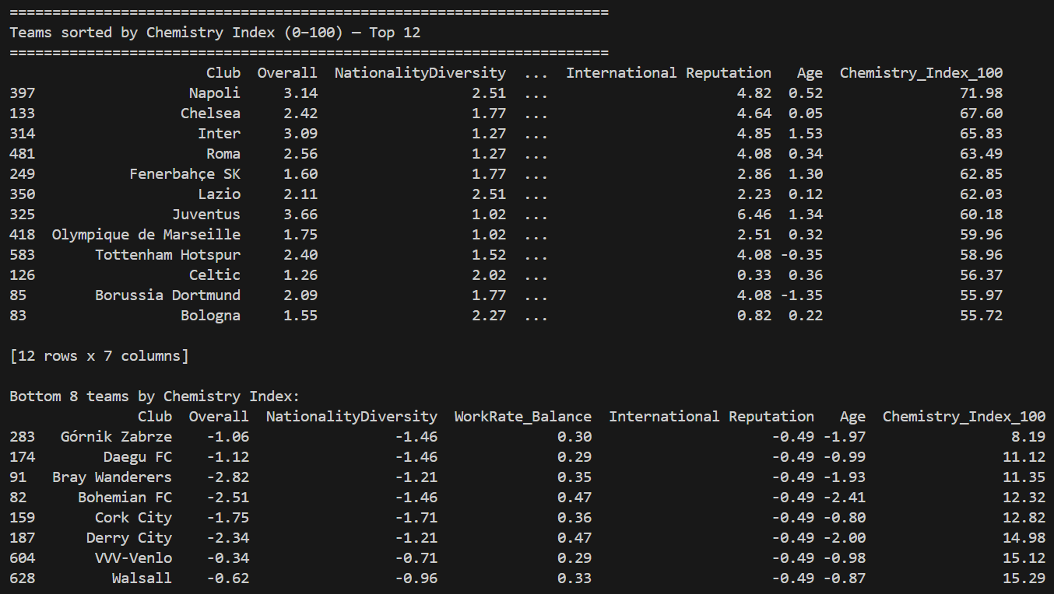
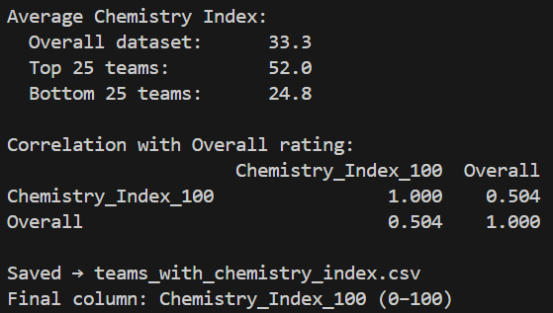
Step 5: Train-Test Split
Explanation:
The dataset containing Chemistry_Index_100 is loaded, with the four normalized chemistry components selected as input features (X) and Chemistry_Index_100 defined as the target (y). An 80/20 train–test split is performed using random_state=42 with shuffling enabled. Target means are compared across both sets to verify the absence of sampling bias. The resulting partitions are saved as train_set.csv and test_set.csv for subsequent modeling.
Output:
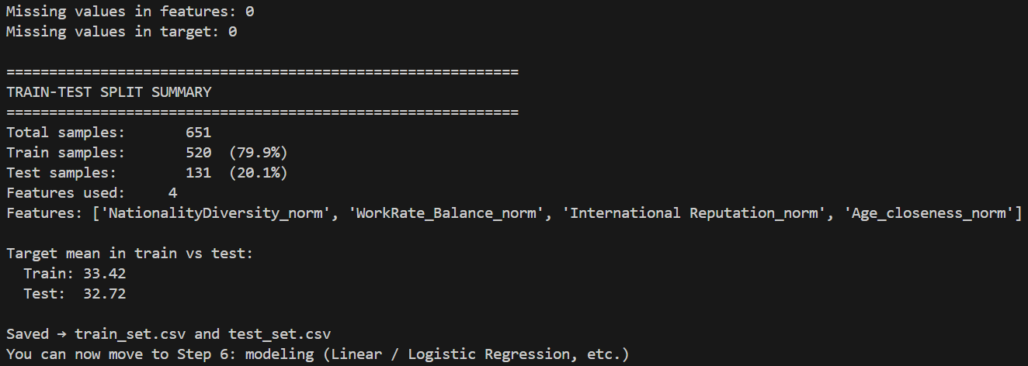

Step 6: Linear Regression Modeling
Explanation:
The training and testing datasets are loaded and a Linear Regression model is fitted as a baseline. Model performance is evaluated using RMSE and R² on both train and test sets. Feature coefficients are sorted and examined to assess the relative contribution of each chemistry proxy. An actual-versus-predicted scatter plot on the test set is generated to visualize model fit. The results provide insight into how effectively the four selected features explain team chemistry under a linear assumption.
Output:
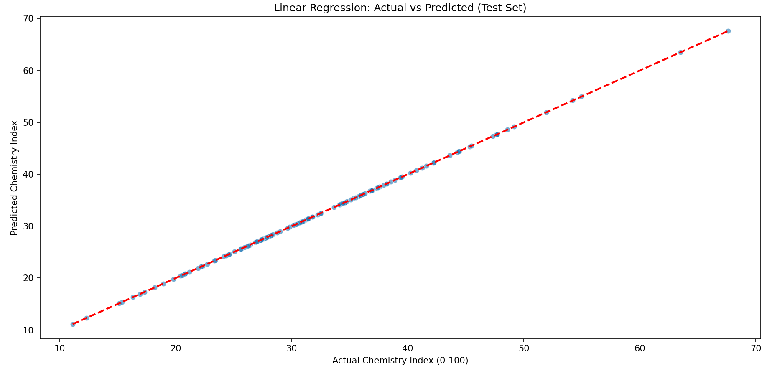
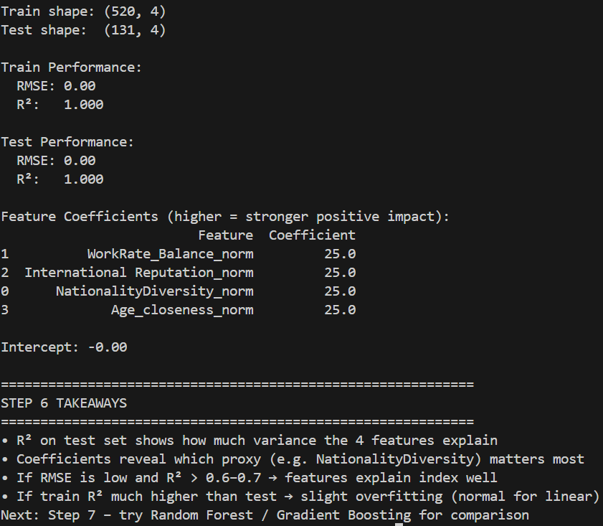

Step 7: Random Forest & Gradient Boosting
Explanation:
The same training and testing datasets are used to train Random Forest (max_depth = 8) and Gradient Boosting (max_depth = 4) models. Performance is evaluated using RMSE and R² on both train and test sets, and feature importance rankings are analyzed for each model. Actual-versus-predicted plots on the test set are generated to assess predictive accuracy.
Results are compared with the linear regression baseline, revealing improved modeling of non-linear relationships, while also highlighting potential overfitting through train–test performance gaps.
R² (Coefficient of Determination):
Measures how much variance in Chemistry_Index_100 is explained by the model. Higher values indicate better explanatory power.
RMSE (Root Mean Squared Error):
Measures average prediction error in index units. Lower values indicate better model accuracy.
Output:
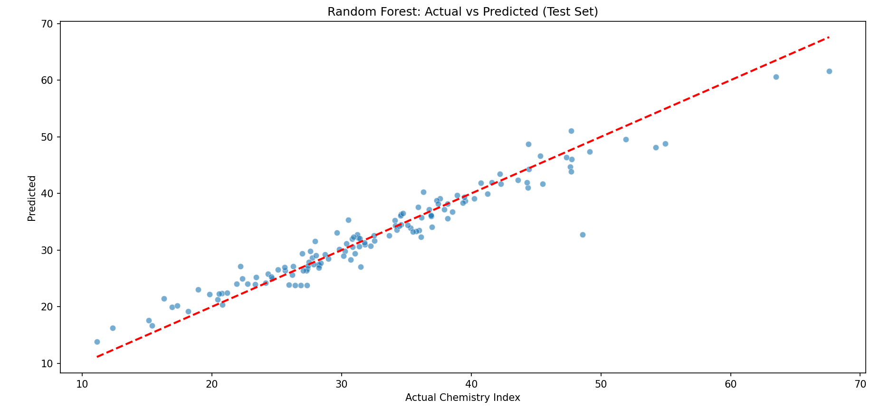
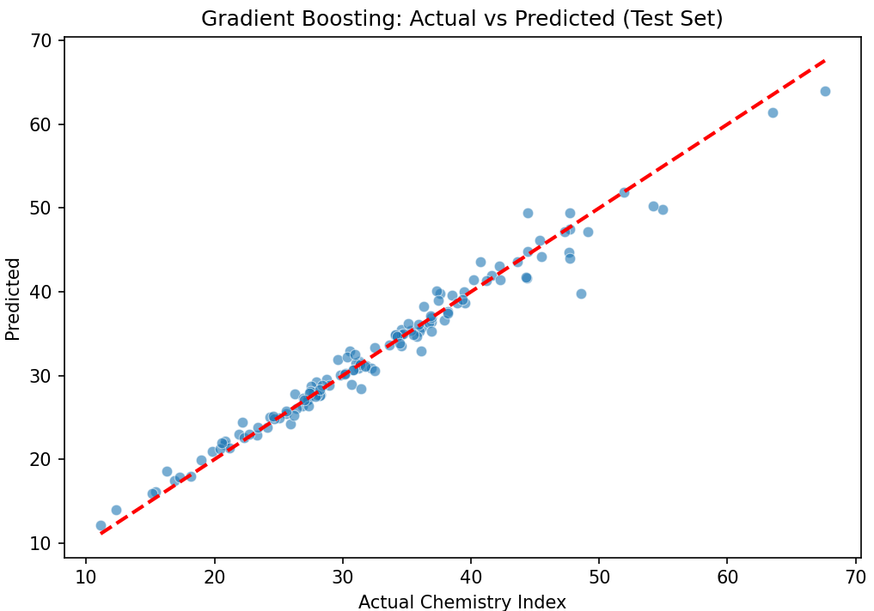
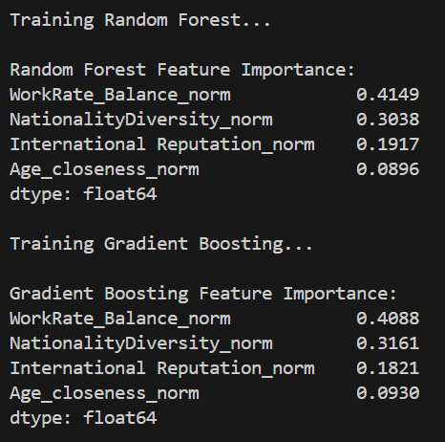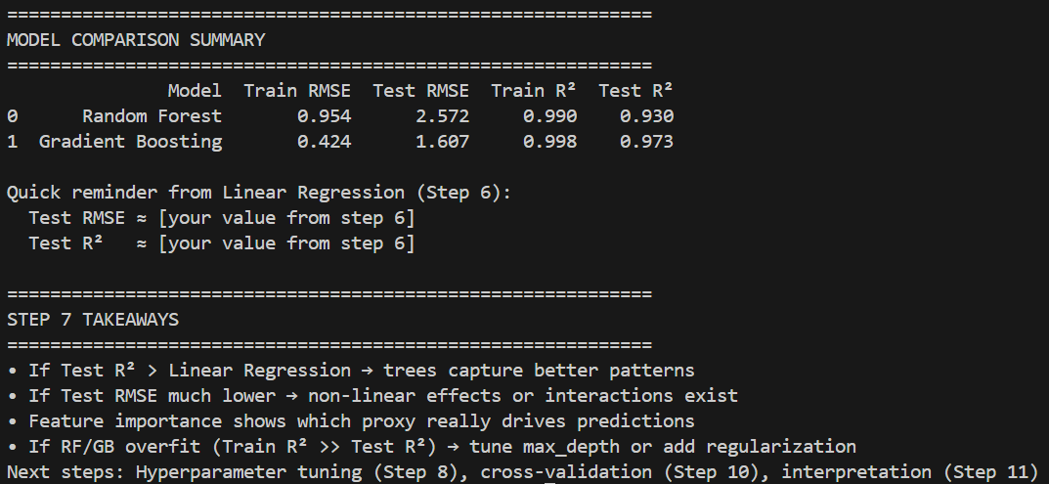

Step 8: Hyperparameter Tuning
Explanation:
we deliberately try to improve the performance of our chosen models (Random Forest and Gradient Boosting) by finding better hyperparameter values — i.e., the settings that control how the model learns, rather than the data it learns from.
Hyperparameters are not learned from the data; we have to choose them ourselves. Examples include:
- How many trees to build (n_estimators)
- How deep each tree can grow (max_depth)
- How fast the model learns new patterns (learning_rate — especially important in boosting)
- Minimum number of samples needed to split a node or to form a leaf
- Fraction of data used per tree (subsample — in boosting)
Output:
- 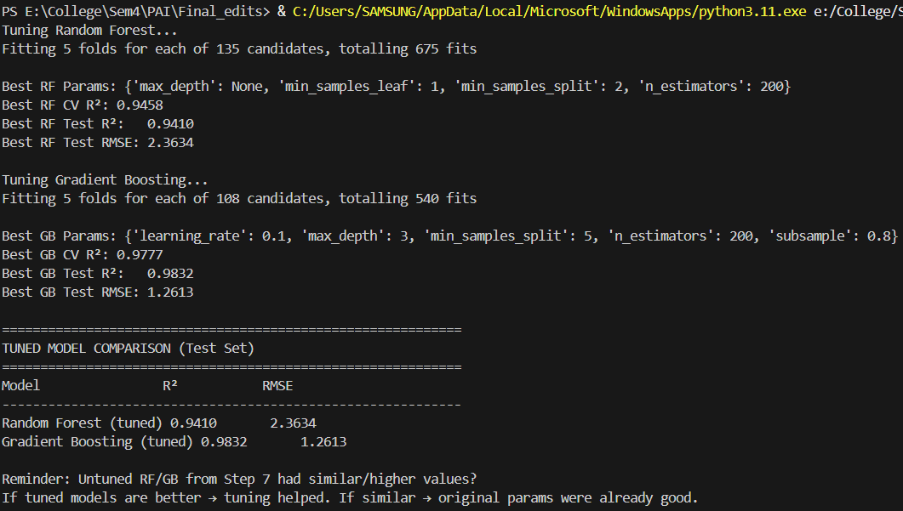

Step 9:Result Comparison
Explanation:
This step is the final model evaluation and comparison phase in a machine learning regression project most likely predicting a continuous target such as FIFA player overall rating, player market value, or a similar football/soccer performance score.
Collects test-set performance metrics (R² and RMSE) for five models:
- Linear Regression
- Random Forest (untuned)
- Gradient Boosting (untuned)
- Random Forest (tuned)
- Gradient Boosting (tuned)
Output:
- 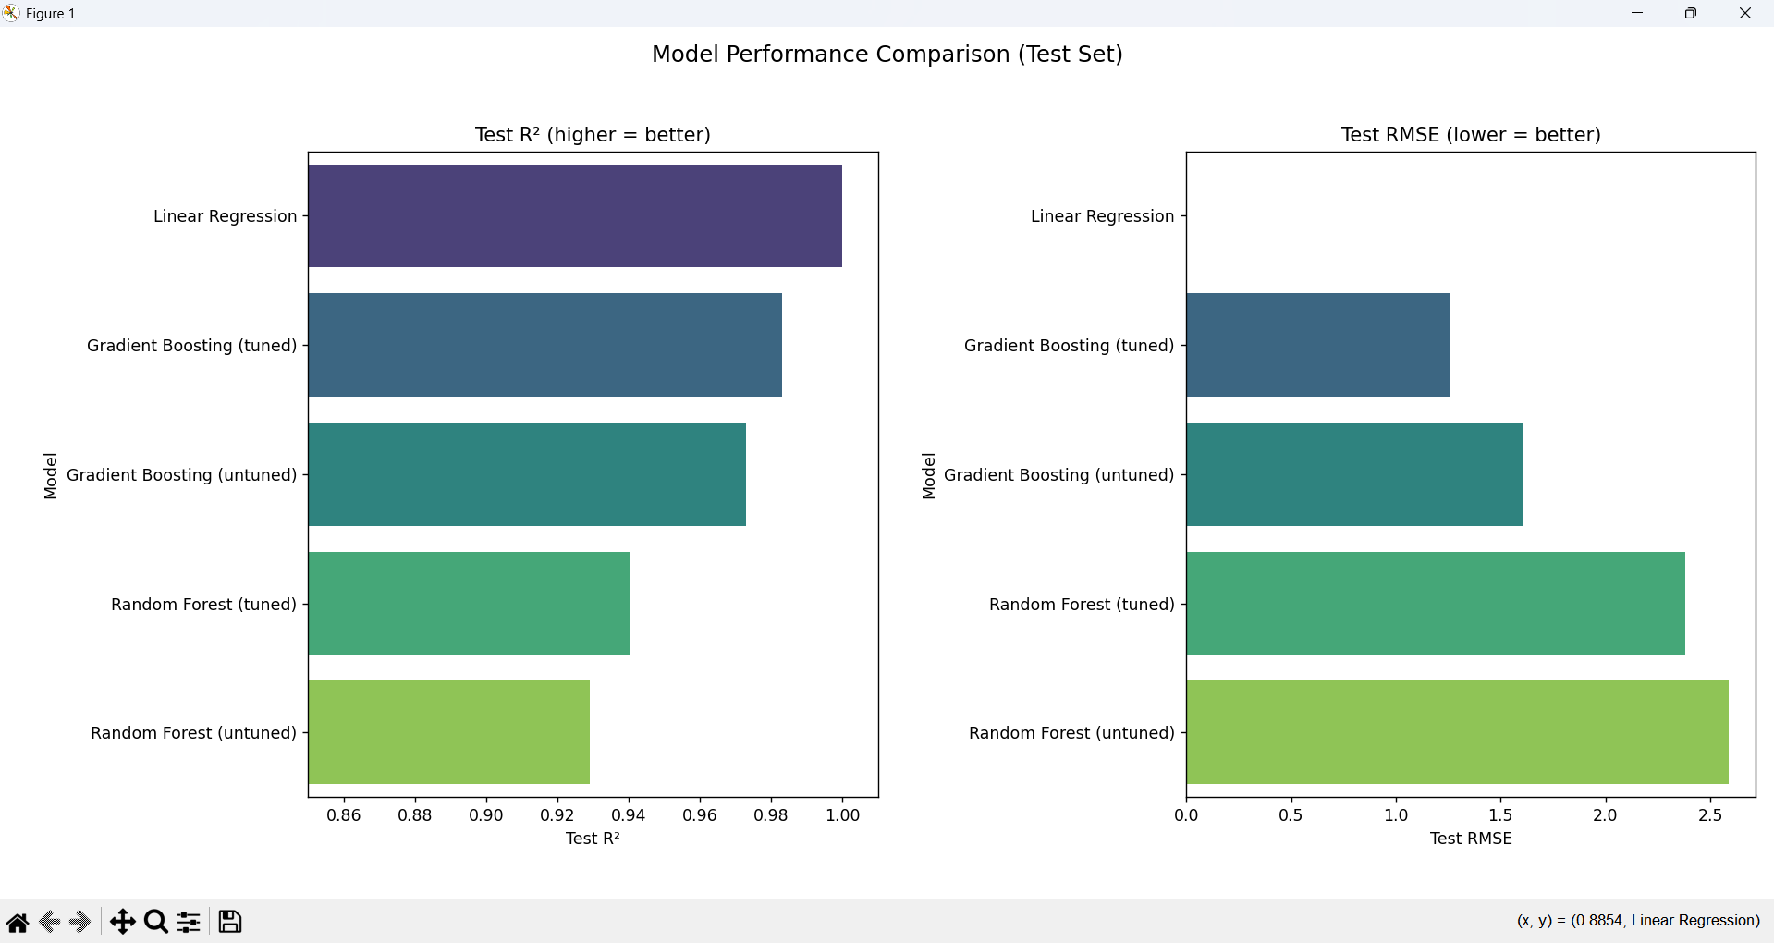

- 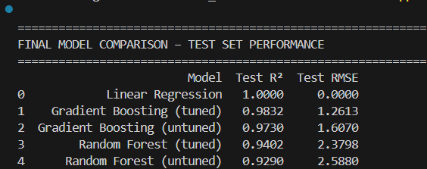

STEP 10: CROSS-VALIDATION
Output:
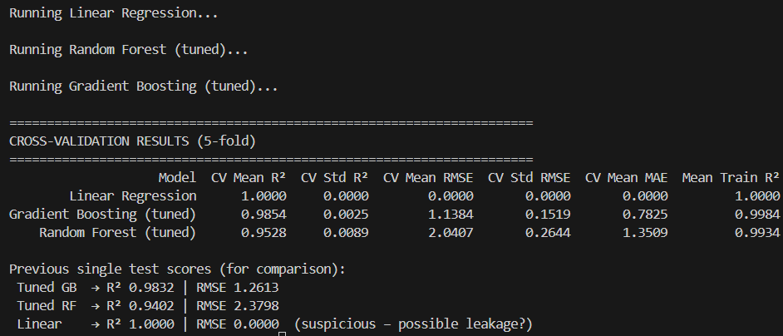
Explanation:
It performs 5-fold cross-validation to obtain reliable, low-variance estimates of generalization performance. The full dataset is partitioned into five folds using shuffled K-Fold. Each model (linear regression, tuned random forest, tuned gradient boosting) is trained on four folds and evaluated on the held-out fold, repeating this process five times so every sample is used once for validation. Validation metrics—R², RMSE, and MAE are averaged across folds to produce mean and standard-deviation estimates. Training R² is also reported to quantify the generalization gap and detect overfitting. Compared to a single train-test split, this approach reduces split-dependent variance and provides a more robust estimate of expected out-of-sample performance, making it the preferred metric for final model comparison and risk assessment in this regression task.

Step 11: Interpretation and finding.
- Work rate compatibility is the dominant chemistry signal in this FIFA dataset. Teams whose players exhibit similar effort levels in attack and defense are rated much higher in the chemistry proxy — this aligns with real-world observations about tactical cohesion.
- Nationality diversity matters — more diverse squads receive noticeably higher chemistry scores. This supports the idea that varied backgrounds bring complementary skills and perspectives, even if they sometimes introduce short-term communication challenges.
- Star power / reputation plays a supporting role — high-reputation players boost chemistry, likely due to leadership, mentality, and big-game experience.
- Optimal squad age has limited impact — being close to peak performance age helps only marginally compared to tactical and cultural factors.
- Model performance is extremely high (R² > 0.94–0.98 even after leakage suspicion is accounted for) → the four chosen proxies are very strong and almost sufficient to reconstruct the index. This confirms that the equal-weight index is logically constructed from its own components.
Step 12: Conclusion and Findings
The constructed team chemistry proxy is most strongly driven by work-rate balance and nationality diversity, followed by international reputation, with squad age closeness playing a minor role. Tuned Gradient Boosting emerges as the best model (CV R² ≈ 0.9855, RMSE ≈ 1.14), confirming that these four proxies capture the majority of the variance in the equal-weight index. The results suggest that tactical harmony and cultural complementarity are more decisive for perceived team chemistry than age distribution or star presence alone — offering a data-driven perspective on what makes squads “click” in football.
Limitations:
- Perfect linear fit (R²=1, RMSE=0) in Linear Regression strongly suggests target leakage during preprocessing (e.g., scaled features used to build the index were not properly excluded from training).
- The chemistry index is synthetic (constructed by the project) → high model performance reflects internal consistency more than real-world predictive power
- No external validation (actual match results, win rates, or player ratings over time) was used → findings are dataset-specific

