CREATE A TABLE WITH THE MENTIONED FIELD VALUES

CREATE TABLE flights (`Year` int,

`Month` int,

`DayofMonth` int,

`DayOfWeek` int,

`Carrier` string,

`OriginAirportID` int,

`OriginAirportName` string,

`OriginCity` string,

`OriginState` string,

`DestAirportID` int,

`DestAirportName` string,

`DestCity` string,

`DestState` string,

`CRSDepTime` int,

`DepDelay` int,

`DepDel15` int,

`CRSArrTime` int,

`ArrDelay` int,

`ArrDel15` int,

`Cancelled` int)

row format delimited fields terminated by ',';

LOAD FLIGHTS.csv data into hive.

cp /mnt/f/assignment/BigData/flights2.csv ~/

hdfs dfs -put flights2.csv ./tmp

LOAD DATA LOCAL INPATH 'flights2.csv' OVERWRITE INTO TABLE flights;

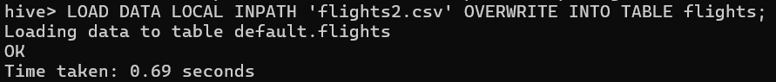

select * from flights limit 10;

describe flights;

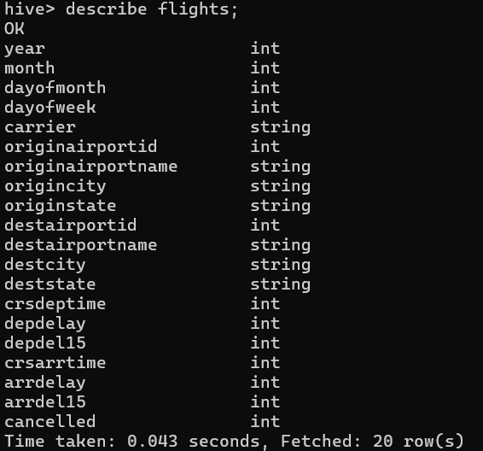

Write Hive Query to

Find the top 2 busiest airports based on the total number of flights departing from or arriving at each airport.

Report the airport code along with the total number of flights.

SELECT

airport_id,

airport_name,

SUM(total_flights) AS total_flights

FROM (

SELECT

originairportid AS airport_id,

originairportname AS airport_name,

COUNT(*) AS total_flights

FROM

flights

GROUP BY

originairportid, originairportname

UNION ALL

SELECT

destairportid AS airport_id,

destairportname AS airport_name,

COUNT(*) AS total_flights

FROM

flights

GROUP BY

destairportid, destairportname

) t

GROUP BY

airport_id, airport_name

ORDER BY

total_flights DESC

LIMIT 2;

Write Hive Query to

Find the longest flight duration (in minutes) for each unique carrier.

Report the carrier along with the longest flight duration.

SELECT

carrier,

MAX(crsarrtime - crsdeptime) AS longest_flight_duration_minutes

FROM

flights

GROUP BY

carrier;

SELECT

carrier,

MAX(crsdeptime - crsarrtime) AS shortest_flight_duration_minutes

FROM

flights

GROUP BY

carrier;

Write Hive Query to

Determine the day of the month with the highest number of flights.

Report the day along with the total number of flights.

SELECT

dayofmonth,

COUNT(*) AS num_flights

FROM

flights

GROUP BY

dayofmonth

ORDER BY

num_flights DESC

LIMIT

1;

