CREATE A TABLE WITH THE MENTIONED FIELD VALUES

LOAD FLIGHTS.csv data into ubuntu.

cp /mnt/f/assignment/BigData/flights2.csv ~/

hdfs dfs -put flights2.csv ./tmp

flights = LOAD ‘pig/flights2.csv' USING PigStorage(',') AS (

Year: int,

Month: int,

DayofMonth: int,

DayOfWeek: int,

Carrier: chararray,

OriginAirportID: int,

OriginAirportName: chararray,

OriginCity: chararray,

OriginState: chararray,

DestAirportID: int,

DestAirportName: chararray,

DestCity: chararray,

DestState: chararray,

CRSDepTime: chararray,

DepDelay: float,

DelDelay15: int,

CRSArrTime: chararray,

ArrDelay: float,

ArrDelay15: int,

Cancelled: int

);

dump flights;

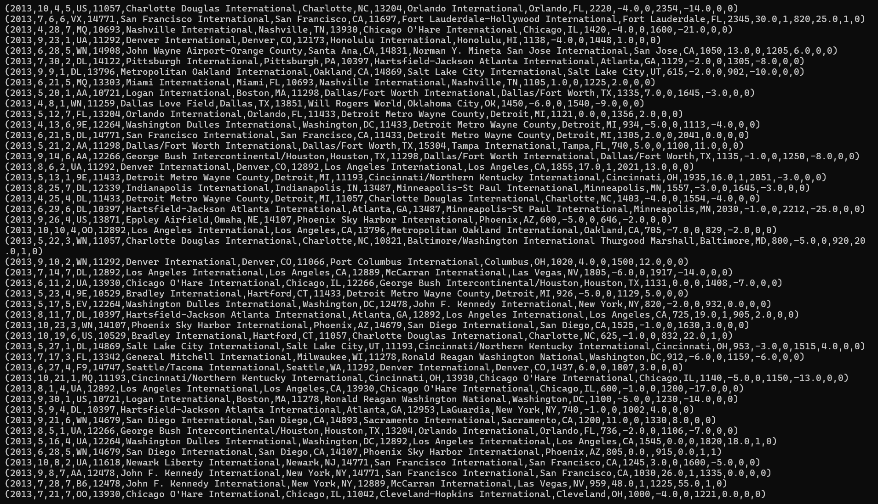

illustrate flights;

select * from flights limit 10;

describe flights;



TASK 1

CODE:

filtered_flights = FILTER flights BY Cancelled == 0;

grouped_flights = GROUP filtered_flights BY (OriginAirportID, OriginAirportName);

count_flights = FOREACH grouped_flights GENERATE group.OriginAirportID AS airport_id, group.OriginAirportName AS airport_name, COUNT(filtered_flights) AS flight_count;

sorted_flights = ORDER count_flights BY flight_count DESC;

top_airports = LIMIT sorted_flights 2;

dump top_airports;

PROCESS:

OUPTUT:



TASK 2

CODE:

flights_not_cancelled = FILTER flights BY Cancelled == 0;

flights_with_time = FOREACH flights_not_cancelled GENERATE Year, Month, DayofMonth, DayOfWeek, Carrier, OriginAirportID, OriginAirportName, OriginCity, OriginState,((int)SUBSTRING(CRSDepTime, 0, 2)) * 60 + (int)SUBSTRING(CRSDepTime, 2, 2) AS CRSDepTime, DepDelay, ((int)SUBSTRING(CRSArrTime, 0, 2)) * 60 + (int)SUBSTRING(CRSArrTime, 2, 2) AS CRSArrTime, ArrDelay, Cancelled;

flights_with_duration = FOREACH flights_with_time GENERATE Year, Month, DayofMonth, DayOfWeek, Carrier, OriginAirportID, OriginAirportName, OriginCity, OriginState, CRSDepTime, DepDelay, CRSArrTime, ArrDelay, CRSArrTime - CRSDepTime AS FlightDuration;

grouped_by_carrier = GROUP flights_with_duration BY Carrier;

max_duration_by_carrier = FOREACH grouped_by_carrier {

max_duration = ORDER flights_with_duration BY FlightDuration DESC;

max_duration_per_group = LIMIT max_duration 1;

GENERATE group AS Carrier, MAX(max_duration_per_group.FlightDuration) AS LongestFlightDuration;

};

DUMP max_duration_by_carrier;

PROCESS:

OUTPUT:

TASK 3

CODE

flights_per_day = GROUP flights_not_cancelled BY DayofMonth;

flights_per_day_count = FOREACH flights_per_day GENERATE group AS Day, COUNT(flights_not_cancelled) AS FlightCount;

max_day = ORDER flights_per_day_count BY FlightCount DESC;

max_day_with_total = LIMIT max_day 1;

DUMP max_day_with_total;

PROCESS

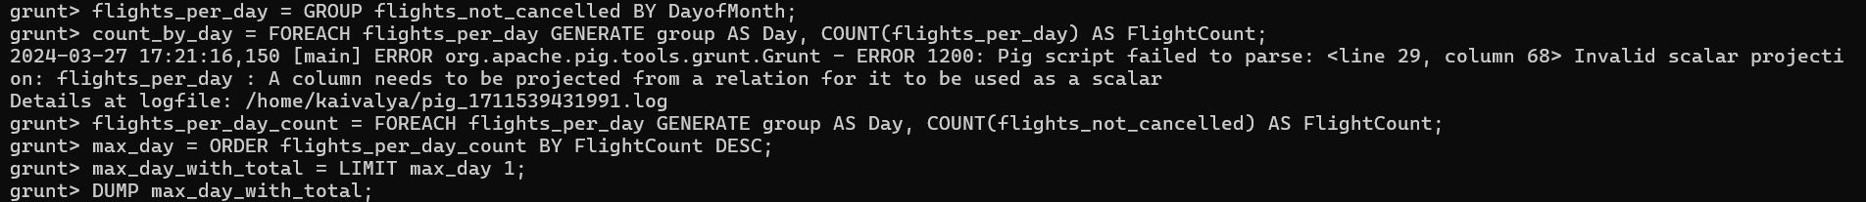

OUTPUT

