

**Data Technician**

|  |
| --- |
|  |

|  |
| --- |
| Name: |
| Course Date: |
|  |

**Table of contents**

Day 1: Task 1 2

Day 1: Task 2 2

Day 2: Task 1 3

Day 2: Task 2 3

Day 3: Task 1 4

Day 3: Task 2 5

Day 4: Task 1 6

Day 4: Task 2 7

Course Notes 7

Additional Information 8

# Day 1: Task 1

Please research the different versions of Tableau, compare and contrast them below and explain the limited functionality on ‘Tableau Public’.

|  |  |
| --- | --- |
| Different Tableau versions |  |

# Day 1: Task 2

Using the *EMSI_JobChange_UK* dataset, create your own dashboard, I want to see a bar chart showing percentage change and a UK based map showing the key city locations impacted.

|  |  |
| --- | --- |
| Paste your print screen here |  |

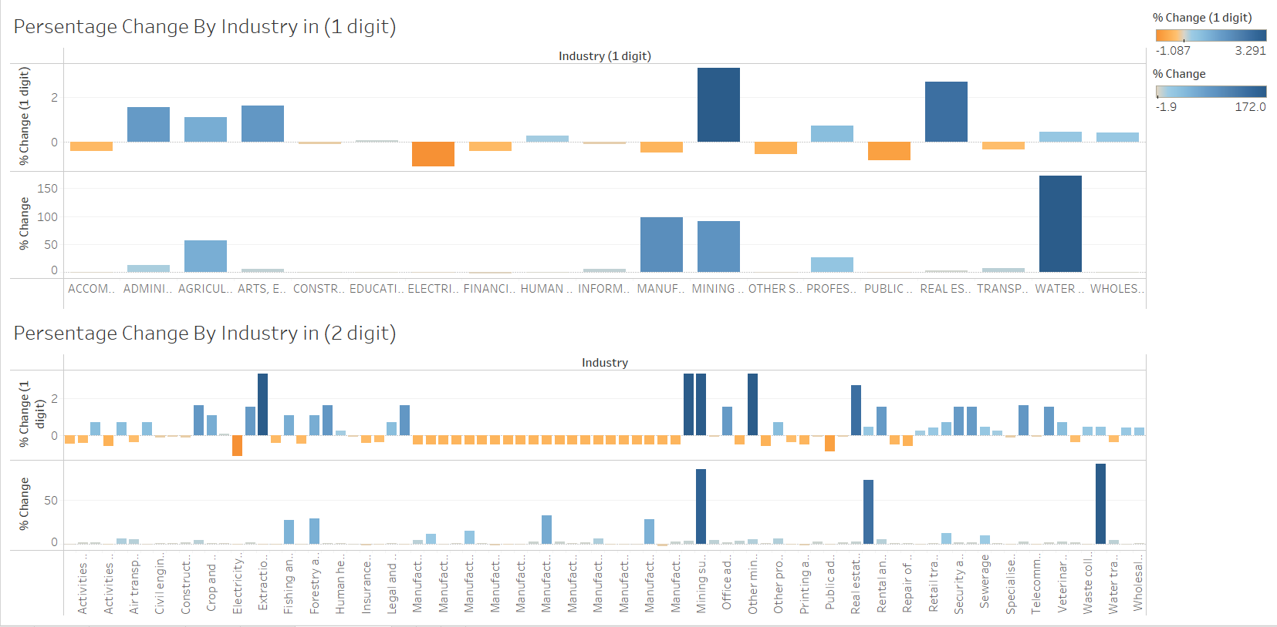

# Day 2: Task 1

Using the Spotify data set, conduct an analysis to find trends and key information that could be used by an organisation for future projects.

There is no set scope for the analysis, simply to find trends and document them below:

|  |  |
| --- | --- |
| Paste your print screens here |  |

|  |  |
| --- | --- |
| What did you find? | The top 5 most popular Artists are Chris Brown, Drake, Future, Hans Zimmer and Nobuo Uematsu.  The most popular genre is Pop and the least popular genre is Children’s music. I guess it is because of the Pop culture influence nowadays.  The longest average track length listened is the world and the least is Children’s music. It might due to the less patient of child.  There’s no clearly correlation between the track length and popularity. The peak point of track length is around popularity of 50.  The Ska has the largest Energy -to- Danceability Ratio whereas Acapella has the least. |

# Day 2: Task 2

Using the Health, conduct an analysis to find trends and key information that could be used by an organisation for future support.

There is no set scope for the analysis, simply to find trends and document them below.

* Data can be lifesaving and is being used more within the NHS, reflect on how this data could support decision making for the NHS.

|  |  |
| --- | --- |
| Paste your print screens here |  |
| What did you find and any reflections on how the NHS could use this? | 1. The cholesterol level between 4.2 and 4.6 tend to be easier to get Liver Cancer. 2. Europe has the Longest average life expectancy but least Population growth. Which indicates a problem of aging and more attention to elderly people’s health 3. Both male’s and female’s BMI increases as time goes by. Which may show a potential obesity rate increase. 4. According to the graph High blood pressure may indicate the life expectancy because as blood pressure decrease the life expectancy increases. 5. Large country tent to have a high rate of getting a lung cancer. This probably due to the factories in the large country. |

# Day 3: Task 1

Please complete Lab 1 ‘Get Data in Power Bi Desktop’. Once complete, paste a print screen below and in the collaboration board.

“Teaching is the best way to learn, so please listen out for support requests from the class and we’ll work through the challenges together”

|  |  |
| --- | --- |
| Paste your completed lab here |  |

# Day 3: Task 2

Please complete Lab 2 ‘Load Transformed Data in Power BI Desktop’. Once complete, paste a print screen below and in the collaboration board.

“Teaching is the best way to learn, so please listen out for support requests from the class and we’ll work through the challenges together”

|  |  |
| --- | --- |
| Paste your completed lab here |  |

# Day 4: Task 1

Please complete Lab 7 ‘Design a Report in Power BI Desktop’. Once complete, paste a print screen below and in the collaboration board.

“Teaching is the best way to learn, so please listen out for support requests from the class and we’ll work through the challenges together”

|  |  |
| --- | --- |
| Paste your completed lab here |  |

# Day 4: Task 2

Please complete Lab 10 ‘Create a Power BI Dashboard’. Once complete, paste a print screen below and in the collaboration board.

“Teaching is the best way to learn, so please listen out for support requests from the class and we’ll work through the challenges together”

|  |  |
| --- | --- |
| Paste your completed lab here |  |

|  |
| --- |
| **Course Notes** |

It is recommended to take notes from the course, use the space below to do so, or use the revision guide shared with the class.

We have included a range of additional links to further resources and information that you may find useful, these can be found within your revision guide.

**END OF WORKBOOK**

**Please check through your work thoroughly before submitting and update the table of contents if required.**

**Please send your completed work booklet to your trainer.**

|  |
| --- |
| **Information** |