**Deliverable 1 | Kaiwen Zhong (kz54)**

**Analyze Emotions of Own Images**

**Relevant MatLab Code:** a4_main.m

Running Multilayer Perceptron algorithm on my 53 images (1-neutral-11 images, 2-angry-10, 3-surprised-10, 4-sad-10, 5-happy-12). Among them, 73.58% (39 images) is correctly classified and 26.42% is not (Figure 1).

**Findings:**

1. Based on the confusion matrix, all images that are categorized as 2-angry are correctly labeled, generating a precision score of 1. It is likely that there are many features that could be extracted from an angry face (furrowed eyebrows, larger eyes, pursed lips, etc.), that easily distinguish the emotion from others.
2. 4-sad is categorized with the lowest precision and recall scores, which is somewhat expected. I have some trouble coming up with extremely exagerated sad face, so the expression is likely less distinguished compared to others. For the 0.5 precision, 3 neutral images are categorized as 4-sad, because my expressions of sadness can be a little blend. 2 angry images are categorized as 4-sad, because both include furrowed eyebrows and pursed lips.
3. There is little confusion between 5-happy and 3-surprised, which is different from my expectations, because both emotions include open mouth. However, there might be enough other features to distinguish between these two, such as different sizes of eyes, different shapes of mouth, etc.
4. I found that increasing the number of images in the analysis extremely useful in improving my analysis results. I ran everything twice. First time I only had 34 qualifying images. The second time I have 53. The accuracy level was extremely low (47.06% accuracy) when I had 34 images. Based on law of large number, the discrepancy between accuracy is expected (Figure 2).
5. It seems that Multilayer Perceptron algorithm is weak when running on not enough data, while much stronger with enough data. Specifically, when I used only 34 images, obtained higher result (50%) using Naïve Bayes, which is surprising, because Naïve Bayes is a much less complicated algorithm compared to Multilayer Perceptron. However, Naïve Bayes did not work well with 53 images, and Multilevel Perceptron is the best performing algorithm among all the other algorithms I experimented with, including Naïve Bayes, Naïve Bayes Multinomial, Random Forest, Random Tree, and Decision Stomp.

**Figures:**

**Figure 1:** I took screenshots of the results because copying the results into doc file messes up the format. For results in a .txt format, please see file in the same directory deliverable1_f1.txt

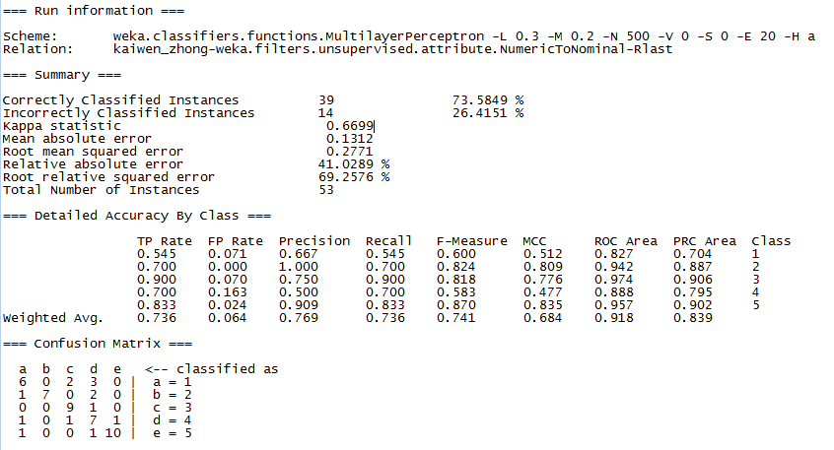

**Figure 2:** For results in a .txt format, please see file in the same directory deliverable1_f2f3.txt

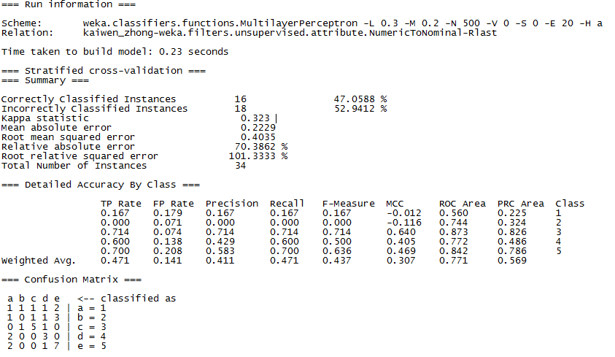

**Figure 3:** For results in a .txt format, please see file in the same directory deliverable1_f2f3.txt

