**Deliverable 3 | Kaiwen Zhong (kz54)**

**Person Identification**

**Relevant MatLab Code:** person_id.m

Using 11 neutral images of my total 53 images, the person identification was successful, resulting in 100% accuracy.

Among my 11 neutral images, I was wearing different clothing and wore light makeup in 4 photos. The algorithm was able to tell me apart from other people, and classify me as one same person without error. This means that the algorithm is rather robust.

However, the first time I ran person identification, I only used 7 neutral images of my total 34 images. The smaller dataset actually resulted in one misclassification, where one of my image is classified as one of student 5’s image, resulted in a 97.9% accuracy.

Since I obtained all other people’s .mat data through Piazza and I do not personally know any of the people my face was compared to, it is difficult to tell why exactly there was a misclassification when I have fewer images. More curiously, judging from the name of the people who shared data, none of them are Asians, and Student 4 is a non-Asian male student. It is likely though, that both of us have lighter complexions, are looking at the camera similarly, and have extremely similar expressions.

The general high accuracy of the classification is very expected, as different people generally have very different facial structures, and features extracted from data are distinct enough that multilayer perceptron can catch the difference among the faces.

**Figures:**

**Figure 1:** I took screenshots of the results because copying the results into doc file messes up the format. For results in a .txt format, please see file in the same directory deliverable3_person_id_reult.txt

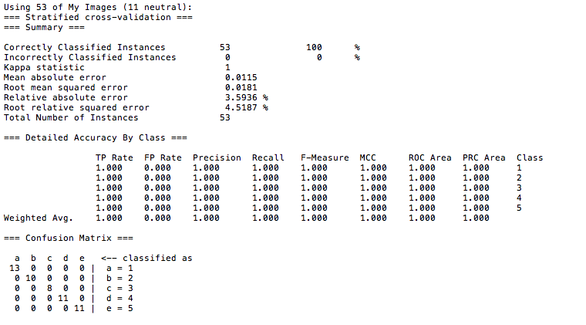

**Figure 2:** For results in a .txt format, please see file in the same directory deliverable3_person_id_reult.txt

