Homework 8: Convolutional Neural Networks

|  |  |  |  |
| --- | --- | --- | --- |
| Student id: | B06502028 | Name: | 莊立楷 |

1. **Create a model only with fully connected layer, then train and test on fashion mnist dataset.**

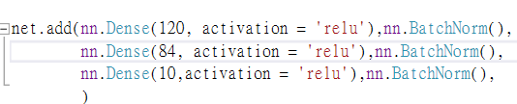

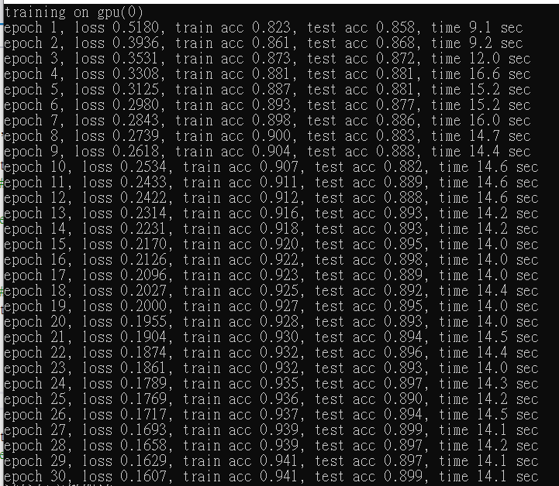

|  |
| --- |
| **Train accuracy:0.941** |
| **Test accuracy:0.899** |

1. **Create a model only with convolutional layer without pooling, then train and test on fashion mnist dataset.(the parameter number need to same as first question)**

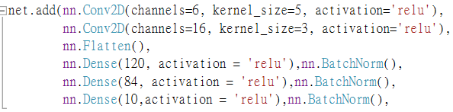

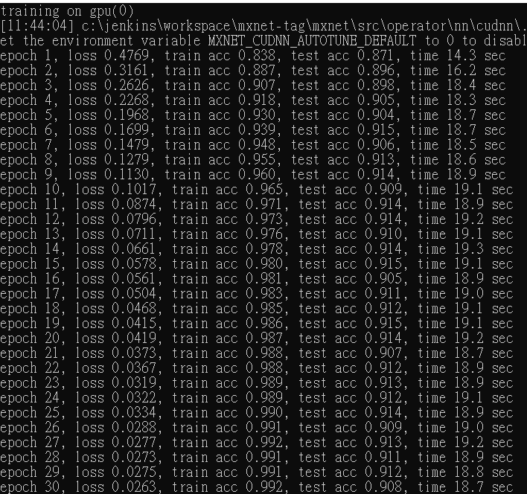

|  |
| --- |
| **Train accuracy:0.992** |
| **Test accuracy:0.908** |

1. **Create a model only with convolutional layer, then train and test on fashion mnist dataset.(the parameter number need to same as first question)**

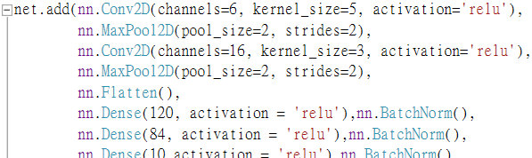

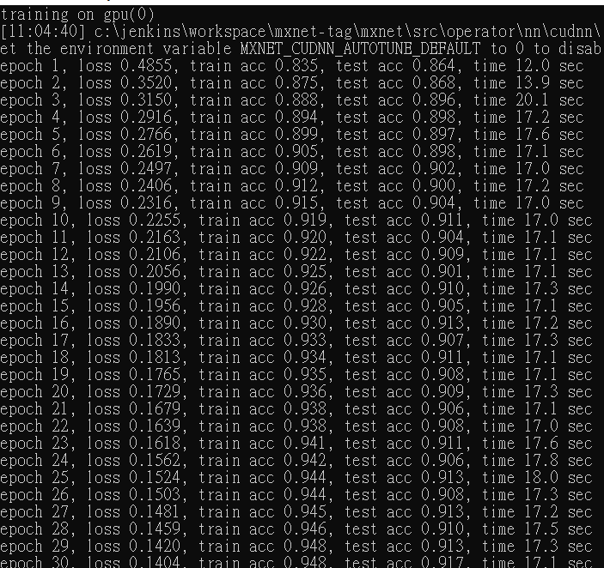

|  |
| --- |
| **Train accuracy:0.948** |
| **Test accuracy:0.917** |

1. **What differences do you observe from the above three questions? like the accuracy or cost time.**

**A:**

使用CPU訓練時，convolution layer會大幅增加訓練時間，但若改用GPU，則在convolution層數較少的情況下，訓練時間主要由fully-connected層的neron數量決定(越多越久)，故在上例子1~3中時間皆差不多在14~18秒左右。其中例子3較例子2多了pooling層，其運算量直接砍半，故例子2的運算時間平均多了1秒左右，符合預期。另外，例子3與2較例子1多了兩層的convolution layer，運算時間每個epoch增加3秒左右。

對於準確度而言，例子2(無pooling)可以在training做到99%準確率，但在testing的結果卻稍微不足有加pooling的例子3，可見pooling有些微regularization的效果。另外，例子3較例子2多了convolution layer，在training的結果準確率差不多，但在testing的準確率平均提升了3%左右，相當於300筆data，可見增加了convolution有regularization的效果及幫助。