Session 3: NUMA and SIMD

Christian Terboven, Paul Kapinos   
IT Center, RWTH Aachen University  
Seffenter Weg 23, 52074 Aachen, Germany  
{terboven, [kapinos}@itc.rwth-aachen.de](mailto:kapinos%7d@itc.rwth-aachen.de)

Yun (Helen) He   
NERSC, Lawrence Berkeley National Laboratory, Berkeley, CA, USA  
yhe@lbl.gov

# Abstract

This document guides you through the exercises. Please follow the instructions given during the training session.

The prepared makefiles provide several targets to compile and execute the code:

* debug: The code is compiled with OpenMP enabled, still with full debug support.
* release: The code is compiled with OpenMP and several compiler optimizations enabled, should not be used for debugging.
* run: Execute the compiled code. The OMP_NUM_THREADS environment variable should be set in the calling shell.
* clean: Clean any existing build files.

The provided *.slurm is a batch script that you can use to submit a batch job to run on a Perlmutter compute node. Submit the job via command “sbatch *.slurm”, and check the output file after it is run, pay attention to run time using different number of threads too.

You can also run an interactive batch job via “salloc” to get on a compute node. For example:

% salloc -N 1 -q interactive -C cpu -t 30:00

<will land on a compute node>

%  export OMP_NUM_THREADS=8 (please try a few different values)

% ./mycode.exe

Please refer to <https://github.com/NERSC/openmp-series-2024/blob/main/Session-1-Introduction/Using-OpenMP-Compilers-on-Perlmutter-CPUs-May2024.pdf> for more details on Using various OpenMP compilers on Perlmutter and running jobs.

# Parallelization of Pi (numerical integration)

Go to the pi directory. This code computes Pi via numerical integration. Compile the pi code via ‘make [debug|release]’ and execute the resulting executable via ‘OMP_NUM_THREADS=procs make run’, where *procs* denotes the number of threads to be used.

**Exercise 1**: Vectorize the Pi code with OpenMP SIMD. The compute intensive part resides in one single loop in the CalcPi() function. Re-compile and execute the code in order to verify your changes. Try to use different compilers and different optimization levels to compare performance results.

# Understanding Thread Affinity

Go to the xthi directory.

**Exercise 1**: Follow the instructions and steps in README.xthi to get the hardware information of the Perlmutter CPU compute node, then compile both xthi.c and xthi_nested_omp.c codes. Understand the numactl -H output by referring to the node diagram below:

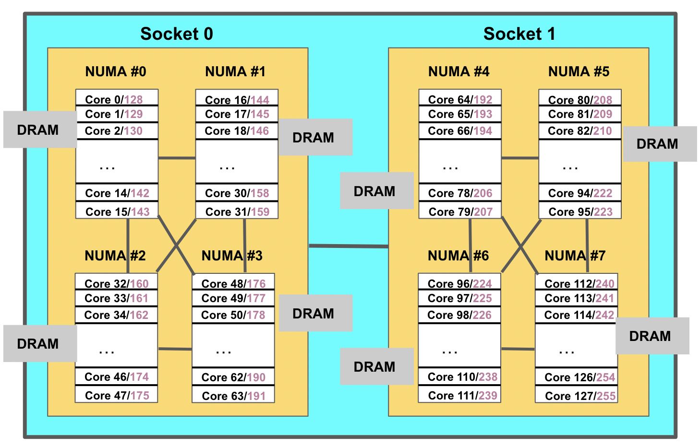

**Exercise 2**: Compile and run both xthi_.c and xthi_nested_omp.c using different OMP_NUM_THREADS, OMP_PROC_BIND and OMP_PLACES and try to understand the results of thread affinity, i.e., binding of OpenMP threads to the logical CPUs on the compute node.

# The Importance of First Touch

Go to the stream directory. Follow the instructions and steps in README.stream.

**Exercise 1**: Compile and run stream_nft.c code with the provided run_stream_nft.sh with different OMP_NUM_THREADS, OMP_PROC_BIND, and OMP_PLACES settings, and check the STREAM Triad bandwidth results.

**Exercise 2**: Modify stream_nft.c code so that it does first touch, and run the same experiements as above. Check the the TRIAD memory bandwidth results, and compare them with the no first touch results. Explain why doing first touch helps with STREAM memory bandwidth results.

# Parallelization of an iterative Jacobi Solver

Go to the jacobi directory. Compile the jacobi.c code via ‘make [debug|release]’ and execute the resulting executable via ‘OMP_NUM_THREADS=procs make run’, where procs denotes the number of threads to be used.

**Exercise 1**: Parallelize at least the most compute-intensive program part with OpenMP, or continue from where you left off in Session 1.

**Exercise 2**: Experiment with different thread affinity binding policies (OMP_PROC_BIND environment variable).

|  |  |  |  |
| --- | --- | --- | --- |
| # Threads | Binding policy | Runtime [sec] | Speedup |
| 1 |  |  |  |
| 2 |  |  |  |
| 4 |  |  |  |
| 8 |  |  |  |
| 16 |  |  |  |
| 24 |  |  |  |

**Exercise 3**: Review your parallelization and ensure that data is correctly laid out on NUMA. Execute your experiments again. Why is there a difference, or maybe where is there no difference?

|  |  |  |  |
| --- | --- | --- | --- |
| # Threads | Binding policy | Runtime [sec] | Speedup |
| 1 |  |  |  |
| 2 |  |  |  |
| 4 |  |  |  |
| 8 |  |  |  |
| 16 |  |  |  |
| 24 |  |  |  |