Dog Hotel Scope Control Agent
Full explanation of the project: what it is, how it works, and what is connected to what
Student | Isomiddin Pulatov
Program | ITPU Master's Degree, IT Project Management & AI (2025–2026)
Internship | EPAM Systems, Inc., 1 September – 23 October 2026
Project | Dog Hotel (EPM-PEDH), an EPAM volunteer project
My role | Project manager, focus on scope
Technical mentor | Tymofii Nazar
Scientific advisor | Olha Kudoiarova
Thesis topic | Enabling Intelligent Scope Control: Designing an AI Agent for IT Project Management
Document date | 16 October 2026 (version 1)

How to read this document. It uses simple English. Hard words are explained in the glossary at the end (section 12). If you only have one minute, read section 1.

Contents

If the contents list is empty, right-click it in Word and choose Update field.

1. The project in one minute
- Where: Dog Hotel, a real EPAM volunteer project. The team builds the website of a dog hotel and shelter in Kyiv.
- My role: project manager (PM), responsible for scope: what work goes into a release, and what does not.
- The problem: new ideas can enter the plan without a check, some tasks are not clear, and there can be more work than people. Jira stores the tasks, but it does not check them.
- The solution: the Scope Control Agent, an AI helper for the PM. First, program code checks the facts. Then the AI (an LLM) gives advice. Then the PM decides.
- Three tools: check a new request, check the health of a release, and answer questions about scope.
- Result so far: it works end to end. In a first test with 10 example requests, the advice was right in 10 of 10 cases and the type of request in 9 of 10. The next step is real Dog Hotel data.

2. The internship and my role

2.1 The internship
The internship is part of my master's program. It lasts two months (1 September – 23 October 2026). Each student joins a real EPAM project, studies it, finds a weak point in his or her area of project management, and solves it with an AI agent.
The internship is finished with three things:
- a demo of the agent (Tuesday, 20 October 2026, 11:30) for the mentor and the internship team;
- an internship report (10–20 pages), uploaded to the Learn platform by 25 October;
- a feedback form from the technical mentor (60 of 100 points), also uploaded by 25 October.

2.2 The Dog Hotel project
Dog Hotel is a real EPAM volunteer project. It started in 2018. The customers are a family who run a dog hotel and a dog shelter in their private house in Kyiv. The team builds and supports their website, doghotel.com.ua:
- the public part for clients: services and prices, "Want a friend" (dogs for adoption), blog, frequently asked questions, contacts;
- the admin part for the owners.
The team are volunteers. They work part-time, and people change often. So the team has little time. The team says itself that it delivers "slowly and with bugs". The project uses Jira (project EPMPEDH) for tasks and a knowledge base (KB) for documents.

2.3 My role: project manager for scope
At the start of the internship, the scientific advisor gave each student one area of project management. My area is scope. (My colleague Asem works on the same project with the area resources.)
As a project manager, I did five things:
- I studied the project and how the team plans its work.
- I looked for problems with scope.
- I decided what an AI agent must do to help, and what must stay with people (the requirements).
- I chose the tools and organised the building of the agent with AI tools.
- I tested the agent and checked the results.

3. The problem

3.1 What is "scope"?
Scope is the list of work that the team promised to deliver in a release. Good scope management means: the team agrees on this list, checks every new idea before adding it, and makes sure the list fits the time and the people.
When nobody controls the scope, the list grows and grows. This is called scope creep. Then the release is late, and the quality goes down.

3.2 Three scope risks on Dog Hotel
Risk | What it means | Example | Result
1. New ideas come at any time | Ideas come from the owners, the team and bugs. Nobody checks how a new idea changes the plan. | "We want online card payment." | The release grows; it is late.
2. Tasks are not clear | Some tasks have no acceptance criteria (no "done" rules). | A task with one line: "Booking form". | Rework and bugs.
3. More work than people | Nobody compares the size of the plan with the team's capacity. | 67 points of work, but the team can do 40. | Some tasks are not finished.

Where do new ideas come from? From four places: the owners (they use the site every day), the team (developers, designers, interns), bugs on the live site, and the PM or BA (when they look at a task more closely). All of them end up as tickets in Jira.

3.3 Why Jira alone does not solve it
The team uses Jira. Jira is like a big shared notebook: it stores the tasks. But it does not check them.
Situation | What Jira does | What the agent adds
A new idea arrives | Anyone can create a ticket and add it to the release. Jira accepts it silently. | Checks the idea against the release goal: "This is scope creep. Move it to the backlog, or remove task X."
A task has no acceptance criteria | Jira saves it anyway. | Finds every such task and warns the PM.
Too much work in the release | Shows the tasks. A person must add up the points. | Counts automatically: "67 points, capacity 40, that is 168%."
Tasks depend on each other | Shows links, if someone added them. | Warns: "These tasks are blocked by a task in the next release."

The agent does not replace Jira. It works on top of Jira: it reads the Jira data and gives advice.

3.4 Honest note
These three risks are my analysis, based on what the project team said and on how volunteer projects usually work. They are not yet confirmed with the real Dog Hotel Jira data, because my Jira access is still being set up. When the real data is loaded, the agent will show the real numbers, and the report will say which risks are confirmed.

4. The solution: the Scope Control Agent

4.1 The idea in one sentence
The Scope Control Agent is a helper for the project manager: program code checks the facts, the AI gives advice, and the project manager decides.

4.2 How it works: four steps
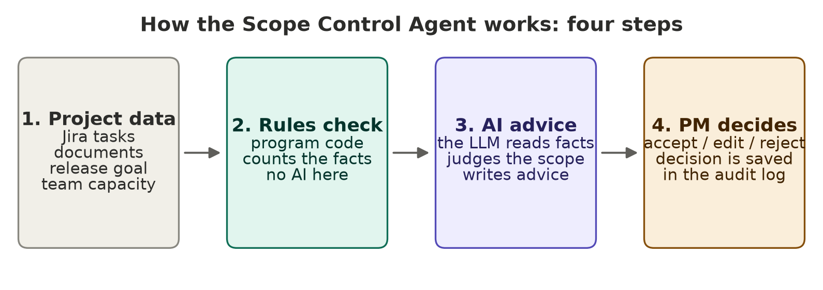
Figure 1. The four steps of the agent
Step | Who does it | What happens
1. Project data | The PM | The PM loads the Jira tasks (a CSV export), the project documents, and the release information: goal, dates and team capacity.
2. Rules check | Program code (no AI) | The code counts and checks the facts: tasks without acceptance criteria, short descriptions, missing estimates, very big tasks, duplicate tasks, tasks added after the plan was agreed, work vs capacity, blocked tasks. These facts are always correct.
3. AI advice | Large language model (LLM) | The AI gets the facts and the tasks. It judges what code cannot judge: does an idea fit the goal, is a task unclear, what is most important. It writes the advice in a fixed structure.
4. PM decides | The PM | The PM reads the advice and clicks Accept, Accept with edits, or Reject. The decision is saved in the audit log.

4.3 The three tools
The agent is a web page with five pages: Overview (project data and release settings), the three tools below, and History.
Tool | Question it answers | You give | You get
Check a request | "Does this new idea fit our release?" | A new request in normal words, and who asked for it. | A class (in scope / scope creep / out of scope / needs clarification), advice (accept / move to backlog / change request / reject), the reason, the impact, what to remove to make room, related tasks, questions to ask, and a ready user story with acceptance criteria.
Release health | "Is our release plan OK?" | The Jira tasks of the release. | A score from 0 to 100, the numbers (work vs capacity, growth of scope, open and closed bugs), a list of problems for each task, a Must / Should / Could / Won't list, risks, and the top actions for the PM. You can download the report.
Ask a question | "Is X in this release?" | A question in normal words. | A short answer with its sources (task numbers, documents). If the sources do not have the answer, it says "not found". It does not guess.
History | "What did we decide?" | Nothing; it fills itself. | A list of all advice and all PM decisions, with time.

4.4 What stays with people
- The agent never changes Jira by itself. It only gives advice.
- The PM sets the release goal, the plan and the capacity.
- The PM (and the owners) decide if a new idea goes into the release.
- Every decision is saved, so it is easy to see later who decided what.

5. What is connected to what
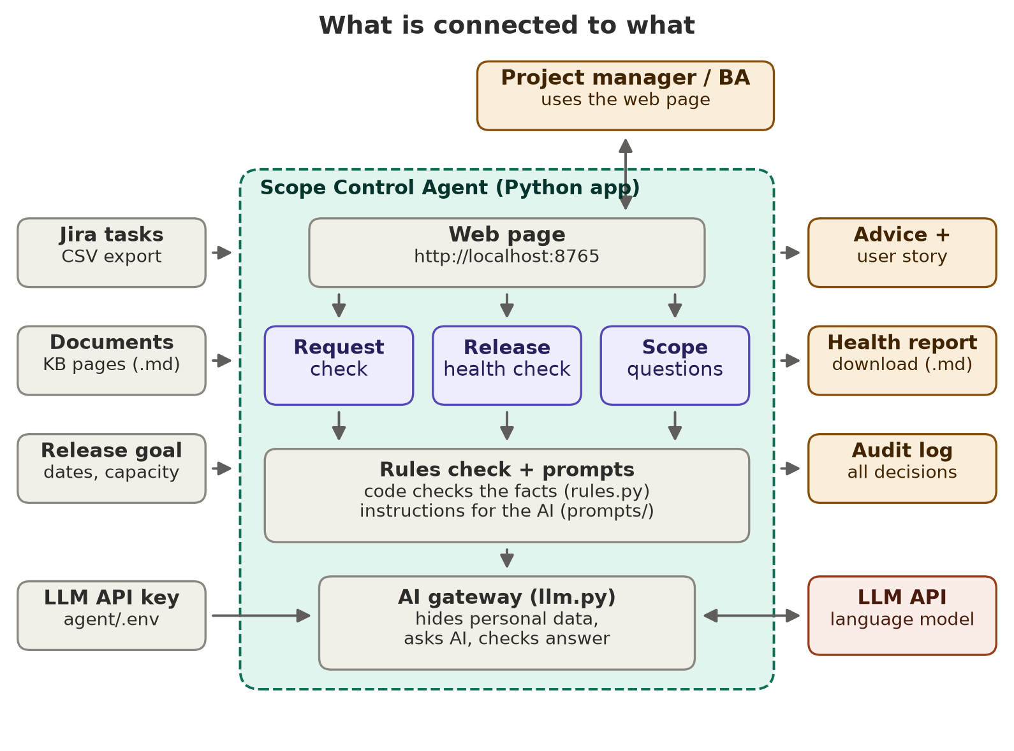
Figure 2. The parts of the system and how they are connected

5.1 The parts of the system
Part | What it does | Connected to | Where in the folder
Web page | The screen the PM uses: a menu on the left with Overview, Check a request, Release health, Ask a question and History. | The PM; the web server | agent/web/ (index.html, styles.css, app.js)
Web server | Receives clicks from the page, loads the data, runs the three tools and returns the results. | Web page; the three tools | agent/server.py
Three tools | Request check, release health check, scope questions. Each one collects the facts, asks the AI, and returns a result. | Web page; rules check; prompts; AI gateway | agent/scope_agent/services/
Rules check | Program code that checks the facts. No AI. | Tools; Jira data | agent/scope_agent/rules.py
Prompts | Written instructions for the AI: its role, the rules, and what to answer. | AI gateway | agent/scope_agent/prompts/
AI gateway | The only part that talks to the AI. It hides personal data, sends the question, checks the answer, and counts tokens. | Tools; LLM API; the key | agent/scope_agent/llm.py
Data readers | Read the Jira CSV export and the documents. | Data files; tools | agent/scope_agent/ingest/
Data model | Describes what a task, a release and each answer look like. | All parts | agent/scope_agent/models.py
Audit log | Saves advice and decisions. | Web page | agent/scope_agent/audit.py → agent/audit/audit.jsonl
Settings | The LLM settings (fixed), folders, rule limits, the key. | AI gateway | agent/scope_agent/config.py, agent/.env

5.2 Inputs (what goes in)
Input | What it is | Where it comes from
Jira tasks | A CSV file with all issues of a release: key, title, type (epic, story, task, bug, sub-task), status, description, points, sprint, components, epic link, dates, links. | Jira → Filters → Export → CSV. Today: sample data (agent/data/sample). Later: the real Dog Hotel export (agent/data/real).
Documents | Knowledge base pages and release notes as .md or .txt files. | The project KB. Today: one page from the real public website and one sample release plan.
Release information | Release name, goal, milestone date, plan date (baseline), team capacity in points. | The PM types it on the Overview page (Release settings), or it is read from release_context.json.
LLM API key | The secret key to use the LLM. | The file agent/.env. Never share this file.

5.3 Outputs (what comes out)
- Advice and a user story on the screen (request check). The PM can edit the story and copy it to Jira.
- A health report on the screen, and as a downloadable file (release health check).
- An answer with sources (scope questions).
- The audit log: all advice and decisions.

5.4 The LLM
The agent uses a large language model (LLM) through the internet (an API). The model and its settings are fixed, so the PM does not need to choose anything. The answer always comes back in a fixed structure, and the program checks it: for example, every task number in the answer must really exist in the data.

6. Example: one request from start to end
This is a real run of the agent on the sample data.
- The owners send an idea: "We want customers to pay for the hotel stay online with a card when they send the booking request, so that there are fewer no-shows."
- The PM opens the page Check a request, pastes the idea, chooses "Owners", and clicks Check request.
- Rules check: the code finds the release numbers: 67 points of open work, capacity 40 (168%), 6 tasks already added after the plan. It also finds similar existing tasks (the booking form tasks).
- AI advice: after about 19 seconds the AI answers: class scope creep, advice move to the backlog. Reason: card payment is a new feature, not part of the current booking request goal, and the release is already over capacity.
- The AI also gives 6 questions for the owners, for example "Full payment or only a deposit?" and "What are the refund rules?", and writes a user story with 5 acceptance criteria.
- The PM decides: the PM reads it and clicks Accept. The decision goes to the audit log. The story can be copied to Jira for a later release.

7. Safety and privacy
- The key is secret. It is only in agent/.env, never in the code or documents.
- Personal data is hidden. E-mails and phone numbers are replaced with [email] and [phone] before any text goes to the AI.
- No storage at the AI provider. Requests are sent with the option "do not store".
- Read only. The agent only reads exported files. It has no access to change Jira.
- A person decides. Every change goes through the PM, and every decision is saved.

8. How to run it
- Open the folder DogHotelIsomiddin\agent.
- Check that agent/.env has the LLM API key.
- Double-click run.bat. It starts the app.
- The browser opens http://localhost:8765 by itself.
- On the Overview page, choose the data (sample data, upload a Jira CSV, or real data) and fill in the release settings: goal, deadline, plan date and team capacity.
- Use the menu on the left: Check a request, Release health, Ask a question, History.
To run the automatic tests (no AI, free): .venv\Scripts\python -m pytest -q tests
To run the evaluation (uses the AI, costs a few cents): .venv\Scripts\python eval/run_eval.py

9. Testing and results

9.1 Automatic tests
Eight automatic tests check the Jira reader and the rules. All eight pass. They prove that the rules find all planted problems in both test files (missing acceptance criteria, the duplicate task, the too-big task, the tasks added after the plan, the overload, the blocked tasks), and that epics, sub-tasks and tasks with the same title pattern are not reported as problems.

9.2 Evaluation with the LLM (16 October 2026)
What was checked | Result
Request check: correct type of request (10 example requests) | 9 of 10 (the vaccination question was called scope creep instead of in scope; the advice was still right)
Request check: correct advice | 10 of 10
Request check: found the related existing tasks | 10 of 10
Invented task numbers | 0
Time for one request (median) | about 15 seconds
Health check: found all tasks that do not serve the goal | 100%
Health check: marked all core tasks as Must | 100%
Health check: time | about 1 minute

Honest note. This is a small first test. I prepared the 10 example requests and the right answers myself, on sample data, and some cases accept more than one right answer. So the results show that the agent works, but they are not yet proof for the real project. The next step is a test on real Dog Hotel data with the project's BA.

10. Limits and next steps
Limit today | Next step
No access yet to the real Dog Hotel Jira and KB (device check and Jira position). | Install the required device software or get a Jira CSV export from the team; run the agent on real data.
The test is small and uses sample data. | Bigger test with real tasks; compare the agent's advice with the PM's decisions.
The agent runs only on one computer. | Put the same instructions on CodeMie (EPAM's AI platform), so the team can use it without installing anything.
It reads exports, not live Jira. | Later: connect to Jira directly, with a "confirm and push" button for the PM.

11. Where to find everything
Folder / file | What is inside
docs/ | This document, the technical architecture (.md), and the diagram images.
agent/ | The agent itself (the web page, the server, the code, the data, the tests, the evaluation).
agent/run.bat | Double-click to start the app.
agent/data/upload_test/ | A test Jira CSV for trying the upload (24 invented issues, DHU-).
agent/.env | Your LLM API key. Secret.
agent/README.md | Short technical instructions.
agent/data/sample/ | Sample data: an invented Jira backlog of a small volunteer dev team, written as developer work items (35 issues with the prefix DHS-: epics, stories, tasks, bugs, sub-tasks). Not real Jira data.
agent/data/real/ | Put the real Jira CSV export and documents here.
agent/eval/results/ | Evaluation results (numbers for the report).
demo/demo_speech.md | The speech and the checklist for the demo on 20 October.
feedback/ | The supervisor feedback form with your name, for Tymofii.
notes/ | What I found in Teams, the plan, message drafts, and draft answers to the mentor's questions.

12. Glossary (simple words)
Word | Meaning
Scope | The list of work the team promised to deliver.
Scope creep | When the list of work grows without control.
Release | A version of the website that the team finishes and gives to the customer.
Baseline | The agreed plan at a certain date. Work added later is "added after the baseline".
Backlog | The list of all ideas and tasks that are not planned yet.
Acceptance criteria | Clear rules that say when a task is done, often written as Given / When / Then.
User story | A task written from the user's view: "As a …, I want …, so that …".
Story points | A number for the size of a task.
Capacity | How much work the team can do in a release (in story points).
MoSCoW | A way to sort tasks: Must have, Should have, Could have, Won't have (now).
Jira | The tool where the team keeps its tasks.
KB (knowledge base) | The place where the project keeps its documents.
PM / BA | Project manager / business analyst.
LLM (large language model) | A program that understands and writes text. The agent uses it for judgement and advice.
API | A way for one program to talk to another program over the internet.
Prompt | The written instruction that we give to the AI.
Token | A small piece of text. The AI is paid per token.
Audit log | A list that saves all advice and decisions with the time.
CodeMie | EPAM's platform for AI assistants.

