MS IN IT PRODUCT MANAGEMENT AND AI · INTERNSHIP PROJECT (SEMESTER 3)
Retail AI Control Tower
An AI platform that aligns customer experience, supply chain and revenue in one retail ecosystem
Master’s thesis topic (approved list, topic 5)
Platform Strategy for an AI-Powered Retail Ecosystem: Aligning Customer Experience, Supply Chain Intelligence, and Revenue Optimization

Student | Farkhod Shonazarov
Scientific adviser | Serhii Bulba
Technical mentor | Raman Loseu (EPAM)
This document | Project concept, architecture and implementation plan
Version / date | 1.0 (draft) — 16 October 2026
Status | Waiting for approval. Building starts only after you approve this plan (see Section 12).

Contents
1. Summary — the project on one page
2. The problem
3. The idea
4. Users and use cases
5. Data
6. How it works — the seven modules
7. Architecture
8. Technology stack
9. Quality requirements (non-functional)
10. Implementation plan
11. How the project fills your required documents
12. Approval — what I need from you
Glossary and sources

How to read this document
Sections 1–3 explain what we build and why. Sections 4–9 explain how it works (architecture). Section 10 is the build plan. Section 12 is the list of things you need to approve before we start.
All English is kept simple on purpose. Technical words are explained in the Glossary at the end.

1. Summary — the project on one page
This document explains the project from zero: the problem, the idea, how the system will work, its architecture, and the plan to build a working version (MVP) before the final internship demo on Thursday, 22 October 2026.
Product | Retail AI Control Tower — a web platform for the managers of an online retail marketplace.
Problem | Customer, supply and revenue teams work in silos. A decision in one area quietly hurts the other areas, and nobody sees the full chain until revenue drops.
Solution | One shared data layer + three AI engines (customers, supply, revenue) + an alignment layer that links them with one KPI tree, measured cause→effect links and a what-if simulator. An AI assistant explains the numbers in plain English.
Data | Olist Brazilian E-Commerce public dataset: about 100,000 real orders (2016–2018) from a company that connects small sellers to large Brazilian marketplaces — a real multi-sided ecosystem.
MVP output | Working dashboard (6 pages), AI assistant, trained models with test results, and all diagrams needed for the thesis.
Deadlines | Final demo: 22 Oct, 13:30 (with Raman Loseu). Report + signed feedback form on the Learn platform: 25 Oct.
Why it fits the topic | “Platform strategy” → the system serves a platform with many sides (customers, sellers, logistics). “Aligning” → the alignment layer. The three AI engines match the three parts of the title: customer experience, supply chain intelligence, revenue optimization.

Product vision in one sentence
“One screen shows managers how a change in one part of the business affects customers, supply and revenue — and what to do next.”

2. The problem

2.1 Retail teams work in silos
In most retail companies, three groups make decisions with different data and different goals:
Team | Looks at | Does not see
Customer / marketing team | Reviews, customer groups, campaigns | If sellers and delivery can handle the extra orders a campaign brings
Supply / logistics team | Sellers, delivery times, stock | Which demand is coming next, and how delays change reviews
Revenue / category team | Sales, prices, order value | How late deliveries and bad reviews reduce future revenue

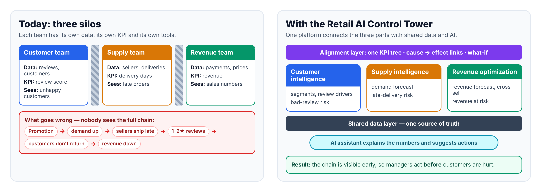
Figure 1. Today: three silos (left) vs. one aligned platform (right)

2.2 A simple example of the problem
- Marketing starts a promotion for one product category.
- Demand goes up quickly. The supply team did not plan for it.
- Some sellers cannot ship on time, so many deliveries are late.
- Customers who waited too long give 1–2★ reviews.
- Unhappy customers do not buy again, and new customers trust the shop less.
- Revenue goes down a few weeks later — and each team only sees its own small part of the story.

2.3 Why this matters for a platform business
A marketplace earns money only when all sides of the ecosystem stay healthy. If sellers are late, customers leave. If customers leave, sellers earn less and also leave. So the owner of the platform cannot manage one team’s KPI alone — it needs to see and balance the whole ecosystem. This is the core of the thesis topic: a platform strategy that aligns customer experience, supply chain and revenue.

3. The idea

3.1 Three pillars and one alignment layer
Part | Question it answers | Main AI features
Customer experience | Who are our customers, and what makes them unhappy? | Customer segments · drivers of bad reviews · bad-review risk for open orders
Supply chain intelligence | Can we deliver what customers will want, on time? | Demand forecast · late-delivery risk · seller scorecard · restock suggestion
Revenue optimization | Where can we earn more, and where are we losing money? | Revenue forecast · cross-sell · revenue at risk · freight check
Alignment layer (core idea) | How does a change in one part affect the others? | KPI tree · impact links · Ecosystem Health Score · what-if simulator · cross-pillar alerts
AI assistant | What does this mean, and what should I do? | Plain-English answers from safe tools · weekly brief

3.2 What “platform strategy” means in this project
Olist is a good real example of a platform: it sits in the middle and connects many sides. The Control Tower is the tool of the platform owner, who must keep all sides healthy:
- Customers — want fast delivery, fair prices and good products.
- Sellers — want many orders, but have limited capacity and different quality.
- Logistics partners — deliver orders; their speed depends on distance and region.
- Marketplaces / sales channels — where customers find the products.
Strategy questions the Control Tower helps to answer: Which categories should we promote, and when? Which sellers need support before a demand peak? Where does slow delivery block growth? How much revenue is at risk because of bad experience?

3.3 What makes this project different
- Many tools optimise one number (only a forecast, or only recommendations). This project links the three parts with one North Star metric.
- The links between parts are measured from real data (for example: how much one extra day of delay lowers the review score), not guessed.
- Managers can test a decision first in a what-if simulator before acting.
- An AI assistant turns numbers into plain-language advice, with clear safety rules (it only sees aggregated numbers).

3.4 Research questions and hypotheses (for the thesis)
ID | Research question / hypothesis | How we test it
RQ1 | Which supply-side factors most affect customer satisfaction on a retail platform? | Review-driver model (M2) on Olist data
RQ2 | Can one KPI tree with data-based impact links help managers find cross-team risks earlier than separate dashboards? | Alignment layer (M5) + scenario examples + short feedback from mentor/classmates
RQ3 | Can an LLM assistant that uses only safe tools answer manager questions correctly? | Test set of 15 questions (M6), % correct
H1 | Late delivery is the strongest driver of 1–2★ reviews. | Feature importance + simple regression
H2 | Decisions checked across all three pillars protect more “Healthy GMV” than decisions based on one pillar only. | What-if simulation, before/after comparison
H3 | The assistant answers at least 80% of test questions correctly. | Manual check of logged answers

Note: these are hypotheses. The build phase will confirm or reject them; both results are valid for the thesis.

4. Users and use cases

4.1 User roles
Role | Description | Main goals | Main pages
Executive (Head of e-commerce) | Owns the platform results | See overall health, top risks, test big decisions | Overview, What-if, Ask AI
Customer experience manager | Owns satisfaction and loyalty | Know customer groups and why reviews are bad | Customers
Supply & logistics manager | Owns sellers and delivery | Plan for demand, find risky sellers and late orders | Supply
Revenue / category manager | Owns sales and categories | Grow revenue, find cross-sell, see revenue at risk | Revenue
System (data pipeline) | Technical actor | Load and refresh data, retrain models | —

4.2 Main use cases (MVP)
ID | Use case | Actor | Result
UC-01 | View ecosystem health | Executive | Health Score, 4 key KPIs, alerts on one screen
UC-02 | Explore customer segments | CX manager | Size, value and behaviour of each segment
UC-03 | Find the drivers of bad reviews | CX manager | Ranked list of causes with effect size
UC-04 | Check the demand forecast | Supply manager | Next 4–8 weeks by category, with error range
UC-05 | See late-delivery risk and seller scorecard | Supply manager | List of risky orders and sellers
UC-06 | See revenue forecast, cross-sell and revenue at risk | Revenue manager | Forecast chart, top category pairs, money at risk
UC-07 | Run a what-if scenario | Executive / any manager | New KPI values after a planned change
UC-08 | Ask the AI assistant / get a weekly brief | Any manager | Plain-English answer + which data was used

The thesis template asks for a UML use-case diagram and one specification table per use case. These will be drawn from this list during the build.

5. Data

5.1 Data source
We use the Brazilian E-Commerce Public Dataset by Olist (Kaggle). Olist connects small merchants to the main marketplaces in Brazil. The data has about 100,000 anonymised orders from 2016 to 2018, with order status, prices, payments, freight, customer location, product details and customer reviews. An optional second dataset, Marketing Funnel by Olist, has about 8,000 seller leads (June 2017 – June 2018) and shows the seller side of the ecosystem.
Table | What it holds | Mainly used by
orders | One row per order: status, purchase time, delivery date, promised (estimated) date | All engines (hub)
order_items | Products in each order: product, seller, price, freight value | Revenue, Supply
order_payments | Payment type, number of instalments, amount | Revenue
order_reviews | Review score 1–5 and comment | Customer
customers | Anonymous customer id, city, state, zip prefix | Customer
sellers | Seller id, city, state, zip prefix | Supply
products | Category, weight, size, number of photos | Supply, Revenue
geolocation | Zip prefix → latitude/longitude | Supply (distance)
category_translation | Portuguese → English category names | All

5.2 Data model
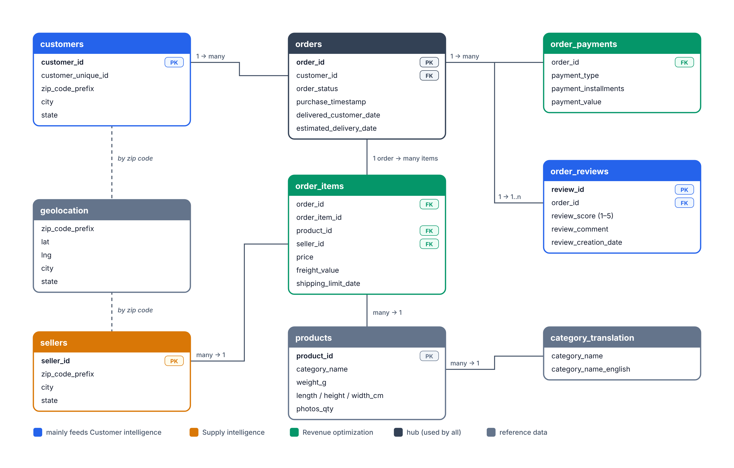
Figure 2. Simplified data model of the Olist dataset (colour = which engine mainly uses the table)

5.3 Data limits and how we handle them
Limit | What it means | How we handle it
No stock levels | We cannot see real stock-outs | Restock suggestions use simulated stock with clear rules; always labelled “simulated”
No costs or margins | We cannot calculate profit | Use GMV, order value and freight; state this as a limitation in the thesis
No promotion calendar | We cannot measure campaign ROI directly | Use visible demand peaks in the data (for example, around Black Friday) as natural events
Data is from 2016–2018 | Numbers are not current | The focus is the method; new data can be plugged in later with the same pipeline
Most customers buy only once (to be measured) | Loyalty models may be weak | Focus on first-order experience and review score; report the finding honestly
Text is in Portuguese | Review comments are hard to read | Use category translation; review text analysis is optional (post-MVP)

6. How it works — the seven modules
The platform is built from seven modules (M1–M7). Each module has one job, a clear input and a clear output, so it can be built and tested on its own.
Module | Job | Main output
M1 Data pipeline | Load, check, clean and join the data | DuckDB warehouse with clean and feature tables
M2 Customer intelligence | Understand customers and satisfaction | Segments, review drivers, bad-review risk
M3 Supply chain intelligence | Plan demand and delivery | Forecasts, late-delivery risk, seller scorecard
M4 Revenue optimization | Find money gained and lost | Revenue forecast, cross-sell rules, revenue at risk
M5 Alignment layer | Connect M2–M4 into one picture | KPI tree, impact links, Health Score, what-if, alerts
M6 AI assistant | Explain and advise in plain English | Answers, weekly brief, answer log
M7 Dashboard | Show everything to users | 6-page web app

M1 — Data pipeline
- What it does: loads the 9 CSV files, checks quality (missing values, duplicate ids, impossible dates), cleans them and builds analysis tables.
- Feature tables: customer (recency, frequency, money spent, average review), order (seller→customer distance, freight share, weight, promised days, weekday), seller (on-time rate, average review, volume) and weekly sales by category.
- Output: one DuckDB file (warehouse.duckdb) + a data-quality report.
- Done when: row counts match the source files and the quality report has no blocking problems.

M2 — Customer intelligence
- Customer segments: RFM scores (Recency, Frequency, Monetary value) + K-Means clustering → 4–5 named groups, for example “Champions”, “One-time buyers”, “At risk”.
- Review drivers: a gradient-boosting model (LightGBM) predicts a 1–2★ review from order facts. Feature importance shows the main causes (tests hypothesis H1).
- Bad-review risk: the same model gives a risk score to orders that are still on the way, so the team can act before the review is written.
- Checked by: ROC-AUC on test data; causes must make business sense.

M3 — Supply chain intelligence
- Demand forecast: weekly orders for the top 10 categories, 4–8 weeks ahead. We compare a simple baseline (same week last period), Holt-Winters (statsmodels) and LightGBM with calendar features, and keep the best one.
- Late-delivery risk: a LightGBM classifier predicts “will arrive after the promised date”. It uses only facts known at purchase time, so there is no data leakage.
- Seller scorecard: on-time rate, average delay, average review, volume and trend; flags risky sellers.
- Restock suggestion (simulated): order quantity = forecast demand during lead time + safety stock − simulated current stock.
- Checked by: forecast error (WAPE) must beat the baseline; ROC-AUC and precision for the top 10% riskiest orders.

M4 — Revenue optimization
- Revenue forecast: built from the demand forecast × average price per category.
- Cross-sell: association rules (support, confidence, lift) show which categories are bought together or by the same customer. Because many orders have one item, rules are made at category level.
- Revenue at risk: value of orders with high bad-review or late-delivery risk × expected loss (taken from the impact links in M5).
- Freight check: shows categories and regions where freight cost is a large share of order value and reviews are low.
- Checked by: back-test of the forecast; rules must have lift > 1.

M5 — Alignment layer (the core of the thesis)
This layer turns three separate engines into one decision system. It has five parts:
- KPI tree: one North Star — Healthy GMV (revenue from orders that arrive on time and get a 4–5★ review) — with three KPIs under each pillar (Figure 3).
- Impact links: simple, explainable models measure how one pillar affects another, for example “+1 day of delay → review score changes by X★”. Each link shows its size and how sure we are.
- Ecosystem Health Score (0–100): a weighted average of the normalised KPIs. Weights are shown on screen and can be changed.
- What-if simulator: sliders such as “late deliveries −X%”, “demand in category +Y%”, “freight −Z%”. The KPIs are recalculated through the impact links.
- Cross-pillar alerts: rules such as “demand forecast up more than 20% AND sellers in this category have high late-risk → alert”.
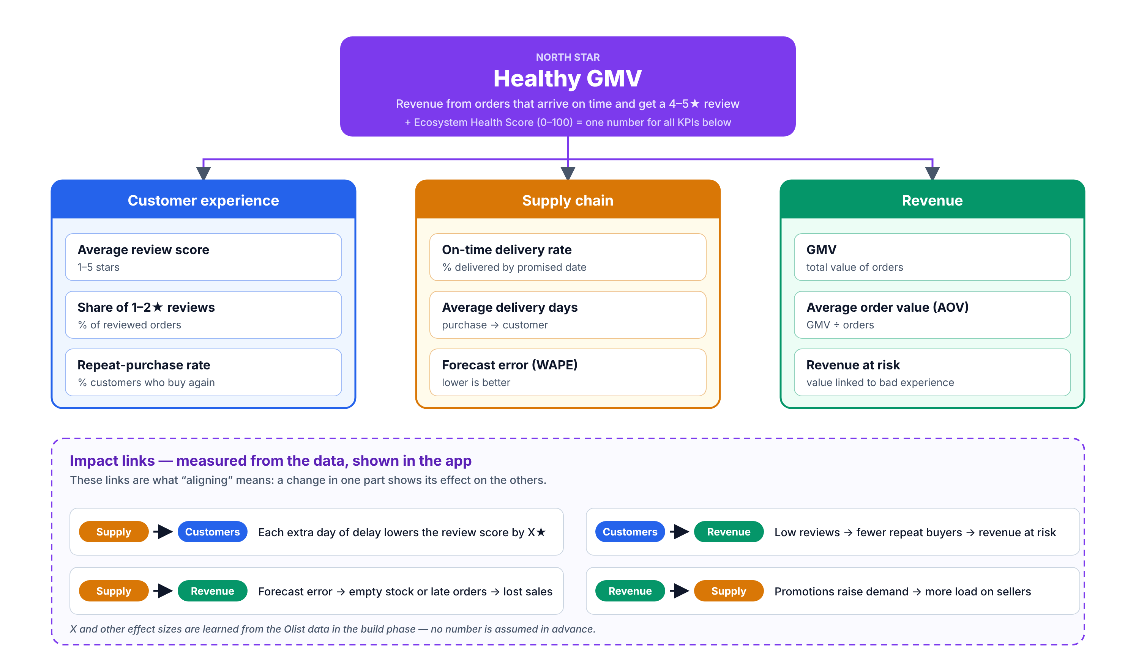
Figure 3. KPI tree with the North Star “Healthy GMV” and the impact links between pillars

M6 — AI assistant “Ask the Control Tower”
- How it works: a large language model (LLM) uses function calling. It can only call safe, read-only tools: get_kpis, get_kpi_trend, get_segment_summary, get_forecast, get_risky_sellers, get_review_drivers, run_what_if.
- Rules: answer only from tool results; say “I don’t know” when data is missing; always show which data was used; never receive raw customer rows.
- Weekly brief: one button creates a short summary of the 5 most important changes and actions.
- Provider: Google Gemini API (free tier). Backup: OpenRouter. If the API is down, the dashboard still works without the assistant.
- Checked by: a test set of 15 questions with known answers (tests H3). Every question and answer is saved to a log.

M7 — Dashboard
Page | What the user sees
Overview | Health Score, 4 key KPIs, small charts for each pillar, cross-pillar alerts, quick “Ask AI” box
Customers | Segments, review score trend, review drivers, orders with bad-review risk
Supply | Demand forecast vs actual, late-delivery risk, seller scorecard, restock suggestions (simulated)
Revenue | GMV trend and forecast, cross-sell pairs, revenue at risk, freight check
What-if | Sliders for planned changes and the new KPI values side by side
Ask AI | Chat with the assistant, weekly brief, list of data used

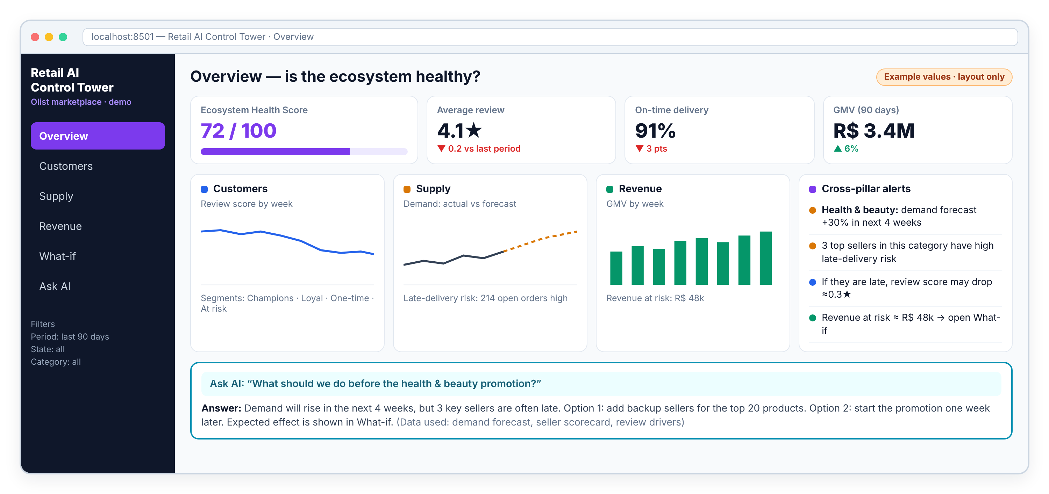
Figure 4. Wireframe of the Overview page (example values, layout only)

7. Architecture

7.1 Layered architecture
The system has five layers. Data flows up from the sources to the apps. Users only touch the top layer.
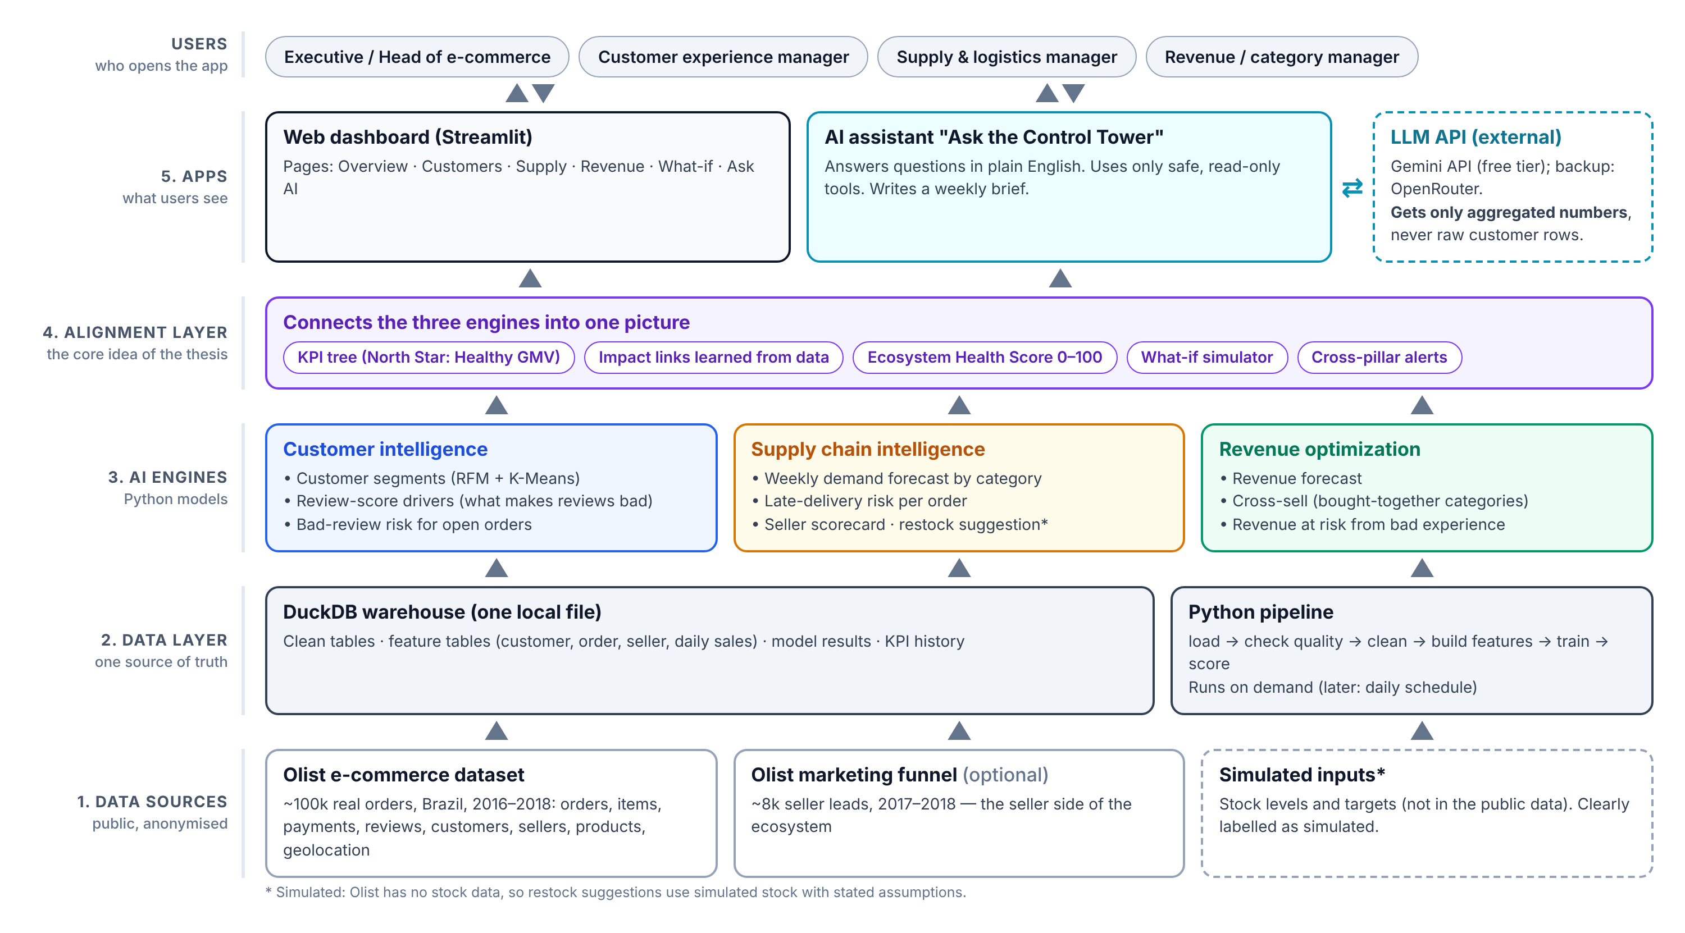
Figure 5. High-level architecture of the Retail AI Control Tower
Layer | Responsibility
1. Data sources | Olist CSV files (real data), optional marketing funnel data, simulated stock and targets
2. Data layer | Python pipeline + DuckDB warehouse: clean tables, feature tables, model results, KPI history
3. AI engines | Customer, supply and revenue models (M2–M4). They read from and write results to the warehouse
4. Alignment layer | KPI tree, impact links, Health Score, what-if and alerts (M5) — combines the engines
5. Apps | Streamlit dashboard (M7) and AI assistant (M6). The assistant talks to an external LLM API

7.2 How data flows, step by step
- The pipeline reads the CSV files and writes clean tables into DuckDB.
- Feature tables are built (customer, order, seller, weekly sales).
- Models are trained; their scores and forecasts are written back to the warehouse.
- The alignment layer calculates KPIs, impact links, the Health Score and alerts.
- The dashboard reads only prepared tables, so pages load fast.
- When a user asks a question, the assistant calls safe tools that run read-only SQL and returns a short answer.

7.3 How the AI assistant answers a question
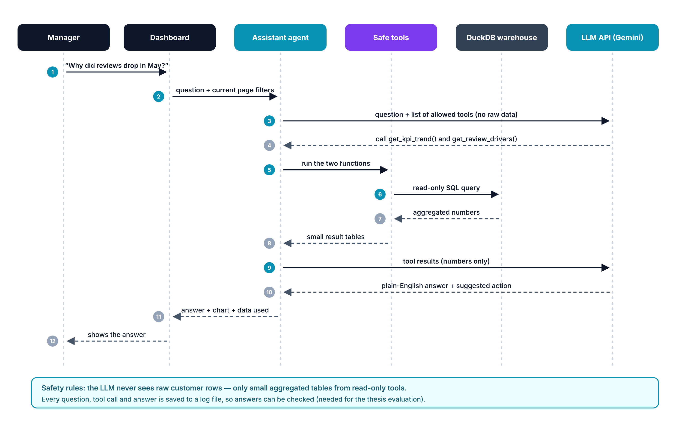
Figure 6. Sequence diagram: how a manager’s question is answered

7.4 Main design decisions
Decision | Choice | Why | Not chosen (for now)
Storage | DuckDB (one file) | No server to install, very fast for analytics, easy to share | PostgreSQL — later, for many users
User interface | Streamlit | Full web app in Python in days, good charts | React — better for a production product
Models | Classic ML (LightGBM, statsmodels, scikit-learn) | Data is tabular and medium-sized; fast and explainable | Deep learning — not needed, harder to explain
LLM | Gemini API (free tier) | No GPU needed, free, good function calling | Local LLM — needs strong hardware
Style | Modular monolith | One app, simple to run and demo; modules have clean interfaces | Microservices — too heavy for an MVP
Privacy | Only aggregated numbers go to the LLM | Protects data even though Olist data is already anonymised | Sending raw rows — not allowed

8. Technology stack
Layer | Technology | Why this choice
Language | Python 3.11 | One language for data, models and web app
Data processing | pandas, DuckDB (SQL) | Simple, fast, works on a laptop
Machine learning | scikit-learn, LightGBM, statsmodels | Strong for tabular data and forecasting; explainable
Explainability (optional) | SHAP | Shows why a model made a prediction
Association rules | mlxtend | Cross-sell rules (support, confidence, lift)
AI assistant | Google Gemini API (google-genai SDK); backup OpenRouter | Free tier, function calling, no GPU
Web app | Streamlit + Plotly | Interactive pages and charts with little code
Code and versions | Git + GitHub (public repo), README | Shows the work to mentor and adviser; needed for the report
Diagrams for thesis | draw.io or PlantUML | Use case, component, sequence, class and ER diagrams
Run / deploy | Local run on your computer; optional Streamlit Community Cloud | Simple demo; a public link is a bonus

9. Quality requirements (non-functional)
The thesis template asks for measurable targets in each category. For the MVP we use these targets:
Category | Target for the MVP | How we meet it
Authentication & authorization | Demo login with one password; pages grouped by role | Simple Streamlit login; full roles are post-MVP
Security & compliance | No secret in GitHub; LLM gets only aggregated data | API key in a .env file (in .gitignore); read-only tools
Availability | Demo must work on 22 Oct even without internet | Local run + recorded demo video as backup
Disaster recovery | Rebuild everything from raw CSV in under 10 minutes | Code on GitHub; one command rebuilds the warehouse
Performance | Each page loads in under 3 s; assistant answers in under 15 s | Pre-computed tables; caching in Streamlit
Data governance | Public, anonymised data; license respected; simulated data always labelled | Data source and license in README; “simulated” labels on screen
Logging & monitoring | Every pipeline run and every assistant question is logged | Log files with time, tool calls and answer

10. Implementation plan
Time is short — the plan is strict
Today is Friday 16 October. The final demo is on Thursday 22 October at 13:30. That gives 5 build days. The plan keeps a clear MVP scope and has a cut list (10.7) in case something takes longer.

10.1 Timeline
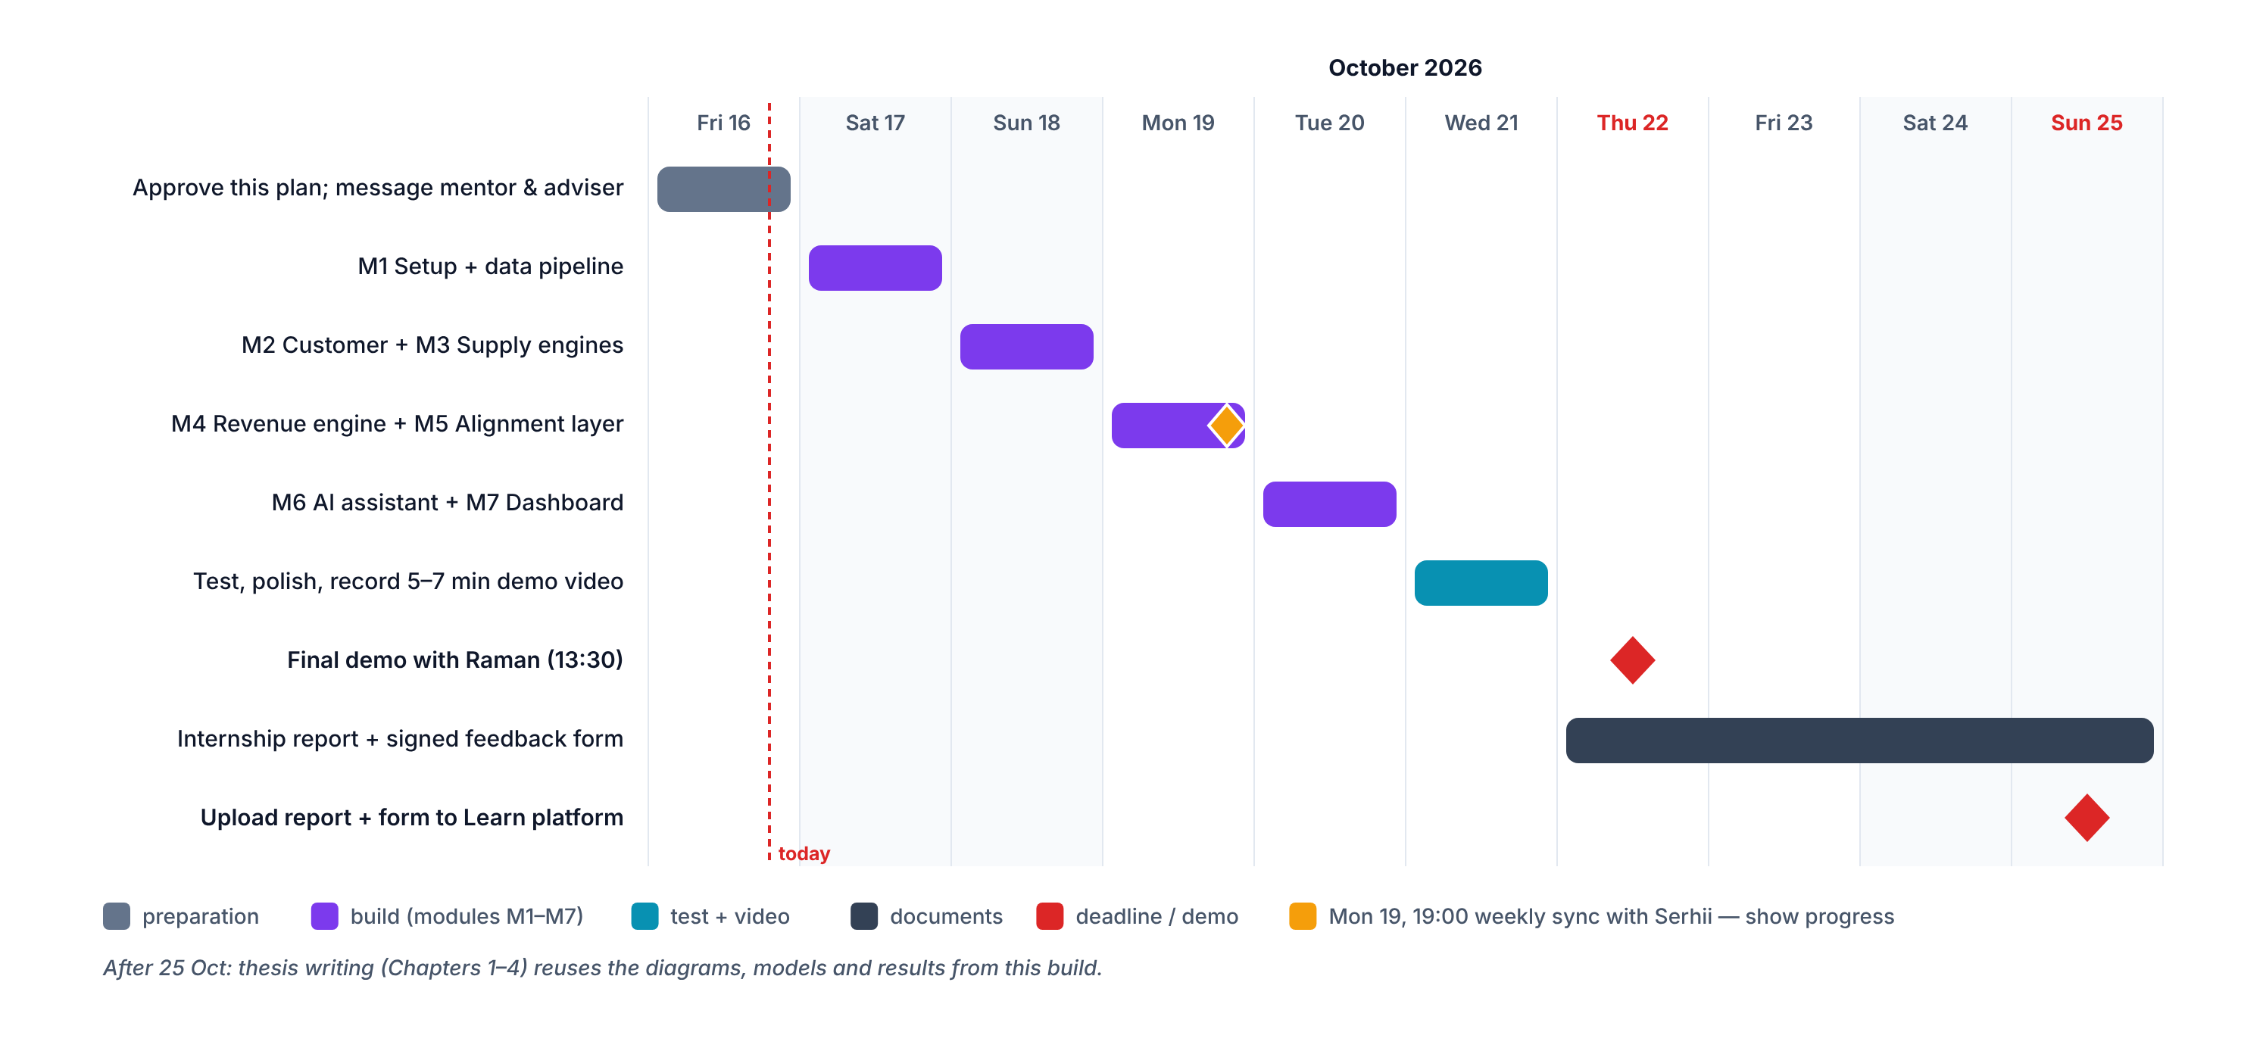
Figure 7. Build and delivery timeline, 16–25 October 2026

10.2 Day-by-day plan
Day | Work | Done when (output)
Fri 16 Oct | You approve this plan. Send a short progress message to Raman and Serhii. Get the Olist data. | Plan approved; data files in the project folder
Sat 17 Oct | M1: project setup (Python env, GitHub repo), data pipeline, quality report. | warehouse.duckdb built; quality report ready
Sun 18 Oct | M2 customer engine + M3 supply engine (segments, review drivers, forecast, late-delivery risk). | Models trained; test metrics saved
Mon 19 Oct | M4 revenue engine + M5 alignment layer. 19:00 weekly sync with Serhii — show progress. | KPI tree, impact links, Health Score, what-if working
Tue 20 Oct | M7 dashboard (6 pages) + M6 AI assistant with safe tools. | App runs end-to-end on your computer
Wed 21 Oct | Testing, bug fixes, 15-question assistant test, record 5–7 min demo video, prepare demo speech. | Video file + test results + speech draft
Thu 22 Oct | 13:30 final demo with Raman. Ask him to fill and sign the feedback form. | Demo done; feedback form requested
Fri 23 – Sun 25 Oct | Internship report (8-week diary, summary, conclusions). Upload report + signed form to Learn. | Both documents uploaded by 25 Oct

10.3 Project folder structure
Project folder structure (repository root):
Retail-AI-Control-Tower/
├── docs/ this document, diagrams, test results
└── retail-ai-control-tower/ the code (also pushed to GitHub)
├── data/raw/ Olist CSV files (not uploaded to GitHub)
├── data/warehouse.duckdb built by the pipeline
├── src/pipeline/ load.py, quality.py, features.py
├── src/engines/ customer.py, supply.py, revenue.py, alignment.py
├── src/assistant/ tools.py, agent.py, prompts.py
├── app/ Overview.py + pages/ (Customers, Supply, ...)
├── notebooks/ experiments and charts for the thesis
├── tests/ data checks, model checks, 15 assistant questions
├── logs/ pipeline and assistant logs
├── requirements.txt, .env.example, README.md
└── run_all.py one command: rebuild data, train, start app

10.4 How we will test and evaluate
What we test | Metric | Target
Data pipeline | Row counts, missing values, date checks | Matches source; no blocking errors
Demand forecast | WAPE on the last 8 weeks (back-test) | Better than the simple baseline
Late-delivery model | ROC-AUC; precision in top 10% risk | AUC ≥ 0.70 (target, to be confirmed)
Review-driver model | ROC-AUC; top features | AUC ≥ 0.70; drivers make business sense
Cross-sell rules | Lift | Lift > 1 for shown rules
AI assistant | % correct answers on 15 test questions | ≥ 80% (hypothesis H3)
Dashboard | Page load time; end-to-end demo run | < 3 s per page; full demo without errors
Users (optional) | Short feedback from mentor / 2–3 classmates | Average ≥ 4 out of 5 for “useful” and “easy”

Targets are goals, not results. Real numbers will be measured in the build and reported honestly, including what did not work (the report template asks for this).

10.5 Demo plan for 22 October (5–7 minutes)
- The problem in 30 seconds: three silos and the broken chain (Figure 1).
- Overview page: Health Score, KPIs and alerts.
- Customers and Supply pages: one real insight from each (for example, the main driver of bad reviews).
- What-if: test one decision and show its effect on all three pillars.
- Ask AI: one question, the answer, and the data it used.
- Results: model metrics and what was learned; next steps after the MVP.
The full 5-minute speech will be written after the build, as agreed.

10.6 Risks and how we reduce them
Risk | Likelihood | Impact | What we do
Not enough time (5 build days) | High | High | Strict MVP scope; cut list ready; build in order of demo value
Mentor already thinks you are not attending | High | High | Send a progress update today; show progress at the 19 Oct sync; attend the 22 Oct demo
Free LLM API limit or outage | Medium | Medium | Backup provider; cache answers; app works without the assistant
Python setup problems on Windows | Medium | Medium | Simple requirements file; can run in the Linux workspace; test on day 1
No stock data in Olist | Certain | Low | Simulated stock, clearly labelled; explained as a limitation
Models give weak results | Medium | Medium | Report honestly; compare with a baseline; this is still a valid finding
Demo fails live | Low | High | Recorded demo video as backup

10.7 Cut list (if time runs out)
We remove features in this order and keep the core story (three pillars + alignment):
- Marketing funnel data (seller leads).
- SHAP explanations (keep simple feature importance).
- Freight check page section.
- Weekly brief button (keep the chat).
- Demo login.

11. How the project fills your required documents

11.1 Internship report (due 25 Oct)
Report section | Content from this project
1. Scope of internship | Sections 1–3 of this document (problem, idea, MVP scope)
2. Internship diary (8 weeks) | Weeks 1–6: topic, research, requirements, design. Weeks 7–8: build days 17–22 Oct (Section 10.2)
3.1 Project description | Sections 3, 6 and 7
3.2 Role and responsibilities | Product manager, solution architect and developer of the MVP
3.3 Tools and technologies | Section 8
4. Conclusions and lessons learned | Test results (10.4), what worked, what did not, and why
5. Submitted documents and artifacts | GitHub link, demo video, this document, diagrams

11.2 Master’s thesis (after 26 Oct)
Thesis chapter | Content from this project
Introduction | Problem (Section 2), research questions and hypotheses (3.4), practical value
Chapter 1 — Theory and subject domain | Literature on retail AI and platform strategy; comparison with existing tools (to be researched)
Chapter 2 — Requirements and design | Users and use cases (4), NFRs (9), architecture and diagrams (7), data model (5.2), roadmap
Chapter 3 — Delivery approach | Team roles, SDLC (Kanban-style daily plan), QA levels (10.4), risk matrix (10.6)
Chapter 4 — MVP results | Tech stack (8), dashboard screenshots, model and assistant test results, post-MVP plan

11.3 Mentor feedback form (60 of 100 points)
What Raman grades | How this plan covers it
Task completion — top score needs a working prototype | A working MVP shown live on 22 Oct + GitHub + video
Meeting deadlines | Day-by-day plan with daily outputs
Cooperation with the mentor | Progress update today, demo on 22 Oct, ask for feedback and apply it
General impression | Clear documentation, honest results, professional demo

12. Approval — what I need from you
Please check each item. When everything is approved, building starts with module M1 in your folder.
- Approve the idea, the architecture (Section 7) and the MVP scope (Sections 6 and 10).
- Approve the product name “Retail AI Control Tower” — or give another name.
- Where we build: on your computer, in the project folder. Is Python 3.10+ installed? (If not, we install it on day 1.)
- Data: download the Olist dataset from Kaggle (needs a free Kaggle login) and put the zip in the folder — or give a Kaggle API token so it can be downloaded for you.
- AI assistant: create a free Gemini API key (Google AI Studio) before Tuesday 20 Oct.
- GitHub: which account should own the public repository?
- Mentors: send the short progress message to Raman and Serhii today (I can draft it for you).
Next step after approval
Start M1: set up the project, load the Olist data into DuckDB and produce the first data-quality report.

Glossary and sources

Glossary
Term | Simple meaning
MVP | Minimum viable product — the smallest version that really works and shows the idea
KPI | Key performance indicator — a number that shows if things go well
North Star metric | The one main number the whole company tries to improve
GMV | Gross merchandise value — total value of all orders
Healthy GMV | Our North Star: GMV from orders that arrive on time and get 4–5★
AOV | Average order value — GMV divided by number of orders
RFM | Recency, Frequency, Monetary — a classic way to group customers
K-Means | A method that groups similar items together automatically
LightGBM | A fast machine-learning method for tables of data
WAPE | Weighted absolute percentage error — how wrong a forecast is (lower is better)
ROC-AUC | How well a model separates two groups (0.5 = guessing, 1.0 = perfect)
Association rules / lift | “People who buy A also buy B”; lift > 1 means the link is real, not random
LLM | Large language model — the AI that writes text answers (for example, Gemini)
Function calling | The LLM asks our code to run a safe function and uses the result
DuckDB | A small, fast database stored in one file
Streamlit | A Python tool for building web dashboards quickly
Data leakage | When a model secretly uses information from the future — gives fake good results

Sources
- Olist. Brazilian E-Commerce Public Dataset by Olist. Kaggle: kaggle.com/datasets/olistbr/brazilian-ecommerce
- Olist. Marketing Funnel by Olist. Kaggle: kaggle.com/datasets/olistbr/marketing-funnel-olist
- Masters_Thesis_Template_IT_Product_Management_AI.docx — shared by Serhii Bulba, 14 Sep 2026 (Teams).
- Internship_Report_Template.docx and Internship_Feedback_Template.docx — shared by Yulyana Huliayeva, 13 Oct 2026 (Teams).
- Internship requirements from the 29 Sep and 13 Oct internship meetings (Oleksandra Chernykh, Olha Kudoiarova).

