Documentation of Jito(ALL MAILS AND NOTIFICATIONS THAT ARE TRIGGERED)

-OTP EMAIL FOR MOBILE LOGIN
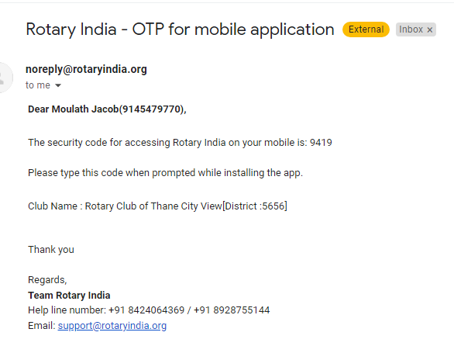
-OTP SMS FOR MOBILE LOGIN
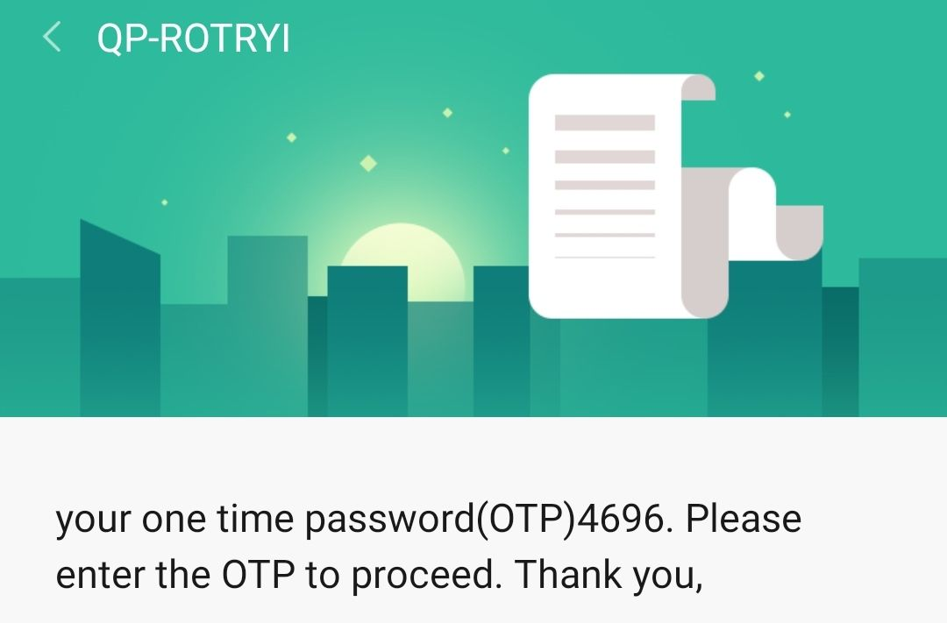

-FEEDBACK EMAIL
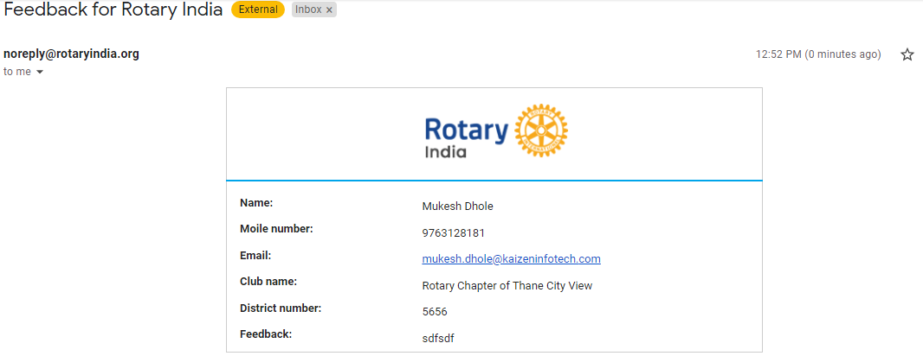
FORGET PASSWORD EMAIL:-
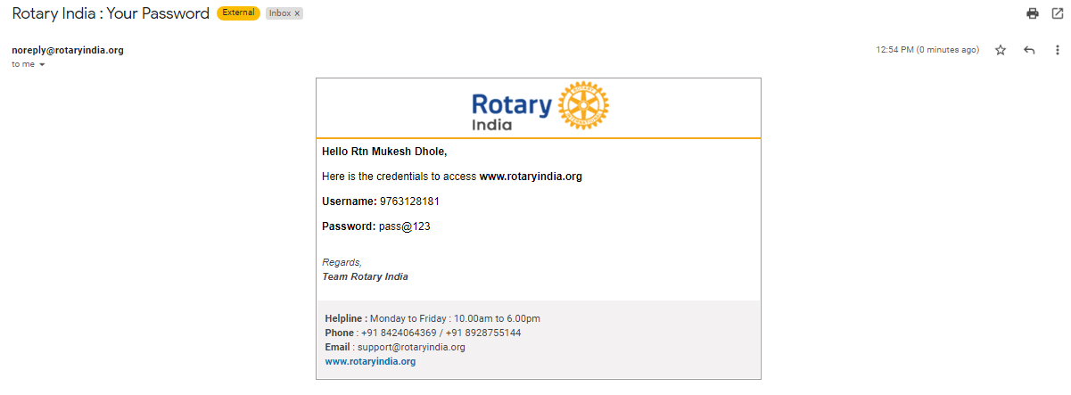
ADMIN RIGHTS:-
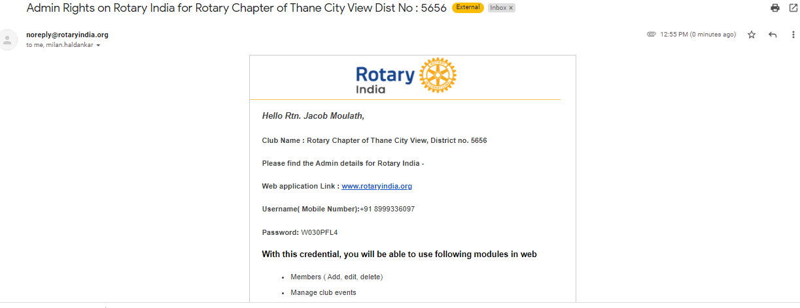

GREETINGS:- WHATSAPP(BIRTHDAY AND ANNIVERSARY)
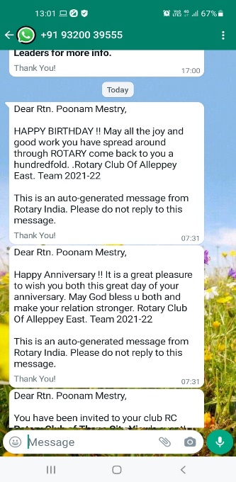
GREETINGS:-EMAIL (ANNIVERSARY)
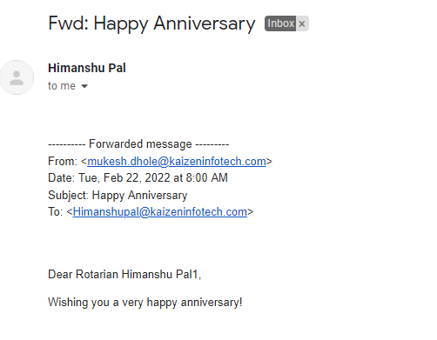

GREETINGS:-EMAIL (BIRTHDAY)

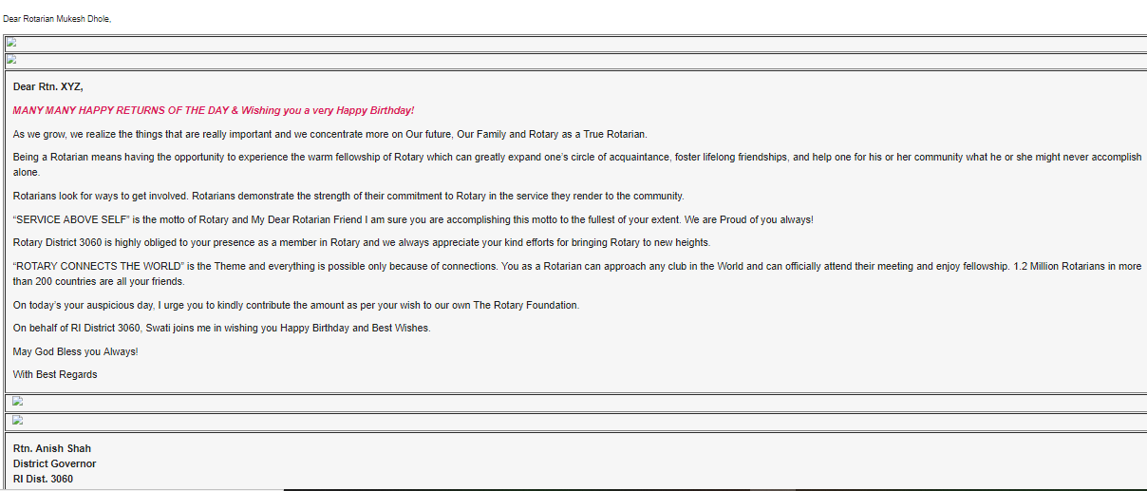

PURCHASE:-EMAIL
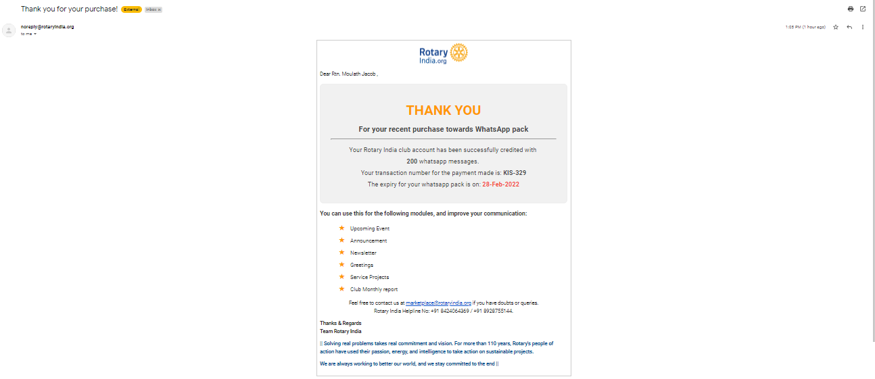

UPCOMING EVENTS WHATSAPP NOTIFICATION:-
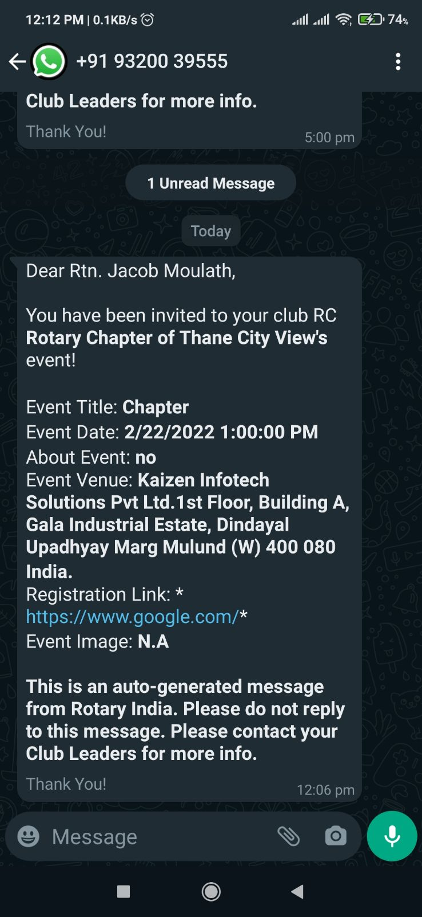
Message when a new child chapter is created (sms and email)
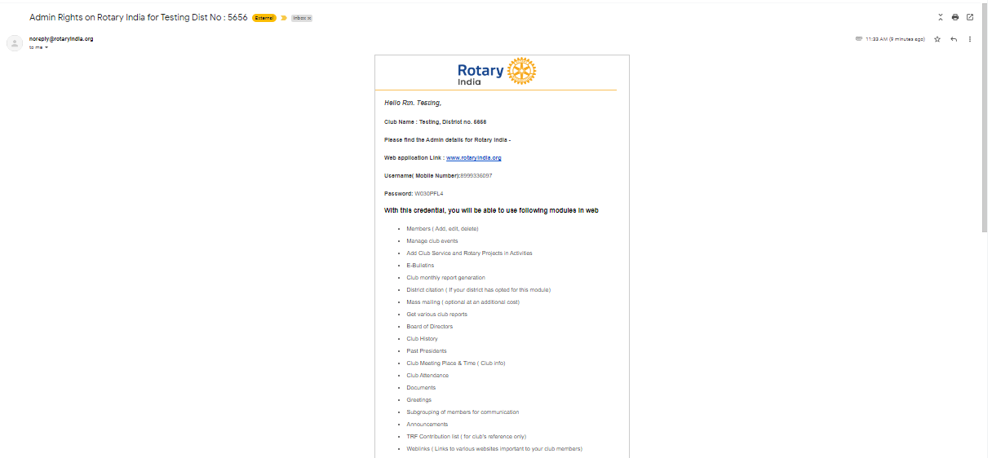
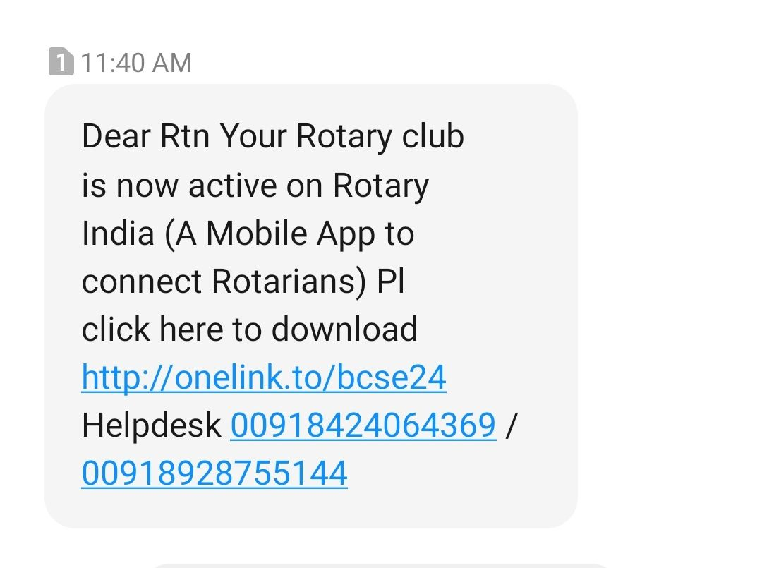

NEWSLETTER WHATSAPP NOTIFICATION:-
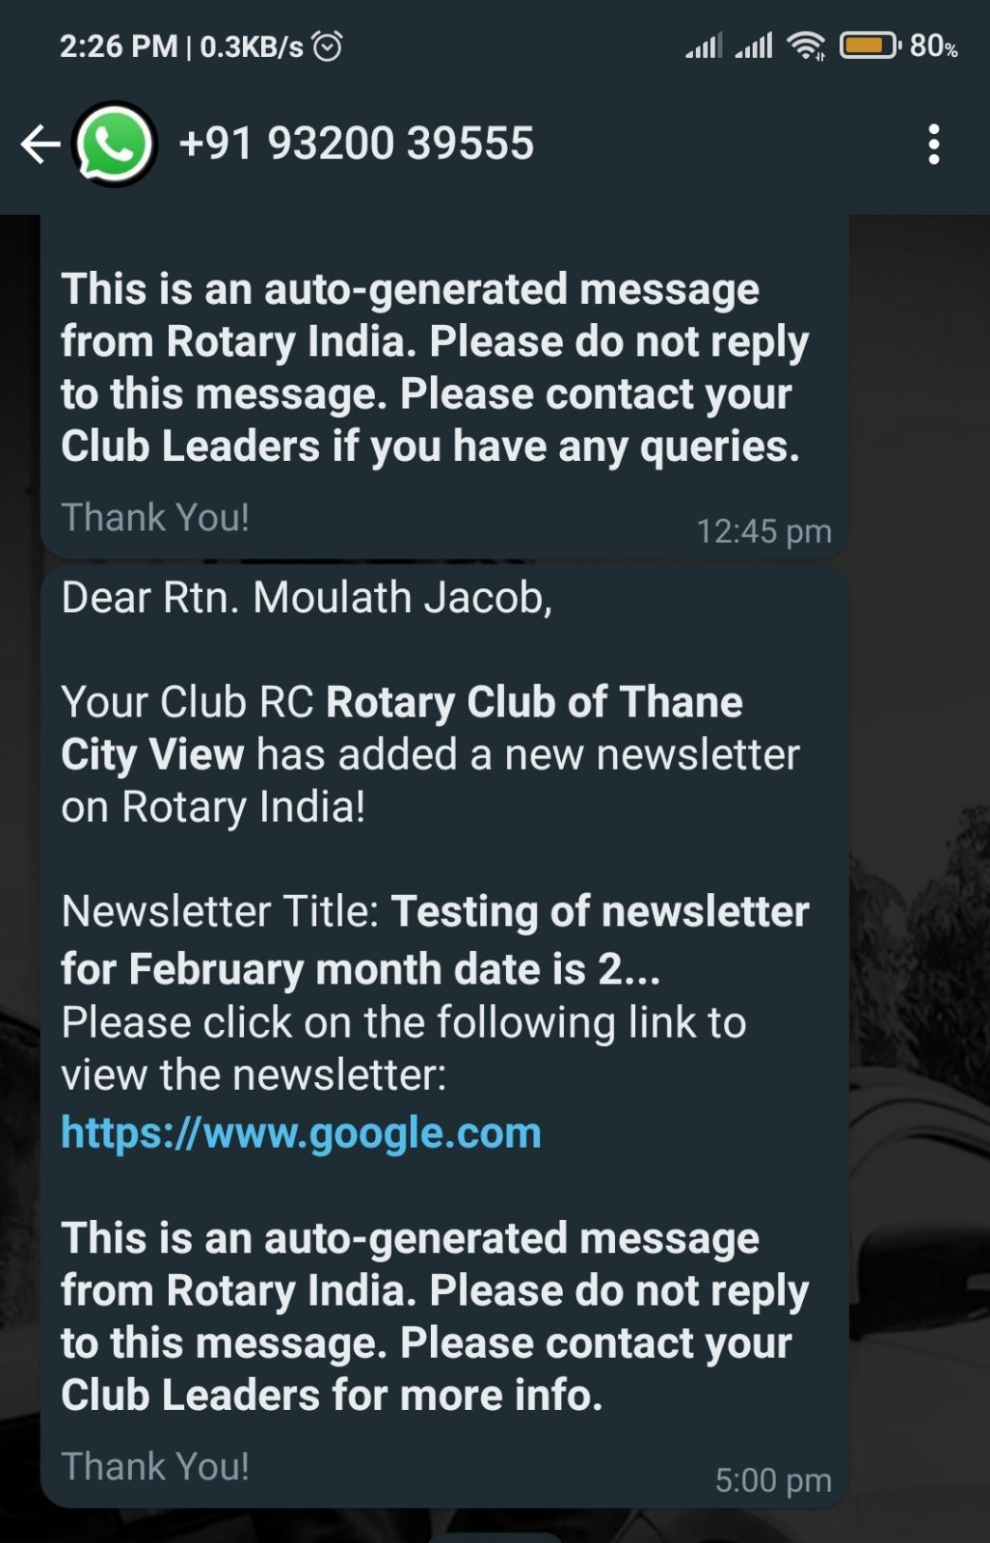

Admin Rights on Rotary India as AG(EMAIL AND SMS NOTIFICATION)
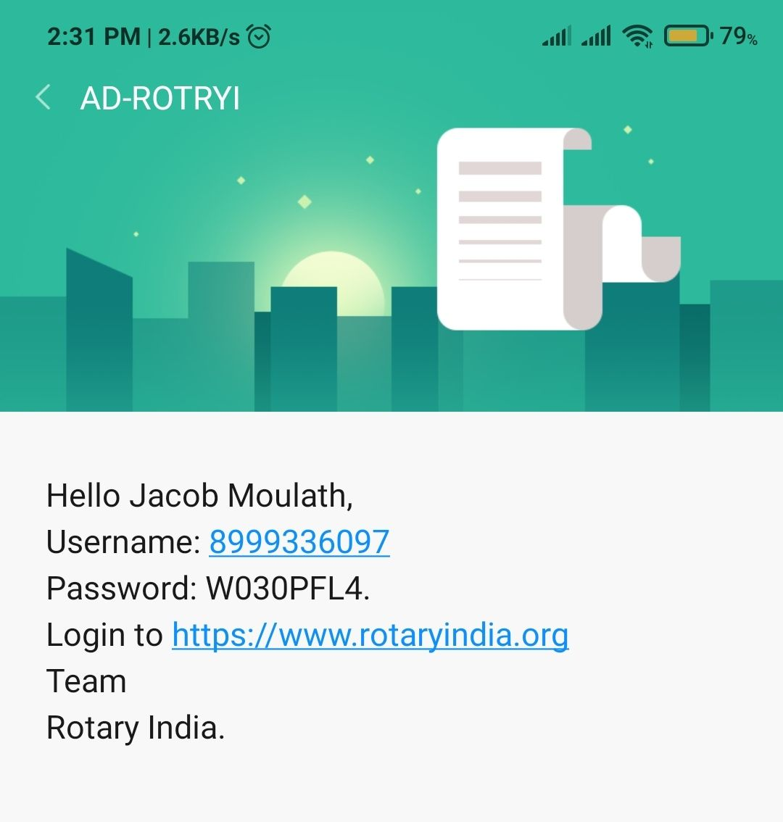
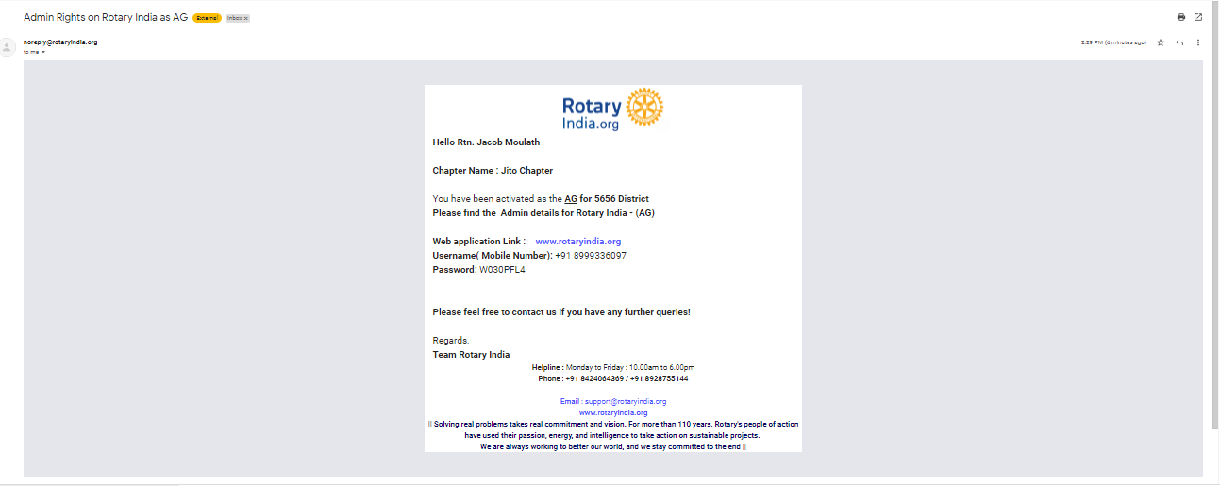

Admin Rights on Rotary India as Modarator
(MAIL AND SMS)
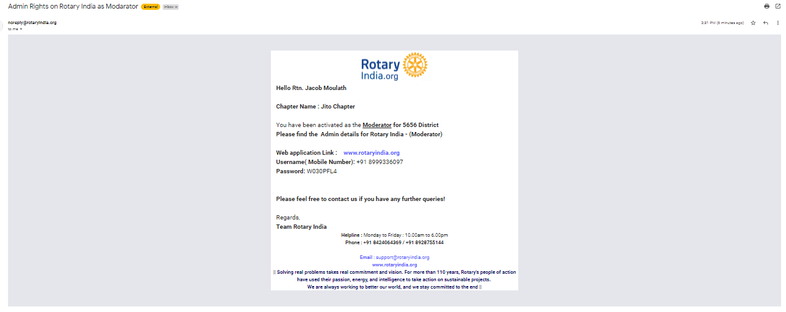

CLUB MONTHLY REPORT UPLOAD TO DISTRICT MAIL:-
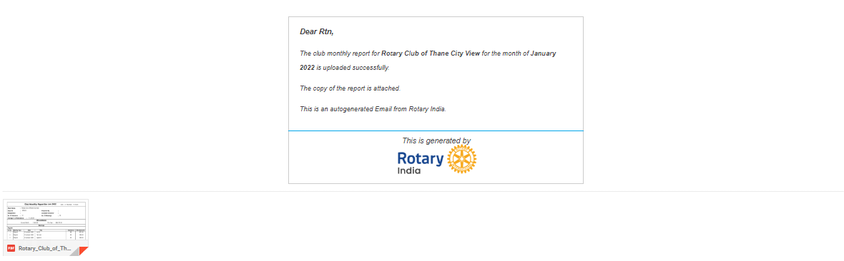

CLUB MONTHLY REPORT NOT SUBMITTED TO DISTRICT WHATSAPP:-
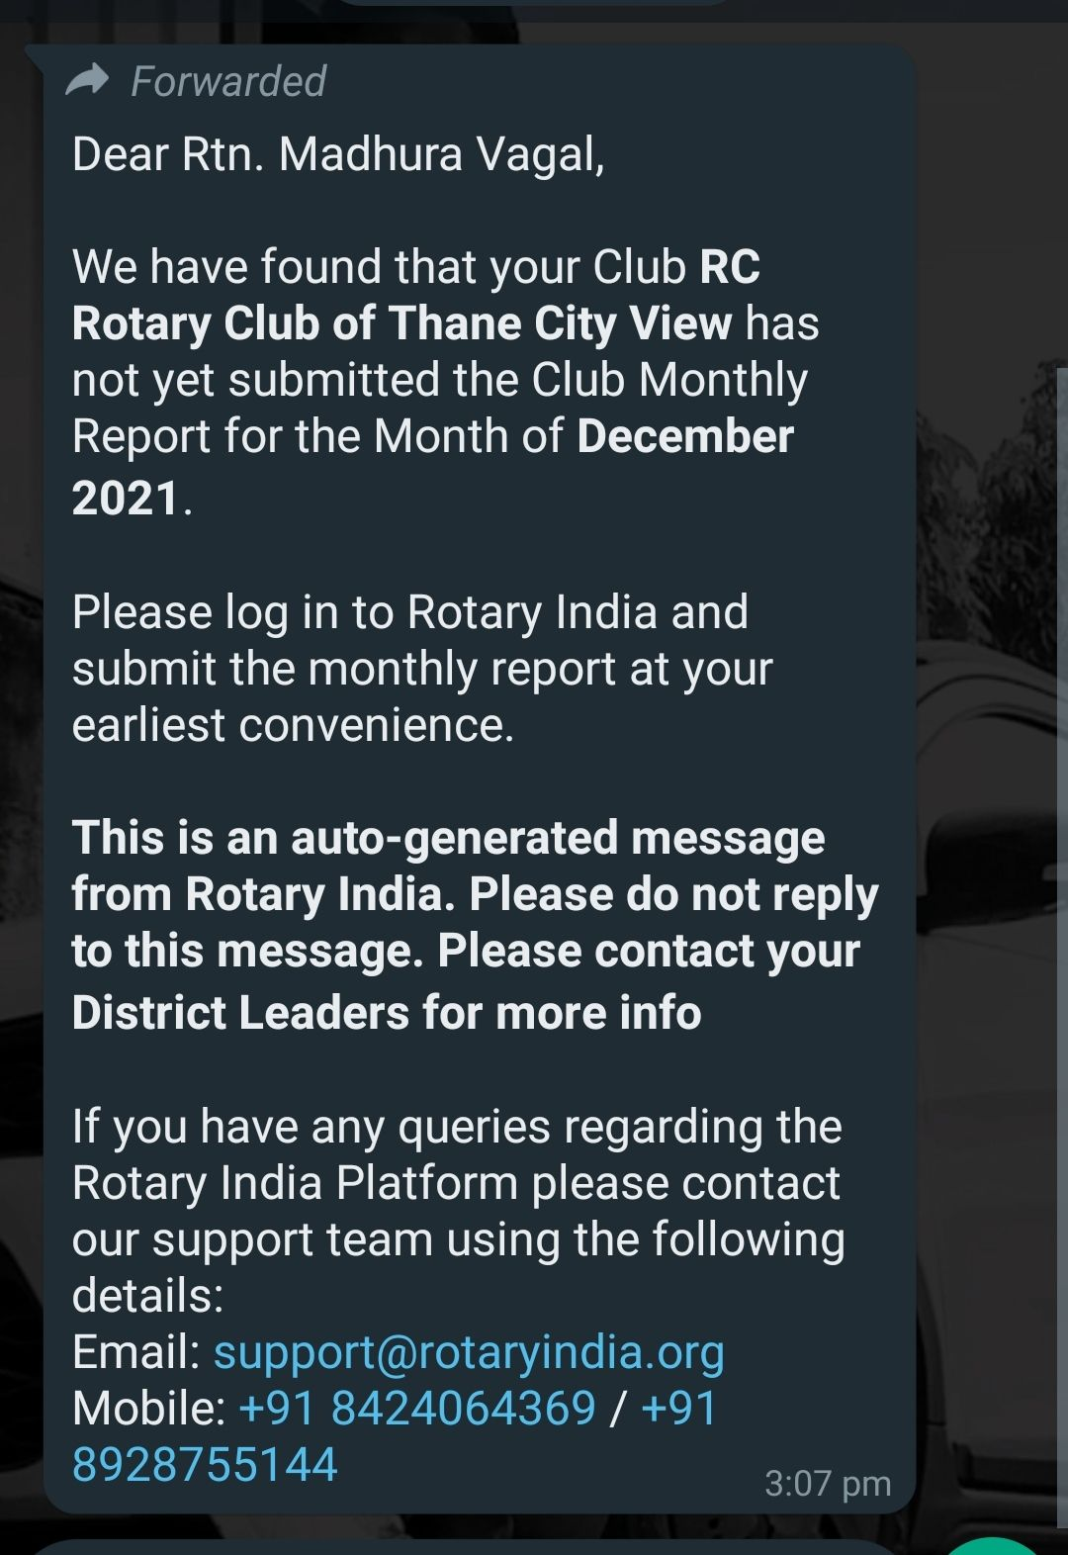
CLUB MONTHLY REPORT NOT SUBMITTED TO DISTRICT EMAIL:-
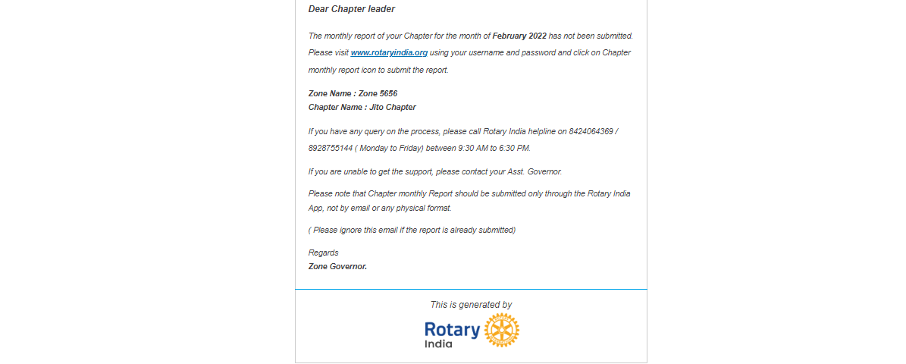

POPUP AFTER SUCCESSFULLY CREATING A CHAPTER SERVICE PROJECT
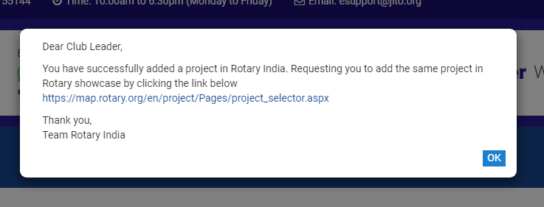

POPUP AFTER BENEFICARY IS MORE THAN 1000 CHAPTER SERVICE PROJECT
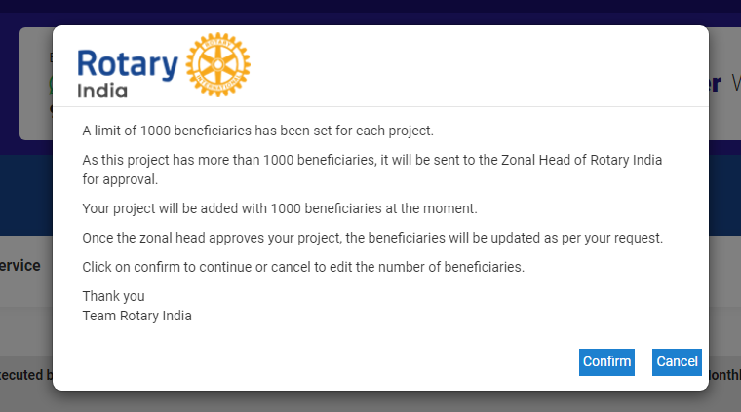

Jito Chapter has added a service project Moderator
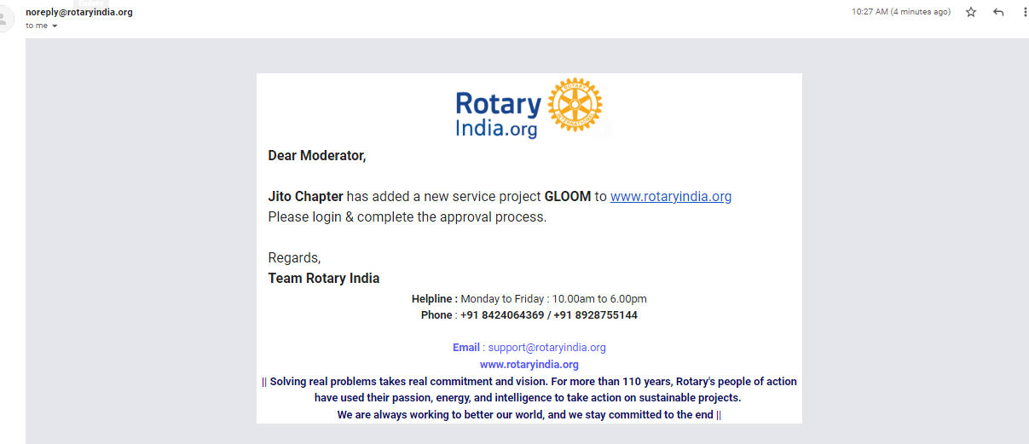

Beneficiaries email Notification:-
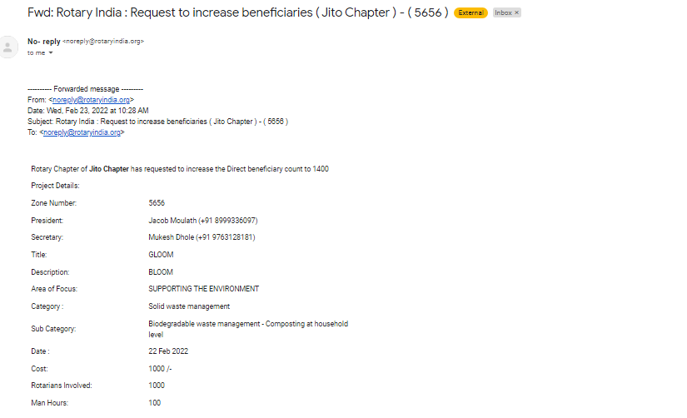

Beneficiary approved
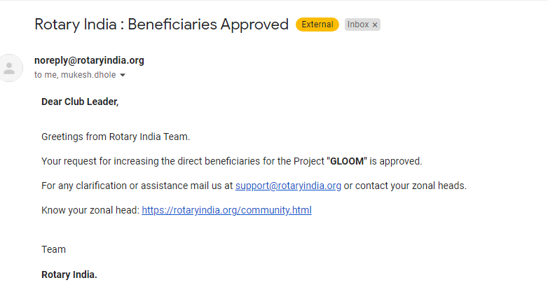
SERVICE PROJECT WHATSAPP NOTIFICATION:-
