
(Application Logo- Each team should Choose their OWN logo)
XUH “Health Hearts at Home” App
Software Requirements Specification (SRS)
Version 1.0
Student1– Project Manager
Student2 – Assistant Project Manager
Student3 – Software Engineer
Student4 – UI/UX Designer

Table of Contents
- Introduction…………………………………………………………………………………………………………………….3
  - Purpose………………………………………………….………………………………………………….3
  - Scope…………………….…………………………………………………………………………………..3
  - Definitions, Acronyms, & Abbreviations……………………………………………………..4
  - References……………………………………………………………………..………………………….4
  - Overview………………………………………………………………………………......................5
- Overall Description……………………………………………………………………………………………….…………..5
  - Product Perspectives……....…………….…………………………………………..................5
2.2.1: System Interface…………………………………………………...............................5
2.1.2: User Interface………………………………………….………………………..................6
2.1.3: Software ..……………………………………………………………………………..………...6
2.1.4: Communication Interfaces………………….…………………………………………...6
2.1.5: Memory………………………..………………………………………………………………….6
2.1.6: Run-Time……………………..…………………………………………………………………..7
  - Product Functions………………………………………………………………………………………….7
  - User Characteristics…………………………………………..……………………..…………………..7
  - Constraints………………………………………………………..……………..…………………………..7
  - Assumptions and Dependencies……………...…………………….…..………………………..8
- Specific Requirements…………………………………………………………………..….....................................8
  - External Interface Requirement………………….…………………..………..………………....8
3.1.1: User interface………………………………..……………………..…..……………………..8
      - Main Menu (Homepage).........................................................8
      - General Childcare Information…..……………..………..…………...….9
      - Tutorials for Child Care Needs…...…………………….……………....10
      - Spiritual Needs………...……………………...…..……………
      - 3.1.1.5. Hospital Information………………………..……….……......12
      - Caregiver Support……………..………………………………..…..…..…...13
      - Track Your Child…………..……………………..……………….……...…...14
      - About Your Child’s CHD…………………….……………….……………...15
3.1.2: Hardware Interface……………………..…………………………….…………..……...15
3.1.3: Software Interface……………………………………………………….…...……….....15
3.1.4: Communication Interface……………………………………………………...……….16
  - Functional Requirements…………………………………………..………………………………..16
3.2.1: Home Page……………………………………………………………………………..……...16
      - Opening Screen…………………………………..……………………...…....16
      - Home Screen…………………………………………..…….…………..……..16
    - Track Your Child…………………….….………………..…………………………..…....16
    - Contacts…………………………….……….……………..……………….…………...…...16
    - Hospital Information……………….…………………………….…..….……….……...17
    - English/Arabic Toggle………………………………………………………..………….17
    - Back Button………………………………………………………..………………..………..17
  - Performance Requirements………………....………………………………………..…....…….17
  - Design Constraints………………………………………………………………………..…….……...17
  - Software System Attributes…………...…………………………………….….……..……..…..17
3.5.1: Reliability………………………………………………………………….….…………...…..17
3.5.2: Availability………………………………………………..…………………..……………....18
3.5.3: Security…………………………….………………………...……………..……………….….18
  - Testing Requirements…....……..……………………………………..…………………………....18
3.6.1: Unit Testing………………………………………………..………………………………....18
3.6.2: Integration…………………………………….…………..……………….………………....18
3.6.3: Acceptance……………………….…………….…………..…………..…………………....18
  - Document Approval……...…………………..…………………………...…………………..……..18

1. Introduction

1.1) Purpose
“Health Hearts at Home” is an application which was requested by the client (X University Hospital), will contain helpful information to provide caretakers of children with Congenital Heart Disease (CHD) convenient access to information and tools they may need or want to use. The client gave the choice to building app for iOS or Android. However, this SRS is focusing on iOS.
You will be developing this application to support the needs of caregivers of children diagnosed with Congenital Heart Disease (CHD). Through this document, the CHD team will define the app’s functionalities, limitations, requirements, and objectives to deliver to our client who requested the application.

1.2) Scope
This application will provide the caretakers of children with CHD easy access to informative pictures, videos, documents, links, tutorials, and additional resources. Furthermore, the app will contain contact resources to their caregivers and doctors, also maps of the hospital and nearby area.
Your team need to create of the pages the client has asked for, and you are also responsible for adding or removing pages by client’s request, and adding any information about CHD the client has available to include in the upcoming prototypes.
The infrastructure for this app includes the standard pages. You will work on the level 1 and level 2 pages, also noting that level 0 (Home Page) also has to be completed. The client would like the work to be done by Dec 1st, so it’s the team’s priority to bringing more functionality and stability to the application over the next weeks. The main work will be in 3rd and 4th prototypes that include the following tasks:
The third prototype will:
- Add English/ Arabic text to Tutorials section
- Add English/Arabic text to Spiritual information
- Change path traversals from home page to match supplied jpeg (possibly adding or removing pages)
- Change button text and order to match client’s choices
- Change logo and jpeg homepage buttons to meet client expectations

The fourth prototype will:
- Add videos spiritual -> Devotionals
- Add videos Caregiver Support -> Patient Stories
- Add links to external websites after permissions are granted

My team and I will not be working on any port of the android version of this application during our 7 weeks working on this project.

1.3) Definitions, Acronyms, and Abbreviations
- App Market - Apple’s Application Market
- CHD - Congenital Heart Disease, this is the disease which the application will contain information, tutorials, videos, contacts, and external links about. Medical specialists will be supplying the information on this subject to ensure its validity.
- Client – XUH: X University Hospital
- Home Screen - The primary page of the application. Appears immediately after the application is opened.
- iOS - iPhone Operating System
- Android OS: Android Operating System
- Memory - refers to the memory (RAM) of the mobile-device.
- Mobile app - Mobile Application
- QA - Quality Assurance
- SRS - Software Requirements Specification
- Swift - Swift is a general-purpose, multi-paradigm, compiled programming language developed by Apple Inc. for iOS, macOS, watchOS, tvOS, and Linux.
- UI - User Interface
- Wi-Fi - A networking technology that allows computers and other devices ● to communicate over a wireless signal.
- Xcode - The integrated development environment (IDE) from Apple that is used to create, compile and test Mac OS X and iOS (iPhone/iPad/iPod) applications.

1.4) References
- Xcode – https://developer.apple.com/xcode/
- IEEE SRS Std 830
- Loma Linda University Medical Center - https://medical-center.lomalindahealth.org/

1.5) Overview
The goal of the product will change accordingly to what the client asks for. UI will change over the course of time with the implementation of ideas, and limitations. Any possible limitations will be discussed in the requirements section and further analyzed.

2. Overall Description

2.1) Product Perspectives
The mobile app will provide users with information about CHD and connect users to caregivers. The client wants the application to be able provide everything that is needed for the user, from a tracker for the child, to hospital helplines, to tutorials for child care including documentation and videos.
Health Hearts at Home will provide an essential tool for the parents and caregivers, and will be informed by the Hospital on the benefits and uses of the app.
The app will be first developed for iOS, with the intent of being developed for Android OS at a later date.

2.1.1: System Interface
The application's first development will be built using Xcode. The mobile app will have several pages that will pull from a database. From the database, documentation and videos for tutorials/information, maps and contact information of the hospital, will be pulled.

TASK 2:

2.1.2: USER INTERFACE
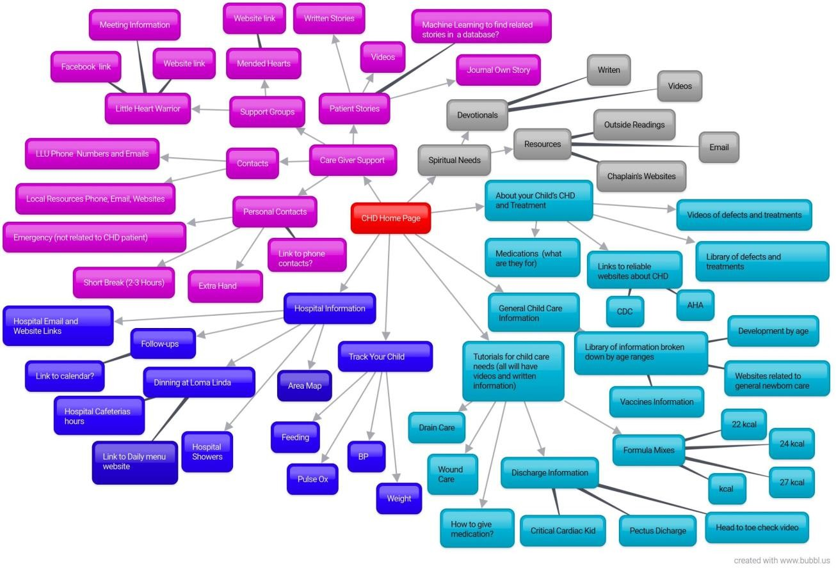
This is the detailed version of the screen traversal map from Level 0 being the red box marked CHD Home Page and moving outward level by level. The user will load into the home screen and will see 8 main options that can load into multiple other screens. The options for screen traversal will be provided in a displayed list. To transverse back to previous screens, there will be a back arrow on the top left. Every screen will include a English/Arabic toggle as long as translations are provided by the client in a timely manner.

2.1.3: Software
- Xcode – for the iOS version
- Android Studio – for the Android version
- Server set up by the Team

2.1.4: Memory
The iOS mobile application will not be memory intensive, as all the documentation and videos for the tutorials will be kept on the database. While the tracking information for the child, entered by the user, will be saved to the phone. When the Android version of the application is developed, it should too follow these same methods.

2.1.5: Run-Time
When the app is downloaded, the app will only be running during the time of active use by the user.

2.2) Product Functions -Use case Diagram
In this use case diagram, we represent the CHD user's interaction with the system. The diagram differentiates between 2 types of individuals who may be using the application and the use cases these individuals may have.

TASK 2: Draw the use case diagram.

2.3) User Characteristics
The user is a parent, or caregiver, that wants fast access to medical information, especially about Congenital Heart Disorder, and a way to track specific imputed statistics about their child’s health. The application will be available on the App Store once the application is completed and given the approval from Loma Linda Children’s Hospital (LLCH). LLCH will be in charge of updating the user with critical information during and after development.

2.4) Constraints
The first release of the application will only be available for Apple devices (e.g. iPhone, iPad, and iPod Touch). However, after the first release we will immediately start the development for the Android version of this application. The system requirements for the Android version will be available as soon as the development team approaches this final phase.

2.5) Assumptions and Dependencies
The development team assumes the user has access to the Internet in order to download and use the application. Additionally, an email address will be required from the parent to register their child on the application. Future updates will be necessary to provide the user with the latest information for their child’s care; hence, someone who is knowledgeable with either platform (e.g. iOS or Android) will be needed to maintain and update the application.

3. Specific Requirements
3.1) External Interface Requirements

3.1.1: User Interfaces
This section shows the current structure of the app. After our discussion with our client, she explained to us she would like the first and last buttons switched, plus the possible addition of another button. As we begin working on our prototypes, we will make these changes. For now, this subsection shows the current app and the purpose of each page.

3.1.1.1. Main Menu (Homepage)
Upon opening the app, the user will have quick and easy navigation between the different pages of the app through the use of 7 section buttons.
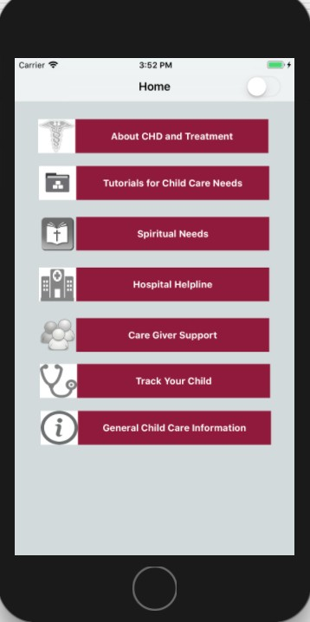

3.1.1.2. General Childcare Information
This page contains further information about childcare and other information regarding the child’s needs and development.
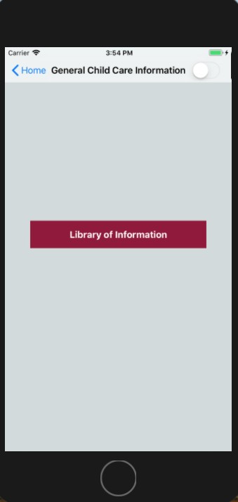

3.1.1.3. Tutorials for Child Care Needs
This page contains tutorial videos and guides for the user to see. For accommodations, these tutorials will be in both English and Arabic.
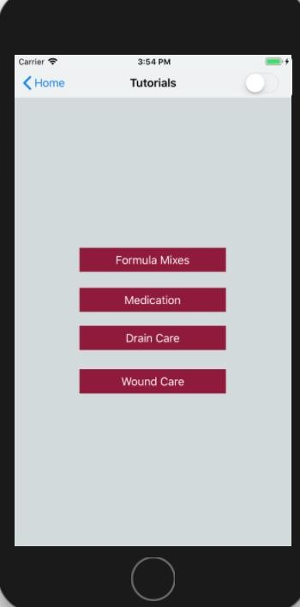

3.1.1.4 Spiritual Needs
This page contains links to pages of text and videos of spiritual information, as well as links to other chaplain services.
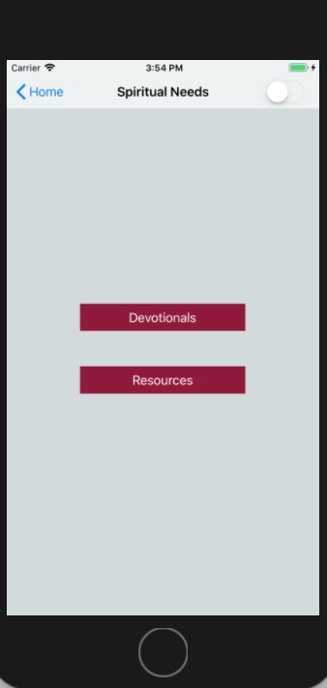

3.1.1.5. Hospital Information
On the Hospital Information page, the user will be able to find links that will redirect the user to more general information needed during a hospital stay.
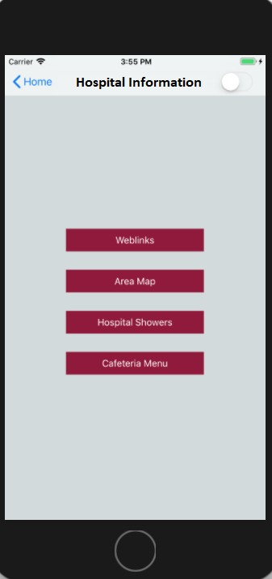

3.1.1.6. Caregiver Support
This page contains support information for individuals taking care of patients diagnosed with CHD. It is meant to help the caregivers find resources that will help them cope with the feelings they are facing.
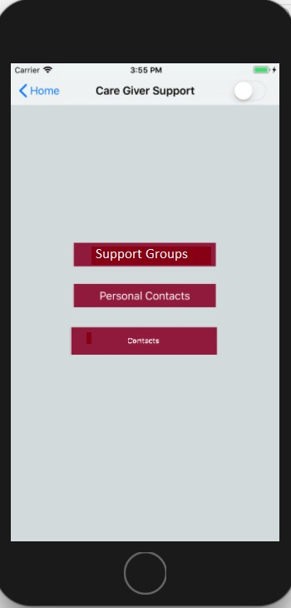

3.1.1.7. Track Your Child
In this section, the user can input information about their child. Such as, weight, feeding schedules, etc.
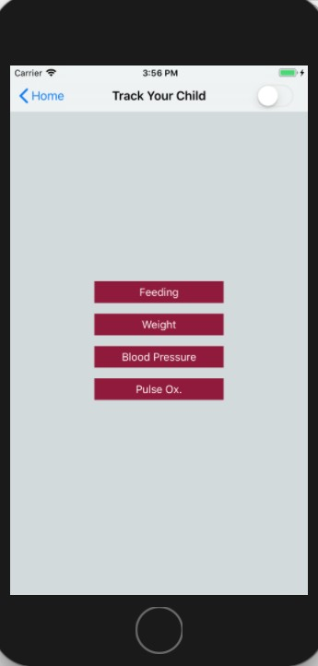

3.1.1.8. About Your Child’s CHD
This section will contain information about Congenital Heart Disease (CHD) of the user or user’s child.
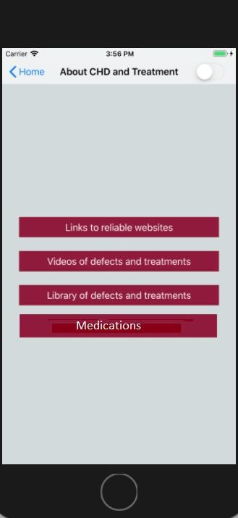

3.1.2: Hardware Interface
The app will first be available on iOS devices through the App Store. In the future, the team plans to expand for Android devices and have the app available on the Google Play Store at a future date.

3.1.3: Software Interface
The app will have a database that will have information stored. In the database, the information will be what the user has inputted into the app, such as their child’s information, equipment, contacts and etc. and needs to be well secured. The database will also contain the documentation, videos and links that will be used in the app.

3.1.4: Communication Interface
Internet access is needed for the app to be downloaded. Using cellular data or connection to WiFi is needed to have access to certain content in the app. However, some pages do not need access to the internet to be able to use once downloaded.
Although videos, and URLs may require internet access.

3.2) Functional Requirements
Below is a detailed list of functions the client wants to see implemented on the app. Such function will facilitate the users’ ability to navigate through the application as well as provide the desired need. These functions are intended to make the application more practical and user friendly.

3.2.1: Homepage

3.2.1.1. Opening Screen
Upon startup, the application will display the “Health Hearts at Home” logo as well as any other logos of affiliates such as Loma Linda University.

3.2.1.2. Home Screen
The home screen will contain the main menu. This menu is composed of the 8 options than can load into the screen. Such options include “Care Give Support”, “Track your Child”, “Hospital Information”, “General Child Care Information”, “About your Child’s CHD and Treatment”, “Spiritual Needs”, and “Tutorials for Child Care Needs” (not necessarily in this order).

3.2.2: Track Your Child
The “Track Your Child” page allows the user to be able to monitor their child’s routinely care. Such as inputting information about the weight, feedings (date, time, amount, breast/bottle), and oxygen saturation. Also, there will be the ability to report the equipment the caregiver is using to tend to their child.

3.2.3: Contacts Page
The contacts page will list LLU phone numbers as well as emails. It will too contain local resources phones, emails, and websites. Another feature will be the users’ accessibility to personal contacts and their own health care providers.

3.2.4: Hospital Information
The hospital helpline page will contain information that is readily available to the user. In it they can find hospital email and website links, cafeteria hours along with a link to the daily menu, area map, and hospital showers availability.

3.2.5: English/Arabic Toggle
To accommodate for both English and Arabic speakers, we will implement a switch that changes the text of each screen between the two languages. The language toggle will be a switch incorporated into the top right corner of every screen. This enhances the accessibility of the switch by allowing the user to have access it no matter in what section or screen of the app they are in. This function is beneficial by allowing a user to choose the language they feel comfortable with when reading the text on each screen.

3.2.6: Back button
This button will act as the standard iPhone/Android back button. Its job is quite simple, when the user presses it, the app will take the user back to the previous screen. That way, if the user is deep in a section of the app, they can always go back to the parent screen or all the way back to the home screen using this button without getting lost in the pages. The back button will be found on the top left of every screen except the Homepage of the app.

3.3) Performance Requirements
This program will be able to run on most version of Apple iOS and will eventually be available for download from the App Store. Functions of the program are primarily data retrieval so it should not be processing intensive.

3.4) Design Constraints
All coding will be done on Apple machines using Xcode. The client has specified several different pages and I/O's available to user as well as a few UI/UX models that contain their preferred colors and user environment.
3.5) Software System Attributes

3.5.1: Reliability
The program will be constructed incrementally, one function at a time with extensive testing on multiple emulations of multiple generations of Apple devices ranging from iPads to iPhones. The QA team will also be keeping track of progress and perform independent testing to ensure reliability.

3.5.2: Availability
For the first several prototype versions of the application, it will only be available on a private server controlled by the Team. Later however, it will be uploaded to the App Store for user download. Eventually the application will also be developed for Android OS and be available on Android devices in the Google Play Store.

3.5.3: Security
Devices and methods will follow security protocols such that:
The teams will be responsible for design decisions and quality assurance. The Development team will adhere to the JUST networks security protocols when connecting to the network. Those with admin access will be the only ones able to view and access sensitive information such as that regarding specific clients and their children along with personal information.

3.6) Testing Requirements

3.6.1: Unit Testing
The development team will continuously test functions built for the application throughout the development phase prior to integration. The team will make sure all functions meet or exceed desired results.

3.6.2: Integration
Once the standalone functions are doing as they are intended, then the team will integrate and test them to ensure reliability/stability. The team will make sure all functions integrations meet or exceed desired results.

3.6.3: Acceptance
The project team is partnered with a QA team to run the app and put it through rigorous testing to ensure the applications software is secure and properly constructed. Once approved CHD is approved by the QA team and the Client, it will be given the approval to launch in the App Store.

3.7) Document Approval
Signature:_____________________________________ XUH (client)

Date:____________________________________

