A Project Report On

“PartyUp Android App”

Submitted To

MES Garware College of Commerce

and

Savitribai Phule Pune University

In partial fulfilment of the degree of

Bachelor of Business Administration- Computer Application

**Pushkar Deepankar**

**&**

**Samarth Birdawade**

Seat No:

**(15423 & 15425)**

BBA-CA

Semester:

**(Semester VI)**

Under the guidance of **Prof. Priyanka Jain**

Research Guide

MES Garware College of Commerce Autonomous, Karve Road, Pune 411004

(2023-24)



**MES GARWARE COLLEGE OF COMMERCE, AUTONOMOUS,**

**PUNE-411004.**

**BACHELOR OF BUSINESS ADMINISTRATION - COMPUTER APPLICATION**

**CERTIFICATE**

This is to certify that **Mr. Pushkar Deepankar &** **Mr. Samarth Birdawade,** Roll Numbers **15423 & 15425,** Exam Seat Numbers _________________________, Students of TY BBA-CA Semester-VI have successfully completed the project work in specialization subject Project based on Java + Kotlin, entitled as " PartyUp " a partial fulfillment of the degree of Bachelors of Business Administration in Computer Application as per the syllabus of Garware College of Commerce and Savitribai Phule Pune University for Year 2023-2024.

I further clarify that the work has been carried out under my supervision.

Project Guide BBA-Coordinator Principal

Internal Examiner External Examiner

**Introduction**

Welcome to PartyUp, the ultimate app designed for gaming enthusiasts seeking the perfect squad! In the dynamic world of online gaming, connecting with like-minded players can be a challenge. Whether you're a seasoned gamer or just starting your virtual adventures, PartyUp is here to revolutionize your gaming experience. Our app is not just a platform; it's a social hub dedicated to fostering friendships, teamwork, and unforgettable gaming moments.

Building on the foundation of community and connection, PartyFinder takes the gaming experience to the next level. It’s not just about finding a game to play; it’s about finding the right people to play with. Our unique GamerCall feature allows you to send out a call to arms, rallying fellow gamers to your cause, be it a cooperative mission or a competitive clan match. With the Live Gamer Call feature, you can find gamers who are online and ready to play at a moment’s notice. Our chat feature provides a space for individual or group conversations, facilitating strategic discussions or friendly banter. And with a dedicated profile screen, you can showcase your gaming achievements and persona to the community. PartyFinder is more than an app; it’s your gateway to a global gaming community. Join us and transform the way you play!

**Objectives**

Efficient Party Formation:

Easily find and connect with compatible party members for gaming sessions, ensuring a quick and efficient process.

Customizable Requests:

Users can create personalized requests, specifying game preferences, skill levels, and other criteria to find the perfect teammates.

Chat Functionality:

Seamless chat features enable communication between potential party members, allowing them to discuss strategies, schedules, and other details.

Group Chat Support:

Facilitates the creation of group chats for coordinated communication within the party, fostering teamwork and camaraderie.

Time Optimization:

Save time that would otherwise be spent manually searching for teammates, letting users focus more on enjoying their gaming experience.

User Profiles:

Detailed user profiles provide information about gaming preferences, experience levels, and other relevant details, aiding in informed decision-making.

**Scope**

Diverse Game Inclusion:

PartyUp aims to support a wide variety of games across genres, platforms, and gaming communities.

Regular updates will introduce new titles to ensure users can connect with others who share interests in both popular and niche games.

Community Customization:

Users have the flexibility to create and modify gaming communities within the app, tailored to specific games, genres, or themes.

Customize community settings, such as visibility, membership criteria, and communication preferences, to enhance the overall gaming experience.

Roles for Group Chats:

Introduce role-based permissions within group chats to facilitate effective communication and coordination.

Assign roles such as moderator, strategist, or captain to streamline in-game decision-making and organization.

AI Integration for In-Game Connection:

Implement artificial intelligence algorithms to analyse gaming preferences, playstyles, and compatibility.

Once users become friends on PartyUp, leverage AI to suggest optimal in-game connections, making it easier for friends to team up and play together seamlessly.

Integration of Voice and Video Communication:

Enhance user interaction by incorporating voice and video communication features within the app.

Enable users to strategize, share tips, and celebrate victories in real-time, fostering a more immersive gaming community experience.

Community Events and Challenges:

Empower community leaders to organize events and challenges within the app.

Introduce features for scheduling, promoting, and participating in community-driven tournaments, leagues, and friendly competitions.

User-Generated Content Sharing:

Allow users to share their gaming highlights, strategies, and content within the app.

Create a platform for users to showcase their achievements, guides, and memorable gaming moments, fostering a sense of community and shared passion.

Cross-Platform Integration:

Support cross-platform gaming by enabling users on different gaming platforms to connect, communicate, and play together seamlessly.

Facilitate a unified gaming experience by breaking down platform barriers and promoting inclusivity.

PartyUp's scope extends beyond traditional gaming apps, aiming to create a versatile platform that adapts to the diverse needs of gamers. By incorporating features like diverse game inclusion, customizable communities, role-based group chats, AI-driven connections, and more, PartyUp aspires to be the go-to app for gamers seeking a comprehensive and tailored gaming community experience.

**System Requirements:**

* **Software Requirements:**

- Android SDK with API level 34 (Android 11.0) as the compile SDK.

- Minimum Android version required to run the application is API level 30 (Android 10.0).

- The application is built to target API level 34 (Android 11.0).

- Kotlin version 1.9.0.

- Gradle version 8.2.2.

* **Dependencies:**

- Google Services version 4.4.1 for Firebase.

- AndroidX libraries for various functionalities such as lifecycle management, activity composition, navigation, and more.

- Firebase libraries for authentication, database, and storage.

- Coil library version 2.5.0 for image loading.

- Room library version 2.6.1 for local database management.

- Retrofit library version 2.9.0 for network operations.

* **Build Configurations:**

- The application uses Java 8 for both source and target compatibility.

- The application uses JVM target 1.8 for Kotlin.

- The application has enabled Compose with Kotlin compiler extension version 1.5.1.

- Proguard is not enabled for release builds.

* **Hardware Requirements:**

- A device or emulator running at least Android 10.0 (API level 30).

- For development, a computer capable of running Android Studio and the Android SDK.

**System Design**

* **ERD**

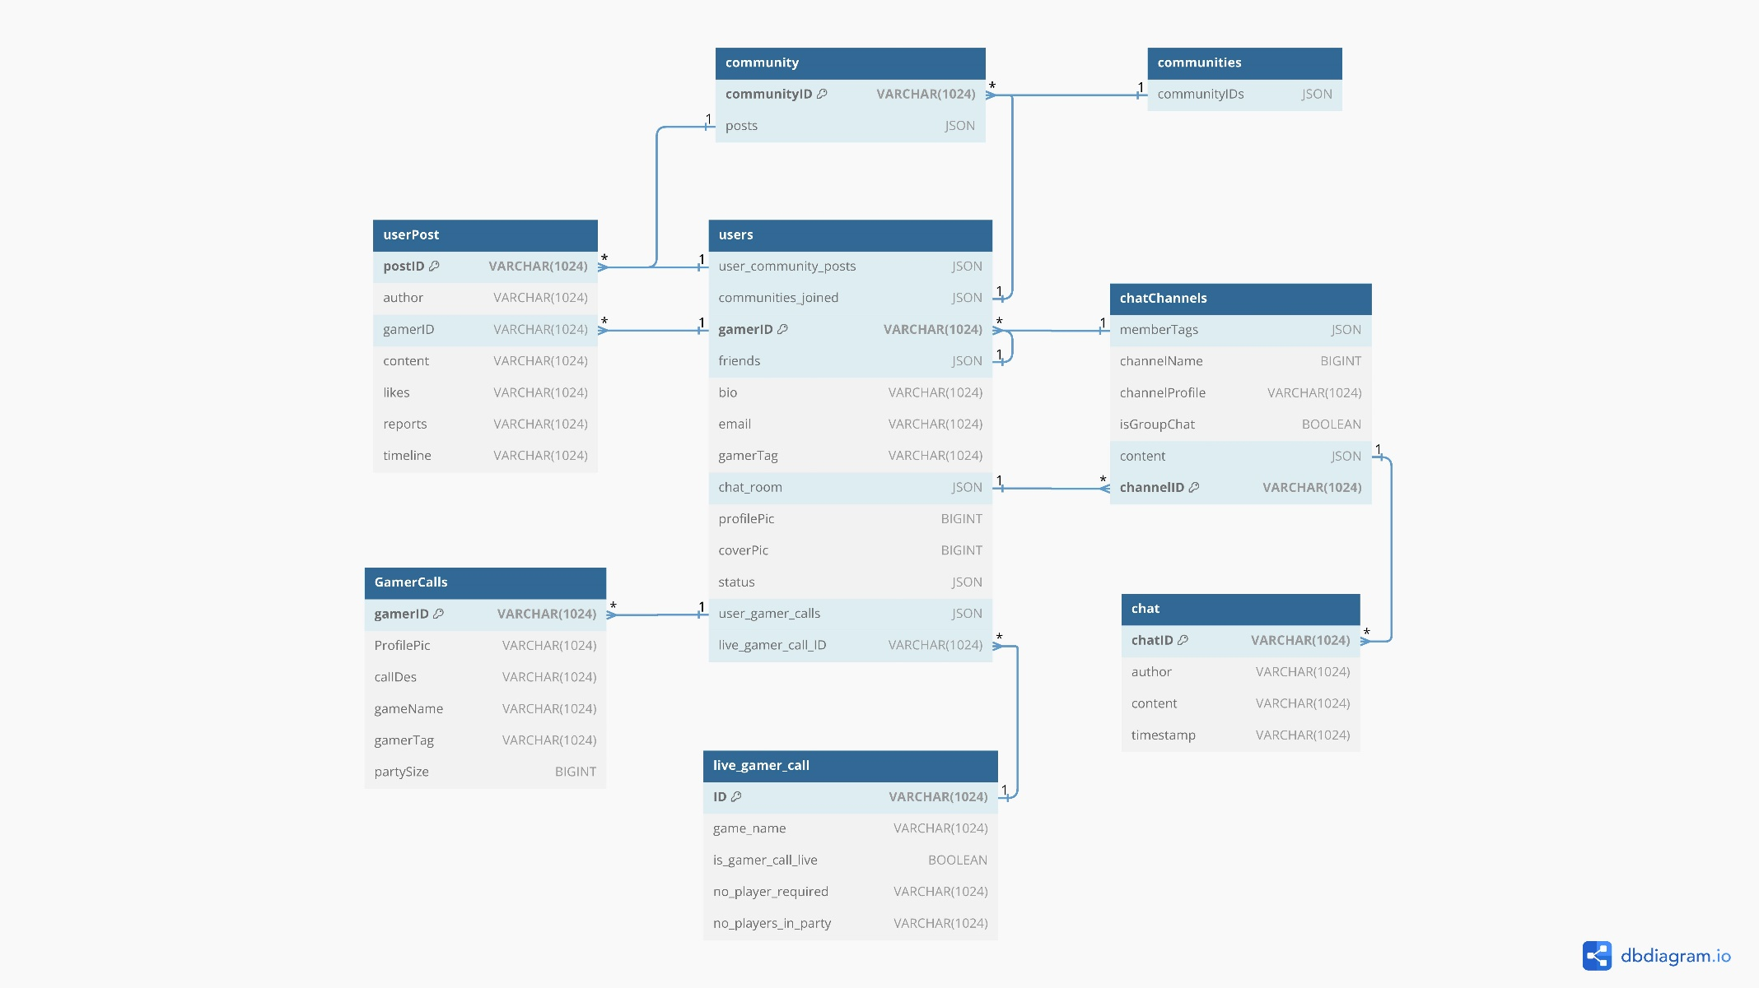

* **DFD**

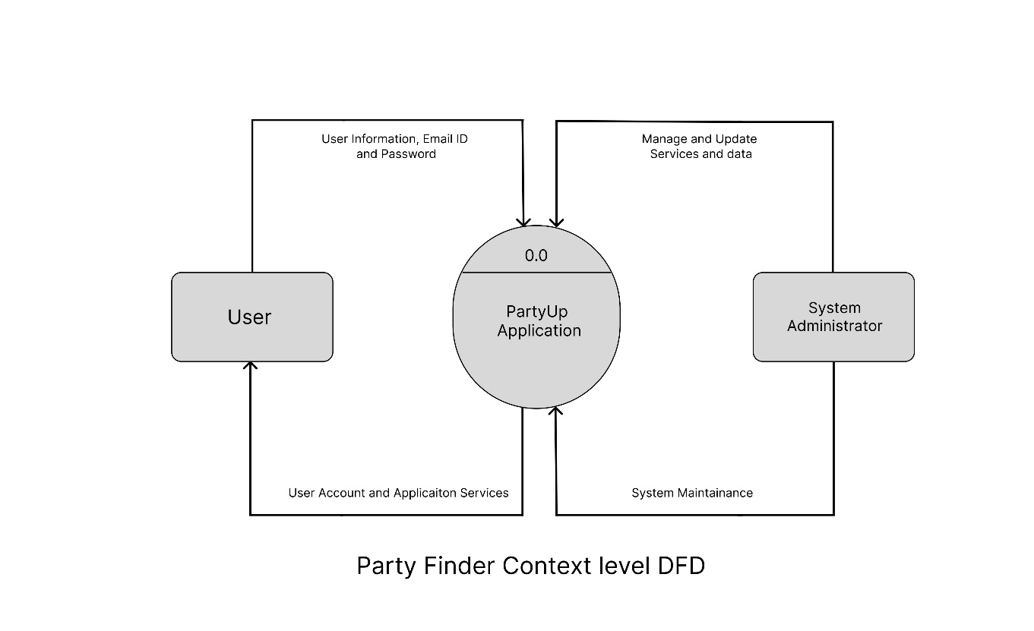

**Snapshots of App**

**Snapshots of Database**

**Limitations of System**

Limited Game Listings:

The app's effectiveness is constrained by the availability of games on its platform; users may not find their desired game titles listed.

Potential Mismatch:

There is a risk of mismatched parties, where the app may not accurately gauge the compatibility of players, leading to suboptimal gaming experiences.

Mobile-Only Access:

The app is limited to mobile devices, restricting access for users who prefer playing on other platforms like PCs. This can be inconvenient for those who want to manage their party while gaming on a different device.

Dependency on App Usage:

Users are required to use the mobile app for all interactions, even if the game they are playing is on a different platform. This may not be convenient for those who prefer managing their parties through other means.

Limited Scope Beyond Chatting:

The app's functionality is limited to matchmaking and chatting, lacking features for more comprehensive party management, such as shared calendars or file sharing.

Privacy Concerns:

Users might be concerned about privacy issues related to sharing personal gaming preferences and information on the platform, impacting the willingness of some players to use the app.

**Conclusion**

PartyUp app aimed to create a comprehensive platform for gamers, offering a wide range of features from diverse game inclusion and community customization for in-game connection and cross-platform integration. The project's scope was ambitious, seeking to break down barriers in the gaming community and provide a tailored experience for each user.

The project successfully implemented several innovative features, such as group chats, text communication, searching for a gamer friend and user-generated content sharing. These features have the potential to significantly enhance the gaming experience, fostering a sense of community and shared passion among users. PartyUp proves to be a social hub dedicated to fostering friendships, teamwork, and unforgettable gaming moments

However, the project also faced several limitations. The availability of games on the platform was limited, potentially restricting its appeal to users interested in unlisted titles. The risk of mismatched parties could lead to suboptimal gaming experiences. The app was also limited to mobile devices, which could be inconvenient for users who prefer other platforms. The dependency on app usage for all interactions, even when the game is on a different platform, may not be convenient for all users. The functionality of the app was primarily limited to matchmaking and chatting, lacking features for more comprehensive party management. Lastly, privacy concerns related to sharing personal gaming preferences and information on the platform could impact some players' willingness to use the app.

In conclusion, while the PartyUp project has made significant strides in creating a versatile platform for gamers, there are areas for improvement and expansion. Future work should focus on addressing these limitations to further enhance the user experience and broaden the app's appeal. The project's successes and challenges provide valuable insights that can guide future development efforts, with the ultimate goal of creating an inclusive, engaging, and user-friendly platform for the gaming community.

**Bibliography**

1. [Microsoft Copilot](https://www.bing.com/chat)
2. [Philipp Lackner - YouTube](https://www.youtube.com/@PhilippLackner)
3. [Figma](https://www.figma.com/)
4. [Github](https://github.com/)
5. [Android Mobile App Developer Tools – Android Developers](https://developer.android.com/)
6. [Stack Overflow - Where Developers Learn, Share, & Build Careers](https://stackoverflow.com/)