**IEDA 5230 Fall 2023, Homework Assignment 2**

**ZHENG Kaixin, 21013165**

Question 1: Refer to Lecture 4, slides 23 to 24

Slide 23 shows the optimal solutions to 5 instances of transportation problem with 3 source nodes and 4 destination nodes.

1. In all these optimal solutions, there are at most 6 non-zero flows. Is this a coincidence or is it always true?
2. For the problem of the grand coalition, the shadow price for one constraint is 0. Is this a coincidence or is it always true?

(1) It is always true. Suppose there are m source nodes and n destination nodes.

From the graph perspective: consider each flow can be both forward and backward, then m+n-1 flows can construct a connected graph. Suppose we have m+n non-zero flows, we can always delete the flow with maximum cost (Cij), and replace it with other paths (the paths are always existing because the graph is connected), and meanwhile achieves a lower cost.

From the LP perspective: Because total supply equals total demand, therefore, only m+n-1 structural constraints are linearly independent, there will be m+n-1 basic independent variables out of m+n variables.

(2) It is always true. If there is no shadow price of 0, we can find a better solution.

Question 2: Refer to Lecture 5, slides 13 to 16

It is found that the company does not have enough buses to serve all orders. The company considers two options, rejecting some orders and renting some outside buses. Assume that each order j has a profit pj, and the cost of renting one outside bus is b.

1. Develop a modified network flow model to determine which orders should be rejected.
2. Develop a modified network flow model to determine the number of outside buses to rent.
3. Is it possible to build a network flow model which can find an optimal decision that considers both options together?

(1) 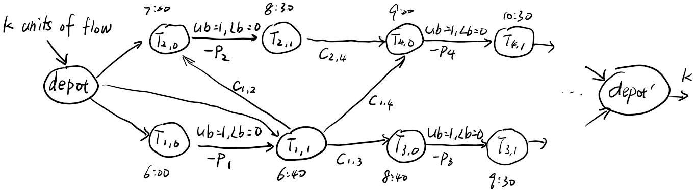

* Each pair of nodes represents a trip $T_{j,0},T_{j,1},j=1,2,…$  
  It has a flow lower and upper bound, equal to 0, 1 respectively, and the cost is -pj.
* Each arc ($T_{j,1}, T_{i,0}$) represents a possible connection trip j to trip i, with a cost cji
* Routing of k buses 🡪sending k units of flow from depot to depot’
* Let $x_{ij}$ denote the number of buses on the arc ($T_{j,1}, T_{i,0}$)  
  Let $y_{i}$ denote whether trip i is chosen  
  To minimize total flow costs $∑x_{ij}c_{ij}-∑y_{i}p_{i}$

(2) 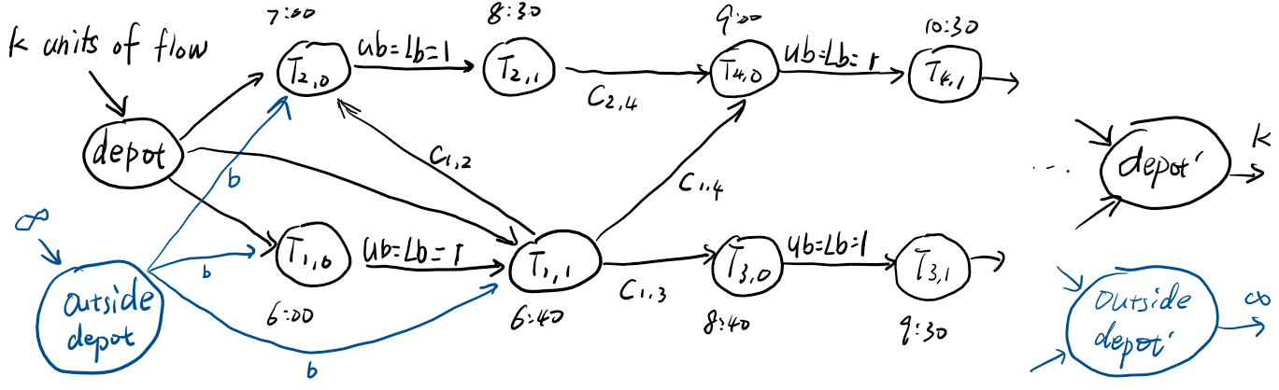

* Each pair of nodes represents a trip $T_{j,0},T_{j,1},j=1,2,…$  
  It has a flow lower and upper bound, both equal to 1
* Each arc ($T_{j,1}, T_{i,0}$) represents a possible connection trip j to trip i, with a cost cji
* sending k units of flow from depot to depot’  
  Additionally, sending ∞ units of flow from outside depot to outside depot’, and arc from this outside depot has a cost $b$.
* Let $x_{ij}$ denote the number of buses on the arc ($T_{j,1}, T_{i,0}$)  
  Let $z_{i}$ denote the number of buses from outside depot to trip i.  
  To minimize total flow costs $∑x_{ij}c_{ij}+∑z_{i}b$

(3) 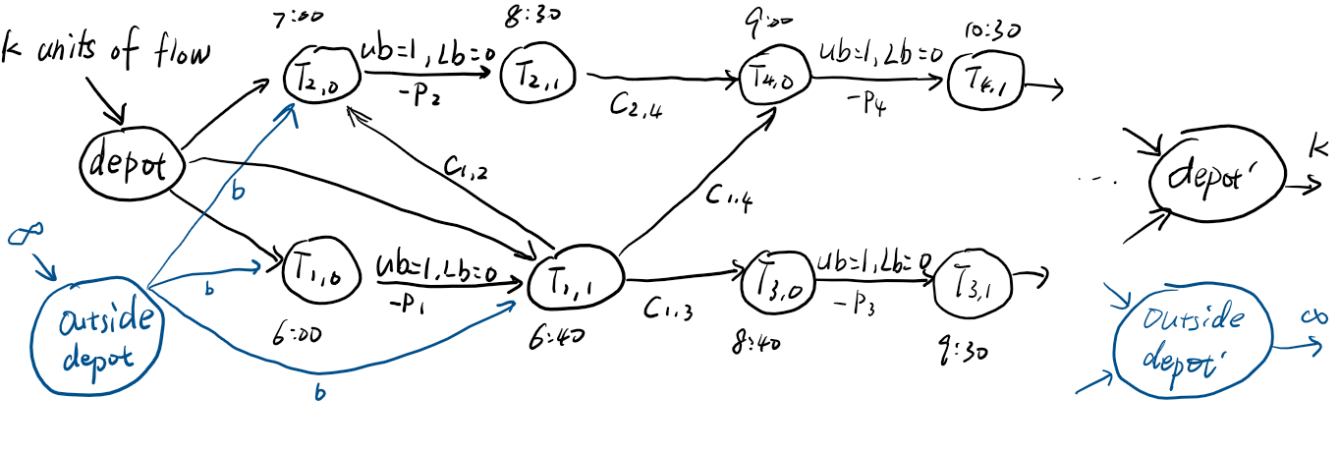

By combining (1),(2), we have this model.

To minimize total flow costs $∑x_{ij}c_{ij}-∑y_{i}p_{i}+∑z_{i}b$