实验报告
2020 年 4 月 19 日 成绩：
姓名 |  | 学号 |  | 班级 | 19185312
姓名 |  | 学号 |  | 班级
专业 | 理工类实验班 |  | 课程名称 | 计算机组成原理课程设计
任课老师 | 章复嘉 | 指导老师 | 章复嘉 | 机位号
实验序号 | 02 | 实验名称 | 多功能ALU设计及于桶形移位器连接实验
实验时间 | 4.19 | 实验地点 | 1教南225 | 实验设备号
一、实验目的和实验要求
- 学习多功能ALU运算器的工作原理，掌握多功能ALU运算器的设计方法；
- 学习利用顶层模块来协助实现板级验证的方法；
- 学习板级实验中，解决外设资源不够的三种方法。

要求设计一个具有14种运算功能的32位ALU运算器，并能够产生NZCV这4位标志位，控制信号S决定是否将ALU输出的4个标志位NZCV写入当前程序状态寄存器CPSR的高4位。
二、实验程序源代码
Board.v
`timescale 1ns / 1ps
module Board(
input [32:1] sw,
input [6:1] swb,
output [32:1] led,
input clk,
output [2:0] which,
output [7:0] seg,
output reg enable = 1
);

reg [32:1] A;
reg [4:1] ALU_OP;
reg ALU_carry_flag;
reg [32:1] shift_data;
reg [8:1] shift_num;
reg [3:1] shift_op;
reg CF;
reg VF=0;
wire [32:1] B;
wire [32:1] F;
wire N,Z,C,V;
wire shift_carry_out;
reg [2:1] cnt;

initial begin
cnt=0;
end

always @(posedge swb[1])begin
if(swb[2]==1)begin
cnt=cnt+1;
if(cnt==1)begin
A=sw;
end
else if(cnt==2)begin
shift_data=sw;
end
else if(cnt==3)begin
ALU_OP=sw[4:1];
shift_op=sw[7:5];
shift_num=sw[15:8];
CF=sw[16];
VF=sw[17];
cnt=0;
end
end
end

// always @(posedge swb[2])begin
// cnt=0;
// end

barrelshifter32 barrelshifter32_instance(shift_data,swb[3],shift_num,shift_op,B,shift_carry_out);

ALU32 ALU32_instance(ALU_OP,A,B,shift_carry_out,CF,VF,F,N,Z,C,V);

// assign led=F;
assign led[1]=N;
assign led[2]=Z;
assign led[3]=C;
assign led[4]=V;
Display Display_instance(.clk(clk),.data(F),.which(which),.seg(seg));

//always @(posedge swb[4])enable<=~enable;

endmodule // Board
barrelshifter32.v
`timescale 1ns / 1ps

module barrelshifter32(shift_data,carry_flag,shift_num,shift_op,shift_out,shift_carry_out);
input [31:0] shift_data;
input carry_flag;
input [7:0] shift_num;
input [2:0] shift_op;
output reg [31:0] shift_out;
output reg shift_carry_out=0;

always@(*)begin
// shift_out=shift_data;
if(shift_op==3'b000||shift_op==3'b001)begin
if(shift_num==8'b00000000)begin
shift_out=shift_data;
end
else if(shift_num>=1&&shift_num<=32)begin
shift_out=shift_data<<shift_num;
shift_carry_out=shift_data[32-shift_num];
end
else begin
shift_out=0;
shift_carry_out=0;
end
end
else if(shift_op==3'b010||shift_op==3'b011)begin
if(shift_num==8'b00000000)begin
if(shift_op==3'b010)begin
shift_out=0;
shift_carry_out=shift_data[31];
end
else shift_out=shift_data;
end
else if(shift_num>=1&&shift_num<=32)begin
shift_out=shift_data>>shift_num;
shift_carry_out=shift_data[shift_num-1];
end
else begin
shift_out=0;
shift_carry_out=0;
end
end
else if(shift_op==3'b100||shift_op==3'b101)begin
if(shift_num==8'b00000000)begin
if(shift_op==3'b100)begin
shift_out={32{shift_data[31]}};
shift_carry_out=shift_data[31];
end
else shift_out=shift_data;
end
else if(shift_num>=1&&shift_num<=31)begin
shift_out={{32{shift_data[31]}},shift_data}>>shift_num;
shift_carry_out=shift_data[shift_num-1];
end
else begin
shift_out={32{shift_data[31]}};
shift_carry_out=shift_data[31];
end
end
else if(shift_op==3'b110||shift_op==3'b111)begin
if(shift_num==8'b00000000)begin
if(shift_op==3'b110)begin
shift_out={carry_flag,shift_data[31:1]};
shift_carry_out=shift_data[0];
end
else shift_out=shift_data;
end
else if(shift_num>=1&&shift_num<=32)begin
shift_out={shift_data,shift_data}>>shift_num;
shift_carry_out=shift_data[shift_num-1];
end
else begin
shift_out={{32{shift_data}},shift_data}>>shift_num[4:0];
shift_carry_out=shift_data[shift_data[4:0]-1];
end
end
end
endmodule // barrelshifter32

ALU32.v
`timescale 1ns / 1ps

module ALU32(
input [3:0] OP,
input [32:1] A,
input [32:1] B,
input SCO,
input CF,
input VF,
output reg [32:1] F,
output reg N,
output reg Z,
output reg C,
output reg V
);

always@(*)begin

C=SCO;
V=VF;
case(OP)
4'b0000:begin
F=A&B;
end
4'b0001:begin
F=A^B;
end
4'b0010:begin
{C,F}=A-B;
V = A[32]^B[32]^F[32]^C;
C=~C;
end
4'b0011:begin
{C,F}=B-A;
V = A[32]^B[32]^F[32]^C;
C=~C;
end
4'b0100:begin
{C,F}=A+B;
V = A[32]^B[32]^F[32]^C;
end
4'b0101:begin
{C,F}=A+B+CF;
V = A[32]^B[32]^F[32]^C;
end
4'b0110:begin
{C,F}=A-B+CF-1;
V = A[32]^B[32]^F[32]^C;
C=~C;
end
4'b0111:begin
{C,F}=B-A+CF-1;
V = A[32]^B[32]^F[32]^C;
C=~C;
end
4'b1000:begin
F=A;
end
4'b1010:begin
{C,F}=A-B+4;
V = A[32]^B[32]^F[32]^C;
C=~C;
end
4'b1100:begin
F=A|B;
end
4'b1101:begin
F=B;
end
4'b1110:begin
F=A&(~B);
end
4'b1111:begin
F=~B;
end
endcase
Z = F==0;
N = F[32];
end
endmodule

三、仿真文件和波形图（有就填，没有就不填）
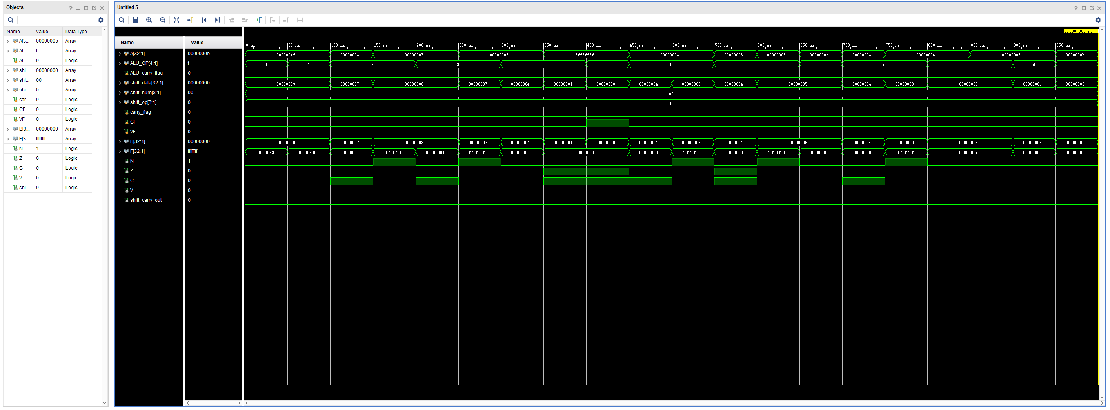
Test.v
`timescale 1ns / 1ps

module Test();

reg [32:1] A;
reg [4:1] ALU_OP;
reg ALU_carry_flag=0;
reg [32:1] shift_data;
reg [8:1] shift_num;
reg [3:1] shift_op;
reg carry_flag=0;
reg CF;
reg VF=0;
wire [32:1] B;
wire [32:1] F;
wire N,Z,C,V;
wire shift_carry_out;

barrelshifter32 barrelshifter32_instance(shift_data,carry_flag,shift_num,shift_op,B,shift_carry_out);

ALU32 ALU32_instance(ALU_OP,A,B,shift_carry_out,CF,VF,F,N,Z,C,V);

initial begin
A<=32'b00000000000000000000000000001001;
CF<=0;
VF<=0;
//only ALU
shift_num<=0;
shift_op<=0;

A<=32'b00000000000000000000000011111111;
shift_data<=32'b00000000000000000000100110011001;
ALU_OP<=0;//F=A&B
#50;
A<=32'b00000000000000000000000011111111;
shift_data<=32'b00000000000000000000100110011001;
ALU_OP<=1;//F=A^B
#50;
A<=8;
shift_data<=7;
ALU_OP<=2;//F=A-B ans=1;
#50;
A<=7;
shift_data<=8;
ALU_OP<=2;//F=A-B all of ans are 1
#50;
A<=7;
shift_data<=8;
ALU_OP<=3;//F=B-A ans=1;
#50;
A<=8;
shift_data<=7;
ALU_OP<=3;//F=B-A ans=-1;
#50;
A<=8;
shift_data<=4;
ALU_OP<=4;//F=A+B ans=1100
#50;
A<=32'b11111111111111111111111111111111;
shift_data<=32'b00000000000000000000000000000001;
ALU_OP<=4;//F=A+B ans=0;
#50;
CF<=1;
A<=32'b11111111111111111111111111111111;
shift_data<=32'b00000000000000000000000000000000;
ALU_OP<=5;//F=A+B+CF CF=1 ans=0
#50;
CF<=0;
A<=8;
shift_data<=4;
ALU_OP<=6;//F=A-B+CF-1 CF=0 normally ans=0011
#50;
CF<=0;
A<=8;
shift_data<=8;
ALU_OP<=6;//F=A-B+CF-1 CF=0 normally all of ans are 1
#50;
CF<=0;
A<=3;
shift_data<=4;
ALU_OP<=7;//F=B-A+CF-1 CF=0 normally ans=0
#50;
CF<=0;
A<=5;
shift_data<=5;
ALU_OP<=7;//F=B-A+CF-1 CF=0 abnormally all of ans are 1
#50;
A<=12;
ALU_OP<=8;//F=A ans=1100
#50;
A<=8;
shift_data<=4;
ALU_OP<=10;//F=A+B-4 normally ans=8
#50;
A<=4;
shift_data<=9;
ALU_OP<=10;//F=A+B-4 abnormally ans=-1
#50;
A<=4;
shift_data<=3;
ALU_OP<=12;//F=A|B ans=0111
#50;
A<=7;
shift_data<=3;
ALU_OP<=12;//F=A|B ans=0111
#50;
shift_data<=12;
ALU_OP<=13;//F=B ans=1100
#50;
A<=11;
shift_data<=0;
ALU_OP<=14;//F=A&(~B) ans=1011
#50;
shift_data<=0;
ALU_OP<=15;//F=~B ,all of ans are 1
#50;
end

endmodule

四、电路图（有就填，没有就不填）
全局缩略图：
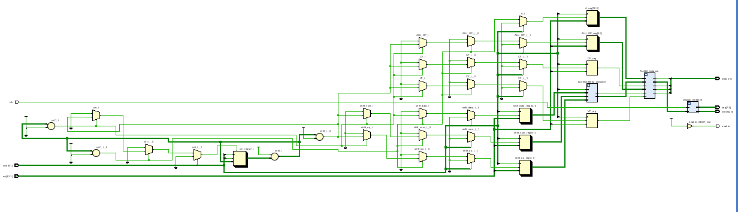
核心部分：
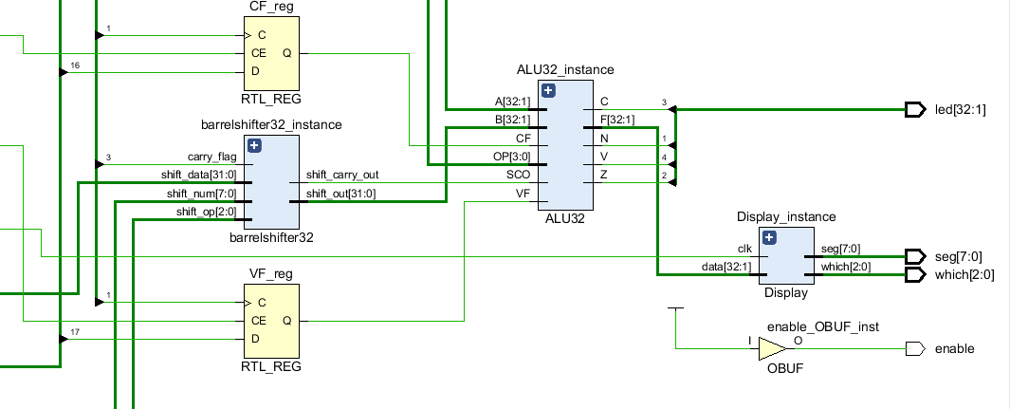
五、引脚配置（约束文件，有就填，没有就不填））
Board.xdc
# 开启比特流压缩，优化 .bit 文件大小
set_property BITSTREAM.GENERAL.COMPRESS TRUE [current_design]

# Switch，开关
set_property PULLDOWN true [get_ports sw]
set_property IOSTANDARD LVCMOS18 [get_ports sw]
set_property PACKAGE_PIN T3 [get_ports {sw[1]}]
set_property PACKAGE_PIN U3 [get_ports {sw[2]}]
set_property PACKAGE_PIN T4 [get_ports {sw[3]}]
set_property PACKAGE_PIN V3 [get_ports {sw[4]}]
set_property PACKAGE_PIN V4 [get_ports {sw[5]}]
set_property PACKAGE_PIN W4 [get_ports {sw[6]}]
set_property PACKAGE_PIN Y4 [get_ports {sw[7]}]
set_property PACKAGE_PIN Y6 [get_ports {sw[8]}]
set_property PACKAGE_PIN W7 [get_ports {sw[9]}]
set_property PACKAGE_PIN Y8 [get_ports {sw[10]}]
set_property PACKAGE_PIN Y7 [get_ports {sw[11]}]
set_property PACKAGE_PIN T1 [get_ports {sw[12]}]
set_property PACKAGE_PIN U1 [get_ports {sw[13]}]
set_property PACKAGE_PIN U2 [get_ports {sw[14]}]
set_property PACKAGE_PIN W1 [get_ports {sw[15]}]
set_property PACKAGE_PIN W2 [get_ports {sw[16]}]
set_property PACKAGE_PIN Y1 [get_ports {sw[17]}]
set_property PACKAGE_PIN AA1 [get_ports {sw[18]}]
set_property PACKAGE_PIN V2 [get_ports {sw[19]}]
set_property PACKAGE_PIN Y2 [get_ports {sw[20]}]
set_property PACKAGE_PIN AB1 [get_ports {sw[21]}]
set_property PACKAGE_PIN AB2 [get_ports {sw[22]}]
set_property PACKAGE_PIN AB3 [get_ports {sw[23]}]
set_property PACKAGE_PIN AB5 [get_ports {sw[24]}]
set_property PACKAGE_PIN AA6 [get_ports {sw[25]}]
set_property PACKAGE_PIN R2 [get_ports {sw[26]}]
set_property PACKAGE_PIN R3 [get_ports {sw[27]}]
set_property PACKAGE_PIN T6 [get_ports {sw[28]}]
set_property PACKAGE_PIN R6 [get_ports {sw[29]}]
set_property PACKAGE_PIN U7 [get_ports {sw[30]}]
set_property PACKAGE_PIN AB7 [get_ports {sw[31]}]
set_property PACKAGE_PIN AB8 [get_ports {sw[32]}]

# Switch Button，按钮
set_property IOSTANDARD LVCMOS18 [get_ports swb]
set_property PACKAGE_PIN R4 [get_ports {swb[1]}]
set_property PACKAGE_PIN AA4 [get_ports {swb[2]}]
set_property PACKAGE_PIN AB6 [get_ports {swb[3]}]
set_property PACKAGE_PIN T5 [get_ports {swb[4]}]
set_property PACKAGE_PIN V8 [get_ports {swb[5]}]
set_property PACKAGE_PIN AA8 [get_ports {swb[6]}]

# LED
set_property PULLDOWN true [get_ports led]
set_property IOSTANDARD LVCMOS18 [get_ports led]
set_property PACKAGE_PIN R1 [get_ports {led[1]}]
set_property PACKAGE_PIN P2 [get_ports {led[2]}]
set_property PACKAGE_PIN P1 [get_ports {led[3]}]
set_property PACKAGE_PIN N2 [get_ports {led[4]}]
set_property PACKAGE_PIN M1 [get_ports {led[5]}]
set_property PACKAGE_PIN M2 [get_ports {led[6]}]
set_property PACKAGE_PIN L1 [get_ports {led[7]}]
set_property PACKAGE_PIN J2 [get_ports {led[8]}]
set_property PACKAGE_PIN G1 [get_ports {led[9]}]
set_property PACKAGE_PIN E1 [get_ports {led[10]}]
set_property PACKAGE_PIN D2 [get_ports {led[11]}]
set_property PACKAGE_PIN A1 [get_ports {led[12]}]
set_property PACKAGE_PIN L3 [get_ports {led[13]}]
set_property PACKAGE_PIN G3 [get_ports {led[14]}]
set_property PACKAGE_PIN K4 [get_ports {led[15]}]
set_property PACKAGE_PIN G4 [get_ports {led[16]}]
set_property PACKAGE_PIN K1 [get_ports {led[17]}]
set_property PACKAGE_PIN J1 [get_ports {led[18]}]
set_property PACKAGE_PIN H2 [get_ports {led[19]}]
set_property PACKAGE_PIN G2 [get_ports {led[20]}]
set_property PACKAGE_PIN F1 [get_ports {led[21]}]
set_property PACKAGE_PIN E2 [get_ports {led[22]}]
set_property PACKAGE_PIN D1 [get_ports {led[23]}]
set_property PACKAGE_PIN B1 [get_ports {led[24]}]
set_property PACKAGE_PIN B2 [get_ports {led[25]}]
set_property PACKAGE_PIN N3 [get_ports {led[26]}]
set_property PACKAGE_PIN M3 [get_ports {led[27]}]
set_property PACKAGE_PIN K3 [get_ports {led[28]}]
set_property PACKAGE_PIN H3 [get_ports {led[29]}]
set_property PACKAGE_PIN N4 [get_ports {led[30]}]
set_property PACKAGE_PIN L4 [get_ports {led[31]}]
set_property PACKAGE_PIN J4 [get_ports {led[32]}]

# 数码管相关
set_property IOSTANDARD LVCMOS18 [get_ports seg]
set_property PACKAGE_PIN H19 [get_ports {seg[7]}]
set_property PACKAGE_PIN G20 [get_ports {seg[6]}]
set_property PACKAGE_PIN J22 [get_ports {seg[5]}]
set_property PACKAGE_PIN K22 [get_ports {seg[4]}]
set_property PACKAGE_PIN K21 [get_ports {seg[3]}]
set_property PACKAGE_PIN H20 [get_ports {seg[2]}]
set_property PACKAGE_PIN H22 [get_ports {seg[1]}]
set_property PACKAGE_PIN J21 [get_ports {seg[0]}]
set_property IOSTANDARD LVCMOS18 [get_ports which]
set_property PACKAGE_PIN N22 [get_ports {which[0]}]
set_property PACKAGE_PIN M21 [get_ports {which[1]}]
set_property PACKAGE_PIN M22 [get_ports {which[2]}]
set_property -dict {IOSTANDARD LVCMOS18 PACKAGE_PIN L21} [get_ports enable]
set_property -dict {IOSTANDARD LVCMOS18 PACKAGE_PIN H4} [get_ports clk]

# [Place 30-574] Poor placement for routing between an IO pin and BUFG.If this
# sub optimal condition is acceptable for this design, you may use the
# CLOCK_DEDICATED_ROUTE constraint in the .xdc file to demote this message to a
# WARNING. However, the use of this override is highly discouraged.

set_property CLOCK_DEDICATED_ROUTE FALSE [get_nets clk_IBUF]
set_property CLOCK_DEDICATED_ROUTE FALSE [get_nets swb_IBUF[1]]
set_property CLOCK_DEDICATED_ROUTE FALSE [get_nets swb_IBUF[2]]
set_property CLOCK_DEDICATED_ROUTE FALSE [get_nets swb_IBUF[3]]
set_property CLOCK_DEDICATED_ROUTE FALSE [get_nets swb_IBUF[4]]
set_property CLOCK_DEDICATED_ROUTE FALSE [get_nets swb_IBUF[5]]
set_property CLOCK_DEDICATED_ROUTE FALSE [get_nets swb_IBUF[6]]

六、实验分工（需写清楚每个人负责的工作，以及个人贡献在小组总工作量中的占比）
七、实验收获（心得体会等，请以个人为单位分别写）
思考问题1:
硬件操作上没有区别，就是将测试数据直接相加，不会识别有符号数和无符号数，要看具体调用的时候是用有符号数形式还是无符号形式。

