实验报告
2021 年 5 月 17 日 成绩：
姓名 |  | 学号 |  | 班级 | 19185312
姓名 |  | 学号 |  | 班级
专业 | 理工类实验班 |  | 课程名称 | 计算机组成原理课程设计
任课老师 | 章复嘉 | 指导老师 | 章复嘉 | 机位号
实验序号 | 07 | 实验名称 | 取指令数据通路设计实验
实验时间 | 5.17 | 实验地点 | 1教南225 | 实验设备号
一、实验目的和实验要求
1.学习指令存储器的设计方法
2.掌握ARM V7 CPU 取指令操作和判断指令条件执行的方法
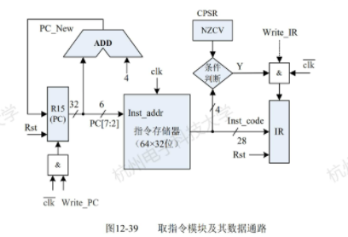
二、实验程序源代码
Board.v
`timescale 1ns / 1ps
module Board(
input [32:1] sw,
input [6:1] swb,
output [32:1] led,
input clk,
output [2:0] which,
output [7:0] seg,
output reg enable = 1
);

wire [7:0] PC;
wire [31:0] data;
wire flag;

FI FI_instance(
.clk(swb[1]),
.rst(swb[2]),
.NF(sw[1]),
.ZF(sw[2]),
.CF(sw[3]),
.VF(sw[4]),
.Write_PC(sw[5]),
.Write_IR(sw[6]),
.PC(PC),
.IR(data[27:0]),
.flag(flag)
);

Display Display_instance(.clk(clk),.data(data),.which(which),.seg(seg));

assign led[1]=flag;
assign led[9:2]=PC;
assign led[32:10]=0;

endmodule // Board
FI.v

`timescale 1ns / 1ps
module FI(
input clk,
input rst,
input NF,
input ZF,
input CF,
input VF,
input Write_PC,
input Write_IR,
output reg [7:0] PC,
output reg [27:0] IR,
output reg flag,
output reg [3:0] op
);
reg [7:0] PC_tmp;
wire [31:0] tmp;

initial begin
PC=0;
PC_tmp=0;
IR=0;
end

always @(posedge clk)begin
op=tmp[31:28];
case(tmp[31:28])
4'b0000:flag=ZF;
4'b0001:flag=~ZF;
4'b0010:flag=CF;
4'b0011:flag=~CF;
4'b0100:flag=NF;
4'b0101:flag=~NF;
4'b0110:flag=VF;
4'b0111:flag=~VF;
4'b1000:flag=CF&~ZF;
4'b1001:flag=~CF&ZF;
4'b1010:flag=~(NF^VF);
4'b1011:flag=NF^VF;
4'b1100:flag=~ZF&~(NF^VF);
4'b1101:flag=ZF|(NF^VF);
4'b1110:flag=1;
default:flag=0;
endcase
end
always @(negedge clk)begin
if(rst==1)begin
PC=0;
PC_tmp=0;
IR=0;
end
else begin
if(flag==1&&Write_IR==1)begin
IR=tmp[27:0];
end
if(Write_PC==1)begin
PC=PC_tmp;
end
PC_tmp=PC_tmp+4;
end
end
rom rom(.a(PC[5:0]),.spo(tmp));

endmodule

Display.v
`timescale 1ns / 1ps
// 8 位七段数码管扫描显示模块
module Display(clk, data, which, seg, count, digit); // 调试接口
input clk; // 接入系统时钟
input [32:1] data; // 32 位显示数据
output reg [2:0] which = 0; // 片选编码（驱动哪一位数码管），低电平有效
output reg [7:0] seg; // 段选信号（点亮哪些笔划），低电平有效
output reg [10:0] count = 0; // 分频扫描，从左至右循环驱动每一位数码管
output reg [3:0] digit; // 显示数据 片选得到 十六进制数码

always @(posedge clk) count <= count + 1'b1;
always @(negedge clk) if (&count) which <= which + 1'b1;

always @* case (which)
0: digit <= data[32:29]; // 最高位
1: digit <= data[28:25];
2: digit <= data[24:21];
3: digit <= data[20:17];
4: digit <= data[16:13];
5: digit <= data[12:09];
6: digit <= data[08:05];
7: digit <= data[04:01]; // 最低位
endcase

always @* begin
case (digit) // 十六进制数码 转换为 段选信号（a,b,c,...g,dp）
4'h0: seg <= 8'b0000_0011; // 除 g、dp 外全亮，显示数码 0
4'h1: seg <= 8'b1001_1111; // 仅 b、c 亮，显示数码 1
4'h2: seg <= 8'b0010_0101;
4'h3: seg <= 8'b0000_1101;
4'h4: seg <= 8'b1001_1001;
4'h5: seg <= 8'b0100_1001;
4'h6: seg <= 8'b0100_0001;
4'h7: seg <= 8'b0001_1111;
4'h8: seg <= 8'b0000_0001;
4'h9: seg <= 8'b0000_1001;
4'hA: seg <= 8'b0001_0001;
4'hB: seg <= 8'b1100_0001;
4'hC: seg <= 8'b0110_0011;
4'hD: seg <= 8'b1000_0101;
4'hE: seg <= 8'b0110_0001;
4'hF: seg <= 8'b0111_0001;
endcase
end
endmodule // Display

三、仿真文件和波形图（有就填，没有就不填）
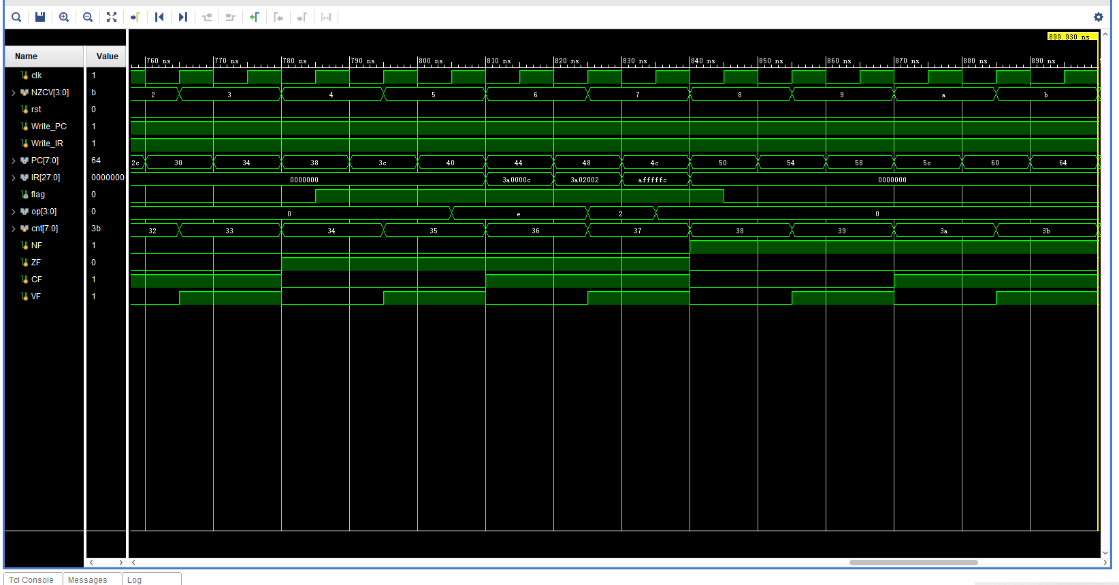
Test.v
`timescale 1ns / 1ps
module Test();
reg clk;
reg [3:0] NZCV;
reg rst;
reg Write_PC;
reg Write_IR;
wire [7:0] PC;
wire [27:0] IR;
wire flag;
wire [3:0] op;

FI FI_instance(clk,rst,NZCV[3],NZCV[2],NZCV[1],NZCV[0],Write_PC,Write_IR,PC,IR,flag,op);

reg[7:0] cnt;
reg NF;
reg ZF;
reg CF;
reg VF;

always #5 clk=~clk;

initial begin
clk=0;
cnt = 0;
Write_PC = 1;
Write_IR = 1;
while(cnt<64) begin
NZCV = cnt[3:0];
NF=NZCV[3];
ZF=NZCV[2];
CF=NZCV[1];
VF=NZCV[0];
rst=0;
Write_PC=cnt[4];
Write_IR=cnt[5];

#15;
cnt = cnt+1;
end

end
endmodule

四、电路图（有就填，没有就不填）
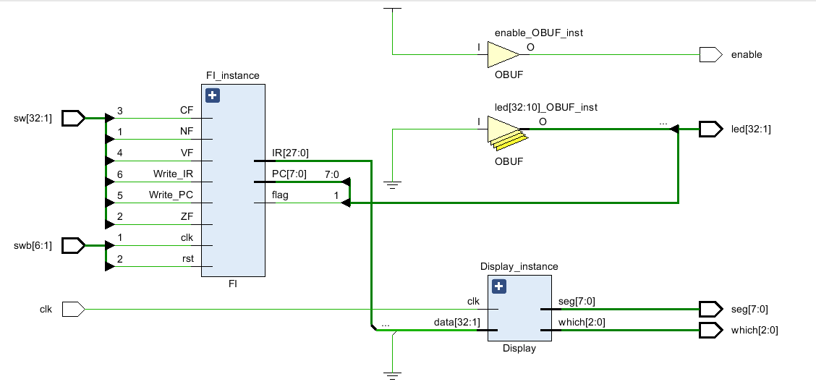
五、引脚配置（约束文件，有就填，没有就不填））
Board.xdc
# 开启比特流压缩，优化 .bit 文件大小
set_property BITSTREAM.GENERAL.COMPRESS TRUE [current_design]

# Switch，开关
set_property PULLDOWN true [get_ports sw]
set_property IOSTANDARD LVCMOS18 [get_ports sw]
set_property PACKAGE_PIN T3 [get_ports {sw[1]}]
set_property PACKAGE_PIN U3 [get_ports {sw[2]}]
set_property PACKAGE_PIN T4 [get_ports {sw[3]}]
set_property PACKAGE_PIN V3 [get_ports {sw[4]}]
set_property PACKAGE_PIN V4 [get_ports {sw[5]}]
set_property PACKAGE_PIN W4 [get_ports {sw[6]}]
set_property PACKAGE_PIN Y4 [get_ports {sw[7]}]
set_property PACKAGE_PIN Y6 [get_ports {sw[8]}]
set_property PACKAGE_PIN W7 [get_ports {sw[9]}]
set_property PACKAGE_PIN Y8 [get_ports {sw[10]}]
set_property PACKAGE_PIN Y7 [get_ports {sw[11]}]
set_property PACKAGE_PIN T1 [get_ports {sw[12]}]
set_property PACKAGE_PIN U1 [get_ports {sw[13]}]
set_property PACKAGE_PIN U2 [get_ports {sw[14]}]
set_property PACKAGE_PIN W1 [get_ports {sw[15]}]
set_property PACKAGE_PIN W2 [get_ports {sw[16]}]
set_property PACKAGE_PIN Y1 [get_ports {sw[17]}]
set_property PACKAGE_PIN AA1 [get_ports {sw[18]}]
set_property PACKAGE_PIN V2 [get_ports {sw[19]}]
set_property PACKAGE_PIN Y2 [get_ports {sw[20]}]
set_property PACKAGE_PIN AB1 [get_ports {sw[21]}]
set_property PACKAGE_PIN AB2 [get_ports {sw[22]}]
set_property PACKAGE_PIN AB3 [get_ports {sw[23]}]
set_property PACKAGE_PIN AB5 [get_ports {sw[24]}]
set_property PACKAGE_PIN AA6 [get_ports {sw[25]}]
set_property PACKAGE_PIN R2 [get_ports {sw[26]}]
set_property PACKAGE_PIN R3 [get_ports {sw[27]}]
set_property PACKAGE_PIN T6 [get_ports {sw[28]}]
set_property PACKAGE_PIN R6 [get_ports {sw[29]}]
set_property PACKAGE_PIN U7 [get_ports {sw[30]}]
set_property PACKAGE_PIN AB7 [get_ports {sw[31]}]
set_property PACKAGE_PIN AB8 [get_ports {sw[32]}]

# Switch Button，按钮
set_property IOSTANDARD LVCMOS18 [get_ports swb]
set_property PACKAGE_PIN R4 [get_ports {swb[1]}]
set_property PACKAGE_PIN AA4 [get_ports {swb[2]}]
set_property PACKAGE_PIN AB6 [get_ports {swb[3]}]
set_property PACKAGE_PIN T5 [get_ports {swb[4]}]
set_property PACKAGE_PIN V8 [get_ports {swb[5]}]
set_property PACKAGE_PIN AA8 [get_ports {swb[6]}]

# LED
set_property IOSTANDARD LVCMOS18 [get_ports led]
set_property PACKAGE_PIN R1 [get_ports {led[1]}]
set_property PACKAGE_PIN P2 [get_ports {led[2]}]
set_property PACKAGE_PIN P1 [get_ports {led[3]}]
set_property PACKAGE_PIN N2 [get_ports {led[4]}]
set_property PACKAGE_PIN M1 [get_ports {led[5]}]
set_property PACKAGE_PIN M2 [get_ports {led[6]}]
set_property PACKAGE_PIN L1 [get_ports {led[7]}]
set_property PACKAGE_PIN J2 [get_ports {led[8]}]
set_property PACKAGE_PIN G1 [get_ports {led[9]}]
set_property PACKAGE_PIN E1 [get_ports {led[10]}]
set_property PACKAGE_PIN D2 [get_ports {led[11]}]
set_property PACKAGE_PIN A1 [get_ports {led[12]}]
set_property PACKAGE_PIN L3 [get_ports {led[13]}]
set_property PACKAGE_PIN G3 [get_ports {led[14]}]
set_property PACKAGE_PIN K4 [get_ports {led[15]}]
set_property PACKAGE_PIN G4 [get_ports {led[16]}]
set_property PACKAGE_PIN K1 [get_ports {led[17]}]
set_property PACKAGE_PIN J1 [get_ports {led[18]}]
set_property PACKAGE_PIN H2 [get_ports {led[19]}]
set_property PACKAGE_PIN G2 [get_ports {led[20]}]
set_property PACKAGE_PIN F1 [get_ports {led[21]}]
set_property PACKAGE_PIN E2 [get_ports {led[22]}]
set_property PACKAGE_PIN D1 [get_ports {led[23]}]
set_property PACKAGE_PIN B1 [get_ports {led[24]}]
set_property PACKAGE_PIN B2 [get_ports {led[25]}]
set_property PACKAGE_PIN N3 [get_ports {led[26]}]
set_property PACKAGE_PIN M3 [get_ports {led[27]}]
set_property PACKAGE_PIN K3 [get_ports {led[28]}]
set_property PACKAGE_PIN H3 [get_ports {led[29]}]
set_property PACKAGE_PIN N4 [get_ports {led[30]}]
set_property PACKAGE_PIN L4 [get_ports {led[31]}]
set_property PACKAGE_PIN J4 [get_ports {led[32]}]

# 数码管相关
set_property IOSTANDARD LVCMOS18 [get_ports seg]
set_property PACKAGE_PIN H19 [get_ports {seg[7]}]
set_property PACKAGE_PIN G20 [get_ports {seg[6]}]
set_property PACKAGE_PIN J22 [get_ports {seg[5]}]
set_property PACKAGE_PIN K22 [get_ports {seg[4]}]
set_property PACKAGE_PIN K21 [get_ports {seg[3]}]
set_property PACKAGE_PIN H20 [get_ports {seg[2]}]
set_property PACKAGE_PIN H22 [get_ports {seg[1]}]
set_property PACKAGE_PIN J21 [get_ports {seg[0]}]
set_property IOSTANDARD LVCMOS18 [get_ports which]
set_property PACKAGE_PIN N22 [get_ports {which[0]}]
set_property PACKAGE_PIN M21 [get_ports {which[1]}]
set_property PACKAGE_PIN M22 [get_ports {which[2]}]
set_property -dict {IOSTANDARD LVCMOS18 PACKAGE_PIN L21} [get_ports enable]
set_property -dict {IOSTANDARD LVCMOS18 PACKAGE_PIN H4} [get_ports clk]

# [Place 30-574] Poor placement for routing between an IO pin and BUFG.If this
# sub optimal condition is acceptable for this design, you may use the
# CLOCK_DEDICATED_ROUTE constraint in the .xdc file to demote this message to a
# WARNING. However, the use of this override is highly discouraged.
set_property CLOCK_DEDICATED_ROUTE FALSE [get_nets clk_IBUF]
set_property CLOCK_DEDICATED_ROUTE FALSE [get_nets swb_IBUF[1]]
set_property CLOCK_DEDICATED_ROUTE FALSE [get_nets swb_IBUF[2]]
set_property CLOCK_DEDICATED_ROUTE FALSE [get_nets swb_IBUF[3]]
set_property CLOCK_DEDICATED_ROUTE FALSE [get_nets swb_IBUF[4]]
set_property CLOCK_DEDICATED_ROUTE FALSE [get_nets swb_IBUF[5]]
set_property CLOCK_DEDICATED_ROUTE FALSE [get_nets swb_IBUF[6]]

六、实验分工（需写清楚每个人负责的工作，以及个人贡献在小组总工作量中的占比）
七、实验收获（心得体会等，请以个人为单位分别写）
实验心得：
通过这次的取指令通路设计实验，我学习并设计了取指令模块。在编写程序代码时，我学会了调用IP核，并运用于实验中。在验收时发现的一些问题，都已经及时改正并解决。
实验思考：
Q：在复位后，第一次按动clk按键，你的程序读出的是那条指令？
A：复位后，PC被重置为0，在第一次按动clk时，读出的指令应是指令存储器0号位置上所对应的指令。

