实验报告
2021 年 4 月 12 日 成绩：
姓名 | 郑凯心 | 学号 | 19063140 | 班级 | 19185312
姓名 |  | 学号 |  | 班级
专业 | 理工类实验班 |  | 课程名称 | 计算机组成原理课程设计
任课老师 | 章复嘉 | 指导老师 | 章复嘉 | 机位号
实验序号 | 01 | 实验名称 | 桶形移位器设计实验
实验时间 | 4.12 | 实验地点 | 1教225 | 实验设备号 | B17
一、实验目的和实验要求
实验目的：
- 学习桶形移位器的工作原理，掌握桶形移位器的设计方法
- 学习利用顶层模块来协助实现板级验证的方法
- 学习采用开关复用的方法来解决输入开关不够用的问题
实验要求：
本实验要求设计一个具有5种移位功能的32位桶形移位器
二、实验程序源代码
Board.v
`timescale 1ns / 1ps
// 通过数据输入输出测试开关、LED、数码管；通过数码管使能测试按钮
module Board(sw, swb, led, clk, which, seg, enable);
input [32:1] sw;
input [6:1] swb;
output [32:1] led;
input clk; // 数码管相关
output [2:0] which;
output [7:0] seg;
output reg enable = 1; // 默认开启数码管使能

reg [32:1] temp;
reg [3:1] op;
reg [8:1] num;
// wire [32:1]out;
wire shift_carry_out;

always @(posedge swb[1])begin
temp<=sw;
end

always @(posedge swb[2])begin
op<=sw[32:30];
num<=sw[24:17];
end

//Display barrelshifter32(.);
barrelshifter32 barrelshifter32(.shift_data(temp),.carry_flag(swb[3]),.shift_num(num),.shift_op(op),.shift_out(led),.shift_carry_out(shift_carry_out));
// assign led=shift_carry_out;
Display Display_Instance(.clk(clk), .data(led),.which(which), .seg(seg));

always @(posedge swb[4]) enable <= ~enable;

endmodule // Board

barrelshifter32.v
`timescale 1ns / 1ps

module barrelshifter32(shift_data,carry_flag,shift_num,shift_op,shift_out,shift_carry_out);
input [31:0] shift_data;
input carry_flag;
input [7:0] shift_num;
input [2:0] shift_op;
output reg [31:0] shift_out;
output reg shift_carry_out;

always@(*)begin
// shift_out=shift_data;
if(shift_op==3'b000||shift_op==3'b001)begin
if(shift_num==8'b00000000)begin
shift_out=shift_data;
end
else if(shift_num>=1&&shift_num<=32)begin
shift_out=shift_data<<shift_num;
shift_carry_out=shift_data[32-shift_num];
end
else begin
shift_out=0;
shift_carry_out=0;
end
end
else if(shift_op==3'b010||shift_op==3'b011)begin
if(shift_num==8'b00000000)begin
if(shift_op==3'b010)begin
shift_out=0;
shift_carry_out=shift_data[31];
end
else shift_out=shift_data;
end
else if(shift_num>=1&&shift_num<=32)begin
shift_out=shift_data>>shift_num;
shift_carry_out=shift_data[shift_num-1];
end
else begin
shift_out=0;
shift_carry_out=0;
end
end
else if(shift_op==3'b100||shift_op==3'b101)begin
if(shift_num==8'b00000000)begin
if(shift_op==3'b100)begin
shift_out={32{shift_data[31]}};
shift_carry_out=shift_data[31];
end
else shift_out=shift_data;
end
else if(shift_num>=1&&shift_num<=31)begin
shift_out={{32{shift_data[31]}},shift_data}>>shift_num;
shift_carry_out=shift_data[shift_num-1];
end
else begin
shift_out={32{shift_data[31]}};
shift_carry_out=shift_data[31];
end
end
else if(shift_op==3'b110||shift_op==3'b111)begin
if(shift_num==8'b00000000)begin
if(shift_op==3'b110)begin
shift_out={carry_flag,shift_data[31:1]};
shift_carry_out=shift_data[0];
end
else shift_out=shift_data;
end
else if(shift_num>=1&&shift_num<=32)begin
shift_out={shift_data,shift_data}>>shift_num;
shift_carry_out=shift_data[shift_num-1];
end
else begin
shift_out={{32{shift_data}},shift_data}>>shift_num[4:0];
shift_carry_out=shift_data[shift_data[4:0]-1];
end
end
end
endmodule // barrelshifter32

Display.v
`timescale 1ns / 1ps
// 8 位七段数码管扫描显示模块
module Display(clk, data, which, seg, count, digit); // 调试接口
input clk; // 接入系统时钟
input [32:1] data; // 32 位显示数据
output reg [2:0] which = 0; // 片选编码（驱动哪一位数码管），低电平有效
output reg [7:0] seg; // 段选信号（点亮哪些笔划），低电平有效

output reg [10:0] count = 0; // 分频扫描，从左至右循环驱动每一位数码管
always @(posedge clk) count <= count + 1'b1;
always @(negedge clk) if (&count) which <= which + 1'b1;

output reg [3:0] digit; // 显示数据 片选得到 十六进制数码
always @* case (which)
0: digit <= data[32:29]; // 最高位
1: digit <= data[28:25];
2: digit <= data[24:21];
3: digit <= data[20:17];
4: digit <= data[16:13];
5: digit <= data[12:09];
6: digit <= data[08:05];
7: digit <= data[04:01]; // 最低位
endcase

always @* case (digit) // 十六进制数码 转换为 段选信号（a,b,c,...g,dp）
4'h0: seg <= 8'b0000_0011; // 除 g、dp 外全亮，显示数码 0
4'h1: seg <= 8'b1001_1111; // 仅 b、c 亮，显示数码 1
4'h2: seg <= 8'b0010_0101;
4'h3: seg <= 8'b0000_1101;
4'h4: seg <= 8'b1001_1001;
4'h5: seg <= 8'b0100_1001;
4'h6: seg <= 8'b0100_0001;
4'h7: seg <= 8'b0001_1111;
4'h8: seg <= 8'b0000_0001;
4'h9: seg <= 8'b0000_1001;
4'hA: seg <= 8'b0001_0001;
4'hB: seg <= 8'b1100_0001;
4'hC: seg <= 8'b0110_0011;
4'hD: seg <= 8'b1000_0101;
4'hE: seg <= 8'b0110_0001;
4'hF: seg <= 8'b0111_0001;
endcase

endmodule // Display

三、仿真文件和波形图（有就填，没有就不填）
Test.v
`timescale 1ns / 1ps

module Test();
reg clk=0;
reg [31:0] shift_data;
reg carry_flag;
reg [7:0] shift_num;
reg [2:0] shift_op;
wire [31:0] shift_out;
wire shift_carry_out;

barrelshifter32 barrelshifter32_Instance(.shift_data(shift_data), .carry_flag(carry_flag), .shift_num(shift_num),
.shift_op(shift_op), .shift_out(shift_out), .shift_carry_out(shift_carry_out));

// always #0.01 clk = ~clk; // 0.01ns == 10ps
initial begin
shift_data<=32'b00100001100010001000100000001001;
carry_flag<=0;

shift_op<=3'b000;
shift_num<=8'b00000000;
#5;
shift_num<=8'b00000101;
#5;
shift_num<=8'b01000001;
#5;

shift_op<=3'b010;
shift_num<=8'b00000000;
#5;
shift_num<=8'b00000101;
#5;
shift_num<=8'b01000001;
#5;

shift_op<=3'b100;
shift_num<=8'b00000000;
#5;
shift_num<=8'b00000101;
#5;
shift_num<=8'b01000001;
#5;

shift_op<=3'b110;
shift_num<=8'b00000000;
#5;
shift_num<=8'b00000101;
#5;
shift_num<=8'b01000001;
#5;
end

endmodule

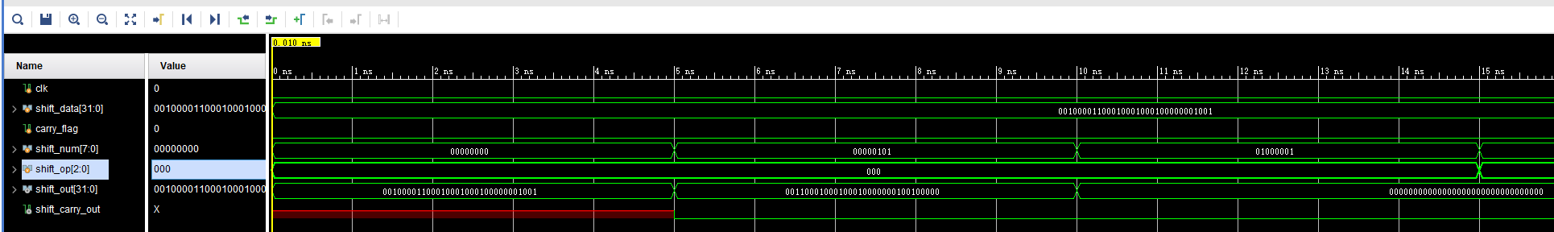
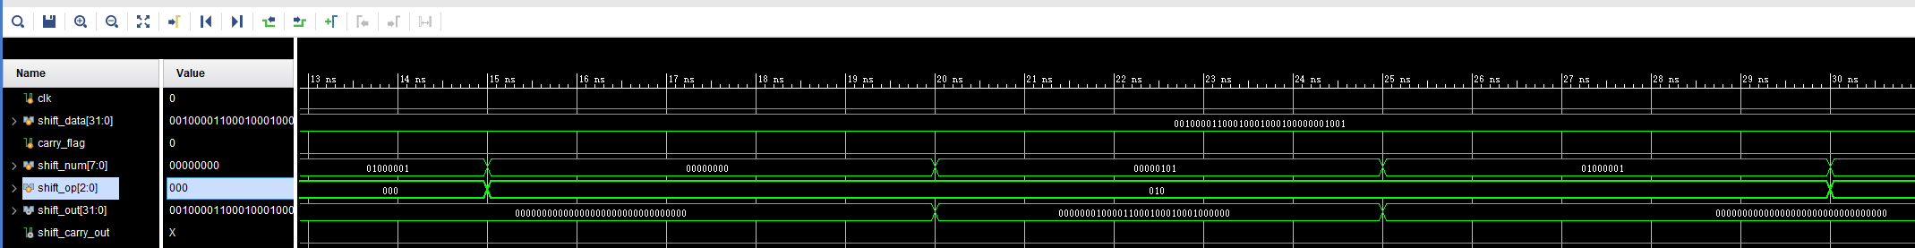
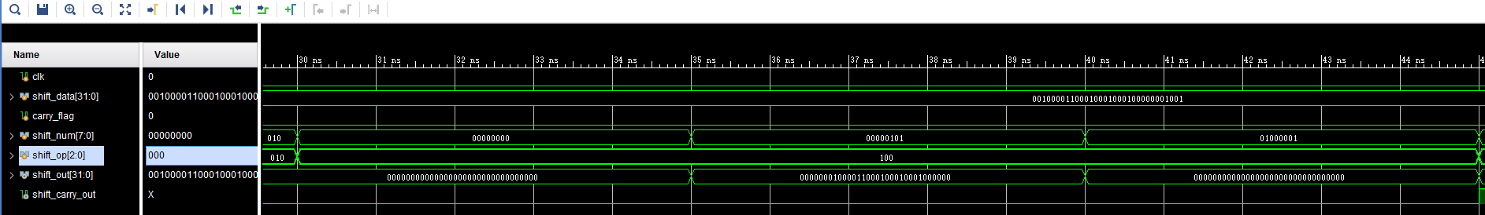
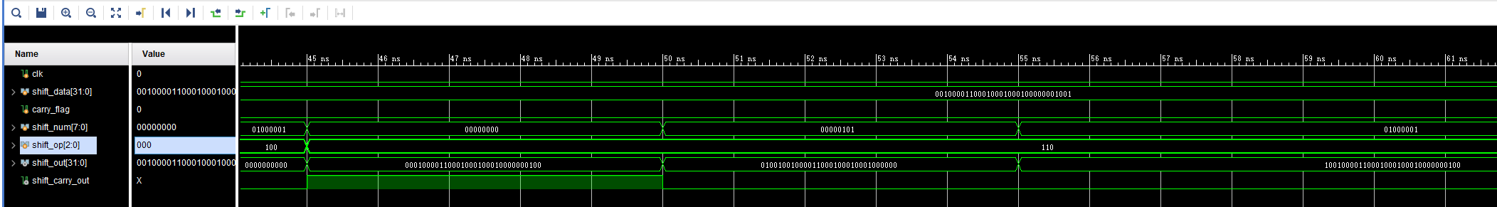
四、电路图（有就填，没有就不填）
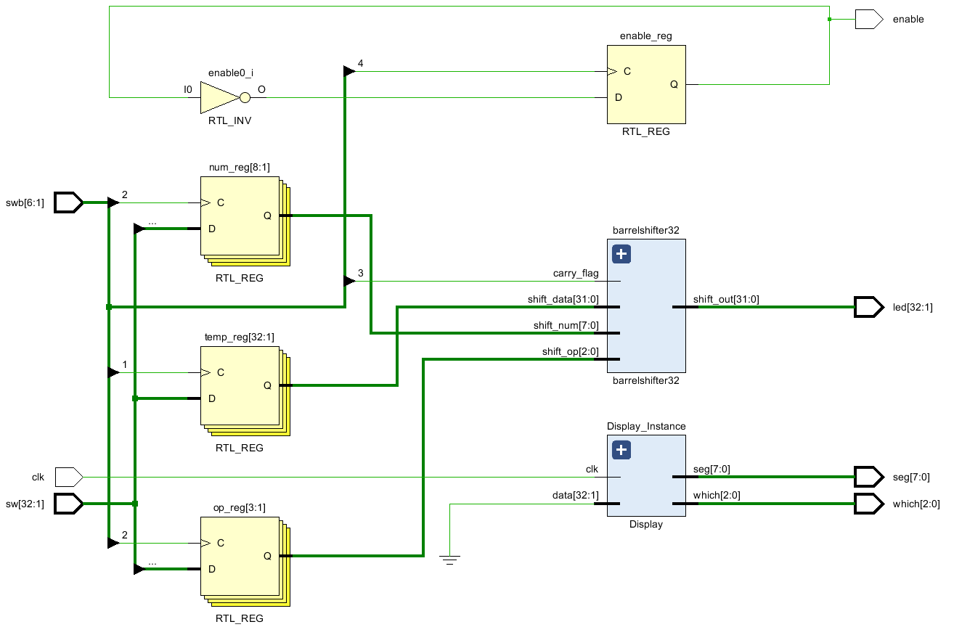
五、引脚配置（约束文件，有就填，没有就不填））
Board.xdc
# 开启比特流压缩，优化 .bit 文件大小
set_property BITSTREAM.GENERAL.COMPRESS TRUE [current_design]

# Switch，开关
set_property PULLDOWN true [get_ports sw]
set_property IOSTANDARD LVCMOS18 [get_ports sw]
set_property PACKAGE_PIN T3 [get_ports {sw[1]}]
set_property PACKAGE_PIN U3 [get_ports {sw[2]}]
set_property PACKAGE_PIN T4 [get_ports {sw[3]}]
set_property PACKAGE_PIN V3 [get_ports {sw[4]}]
set_property PACKAGE_PIN V4 [get_ports {sw[5]}]
set_property PACKAGE_PIN W4 [get_ports {sw[6]}]
set_property PACKAGE_PIN Y4 [get_ports {sw[7]}]
set_property PACKAGE_PIN Y6 [get_ports {sw[8]}]
set_property PACKAGE_PIN W7 [get_ports {sw[9]}]
set_property PACKAGE_PIN Y8 [get_ports {sw[10]}]
set_property PACKAGE_PIN Y7 [get_ports {sw[11]}]
set_property PACKAGE_PIN T1 [get_ports {sw[12]}]
set_property PACKAGE_PIN U1 [get_ports {sw[13]}]
set_property PACKAGE_PIN U2 [get_ports {sw[14]}]
set_property PACKAGE_PIN W1 [get_ports {sw[15]}]
set_property PACKAGE_PIN W2 [get_ports {sw[16]}]
set_property PACKAGE_PIN Y1 [get_ports {sw[17]}]
set_property PACKAGE_PIN AA1 [get_ports {sw[18]}]
set_property PACKAGE_PIN V2 [get_ports {sw[19]}]
set_property PACKAGE_PIN Y2 [get_ports {sw[20]}]
set_property PACKAGE_PIN AB1 [get_ports {sw[21]}]
set_property PACKAGE_PIN AB2 [get_ports {sw[22]}]
set_property PACKAGE_PIN AB3 [get_ports {sw[23]}]
set_property PACKAGE_PIN AB5 [get_ports {sw[24]}]
set_property PACKAGE_PIN AA6 [get_ports {sw[25]}]
set_property PACKAGE_PIN R2 [get_ports {sw[26]}]
set_property PACKAGE_PIN R3 [get_ports {sw[27]}]
set_property PACKAGE_PIN T6 [get_ports {sw[28]}]
set_property PACKAGE_PIN R6 [get_ports {sw[29]}]
set_property PACKAGE_PIN U7 [get_ports {sw[30]}]
set_property PACKAGE_PIN AB7 [get_ports {sw[31]}]
set_property PACKAGE_PIN AB8 [get_ports {sw[32]}]

# Switch Button，按钮
set_property IOSTANDARD LVCMOS18 [get_ports swb]
set_property PACKAGE_PIN R4 [get_ports {swb[1]}]
set_property PACKAGE_PIN AA4 [get_ports {swb[2]}]
set_property PACKAGE_PIN AB6 [get_ports {swb[3]}]
set_property PACKAGE_PIN T5 [get_ports {swb[4]}]
set_property PACKAGE_PIN V8 [get_ports {swb[5]}]
set_property PACKAGE_PIN AA8 [get_ports {swb[6]}]

# LED
set_property IOSTANDARD LVCMOS18 [get_ports led]
set_property PACKAGE_PIN R1 [get_ports {led[1]}]
set_property PACKAGE_PIN P2 [get_ports {led[2]}]
set_property PACKAGE_PIN P1 [get_ports {led[3]}]
set_property PACKAGE_PIN N2 [get_ports {led[4]}]
set_property PACKAGE_PIN M1 [get_ports {led[5]}]
set_property PACKAGE_PIN M2 [get_ports {led[6]}]
set_property PACKAGE_PIN L1 [get_ports {led[7]}]
set_property PACKAGE_PIN J2 [get_ports {led[8]}]
set_property PACKAGE_PIN G1 [get_ports {led[9]}]
set_property PACKAGE_PIN E1 [get_ports {led[10]}]
set_property PACKAGE_PIN D2 [get_ports {led[11]}]
set_property PACKAGE_PIN A1 [get_ports {led[12]}]
set_property PACKAGE_PIN L3 [get_ports {led[13]}]
set_property PACKAGE_PIN G3 [get_ports {led[14]}]
set_property PACKAGE_PIN K4 [get_ports {led[15]}]
set_property PACKAGE_PIN G4 [get_ports {led[16]}]
set_property PACKAGE_PIN K1 [get_ports {led[17]}]
set_property PACKAGE_PIN J1 [get_ports {led[18]}]
set_property PACKAGE_PIN H2 [get_ports {led[19]}]
set_property PACKAGE_PIN G2 [get_ports {led[20]}]
set_property PACKAGE_PIN F1 [get_ports {led[21]}]
set_property PACKAGE_PIN E2 [get_ports {led[22]}]
set_property PACKAGE_PIN D1 [get_ports {led[23]}]
set_property PACKAGE_PIN B1 [get_ports {led[24]}]
set_property PACKAGE_PIN B2 [get_ports {led[25]}]
set_property PACKAGE_PIN N3 [get_ports {led[26]}]
set_property PACKAGE_PIN M3 [get_ports {led[27]}]
set_property PACKAGE_PIN K3 [get_ports {led[28]}]
set_property PACKAGE_PIN H3 [get_ports {led[29]}]
set_property PACKAGE_PIN N4 [get_ports {led[30]}]
set_property PACKAGE_PIN L4 [get_ports {led[31]}]
set_property PACKAGE_PIN J4 [get_ports {led[32]}]

# 数码管相关
set_property IOSTANDARD LVCMOS18 [get_ports seg]
set_property PACKAGE_PIN H19 [get_ports {seg[7]}]
set_property PACKAGE_PIN G20 [get_ports {seg[6]}]
set_property PACKAGE_PIN J22 [get_ports {seg[5]}]
set_property PACKAGE_PIN K22 [get_ports {seg[4]}]
set_property PACKAGE_PIN K21 [get_ports {seg[3]}]
set_property PACKAGE_PIN H20 [get_ports {seg[2]}]
set_property PACKAGE_PIN H22 [get_ports {seg[1]}]
set_property PACKAGE_PIN J21 [get_ports {seg[0]}]
set_property IOSTANDARD LVCMOS18 [get_ports which]
set_property PACKAGE_PIN N22 [get_ports {which[0]}]
set_property PACKAGE_PIN M21 [get_ports {which[1]}]
set_property PACKAGE_PIN M22 [get_ports {which[2]}]
set_property -dict {IOSTANDARD LVCMOS18 PACKAGE_PIN L21} [get_ports enable]
set_property -dict {IOSTANDARD LVCMOS18 PACKAGE_PIN H4} [get_ports clk]

# [Place 30-574] Poor placement for routing between an IO pin and BUFG.If this
# sub optimal condition is acceptable for this design, you may use the
# CLOCK_DEDICATED_ROUTE constraint in the .xdc file to demote this message to a
# WARNING. However, the use of this override is highly discouraged.

set_property CLOCK_DEDICATED_ROUTE FALSE [get_nets clk_IBUF]
set_property CLOCK_DEDICATED_ROUTE FALSE [get_nets swb_IBUF[1]]
set_property CLOCK_DEDICATED_ROUTE FALSE [get_nets swb_IBUF[2]]
set_property CLOCK_DEDICATED_ROUTE FALSE [get_nets swb_IBUF[3]]
set_property CLOCK_DEDICATED_ROUTE FALSE [get_nets swb_IBUF[4]]
set_property CLOCK_DEDICATED_ROUTE FALSE [get_nets swb_IBUF[5]]
set_property CLOCK_DEDICATED_ROUTE FALSE [get_nets swb_IBUF[6]]

六、实验分工（需写清楚每个人负责的工作，以及个人贡献在小组总工作量中的占比）
张浩杨：顶层模块的设计和编写。33%
汤丰瑜：移位模块的设计和编写。33%
郑凯心：仿真与测试。34%
七、实验收获（心得体会等，请以个人为单位分别写）
第一次使用Vivado，第一次用verilog语言，虽然第一个实验的内容比较简单，但是还是经历了很多困难，通过这次实验，我大致上掌握了实验操作的具体步骤，希望接下来的实验能做得更好。

