LedgerLine — Final Architecture Validation & Technical Specification
Money movement with a ledger you can prove.
Individual Engineering Assessment — Snovasys | Date: 05 November 2026
[EXECUTIVE MANDATE & FINANCIAL INVARIANT DIRECTIVE] This specification establishes the authoritative, production-grade technical and architectural blueprint for LedgerLine. It defines the double-entry accounting rules, PostgreSQL ACID concurrency model, early atomic idempotency claim engine, parent-row closure locks, deferred constraint triggers, defense-in-depth authorization matrix, and automated test suite. No application implementation may deviate from the financial invariants codified in this document.

1. Final Technology Architecture & Justifications
LedgerLine is engineered as a high-concurrency, double-entry financial transaction management system. The primary engineering objective is not merely providing an operational API, but proving absolute financial correctness: money is strictly conserved, transactions execute atomically, duplicate client submissions never pay twice, and concurrent withdrawals can never drive an account balance negative. Every architectural layer is selected to enforce these guarantees.
Layer / Component | Technology Choice | Architectural Justification & Role
API & Transport Engine | Python 3.11+ / FastAPI | Asynchronous runtime, native OpenAPI 3.1 schema generation, dependency injection for security/DB.
Data Validation | Pydantic v2 | Strict schema sanitization at API perimeter; enforces positive integer minor units (paise) and rejects floats.
ORM & Connection Layer | SQLAlchemy 2.0 / Alembic | Explicit session management (async with session.begin()), row-level locks, versioned migrations.
Database Engine | PostgreSQL 15+ | ACID compliance, READ COMMITTED with SELECT FOR UPDATE, deferred constraint triggers, PL/pgSQL immutability.
Client Presentation | React 18 / TypeScript / Vite | Deterministic UUIDv4 idempotency generation, type-safe API consumption, role-tailored dashboards.
Test Infrastructure | Pytest / HTTPX / asyncpg | asyncio.Barrier concurrent request synchronization against an actual PostgreSQL connection pool.
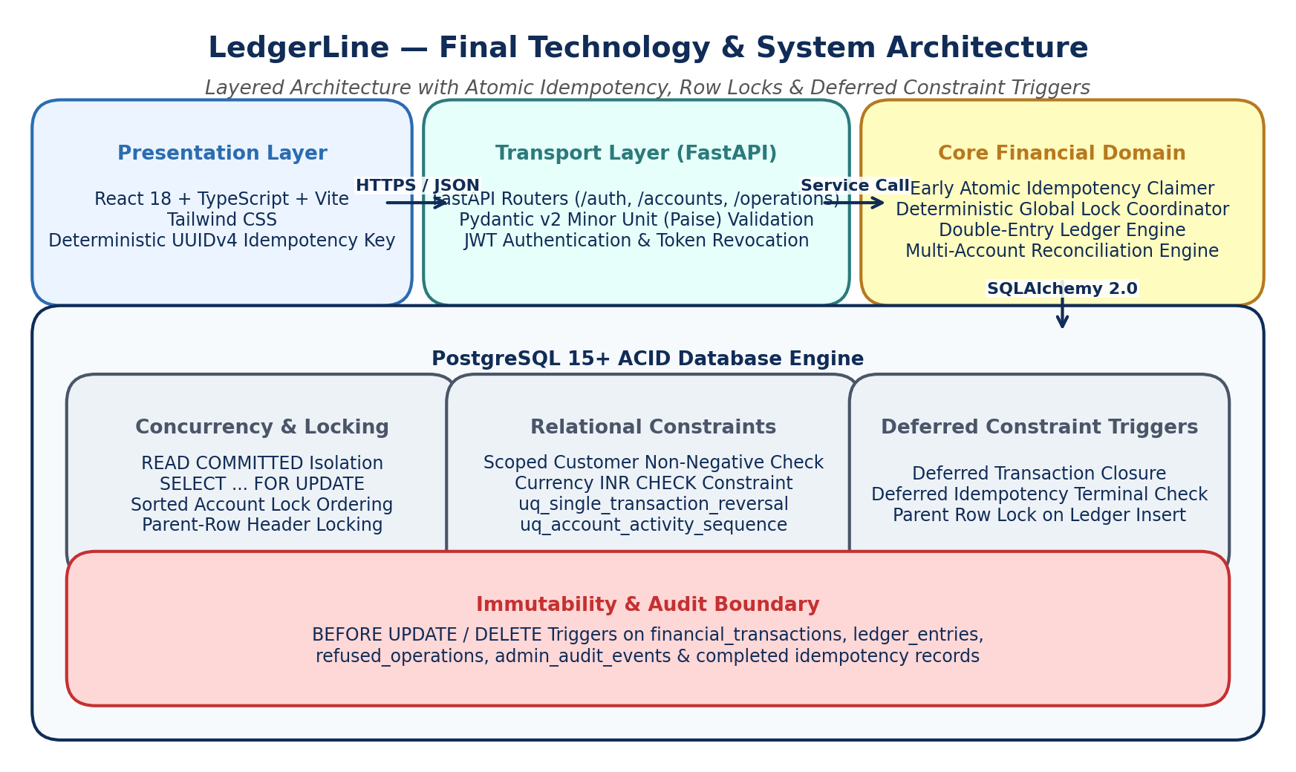
Figure 1: Overall System Architecture, Layer Boundaries & Database Triggers

2. System Architecture, Actors & Component Boundaries
The application architecture strictly decouples transport parsing, authentication, role authorization, resource ownership, transaction coordination, and ledger persistence. System actors interact exclusively through authenticated REST endpoints governed by defense-in-depth guards.
- Administrator: System management, user onboarding, customer account creation, account freezing/unfreezing, transaction reversals, operational audits.
- Account Holder: Personal account inspection, balance queries, transaction statements, simulated deposits, withdrawals, and internal transfers.
- Auditor: Strictly read-only access to all accounts, balances, immutable ledger entries, refusal logs, and real-time reconciliation reports.
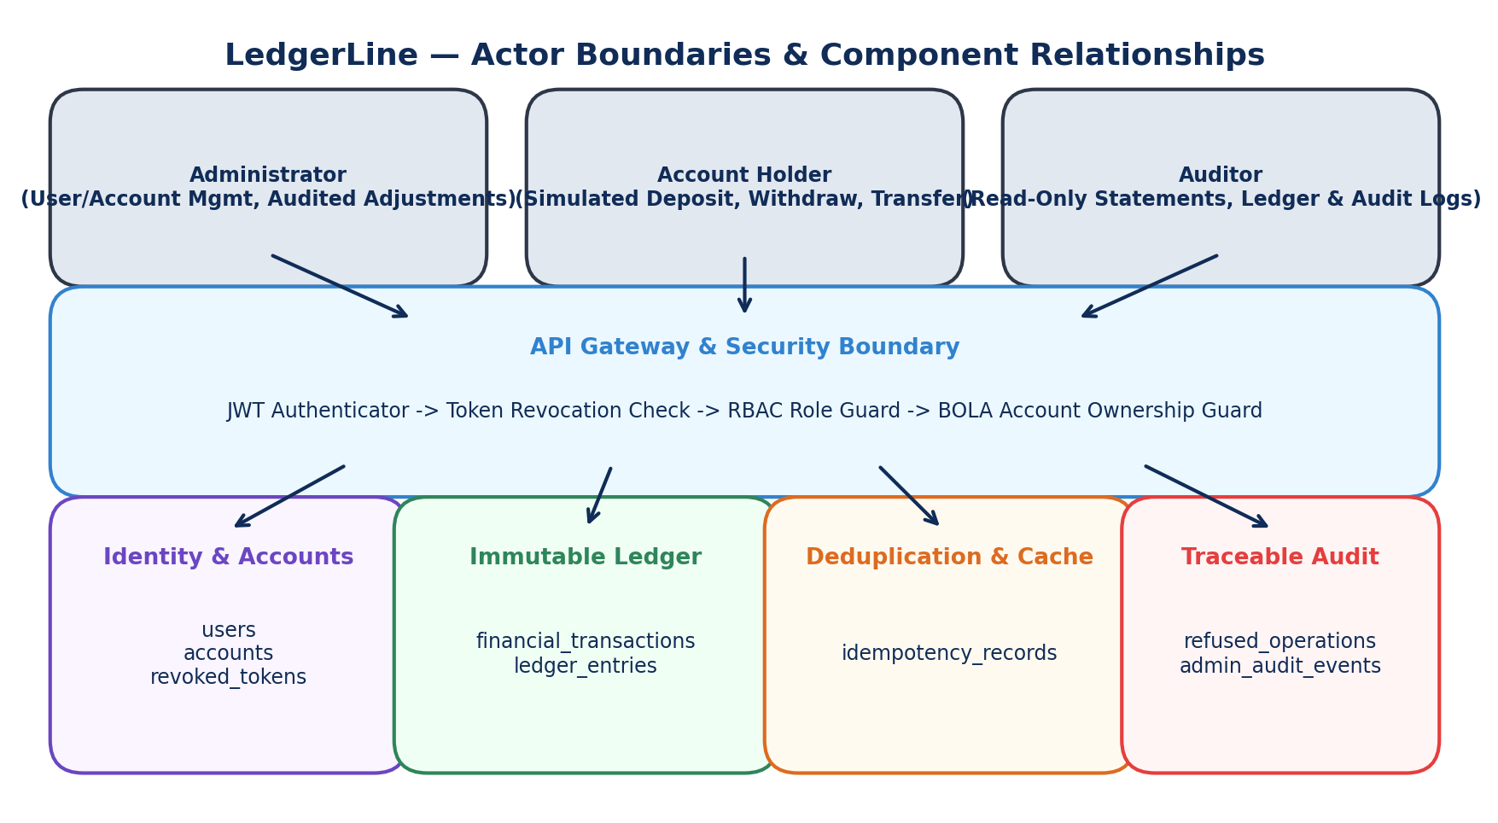
Figure 2: System Actors, Security Boundary, Domain Engines & Relational Data Stores

3. Detailed Component Responsibilities & Interface Contracts
To prevent architectural blurring and ensure testability, each service component operates under explicit, non-overlapping boundaries:
- API Routers (`app.api`): Parse incoming HTTP requests, validate headers (including mandatory Idempotency-Key), delegate to domain services, and serialize JSON responses. Absolutely no direct balance checks or financial mutations occur in routers.
- Security Middleware (`app.core.security`): Verifies JWT cryptographic signatures, checks expiration (`exp`), verifies token has not been revoked against `revoked_tokens`, and validates that `user.is_active == TRUE`.
- Idempotency Service (`app.services.idempotency`): Computes SHA-256 canonical fingerprints, executes early atomic claims using PostgreSQL unique index locks, catches concurrent collisions, and returns cached terminal responses.
- Transaction Coordinator (`app.services.transfer_svc`): Enforces deterministic account lock ordering, acquires `SELECT ... FOR UPDATE` row locks, manages the parent transaction header lifecycle, and coordinates balanced ledger postings.
- Ledger Engine (`app.services.ledger_engine`): Calculates account-specific activity sequences, updates transactionally projected balances, and generates balanced debit/credit posting pairs according to account normal balance sides.
- Reconciliation Engine (`app.services.reconcile`): Executes independent 4-way mathematical verification across all account classifications without modifying database state.

4. Accounting Model & Normal Balance Sides
LedgerLine adheres strictly to standard financial double-entry accounting conventions. Every account classification possesses a defined perspective, normal balance side, and calculation formula. Floating-point numbers are prohibited across all layers; all monetary arithmetic is conducted strictly in integer minor units (paise, where ₹1.00 = 100 paise).
Account Classification | Perspective | Normal Balance | Balance Calculation Formula | Database Constraint Rules
Customer Accounts (`CUSTOMER`) | Platform Liability | CREDIT | Balance = Credits - Debits | CHECK (projected_balance_paise >= 0) strictly enforced.
Deposit Clearing (`SYSTEM_CLEARING_DEPOSIT`) | Asset / Source | DEBIT | Balance = Debits - Credits | Tracks cumulative gross inbound volume. Unconstrained.
Withdrawal Clearing (`SYSTEM_CLEARING_WITHDRAWAL`) | Liability / Sink | CREDIT | Balance = Credits - Debits | Tracks cumulative gross disbursements. Unconstrained.

5. Financial Invariants & Conservation Equation
The system enforces two foundational mathematical invariants that govern all money movement:

Invariant 1: Transaction Balance Equality
For every completed financial transaction T, the sum of all debit postings must exactly equal the sum of all credit postings. No transaction may possess an odd number of entries or unequal amounts:
SUM(amount_paise WHERE entry_type = 'DEBIT') == SUM(amount_paise WHERE entry_type = 'CREDIT')

Invariant 2: Platform Conservation of Money
Customer balances can change exclusively through documented external deposits, external withdrawals, and their authorized reversals. Arbitrary administrator adjustments that unilaterally inflate or deflate customer balances are prohibited. Internal transfers have a net customer impact of exactly zero:
Total Closing Customer Balances = Total Opening Customer Balances + Net Deposits - Net Withdrawals
Where Net Deposits = Gross Deposits - Reversed Deposits
Where Net Withdrawals = Gross Withdrawals - Reversed Withdrawals

6. Financial Operations: Postings & Reversals
All four core financial operations generate balanced double-entry ledger postings:
- Simulated External Deposit: Debits `SYSTEM_CLEARING_DEPOSIT` (Asset increases), Credits `Customer Account` (Customer Liability increases). Customer balance increases.
- Simulated External Withdrawal: Debits `Customer Account` (Customer Liability decreases), Credits `SYSTEM_CLEARING_WITHDRAWAL` (Disbursement increases). Customer balance decreases.
- Internal Account Transfer: Debits `Source Customer Account` (-amount), Credits `Destination Customer Account` (+amount). Net customer change is exactly ₹0.
- Compensating Transaction Reversal: Creates a new transaction referencing `reverses_transaction_id`, generating exact inverted postings (Debits <-> Credits) for the identical accounts and amounts.
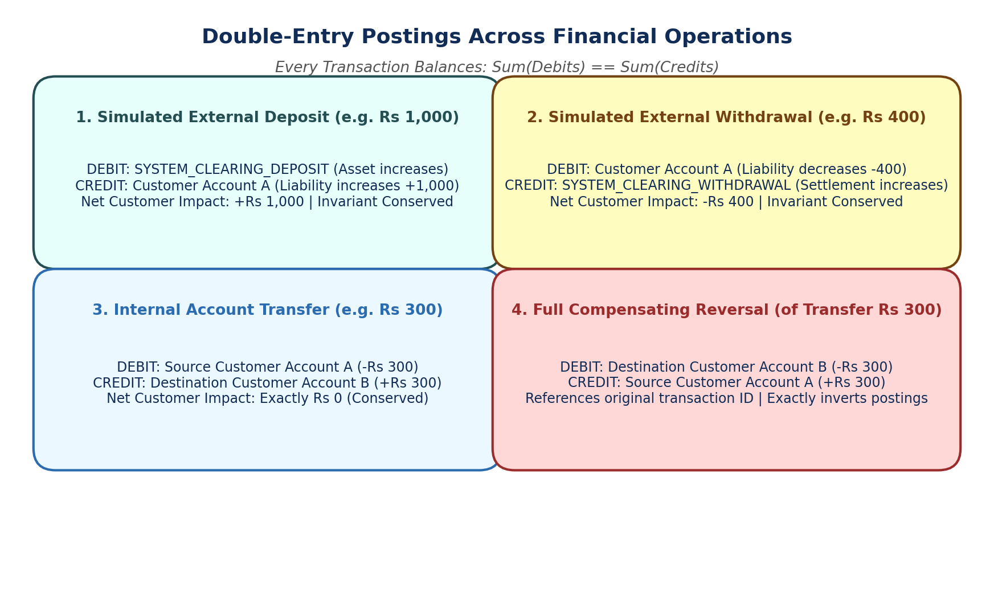
Figure 3: Double-Entry Postings Across Deposit, Withdrawal, Transfer and Reversal Operations

7. PostgreSQL Relational Database Schema
The database schema is partitioned into eight specialized tables with independent lifecycles and append-only immutability triggers:
-- Enable UUID extension
CREATE EXTENSION IF NOT EXISTS "pgcrypto";
-- 1. Users Table (Identity & RBAC)
CREATE TABLE users (
id UUID PRIMARY KEY DEFAULT gen_random_uuid(),
email VARCHAR(255) UNIQUE NOT NULL,
hashed_password VARCHAR(255) NOT NULL,
role VARCHAR(32) NOT NULL, -- 'ADMINISTRATOR', 'ACCOUNT_HOLDER', 'AUDITOR'
is_active BOOLEAN NOT NULL DEFAULT TRUE,
created_at TIMESTAMP WITH TIME ZONE NOT NULL DEFAULT NOW(),
updated_at TIMESTAMP WITH TIME ZONE NOT NULL DEFAULT NOW()
);
-- 2. Accounts Table (Customer & System Clearing Accounts)
CREATE TABLE accounts (
id UUID PRIMARY KEY DEFAULT gen_random_uuid(),
account_number VARCHAR(32) UNIQUE NOT NULL,
user_id UUID NULL REFERENCES users(id) ON DELETE RESTRICT,
account_type VARCHAR(32) NOT NULL, -- 'CUSTOMER', 'SYSTEM_CLEARING_DEPOSIT', 'SYSTEM_CLEARING_WITHDRAWAL'
currency VARCHAR(3) NOT NULL DEFAULT 'INR',
status VARCHAR(32) NOT NULL DEFAULT 'ACTIVE', -- 'ACTIVE', 'FROZEN', 'CLOSED'
projected_balance_paise BIGINT NOT NULL DEFAULT 0,
last_activity_sequence BIGINT NOT NULL DEFAULT 0,
created_at TIMESTAMP WITH TIME ZONE NOT NULL DEFAULT NOW(),
updated_at TIMESTAMP WITH TIME ZONE NOT NULL DEFAULT NOW(),
CONSTRAINT chk_currency_inr CHECK (currency = 'INR'),
CONSTRAINT chk_customer_balance_non_negative CHECK (
account_type != 'CUSTOMER' OR projected_balance_paise >= 0
)
);
-- 3. Financial Transactions Table (Controlled Closure Header)
CREATE TABLE financial_transactions (
id UUID PRIMARY KEY DEFAULT gen_random_uuid(),
transaction_type VARCHAR(32) NOT NULL, -- 'DEPOSIT', 'WITHDRAWAL', 'TRANSFER', 'REVERSAL'
initiator_user_id UUID NOT NULL REFERENCES users(id) ON DELETE RESTRICT,
reference_id VARCHAR(64) UNIQUE NOT NULL,
description TEXT NOT NULL,
metadata JSONB NOT NULL DEFAULT '{}'::jsonb,
is_closed BOOLEAN NOT NULL DEFAULT FALSE,
posted_at TIMESTAMP WITH TIME ZONE NULL,
reverses_transaction_id UUID NULL REFERENCES financial_transactions(id) ON DELETE RESTRICT,
created_at TIMESTAMP WITH TIME ZONE NOT NULL DEFAULT NOW()
);
CREATE UNIQUE INDEX uq_single_transaction_reversal
ON financial_transactions (reverses_transaction_id)
WHERE reverses_transaction_id IS NOT NULL;
-- 4. Ledger Entries Table (Strictly Append-Only Double-Entry Postings)
CREATE TABLE ledger_entries (
id UUID PRIMARY KEY DEFAULT gen_random_uuid(),
transaction_id UUID NOT NULL REFERENCES financial_transactions(id) ON DELETE RESTRICT,
account_id UUID NOT NULL REFERENCES accounts(id) ON DELETE RESTRICT,
entry_type VARCHAR(16) NOT NULL, -- 'DEBIT', 'CREDIT'
amount_paise BIGINT NOT NULL CHECK (amount_paise > 0),
account_activity_sequence BIGINT NOT NULL,
running_balance_paise BIGINT NOT NULL,
created_at TIMESTAMP WITH TIME ZONE NOT NULL DEFAULT NOW(),
CONSTRAINT uq_account_ledger_sequence UNIQUE (account_id, account_activity_sequence)
);
-- 5. Idempotency Records Table (Atomic Key Claim & Terminal State Cache)
CREATE TABLE idempotency_records (
user_id UUID NOT NULL REFERENCES users(id) ON DELETE RESTRICT,
key VARCHAR(255) NOT NULL,
request_path VARCHAR(255) NOT NULL,
request_method VARCHAR(16) NOT NULL,
request_hash VARCHAR(64) NOT NULL,
status VARCHAR(32) NOT NULL DEFAULT 'IN_PROGRESS', -- 'IN_PROGRESS', 'COMPLETED', 'REFUSED'
response_status_code INTEGER NULL,
response_body JSONB NULL,
transaction_id UUID NULL REFERENCES financial_transactions(id) ON DELETE RESTRICT,
created_at TIMESTAMP WITH TIME ZONE NOT NULL DEFAULT NOW(),
PRIMARY KEY (user_id, key)
);
-- 6. Refused Operations Table (Authorized Business Rejection Audit)
CREATE TABLE refused_operations (
id UUID PRIMARY KEY DEFAULT gen_random_uuid(),
user_id UUID NOT NULL REFERENCES users(id) ON DELETE RESTRICT,
account_id UUID NOT NULL REFERENCES accounts(id) ON DELETE RESTRICT,
observed_balance_paise BIGINT NOT NULL,
account_activity_sequence BIGINT NOT NULL,
operation_type VARCHAR(32) NOT NULL,
attempted_amount_paise BIGINT NOT NULL,
reason_code VARCHAR(64) NOT NULL, -- 'INSUFFICIENT_FUNDS', 'ACCOUNT_FROZEN', 'SELF_TRANSFER'
reason_message TEXT NOT NULL,
idempotency_key VARCHAR(255) NULL,
request_metadata JSONB NOT NULL DEFAULT '{}'::jsonb,
created_at TIMESTAMP WITH TIME ZONE NOT NULL DEFAULT NOW(),
CONSTRAINT uq_account_refused_sequence UNIQUE (account_id, account_activity_sequence)
);
-- 7. Admin Audit Events Table (Privileged Action & Security Audit Log)
CREATE TABLE admin_audit_events (
id UUID PRIMARY KEY DEFAULT gen_random_uuid(),
admin_user_id UUID NOT NULL REFERENCES users(id) ON DELETE RESTRICT,
action_type VARCHAR(64) NOT NULL, -- 'FREEZE_ACCOUNT', 'UNFREEZE_ACCOUNT', 'CREATE_ACCOUNT', 'UNAUTHORIZED_ACCESS_ATTEMPT'
target_resource_id UUID NOT NULL,
reason_narrative TEXT NOT NULL,
details JSONB NOT NULL DEFAULT '{}'::jsonb,
created_at TIMESTAMP WITH TIME ZONE NOT NULL DEFAULT NOW()
);
-- 8. Revoked Tokens Table (Authentication Revocation)
CREATE TABLE revoked_tokens (
id UUID PRIMARY KEY DEFAULT gen_random_uuid(),
token_jti VARCHAR(64) UNIQUE NOT NULL,
user_id UUID NOT NULL REFERENCES users(id) ON DELETE CASCADE,
expires_at TIMESTAMP WITH TIME ZONE NOT NULL,
revoked_at TIMESTAMP WITH TIME ZONE NOT NULL DEFAULT NOW(),
reason VARCHAR(64) NOT NULL DEFAULT 'LOGOUT'
);
CREATE INDEX idx_revoked_tokens_jti ON revoked_tokens (token_jti);

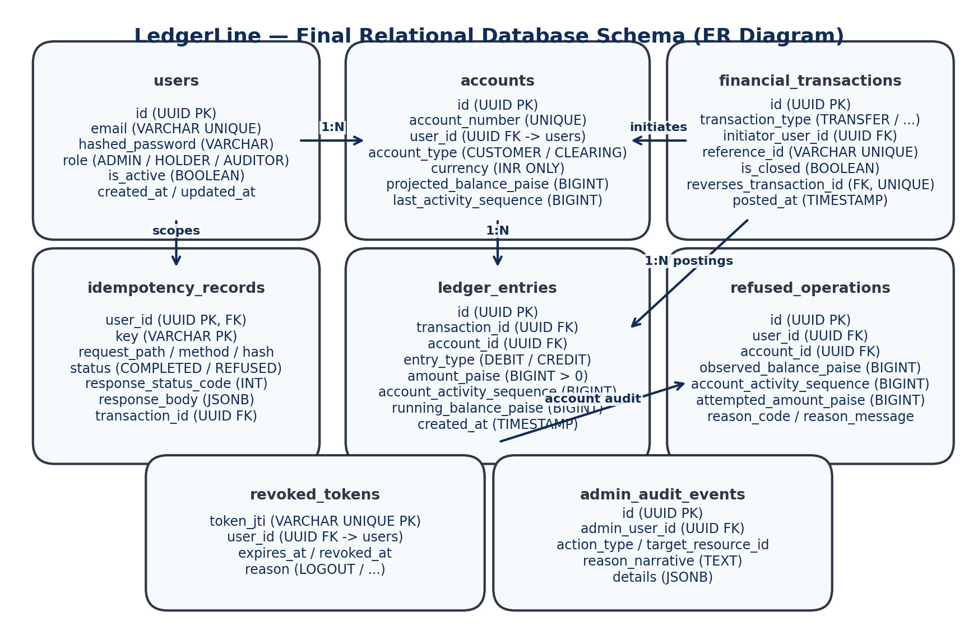
Figure 4: PostgreSQL Relational Entity-Relationship Diagram

8. Double-Entry Database-Level Validation & Stale Event Resolution
A critical flaw in standard database trigger design is reliance on the trigger event's `NEW` row image. When a financial transaction header is inserted with `is_closed = FALSE` and subsequently updated to `TRUE` within the same transaction, a deferred `INSERT` trigger can evaluate the obsolete initial state. To resolve this, LedgerLine's deferred trigger queries the current live row state by primary key at `COMMIT` time:
CREATE OR REPLACE FUNCTION verify_financial_transaction_closure()
RETURNS TRIGGER AS $$
DECLARE
v_is_closed BOOLEAN;
v_debit_total BIGINT;
v_credit_total BIGINT;
v_posting_count INTEGER;
BEGIN
-- Query current live row state to eliminate stale NEW event image
SELECT is_closed INTO v_is_closed
FROM financial_transactions
WHERE id = NEW.id;
IF v_is_closed IS NULL OR NOT v_is_closed THEN
RAISE EXCEPTION 'Double-entry violation: Financial transaction % was not marked closed (is_closed=TRUE) before commit.',
NEW.id;
END IF;
-- Aggregate complete postings
SELECT
COALESCE(SUM(CASE WHEN entry_type = 'DEBIT' THEN amount_paise ELSE 0 END), 0),
COALESCE(SUM(CASE WHEN entry_type = 'CREDIT' THEN amount_paise ELSE 0 END), 0),
COUNT(*)
INTO v_debit_total, v_credit_total, v_posting_count
FROM ledger_entries
WHERE transaction_id = NEW.id;
IF v_posting_count < 2 THEN
RAISE EXCEPTION 'Double-entry violation: Financial transaction % has % posting(s). Minimum 2 balanced postings required.',
NEW.id, v_posting_count;
END IF;
IF v_debit_total <> v_credit_total THEN
RAISE EXCEPTION 'Double-entry violation: Financial transaction % does not balance (Debits: %, Credits: %).',
NEW.id, v_debit_total, v_credit_total;
END IF;
RETURN NEW;
END;
$$ LANGUAGE plpgsql;
CREATE CONSTRAINT TRIGGER trg_verify_financial_transaction_closure
AFTER INSERT OR UPDATE ON financial_transactions
DEFERRABLE INITIALLY DEFERRED
FOR EACH ROW
EXECUTE FUNCTION verify_financial_transaction_closure();

9. Financial Transaction Header Lifecycle & Parent-Row Locking
To prevent race conditions where a concurrent worker attempts to append a ledger posting while a transaction is closing, the posting insertion trigger enforces parent-row locking using `SELECT ... FOR UPDATE` on `financial_transactions`:
CREATE OR REPLACE FUNCTION prevent_posting_to_closed_transaction()
RETURNS TRIGGER AS $$
DECLARE
v_is_closed BOOLEAN;
BEGIN
-- Parent-row locking strategy: lock header FOR UPDATE to eliminate concurrency races
SELECT is_closed INTO v_is_closed
FROM financial_transactions
WHERE id = NEW.transaction_id
FOR UPDATE;
IF v_is_closed IS NULL THEN
RAISE EXCEPTION 'Foreign key violation: Parent transaction % does not exist.', NEW.transaction_id;
END IF;
IF v_is_closed THEN
RAISE EXCEPTION 'Immutability violation: Cannot append ledger entry % to transaction % because it is already closed.',
NEW.id, NEW.transaction_id;
END IF;
RETURN NEW;
END;
$$ LANGUAGE plpgsql;
CREATE TRIGGER trg_prevent_posting_to_closed_transaction
BEFORE INSERT ON ledger_entries
FOR EACH ROW
EXECUTE FUNCTION prevent_posting_to_closed_transaction();
-- Immutability Trigger: Header allows exactly one transition from FALSE -> TRUE
CREATE OR REPLACE FUNCTION protect_financial_transaction_header()
RETURNS TRIGGER AS $$
BEGIN
IF OLD.is_closed THEN
RAISE EXCEPTION 'Immutability violation: Closed financial transaction % cannot be modified or reopened.', OLD.id;
END IF;
IF NOT OLD.is_closed AND NEW.is_closed THEN
-- Allow ONLY setting is_closed = TRUE and posted_at = NOW()
IF NEW.transaction_type <> OLD.transaction_type OR
NEW.initiator_user_id <> OLD.initiator_user_id OR
NEW.reference_id <> OLD.reference_id THEN
RAISE EXCEPTION 'Immutability violation: Core financial transaction attributes cannot be altered during closure.';
END IF;
END IF;
RETURN NEW;
END;
$$ LANGUAGE plpgsql;
CREATE TRIGGER trg_protect_financial_transaction_header
BEFORE UPDATE ON financial_transactions
FOR EACH ROW
EXECUTE FUNCTION protect_financial_transaction_header();

10. Idempotency Terminal State Validation
To guarantee that an `IN_PROGRESS` idempotency record can never be committed to the database, a deferred constraint trigger queries the live record at `COMMIT` time and verifies that a terminal state (`COMPLETED` or `REFUSED`) and non-null HTTP response payloads are present:
CREATE OR REPLACE FUNCTION verify_idempotency_terminal_state()
RETURNS TRIGGER AS $$
DECLARE
v_status VARCHAR(32);
v_code INTEGER;
v_body JSONB;
v_tx_id UUID;
BEGIN
-- Query live row by composite primary key (user_id, key)
SELECT status, response_status_code, response_body, transaction_id
INTO v_status, v_code, v_body, v_tx_id
FROM idempotency_records
WHERE user_id = NEW.user_id AND key = NEW.key;
IF v_status NOT IN ('COMPLETED', 'REFUSED') THEN
RAISE EXCEPTION 'Idempotency violation: Record for key % (user %) cannot commit with non-terminal status %.',
NEW.key, NEW.user_id, v_status;
END IF;
IF v_code IS NULL OR v_body IS NULL THEN
RAISE EXCEPTION 'Idempotency violation: Record for key % (user %) must contain non-null response_status_code and response_body upon commit.',
NEW.key, NEW.user_id;
END IF;
IF v_status = 'COMPLETED' AND v_tx_id IS NULL THEN
RAISE EXCEPTION 'Idempotency violation: Completed financial record for key % must reference a valid transaction_id.',
NEW.key;
END IF;
RETURN NEW;
END;
$$ LANGUAGE plpgsql;
CREATE CONSTRAINT TRIGGER trg_verify_idempotency_terminal_state
AFTER INSERT OR UPDATE ON idempotency_records
DEFERRABLE INITIALLY DEFERRED
FOR EACH ROW
EXECUTE FUNCTION verify_idempotency_terminal_state();
-- Immutability Trigger: Completed / Refused records can NEVER be modified or deleted
CREATE OR REPLACE FUNCTION protect_completed_idempotency_record()
RETURNS TRIGGER AS $$
BEGIN
IF OLD.status IN ('COMPLETED', 'REFUSED') THEN
RAISE EXCEPTION 'Immutability violation: Finalized idempotency record for key % cannot be modified or deleted.', OLD.key;
END IF;
RETURN NEW;
END;
$$ LANGUAGE plpgsql;
CREATE TRIGGER trg_protect_completed_idempotency_record
BEFORE UPDATE OR DELETE ON idempotency_records
FOR EACH ROW
EXECUTE FUNCTION protect_completed_idempotency_record();

11. Early Atomic Idempotency Claiming & Replay Handling
Instead of checking for a key, moving funds, and inserting an idempotency record at the end, LedgerLine implements early atomic claiming. The very first SQL operation inside the transaction attempts to claim the key using PostgreSQL's row-level unique index:
INSERT INTO idempotency_records (
user_id, key, request_path, request_method, request_hash, status
)
VALUES (
:user_id, :key, :request_path, :request_method, :request_hash, 'IN_PROGRESS'
)
ON CONFLICT (user_id, key) DO NOTHING
RETURNING user_id, key;

If the query returns a row, the request owns the key and proceeds with financial execution. If the query returns zero rows, the key already exists or is currently being processed by another worker.

12. Concurrent Idempotency Execution under READ COMMITTED
When two identical requests R1 and R2 arrive simultaneously under PostgreSQL READ COMMITTED isolation:
- 1. R1 enters Tx 1; R2 enters Tx 2. Both attempt `INSERT INTO idempotency_records ... ON CONFLICT DO NOTHING`.
- 2. Tx 1 inserts the uncommitted row under unique constraint lock. Tx 2's insert automatically BLOCKS in PostgreSQL waiting for Tx 1 to resolve.
- 3. If Tx 1 Commits: Tx 2 unblocks immediately. `ON CONFLICT DO NOTHING` returns 0 rows. Tx 2 queries the committed record, verifies payload hashes match, and returns the cached HTTP response with `Idempotent-Replay: true`. Zero financial mutations occur.
- 4. If Tx 1 Aborts: Tx 2 unblocks. The uncommitted row disappears. Tx 2's insert succeeds, returning the claimed key. Tx 2 becomes the primary executor.
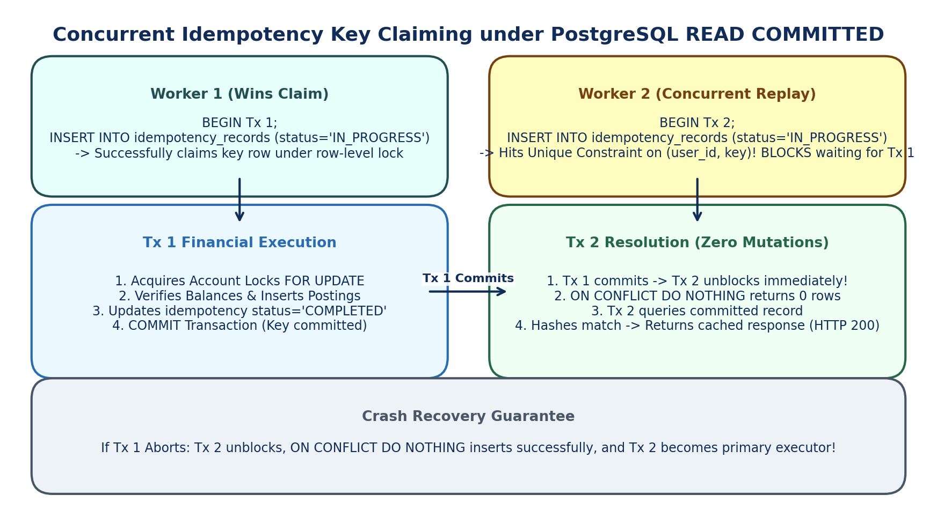
Figure 5: Concurrent Idempotency Key Claiming under PostgreSQL READ COMMITTED

13. Exact Financial Transaction Execution Sequence
The complete lifecycle of a financial transaction follows a strict 12-step deterministic sequence:
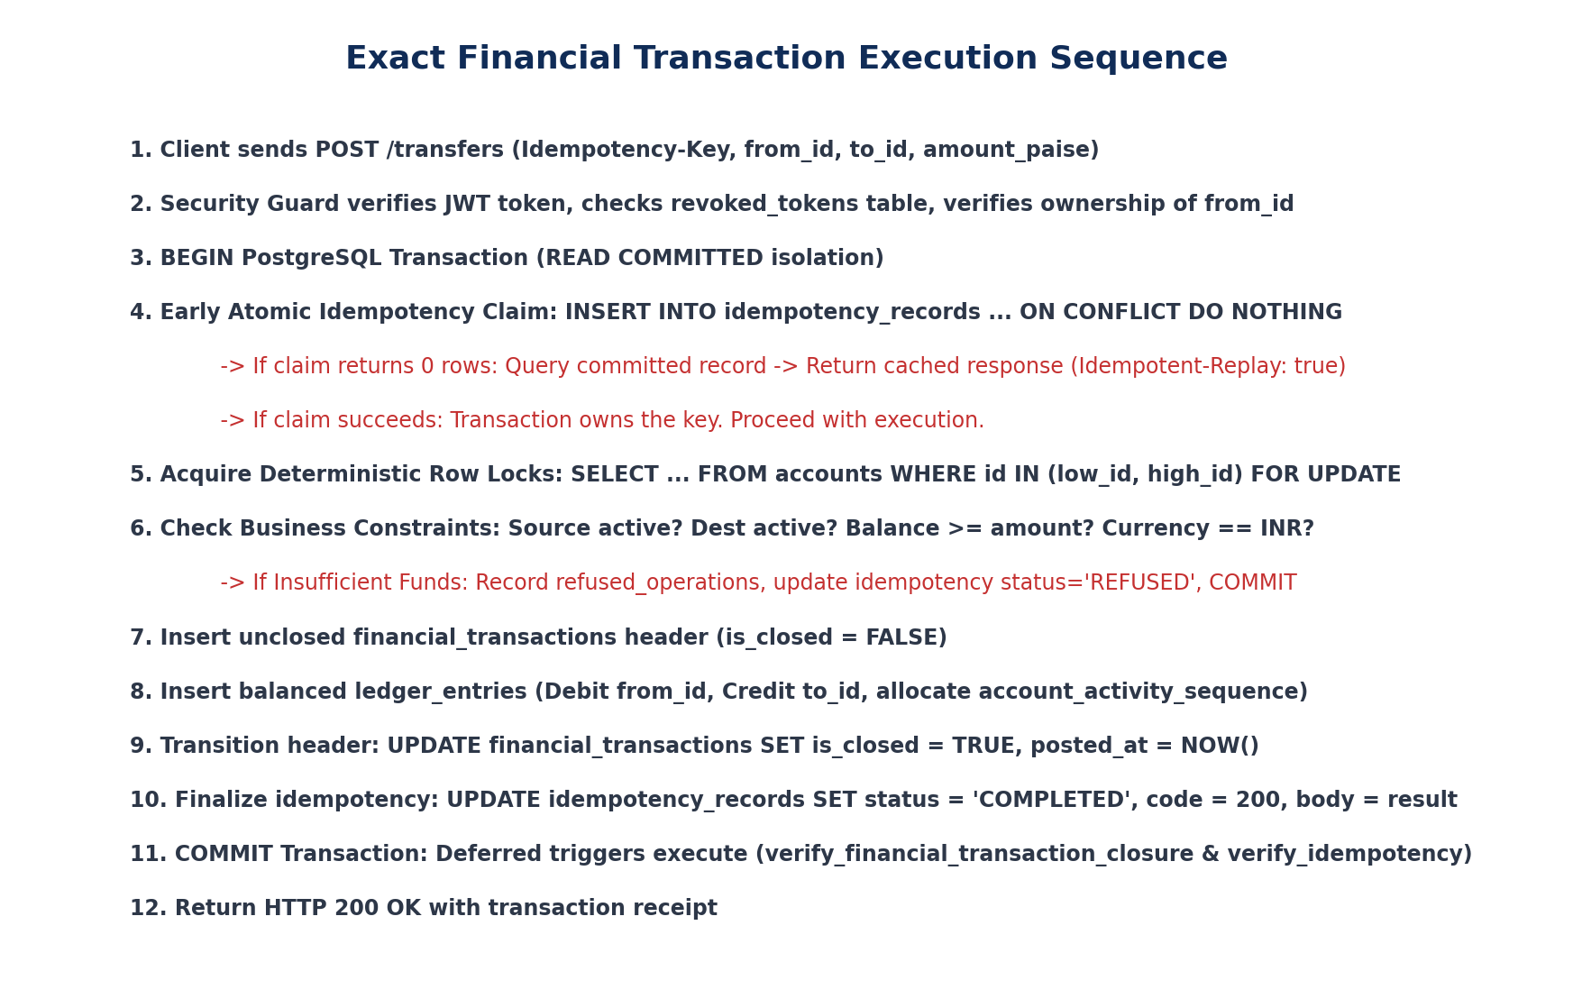
Figure 6: Step-by-Step Financial Transaction Execution Sequence

14. Deterministic Account Locking & Deadlock Recovery
To prevent cross-account deadlocks during simultaneous opposing transfers (A -> B and B -> A), all modified accounts (customer and clearing) are locked in strict ascending lexicographical order of their UUIDs:
async def acquire_deterministic_account_locks(session: AsyncSession, account_ids: list[UUID]) -> dict[UUID, Account]:
# Sort IDs ascending to eliminate circular wait deadlocks
sorted_ids = sorted(list(set(account_ids)))
locked_accounts = {}
for aid in sorted_ids:
query = select(Account).where(Account.id == aid).with_for_update()
result = await session.execute(query)
account = result.scalar_one_or_none()
if not account:
raise AccountNotFoundException(f"Account {aid} does not exist.")
locked_accounts[aid] = account
return locked_accounts

Bounded Deadlock Recovery: While deterministic row ordering prevents application deadlocks, database engines can still experience deadlocks from internal index page locks. The database wrapper intercepts PostgreSQL error code `40P01` (`DeadlockDetected`) and retries up to 3 times with randomized exponential jitter (20ms, 50ms, 100ms) before reporting failure.

15. Defense-in-Depth Authentication & Authorization Architecture
Authorization is enforced across four independent layers. Even if an attacker bypasses the client or route guard, the financial service layer validates account ownership and account status on the locked database row inside the transaction:
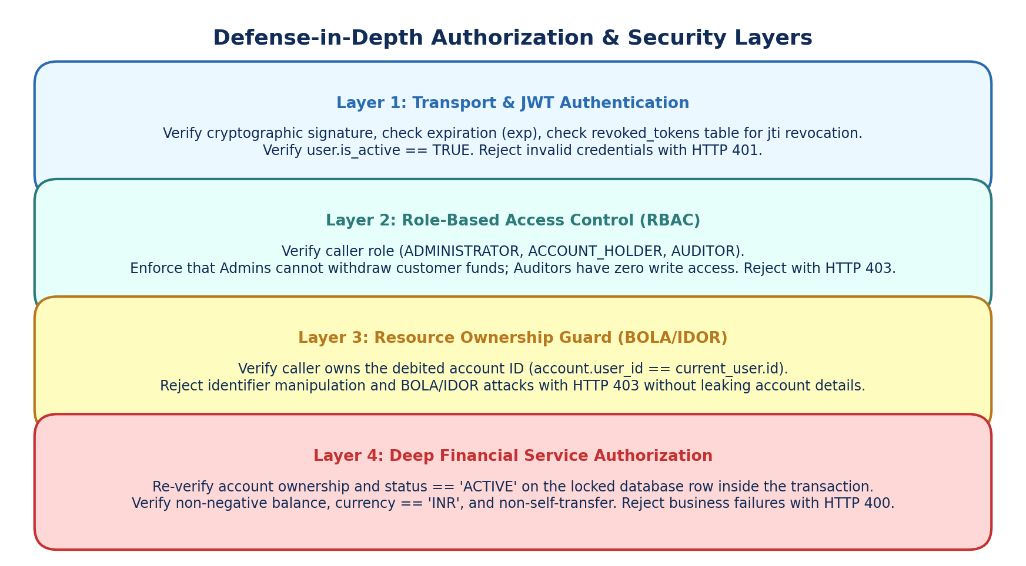
Figure 7: Four-Layer Defense-in-Depth Security & Authorization Architecture

16. Complete Role & Permission Matrix
Strict separation of duties is enforced across all roles. Administrators cannot withdraw customer funds or perform unauthorized customer transfers:
Operational Endpoint | Administrator | Account Holder | Auditor | Enforcement Mechanism
User Management (`/users`) | Full Access | Denied | Denied | RoleChecker([ADMINISTRATOR])
Create Customer Account (`/accounts`) | Full Access | Denied | Denied | RoleChecker([ADMINISTRATOR])
Freeze / Unfreeze Account | Full (Audited) | Denied | Denied | RoleChecker([ADMINISTRATOR]) + Audit Log
View Personal Statements | Denied | Owned Only | Denied | AccountOwnerChecker(strict=True)
Simulated Deposit | Denied | Owned Only | Denied | AccountOwnerChecker() + Simulated Tag
Simulated Withdrawal | DENIED | Owned Only | Denied | AccountOwnerChecker() + Balance Check
Internal Transfer | DENIED | Owned Source | Denied | AccountOwnerChecker() on from_account
Transaction Reversal | Authorized Only | Denied | Denied | RoleChecker([ADMINISTRATOR]) + Reason Narrative
Inspect Ledger / Reconciliation | Full Access | Denied | Read-Only | RoleChecker([ADMINISTRATOR, AUDITOR])

17. Refused-Operation Balance History & Security Boundary
A critical requirement of the assessment is that account statements must display refused attempts with the resulting running balance and initiating user, without polluting the double-entry financial ledger. To accomplish this, `refused_operations` records the `observed_balance_paise` and shares a monotonic `account_activity_sequence` with `ledger_entries`.
[SECURITY AUDIT VS ACCOUNT STATEMENT BOUNDARY] SECURITY BOUNDARY DISTINCTION: 1. Authorized Business Refusals: When the legitimate owner of Account A attempts an operation that fails business checks (e.g. Insufficient Funds), it is logged in `refused_operations` with `account_id`, `observed_balance_paise`, and `account_activity_sequence`. This allows the owner to view the refused attempt in their statement.
2. Unauthorized Cross-Account Attacks: When User B attempts to access or withdraw from Account A without authorization (BOLA / IDOR attack), recording this in Account A's statement would leak private information. Instead, unauthorized attacks are logged in `admin_audit_events` with `action_type = 'UNAUTHORIZED_ACCESS_ATTEMPT'`, logging User B's IP and user_id without disclosing Account A's balance or internal activity sequence.

18. Unified Account Activity Sequence & Statement Generation
To eliminate dependency on wall-clock timestamps and guarantee deterministic chronological ordering under high concurrency, each account maintains an atomic, monotonically increasing `account_activity_sequence`. This sequence is incremented under row-level lock:
# In active transaction under SELECT ... FOR UPDATE on accounts:
next_sequence = account.last_activity_sequence + 1
account.last_activity_sequence = next_sequence
# In ledger_entries or refused_operations:
# account_activity_sequence = next_sequence
-- Statement generation query orders strictly by activity sequence:
SELECT 'POSTING' as kind, entry_type, amount_paise, running_balance_paise, account_activity_sequence, created_at
FROM ledger_entries WHERE account_id = :aid
UNION ALL
SELECT 'REFUSED' as kind, operation_type, attempted_amount_paise, observed_balance_paise, account_activity_sequence, created_at
FROM refused_operations WHERE account_id = :aid
ORDER BY account_activity_sequence ASC;

19. Exact Reversal Validation & Compensating Postings
Reversals are executed as new compensating financial transactions. Version one strictly supports full reversals:
- 1. Reversal Legality: The original transaction must be completed and must NOT be a reversal (`reverses_transaction_id IS NULL`).
- 2. Single Reversal: Enforced by database constraint `uq_single_transaction_reversal` on `financial_transactions(reverses_transaction_id)`.
- 3. Exact Compensating Postings: For every original posting (account, amount, entry_type), the reversal generates an entry for the exact same account and amount with inverted entry type (`DEBIT` <-> `CREDIT`).
- 4. Customer Balance Sufficiency: If reversing a deposit, the customer account will be debited. The engine verifies `customer.projected_balance_paise >= amount`. If the customer already spent the funds, the reversal is rejected with HTTP 400 (`INSUFFICIENT_FUNDS_FOR_REVERSAL`) to prevent driving customer balances negative.
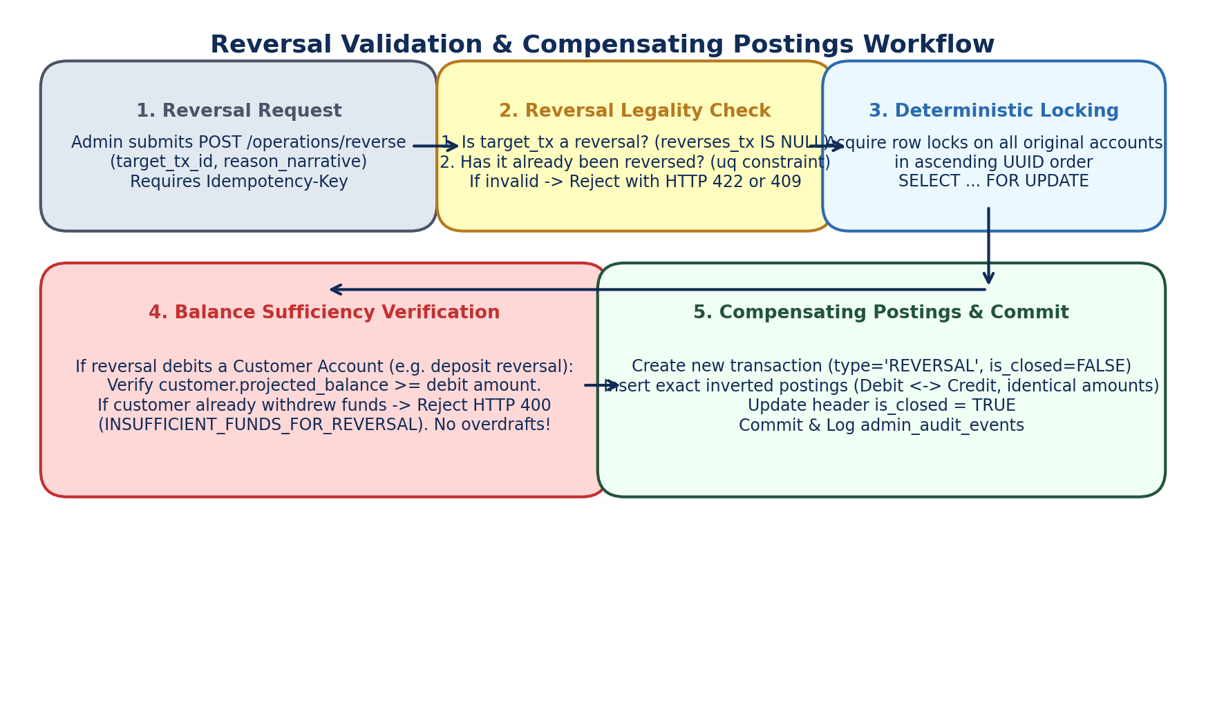
Figure 8: Reversal Validation & Compensating Postings Workflow

20. Multi-Account 4-Way Reconciliation Engine
An independent, read-only reconciliation service verifies mathematical consistency across all accounts:
- 1. Customer Liability Reconciliation: Verifies `Credits - Debits == projected_balance_paise` for every customer account.
- 2. Deposit Clearing Asset Reconciliation: Verifies `Debits - Credits == projected_balance_paise` for `SYSTEM_CLEARING_DEPOSIT`.
- 3. Withdrawal Clearing Liability Reconciliation: Verifies `Credits - Debits == projected_balance_paise` for `SYSTEM_CLEARING_WITHDRAWAL`.
- 4. Platform Conservation Verification: Verifies that total customer balances equal initial balances + net deposits - net withdrawals.
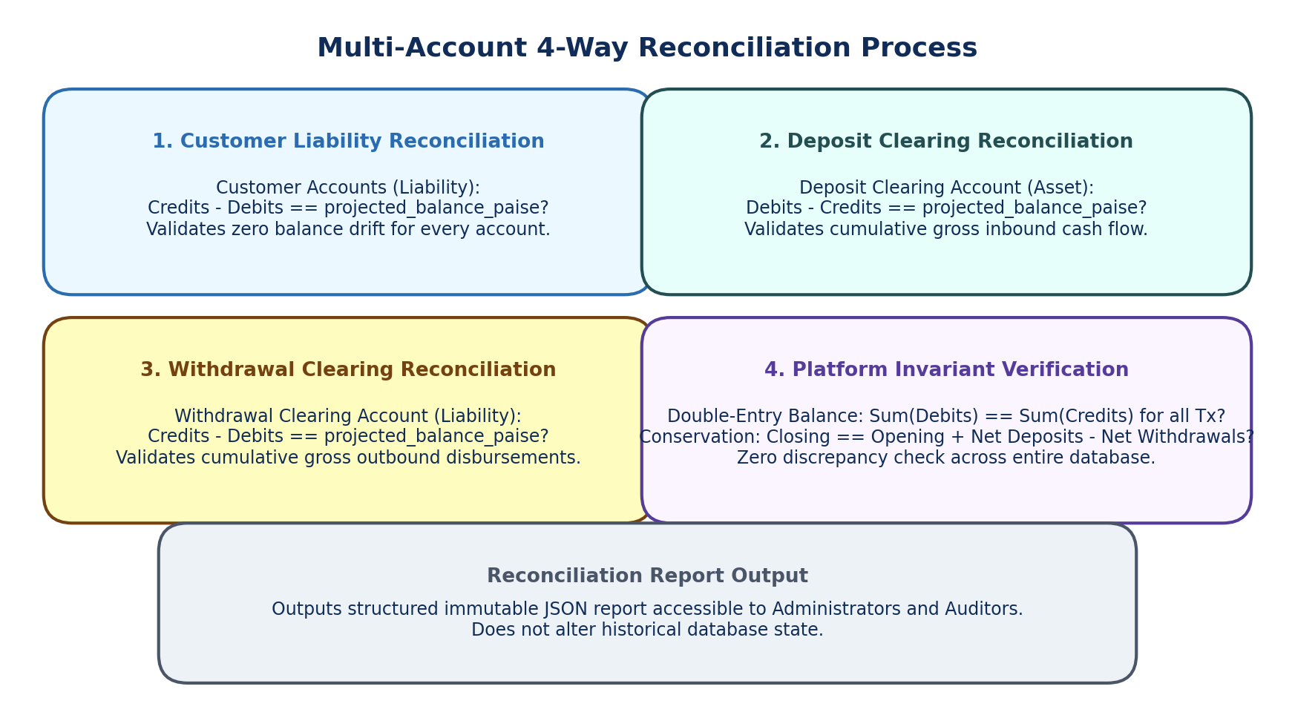
Figure 9: Multi-Account 4-Way Reconciliation Audit Process

21. Append-Only Ledger & Immutability Audit Triggers
PostgreSQL triggers prohibit `UPDATE` and `DELETE` operations on historical financial and audit tables:
CREATE OR REPLACE FUNCTION trg_enforce_immutable_financial_records()
RETURNS TRIGGER AS $$
BEGIN
RAISE EXCEPTION 'Immutability violation: % operation is strictly prohibited on table %.',
TG_OP, TG_TABLE_NAME;
END;
$$ LANGUAGE plpgsql;
CREATE TRIGGER trg_protect_ledger_entries
BEFORE UPDATE OR DELETE ON ledger_entries
FOR EACH ROW EXECUTE FUNCTION trg_enforce_immutable_financial_records();
CREATE TRIGGER trg_protect_refused_operations
BEFORE UPDATE OR DELETE ON refused_operations
FOR EACH ROW EXECUTE FUNCTION trg_enforce_immutable_financial_records();
CREATE TRIGGER trg_protect_admin_audit_events
BEFORE UPDATE OR DELETE ON admin_audit_events
FOR EACH ROW EXECUTE FUNCTION trg_enforce_immutable_financial_records();

22. Comprehensive Security Threat Register
The project maintains an active threat register (`THREATS.md`) connecting every attack scenario to its concrete mitigation and automated test proof:
Threat ID | Attack Vector & Scenario | Potential Impact | Implemented Mitigation | Automated Verification Test
T-01 | 10 concurrent withdrawals of ₹800 against ₹1,000 balance. | Negative balance, money creation. | SELECT FOR UPDATE row locks + CHECK (balance >= 0). | test_concurrent_withdrawals_prevent_overdraft
T-02 | Concurrent transfers A->B and B->A cause deadlocks. | 500 error, transaction abort. | Ascending UUID lock ordering + retry on 40P01. | test_opposing_transfers_no_deadlock
T-03 | Network timeout after debit; client resends transfer. | Duplicate debit / payment. | Early atomic claim via INSERT ON CONFLICT DO NOTHING. | test_replayed_transfer_returns_original
T-04 | Attacker replays key K with altered amount or recipient. | Fraudulent transfer. | SHA-256 canonical hash comparison; returns 422. | test_idempotency_payload_mutation_rejected
T-05 | User A modifies account_id to User B's account in withdrawal. | Theft of third-party funds. | Server-side account.user_id == current_user.id check. | test_cross_account_withdrawal_rejected_403
T-06 | Attacker or admin executes direct SQL UPDATE on ledger. | Audit trail destruction. | BEFORE UPDATE/DELETE triggers throwing exceptions. | test_ledger_immutability_trigger
T-07 | Administrator attempts direct withdrawal from customer. | Administrative siphoning. | RBAC blocking admins from customer withdrawal APIs. | test_admin_cannot_withdraw_customer_funds
T-08 | Database crashes after debit before credit insertion. | Money destroyed; unbalanced. | Single atomic database transaction (session.begin()). | test_transfer_partial_failure_rollback
T-09 | Buggy code commits transaction with unequal debits/credits. | Unbalanced books. | Deferred trigger verify_financial_transaction_closure. | test_unbalanced_transaction_rejected
T-10 | Admin attempts duplicate reversal of same transaction. | Double compensation. | Partial unique index uq_single_transaction_reversal. | test_duplicate_reversal_rejected

23. Real PostgreSQL Automated Concurrency & Failure Recovery Tests
All concurrency and integrity tests execute against an actual PostgreSQL database instance using independent connection pool sessions and `asyncio.Barrier` synchronization:
- 1. Mandatory Concurrent Overdraft Test: Account initialized with ₹1,000. 10 concurrent requests of ₹800 synchronized via `asyncio.Barrier(10)`. Exactly 1 request returns HTTP 200; exactly 9 return HTTP 400 (`INSUFFICIENT_FUNDS`). Final balance is exactly ₹200. Exactly 1 debit and 1 credit posting exist in `ledger_entries`. Exactly 9 refusal rows exist in `refused_operations`.
- 2. Mandatory Identical Idempotency Key Test: Sender with ₹500, recipient with ₹0. 5 concurrent requests with identical key K and amount ₹300 via `asyncio.Barrier(5)`. Exactly one transfer transaction executes. All 5 workers receive identical HTTP 200 responses with the same `transaction_id`. Sender closing balance: ₹200; recipient closing balance: ₹300.
- 3. Opposing Cross-Transfer Test: Account A (₹10,000) and Account B (₹10,000). 20 concurrent tasks (10 transferring A->B, 10 transferring B->A). 100% of transfers complete successfully without unhandled deadlocks. Total money conserved across both accounts remains exactly ₹20,000.
- 4. Partial Failure & Rollback Test: Simulate exception prior to transaction closure. Entire transaction rolls back; zero ledger rows created; sender balance unchanged.
- 5. Incomplete Header Rejection Test: Insert `financial_transactions` without postings. At commit, deferred trigger throws exception and rolls back transaction.
- 6. Token Revocation Test: User logs out, inserting JWT JTI into `revoked_tokens`. Subsequent requests with the token are rejected with HTTP 401.

24. Git Policy, Seven-Day Roadmap & Accepted Limitations
Git & Repository Workflow: The GitHub repository remains strictly PRIVATE throughout development (Nov 5 to Nov 12). Automatic commits and automatic pushes to the private repository are authorized for logically completed, verified milestones. Public publication is reserved exclusively for the authorized final submission stage, following placement-cell clarification and explicit user approval.

Seven-Day Development Roadmap
- Day 1 (Nov 5): Milestone 1 — Architecture Approval, Project Scaffolding, Alembic Migrations, Invariant Triggers.
- Day 2 (Nov 6): Milestone 2 — Authentication, Token Revocation, RBAC, BOLA Account Ownership Guards & Tests.
- Day 3 (Nov 7): Milestone 3 — Core Financial Engine, Double-Entry Postings, Simulated Cash Flow, Balance Projections.
- Day 4 (Nov 8): Milestone 4 — Concurrency Row-Level Locking, Early Idempotency Claiming, Parent-Row Closure.
- Day 5 (Nov 9): Milestone 5 — Security Hardening, Automated Concurrency Stress Tests (Overdraft, Replays, Deadlocks).
- Day 6 (Nov 10): Milestone 6 — React Dashboards (Admin, Holder, Auditor), Statements, Documentation (README, THREATS, PROMPTS).
- Day 7 (Nov 11-12): Milestone 7 — Cloud Deployment, Demo Accounts, Production End-to-End Verification, Video Recording & Submission.

Documented & Accepted Limitations
- Currency Scope: Version one strictly supports Indian Rupee (INR) only. Multi-currency foreign exchange is out of scope.
- Simulated External Flow: Deposits and withdrawals are simulated cash operations; no external banking gateway is integrated.
- Full Reversals Only: Version one supports full transaction reversals only; partial reversals are disallowed to prevent accounting ambiguity.
- Infrastructure Superusers: Database triggers enforce immutability against the application database role. Operating system root and database superusers are outside the application security boundary.

