SMART EXPENSE ANALYZER

A Major Project Work
Submitted in partial fulfilment of the requirements for the award of the degree of
BACHELOR OF TECHNOLOGY
In
COMPUTER SCIENCE AND ENGINEERING (ARTIFICIAL INTELLIGENCE AND MACHINE LEARNING)
By
KAJA NAVYA 226W1A6119
KANNURU HYKULU 226W1A6120
KOPIRI ASWITHA 226W1A6124 RAVADA NIHARIKA 226W1A6144

Under the guidance of
Mrs. CH. ANUSHA M.Tech,(Ph.D)
Assistant Professor


DEPARTMENT OF ARTIFICIAL INTELLIGENCE AND MACHINE LEARNING INTERNATIONAL SCHOOL OF TECHNOLOGY AND SCIENCES FOR WOMEN
(An Autonomous Institution)

(Approved by AICTE and Affiliated to JNTU, Kakinada) Accredited by
NBA for CSE, ECE &AGRI, Accredited by NAAC with A+
East Gonagudem, Rajanagaram, Rajamahendravaram, East Godavari District, Andhra Pradesh, India-533294.
(2025-2026)

INTERNATIONAL SCHOOL OF TECHNOLOGY AND SCIENCES FOR WOMEN
(An Autonomous Institution)
(Approved by AICTE and Affiliated to JNTU, Kakinada) Accredited by NBA for CSE, ECE & AGRI, Accredited by NAAC with A+
East Gonagudem, Rajanagaram, Rajamahendravaram, East Godavari District, Andhra Pradesh, India– 533294.
DEPARTMENT OF ARTIFICIAL INTELLIGENCE AND MACHINE LEARNING

CERTIFICATE

This is to certify that the project work entitled “Smart Expense Analyzer” is a bonafide work of K. Navya (226W1A6119), K. HYKULU (226W1A6120), K. ASWITHA (226W1A6124), R.NIHARIKA (226W1A6144) submitted to the department of Artificial Intelligence and Machine Learning, in partial fulfillment of the requirements for the award of the degree of BACHELOR OF TECHNOLOGY in ARTIFICIAL INTELLIGENCE AND MACHINE LEARNING from International School of Technology and Sciences for women, East Gonagudem, Rajanagaram.

Project Guide Head of the Department
Mrs.CH.ANUSHA Mr G. SURESH
Assistant Professor Assistant Professor
Department of AIML Department of AIML
International School of Technology International School of Technology
and Sciences for Women and Sciences for Women
Rajanagaram-533294 Rajanagaram-533294

EXTERNAL EXAMINER

ACKNOWLEDGEMENT

The satisfaction and euphoria that accompany the successful completion of any task would be incomplete without the mention of people who made it possible, whose constant guidance and encouragement crowned our efforts with success. It is a pleasant aspect that we have now the opportunity to express my gratitude for all of them.

The first person we would like to thank our Guide Mrs. CH. Anusha, Assistant Professor, Department of AIML, International School of Technology and Sciences for Women. His wide knowledge and logical way of thinking have made a deep impression on me. His understanding, encouragement and personal guidance have provided the basis for this project. He is a source of inspiration for innovative ideas and his kind support is well known to all his students and colleagues.

We would like to thank is my HOD Mr. G. Suresh, Assistant Professor, Artificial Intelligence and Machine Learning, International School of Technology and Sciences for Women. His wide knowledge and logical way of thinking have made a deep impression on me. His understanding, encouragement and personal guidance have provided the basis for this project. He is a source of inspiration for innovative ideas and his kind support is well known to all his students and colleagues.

We owe my sincere gratitude to our Principal Dr. Y. Rajasree Rao, International School of Technology and Sciences for Women for her constant encouragement and timely suggestion during academic period.

By:

K. NAVYA (226W1A6119)
K. HYKULU (226W1A6120)
K. ASWITHA (226W1A6124)
R. NIHARIKA (226W1A6144)

DECLARATION

We K. Navya (226W1A6119), K. Hykulu (226W1A6120), K.Aswitha (216W1A6142), R.Niharika (226W1A6144) here by declare that the project report titles “Personal Expense Analyzer” under the guidance of Mrs.Ch. Anusha, is submitted in partial fulfillment of the requirements for the Bachelor of Technology in Artificial Intelligence and Machine Learning.

This is a record of bona fide work carried out by me and the result embodied in this project have not been reproduced or copied from any source. The results embodied in this project report have not been submitted to any other University or Institute for the award of any other degree.

K. NAVYA 226W1A6119
K. HYKULU 226W1A6120
K. ASWITHA 226W1A6124
R. NIHARIKA 226W1A6144

ABSTRACT

The Personal Expense Analyzer is a Python desktop application built with Tkinter and SQLite3 for secure, persistent financial tracking. It provides an intuitive interface for users to register, log in, and manage their daily transactions within a centralized, local database.

The system features a Data Visualization module that utilizes Matplotlib to generate real-time pie and bar charts. These insights help users identify spending patterns and optimize their budgets through automated categorization and searchable history views. For enhanced security, the project includes a "Code Red" privacy feature that allows users to permanently delete their records. This combination of a relational backend and event-driven frontend creates a practical tool for organized asset management and financial literacy.

CONTENTS

S.NO CHAPTER PAGE NO
Abstract

Introduction 2

Problem Statement

Objectives

Literature Survey 9

System Analysis 11

3.1 | Existing System
3.2 | Proposed System
3.3 | Feasibility Study
3.4 | Requirement Specification  3.4.1 Hardware Requirements  3.4.2 Software Requirements  3.4.3 Functional Requirements
4. | System Study | 16
4.1 | Module Description
4.2 | System Architecture
4.3 | Data Flow Diagrams
4.4 | UML Diagrams
- Software Environment 19

Source Code 20

System Testing 48

Screenshots 51

Conclusion 65

Bibliography 66
LIST OF SCREENSHOTS

S.NO | NAME OF THE SCREENSHOT | PAGE NO
8.1 | User Login | 44
8.2 | Create Account | 44
8.3 | Account Created | 45
8.4 | Account Login | 45
8.5 | Dashboard | 46
8.6 | Adding Expenses | 46
8.7 | Add Expenses | 47
8.8 | Change in Dashboard | 48
8.9 | After adding more expenses  again, change in Dashboard | 48
8.10 | View & Edit Expenses | 49
8.11 | Edit & Update Expenses | 50
8.12 | View the update expense | 51
8.13  8.14  8.15  8.16  8.17  8.18  8.19 | Open Visual Statistics  Bar & Pie Chart Breakdown  Monthly Report  Next Monthly Prediction  Smart Advice  Export Excel  Final Outcome | 51  52  53  54  54  56  57

Chapter-1

INTRODUCTION

1.1 Introduction
Financial management is a critical aspect of daily life, yet many individuals struggle to effectively monitor and control their spending. The increasing reliance on digital transactions, credit cards, and online payment platforms has made tracking spending habits more complex than ever before. To address these modern challenges, the Smart Expense Analyzer was designed as a Python-based application that simplifies expense tracking and offers intelligent insights into financial behavior. By leveraging powerful Python libraries for data handling and visualization, the system can automatically categorize expenses and generate clear reports to highlight specific spending patterns

Problem Statement
Convenience vs. Complexity: In the modern digital era, individuals engage in various daily transactions using cash, cards, UPI, and online wallets. While these methods offer convenience, they simultaneously complicate the process of consistent expense tracking. Lack of Insight: Many people find it difficult to track daily expenses consistently. Without the proper analytical tools, it is challenging to identify unnecessary costs, understand spending patterns, or plan monthly budgets effectively.

. Objectives
The primary objective of this project is to develop a structured, Python-based application that: Records and manages daily expenses in a centralized format. Automates categorization to reduce manual effort and human error. Provides visualization through real-time charts to help users identify spending habits at a glance. Encourages financial discipline by setting budget limits and triggering alerts when spending exceeds predefined thresholds. Forecasts future expenses using regression models to assist in proactive financial planning.
Chapter-2

LITERATURE SURVEY
Emotion detection through facial expressions has been an active area of research in the fields of computer vision, psychology, and artificial intelligence. Numerous methods have been proposed over the years, evolving from traditional machine learning approaches to advanced deep learning architectures.

Early Approaches
Initial studies in facial expression detection relied heavily on handcrafted features and classical classifiers.
Techniques like:

    - Local Binary Patterns (LBP)
    - Histogram of Oriented Gradients (HOG)
    - Gabor Filters

These features were often fed into classifiers like Support Vector Machines (SVM) or K-Nearest Neighbors (KNN) for emotion prediction. While these methods performed reasonably well on controlled datasets, they lacked robustness in real-world scenarios with varying lighting, pose, and occlusion.

Deep Learning and CNNs
The emergence of deep learning revolutionized the field. Convolutional Neural Networks (CNNs) automatically learn spatial hierarchies of features, outperforming traditional methods in both accuracy and generalization.
    - Goodfellow et al. (2013) introduced deep neural networks for Emotion detection, using datasets like FER-
    - Subsequent models, including VGGNet, ResNet, and Inception, were fine-tuned for emotion classification tasks.
    - Transfer learning became a key technique, allowing the use of pre-trained models with fewer training samples.

Datasets
Several benchmark datasets have been critical for training and evaluating Emotion detection models:
    - FER-2013: Contains 35,887 grayscale face images labelled with seven emotions.
    - CK+ (Cohn-Kanade Extended Dataset): Includes posed expressions with action unit annotations.
    - Affect Net: A large dataset with over 1 million facial images labelled with both categorical and dimensional emotion labels.
Each dataset varies in terms of image quality, expression intensity, and subject diversity, influencing model performance.

Tools and Libraries
Open-source tools have accelerated research and development:

    - OpenCV: Widely used for face detection and image processing.
    - Dlib: Provides robust face alignment and feature extraction.
    - FER Python Package: A high-level library built on top of TensorFlow or Keras for easy integration of Emotion detection.

Research Gaps
Despite progress, several challenges remain:

    - Emotion confusion due to subtle facial changes (e.g., fear vs. surprise)
    - Real-time performance and efficiency
    - Generalization across ethnicities, lighting conditions, and occlusion
    - Lack of multimodal integration (e.g., audio + facial expressions)

Chapter-3

SYSTEM ANALYSIS

Existing System
The current methods for managing personal finances are largely manual or lack integrated intelligence
Manual Bookkeeping: Individuals often record expenses in physical diaries or notebooks, which is time-consuming and prone to human error.
Basic Digital Tools: Spreadsheets (Excel) are used but require significant manual effort for categorization and do not offer real-time visualization or automated insights.
Transactional Complexity: The rise of digital payments (UPI, cards, wallets) makes it difficult to consistently track spending without a dedicated, centralized tool.
Limitations: These systems are reactive and fail to provide predictive analysis or proactive budget alerts

Proposed System
The Smart Expense Analyzer is a Python-based desktop application designed to provide a secure, intelligent, and user-friendly alternative.
Automated Categorization: The system automatically classifies expenses into 30+ predefined categories (e.g., Rent, Groceries, Travel).
Data Visualization: It generates real-time pie and bar charts using Matplotlib to highlight spending patterns.
Predictive Analytics: Uses Linear Regression to forecast future expenses based on historical data.

Budget Monitoring: Sets spending thresholds and triggers visual alerts when expenses exceed 70% of the user's registered monthly salary.
Privacy-Centric: Features a local SQLite database and a "Code Red" function for permanent data deletion to ensure total user privacy.

Feasibility Study
Technical Feasibility: The system leverages established Python libraries like Tkinter for the UI, Pandas for data handling, and SQLite3 for persistent storage, all of which are highly compatible with modern operating systems.
Operational Feasibility: The interface is designed to be intuitive, requiring minimal technical knowledge for users to log transactions and view reports.
Economic Feasibility: The project is built entirely on open-source technology, eliminating licensing costs while providing professional-grade financial tools.

Requirement Specification
    - Hardware Requirements:
Processor: Intel i3 or equivalent (minimum).
RAM: 4GB or higher.
Storage: 100MB for the application and the growing SQLite database.
    - Software Requirements:
Language: Python 3.x.
Libraries:
Tkinter & ttk: For the graphical user interface.
tkcalendar: For precise date selection in entries.
SQLite3: For relational, local database management.
Matplotlib: For rendering analytics charts.
Pandas: For data cleaning and Excel exports.
Scikit-learn: For implementing regression-based predictions.
Authentication: Secure user registration and login.
    - Functional Requirements:
CRUD Operations: Capability to add, view, edit, and delete expense records.
Report Generation: Ability to export data to Excel format for external auditing.
Smart Features: Automatic budget alert triggers and future cost estimations.

Technical Feasibility:
The system is technically feasible as it leverages mature and widely-used technologies

Programming Language:

Python – suitable for ML applications with strong community support.

Libraries:

  - OpenCV for real-time face detection
  - TensorFlow for deep learning
  - FER for emotion classification.

Hardware Requirements:

  - A standard laptop/PC
  - Webcam with 720p
  - Moderate GPU (optional but improves performance).

Platform Compatibility:

  - Can run on Windows, macOS, or Linux with basic Python environment setup.
  - The system is also scalable, allowing integration with advanced models or expansion into multi-modal Emotion detection using speech or physiological signals.

Economic Feasibility
Development and testing are done on personal computers, and the deployment does not require additional investments. Hence, it is economically viable, especially for academic or small-scale commercial use.
The project is cost-effective due to the use of

  - Open-source libraries (no licensing fees)
  - Publicly available datasets like FER-2013
  - No specialized hardware requirements, unless scaling for high-performance or embedded systems

Chapter-4

SYSTEM STUDY

Module Description
The application is structured into several interconnected modules that handle distinct functionalities:
User Authentication Module: Managed by LoginPage and SignupPage classes, this module handles secure registration and login using SQLite3 to verify credentials. It includes features like password visibility toggling.
Expense Management Module: Centered around the HomePage and AddExpense classes, it allows users to perform CRUD (Create, Read, Update, Delete) operations on their financial records.
AI & Analytics Module: Implements Scikit-learn’s Linear Regression to forecast future spending and provides an "AI Smart Advisor" to offer categorical saving tips based on current percentages.
Data Visualization Module: Utilizes the Matplotlib library to transform raw database entries into interactive pie and bar charts for categorical spending analysis.
Features a dedicated function to export local data into Excel (.xlsx) format using the Pandas library for external use.

System Architecture
The project follows a Two-Tier (Client-Server) Architecture designed for local execution:
Presentation Tier (Frontend): Developed using Tkinter, it provides an event-driven graphical user interface (GUI).
Application Logic Tier: Built in Python, it serves as the intermediary, handling data validation, budget threshold calculations (at 70% of salary), and predictive modeling.

Data Tier (Backend): Uses a local SQLite relational database (expenses.db) for persistent storage of user profiles and transaction history.

Data Flow Diagram (DFD)
The DFD illustrates how data moves through the system from input to output:
Level 0 (Context Diagram): The User interacts with the Smart Expense Analyzer by providing expense details and receiving visual reports and budget alerts.
Level 1 (Process Flow):
Input: User enters Amount, Date, and Category.
Processing: The system cleans and organizes data with Pandas, then checks if the total exceeds the budget limit.
Storage: Validated data is committed to the SQL database.
Output: Data is queried for rendering charts or generating monthly reports.

System Architecture
UML diagrams represent the structural and behavioral aspects of the system study:
Use Case Diagram:
Actors: Registered User.
Use Cases: Login, Add Expense, View History, Generate Analytics, Predict Future Costs, Export to Excel, and "Code Red" data deletion.
Class Diagram:
Expense Analyzer: The main application controller managing frame switching.
Home Page: The central dashboard containing logic for budget alerts and summary updates.

Statistics: A specialized class for rendering visual data via Matplotlib
Database: Represents the relational schema with tables for users and expenses.
Sequence Diagram:
User inputs an expense via the GUI.
The GUI calls the Database controller to perform an INSERT operation.
Upon success, the GUI triggers a refresh_summary event to update the dashboard display in real-time.

Chapter-5

SOFTWARE ENVIRONMENT

Language Environment
Primary Language: Python 3.10.x (or higher).
Paradigm: Object-Oriented Programming (OOP) is used to manage the GUI frames and database connections efficiently.
Interpreter: C, Python.

Development Tools (IDE)
VS Code / PyCharm: Used for script writing, debugging, and terminal integration.
SQLite Browser: Used as an external utility to verify database tables, schema integrity, and data persistence during testing.

Graphical User Interface (GUI) Environment
The application uses a "Thin Client" approach where the logic and UI are bundled together:
Tkinter: Python’s built-in toolkit for creating the windowing system.
ttk (Themed Tkinter): Used for advanced widgets like the Notebook (tabs) and Treeview (for transaction tables).
tkcalendar: An external plugin used to provide a graphical calendar for user-friendly date selection.

Database Environment
Engine: SQLite3.
Type: Relational Database Management System (RDBMS).
Characteristics: Serverless and self-contained. The database is stored as a single file (expenses.db) within the project directory, ensuring portability.

Graphical User Interface (GUI) Environment
The "Smart" features of the analyzer rely on the following specialized libraries:
Pandas: For high-performance data manipulation and converting SQL queries into Data Frames for Excel export.
Matplotlib (Pyplot): The core engine for rendering Pie Charts and Bar Graphs within the application.
Scikit-learn: Specifically, the Linear Regression module, which processes historical time-series data to predict future expenditures.
NumPy: Used internally by Scikit-learn for handling the numerical arrays required for machine learning calculations.
The software environment is designed to be Cross-Platform, meaning it can run on:
Windows 10/11: Using .exe wrappers or direct Python execution.
macOS: Utilizing Homebrew Python environments.
Linux (Ubuntu/Debian): Utilizing standard python3-tk packages.

Software Requirements Specification (Library Versions)
To replicate the environment, the following dependencies are required:
Plaintext
python >= 3.8
pandas >= 1.3.0
matplotlib >= 3.4.0
scikit-learn >= 1.0.0
tkcalendar >= 1.6.1
sqlite3 (built-in)

What is Python :-
Python is currently the most widely used multi-purpose, high-level programming language.
Python allows programming in Object-Oriented and Procedural paradigms. Python programs generally are smaller than other programming languages like Java.
Programmers have to type relatively less and indentation requirement of the language, makes them readable all the time.
Python language is being used by almost all tech-giant companies like – Google, Amazon, Facebook, Instagram, Dropbox, Uber… etc.
The biggest strength of Python is huge collection of standard libraries which can be used for the following –
- Machine Learning
- GUI Applications (like Kivy, Tkinter, PyQt etc.)
- Web frameworks like Django (used by YouTube, Instagram, Dropbox)
- Image processing (like Opencv, Pillow)
- Web scraping (like Scrapy, BeautifulSoup, Selenium)
- Test frameworks
- Multimedia

Advantages of Python:-
Let’s see how Python dominates over other languages.
1. Extensive Libraries
Python downloads with an extensive library and it contain code for various purposes like regular expressions, documentation-generation, unit-testing, web browsers, threading, databases, CGI, email, image manipulation, and more. So, we don’t have to write the complete code for that manually.

2. Extensible
As we have seen earlier, Python can be extended to other languages. You can write some of your code in languages like C++ or C. This comes in handy, especially in projects.
3. Embeddable
Complimentary to extensibility, Python is embeddable as well. You can put your Python code in your source code of a different language, like C++. This lets us add scripting capabilities to our code in the other language.
4. Improved Productivity
The language’s simplicity and extensive libraries render programmers more productive than languages like Java and C++ do. Also, the fact that you need to write less and get more things done.

Chapter-6

SOURCE CODE

App.py
fromimport tkinter as tk
import tkinter as tk
from tkinter import messagebox, ttk, filedialog
from tkcalendar import DateEntry
import sqlite3
import matplotlib.pyplot as plt
import pandas as pd
from sklearn.linear_model import LinearRegression
import numpy as np
from datetime import datetime
# ---------------- DATABASE SETUP ----------------
conn = sqlite3.connect("expenses.db")
cursor = conn.cursor()
cursor.execute("CREATE TABLE IF NOT EXISTS users(id INTEGER PRIMARY KEY AUTOINCREMENT, username TEXT UNIQUE, password TEXT, salary REAL)")
cursor.execute("CREATE TABLE IF NOT EXISTS expenses(id INTEGER PRIMARY KEY AUTOINCREMENT, user_id INTEGER, date TEXT, category TEXT, amount REAL, description TEXT)")
conn.commit()
# ---------------- CONFIGURATION ----------------
EXPANDED_CATEGORIES = [
"Rent", "EMI", "Groceries", "Food Delivery", "Dining Out",
"Transport", "Fuel", "Electricity", "Water Bill", "Internet",
"Mobile Recharge", "Subscriptions", "Shopping", "Clothes",
"Health", "Medicines", "Insurance", "Education", "Books",
"Entertainment", "Travel", "Gifts", "Charity", "Maintenance",
"Repairs", "Savings", "Investment", "Tax", "Bills", "Other"
]

# ---------------- MAIN APPLICATION ----------------
class ExpenseAnalyzer(tk.Tk):
def __init__(self):
super().__init__()
self.title("AI Smart Expense Analyzer")
self.geometry("800x650")
self.active_user = None
self.switch_login()
def clear(self):
for w in self.winfo_children():
w.destroy()
def switch_login(self):
self.clear()
LoginPage(self)
def switch_signup(self):
self.clear()
SignupPage(self)
def switch_home(self):
self.clear()
HomePage(self)
# ---------------- AUTHENTICATION ----------------
class LoginPage(tk.Frame):
def __init__(self, parent):
super().__init__(parent)
self.parent = parent
self.pack(pady=50)
tk.Label(self, text="User Login", font=("Arial", 22, "bold")).pack(pady=20)
tk.Label(self, text="Username").pack()
self.user = tk.Entry(self, font=("Arial", 12)); self.user.pack(pady=5)
tk.Label(self, text="Password").pack()
self.pw = tk.Entry(self, show="*", font=("Arial", 12))
self.pw.pack(pady=5)
self.var = tk.IntVar()
self.cb = tk.Checkbutton(self, text="Show Password", variable=self.var, command=self.toggle_pw)
self.cb.pack()

tk.Button(self, text="Login", width=15, bg="#4CAF50", fg="white", command=self.login).pack(pady=15)
tk.Button(self, text="New User? Signup", command=self.parent.switch_signup, relief="flat").pack()
def toggle_pw(self):
self.pw.config(show="" if self.var.get() == 1 else "*")
def login(self):
cursor.execute("SELECT * FROM users WHERE username=? AND password=?", (self.user.get(), self.pw.get()))
user = cursor.fetchone()
if user:
self.parent.active_user = user[0]
self.parent.switch_home()
else:
messagebox.showerror("Error", "Invalid Credentials")

class SignupPage(tk.Frame):
def __init__(self, parent):
super().__init__(parent)
self.parent = parent
self.pack(pady=50)
tk.Label(self, text="Create Account", font=("Arial", 22, "bold")).pack(pady=20)
tk.Label(self, text="Username").pack()
self.u = tk.Entry(self); self.u.pack(pady=2)
tk.Label(self, text="Password").pack()
self.p = tk.Entry(self, show="*"); self.p.pack(pady=2)
tk.Label(self, text="Monthly Salary").pack()
self.s = tk.Entry(self); self.s.pack(pady=2)
tk.Button(self, text="Register", bg="#2196F3", fg="white", command=self.signup).pack(pady=15)
tk.Button(self, text="Back to Login", command=self.parent.switch_login).pack()

def signup(self):
try:
cursor.execute("INSERT INTO users(username,password,salary) VALUES(?,?,?)",
(self.u.get(), self.p.get(), float(self.s.get())))
conn.commit()
messagebox.showinfo("Success", "Account created!")
self.parent.switch_login()
except: messagebox.showerror("Error", "Registration failed.")
# ---------------- HOME DASHBOARD ----------------

class HomePage(tk.Frame):
def __init__(self, parent):
super().__init__(parent)
self.parent = parent
self.pack(pady=20, fill="both", expand=True)
tk.Label(self, text="Expense Dashboard", font=("Arial", 24, "bold")).pack(pady=10)
self.summary = tk.Label(self, font=("Arial", 14), fg="#333"); self.summary.pack(pady=5)

tk.Button(self, text="Edit Salary", font=("Arial", 9), command=self.edit_salary_window, relief="flat", fg="blue").pack()

self.topcat = tk.Label(self, font=("Arial", 11, "italic"), fg="blue"); self.topcat.pack(pady=5)
self.update_summary()
self.check_budget_alerts()

btn_grid = tk.Frame(self)
btn_grid.pack(pady=20)

menu_items = [
("Add New Expense", self.add),
("View & Edit Expenses", self.view),
("Visual Statistics", self.stats),
("Monthly Report", self.report),
("Predict Next Month", self.predict),
("AI Smart Advisor", self.smart_advisor),
("Export to Excel", self.export)
]
for text, cmd in menu_items:
color = "#673AB7" if "AI" in text else "SystemButtonFace"
fg_color = "white" if "AI" in text else "black"
tk.Button(btn_grid, text=text, width=25, bg=color, fg=fg_color, font=("Arial", 10), command=cmd).pack(pady=5)

tk.Button(self, text="Logout", fg="red", command=self.parent.switch_login, relief="flat").pack(pady=20)

def update_summary(self):
uid = self.parent.active_user
cursor.execute("SELECT SUM(amount) FROM expenses WHERE user_id=?", (uid,))
total = cursor.fetchone()[0] or 0
cursor.execute("SELECT salary FROM users WHERE id=?", (uid,))
salary = cursor.fetchone()[0]
self.summary.config(text=f"Total: ₹{total} | Salary: ₹{salary} | Balance: ₹{max(0, salary-total)}")
cursor.execute("SELECT category, SUM(amount) FROM expenses WHERE user_id=? GROUP BY category ORDER BY SUM(amount) DESC LIMIT 1", (uid,))
top = cursor.fetchone()
if top: self.topcat.config(text=f"Highest Spend: {top[0]} (₹{top[1]})")

def check_budget_alerts(self):
uid = self.parent.active_user
cursor.execute("SELECT SUM(amount) FROM expenses WHERE user_id=?", (uid,))
total = cursor.fetchone()[0] or 0
cursor.execute("SELECT salary FROM users WHERE id=?", (uid,))
salary = cursor.fetchone()[0]
if total > (0.7 * salary):
messagebox.showwarning("Budget Alert", f"Warning: Spent ₹{total} ({round((total/salary)*100)}% of salary)!")

def add(self): AddExpense(self)
def view(self): ViewExpenses(self)
def stats(self): Statistics(self)
def report(self): MonthlyReport(self)
def edit_salary_window(self): EditSalary(self)

def export(self):
uid = self.parent.active_user
file_path = filedialog.asksaveasfilename(defaultextension=".xlsx", initialfile="My_Expenses.xlsx")
if file_path:
try:
df = pd.read_sql_query(f"SELECT date, category, amount, description FROM expenses WHERE user_id={uid}", conn)
df.to_excel(file_path, index=False)
messagebox.showinfo("Success", f"Saved to: {file_path}")
except Exception as e:
messagebox.showerror("Export Error", f"Failed: {e}")

def predict(self):
uid = self.parent.active_user
cursor.execute("SELECT strftime('%m',date), SUM(amount) FROM expenses WHERE user_id=? GROUP BY strftime('%m',date)", (uid,))
data = cursor.fetchall()
if len(data) < 2:
messagebox.showinfo("AI", "Need more data to predict.")
return
months = np.array([int(d[0]) for d in data]).reshape(-1, 1)
values = np.array([d[1] for d in data])
model = LinearRegression().fit(months, values)
pred = model.predict([[max(months)[0] + 1]])
messagebox.showinfo("AI Prediction", f"Estimated next month: ₹{round(pred[0], 2)}")

def smart_advisor(self):
uid = self.parent.active_user
cursor.execute("SELECT category, SUM(amount) FROM expenses WHERE user_id=? GROUP BY category", (uid,))
data = cursor.fetchall()
if not data:
messagebox.showinfo("AI Advisor", "No data to analyze yet.")
return

total_spent = sum([d[1] for d in data])
advice = []

for cat, amt in data:
percent = (amt / total_spent) * 100
if percent > 15 and cat not in ["Rent", "EMI"]:
reduce_amt = round(amt * 0.4)
advice.append(f"• You're spending too much on '{cat}' (₹{amt}).\n You MUST reduce this by ₹{reduce_amt} to improve your savings!")

if not advice:
final_msg = "Your spending is currently under control, but keep an eye on those 'Other' expenses!"
messagebox.showinfo("AI Smart Advisor", f"--- Savings Intervention ---\n\n{final_msg}")
else:
final_msg = "\n\n".join(advice)
messagebox.showwarning("AI Smart Advisor", f"--- Savings Intervention ---\n\n{final_msg}")

# ---------------- SUPPORTING CLASSES ----------------

class EditSalary(tk.Toplevel):
def __init__(self, home_page):
super().__init__(home_page)
self.home = home_page
self.title("Update Salary")
self.geometry("250x150")
tk.Label(self, text="New Salary:").pack(pady=10)
self.salary_entry = tk.Entry(self); self.salary_entry.pack(pady=5)
tk.Button(self, text="Update", bg="#4CAF50", fg="white", command=self.update).pack(pady=10)

def update(self):
try:
new_salary = float(self.salary_entry.get())
cursor.execute("UPDATE users SET salary=? WHERE id=?", (new_salary, self.home.parent.active_user))
conn.commit(); self.home.update_summary(); self.destroy()
except: messagebox.showerror("Error", "Enter a valid number.")

class MonthlyReport(tk.Toplevel):
def __init__(self, parent):
super().__init__(parent)
self.parent = parent; self.title("Monthly Report"); self.geometry("350x450")
f = tk.Frame(self); f.pack(pady=10)
self.m = ttk.Combobox(f, width=5, values=[f"{i:02d}" for i in range(1,13)])
self.m.set(datetime.now().strftime("%m")); self.m.pack(side="left", padx=5)
self.y = ttk.Combobox(f, width=8, values=[str(i) for i in range(2023, 2031)])
self.y.set(datetime.now().strftime("%Y")); self.y.pack(side="left", padx=5)
tk.Button(self, text="Show Report", bg="#2196F3", fg="white", command=self.show).pack(pady=10)
self.res = tk.Label(self, text="", justify="left", font=("Arial", 10)); self.res.pack(pady=10)

def show(self):
uid = self.parent.parent.active_user
cursor.execute("SELECT category, SUM(amount) FROM expenses WHERE user_id=? AND strftime('%m', date)=? AND strftime('%Y', date)=? GROUP BY category", (uid, self.m.get(), self.y.get()))
data = cursor.fetchall()
if not data:
self.res.config(text="No expenses found.")
return
txt = f"Summary for {self.m.get()}/{self.y.get()}:\n" + "-"*30 + "\n"
for c, a in data: txt += f"• {c}: ₹{a}\n"
txt += f"\nTotal: ₹{sum(d[1] for d in data)}"
self.res.config(text=txt)

class ViewExpenses(tk.Toplevel):
def __init__(self, parent):
super().__init__(parent); self.parent = parent; self.title("Manage Expenses"); self.geometry("850x500")
cols = ("ID", "Date", "Category", "Amount", "Description")
self.tree = ttk.Treeview(self, columns=cols, show="headings")
for c in cols: self.tree.heading(c, text=c); self.tree.column(c, width=120)
self.tree.pack(fill="both", expand=True, padx=10, pady=10)

btn_frame = tk.Frame(self)
btn_frame.pack(pady=10)

tk.Button(btn_frame, text="Edit Selected", bg="#FFC107", width=15, command=self.edit_selected).pack(side="left", padx=10)
tk.Button(btn_frame, text="Delete Selected", bg="#F44336", fg="white", width=15, command=self.delete_selected).pack(side="left", padx=10)
self.load()
def load(self):
self.tree.delete(*self.tree.get_children())
cursor.execute("SELECT id, date, category, amount, description FROM expenses WHERE user_id=?", (self.parent.parent.active_user,))
for r in cursor.fetchall(): self.tree.insert("", tk.END, values=r)
def delete_selected(self):
selected = self.tree.selection()
if not selected:
messagebox.showwarning("Warning", "Please select an item to delete.")
return
if messagebox.askyesno("Confirm", "Delete this expense?"):
item_id = self.tree.item(selected[0])['values'][0]
cursor.execute("DELETE FROM expenses WHERE id=?", (item_id,))
conn.commit()
self.load()
self.parent.update_summary()
def edit_selected(self):
selected = self.tree.selection()
if not selected:
messagebox.showwarning("Warning", "Please select an item to edit.")
return
data = self.tree.item(selected[0])['values']
EditExpenseWindow(self, data)
class EditExpenseWindow(tk.Toplevel):
def __init__(self, parent_view, data):
super().__init__(parent_view); self.parent_view = parent_view; self.exp_id = data[0]
self.title("Edit Expense"); self.geometry("300x400")

tk.Label(self, text="Date").pack(pady=5)
self.dt = DateEntry(self); self.dt.set_date(datetime.strptime(data[1], "%Y-%m-%d")); self.dt.pack()
tk.Label(self, text="Category").pack(pady=5)
self.cat = ttk.Combobox(self, values=EXPANDED_CATEGORIES); self.cat.set(data[2]); self.cat.pack()
tk.Label(self, text="Amount").pack(pady=5)
self.amt = tk.Entry(self); self.amt.insert(0, data[3]); self.amt.pack()
tk.Label(self, text="Description").pack(pady=5)
self.ds = tk.Entry(self); self.ds.insert(0, data[4]); self.ds.pack()
tk.Button(self, text="Update Expense", bg="#4CAF50", fg="white", command=self.update).pack(pady=20)
def update(self):
try:
cursor.execute("UPDATE expenses SET date=?, category=?, amount=?, description=? WHERE id=?",
(self.dt.get_date().strftime("%Y-%m-%d"), self.cat.get(), float(self.amt.get()), self.ds.get(), self.exp_id))
conn.commit()
self.parent_view.load()
self.parent_view.parent.update_summary()
self.destroy()
messagebox.showinfo("Success", "Expense updated!")
except:
messagebox.showerror("Error", "Invalid inputs. Check amount.")
class AddExpense(tk.Toplevel):
def __init__(self, parent):
super().__init__(parent); self.parent = parent; self.title("Add Expense"); self.geometry("300x350")
tk.Label(self, text="Date").pack()
self.dt = DateEntry(self); self.dt.pack()
tk.Label(self, text="Category").pack()
self.cat = ttk.Combobox(self, values=EXPANDED_CATEGORIES); self.cat.pack()
tk.Label(self, text="Amount").pack()
self.amt = tk.Entry(self); self.amt.pack()
tk.Label(self, text="Description").pack()
self.ds = tk.Entry(self); self.ds.pack()
tk.Button(self, text="Save", bg="#4CAF50", fg="white", command=self.save).pack(pady=15)
def save(self):
try:
uid = self.parent.parent.active_user
cursor.execute("INSERT INTO expenses(user_id,date,category,amount,description) VALUES(?,?,?,?,?)", (uid, self.dt.get_date().strftime("%Y-%m-%d"), self.cat.get(), float(self.amt.get()), self.ds.get()))
conn.commit(); self.parent.update_summary(); self.destroy()
except: messagebox.showerror("Error", "Check inputs.")
class Statistics(tk.Toplevel):
def __init__(self, parent):
super().__init__(parent); self.parent = parent; self.title("Analytics")
tk.Button(self, text="Pie Chart Breakdown", width=25, bg="#2196F3", fg="white", command=self.pie).pack(pady=10, padx=20)
tk.Button(self, text="Bar Chart Comparison", width=25, bg="#4CAF50", fg="white", command=self.bar).pack(pady=10, padx=20)
def pie(self):
cursor.execute("SELECT category, SUM(amount) FROM expenses WHERE user_id=? GROUP BY category", (self.parent.parent.active_user,))
d = cursor.fetchall()
if d:
plt.figure("Category Breakdown")
plt.pie([x[1] for x in d], labels=[x[0] for x in d], autopct="%1.1f%%")
plt.show()
def bar(self):
cursor.execute("SELECT category, SUM(amount) FROM expenses WHERE user_id=? GROUP BY category", (self.parent.parent.active_user,))
d = cursor.fetchall()
if d:
plt.figure("Spending Comparison")
categories = [x[0] for x in d]
amounts = [x[1] for x in d]
plt.bar(categories, amounts, color='skyblue')
plt.xticks(rotation=45)
plt.ylabel("Amount (₹)")
plt.tight_layout()
plt.show()
if __name__ == "__main__":
app = ExpenseAnalyzer()
app.mainloop()

Chapter-7

SYSTEM TESTING

7.1. Unit Testing
Unit testing focuses on the smallest testable parts of the application in isolation, such as individual functions or classes.
Focus: Logic and calculations.
Example in our project: Testing the prediction() function in ea.py with a fixed set of dummy data to ensure the Linear Regression math returns a logical number.
Test Case: Pass 3 expense amounts (100, 200, 300) to the logic; check if the predicted value for the next step is 400.

7.2. Integration Testing
Ensuring different modules (GUI, Database, and Analytics) communicate correctly.
Test Case: When an expense is saved, does it immediately appear in the Treeview (Table) and update the Matplotlib charts?
Result: Data flows correctly from the input form to the database and reflects in the visual summary.

7.3. Functional Testing
In this functional testing, ensures that the system behaves according to the functional requirements.
Test Case: Enter an expense that exceeds 70% of the registered salary.
Result: The system triggers a "Budget Alert" warning message as expected.

7.4. System Testing
System testing is "end-to-end" testing of the complete and integrated software product to evaluate its compliance with specified requirements.

Focus: Overall system behavior and performance.
Example in your project: Running the entire application from Login $\rightarrow$ Adding Data $\rightarrow$ Generating Pie Charts $\rightarrow$ Exporting to Excel.
Test Case: Ensure that exporting to Excel doesn't crash the application while the Matplotlib charts are open.

7.5. White Box Testing
White box testing (also known as Clear Box or Structural Testing) involves testing the internal structure and coding of the software. The tester has full access to the source code.
Focus: Internal logic, loops, and branches.
Example in your project:
Verifying that the try-except blocks in the signup () function correctly handle database "Unique Constraint" errors if a username is repeated.
Checking if the SQL queries in ea.py use proper parameterization (? placeholders) to prevent SQL injection.

7.6. Black Box Testing
Black box testing (also known as Behavioral Testing) involves testing the application from the user's perspective without looking at the internal code structure.
Focus: Input and Output.
Example in your project:Input: Typing "Fifty" instead of "50" in the amount field.
Expected Output: An error message "Check inputs" should appear. The tester doesn't care how the code catches the error, only that the error message is displayed correctly to the user.

7.6. Regression Testing
Ensuring that new code changes (like adding the AI prediction module) didn't break existing features (like the login system).
During the testing of the Smart Expense Analyzer, a few issues were identified and resolved:
Issue: The app crashed when the "Amount" field was left empty.
Fix: Added a try-except block in the save () function to handle Value Error.
Issue: Charts didn't update unless the app was restarted.
Fix: Implemented a refresh_summary () callback that triggers after every successful database commit.

7.6. Regression Testing
The final stage where the system was tested against real-world user scenarios (e.g., logging a month's worth of transactions). The system successfully demonstrated:
Stability: No crashes during prolonged use.
Accuracy: Numerical totals matched manual calculations.
Usability: The interface was easy to navigate without a manual.

Chapter-8

SCREENSHOTS
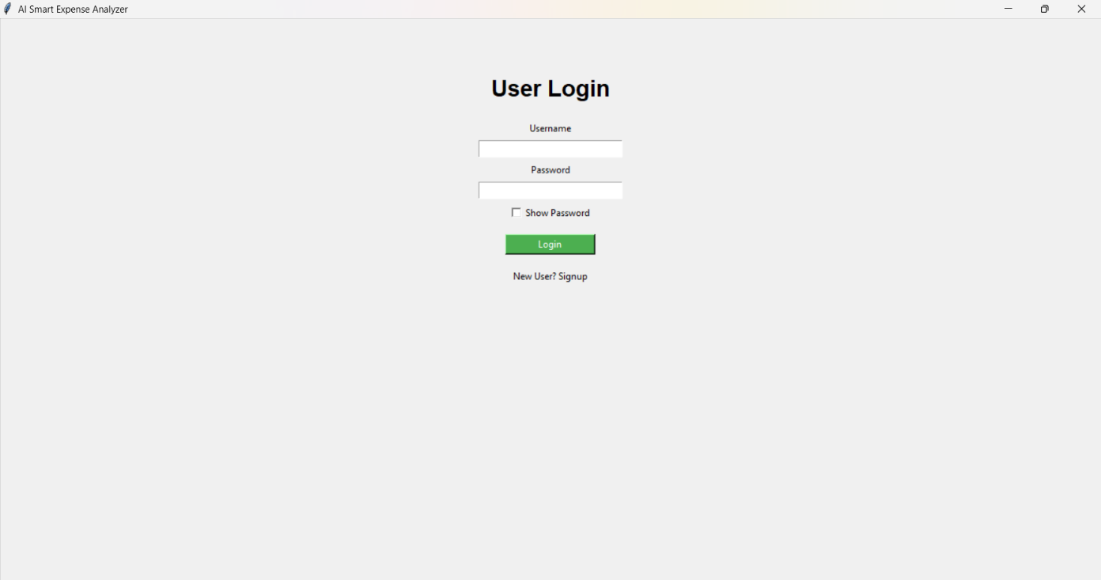
Step:1: Create a new account by clicking Signup
Screenshot 8.1: User Login

Step:2: Create account by clicking Register
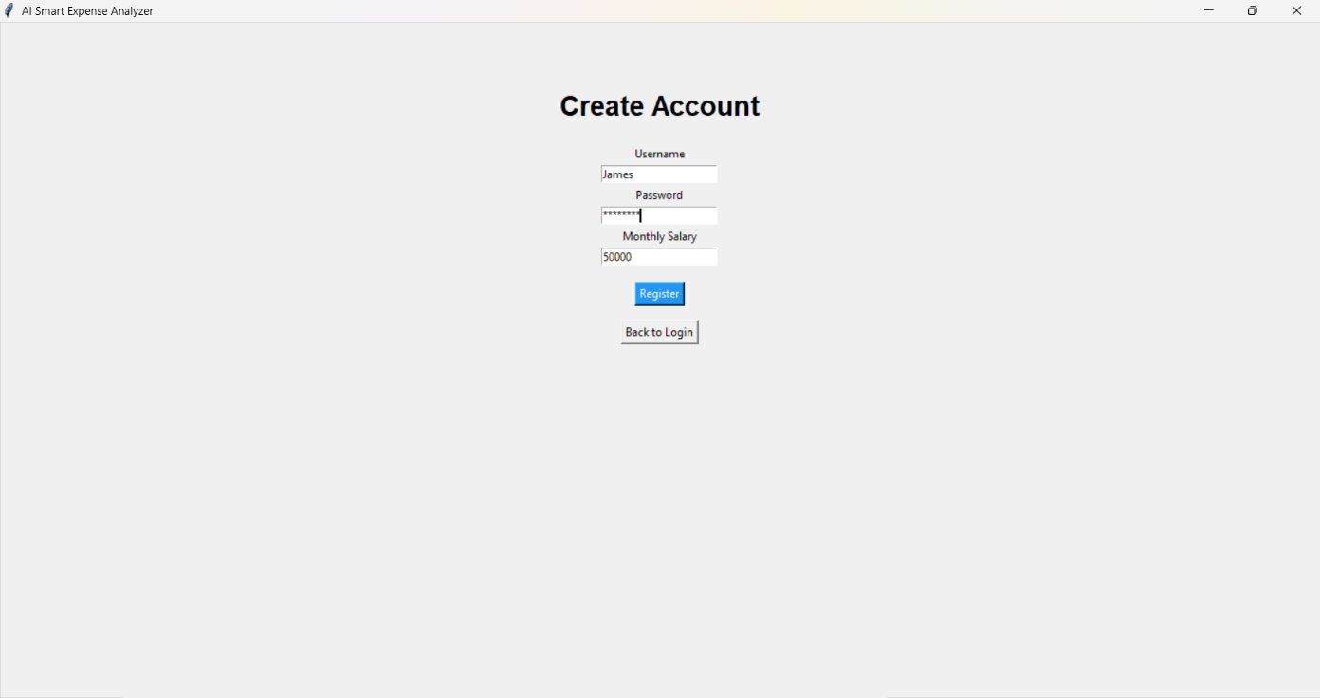
Screenshot 8.2: Create Account

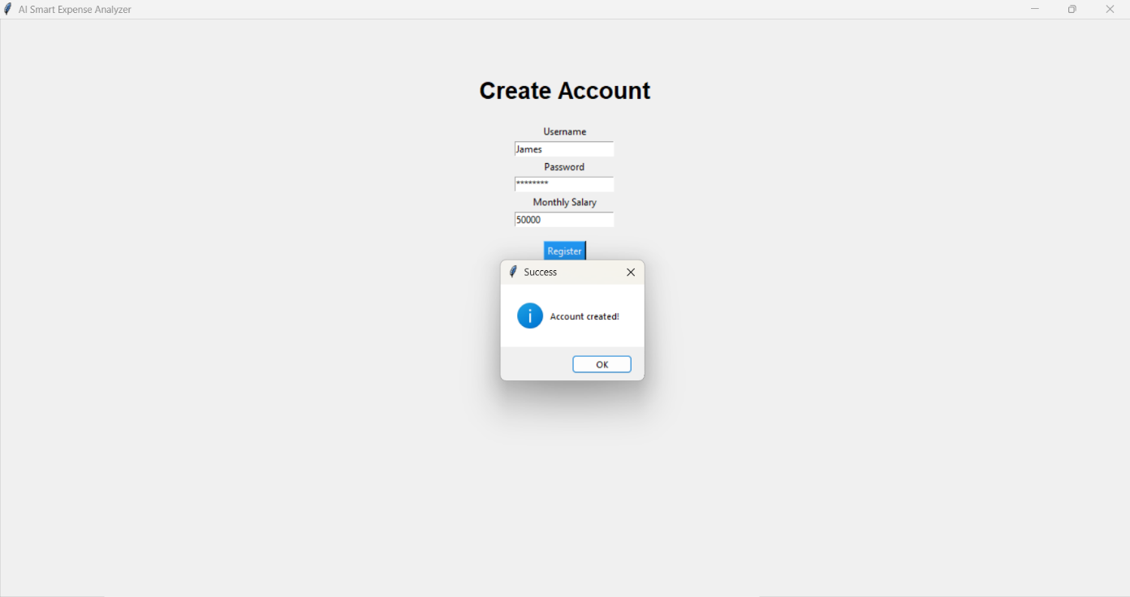
Step:3: Then successfully account is created
Screenshot 8.3: Account created
Step:4: Now login to the created account
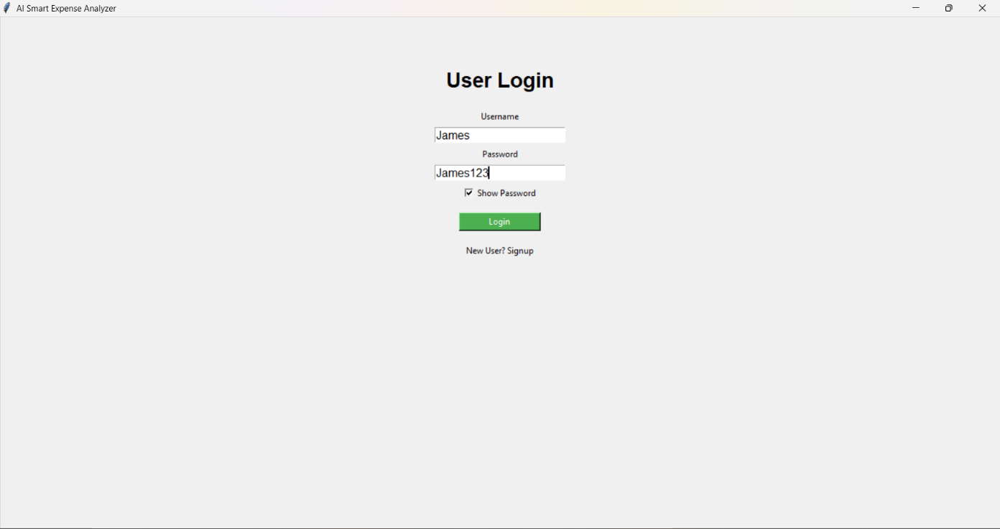

Screenshot 8.4: Account Login

Step:5: Dashboard is opened as shown below there we can see our salary and balance, there is also edit salary
We can edit our salary there.

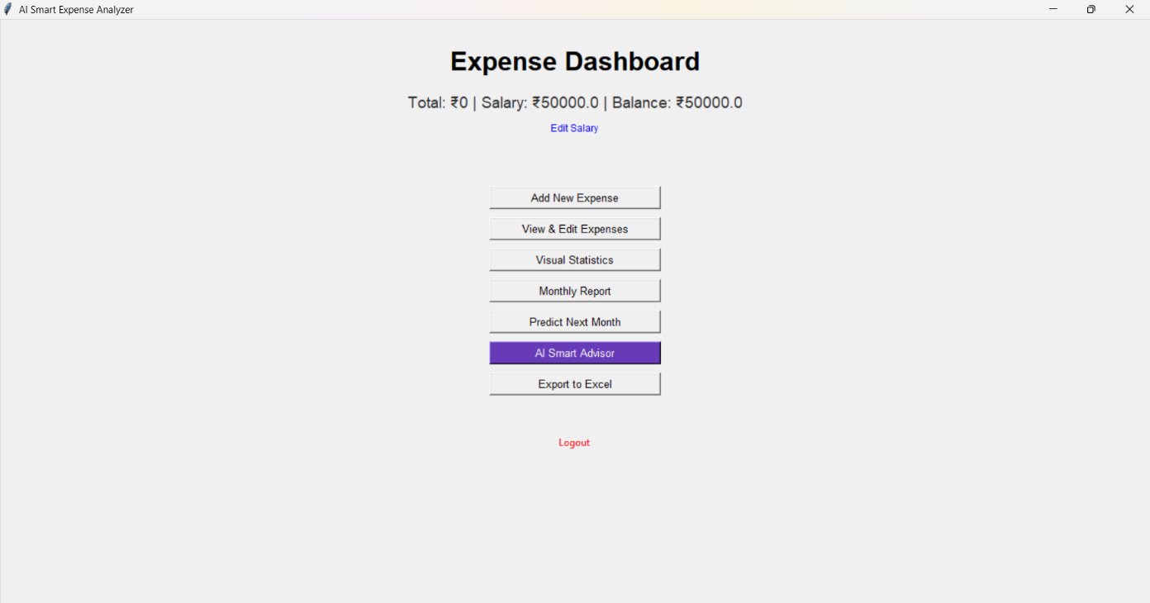
Screenshot 8.5: Dashboard

Step:6: Now click on the Add New Expenses

Screenshot 8.6: Adding Expenses
Step:7: Now in add expense, select a date, category the amount you spent and the reason the amount is spent for that
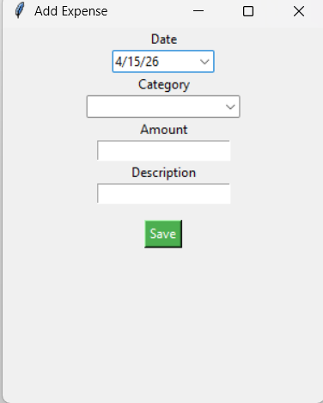
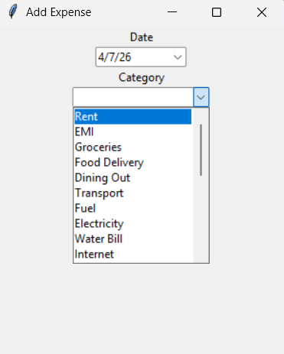

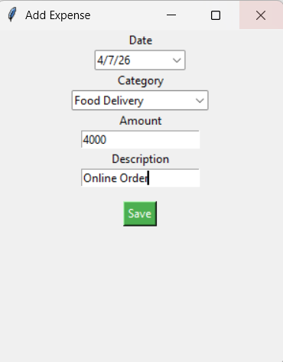

Screenshot 8.7: Add Expense

Step:8: When we add expense then there is immediate change in Dashboard as you can see below there is a immediate change in Total, Salary, Balance. Here we can observe there is a change in Dashboard i.e, Highest Spend

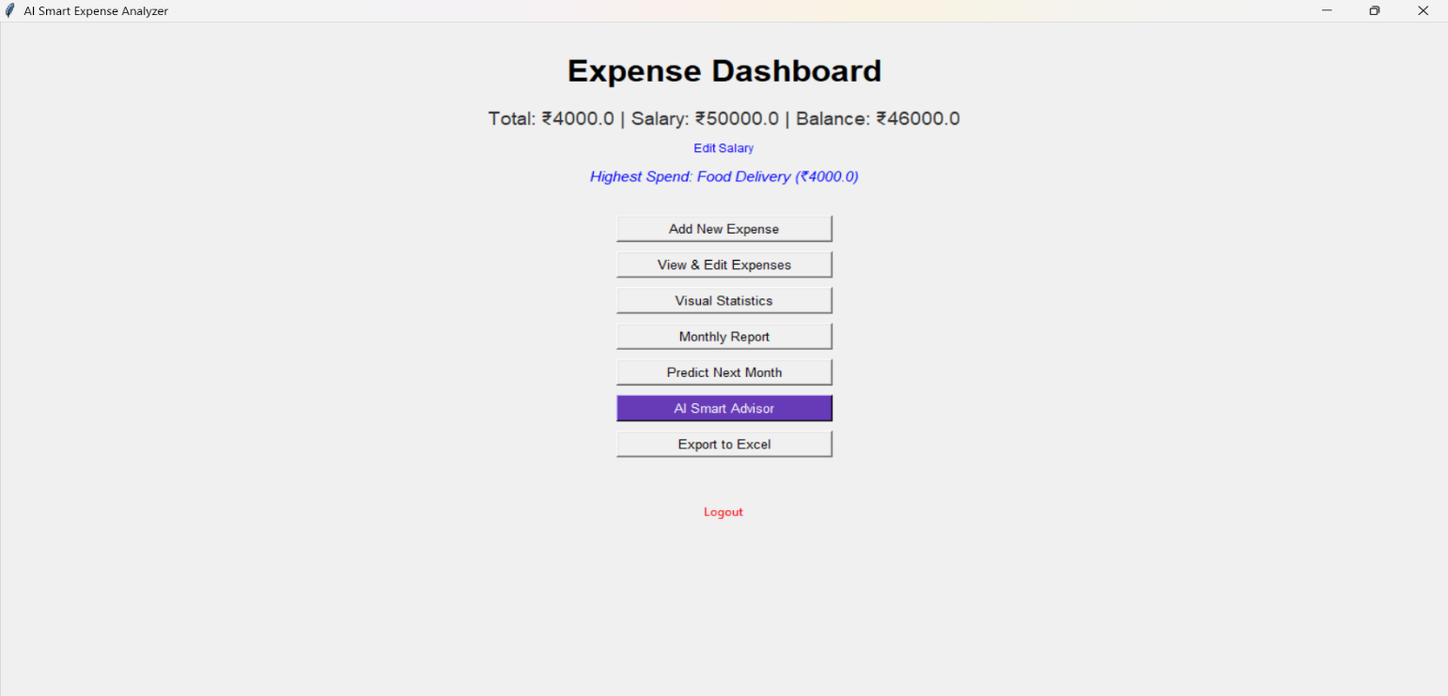

Screenshot 8.8: Change in Dashboard

Step:9: Now we have to add new expenses more then we can see a change in Dashboard again
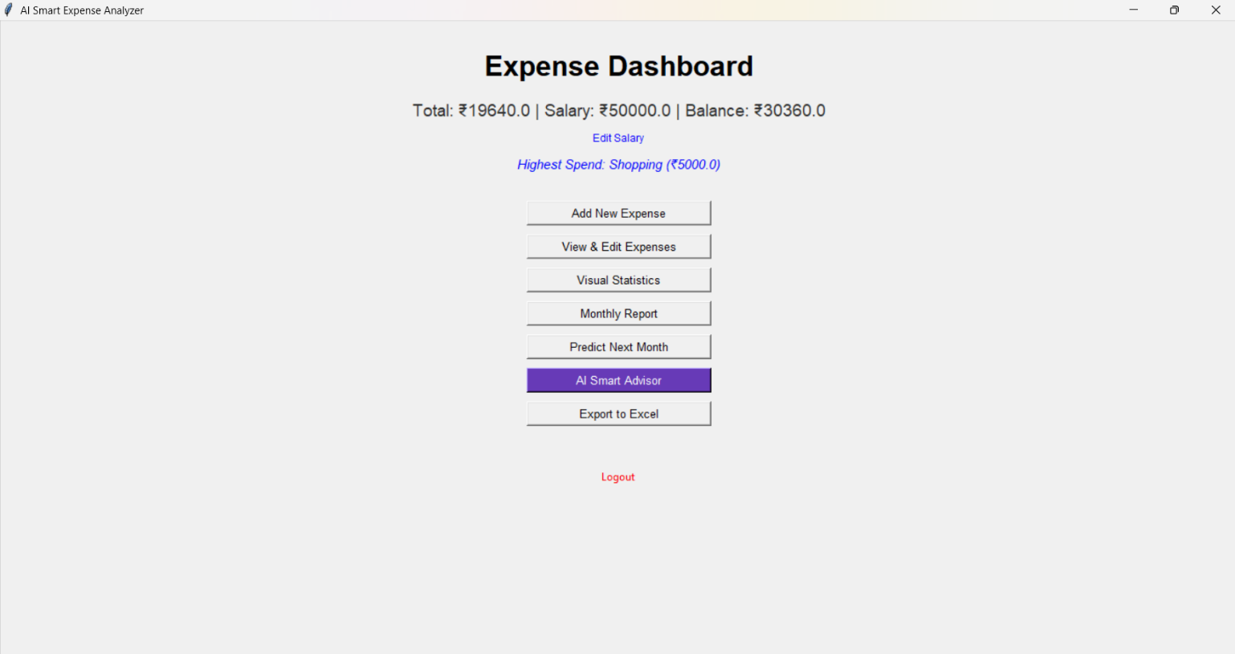
Screenshot 8.9: After adding more expenses again change in Dashboard

Step:10: Now Open View & Edit Expenses there we can see all added expenses

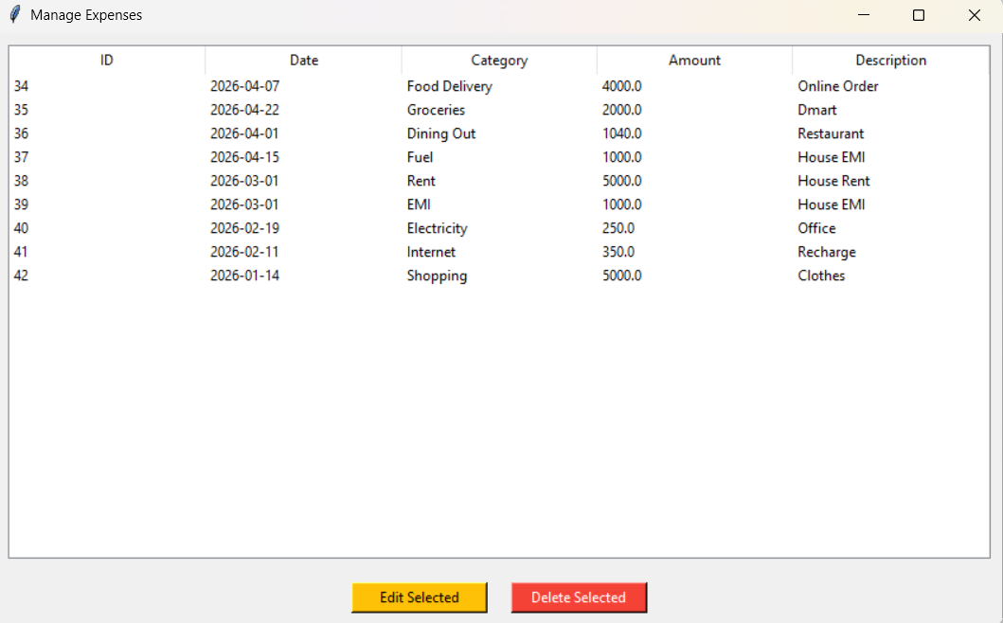

Screenshot 8.10: View & Edit Expenses

Step.11: Edit expense, lets select Electricity and change the amount from 250 to 360 then update it

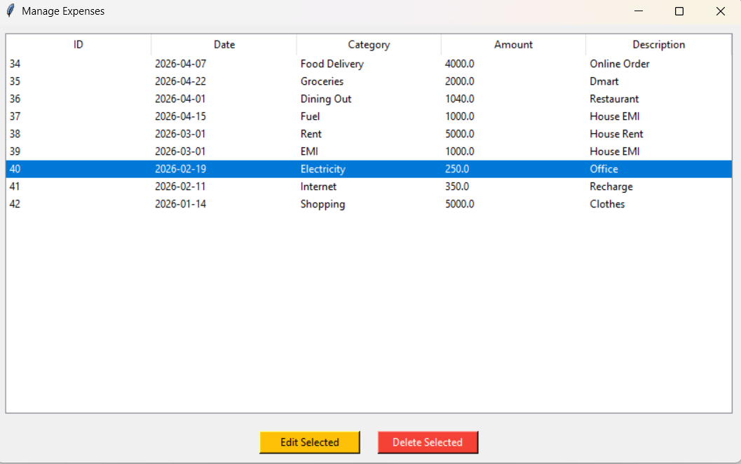
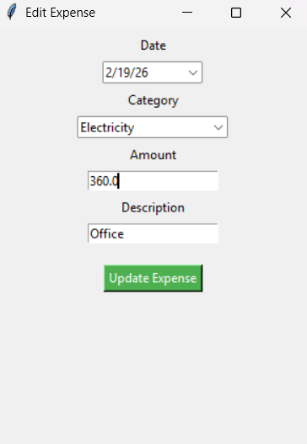
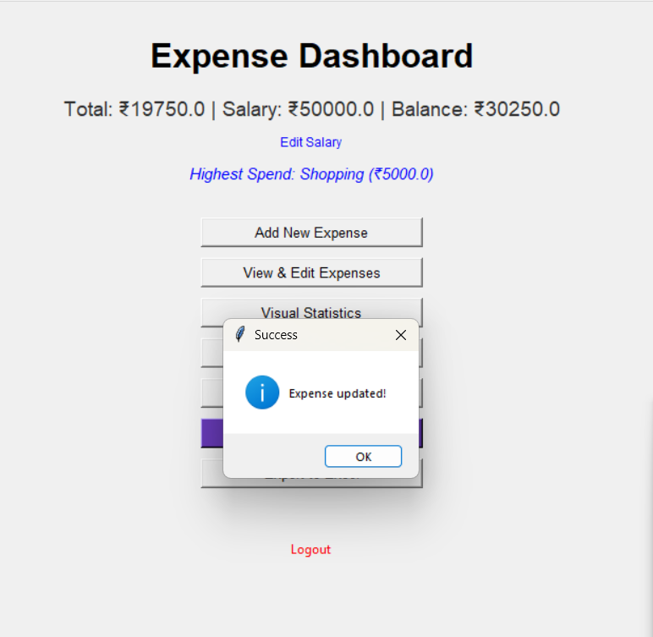

Screenshot 8.11: Edit & Update Expense
Step.12: View the updated expense changed from 250 to 360 and we can select any category to delete it also
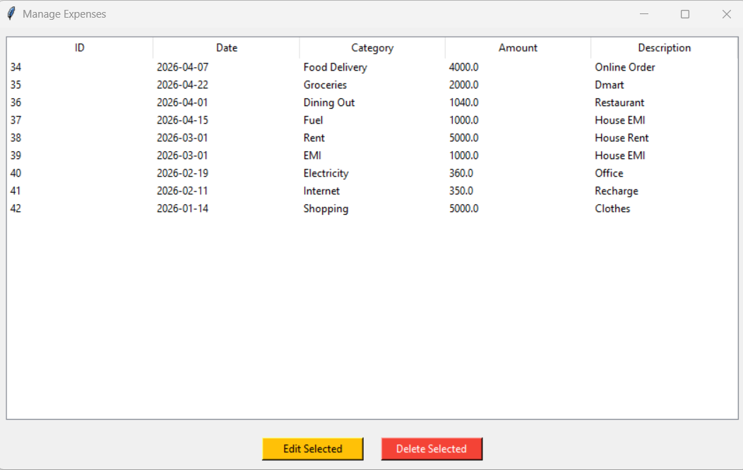
Screenshot 8.12: View the updated expense

Step.13: Open the Visual Statistics then we can see Pie&Bar Chart Breakdown

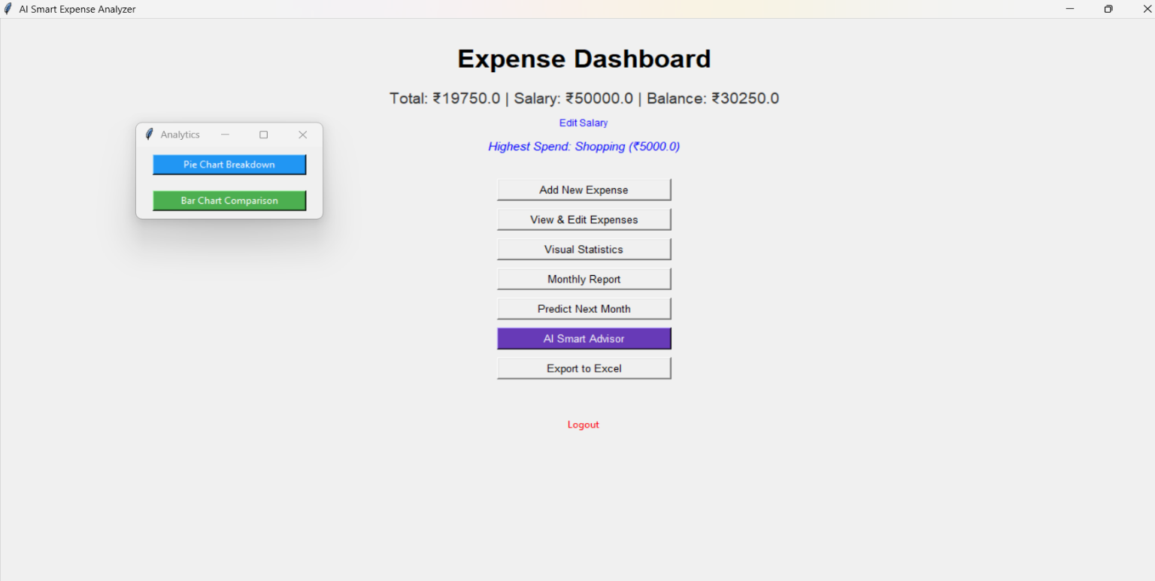
Screenshot 8.13: Open Visual Statistics
Step.14: Open Bar & Pie Chart

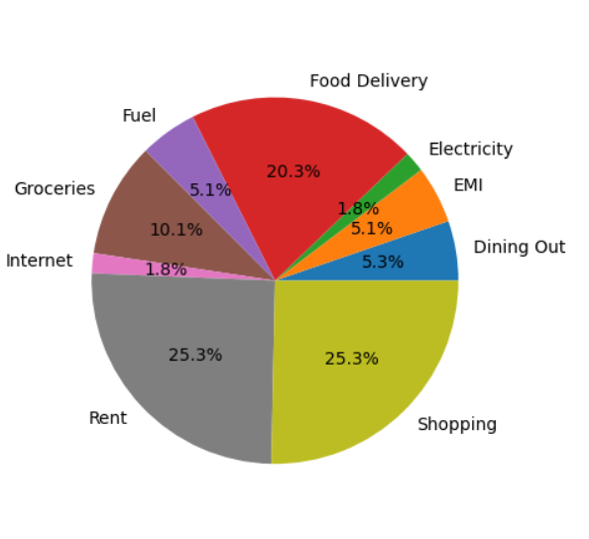
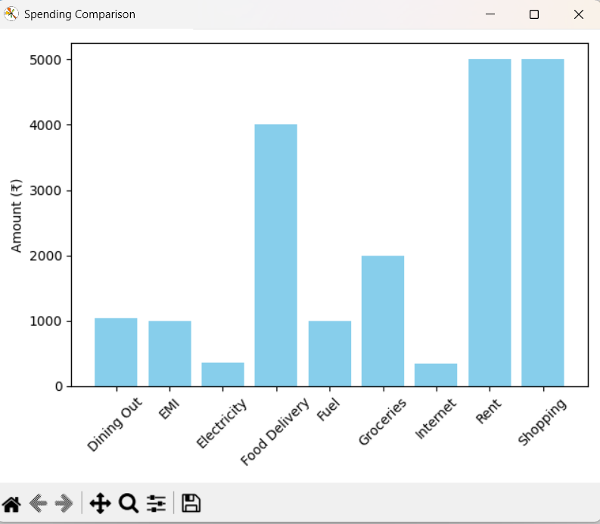

Screenshot 8.14: Bar & Pie Chart Breakdown

Step.15: Open Monthly Report then select a month to see that month expenditure

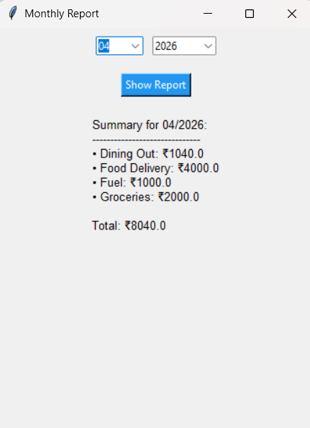
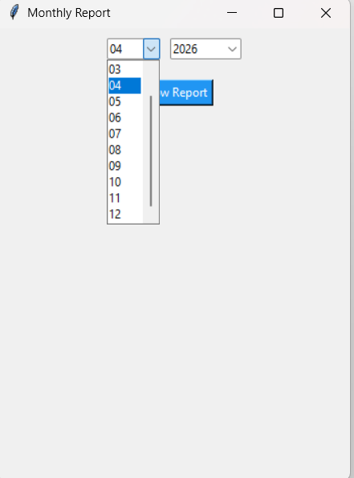
Screenshot 8.15: Monthly Report

Step.16: Click Predict Next Month
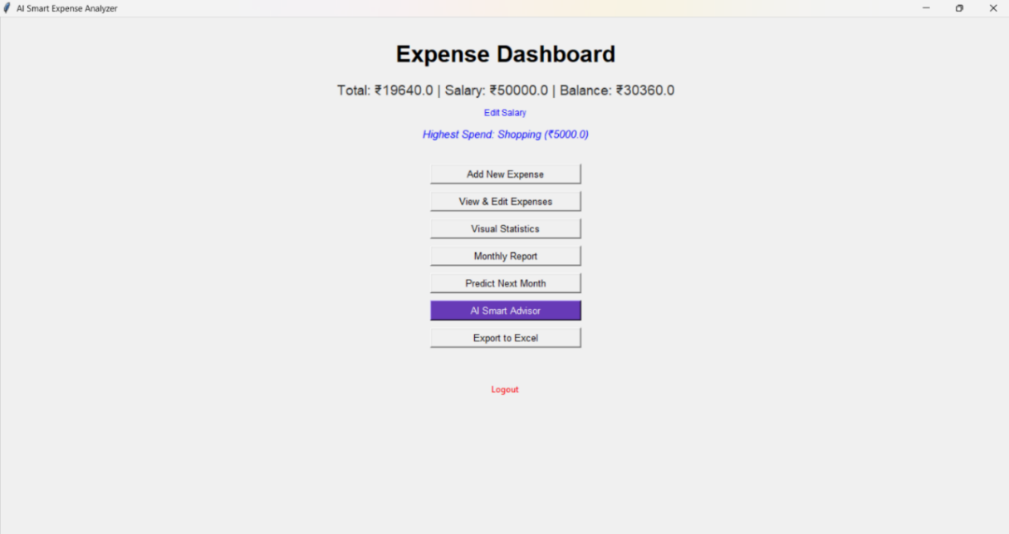

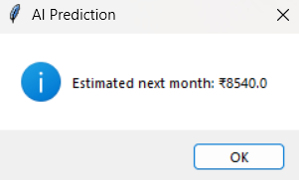

Screenshot 8.16: Next Month Prediction

Step.16: Click AI Smart Advisor

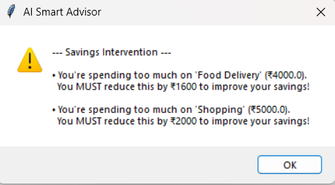

Screenshot 8.17: Smart Advice

Step.17: Click Export Excel then it redirects to our documents there we can save excel and that excel is directly saved in our device and we can access it anytime

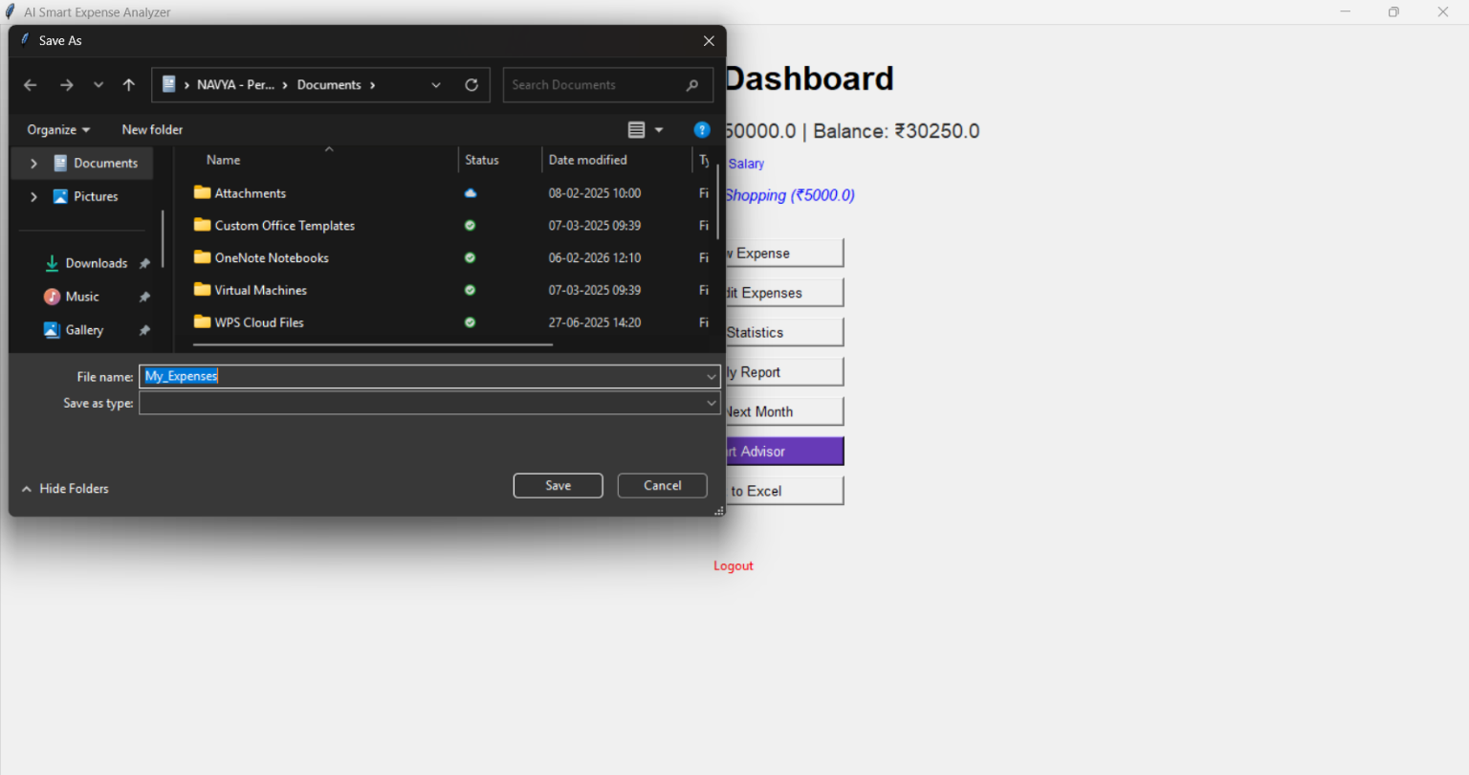
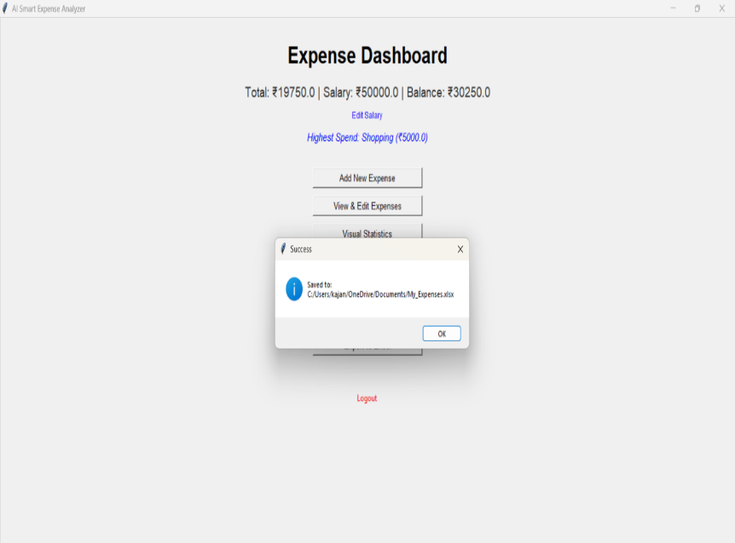

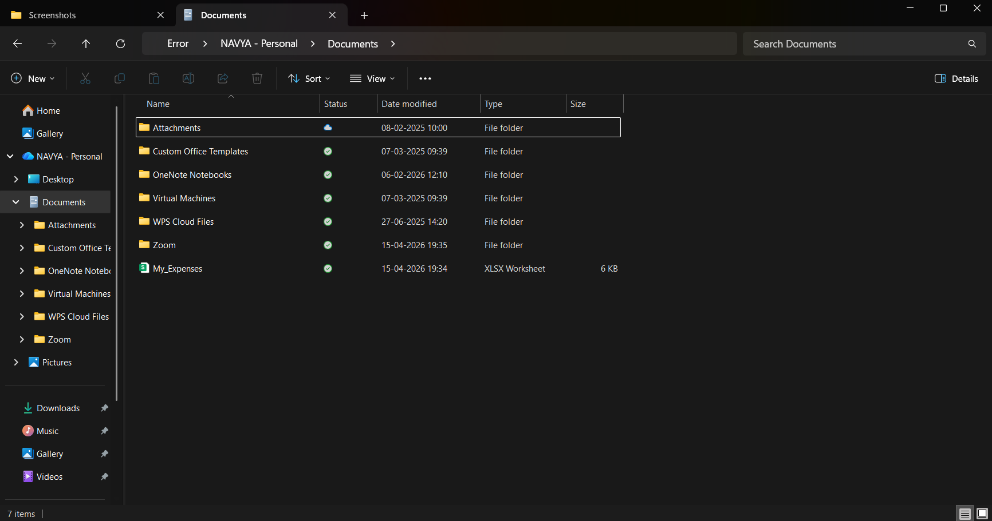

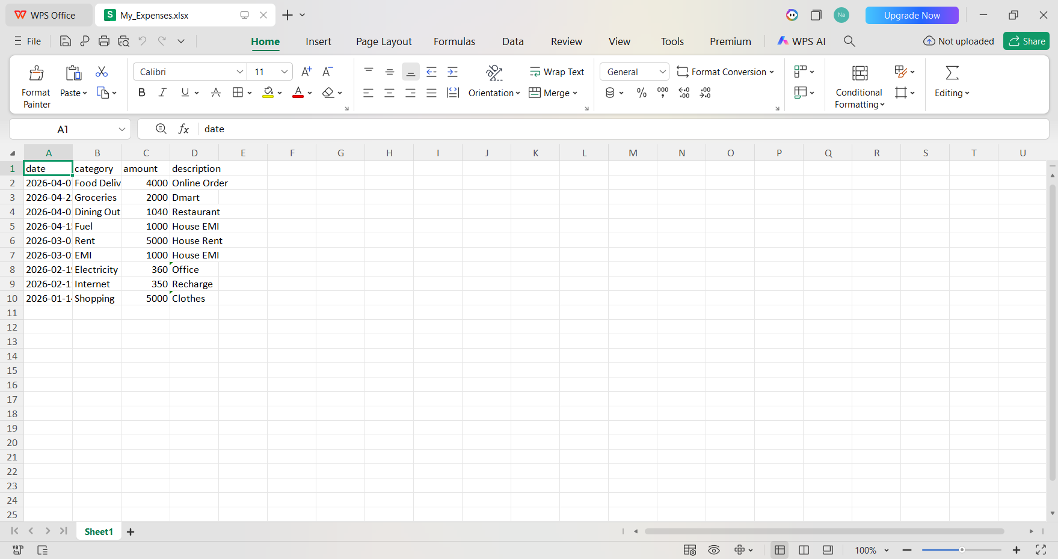

Screenshot 8.18: Export Excel

Step:18: Final Output

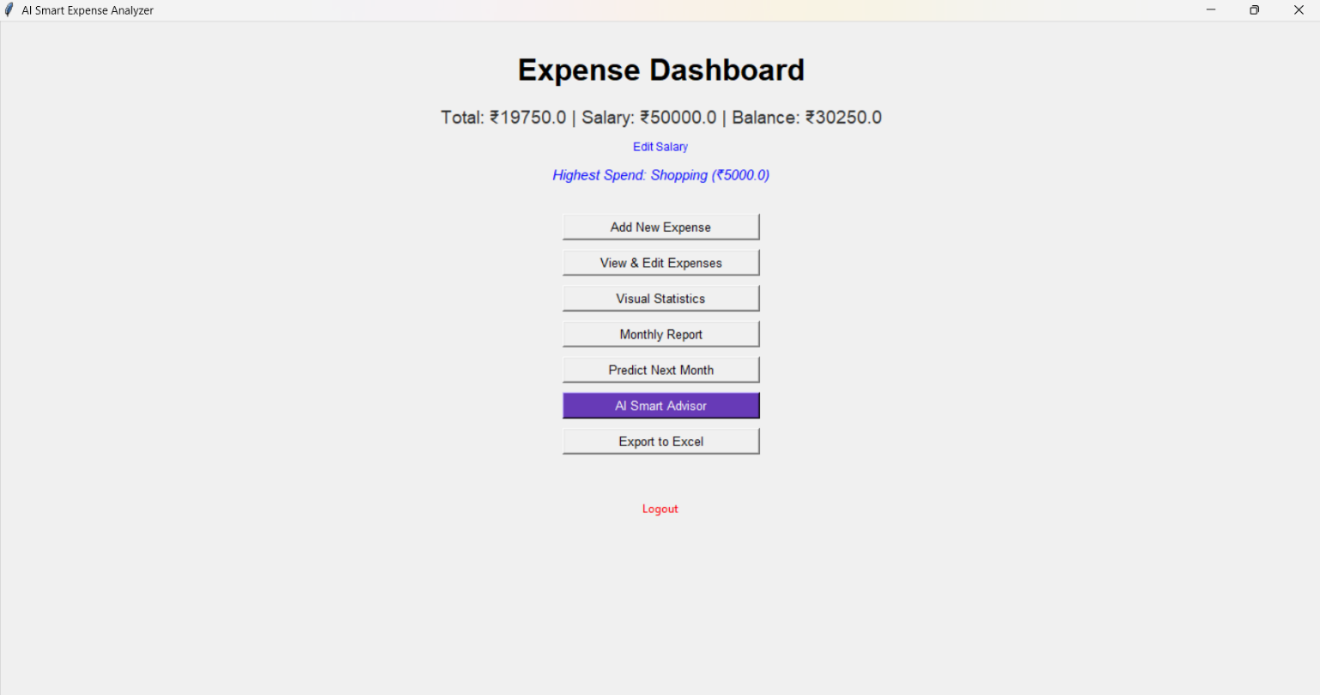

Screenshot 8.19: Final Outcome

Chapter-9

CONCLUSION
The development of the Smart Expense Analyzer marks a significant step toward simplifying personal financial management through the application of modern software engineering and data science principles. By utilizing the Python ecosystem, this project successfully bridges the gap between raw, unorganized financial transactions and meaningful, actionable insights. The integration of a user-friendly graphical interface with a persistent local database ensures that users can manage their finances with ease while maintaining complete ownership and privacy of their sensitive data. This localized approach addresses a critical gap in the market, providing a secure alternative to cloud-based applications that often compromise user anonymity.
The core strength of this system lies in its transition from a passive recording tool to a proactive financial assistant. Through the use of Matplotlib, the application transforms dry numerical logs into vibrant, real-time visualizations that highlight spending patterns at a glance. Furthermore, the inclusion of Scikit-learn’s Linear Regression model introduces a predictive element that is rarely found in beginner-level tools. By forecasting future expenditures and triggering budget threshold alerts, the system actively encourages financial discipline, helping users recognize and curb impulsive spending habits before they impact long-term savings goals.
Looking ahead, the Smart Expense Analyzer provides a versatile foundation for further innovation. While the current version excels as a standalone desktop application, future iterations could incorporate advanced features such as Optical Character Recognition (OCR) for automatic receipt scanning, bank API integration for real-time transaction syncing, and mobile compatibility. Ultimately, this project demonstrates how accessible technology can be harnessed to improve financial literacy, empowering individuals to take informed control of their financial destiny and achieve long-term economic stability.

Chapter-10

BIBLIOGRAPHY
- Lutz, M. (2013). Learning Python: Powerful Object-Oriented Programming. O'Reilly Media. (Used for core Python logic and OOP structures).
- Grinberg, M. (2014). Writing Desktop Applications with Tkinter. Packet Publishing. (Used for GUI design and frame switching logic).
- McKinney, W. (2022). Python for Data Analysis: Data Wrangling with Pandas, NumPy, and Jupiter. O'Reilly Media. (Used for CSV/Excel export and data cleaning processes)
- Muller, A. C., & Guido, S. (2016). Introduction to Machine Learning with Python: A Guide for Data Scientists. O'Reilly Media. (Consulted for the Linear Regression implementation).
- Thaler, R. H. (1999). Mental accounting matters. Journal of Behavioral Decision Making. (Theoretical framework for expense categorization).
- Pedregosa, F., et al. (2011). Scikit-learn: Machine Learning in Python. Journal of Machine Learning Research.
- Harris, C. R., et al. (2020). Array Programming with NumPy. Nature. (Used for numerical computations and efficient array operations in data processing).
- Hunter, J. D. (2007). Matplotlib: A 2D Graphics Environment. Computing in Science & Engineering. (Used for generating graphs and expense visualizations)
- SQLite Documentation. Structured Query Language (SQL) in SQLite. (Used for implementing local database storage and managing user transaction data).
- Official Python Documentation. The Python Standard Library. (Used for built-in functions, file handling, and system operations).
- Waskom, M. L. (2021). Seaborn: Statistical Data Visualization. (Used for advanced and visually appealing financial data charts)

- Geron, A. (2019). Hands-On Machine Learning with Scikit-Learn, Keras, and TensorFlow. O’Reilly Media. (Used for predictive analytics and model improvement concepts)
- VanderPlas, J. (2016). Python Data Science Handbook. O’Reilly Media. (Used for integrating NumPy, Pandas, and visualization workflows).
- Fowler, M. (2018). Refactoring: Improving the Design of Existing Code. (Used for optimizing and improving code structure).
- IEEE Standard 830-1998. Recommended Practice for Software Requirements Specifications. (Used for structuring project documentation).
- Al-Natour, S., et al. (2018). Automated Expense Tracking System Using Machine Learning. (Used as domain reference for similar systems).
- ISO/IEC 27001. Information Security Management. (Used for ensuring data security and privacy in the application).
- Silberschatz, A., Korth, H. F., & Sudarshan, S. Database System Concepts. (Used for understanding database design and data management).
- Russell, S., & Norvig, P. (2010). Artificial Intelligence: A Modern Approach. (Used for understanding intelligent decision-making and prediction concepts).
- Ramalho, L. (2015). Fluent Python. O’Reilly Media. (Used for writing efficient and Pythonic code practices).
- Downey, A. B. (2015). Think Python: How to Think Like a Computer Scientist. (Used for strengthening programming logic and problem-solving skills).
- Hunt, A., & Thomas, D. (1999). The Pragmatic Programmer. (Used for best practices in software development and debugging).
- Beazley, D., & Jones, B. K. (2013). Python Cookbook. O’Reilly Media. (Used for advanced Python techniques and real-world coding solutions).
- Provost, F., & Fawcett, T. (2013). Data Science for Business. (Used for understanding data-driven decision-making in expense analysis).
- Goodfellow, I., Bengio, Y., & Courville, A. (2016). Deep Learning. MIT Press. (Referenced for advanced predictive modeling concepts).

