1. Your Existing Folder Structure
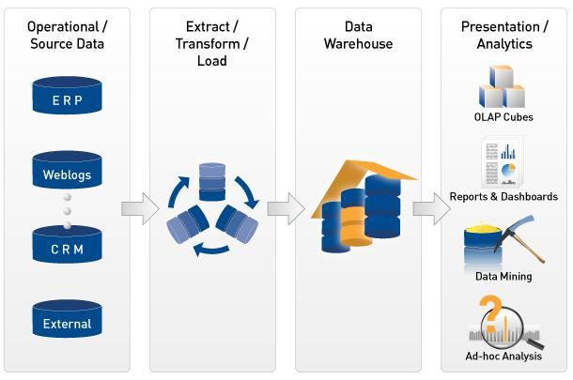
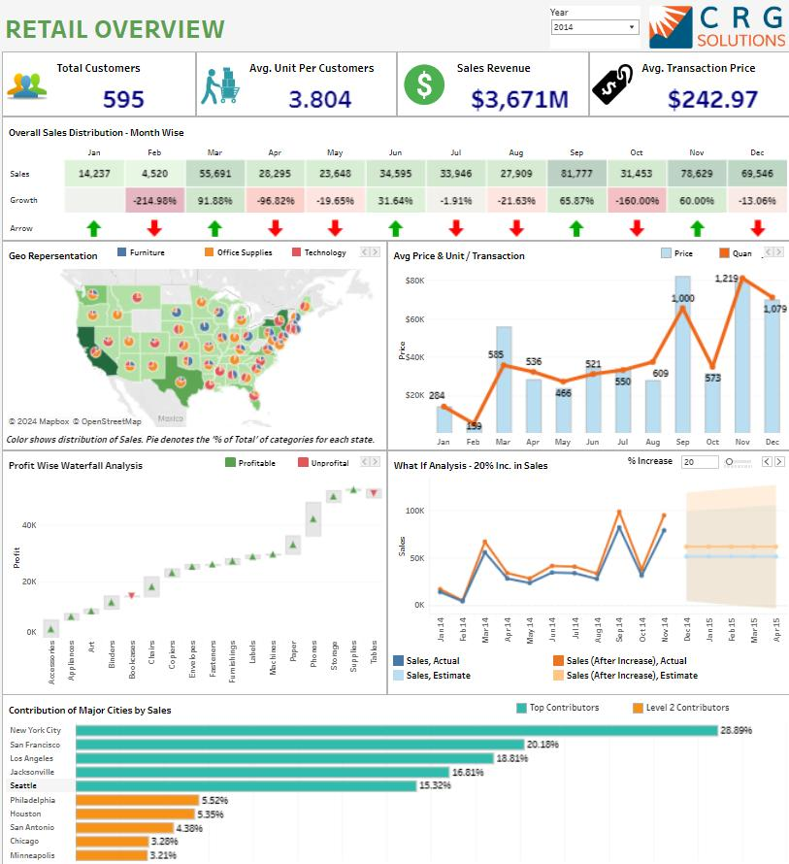
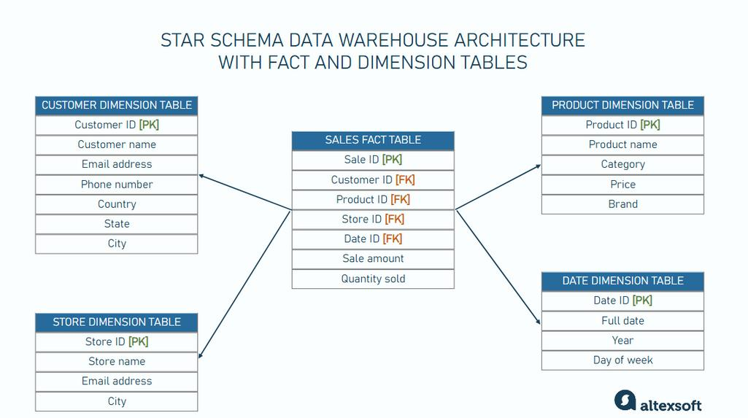
7
Your current structure:
00-Foundation-Skill-Assessment
01_SQL
02_Data_Cleaning
03_Python
04_Data_Modeling
05_Data_Warehousing
06_ETL_ELT
07_dbt
08_Airflow
09_BigQuery
10_Tableau
11_Tableau_Server
12_AI_Analytics
13_Capstone_Project
README.md
Do not recreate it.
We will use this exact structure.

2. The Project We Will Build
RetailMart Enterprise Analytics Platform
We will use a realistic company:
RetailMart Pvt. Ltd.
- 120 stores
- 15 states
- 3 warehouses
- 600 products
- 40,000 customers
- Multiple daily transactions
- Store + online sales
- Multiple product categories
- Multiple payment methods
- Returns
- Discounts
- Inventory
- Customer analysis
Business problem
Currently:
Stores
↓
Excel / CSV files
↓
Manual consolidation
↓
Excel reports
↓
Management
Problems:
- Manual reporting
- Duplicate records
- Incorrect calculations
- No centralized KPI definitions
- Slow monthly reporting
- Difficult store comparison
- No automated refresh
- Poor visibility into sales trends
- Difficult root-cause analysis
We will convert it into:
Source Systems
↓
Raw Data
↓
Data Cleaning
↓
ETL / ELT
↓
Staging
↓
Data Warehouse
↓
Star Schema
↓
Data Mart
↓
Tableau
↓
Tableau Server
↓
Business Users
And eventually:
Requirement
↓
Development
↓
Unit Testing
↓
QA
↓
UAT
↓
Deployment
↓
Monitoring
↓
Performance Optimization
↓
Production Support
That is the experience your interview answers need to demonstrate.
3. The 60-Day Roadmap
I recommend 60 structured working days.
Assuming approximately 4–6 focused hours/day, you should not think:
"Today I have to study SQL."
Instead:
"Today I have to solve this business problem using SQL."
That distinction is extremely important for your target role.

PHASE 1 — FOUNDATION + BUSINESS UNDERSTANDING
Days 1–3
Folder: 00-Foundation-Skill-Assessment
DAY 1 — Project Kickoff
Learn:
- What is BI?
- What is Business Analytics?
- BI vs Data Analytics vs Business Analyst
- SDLC
- Analytics SDLC
- Agile
- Scrum
- Kanban
- Dev → QA → UAT → Production
Project task
Create:
01_Project_Charter
02_Business_Problem
03_Project_Objectives
04_Project_Scope
05_Out_of_Scope
06_Stakeholders
07_Assumptions
08_Risks
Interview question
"Explain your RetailMart project."
You should be able to answer in 2 minutes.

DAY 2 — Requirement Gathering
Learn:
- Stakeholder identification
- Business requirements
- Functional requirements
- Non-functional requirements
- BRD
- FRD
- User stories
- Acceptance criteria
- Requirement traceability matrix
Create:
Requirement_ID
Business_Requirement
Functional_Requirement
Priority
Acceptance_Criteria
Stakeholder
Status
Example:
REQ-001

Business Requirement:
Management needs daily sales visibility.

Functional Requirement:
Dashboard should display daily sales by
store, state and product category.

Acceptance Criteria:
Dashboard sales must reconcile with
source transaction data.

DAY 3 — KPI Catalog
This is extremely important for your target role.
Create:
KPI_ID
KPI_Name
Business_Definition
Formula
Numerator
Denominator
Data_Source
Grain
Owner
Refresh_Frequency
RetailMart KPIs:
- Gross Sales
- Net Sales
- Discount %
- Return %
- Units Sold
- Average Order Value
- Sales Growth %
- Profit
- Profit Margin %
- Customer Count
- Repeat Customer %
- Inventory Turnover
- Stock-out Rate
Also document:
One KPI = One agreed definition.
This directly prepares you for the JD's requirement around standardizing measures and defining best practices.

PHASE 2 — SQL
Days 4–15
Folder: 01_SQL
This will be your deepest technical phase.

DAY 4 — SQL Fundamentals
Master:
SELECT
FROM
WHERE
ORDER BY
DISTINCT
TOP / LIMIT
Practice:
- Store sales
- Product sales
- Customer filtering
Deliver:
20 SQL queries

DAY 5 — Filtering
Master:
AND
OR
IN
BETWEEN
LIKE
IS NULL
IS NOT NULL
Scenario:
Find customers who purchased between ₹5,000 and ₹10,000.

DAY 6 — Aggregations
Master:
COUNT
SUM
AVG
MIN
MAX
GROUP BY
HAVING
Business questions:
- Sales by store
- Sales by state
- Sales by category
- Average order value
- Highest-selling products

DAY 7 — CASE + NULL Handling
Master:
CASE
COALESCE
ISNULL
NULLIF
Build:
Sales_Category
High Value
Medium Value
Low Value

DAY 8 — String Functions
Master:
UPPER
LOWER
TRIM
LTRIM
RTRIM
SUBSTRING
LEFT
RIGHT
LEN
REPLACE
CONCAT
Use them to clean customer/product/store data.

DAY 9 — Date Functions
Master:
YEAR
MONTH
DAY
DATEPART
DATETRUNC
DATEDIFF
DATEADD
EOMONTH
Build:
Year
Quarter
Month
Week
Day
Financial Year

DAY 10 — JOINS
This is an interview-critical day.
Master:
INNER JOIN
LEFT JOIN
RIGHT JOIN
FULL JOIN
CROSS JOIN
SELF JOIN
Practice:
FactSales
↓
DimCustomer
DimProduct
DimStore
DimDate
You should be able to explain:
Why did you use LEFT JOIN instead of INNER JOIN?

DAY 11 — Advanced Joins + Data Quality
Scenarios:
- Duplicate customers
- Missing products
- Missing stores
- Orphan transactions
Write SQL to identify:
Duplicate records
Missing dimension records
Referential integrity issues

DAY 12 — Subqueries + CTE
Master:
Subquery
CTE
Recursive CTE
Business questions:
Find stores whose sales are above the average store sales.

DAY 13 — Window Functions
This is one of your most important SQL interview days.
Master:
ROW_NUMBER()
RANK()
DENSE_RANK()
LAG()
LEAD()
SUM() OVER()
AVG() OVER()
PARTITION BY
Scenarios:
- Top 3 products per category
- Store ranking
- Monthly sales growth
- Running sales total
- Previous month sales

DAY 14 — Views + Stored Procedures
Learn:
CREATE VIEW
CREATE PROCEDURE
CREATE FUNCTION
Create:
vw_MonthlySales
vw_StorePerformance
vw_ProductPerformance
sp_LoadSales
sp_RefreshKPIs

DAY 15 — SQL Performance
Learn:
- Indexes
- Clustered index
- Non-clustered index
- Execution plan
- Scan vs seek
- SARGability
- Temp tables
- CTE performance
- Avoiding SELECT *
- Join optimization
Take one slow query and optimize it.
Document:
Before:
Execution time = X

Problem:
Full table scan

Solution:
Index + query rewrite

After:
Execution time = Y
This becomes an excellent interview story.

PHASE 3 — DATA CLEANING
Days 16–18
Folder: 02_Data_Cleaning

DAY 16
Learn:
- Missing values
- Duplicates
- Invalid dates
- Invalid categories
- Outliers
- Data type problems
Create a Data Quality Checklist.

DAY 17
Clean RetailMart source files.
Example:
23-05-2024
2024/05/23
05/23/2024
Standardize them.
Clean:
- Customer names
- Product names
- State names
- Dates
- Phone numbers
- Email
- Amounts

DAY 18
Create automated data-quality checks:
Duplicate Check
NULL Check
Date Check
Amount Check
Referential Integrity
Row Count Check
Generate:
Data_Quality_Report.xlsx

PHASE 4 — PYTHON
Days 19–25
Folder: 03_Python
The goal is not to become a software developer.
Your Python target is:
Python for analytics automation.

DAY 19 — Python Fundamentals
Master:
Variables
Lists
Tuples
Sets
Dictionaries
If
For
While
Functions
Build small scripts.

DAY 20 — Pandas
Master:
read_csv()
read_excel()
head()
info()
describe()
shape
columns
dtypes

DAY 21 — Data Cleaning with Pandas
Master:
dropna()
fillna()
drop_duplicates()
astype()
rename()
replace()
Clean RetailMart data.

DAY 22 — Pandas Transformation
Master:
merge
concat
groupby
pivot_table
sort_values
apply
lambda
Reproduce some of your SQL analysis in Python.

DAY 23 — NumPy + Statistics
Learn:
- Mean
- Median
- Standard deviation
- Percentiles
- Outliers
Use NumPy/Pandas.

DAY 24 — Python Automation
Build:
Input CSV
↓
Python
↓
Clean
↓
Validate
↓
Transform
↓
Output cleaned CSV

DAY 25 — Python Analytics Project
Build:
RetailMart Automated Data Quality & Sales Analysis Tool
Input:
sales.csv
customers.csv
products.csv
stores.csv
Output:
clean_sales.csv
data_quality_report.xlsx
sales_summary.xlsx

PHASE 5 — EXCEL
Days 26–30
Excel is explicitly mentioned in the market expectation, so do not treat it as secondary.

DAY 26 — Excel Formulas
Master:
XLOOKUP
VLOOKUP
INDEX + MATCH
IF
IFS
IFERROR
SUMIFS
COUNTIFS
AVERAGEIFS

DAY 27 — Text + Date Functions
Master:
LEFT
RIGHT
MID
LEN
TRIM
CLEAN
TEXT
YEAR
MONTH
DAY
DATE
EOMONTH

DAY 28 — Pivot Tables
Create:
Sales by State
Sales by Store
Sales by Category
Monthly Sales
Top Products

DAY 29 — Power Query
This is critical.
Learn:
Import
Transform
Merge
Append
Pivot
Unpivot
Group By
Parameters
Refresh
Take a messy RetailMart file and turn it into a clean dataset.

DAY 30 — Power Pivot + Data Model
Learn:
Relationships
Fact tables
Dimension tables
Calculated columns
Measures
DAX basics
Build an Excel analytical model.

PHASE 6 — DATA MODELING
Days 31–34
Folder: 04_Data_Modeling

DAY 31 — OLTP vs OLAP
Understand:
OLTP
↓
Staging
↓
DWH
↓
Data Mart
↓
BI
Know:
- Normalization
- Denormalization
- OLTP
- OLAP

DAY 32 — Fact + Dimension
Design:
FactSales

DimDate
DimCustomer
DimProduct
DimStore
DimPromotion
DimPayment
Understand:
- Grain
- Primary key
- Foreign key
- Surrogate key
- Natural key

DAY 33 — Star Schema
Create the RetailMart star schema.
DimCustomer
|
|
DimProduct — FactSales — DimStore
|
|
DimDate
Document the grain of FactSales.
Example:
One row represents one product line within one customer transaction.

DAY 34 — Advanced Modeling
Learn:
- Slowly Changing Dimensions
- SCD Type 1
- SCD Type 2
- Degenerate dimensions
- Junk dimensions
- Role-playing dimensions
- Factless fact tables
Implement SCD Type 2 for Customer/Store.

PHASE 7 — DATA WAREHOUSING
Days 35–38
Folder: 05_Data_Warehousing

DAY 35
Build:
Raw
Staging
DWH
Data Mart
Document the architecture.

DAY 36
Create:
DimDate
DimCustomer
DimProduct
DimStore

DAY 37
Create:
FactSales
FactReturns
FactInventory

DAY 38
Implement:
- Incremental loading
- Audit columns
- Load timestamps
- Batch IDs
- Row counts
- Error logging
Now your project starts looking like an actual enterprise solution.

PHASE 8 — ETL / ELT
Days 39–42
Folder: 06_ETL_ELT

DAY 39 — ETL Fundamentals
Understand:
Extract
Transform
Load
versus:
Extract
Load
Transform

DAY 40 — Build ETL
Create:
CSV
↓
Raw
↓
Staging
↓
Transformation
↓
DWH

DAY 41 — Incremental ETL
Learn:
- Full load
- Incremental load
- CDC concept
- Watermark
- Last modified date
Implement:
Initial Load
+
Daily Incremental Load

DAY 42 — ETL QA
Create:
Source Count
Target Count
Rejected Count
Duplicate Count
NULL Count
Error Count
Create an ETL reconciliation report.

PHASE 9 — DBT
Days 43–45
Folder: 07_dbt

DAY 43
Learn:
- dbt concept
- Models
- Sources
- Seeds
- Tests
- Documentation

DAY 44
Create:
stg_sales
stg_customer
stg_product
stg_store

dim_customer
dim_product
dim_store

fact_sales

DAY 45
Implement:
not_null
unique
relationships
accepted_values
Generate dbt documentation.

PHASE 10 — AIRFLOW
Days 46–48
Folder: 08_Airflow

DAY 46
Learn:
- DAG
- DAG run
- Task
- Operator
- Scheduler
- Dependency

DAY 47
Build:
Extract
↓
Clean
↓
Load
↓
Transform
↓
QA
↓
Refresh
as an Airflow DAG.

DAY 48
Add:
- Failure handling
- Retry
- Logging
- Dependencies
- Alerts
- Scheduling
Example:
Every day at 6 AM

PHASE 11 — BIGQUERY
Days 49–51
Folder: 09_BigQuery
Because your target environment may involve cloud analytics, use BigQuery as your cloud layer.

DAY 49
Learn:
- Datasets
- Tables
- Views
- Partitioning
- Clustering
- Cost model

DAY 50
Load RetailMart data into BigQuery.
Create:
raw
staging
dwh
mart

DAY 51 — BigQuery Performance
Learn:
- Partition pruning
- Clustering
- Query optimization
- SELECT *
- Bytes processed
Compare:
Unoptimized query
vs
Optimized query
Document the result.

PHASE 12 — TABLEAU DESKTOP
Days 52–57
Folder: 10_Tableau
This is another major interview phase.

DAY 52 — Tableau Fundamentals
Master:
- Dimensions
- Measures
- Discrete
- Continuous
- Aggregation
- Marks card
- Filters
- Sorting
- Groups
- Hierarchies
Build basic sales views.

DAY 53 — Tableau Calculations
Master:
Calculated Fields
IF
CASE
DATE
String calculations
Aggregate calculations
Create:
Net Sales
Profit
Profit Margin
Sales Growth

DAY 54 — LOD Expressions
This deserves an entire day.
Master:
FIXED
INCLUDE
EXCLUDE
Scenarios:
Customer lifetime sales
Store-level average sales
First purchase date
Customer-level KPI regardless of visualization level

DAY 55 — Table Calculations
Master:
Running Total
Percent of Total
Difference
Percent Difference
Rank
Moving Average

DAY 56 — Parameters + Sets
Build:
Metric Selector
Date Selector
Top N Products
Dynamic Store Selection
Use:
- Parameters
- Sets
- Set actions

DAY 57 — Dashboard UX + Data Storytelling
Build executive dashboard.
Dashboard 1 — Executive Overview
KPIs:
Net Sales
Gross Sales
Profit
Margin
Orders
Customers
Sales Growth
Charts:
- Sales trend
- State performance
- Category performance
- Top products
- Store performance

PHASE 13 — TABLEAU SERVER
Days 58–60
Folder: 11_Tableau_Server
This is where many candidates stop at Tableau Desktop.
You won't.

DAY 58 — Tableau Server
Learn:
- Projects
- Workbooks
- Data sources
- Users
- Groups
- Permissions
- Published data sources
- Extracts
- Live connections
Publish RetailMart dashboard.

DAY 59 — Refresh + Security
Implement:
Scheduled Refresh
Extract
Incremental Refresh
User Permissions
Project Permissions
Row Level Security
Understand:
How would Store Manager A see only their stores?

DAY 60 — Tableau Performance + Production
Learn:
- Performance Recorder
- Extract optimization
- Reduce unnecessary marks
- Efficient calculations
- Context filters
- Data source optimization
- Dashboard design
- Query optimization
Perform a complete performance review.
Document:
Problem
Root Cause
Solution
Before
After

BUT WE ARE NOT FINISHED YET
The 60 days above build the technical foundation.
Your interview transformation comes next.

PHASE 14 — AI + ANALYTICS
Folder: 12_AI_Analytics
Spend approximately Days 61–64.
DAY 61
Use Python for:
- Trend detection
- Outlier detection
- Anomaly identification

DAY 62
Build:
Automated sales anomaly detection.
Example:
Store 104
Sales ↓ 38%
Python identifies the anomaly.

DAY 63
Create management insights:
What happened?
Why did it happen?
Where did it happen?
What is the financial impact?
What should management do?

DAY 64
Create an AI-assisted analytics workflow:
Data
↓
KPI
↓
Anomaly
↓
Root Cause
↓
Business Explanation
↓
Recommended Action

PHASE 15 — CAPSTONE
13_Capstone_Project
Now you rebuild/document the entire project as though you were working in a real company.

DAY 65 — Requirement → Architecture
Create:
BRD
FRD
User Stories
Architecture
Data Flow
KPI Catalog
Data Dictionary

DAY 66 — Database
Deliver:
DDL
Tables
Constraints
Indexes
Views
Stored Procedures

DAY 67 — Data Warehouse
Deliver:
Star Schema
Fact Tables
Dimension Tables
SCD
Data Mart

DAY 68 — ETL
Deliver:
ETL Pipeline
Incremental Load
Error Handling
Logging
Reconciliation

DAY 69 — Tableau
Deliver:
Dashboard 1
Executive Sales Dashboard
Dashboard 2
Store Performance
Dashboard 3
Product Performance
Dashboard 4
Customer Analytics
Dashboard 5
Inventory Analytics

DAY 70 — Production Simulation
Simulate:
Developer
↓
Git
↓
Pull Request
↓
Code Review
↓
QA
↓
UAT
↓
Production
Create Jira tickets.

4. Then We Add the Most Important Interview Layer
Your target JD repeatedly emphasizes:
independently structure → build → QA → present
So your preparation needs a second track running alongside the project.
Every day, maintain:
Technical Learning
+
Project Work
+
Interview Questions
+
Communication

Your Daily 5-Hour Routine
Since your available study window is primarily during the day, use:
Hour 1 — Learn
Concepts.
Hours 2–3 — Build
RetailMart project.
Hour 4 — Practice
Interview/scenario questions.
Hour 5 — Explain
Close your laptop and verbally explain:
What did I build today?
Why did I build it?
What problem did it solve?
What alternatives were possible?
What could go wrong?
How would I QA it?
That last hour is what will move you toward Senior Analyst-level communication.

5. Your Interview Preparation Matrix
This JD can be broken into the following areas:
JD Expectation | Our Preparation
Requirement Gathering | Days 1–3
Business Analysis | Throughout project
KPI Development | Day 3 + Capstone
SQL | Days 4–15
Excel | Days 26–30
Python | Days 19–25
Data Cleaning | Days 16–18
Data Modeling | Days 31–34
Data Warehouse | Days 35–38
ETL/ELT | Days 39–42
dbt | Days 43–45
Airflow | Days 46–48
BigQuery | Days 49–51
Tableau Desktop | Days 52–57
Tableau Server | Days 58–60
Performance Optimization | SQL + Tableau + BigQuery
QA | Throughout
Agile/Jira | Capstone
Stakeholder Communication | Daily
Data Storytelling | Tableau phase
Financial Impact | Capstone + RCM case
Production Deployment | Days 60–70

6. Very Important: RCM Interview Preparation
Your RetailMart project will demonstrate your technical capability.
But the JD is specifically around Revenue Cycle / Revenue Optimization Analytics.
Therefore, after the RetailMart project, we should build a small RCM analytics case study rather than rebuilding a second huge project.
You already have useful RCM experience, so this is where we turn that experience into interview strength.
Build a mini case around:
Claims
↓
Payer
↓
Payments
↓
Adjustments
↓
Denials
↓
Collections
KPIs:
A/R Days
Accounts Receivable
--------------------
Average Daily Revenue
Denial Rate
Denied Claims
-------------
Total Claims
Net Collection Ratio
Actual Collections
------------------
Expected Collections
Collection Rate
Collections
-----------
Charges
Other KPIs
- Clean Claim Rate
- First Pass Rate
- Days in A/R
- Aging
- Payer turnaround
- Denial dollars
- Denial rate
- Appeal rate
- Payment variance
- Underpayment
- Overpayment
Then create one Tableau RCM dashboard.
This gives you a powerful interview combination:
RetailMart = end-to-end technical BI project
and
RCM Analytics = domain expertise
That is much stronger than trying to pretend you are only a generic Tableau developer.

7. Your Senior Analyst Interview Framework
For almost every scenario question, answer using:
B → A → T → S → R
B — Business Problem
What problem did the stakeholder have?
A — Analysis
What data did you analyze?
T — Technical Solution
What did you build?
S — Solution Validation
How did you QA/reconcile it?
R — Result
What business impact did it create?

Example
Interviewer:
"How did you solve a dashboard data discrepancy?"
Weak answer:
"I checked SQL and Tableau."
Senior-level answer:
"First I clarified the KPI definition with the business because the discrepancy could have originated from different business logic. I then reconciled the source transaction count with the staging, warehouse and Tableau data. I isolated the difference using SQL at each pipeline layer, identified that returned transactions were being treated differently in the Tableau calculation, corrected the transformation logic, added a reconciliation test, and then validated the dashboard against the agreed KPI definition before production deployment."
That is the level we are targeting.

8. Your SQL Interview Target
By the end, you should be able to solve questions like:
Beginner
Find total sales.
Intermediate
Find monthly sales by state.
Advanced
Find the top 3 products in every category.
Senior
Identify stores whose sales
declined for three consecutive months.
Business Analyst
Sales decreased 15% this month.

How would you investigate?
Your answer should be:
Validate KPI
↓
Check data freshness
↓
Check source volume
↓
Check stores
↓
Check products
↓
Check geography
↓
Check customers
↓
Check returns
↓
Check discounts
↓
Identify root cause
↓
Quantify impact
↓
Recommend action
That is exactly the type of thinking this role is looking for.

9. Your Tableau Interview Target
You need to be able to explain not just what a feature does, but when and why you use it.
For example:
LOD
Why use FIXED instead of a normal aggregation?
Context Filter
When would you use a context filter?
Parameter
Why use a parameter instead of a filter?
Set
When would you use a Set?
Table Calculation
Why use WINDOW_SUM versus SUM?
Extract
When would you use an extract instead of live connection?
Tableau Server
How would you implement row-level security?
Performance
Dashboard is taking 30 seconds. What would you investigate?
These should become automatic answers.

10. Your Excel Interview Target
You need to move beyond:
"I know XLOOKUP."
Instead:
"I used Power Query to ingest and standardize multiple monthly files, applied transformations consistently, loaded the output into the data model, created relationships, and built measures for management reporting."
That's a Senior Analyst answer.

11. Your Python Interview Target
Don't spend weeks learning advanced Python programming.
Focus on:
Pandas
NumPy
Data Cleaning
Data Transformation
Aggregation
Merge
Automation
Data Quality
EDA
Visualization
The interviewer should see Python as:
a scalable analytics and automation tool
rather than your primary software-development language.

12. Your Production Folder Structure
Eventually your repository should look something like:
RetailMart-Analytics/
│
├── 00-Foundation-Skill-Assessment/
│ ├── Project_Charter
│ ├── BRD
│ ├── FRD
│ ├── User_Stories
│ ├── KPI_Catalog
│ └── Requirements_Matrix
│
├── 01_SQL/
│ ├── DDL
│ ├── DML
│ ├── Queries
│ ├── Views
│ ├── Stored_Procedures
│ └── Performance
│
├── 02_Data_Cleaning/
│ ├── Data_Profile
│ ├── Quality_Checks
│ └── Cleaned_Data
│
├── 03_Python/
│ ├── EDA
│ ├── Cleaning
│ ├── Automation
│ └── Reports
│
├── 04_Data_Modeling/
│ ├── ERD
│ ├── Star_Schema
│ └── Data_Dictionary
│
├── 05_Data_Warehousing/
│ ├── Staging
│ ├── Dimensions
│ ├── Facts
│ └── Data_Marts
│
├── 06_ETL_ELT/
│ ├── Pipelines
│ ├── Validation
│ ├── Logging
│ └── Reconciliation
│
├── 07_dbt/
│
├── 08_Airflow/
│
├── 09_BigQuery/
│
├── 10_Tableau/
│ ├── Dashboards
│ ├── Calculations
│ └── Data_Sources
│
├── 11_Tableau_Server/
│ ├── Deployment
│ ├── Security
│ ├── Refresh
│ └── Performance
│
├── 12_AI_Analytics/
│
├── 13_Capstone_Project/
│ ├── Architecture
│ ├── BRD
│ ├── Technical_Documentation
│ ├── QA
│ ├── UAT
│ ├── Deployment
│ ├── Performance
│ └── Presentation
│
└── README.md

13. The Most Important Rule for This Plan
Don't jump around.
For example, don't spend today learning Tableau LOD, tomorrow Python decorators, and the next day Airflow.
We are going to follow the actual lifecycle:
BUSINESS
↓
REQUIREMENTS
↓
DATA
↓
SQL
↓
CLEANING
↓
PYTHON
↓
DATA MODEL
↓
DWH
↓
ETL
↓
ORCHESTRATION
↓
TABLEAU
↓
SERVER
↓
QA
↓
PRODUCTION
↓
PERFORMANCE
↓
BUSINESS PRESENTATION
That sequence will make everything much easier to remember because each technology solves a problem created by the previous stage.

14. How I Want You to Work With Me
Don't try to complete this roadmap independently.
We can run it as an actual 60/70-day mentorship project.
For each day, I can give you:
1. Concept
What you need to learn.
2. Business scenario
What the RetailMart stakeholder asks for.
3. Hands-on task
Exactly what you need to build.
4. Dataset
What tables/data you should work with.
5. SQL/Python/Excel/Tableau tasks
Exact exercises.
6. Expected output
What should exist in your GitHub folder at the end of the day.
7. Interview questions
5–20 questions based on that day's topic.
8. Scenario questions
Senior Analyst-style questions.
9. Interview answer practice
I can challenge your answer and improve it.
10. Daily checkpoint
You tell me:
DAY X COMPLETED

Learned:
...

Built:
...

Problems:
...

Interview questions attempted:
...

Confidence:
__/10
Then we move to the next day.

Your Starting Point — DAY 1
Don't start with SQL tomorrow.
Start with the business.
Your Day 1 deliverables should be:
00-Foundation-Skill-Assessment/

01_Project_Charter
02_Business_Problem
03_Project_Objectives
04_Project_Scope
05_Out_of_Scope
06_Stakeholders
07_Assumptions
08_Risks
09_High_Level_Architecture
And I would make Day 1 specifically a requirement-gathering simulation:
You are the Senior BI Analyst. I am the RetailMart Business Stakeholder.
You will gather requirements from me, ask the right questions, identify ambiguities, define KPIs, determine scope, and convert the conversation into a BRD.
That is a much better way for you to learn the first part of this JD than simply reading about requirement gathering.
Your repository is now the project; every day we add one production-quality piece to it.

