1. Create a simple Todo app in ReactJS using class based components, which can add Todo, and delete Todo.

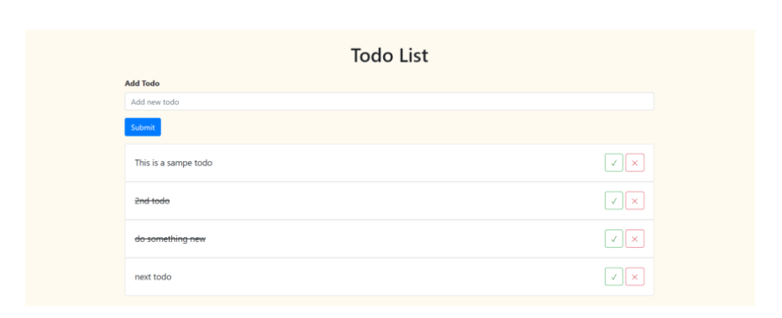Create To-do web app as given above,   
User can add activity, delete activity and save in local storage.