**REACT JS ASSIGNMENT-1**

**___________________________________________________**

**Authentication**

Design a login page, which will allow the user to sign in to view protected content. Users should also be able to sign logout.

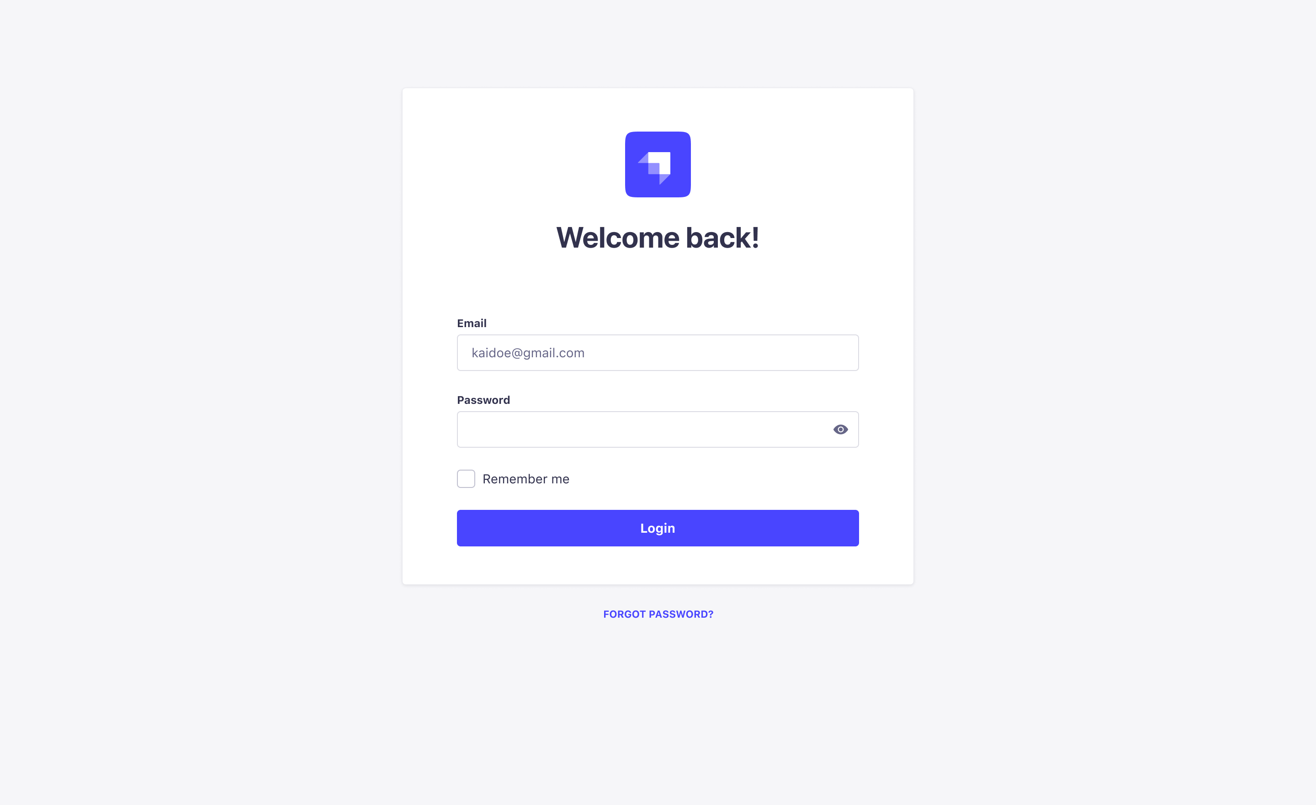

What will we evaluate?

1. We will evaluate how you structure your code and how you organize the overall solution.
2. Is your code understandable and readable?
3. Have you used proper variable names and function names?
4. How have you dealt with duplicate code? (Hint: code reusability)
5. How have you used Advanced react and JavaScript concepts?