**Security In the Modern World**

**(Quantifying The Security Risk Of An Enterprise)**

The substantial usage of Communication devices, IOT devices and increasing interconnectivity among systems, organization and people, is exposing them for security risk and vulnerabilities.

Security risk management is an ongoing process to identify these risk, manage them and implementing plans to mitigate them. It assigns relative priorities for mitigation plans and implementation. Thus, a risk assessment framework is needed for categorizing and sharing information about the security risk information technology infrastructure.

* Overview of Vulnerabilities and Security Framework

System Vulnerabilities are defined as fault or weaknesses that reduces and limits system ability.

Assessing risk is a major task in any organization. The vulnerability analysis is a part of risk assessment process which focuses on methods for identifying vulnerability and implementing suitable protection plans to maintain acceptable network security and protect information. A security framework is a holistic structure for risk assessment.

and yes natural calamities like (earthquake, flood and fire) too are in the list of risk as these can have impact on organization asset and its physical structure.

Also the nature of information network allows an attacker to attack from anywhere in the world making the task of identification too cumbersome.

* Security Risk Assessment Overview

Security Risk Assessment is defined as the process of evaluating the security risk of an organization that identifies the required security measures. This assessment is done at very early stages. The assessment is done at very early stages of the product development and later on the stages when there is change to information asset and its environment. The process involves assessment of and analysis of all asset and processes related to the system to identifying the threat and vulnerabilities that could affect your system’s confidentiality, integrity and availability of the system. Risk assessment is an essential part component of risk management and to be effective, risk assessment must be an ongoing process.

**It can be divide into three categories**

1. High level assessment which is applied to system at design phase to identify risk before implementation.
2. Comprehensive assessment which can be use to assess particular system at department and provide recommendation for improvement.
3. Pre-Production assessment conducted on new information system before it is rolled out.

* **Modern Risk Assessment tools AKA HEROES OF THE SHOW**

**1.LUCIDEUS SAFE**

SAFE is an AI and ML backed platform which performs enterprise wide cyber risk and quantifies organization security on a scale from one to five.

It is a self-evolving and dynamic cyber risk assessment platform that integrates with your exsiting IT infrastructure and security tools deployed within your organization to do real time assessment both at a macro(Enterprise wide) and a micro(Asset wise) level to allow the organization visualize, track and enhance their cyber risk posture.

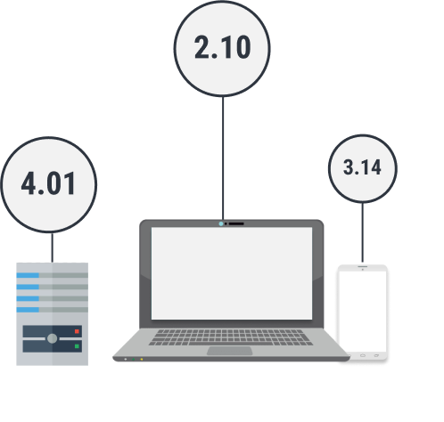

**MACRO LEVEL ASSESMENT**

|

\/

using 2500+ controls encompasses over 15+ global compliances, SAFE assesse your complete IT stack and quantifies your security overview on a scale from 0 to 5

**MICRO LEVEL ASSESSMENT**

**|**

**\/**

Provides 360 degree view of technology-wise security posture which is then furthers funneled down to an individual Asset’s level.

**KEY FEATURES**



**ON SAFE SCORE ->** one SAFE score represents your entire organization security position.



**REAL TIME ASSESSMENT ->** enables the organization to have real-time assessment on their assets.



**HACK SIMULATION ->** virtually simulate real hacks to find out your cyber defense against known hacks



**AUTO PATCHING ->** easily remediate vulnerability and configuration controls following a change control process



**COMPLIANCE MANAGEMENT ->** gives a real time analysis against the global compliance framework

