RISE OF BLOCKCHAIN
The technology with unmatched potential.

The technology likely to have the greatest impact on the next few decades has arrived. Its neither about big data, nor robotics or AI but it is ‘Blockchain’, the uderlying technology of digital currencies like bitcoin and ethereum. From secure and hassle free payment processing to data sharing, real estate title transfers or copyrighting you name it and blockchain provides the solution to every one of them.
WHAT IS A BLOCKCHAIN?
As one can guess from the name a blockchain is simply a chain of blocks(ledgers) containing information. The idea was originally thought of in 1991 to secure digital documents by time stamping them to protect them from getting back dated or tampered with. Although it went mostly unused through the decades, until in 2009 Satoshi Nakamoto (presumed pseudononymous) used the idea to create a digital crypto currrency – “Bitcoin”.
HOW DOES A BLOCKCHAIN WORK?
Think of blockchain as a distributed ledger with each block containing :
- Data
- Hash
- Hash of the previous block
The data stored in a single block depends on the type of a blockchain, in the case of a bitcoin blockchain, the block stores the transactional data such as the sender, reciever and the amount of coins
A block also has a hash which can be compared to a fingerprint i.e the hash is unique for each and every block in the blockchain. Once created the hash of the block is calculated with any changes being made inside the block causing it’s hash to change
WHAT MAKES A BLOCKCHAIN SO SECURE?
The thing that makes a blockchain so secure is the hash of the previous block.
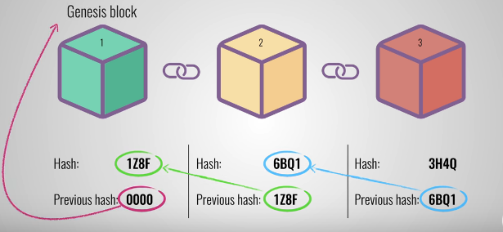
Lets understand this with the picture above. Suppose the second block here is tampered causing its hash to change that will make block 3 and all following blocks invalid as it does not anymore store a valid hash of the previous block thus changing a singles block will disrupt the chain.
Together with a hash which is a tad easier to calculate with a ton of powerful machines available in the market and hence can be cracked, a blockchain also has something called a proof-of-work for every block. It’s a simple technique that slows down the creation of each block so that the tampering becomes more difficult. Thus the security of a blockchain comes from it’s innovative use of hashing and POW.
One more technique through which a blockchain provides security is through being distributed using a Peer to Peer (decentralized) network instead of a central database. Every peer on the network is provided with a complete copy of the blockchain and the creation of a new block is added on to every blockchain copy on the network all the nodes then create a consensus to agree upon which block is valid and which block is not this ensures that the tampered blocks are rejected from the network.


Now consider a network of a 100,000 nodes, to tamper with a block on the blockchain one needs to calculate all the hashes of the blocks and their proof-of-work(which takes about 10 minutes for a bitcoin blockchain) and this has to be done for more than 50% of the nodes on the P2P network only then will the block be accepted. Which is almost impossible to accomplish thus making it the safest way to transact.
POTENTIAL USES OF BLOCKCHAIN
- Banking : Often a slow and complex system due to multiple intermidiaries, blockchain provides a secure way to transfer assets without the involvement of any third party thus simplifying the process.
- Real Estate : Eliminating the need of middlemen, blockchain could create vast changes here like processing title deeds and more.
- Online Voting : Exploring the option to digitalize voting systems using encrypted blockchains creating a transparent and secure voting system.
- Stock Trading : Blockchain is being considered as the means of recording transactional data of stocks by trading companies. Infact Intercontinental Exchange, the parent company of NYSE has launched its own bitcoin futures contracts.
The possibilities of the usage it provides are seemingly enormous and the impact it'll have is immeasurable.

Just like the boom of the internet in the 90s, blockhain technology has taken over the world by storm. Like the internet in its early stages blockchain had created a lot of buzz and investors had rushed to put their money on crypto companies, but as the euphoria wore off, the investors learnt that there is money to be lost here too. As per many, this meant the end of cryptocurrency and for that matter blockchain. This not being true at all, instead of ceasing off the investments the investors have started investing smartly.
The value of a bitcoin from 0.08 USD/coin in 2010 to 8000 USD/coin in 2019 showcases it’s lightining rise, and hence is the technology to look out for the next few decades.

