Missing Software Request Automation

Purpose:

We are trying to automate the resolution of missing software tickets, by using Robotic Process Automation with the help of UIPath.

High Level Overview:

We are using three portals for ticket resolution namely:-

* Service Now
* MyTech
* Aspera (Smart Track)

1. We will get the ticket details from **Service Now .** Then analyze the ticket for missing software request and get the caller SSO and software name(product name)
2. We will search for the product in **MyTech** and if the product is found we will notify the user that the product is available in **MyTech** and resolve the ticket.
3. If the product is not found then we will go to **Aspera .**
4. In **Aspera** we will search for product license and pending requests and accordingly resolve the ticket.

Missing Software Pseudo code

1. Open Service Now.
2. On the left hand side search bar type “Run” and open the “View/Run” report.
3. Click on the “Missing Software” report.
4. Open the report and get the SSO Id from “Caller” column.
5. Get the “Product name” from description column.
6. Go to MyTech 🡪Account & Expenses🡪Software and search for the product
   1. If product found then close the ticket stating that “The software is available for you in MyTech.”
   2. If it doesn’t exist then go to step 7
7. Open SmartTrack application.
8. Go to License🡪Effective License🡪 Effective License screen.
9. In the “Assigned to User” column put the SSO of caller and put product name in the “Product name” field (**similar** match) click enter.
10. If license not found, then proceed with step 10.
11. If license found, then
12. Save the “ULID”, “Assigned to request” and “Assigned to user” values
13. Search based on “ULID” in the “effective license” screen
14. Remove the entitlement
15. Again assign the license back to user and request (if any) Please find the steps for removing entitlement and assigning at the end of this pseudocode.
16. Go to MyTech 🡪Account & Expenses🡪Software and search for the product
17. If product found then close the ticket stating that “The software is available for you in MyTech.”
18. If it doesn’t exist then, notify SGL saying “License is available in SmartTrack but not reflected in Mytech” via mail. Update the INC saying “Notified SGL team”.
19. If license not found then check Processes🡪Requests🡪Active Requests page and enter caller SSO In “Account” column.
20. If “Request status” is anything that contains key “Pending” then
21. Update comments in the incident saying “Request is in progress.”
22. Notify SGL team via mail.
23. If “Request status” is “Closed” then
24. Copy “Order number” and “Product name” from “Active request” screen
25. Go to “Expired license screen” search with “Order number” and “Product name”(**similar** match)
26. If license is found then

* Close the incident by clicking on “Resolve Incident” button
* Update Close notes saying “Your license is expired. Please raise a new request”.
* Click on “Save”.

1. If license not found

* Notify SGL team via mail saying “Request is found but there is no record for license. Please take necessary actions”
* Update comments in INC saying “notified SGL team”.

1. If “Request status” is anything that contains key “Rejected” then
2. Close the incident by clicking on “Resolve Incident” button
3. Update Close notes saying “Your request is rejected”.
4. Click on “Save”.

Removing and assigning entitlement:

1. Search for the ULID

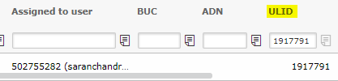

1. Select the record and click on the highlighted option



1. Select “Remove assignment”

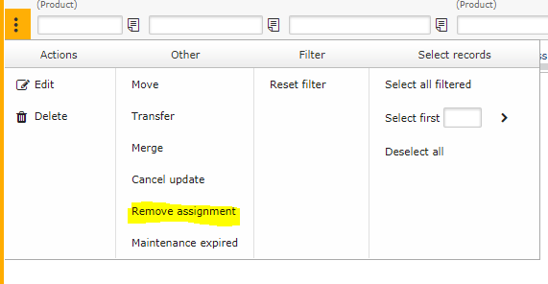

1. Click on “Remove”

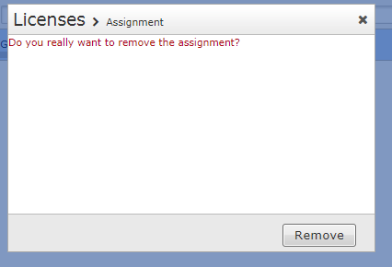

1. Click on the highlighted 3 dots



1. Select “Assignment”

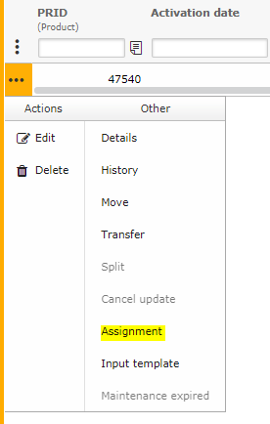

1. Give “Assigned to user” value in “User” field and “Assigned to request” value(If any) in “Request” filed and click on Save.

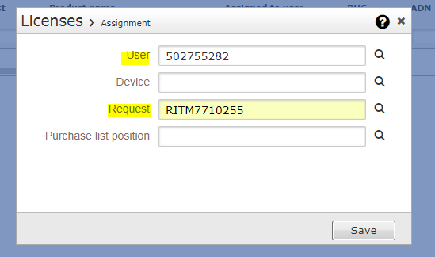

Please use the following values to resolve the incident:

