-
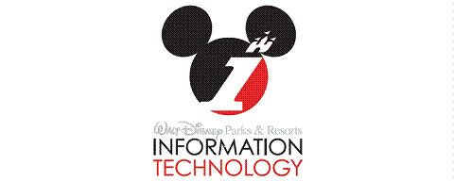

GBTS Services
Overview Document

Version 1.0

Release History
Author(s): Jonathan Timianko
Date Created: 09/19/2012
Date Modified: 04/01/2013

Welcome to GBTS Services!
The following document has been prepared to introduce GBTS and DREAMS Services to new consultants joining Disney. This document is designed as a broad overview of the information systems at Walt Disney World Parks and Resorts. After reading this document, one should feel comfortable about both the business and technical architecture of the composite applications / services.
In order for this document to be most effective, it is helpful to understand how it is organized. Each section is designed to introduce new concepts that build upon each other with each ensuing section. Therefore, as one progresses, the document becomes narrower in scope. The document should be read in chronological order as all new vocabulary (denoted by bold-faced type) is defined before it is utilized. If a term seems foreign be sure to revert to an earlier place in the document to discover its definition. In addition, much of the document’s content has been consolidated from a foundational document entitled “PMSR Release 2.0 System Delivery Specification,” amongst others. Source citations have been provided for material found in a document other than the foundational document.
-The Global Business Technology Strategy (GBTS) Services Delivery Team

Contents
1) Introduction 3
2) Team Structure and Release Timeline 4
3) User Interfaces: The Visual Gateway to DREAMS Services 5
4) Overview of DREAMS Services 7
• Reservation Management: 7
• Folio Management: 7
• Inventory Management: 7
• Groups and Block Management: 7
• Accounting Management: 7
• Entitlement Management: 8
• Profile Management: 8
• Service Request Management: 8
• Housekeeping Management: 8
• Party Management: 8
5) GBTS Application Landscape 10
• Sales Support Systems: 10
• Fulfillment Support Systems: 12
• Finance/Reporting Systems 14
6) Special Features of DREAMS Services 15
7) The Architecture of DREAMS Services 18
• System Architecture 18
• Separation of concerns: 18
• Technical Architecture 19
• Security Architecture 20
8) The Domains in-Depth: Reservation Management 21
• Reservation Management Overview 21
• Reservation Management Sub-domains 23
• Reservation Management Services List 24
• Reservation Management System Interactions 27
9) The Domains in-Depth: Folio Management 29
• Folio Management Features 29
• Folio Management Services List 38
• Folio Management System Interactions 40
10) The Domains in-Depth: Inventory Management 41
• Inventory Management Features 41
• Inventory Management Services List 43
11) The Domains in-Depth: Profile Management 44
• Profile Management Features 44
• Profile Management Services List 45
12) The Domains in-Depth: Srvc. Request Management 45
• Service Request Management Features 45
• Service Request Management Services List 47
13) The Domains in-Depth: Entitlement Management 47
• Entitlement Management Features 47
• Entitlement Management Services List 48
14) The Domains in-Depth: Accounting Management 48
• Accounting Management Features 48
• Accounting Management Services List 49
• Accounting Management System Interactions 49
15) The Next Generation Experience 50
16) Conclusion 54

Introduction
The “DREAMS Services” moniker refers to the Disney Reservation Entry and Management System. Its goal is to stream-line communication among business services while performing certain business processes, and to be agile and service oriented to support future enhancements and business needs. Its interface should be intuitive, user friendly, and secure for both Disney customers and Cast Members (Disney Parks and Resorts employees). Some examples of business processes that became more efficient under DREAMS Services are the following:
- The room check-in process, accounting for both room and non-room related charges
- Booking multiple rooms as a group (such as for a wedding or convention)
- Consolidating the accounting systems for when Disney sells a room and when a customer pays for it
- Better room matching based on guest preferences and room attributes

Team Structure and Release Timeline
The Solution and Design Team acts as a gateway from the line of business (LOB) to the software development team. It gathers business requirements, defines a high level solution, and produces platform independent design specifications of the software solution before passing it to the Development Team. The development team builds the software and supports it through system testing and user acceptance testing phases until the release is deployed to production. During the testing cycles, based on the nature of the defects, they may be handled either by the development team or jointly by the solution/design and development teams. Once the release is deployed to production, the majority of defects and incident management is handled by the Sustainment Team.

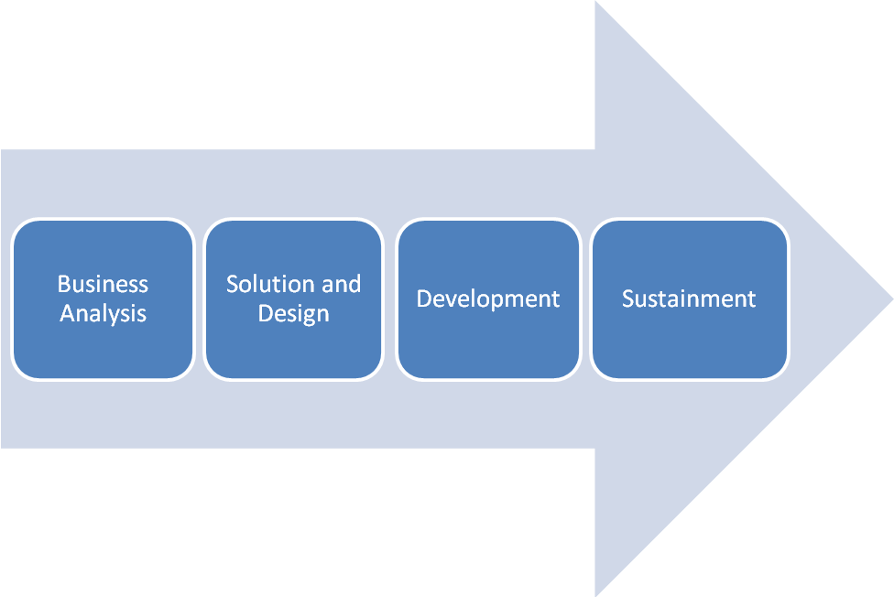

User Interfaces: The Visual Gateway to DREAMS Services
Different cast members at the resort use different user interfaces to interact with the back-end network architecture of DREAMS Services. These include the following:
- LILO UI: LILO UI is used primarily in resort operations. Front-desk personnel at Disney’s many resort hotels use the LILO UI to interact with the back-end DREAMS Services databases in order to book walk-ins, check-in, and check-out resort rooms (and all of the financial functionality associated with those processes). LILO UI can also be used to sell special event tickets and annual passes.
- DVC Member Services UI (WISHES UI): DVC (Disney Vacation Club) refers to Disney guests that are on Disney vacation timeshares. Sales for DVC reservations are done through the Wishes UI by DVC Res Agents. Once a reservation is made through the DVC Member Services UI, a shadow reservation is created in DREAMS Services to record that the reservation has been processed.
- SBC UI: The DRC (Disney Reservation Center) is a call center used for Disney’s package reservations and retail reservations. DRC agents use the SBC (sales and booking client) UI in order to sell rooms.
- A-La-Carte-UI: The A-La-Carte-UI is a user interface used by Disney cast members at restaurants and dinner show podiums. The UI is also used by personnel at the DRC that receives calls from the guests to book dining reservations/activity reservations in advance.
- DREAMS UI: The resort’s back office uses DREAMS Services UI for back office functions such as rate and inventory overrides and adding confirmation recipients. DREAMS Services UI is also used by groups and conventions when booking their rooms.
- WDPRO: WDPRO is an internet-based user interface that Disney guests can use at home to book their own reservations. It is used for internet packages and room only reservations.
- Charge Account UI: A charge account is essentially a virtual wallet tied to a particular guest that contains information on how they would like to pay for costs incurred at Disney parks. The Charge Account UI displays the payment methods available to a guest, allowing him/her to select one to use for payment or set one as a resort settlement method. It also provides the capability of updating the guest’s PIN number associated to their account. The Charge Account UI is integrated with the xPd media encoder device. This front desk device allows cast members to 1) swipe and 2) tap to provide door access and 3) enter a pin to update the security parameter on the guest’s charge account. Therefore, the Charge Account UI works in tandem with the xPd device to provide Touch-to-Pay capability. And since Payment UI is integrated with Charge Account UI, this allows for providing Touch-to- Pay at resort front desks or A-la-Carte locations in the future. For more information on the Charge Account UI please refer to the Charge Account UI section of CSFBS Release 2.2 Solution Definition.
- Payment UI: The Payment UI allows a Disney cast member to take a payment from a guest so that he can either settle the remaining balance on his folio or add a settlement method to it. It also allows a guest to pay for a particular product or service sold by the DREAMS UI, LILO UI, DVC Wishes UI, and ALC UI.
- Pascal UI: Pascal UI initiates the transaction for purchasing a miscellaneous consumer package and printing the receipt. Initially, the only products that will be sold through this UI are the NGE personal Magic Products (My Memory Maker and My Story Maker). The UI is launched through the DREAMS UI, Wishes UI, and LILO UI.

Overview of DREAMS Services
Perhaps the most outstanding feature of DREAMS Services is the organization of business processes and business services. Upon performing a business process (like a Cast Member checking in a room), each domain interacts with the other domains through a set of loosely coupled component services in order to achieve a business goal. For the purposes of this high- level overview, we will refer to a domain as a set of similar business processes or services lumped together within the context of a business need.
The following are the business domains that form the core of DREAMS Services:
- Reservation Management: This domain is responsible for managing the lifecycle of a reservation from sales through fulfillment.
  - The process for allowing revenue for a resort room to be recognized is divided into two phases: Sales and fulfillment. Sales starts when a prospective Disney customer calls the sales channels to book a room, the room inventory is frozen so no one else can take the room, and the reservation number is generated. The fulfillment process can begin as early as when the customer lands at the airport and his luggage is sent to the Disney Resort and he boards the DME (Disney Magical Express transportation bus) to go to the resort. Otherwise, fulfillment begins when the guest arrives at the front desk.
- Folio Management: This domain is responsible for managing the reservation specific financial folios for guests and groups.
- Inventory Management: This domain is responsible for the creation and maintenance of physical room inventory in support of the resort operations. This domain is extendable to managing other kinds of physical inventories.
- Groups and Block Management: This domain is responsible for the creation and management of wholesaler groups and convention groups along with their inventory blocks in support of the Reservation Management domain. This domain contains travel withs (TW), which are minimalistic groups without a folio or room inventory associated with them (CSFBS Release 2.4 Passport) .
- Accounting Management: This domain is responsible for managing the resort analysis ledger (which is simply a line item in a T-account) entries for the reservations. It aims to reconcile the end of day financial feeds with SAP (the back office financial accounting system). Accounting also maintains all configuration data needed in order for items posted on the folio to resolve to the correct financial accounts.
- Entitlement Management: This domain is responsible for managing the lifecycle of the guest coupons or entitlements for the reservations. “Coupons” refers to specific meal vouchers for a given person.
- Profile Management: This domain acts as a support domain for the Reservation Management domain. It is responsible for maintaining the coded comments and their associations to the various fulfillment constructs. An example of a coded comment is CRIB, or BDAY, specifying that a crib should be delivered to a certain room or the front desk personnel should wish someone a happy birthday. These coded comments are requested for a particular guest’s reservation.
- Service Request Management: This domain manages the lifecycles of different kinds of service requests (such as maintenance) that are created for the in-house reservations. Service requests may be generated as special orders that are requested by the guest.
- Housekeeping Management: The Housekeeping management domain manages the housekeeping boards for all WDW resorts.
- Party Management: The party management domain contains guest information relevant to the reservation. Each reservation has a primary guest whose name and contact information is contained within the reservation. Each supplementary guest on the reservation is connected to the primary guest through the reservation. The party management domain maintains this guest information when other domains such as reservation and folio perform remains independent of the guest information.
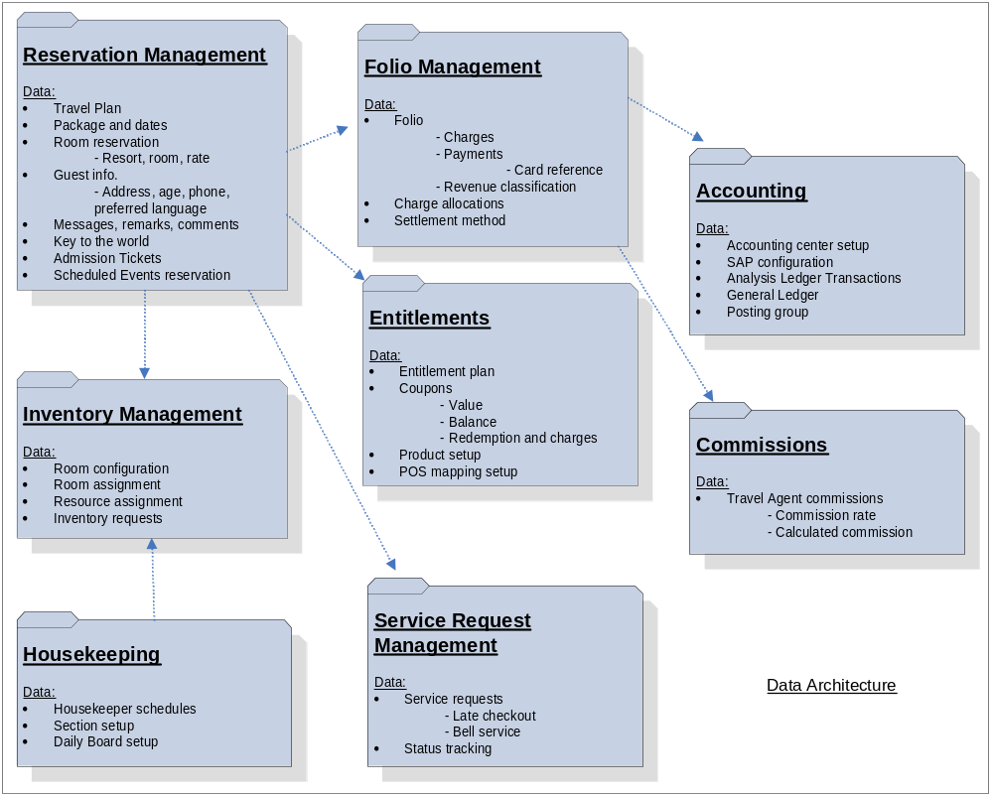These business domains form the backbone of DREAMS Services, and each domain must talk to one another in order to accomplish a multitude of business functions. For example, Reservation Management must talk to Inventory Management when a room is booked so as to freeze the inventory, a process to be detailed later in this document. As one can suspect, there are a plethora of ways that each domain can talk to another domain. It is the responsibility of the Solution and Design team to manage the communications and enhancements of these services.

GBTS Application Landscape
Now that you are familiar with the user interfaces and functionality of DREAMS Services, it is now best to illustrate the entire GBTS application landscape. This will aid in introducing the external systems that assist in the sales and fulfillment processes:
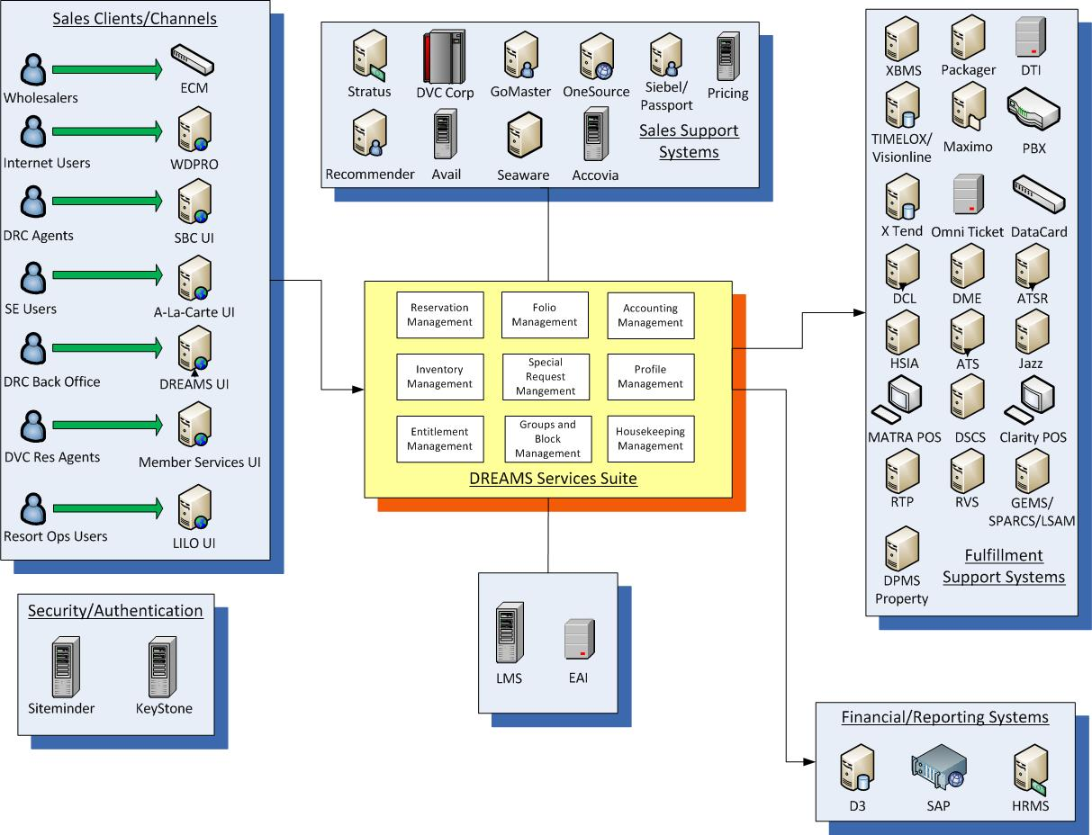

Sales Support Systems:
- Stratus: Stratus is an external “payment gateway” used during credit card, gift card, and rewards card transactions. By acting as a payment gateway, Stratus helps in preserving guests’ credit card security. In addition, Stratus interfaces with all the credit card companies, providing a common interface when processing different types of card payments.
- DVC Corp: This is the system of record for Disney Vacation Club member bookings. This external system reconciles reservations with DREAMS Services.
- GoMaster: GoMaster is a domain designed to hold guest information such as name, email, and address. It is a system of record that replicates guest information held in the reservation management domain. The data contained in the DREAMS Party domain is only a subset of the GoMaster system. GoMaster is the true system of record for this information.
- OneSource: OneSource is the content management system for all Disney products and it publishes information for different kinds of products (facilities, rooms, etc.) to interested systems.
- Siebel: It holds travel plan information (see Reservation Management section).
- Passport: Passport, as part of release 2.4, is replacing Siebel.
- Pricing: This support system provides the pricing components for any product or package. When a customer is booking a Disney priced travel component, the pricing system gathers the prices for the separate components and creates a finalized package price.
- Recommender: Recommender is an automated recommending service that is used by various UIs. A recommendation template recommends items based on certain criteria such as party mix, affiliation, zip code, and date range. This helps to provide appropriate products to the guests.
- EAI: EAI is a messaging based infrastructure that allows systems to communicate with one another. Most external applications come through EAI to communicate with DREAMS Services.This is because some external systems do not support the same web services as DREAMS Services. Therefore, their output must go through an intermediary entity to be translated before it can be processed by DREAMS Services.
- Seaware: DCL (Disney Cruise Line) utilizes these services for selling Disney Cruise Line package reservations.
- ECM/ABS/EAI: Wholesalers such as Expedia and Travelocity interact with DREAMS Services in order to sell rooms. Their booking requests are handled through an ECM (external channel manager) utilizing an ABS (automated batch service) and EAI.
- Avail: Avail is a sales support system that maintains the statuses of WDW logical inventory.This system works in tandem with the sales systems in order to display information on the user interface concerning resort room availability. Some of the tasks that Avail concerns itself with are blocking inventory,releasing blocked inventory, booking inventory, updating inventory, or reconciling the available inventory with the system of record for reservations (DREAMS Services).
The difference between avail and the inventory management domain of DREAMS Services is the following: Avail is concerned with logical and not physical inventory. This means that if there are a certain number of rooms available in a resort and an individual wants to book a room, the avail server will let the user know how many rooms are available based on algorithms concerning probable cancellations. The principle difference between avail and inventory is that the avail sales support system allows for the overbooking of rooms while inventory management does not.
Accovia: Accovia is the Walt Disney Travel Company reservation system. The Walt Disney Travel Company is a wholesaler for Disney package reservations.

Fulfillment Support Systems:
- TIMELOX/Visionline: TIMELOX is a system that is used to grant media access to a particular room(s). This system is used for other access-related tasks such as check-out (so that your room key cannot open the door after you check-out), room change, and creating an additional card(s) for a room. This system interacts directly with the door locks for the aforementioned functions.
- Maximo: Maximo is the system of record used by the resort operations team to create work orders for special requests. Special requests can be submitted by a guest to the resort operations team at any point during his stay. These cast members then use the LILO UI to record the special request and the work order is then created. An example of a special request is delivery or pickup of certain items, such as the delivery of a rollaway bed to a room.
- PBX: PBX is a telephone switch system. DREAMS Services notifies a check-in of a guest in a room to PBX. PBX uses this information to set the guest name to display on phones when a call is made from that room. In addition, PBX allows the following additional functionality:
  - DREAMS Services sends PBX a message to copy the voicemail inbox from one room to another in the event of a room change.
  - DREAMS Services receives status codes dialed into room phones by housekeepers to change the room status.
  - PBX sends DREAMS Services voicemail counts. DREAMS Services forwards this information to X Tend.
- X Tend: X Tend is an application used in resort call centers used to provide guest information. These call center agents have a snapshot of this data from the reservation management domain.
- ATS: ATS is a fulfillment support system for park admission.
- DTI: DTI stands for Disney Ticketing Interface. It is a system that allows DREAMS Services to communicate in the same language (web-service) as ATS so that they can seamlessly communicate information.
- DME: DME refers to the systems relevant to the Disney Magical Express transportation bus. The following is a simplified process of DME’s systems interacting with the DREAMS Services database.
  - DME sends DREAMS Services the flight arrival time for arriving guests.
  - DME notifies DREAMS Services that a particular guest has landed at the airport. This happens when the guest has checked in at the DME Welcome Center OR has been scanned into the Welcome Center’s motor coach queue OR has been scanned while boarding the resort-bound motor coach. This notification helps the resort operations personnel ensure that the room assigned for DME arrivals is ready for occupancy.
  - DME sends the motor coach number to DREAMS Services with the reservation numbers of arriving guests. This is sent from DME on a motor coach departure.
  - DME notifies DREAMS Services of motor coach pick up times for a guest’s departure from the resort.
- HSIA: HSIA refers to the external systems surrounding high-speed internet access service in the resort rooms. DREAMS Services notifies HSIA of check-ins and check-outs so that appropriate charges can be levied on the guest’s folio.
- RVS: Resort Valet Service. Just like DME they get information and do a service related to that activity. Like HSIA, DREAMS Services notifies RVS of check-ins and check-outs so that appropriate charges can be levied on the guest’s folio.
- Jazz: Jazz is a system that handles the charges incurred by a guest utilizing his in-room telephone.
- MATRA POS: MATRA POS is the point-of-sale cash register system. Currently MATRA POS sends the summarized amount for a POS charge to the Property Management System. LILO UI has the ability to talk to MATRA POS to retrieve the receipt of a guest’s previous transactions.
- Clarity POS: It is a point-of-sale system that is capable of Touch to Pay. It allows the guest to touch their RFID-enabled media (x-Band, to be later explained in ensuing sections) to retrieve a stored payment method from their charge accounts (either directly or via Stratus) and apply the payment to the stored payment method.
- DSCS: DSCS stands for Disney Sales and Catering system. It is a legacy system which manages Disney’s catering bookings and fulfillment.
- RTP: The Retail Transaction Processor (RTP) stores transaction details and sends credit card transaction details to SAP for settlement. It also sends daily hotel charges or electronic coupon tenders into the DREAMS repost file. A repost file is a type of backup file that holds information in case any part of the Disney system is non-functional. The RTP will ensure that no transactions (like offline transactions) are missed from getting posted into folio.
- GEMS/SPARCS/LSAM: This system provides housekeeping labor schedules to DREAMS.
- Keystone: Keystone is a security framework used across the Walt Disney Company to maintain user profiles, user roles, and functional abilities. The security framework is UI centric, meaning that the user interfaces such as LILO and ALC determine user authorizations.
- Siteminder: Like Keystone, Siteminder is a security tool used to authenticate users.
- DPMS Property: DPMS Property used to be the fulfillment system for Walt Disney World Resorts. DREAMS Services downloads all bookings to Property 10 days prior to arrival and sends the deposits on the day of arrival. DREAMS Services also keeps the reservations in synch with Property for subsequent modifications. This system is retired as part of the PMSR project in Walt Disney World. It is still used in Walt Disney Land (DLR) in California.
- LMS: The Land Management System (LMS) is used by Disney Land in California. This performs the functions that are performed by DREAMS, LILO UI, Avail, and Groups all for DLR. This works in conjunction with DPMS.
- Packager/PMA: Packager is responsible for the maintenance of packages and provides package information to DREAMS Services.
- XBMS: XBMS is a system of record for x-Bands. It holds the relevant guest information for the magic bands. This system maintains the association between a guest and his x-Band so that in the case an x-Band is lost or stolen, the proper band is connected with the proper guest.
- OneView: Oneview is a flattened snapshot view of information coming from various systems of record, including DREAMS Services, ATS, XBMS, etc.

Finance/Reporting Systems

- D3: D3 is a reporting system that replicates DREAMS data in order to provide business reports to multiple lines of business including finance and resort operations.
- SAP: SAP is the backend accounting system for Disney. DREAMS Services sends summarized general ledger, credit settlement and account payable information to SAP on a nightly basis.
- HRMS: HRMS is the Hotel and Revenue Management System. DREAMS Services provides an inventory and rate extract for Group Convention blocks at the end of each day to HRMS.

Special Features of DREAMS Services
The following were special features embedded within PMSR Release 2.0 that formed the foundation for future enhancements over the past number of years:
- Single System of Record for Room Reservations: The DREAMS Services database will serve as a single system of record for the room reservations from sales through fulfillment functionalities. By a single system of record, the need for data synchronization and reconciliation between the sales and the fulfillment systems is avoided. This network enhancement reduces the workload of the back-end systems and therefore makes Disney’s network architecture more efficient.
- Automated Room Assignment: The room assignment process is automated in PMSR. The automated room assignment algorithm is built to accommodate the room operations requirements for guest convenience and at the same time ensure optional room assignment so as to maximize revenue and minimize operational costs. The automated room assignment system therefore greatly affects the capacity utilization of a Disney World resort.
- Attribute Level Fulfillment: Additional features of a room (such as a rollaway bed or balcony) are referred to as attributes. The PMSR solution is built to be able to fulfill rooms using attributes. The system provides the ability to configure attributes at the individual room level for all the resorts. As part of an automated room assignment process, the available room attributes in the system are matched against the room attributes that a customer chooses while making his reservation, so as to ensure an accurate match for the guest. An important part of attribute level fulfillment is to ensure that the specific room attributes that are requested as coded comments are actually fulfilled and that there are no holes in the system (the gap between 2 consecutive reservations assigned to a room). When the fulfillment process occurs in this manner, the upstream sales systems are not impacted by the selection of room attributes.
- Special Request Fulfillment: The fulfillment of guest special requests is completely automated by the PMSR solution. During the sales process, a special request can be booked by way of coded comments. Coded comments are configured to map to a unique special request in order to enable fulfillment. During the fulfillment process unique products are created for each special request with the appropriate price and the charging frequency. The system thus allows users to capture the fulfillment frequency for the special request.
- Seamless Guest Experience: The Seamless Guest Experience is one of the most important core architectural features of the PMSR solution. It is achieved by the following functional features:
  - Single Guest Folio: A single guest folio is created and maintained for a guest at the travel plan level. This folio will help track the charges, payments and the folio balance throughout the entire guest stay spanning across multiple rooms and even resorts. The guest will get a single folio invoice for the entire stay spanning the multiple stays across the same resort or different resorts.
  - Single Access Media (KTTW/RFID Media(s)): The objective of the solution is to provide the guest with a single key which will allow access to the different rooms the guest will be staying in throughout his/her stay. The single access media feature is dependent on a wireless door access system implementation. Aside from door access the media can also be used for entrance into the park and for point-of-sale purchases.
- Centralized Accounting: As part of the solution, the accounting engine will serve as the single repository for Scheduled Events (dinner shows, musical events, etc), resort operations and DRC revenue accounting (a.k.a Business units). In addition, the SAP feeds are also segregated by business units.
- Multiple Campus Support: DREAMS Services is designed to support multiple campuses and business units:
  - Business Unit: A Business Unit is a specific business related entity operating within a campus and performing reservations and financial activity. Some examples of business units are DRC, resort ops, and Scheduled Events.
  - Campus: Campus is the concept that is represented in the system to depict the groupings of all the business units within a single geographical time zone maintaining reservations in facilities belonging to that campus. Campus also controls the booking/posting date of all the booking transactions.
  - Location: The concept of location is to represent the physical location where the cast members are using the system. Some examples of location are front desk, DRC, and Grand Floridian Concierge Desk. The location always belongs to one business unit. Cast members using the system are always associated to a location. The environment setup, access to resources, and other business processes are driven off of location.
The features for multiple campus support are support for multiple time zones and currencies (along with currency conversations), separate date rolls for different campuses and business units, and support for multiple cast member and guest languages.
- Improved Bill Trap Process and Fine-Grained Billing Profile: The bill trap process is an intensive business process to identify the specific folio onto which a particular charge will be posted. With the PMSR solution, a guest can configure multiple folios for trapping the different charges posted on the reservation. For example, a guest can create a personal folio to trap entertainment charges and a business folio to trap the dining charges to generate different invoices. The bill trap process in the folio management module is enhanced to a complete in-memory process from the current state process involving numerous database calls.
- PIN (Marketing Campaign Offer Service): Guest-targeted marketing offers (PIN Offers) are sales promotions for Disney travel products marketed directly to guests of various demographics via communication channels such as email, direct mail, etc. The PIN solution will contain capabilities to load, purge, and retrieve guest pinned offers (CSFBS Release 2.4 Passport) .
- Collateral:Thisn The collateral program is a part of the PIN Marketing Campaign Offer Service. The marketing materials shipment involves Passport validating the name, address, and email with GoMaster. (CSFBS Release 2.4 Passport) .
- Sales Order (SO) and Travel Plan Sales Order (TPSO): An SO is a concept that holds multiple sales order items like accommodation (lodging), admission (ticketing and shows), bundles (accommodation, admission, and other travel components booked together), air, car, etc. It is responsible for maintaining the business rules for the order as well as combinability, state, and validity across order items (CSFBS Release 2.4 Level N) . The role of TPSO is to orchestrate transitions between Travel Plan (see beginning of Reservation Management section) and Sales Order.
- Itinerary and Activity Planning (IPO): An itinerary is an organized list of all of the activities that a guest is planning to do on his Disney vacation. An activity is the actual event that the guest is planning to do in an itinerary. Every activity has an owner associated to it. In addition, an activity can have one or more items that are scheduled in advance that represent the participants and the duration of their participation in that activity. Examples of activities include Disney bookable items (room, dining, etc.) non-Disney bookable items (e.g. Universal Park Tickets) and non-bookable items such as personal items. (CSFBS Release 2.4 IPO) .

The Architecture of DREAMS Services

System Architecture
Now that you know how DREAMS Services are organized from a business perspective and how it enhances the customer experience, it is now time to address the technological framework of DREAMS Services. The complete PMSR solution is designed using a service oriented approach. The solution is built over multiple domains, with each domain providing a set of business and component services.
- Separation of concerns: Functionalities are grouped into individual domains in order to handle the separation of concerns. Each domain interacts with other domains through a set of loosely coupled component services in order to achieve a business process (business goal). A business process is achieved by using one or more business services exposed by the individual domains.
- Modular approach: Each module owns its own data and is not replicated in order to avoid data duplication.
- Scalability: The business services are built in such a way that they can be scaled independent of other services within or outside the domain.
The system’s service oriented architecture (SOA) contains the following features:
- Robust Notification Service: Because the PMSR solution entails communicating to a large number of external interfaces, a robust asynchronous (meaning a message is sent one at a time in one direction and not dependent upon a response from the target service, also referred to as fire and forget) communication mechanism was required to streamline communication among services so that the sending entity is not dependent on a response and can continue its operation.
- Publish-subscribe (event) based architecture
  - Highly configurable - Listeners can be configured for events for a specific campus or a Resort.
  - Guaranteed message delivery – Messages will be left back in the queue if the target listeners are down.
  - Highly extendable - New adapters can be built with minimal code by extending framework adapters.
- Course-Grained Module Level Interactions: The communication among the different DREAMS Services modules was enhanced to a macro level in order to avoid too many hops among the modules in order to execute a business transaction. For example, a single book transaction before the system overhaul involved multiple calls to folio for each charge posted. This was enhanced to consolidate the calls to the folio module into a single call to for a book or a modify transaction.
- Enhance External Interfaces: As part of the PMSR solution, the key external interfaces were assessed for architectural improvements to support the future state Disney IT architecture vision. Existing interfaces wherever applicable were enhanced with web services and/or migrated to the robust notification service platform.

Technical Architecture
PMSR solution extends the existing component based architecture built for DREAMS Services. Business functions are housed in individual domains. Each business domain provides a set of business services and component services. The domain is optionally complemented by additional reusable, embedded components in order to serve a particular business function:
- Business Domain: A Business domain or a module represents the business logic specific to a particular business domain such as Housekeeping Management, Reservation Management etc. Typically, it owns a database schema and is deployed as a single application package as an EAR.
- Component: A Component is a reusable, encapsulated software element capable of executing related tasks. It is context agnostic and can be deployed in multiple modules. It is packaged as a JAR. An example can be Party which can be made as a component for both reservation and folio management.
- Business Service: A Business service is a collection of self-contained business functions related to a single business entity. Examples of business functions include booking a room, taking a payment etc. It is always executed as a single atomic transaction. It is provided by a business domain in a technology-agnostic, self-descriptive manner. Typically it adheres to a generic specification such as WS-I (Web Service Interoperability).
- Component Service: A Component service is a collection of sub-process functions that belong to a single business entity that are used in the context of a executing a larger business service. Examples of component service functions include pricing a package, posting a charge in the context of a book room business service function. Additionally, a component service adds non-functional aspects such as accessibility, transaction, security, scalability etc. Typically it adheres to a technology specification such as EJB.

Security Architecture
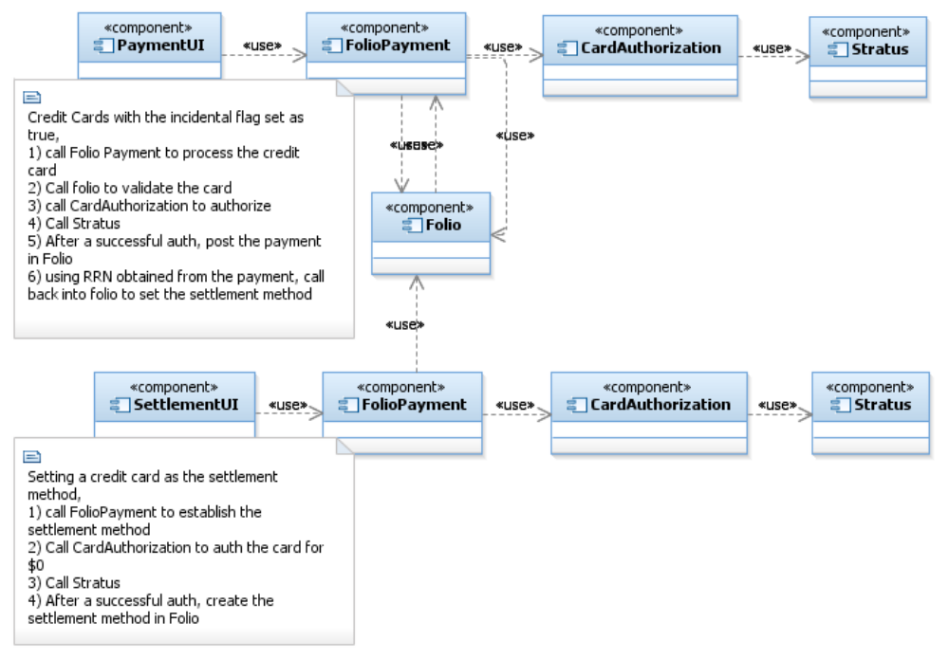
- Credit Card Security: As part of the PMSR and CCREF (Credit Card Reference) solution, credit card information will not be stored within DREAMS Services. For taking credit card payments Payment UI is used. Sensitive information such as a credit card number and expiry date etc. will be captured in the UI, converted to a reference number by the payment/auth service and posted to DREAMS Services.

- Data Security: As per Disney security guidelines, the data stored and transferred within DREAMS Services should follow the following data security guidelines:
  - The access to the data should be controlled.
  - The data cannot be publicly available.
  - The data need not be encrypted during storage and transfer.
  - DREAMS Services does not store sensitive guest information such as social security number, date of birth, etc.
  - DREAMS Services records the username in the database and log-files for auditing purposes. It does not store the user password.

The Domains in-Depth: Reservation Management

Reservation Management Overview
The reservation management domain stores the reservation information during the entire life cycle from booking to fulfillment and all the way through archival. It stays in the system for research purposes for a pre-determined amount of time after the guest leaves. The creation of a reservation results in the creation of a Travel Plan in the Reservation Mgt. domain. A Travel Plan also includes a Travel Plan Segment and Travel Component Grouping. These entities are detailed below:
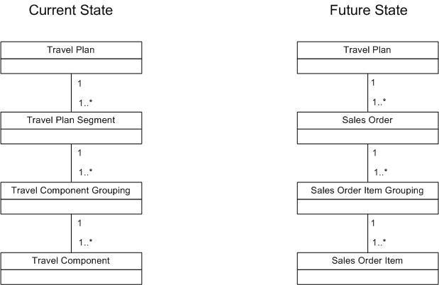

  - Travel Plan: Travel Plan is an entity that stores the guest’s reservation information and is the umbrella for data concerning said guest’s entire duration of the trip. It holds all of the reservations made for the length of stay and the guest list for the length of stay (with a primary guest designation). It also holds other reservations such as dinner shows and activities. A travel plan is associated to many travel plan segments.
  - Travel plan segment: Travel Plan Segment represents scheduled segments of a reservation all contained within a Travel Plan. A scheduled segment could be an accommodation, a dinner show, or a recreational activity. The construct holds together all the travel component groupings booked for an owner e.g. WDW, DVC, etc. A travel plan segment is associated with multiple travel component groupings.
  - Travel Component Grouping: A Travel component grouping lumps together components which are fulfilled together e.g., accommodation, tickets for each guest, dining plans etc. A travel component grouping is always associated to one room stay. Stays in multiple rooms at the same time or continuous stays create multiple travel component groupings. A travel component grouping is also created for scheduled events related bookings such as dinner shows, recreation, etc, but these will be under different travel plan segments than the accommodation.
  - The Reservation Life-Cycle: The following status transition diagram shows the life cycle of a reservation from sales to fulfillment to check-out:
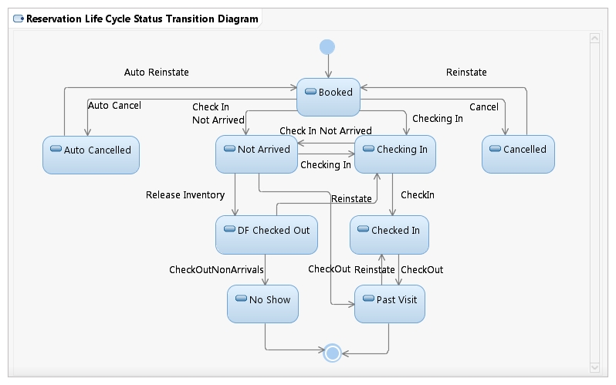

Reservation Management Sub-domains
- Internal Sub-domains
In addition, the reservation management domain acts as a hub for several sub-domains. These sub domains hold their own information and they are housed within the reservation management domain because the services that they perform are related to (as you would expect) reservation management. These internal sub-domains are the following:
  - Guest Messages: Guest messages are messages that are captured at the resort front desk to be eventually delivered to the resort guests. The guest messages are captured in the system in the context of a specific guest within the travel plan. The system also allows one to change the delivery status of the message and delivery methods. The message will store the actual message, the guest for which the message was placed, and the source of the message (which is the name of the person who placed the message).
  - Rooming List/Mass Option: The group reservation office needs to upload reservations received from external booking sources such as Expedia and Travelocity. This is because these external websites access Disney databases to see what rooms are available, but they don’t have direct access to Disney systems because they are not used by Disney cast members. To that end, the bookings that they conduct must be fed through an ECM in bulk utilizing an ABS.
- External Sub-domains
The bulk reservations received from these external sources need to be automatically placed within the reservation management domain because manual entry of each reservation is time consuming. Therefore, in order for the system to streamline the reservation upload process, templates are maintained for each source and the data is parsed based on the template to load the reservations in the system.
  - Party: The party sub-domain maintains guest data such as address, phone, and email. Additionally, the system allows adding confirmation recipients with name and address information. Travel Agencies booking on the guest’s behalf also need to be maintained in the system. At the Front Desk, incidental Folios are created to track additional charges at the property. Name and address information is provided for these folios.
  - GuestLink: Certain Disney guests repeat their resort vacations year over year. GuestLink is a system feature that recognizes repeat guests and links a repeat guest’s new reservation with their past reservations.
  - GuestAccess: GuestAccess is a sub-domain within the reservation management database that holds information for room access.
  - KeyToTheWorld (KTTW): On a guest check-in, the system creates the Key to the World information and tracks the door access and the entitlements for the stay per guest. The system maintains the Key to the World Card per resort guest for a travel plan. As part of NGE the key cards are being replaced by Magic Bands. A Key to the World Card provides the following:
    - Access to the coupon entitlements stored in the system.
    - Allows the guest to charge using the KTTW
    - Allows access to the room or connecting rooms or common rooms in the resort (door access is maintained by an external system)
    - Access to the parks (ticket entitlements are encoded on the KTTW)
      - For day guests, the tickets are issued at the front desk and the same media (KTTW) is used to issue tickets. As of release 3.3, day guests will have the ability to use their magic bands for incidental expenses in-park.

Reservation Management Services List
As stated above, the architecture of DREAMS Services is organized around business functions. Each domain talks to one another through a set of loosely coupled component services. The following is a list of services that the reservation management domain both sends and receives in order to accomplish a certain business goal:
- AccommodationSalesService: AccommodationSalesService is a business service used by all sales clients and all booking channels to book room reservations in DREAMS Services. It caters to all of the pre-arrival activity related to an accommodation reservation. The following is a sample of the business functions provided by the AccommodationSalesService:
- Book
- Modify
- Cancel
- Share
- Un-share
- Search
- Override Accommodation Rates
- Re-instate
- Auto Cancel
- AccommodationFulfillmentService: AccommodationFulfillmentService is a business service which provides the abilities to perform all business functions in the course of fulfillment for an accommodation reservation. This service is used primarily by the LILO UI and resort operations users. This service is used by a variety of business functions:
  - Check-in, checkout
  - Assigning and changing rooms
  - Adding special requests to a room reservation
  - Performing upgrades
  - Request for late checkouts
  - Approve or deny the late checkout requests
  - Add messages and comments on an accommodation
- TravelPlanSegmentService: TravelPlanSegmentService provides the abilities to perform business functions for all room reservations inside a TravelPlanSegment. It also provides an ability to add internal comments to a Travel Plan Segment.
- RoomingListService: RoomingListService is a business service providing abilities for the group reservation officer to create templates for multiple vendors and booking mass reservations. The group reservation office is the main consumer of this service using the LILO UI. This service will primarily provide the business functions of maintaining templates for each vendor or loading room lists.
- TravelPlanService: TravelPlanService is a business service whose primary functions are the maintenance of guest lists for a travel plan and to comment additions. The front desk is the primary consumer of these functions using LILO UI.
- TravelPlanServiceV3(TPV3): TPV3 is an evolution of the TravelPlanService. This new version allows some additional caching and searching functionality. It also allows the TravelPlanService to interact with other services outside of DREAM Services.
- AdmissionSalesService: AdmissionSalesService is a business service which provides the business function of selling freestanding tickets or processing those tickets that came with a room reservation.
- AdmissionFulfillmentService: AdmissionFulfillmentService is a business service used for all of the fulfillment business functions for tickets. It also lets users collect their tickets pre-arrival. This service is used by resort operations (front desk and guest services) using the LILO UI. This service provides the following business functions:
  - Pre-arrival ticket check-in
  - Upgrade tickets
  - Refund tickets
  - Search for will-call reservations.
  - Fulfill will-call reservations.
  - Transfer tickets
  - Void tickets
  - Complimentary tickets
Aside from the above mentioned resort operations business functions, this service also maintains a ticket bank. The ticket bank is maintained to keep the system operational in case of the ticket provider (DTI/ATS) undergoing downtime or not responding because of performance issues.
- DMEService: DME Service is a business service which is used to book a “shadow” reservation of the DME component in DREAMS Services. This service is used by DRC users using SBC UI. This service is called when a DRC agent books a transfer component (Disney Magical Express) and this component has to be created in DREAMS Services to reconcile with DME. This service provides the business functions of adding a DME component to a travel plan and modifying a DME component in a travel plan.
- KTTWService: The KTTW service is a business service providing the business functions required for maintaining the KTTW cards for resort guests in the context of room reservations and day guests for ticket reservations. This service is used by the front desk and guest services using LILO UI. This service provides the following business functions:
  - Cutting new keys
  - Replacing keys
  - Deactivating Keys
  - Modifying access to rooms
  - Enable/disable charging privileges
- ContactEventService: Contact events are used to represent the overall contact/communication the guest makes with Disney from a customer relation perspective. This new service will provide the capabilities to create, update, retrieve, and purge contact events and customer interactions.
- SalesOrderService: SalesOrderService is being implemented to support shop, retrieve, and future sales order booking and modifying functionality.
- TravelPlanSalesOrderService: TravelPlanSalesOrderService orchestrates traffic between the TravelPlan and SalesOrder services, allowing for clients to create, shop, or book a reservation without knowledge of how and when to book a travel plan.
- MarketingCampaignOfferService: This service provides the capabilities to load, retrieve, and purge guest marketing pinned offers.
- CollateralService: This service manages the data surrounding marketing mailings to prospective Disney customers.

Reservation Management System Interactions
Thus far the terminology of DREAMS Services and what each domain and sub-domain statically represent has been outlined. It is now time to put a dynamic spin on the material by introducing how each domain and sub-domain “speak” to one another. This communication among the various hubs of information is referred to as system interactions.
There are many business processes encapsulated within the reservation management domain. For the brevity of this document, we will outline “book room reservation” and “check-in” in detail. For a complete list of the remaining business goals please refer to pages 54-85 in “PMSR Release 2 System Delivery Specification.”
- Book Room Reservation: The book operation is used by all of the sales clients across all sales channels. At a high level, the booking process performs the following:
  - Freezes the inventory OR revalidates the frozen inventory. The inventory is blocked to ensure availability before confirming the booking. The booking process fails to complete if the inventory for the reservation is not available. WDW inventory is held by Avail and the validation is made against that system. For DVC inventory, however, this validation is performed against DVC Corp which holds inventory for DVC Member reservations.
  - Prices the package for charge postings. Pricing for cash-based reservations is performed by using DREAMS Pricing. Pricing for room reservations is done by sending a sample of information such as package, resort, room type, travel dates, and booking date. The selectable components are passed for pricing.
  - Creates the ChargeGroup (analogous to a Travel Plan, to be later explained in the folio section below), folio, and associated entries in the folio domain. A default folio is created upon the inception of a travel plan in the reservation management domain.
  - A booking update is sent to the inventory system e.g. resource inventory (Avail).
  - Based on the guest information for the travel plan, the system prepares information to be sent in the confirmation with the appropriate confirmation method.
  - A notification is sent to GoMaster to create guests. On a successful response which sends the GoMaster IDS for guests, the system creates a travel plan in Siebel.
  - If the reservation is cancelled at a later point, the inventory gets released and its availability information is sent back to Avail.
- Check-In: The Check-in process performs the following:
  - Changes the status of the accommodation
  - Recognizes the non-room revenue and approves the room revenue for the length of stay for recognition
  - Earns payments made pre-arrival into the guest ledger
  - Changes the folio status to earned
  - Determines the number of coupons to be issued and creates entitlement plans
  - Creates tickets to get into the park in the ticketing system (ATS) and gets an entitlement number for each ticket associated to the guests in the room.
  - If the ticketing interface is not functional, fetch the empty entitlement or a valid ticket from the ticket bank.
  - If the room number assigned is ready for occupancy, notify all the downstream fulfillment system s of the check-in or the guest (phone system, guest call center, phone switch etc.)

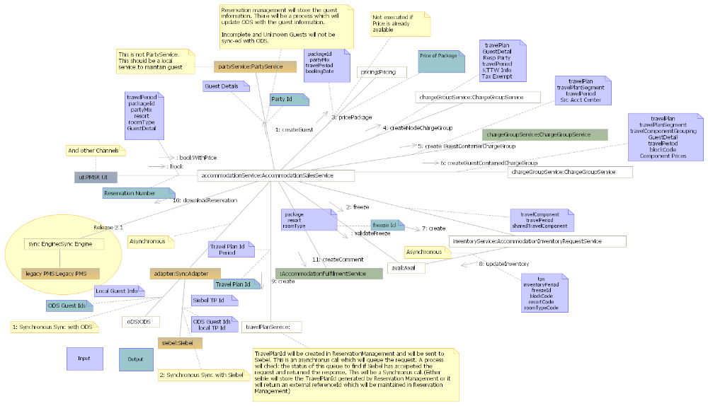

The Domains in-Depth: Folio Management

Folio Management Features
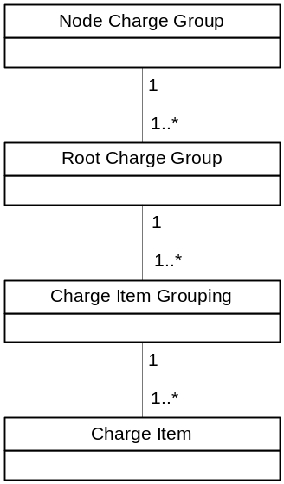As stated above, a folio is a “bucket” that traps all charges that a guest incurs during the course of his stay at WDW. Because the hierarchy of reservation management was designed to allow for both sales and fulfillment of resort rooms, the folio domain had to be designed the same way:

- Charge Group: Charge group is an entity created for a travel plan, travel plan segment, group and block. A root charge group is created for a travel plan and group. A node charge group is created for a travel plan segment, travel component grouping (TCG) and a block.
- Charge Allocation: Charge allocations are a set of billing rules based on which charge can be trapped to the right folio. These rules primarily answer the questions who? What? When? Charge allocations can be defined on the packages, products, and revenue classification. Charge allocations can also be defined to share a charge between two folios. Charge allocations are set up with bill codes to trap the charges. For the different types of charge allocations refer to page 87 of “PMSR Release 2 System Delivery Specification.”
- Bill Codes: A bill code defines who pays for the charges. Some of the example bill codes are defined as follows: *GNADA (group pays no charges), *DCL (Disney Cruise Line pays the charges), and *WDTC (Walt Disney Travel Company (a Disney travel wholesaler) pays the charges)).
- Folio: A folio is a “bucket” representing the billable entity which traps charges and payment items. The two types of folio are ChargeGroupFolio and Suspense Folio. ChargeGroupFolio is associated with a charge group and is created in the context of a reservation or a group. Suspense folios represent when something is “missing” from a guest’s transaction.
  - Charge group folio is further broken down into the following types and sub-divisions:
    - Guest pay folio: Responsible party is a singular guest.
    - Group-pay folio: The folio created for every reservation for the charges that a group is responsible for. It represents charges that particular members of a group are responsible for.
    - RSR folio: Created to keep track of the charges posted for a resort special reservation.
    - Group master folio: The folio to which all the group-pay folios will settle to on check-out.
It is important to understand the distinction between group-pay folio and group master folio. When a guest is charged and that charge hits his group-pay folio, that charge will ultimately be paid for by the group which that person belongs. The amount to be paid by the group to Disney will be reflected on the group master folio.
- The suspense folio is further categorized as charge suspense folio and payment suspense folio:
  - Charge suspense folio: A charge will be posted to a charge suspense folio if the right folio cannot be found for that charge. These folios are set up by revenue classifications. Examples are telephone suspense folios that trap telephone charges posted after check-out of an accommodation.
  - Payment suspense folio: Any payment for which the folio cannot be found are posted into the payment suspense folios. Two payment suspense folios in the system are unapplied guest and unapplied group folios.
- Charge: A charge is a unit of posting which is based on the required frequency of a component product. For example, a room is priced per night (in accounting, a room is charged per night). A ticket is priced per person / per reservation (in accounting, a ticket equates to a charge per reservation). Each charge posted will have a revenue classification (like accommodation, admission, etc.), the transaction accounting center (the origin of a charge transaction) it is associated with, the source accounting center (which identifies who owns the revenue for the transaction) it should belong to. Each charge item will have its own revenue type. Every charge should have at least one charge item with the revenue type as “Base” (and other types can be taxes). Charges can be posted for a reservation component that is booked (product charge, fee charge), group conventions (event charge), or anything that the guest incurs during the course of stay (POS (point-of-sale i.e. a cash register) charge, phone charge)). The following sub-section breaks down the different types of charges:
  - Reservation Related Charges: These are posted when a reservation is booked in the system. A room reservation will result in posting of room charges for each night. Tickets included in the package will post charges per person for that reservation, excluding infants. Other package included components such as dine, recreation, etc. also post charges based on the charging frequency of the products.
  - Fee charges: These charges are related to the policies set up on the packages. Some examples of these charges are:
    - Cancellation fees: Cancellation fees are applied when a manual cancellation of a reservation is processed in the system. Based on the cancellation date and the arrival date, the package policy applies the cancellation fee which is posted to the appropriate folio.
    - Exchange fees: Exchange fees are posted with some DVC reservations.
  - POS Charges are either redeemed against an existing entitlement plan or posted as hotel charges.
    - Hotel Charges: Hotel charges are charges that come thru the POS posting channel and are posted on the guest, group, RSR (Resort Special Reservations), or incidental folio. Some examples of these charges are valet service charges and room service charges.
    - Coupon Charges: Coupon charges are charges that are redeemed against an existing entitlement plan. An example of this charge is the dine plan included as part of a reservation package. A dine plan creates entitlement plans for components of the dine plan i.e. Quick Service, Snacks, and Table Service. When the guest uses that services and uses the KTTW card for payment, the resulting charge is posted in DREAMS Services and is redeemed against an existing entitlement plan.
  - Phone Charges: These charges are posted from the phone system into DREAMS Services when the phone in the room is used for making local or international calls. These charges are posted against the room number.
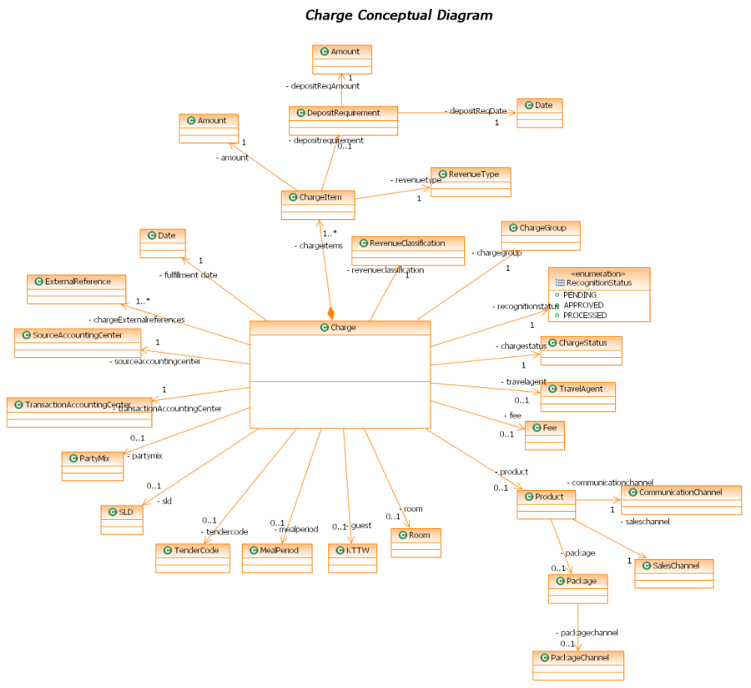
  - Event Charges (BEO Postings): Guests booking events along with room stays get event charges posted from the DSCS Event Management system (DSCS). These charges are posted against the group master folio and not the guest folio.

- The charge life cycle: Any charge posted to Folio will be revenue recognized immediately or later depending on the fulfillment date. A charge that will be fulfilled at a later date than posting date will have the revenue recognition status of pending. The status will be changed to “approved” at the time of fulfillment or check-in. On the other hand a charge posted for a fulfilled service will have the revenue recognition status approved. Charges with “approved” status qualify for revenue recognition.

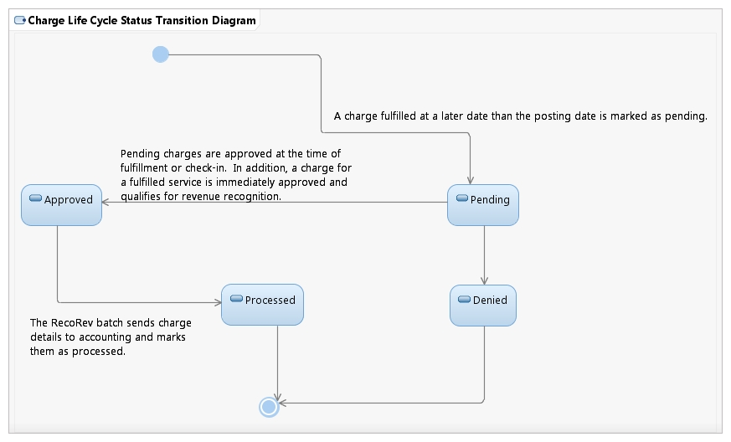
Typically, all the room related charges have a fulfillment date of the stay dates and end of day as the time. All other non-room related charges in the context of package components have the fulfillment date of the arrival date of the reservation and the time as the start of the day. Fees are posted and recognized immediately. This applies for all other postings as well.
  - Charge Items: Each charge posted in accounting is further categorized into charge items. Charge items are types of revenue categorization for the charge posting for a product or fee. The following are types of charge items:
    - Base price
    - Additional price
    - Discount
    - Taxes (accommodation, tourism, county, and state taxes)
    - Deposit requirements
- Charge Transactions
Charge transactions refer to actions that are concerned with the status of a charge. It essentially breaks down charge types further. DREAMS Services supports the following types of charge transactions:
  - Sale (SALE): All charges recognized in the system are recorded as sales transactions.
  - Write-Off (WOFF): On every settlement process, if the Folio balance is below a certain amount, the amount remaining is not processed for billing but is written off. These are recorded in the system as write-off transactions.
  - Adjustment (ADJ): Incorrect postings done manually can be adjusted. These adjustments for charges are recorded as adjustment transactions.
  - Settle (SETT): A settlement process for Group Pay Folios results in creation of a settlement transaction. A settlement transaction is associated to a settlement method on the group pay folio and a settlement charge on the group master folio. It is important to remember the difference between these two types of charge transactions, as they can be easily confused.
  - UPGRADE (UPGD): Any upgrade/downgrade of a component is recorded in the system as an upgrade ticket transaction.
  - Void (REV): A voiding of a charge is recorded in the system as a void transaction.
  - ACB (REF): ACB stands for auto charge back. These types of charge transactions occur when refunds are issued for travel components.
  - Transfer (TRF): Charges can be manually transferred between folios. This is recorded as a transfer transaction which has a transfer from and a transfer to folio and charge information.
After a charge item is paid for on the folio side from the guest, it must move to the accounting domain for revenue recognition. A batch process called RecoRev (Recognize revenue) moves the approved charges in the folio domain over to the accounting domain for revenue recognition.
- Payment
Payment is the money posted to the folio to balance the charges. DREAMS Services receives payments from SBC, Accovia, DCL, Lockbox (a box in which someone can place a check for Disney to cash at a later date), Payment UI [via the DREAMS UI, LILO UI, A La Carte UI, Wishes UI]:
  - Modes of Payment: These payments are received by DREAMS Services as a file-based payment or individual postings:
    - File-based payment: WDTC (Accovia) and DCL send a payment file for the wholesaler reservations. These are inter-company transfers from the wholesaler company to WDW. Special events reservations and lockbox payments also send a file-based payment.
    - Individual Postings: Individual postings are made using most of the user interface clients using several payment methods. It essentially refers to all payments among all types of guests where a third party like a wholesaler is not involved.
- Payment Method Type and Payment Methods: There are several payment methods that are supported by DREAMS Services. Some of these are available for user payment postings whereas some of these are used by system driven processors for setting settlement methods or posting special payments. A payment method type is a particular class of payment such as cash, credit card, check, voucher, etc. A payment method is a particular instance of the payment method class.
Purpose | Types of Payment Method | Payment Methods
UI Payment Postings | Credit Card | VISA
UI Payment Postings | Credit Card | AMEX
UI Payment Postings | Credit Card | MASTERCARD
UI Payment Postings | Credit Card | DINERS CLUB
UI Payment Postings | Credit Card | Others
UI Payment Postings | Pre Paid Card | Gift Card
UI Payment Postings | Check | Manual Check
UI Payment Postings | Check | Travelers Check
UI Payment Postings | Check | Lockbox
UI Payment Postings | Vouchers
UI Payment Postings | Cash | Cash
UI Payment Postings | Cash | Disney Dollars
UI Payment Postings | Rewards Card | Disney Rewards Card

- Payment Life Cycle: A payment is created in the system in an “approved” state. It is processed immediately and an analysis ledger transaction is created as soon as the payment is posted to the folio. The payment is then changed to “processed”. The only exception to the above is for refunds. Refunds are created with a status of “pending” and are approved after a number of days by a batch process entitled Apref as per the business. The refunds are changed to “approved” status and then eventually “processed”.
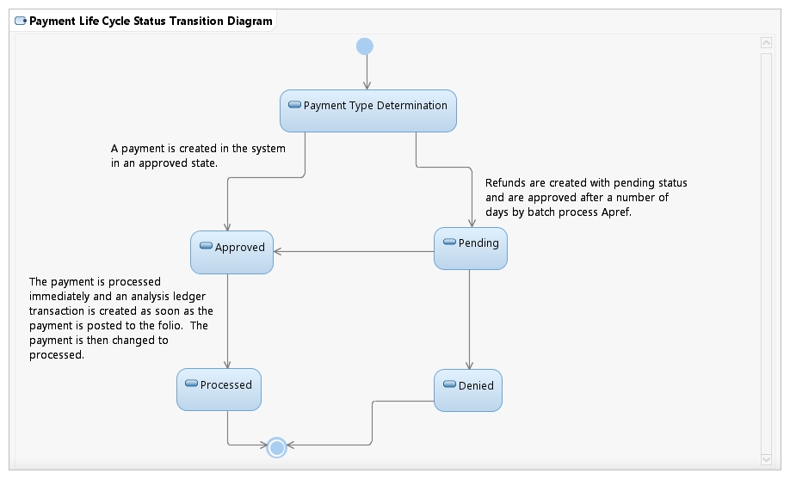
- Payment Transactions
Payment transactions are operations that can be performed on the payments received. DREAMS Services supports the following payment transactions:
- Receipt: All payments received in the System are recorded as receipt transactions.
- Settle: This transaction is created when a group pay folio is settled. The settlement transaction for payment is recorded on the group pay folio. This gets balanced by the settlement transaction for a charge on the group master folio.
- Transfer: This transaction is recorded in case a payment is transferred between folios. The amount to transfer would be spread across based on the folio balance. The transfer can also be done for a single payment. Money can also be transferred from a group master folio to all of its delegate folios. Every transfer transaction tracks the transfer from and the transfer to folio.
- Refund: In case a payment is posted after the reservation has cancelled with an existing deposit, a refund transaction is created and the remaining money on the guest pay folio is settled to the guest.
- Reversal: Incorrect payment postings are reversed by using the user interface. These reversals are recorded in the system as reversal transactions. The folio balance is adjusted based on the reversal transaction being posted.
- Adjustment: An adjustment transaction is created for a specific payment posted in case the original posting has to be adjusted to a different amount.
- Bank Return Transaction: Based on business criteria, certain payments are returned to the bank. For example, when a check is received with insufficient funds, the payment is sent back to the bank via a bank return transaction. A bank return transaction is created when a credit card is charged back or cash/check deposits receive a correction from the bank/financial institution.
- Redeem: Pre-arrival payments need to be moved from an unearned account to a guest ledger at check-in. This redeem transaction recognizes that the unearned payment has been earned, and that its quantity shall be transferred to the accounting domain for revenue recognition.
- Settlement Method
A settlement method is the mode of payment and the payment information to be used by the system for settling the folio balance. This information is either provided by the guest or defaulted by the system in some scenarios. A payment applied to a folio can also be designated as the settlement method. DREAMS Services receives settlement methods from SBC, WDPRO, IVR, Settlement Method UI [via the DREAMS UI, LILO UI, A La Carte UI, Wishes UI]. The following are types of settlement methods:
- Guest settlement methods: In the case of guest pay folios, the default folio is created with “cash” as the settlement method. On payment of the balance due of the folio, the payment can be optionally set as settlement method. Additionally, the guest can specify a settlement method. Rewards, gift cards, and vouchers cannot be specified as settlement methods. The system can maintain multiple settlement methods but only one can be active or default. Any credit card can be specified as settlement method. The system performs a dollar authorization for the credit cards. It stores the authorization information and the masked card number to use for actual payments.
- Group reservation settlement methods: In the case of group pay folios, the settlement method is the group master folio. The balance of the group pay folio is settled to the group master folio.
- Groups settlement methods: A group (convention, wedding, sports team) etc. can have settlement methods similar to the guest settlement methods.
- Wholesaler settlement methods: For wholesalers, the settlement method is direct bill where the SAP customer number is specified and the wholesalers are invoiced nightly.
- RSR settlement methods: In the case of RSR Folios, the settlement method is an internal account number. The balance of a RSR folio settles against this SAP account number.
- Bank-In
A bank-in process notifies the system of the starting balance at the front desk, in case the cashier session has started with a till. Additionally, the users who take payments in DREAMS Services can also bank in without a till. The bank-in process is based on an overall solution which is based on the setup of users in Keystone. This profile is assumed to associate the users of the system to one role.
- Bank-out: A bank-out is notifying the system of the ending balance and the financial activity that happened in the bank-in session.
  - The actor can do advance or late deposits during a bank-in session.
  - An actor has to bank-out before banking in to another location.
  - Any actor that is not banked out will be auto banked out by an end of day batch.
  - Only the user entered items like coins, currency, non-folio refunds are captured and the rest of the payment activity is derived from the payments taken by the cashier during the bank-in session.
- Commissions
The travel agent commission is remuneration for products sold. There are several business processes involved in the commissions’ domain including the setup of commissions, the calculation of commissions on the commission rates, the reconciliation and approval process, and finally the sending of commissions to SAP.

Folio Management Services List
- ChargeService: ChargeService is a business service used for posting charges across all channels. It is used by the following channels/clients in order to accomplish posting of charges, pre-authorizing of charges, transferring charges form entitlements plans to folios and vice versa, and voiding charges:
  - DREAMS Services UI: Used by DRC back office for posting cancellation fees
  - LILO UI: Used by the resort ops for posting, voiding, and adjusting manual charge postings
  - Jazz: Sends phone charges
  - DSCS: Sends event charges
  - Stratus: Sends postings through RVS, HSIA (High-speed internet access), POS terminals, and ATS
- PaymentService: PaymentService is a business service used for posting payments across all channels. It is used by the following channels/clients to post all online payments from the user interfaces and enquire about the balance of a pre-paid card and rewards card:
  - DREAMS Services UI: DRC back office payment posting
  - LILO UI: Resort ops posting payments
  - SBC payment for WDW: DRC Res Agents posting payments
- FolioChargeService: FolioChargeService is a component service used by the following channels/clients.
  - ChargeService: The business service uses this component for posting, voiding, and authorizing charges
  - AccommodationSalesService: AccommodationSalesService posts charges for new bookings, modifications, cancellations, shares, un-shares, reinstates, rate overrides, and upgrades
  - AccommodationFulfillmentService: AccommodationFulfillmentService posts charges for upgrade to this service.
  - Revenue Recognition Daemon: The daemon recognizes charges due and updates the status of recognized charges.
- FolioPaymentService: FolioPaymentService is a component service used for posting payments across all channels. It is used by the following channels/clients to earn payments, post payments, and get folio payment validation information:
  - PaymentService: PaymentService delegates the actual creation of “payment” in the system to this service. It also retrieves information from this service for validation for posting a payment.
  - Revenue Recognition Daemon: The Revenue recognition daemon uses this service for earning payments.
- FolioService: FolioService is a business service used for posting charges across all channels. It is used by the following channels/clients to transfer charges and payments within folios, create responsible parties, retrieve folios, and re-filter.
  - LILO UI: Resort Ops uses this for transfers of charges and payments and creating incidental folios and viewing folios.
  - DREAMS SERVICES UI: DRC back office uses this for retrieving folios for display and transfer of payments
  - System Driven Processes: Billing profile changes and changes in tax exemption status trigger re-filter of all charges on the folios for a travel plan.
- ChargeGroupService: ChargeGroupService is a component service used for posting charges across all channels. It is used by the following channels/clients to create, modify, and maintain the status of charge groups, check-in and checkout a charge group, and determine a guarantee status:
  - AccommodationSalesService: This business service uses this component service for all reservation related functionalities.
  - AccommodationFulfillmentService: This business service uses this component service for all fulfillment related functionalities.
- BankInService: BankInService is a business service used by the following clients/channels for auto bank-out, bank-in, bank-out, and creating bank-out interfaces:
  - LILO UI: Resort Ops users for banking in and banking out
  - EOD (end of day) Jobs; Auto bank-out and creating bank-out interfaces

Folio Management System Interactions
Just as in the reservation management domain, there are a multitude of system interactions that can occur when the folio management domain must talk to other parts of DREAMS Services. For the brevity of this document, the system interaction that will be outlined will be “post charge.” For a complete list of folio management system interactions please refer to pages 109-123 in “PMSR Release 2 System Delivery Specification”.
- Post Charge
  - ChargeService is a business service that receives the post charge requests from JAZZ, Stratus, RTP, ATS adapters, and LILO UI and does validations as necessary and passes the request to entitlement service or FolioChargeService for posting charges. The charge is passed to entitlements if the charge is found to be valid to redeem coupons. DREAMS UI and Booking services call FolioChargeService for posting charges.
  - POS postings originate from a host of channels:
    - POS Terminals: Guests using media (Magic Bands, KTTW) at food and beverage, merchandise, and other locations within the WDW Property end up posting a charge on their reservation. These charges are either redeemed against coupons available as part of the package entitlements or posted as hotel charges.
    - Resort Valet Service: A valet parking placard is issued at the time of check-in or the room reservation. The parking placard holds reservation information. Whenever a valet service is used by the guest, the parking placard is used for getting the reservation information and the valet charge is posted to folio using the KTTW.
    - High Speed Internet Access: Guests using high speed internet access in the rooms get charged on the charging frequency of the Internet usage. These charges are also posted against the KTTW of the Primary Guest.
    - ATS: Guests using the KTTW to purchase tickets at Guest Services result in posting of charges from ATS into DREAMS SERVICES.
  - The posting of charges performs the following steps:
    - Determines if the charge needs to be posted to a folio or an entitlement for POS charges
    - For other charges and the charges to be posted on the folio for POS charges, the posting of charges process performs a bill trap process.
    - The process then posts the charge to the folio based on the bill trip.
    - If a charge is partially trapped by the folio as a result of the bill trap, a bill trap for the remaining balance of the charge is performed.
    - Adapters parse and interpret the request coming from various channels and translate to appropriate message formats to invoke the respective ChargeBusinessService methods.

The Domains in-Depth: Inventory Management

Inventory Management Features
The inventory management domain is responsible for the maintenance and creation of physical inventory. This domain is extendable to other types of physical inventory that are not necessarily hotel rooms, such as dining tables, golf carts, and boat rentals. The inventory management domain contains the following entities:
  - Assignment Owner: An assignment owner is the grouping of inventory for a resort stay or another inventory request for tables, dinner shows, boat rentals, etc. It is also created for each room taken out of order. Assignment owner holds on to the assignment request.
  - Assignment Request: This is the logical inventory request for each unit of inventory. For example, a room is tracked nightly, a table is tracked per dinner show or per hour, and boat rentals are tracked every half an hour.
  - Resource: Resource is the physical resource assigned to the reservation for fulfilling the assignment request. In the case of room reservations, the resource is the room itself.
  - Assignment: An assignment is created once the room is assigned to the reservation. An assignment is tracked for the room nightly.
  - Cleaning Schedule: Cleaning Schedule is for tracking the extra cleaning schedules purchased by the guest. This is only applicable to a resource type designated as room. This is similar to an assignment request, tracked by the day if the guest has purchased any cleaning schedule for the day.
  - Inventory Resort Configuration: The setup of configuration data for fulfillment functionality requires data to be set up at the Resort level. For a full list of these rules in detail please refer to “PMSR Release 2 System Delivery Specification” pages 128-129.
  - Inventory Room Configuration: As part of the PMSR solution, the inventory domain has configuration data required for the room inventory related business processes. Listed below are the concepts maintained by this domain:
    - Inventory Resort: This concept is created to represent the resort. The resorts are published by OneSource in the WDW composite application. DREAMS Services retrieves the resorts using the FacilityService. DREAMS Services stores the Inventory Resort to maintain additional data for fulfillment in the context of each resort.
    - Room type: Room types are logical constructs depicting different categorizations of rooms within each resort. OneSource publishes the room types for each resort and DREAMS Services retrieves the list of room types for each Resort using FacilityService. DREAMS Services stores the Room type to further associate additional data required for fulfillment.
    - Room type hierarchy: The room type hierarchy is defined for the room adjustment process to qualify the next available upgrades to be recommended by the system for the room assigners.
    - Room: Room is the physical resource that is assigned for fulfilling a room reservation in the resort. The room is created in the DREAMS Services system using the LILO UI by the resort operations personnel. A room created in the system has to be associated to a room type belonging to that resort.
    - Room sequence:
        - Resort Occupancy Percentage: (number of occupied rooms + number of due in rooms + rooms in out of inventory status – number due out in rooms) / (total number of rooms in resort) * 100.
        - Room rack sequence Room rack sequence is the sequence of rooms in the resort to be used by the room assignment process based on a specified resort occupancy percentage range.
    - Attribute Type: Attribute type is a high level categorization of features that are configured for each room in the resort. Some examples of attribute types are view (broken down into garden, ocean, etc.), proximity, bedding, and connecting rooms.
    - Attribute: Attributes are features of rooms specified for each room configured in the system. Attributes are used for the automated room assignment process to ensure fulfillment of the attributes requested as part of the reservation.
        - Each attribute is always categorized for one attribute type. For example, queen bed belongs to the attribute type bedding.
        - Each room is allowed to have multiple attributes
        - Each room cannot have multiple attributes belonging to the same attribute type. For example, a room cannot have a queen bed and king bed as attributes for the bedding attribute type.
    - Status Types:
        - Housekeeping: These statuses are changed based on the reservation statuses associated to that room and also determine the room ready criteria. Some examples of housekeeping statuses are dirty, clean, pick up, inspected etc. For example, when a reservation checks out, the system automatically assigns a dirty status to the room. A room with the housekeeping status of clean and inspected completes the check-in process.
        - Housekeeping occupancy: These are housekeeping reported occupancy statuses and are not transitioned by the rules in the system. These are maintained on the room and help track housekeeping productivity. Examples of statuses in this area are occupied and empty.
        - Room Occupancy: The room occupancy statuses are driven off the assignment of the room reservation to the room. These are the values of the room occupancy statuses. When a reservation is checked-in to a room, the room occupancy status is occupied. When a reservation is checked out of a room, the room occupancy is vacant.
        - Inventory
          - Closed floor: Rooms are put on a closed floor for group reservations or during times of low occupancy. The rooms that are on closed floor are not used for normal room assignments.
          - Out of Inventory: Rooms are taken out of inventory for maintenance purposes. These rooms are not available for assignments and also impact the true availability counts for that resort.
    - Campus, Resort, and Location Configuration

Inventory Management Services List
  - AccommodationInventoryRequestService: This business service is used by the AccommodationSalesService in creating assignment requests for every accommodation component. This service provides the business functions of creating, modifying, releasing, sharing, and un-sharing assignment requests.
  - AccommodationInventoryService: AccmmodationInventoryService is a business service used to set up new inventories (rooms) for a resort. This service is primarily used by actors utilizing the LILO UI and provides the business functions of creating rooms, creating attributes, creating rack sequences, creating schedule type transition rules, and loading rooms for DVC resorts.
  - AccommodationInventoryServiceRequestService: AccommodationInventoryServiceRequestService is a business service used primarily by resort operations. It is used for the business functions of creating, cancelling, and modifying inventory requests for out of inventory or closed floors.
  - AccommodationAssignmentService: AccommodationAssignementService is a business service used primarily by AccommodationFulfillmentService in checking-in and checking-out a room. It is also used by the LILO UI in finding an available room and saving the assignment.
  - AccommodationStatusService: AccommodationStatusService is used primarily by the inventory management services list as part of the fulfillment processes and by the resort front desk for changing the housekeeping statuses of the rooms. PBX Maid Dial- in uses this service to change the status of the room whenever they are done cleaning it and the LILO UI displays and updates the status of the room.
Note: For a list of system interactions involving the inventory management domain please refer to pages 138-150 in “PMSR Release 2 System Delivery Specification”.

The Domains in-Depth: Profile Management

Profile Management Features
As you learned above, coded comments are pre-defined codes added to the reservation to represent additional guest requests in the course of their stay such as requests for specific rooms and certain services to be provided by the resort. These profiles are configured in DREAMS Services. Each profile has a brief description to convey the purpose of that profile code. As part of the PMSR solution, the profile management has been enhanced. The configuration of the profiles can be done using a user interface. Also, at the time of configuration, the profiles can be categorized into the following:
- Attributes: These typically represent any preference for connecting rooms or bedding or a specific amenity provided in the room. The same is also used to specify special needs rooms.
- Alerts for front desk validation: The coded comments are also added for certain ID validations at the front desk e.g. tax certifications, ID, etc.
- Service requests: Service requests for housekeeping and bell services are also added using coded comments.
- Comments: A coded comment is also used for informational purposes such as the check-in and checkout time for the resorts.
Profiles can also be specified for a specific resort or a group of resorts. They can also be specified for specific room types within a resort. The profile can be configured to be “default” for a combination of a resort or room type.
Profiles can also be set up for a specific package. For example, a reservation for MYW Dine Package drives the default profile “Please call 407-WDW-DINE for making dining reservations”.
Default profiles on an accommodation cannot be removed. Additional profiles can be added to the accommodation reservation. The list of profiles available while booking an accommodation is displayed on the package, resort, and room type being booked for that reservation.

Profile Management Services List
- ProfileService: The ProfileService is a business service and is mainly used by the LILO UI, DVC Member Services UI, and DREAMS Services UI to populate the list of profiles applicable for the reservations being booked. This service is also used to create profiles from the LILO UI.

The Domains in-Depth: Srvc. Request Management

Service Request Management Features
The service request management domain has been enhanced in the PMSR solution to capture guest requests requiring an action from the cast members for fulfillment of the request. These requests can be either made at the time of making a reservation, on the day of check-in, mid-stay, or even on the day of checkout. Each of these requests has to be fulfilled. Some of the requests require the guests to incur additional charges and are not covered as part of their stay. The special requests handled by the PMSR solution include the following:
- Special request: Special requests are added in the context of the guest stay to the accommodation. They can be for delivery or pickup of special items like hair dryers, cribs, or water bottles.
A special request of this type requires a cast member to be assigned to complete the task. Maximo is the system of record used by the resort operations team to create work orders to assign the tasks for special requests. PMSR sends these requests to the Maximo interface for eventual work order creation and fulfillment.
Some special requests that are added require housekeeping services. These types of requests are printed on the housekeeping boards. In addition, some special requests incur additional charges. The PMSR solution handles these chargeable requests by creating products for these requests. The requests are priced like a normal product and charged to the guest.
- Bell service request: These are created for guests requesting bell services at the time of check-in and mid-stay in the case of room changes, or checkout. A bell service also needs to be sent to the Maximo Interface as it involves the assignment of a cast member to fulfill the request.
- Inventory Request: These can be maintenance requests to fix any operational issues with the room. The maintenance requests can be in the context of a guest stay. An inventory request is created in the system and sent to the Maximo interface for fulfillment. Additionally, the resort operations can close a wing or floor for refurbishment or regular maintenance. These rooms are taken out of inventory. These requests are also created and tracked in the system as inventory requests.
- Late checkout request: Late checkout requests are requested typically on the day of checkout. The PMSR solution does not restrict the creation of the late checkout requests before the day of checkout. A late checkout request is created in the system and goes thru a manual approval process by the housekeeping manager.
The PMSR solution tracks the status of the late checkout requests. All approved late checkout requests are priced based on the policy of the resort and the room type at the time of actual checkout and charged to the guest.

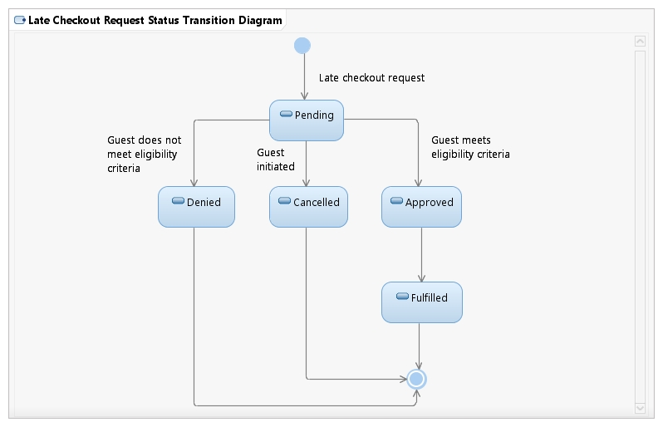

Service Request Management Services List
- ServiceRequestService: ServiceRequestService is a component service that is used mainly by the AccommodationFulfillmentService to perform service requested related tasks. The key business functions of this service are creating and fulfilling service requests and tracking the status and display requests in the context of a reservation.

The Domains in-Depth: Entitlement Management

Entitlement Management Features
- Entitlement Plan: Entitlement Plan is the “bucket’ which holds all the coupons issued for that resort stay for a Travel Plan for all the guests. Entitlement plans are created when the travel plan is checked in. One entitlement plan per each dine plan in the package is created. Each entitlement plan will have a starting balance. Entitlement plans can optionally be shared with guests who have the same plan and who are in the same reservation.
- Coupon: Coupons are the electronic entitlements that are issued to the guest for the components in the package that can be redeemed thru the KTTW card. Coupons can be of several types, such as guest count, dollar count, or unlimited recreation.
Every coupon maintains the running balance based on its type. Each coupon is redeemed against a coupon charge. Each coupon charge that is posted will redeem coupons from the entitlement plans and will decrease the available balance.
The system supports the ability for coupons to be shared among members of a party. For example, let’s say a family comes to Disney with two children and have booked two separate rooms. If the family has a coupon for a free meal voucher at a Disney resort restaurant the system should recognize that the entire family shall be entitled to the coupon even though there are two separate rooms in the reservation.
- Coupon Profile: For each coupon, a coupon profile is created that defines the coupon code and the mapping to a point of sale tender code. Coupon profile allows setting up the usage restrictions of the coupon and the redemption requirements per accounting center.

Entitlement Management Services List
- EntitlementService: EntitlementService is a business service used primarily by resort operations and the ChargeService. ChargeService uses this service for entitlement postings and the LILO UI uses it for sharing, un-sharing, transferring coupon charges, viewing coupons, and posting coupons manually.

The Domains in-Depth: Accounting Management

Accounting Management Features
- Accounting Centers: Accounting Centers are used to assign a financial transaction to SAP’s cost center, profit center, company, and general ledger account numbers. Each accounting center can play the following roles:
  - Transaction Accounting Center: Identifies the origin of a charge transaction
  - Banking Accounting Center: The accounting center which owns the bank account where the money is deposited. Designating the accounting center as a banking accounting center drives what displays in the drop down boxes for methods of payments.
  - Charge Accounting Center: Identifies the destination from which revenue is earned. A charge accounting center is derived from a combination of a transaction accounting center with a posted item and a banking accounting center and a method of payment.
  - Source Accounting Center: The accounting center that financially owns a particular reservation.
- Analysis Ledger: Each charge or payment transaction creates one analysis ledger transaction per each offset posting item or payment method determined. An analysis ledger transaction is associated with a source accounting center and source company (Walt Disney Travel Company, Walt Disney World, Walt Disney Land) information.
  - Each analysis ledger has to be created with both a natural entry and an offset entry. In accounting terms, the natural entry refers to the entry in the account that is directly affected by a business transaction and an offset entry refers to the entry in an account that is indirectly affected by a business transaction. Each account in a general ledger naturally balances on a “debit” or “credit” side, where debit, for simplicity, just means that the account has a left hand balance and credit means a right hand balance.
    - An example of this would be a guest paying for a room on credit. The natural entry would be a debit to accounts receivable and the offset entry would be a credit to revenue, where both sides of the ledger balance to zero.
- Natural Posting Item Configuration: This configuration is used in looking up a natural posting item in the process of creating analysis ledger entries for a transaction.
- Offset Posting Group Configuration: This configuration is used in looking up an offset posting item in the process of creating analysis ledger entries for a charge transaction.

Accounting Management Services List
- AccountingService: The AccountingService is a component service used by the revenue recognition daemon process to recognize the revenue. This service is also used by the PaymentService to retrieve payment validation information.

Accounting Management System Interactions
- Accounting Process: The accounting process in DREAMS Services includes determining the appropriate general ledger account numbers for all of the financial activity recorded for the folios maintained in the system for reservations. It involves the determination of the “true” accounting structure maintained by the financial system of record based on the concepts used in the folio domain.
SAP is used for recording the financial activity and is designed with the following in mind:
  - Company
  - Profit Center (A division of Disney that makes money for the company)
  - Cost Center (A division of Disney that costs the company money)
  - WBS (Work Breakdown Structure)
The accounting process in DREAMS Services is used to “bridge” the folio domain concepts to derive the SAP concepts and map the folio entries to SAP entries. Once the data is mapped, the end of day feeds use this information stored in the analysis ledger to produce the financial feeds to be sent to SAP.
The following illustrates the process of the financial data being transported from the folio domain to the analysis ledger:
  - Determining the sign of the entries
    - Any entry in the folio which increases the balance of the folio is recorded as a positive entry in the analysis ledger.
    - Any entry in the folio which decreases the balance of the folio is recorded as a negative entry in the analysis ledger.
    - The sign of the folio item (charge or payment) is used to drive the sign of the natural entry.
  - Finalizing the entry
    - Create an analysis ledger transaction

The Next Generation Experience
Now that the core foundation of DREAMS Services has been explained in detail, it is important to depict where it is headed in the near future. This will allow for the understanding of how each individual component of the DREAMS Services foundation is evolving in order to accommodate the future technological enhancements.
The Next Generation Experience aims to leverage the latest technology to radically modernize and enhance the theme park experience for Disney’s guests. The central component surrounding this experience is an RFID-enabled Magic Band (code-named xBand) that is mailed to customers’ doors before they arrive at the park. These bands allow individuals to access their rooms, pay for items, and be admitted to the theme park, etc. The band acts as a gateway to an unbelievable amount of innovation in the future.
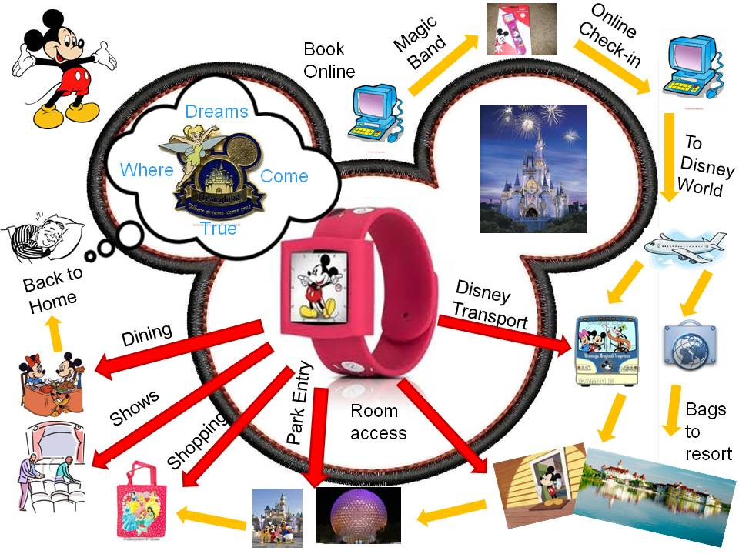

The Next Generation Experience revolves around the following three areas of functionality:
- Touch to Pay: The objective of the Touch to Pay (TTP) functionality within NGE is to provide the guest an ability to create a charge account (which is like a personal wallet) and set up payment methods to enable payment for park incidentals as well as payment at other establishments by xBands. The business functionality for releases 2.2, 2.4, and 3.3 includes the following:
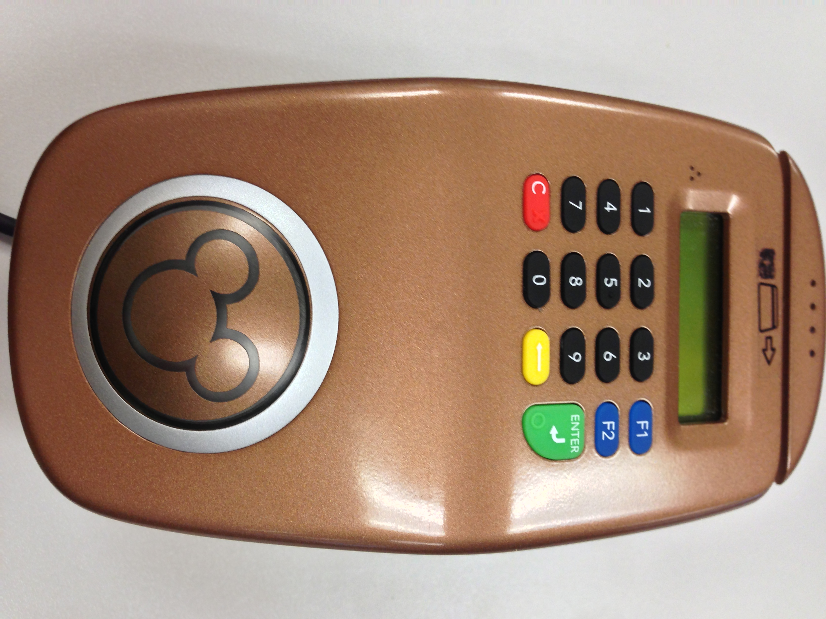
- Creation of charge accounts for NGE resort guests; and adding/updating credit card payment methods (2.2)
- Managing charge account PINs with PIN entry completed on an RFID encoder pictured to the right. (2.2)
- Supporting Touch to Pay at Point-of-Sale locations (2.2)
- Setting Charge Account PINs and supporting Touch to Pay at front desk locations (2.2)
- Charge Account UI and Payment UI (see section user interfaces) will be changed to handle multiple active KTTW and credit card payment methods (2.4).
- Allowing park day guests to use Touch to Pay for transactions (3.3).
- Touch to Play: Touch to Play was introduced in Release 2.4 and enables the guest to tap their xBand to enter the park. The following types of tickets are supported by Touch to Play:
  - Standard tickets: Current state tickets which are physically encoded/printed on media (paper or magnetic stripe)
  - E-Tickets: E-ticket entitlements are not physically encoded/printed to any Media. E-tickets are linked to the guest’s ticket account and the ticket account has the guest’s media.
ATS: (A fulfillment support system for ticketing services) creates a ticket account for each guest which has a relationship with the guest’s e-ticket entitlements and the guest’s xBand.
- Touch to Stay: Touch to Stay, introduced in Release 2.0, provides the ability for a guest to touch his xBand at the resort rooms and common areas to gain room access. The xBand has an RFID chip which stores the door access information. Touch to Stay supports the following flows as part of Release 2.4:
  - Grant Access—Online
  - Grant Access—Offline
  - Modify Access
  - Check-in
  - Associate/Issue new xBand
  - Capture Guest’s First Entry into Room
  - Encode RFID only Card
  - Activate/Deactivate xBand.
- Level N (Personal Magic aka Memory Maker) aka Bundle Service: Level N (which was introduced in release 2.4) is the technical term for what Disney calls “Personal Magic” or “Memory Maker.” Personal Magic is a way for families to digitally capture the small moments on their Disney vacation which add up to a lifetime of memories. Disney has partnered with external contractors to be able to deliver physical media such as memory books and calendars as well as virtual media such as videos and slideshows to sell to guests.
  - Direct to Room (DTR) and Bypass Front Desk (BFD) : Release 3.1 gives guests an additional feature to make their Disney experience even more seamless. Direct to Room functionality allows resort guests to bypass the resort front desk and seamlessly go straight to their rooms after they arrive at a particular resort hotel.
  - As part of the BFD pilot program, a primary guest (guest whose name is on the reservation) must meet a list of certain Direct to Room criteria. The following are these criteria:
    - Credit Card on File with “Use for Incidentals” flag as true: The true flag means the system recognizes that the user has marked that he wants his card used for incidentals.
    - Member Guaranteed: Disney Vacation Club Member.
    - Group Guaranteed: If a group is guaranteeing the reservation, it qualifies for BFD and does not matter if it’s a wholesaler or non-wholesaler group. In addition, even if a group pays for just one night and its tax, it will be marked as DTR ready, so it will work exactly like Member Guaranteed.
    - Paid in Full
- Paid in Full means the balance is zero or less on the Folio. A folio is a “bucket” that traps all charges and payment items that the guest incurs. These include both room and non-room related expenses.
Upon verification that the guest has met the requirements, an agent will manually check-in the accommodation before the guest arrives at the resort using a typical check-in flow in the LILO UI (see section on user interfaces). Room access will be granted to the Guest’s media (xBand) upon check-in completion and Room Ready notifications will be sent to the guest. Based on the Room ready status, the guest can directly go to the room and bypass the Front Desk. These messages will be sent to the onsite phone and email that the guest provided while he made his reservation.
  - The existing reservation framework has a room ready notification system that allows a guest to be notified by SMS text when their room is ready for access. The existing room ready notification and new BFD messaging will be consolidated to use the same messaging back-bone in order to reduce the overall cost of sending these messages.
  - Many external systems talk to DREAMS Services. DREAMS Services acts as a hub and processes all of the information coming from the external system to determine whether a party is DTR eligible or not.
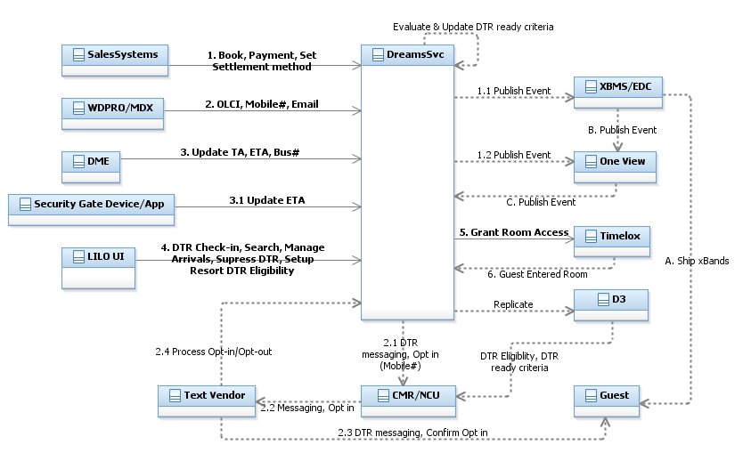

Conclusion
This document highlights that the DREAMS Services suite has undergone an incredible amount of enhancements and modifications in the past few years. These system upgrades make both the cast member and guest experiences even more seamless and efficient. But more importantly, it continues to serve as a platform that allows the Walt Disney World company to deliver the most cutting edge innovations in the hospitality industry. The GBTS Services team has, and will continue, to allow Walt Disney World to fully achieve its business goals in the near and long term. Again, welcome to the team!

https://wdpr.sharepoint.disney.com/sites/CSFBST/Design%20and%20Dev%20Teams/Offshore%20Team/Dev%20Onboarding/Project%20Execution%20in%20Disney.doc#Teams
https://wdpr.sharepoint.disney.com/sites/CSFBST/Design%20and%20Dev%20Deliverables/Release%202.2/CSFBS%20Release%202.2%20Solution%20Definition.docx
https://wdpr.sharepoint.disney.com/sites/CSFBST/Design%20and%20Dev%20Deliverables/Release%202.4/Solution%20Definition%20-%20CSFBS%20Release%202%204%20%20Passport%20-%20v1%20b.doc
https://wdpr.sharepoint.disney.com/sites/CSFBST/Design%20and%20Dev%20Deliverables/Release%202.4/Solution%20Definition%20-%20CSFBS%20Release%202%204%20%20Passport%20-%20v1%20b.doc
Ibid
https://wdpr.sharepoint.disney.com/sites/CSFBST/Design%20and%20Dev%20Deliverables/Release%202.4/Solution%20Definition%20-%20CSFBS%20Release%202.4%20%20-%20Level%20N%20-v1g.doc
https://wdpr.sharepoint.disney.com/sites/CSFBST/Design%20and%20Dev%20Deliverables/Release%202.4/Solution%20Definition%20-%20CSFBS%20Release%202.4%20%20-%20IPO%20-v1.doc
https://wdpr.sharepoint.disney.com/sites/CSFBST/Design%20and%20Dev%20Deliverables/Release%202.2/CSFBS%20Release%202.2%20Solution%20Definition.docx
https://wdpr.sharepoint.disney.com/sites/CSFBST/Design%20and%20Dev%20Deliverables/Release%202.4/Solution%20Definition%20-%20CSFBS%20Release%202.4%20-%20NGE%20-%20v1.doc
https://wdpr.sharepoint.disney.com/sites/CSFBST/Design%20and%20Dev%20Deliverables/Release%203.3/Solution%20Definition/Solution_Definition_ServicesDelivery_Release_3.3%20-%20NGE.docx
https://wdpr.sharepoint.disney.com/sites/CSFBST/Design%20and%20Dev%20Deliverables/Release%203.1/SDS/Solution_Definition_CSFBS_Release_3.1%20-%20NGE.docx

